Supporting Information
Tribological properties of SiO₂@Cu and SiO₂@MoS₂ core-shell microspheres as lubricant additives
Xiaoliang Maª, Chaoliang Gan^{b}, Yuting Liª, Peng Fengª, Xiaoqiang Fan^{a,*}, Xiangyuan Ye^{c,*}, Minhao Zhu^{a,b}

* Corresponding Author: E–mail address: fxq@home.swjtu.edu.cn (X. Fan), bjuasyxy@163.com (Y. Ye).

- SEM micrographs of obtained powder samples
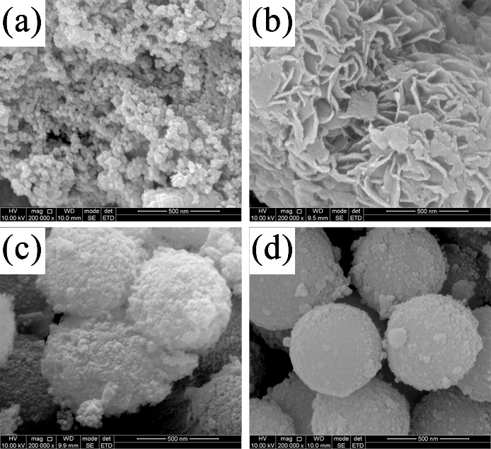
Fig. S1 SEM micrographs: a single Cu sample, b single MoS₂ sample, c SiO₂@Cu sample, and d SiO₂@MoS₂ sample

2) 3D profile and 2D depth profile of wear tracks
Fig. S2 3D profile and 2D depth profile of wear tracks lubricated by hybrid oil at an applied load of 200 N: a Cu and b MoS₂

3) SEM spectra of wear tracks at 200 N
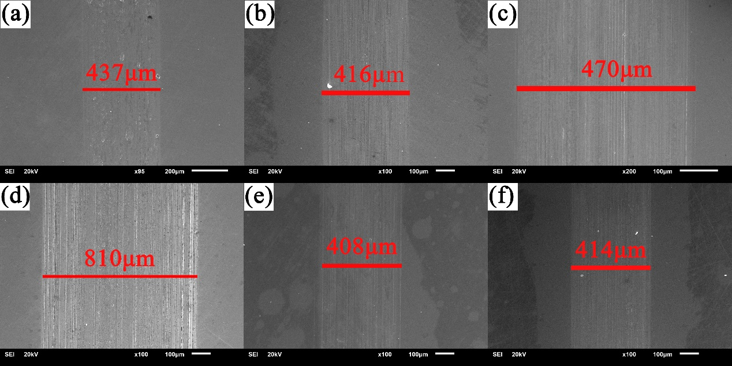
Fig. S3 SEM micrographs of wear tracks at 200 N lubricated with: a PAO, b SiO₂, c Cu, d MoS₂, e SiO₂@Cu, and f SiO₂@MoS₂

