When the impossible happens: how February 2022 event redefines extreme floods in Australia
Supplementary Material
Julien Lerat⁽¹⁾, Jai Vaze⁽¹⁾
- CSIRO Environment, Canberra, ACT, Australia

Site selection process
The selection of 1131 streamflow gauging stations mentioned in section 3 of the paper is based the height following criteria:
- The catchment area drained at the gauging station site must range between 5 and 200,000 km². Catchments smaller than 5 km² are excluded due to their low relevance in terms of riverine flooding. Catchments larger than 200,000 km² are generally highly influenced by a range of anthropogenic activities such as artificial reservoir or irrigation, and hence do not represent an unimpaired flood regime.
- The maximum streamflow gauging at the site (i.e. joint observation of water level and streamflow) must exceed the maximum streamflow divided by a factor of 20. This threshold eliminates stations for which the rating curve used to convert water level to streamflow is derived from gaugings that are limited to low flow regimes. The factor of 20 is chosen is agreement with previous studies on flood records in Australia^{1,2}. This factor, which could be considered as high, is a compromise between data accuracy (which would favour lower factors, hence more high flow gaugings) and data availability in many parts of Australia (which is limited when considering low factor is low). Many sites in Australia are not easily accessible, hence limiting the possibility to collect extensive sets of gauging points.
- The mean annual runoff coefficient, computed as the ratio between the mean annual streamflow by the mean annual rainfall, must be lower than 0.99. This criterion ensures that catchment water balance remains conservative (mean annual streamflow remains lower than mean annual rainfall).
- The runoff coefficient must also be greater than half of the inverse of aridity index. This index is computed as the ratio between mean annual rainfall and evapotranspiration derived via the Penman equation within the AWRA landscape model³. Theoretically, runoff coefficient lower than the inverse of the aridity index implies that actual evapotranspiration is greater than potential evapotranspiration, which is physically impossible. However, estimation of potential evapotranspiration is associated with large uncertainty, hence the allowance for a lower threshold of 0.5 times the inverse of the aridity index.
- The sum of storage capacities of reservoir located within the catchment must remain lower than 10% of mean annual streamflow at the site. This criterion ensures that the impact of artificial storages on flood regime remains limited.
- The streamflow record duration at the site must exceed ten years. Note that a more stringent is adopted for the selection of flood events as indicated in the next section.
- The proportion of urban areas within the catchment must be lower than 10% of the total area.
- The site must not be located on an artificial channel such as a canal or drain.

Complementary results for the surprise index
This section presents figures similar to Figure 4 of the paper using different probability model and Bayesian inference assumptions:
- Figure 1 shows the surprise index values using the Log Pearson 3 probability distribution instead of the GEV distribution.
- Figure 2 shows the surprise index values using the GEV distribution and a censoring threshold set to the 20% percentile of observed values (i.e. left censoring the lowest 20% of observed data for the computation of the likelihood function).
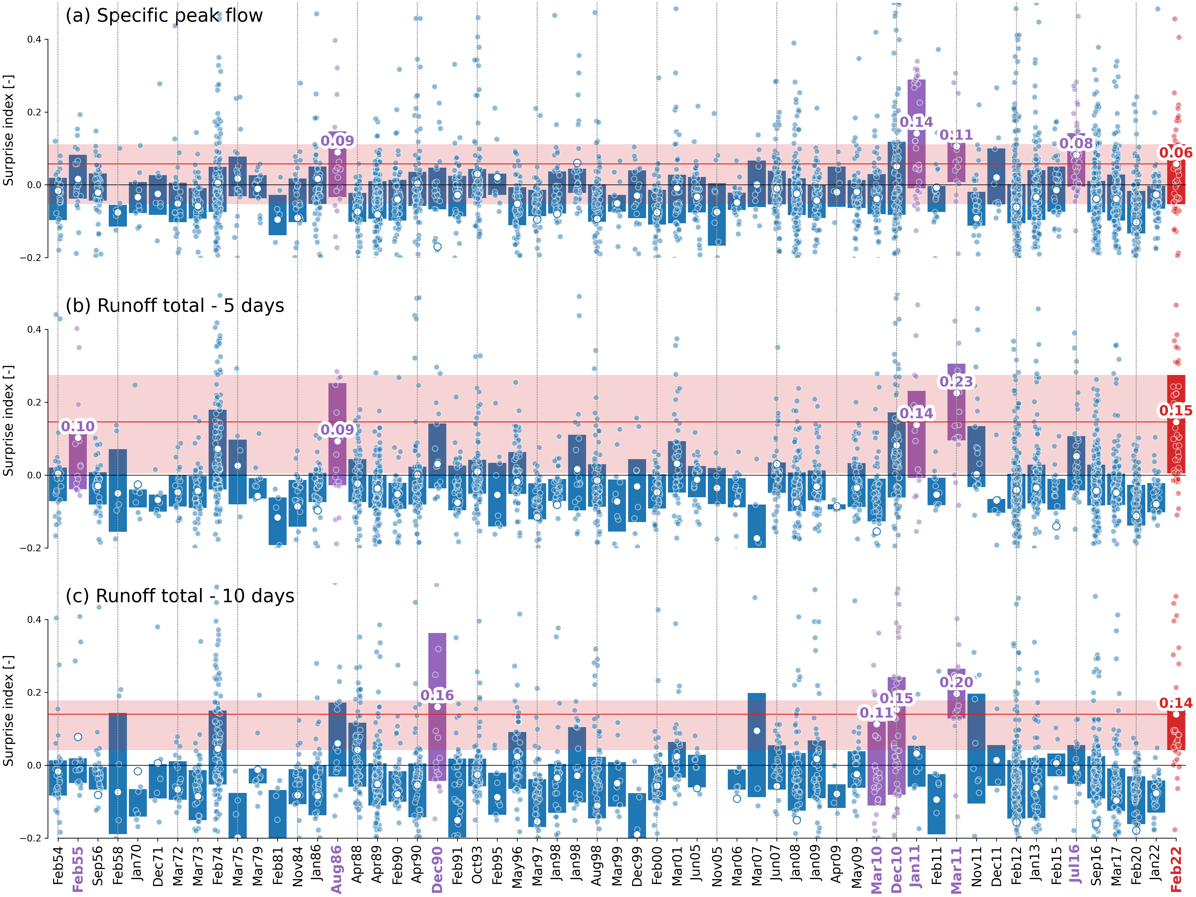
Figure 1: Surprise index using the Log-Pearson3 distribution and no censoring threshold
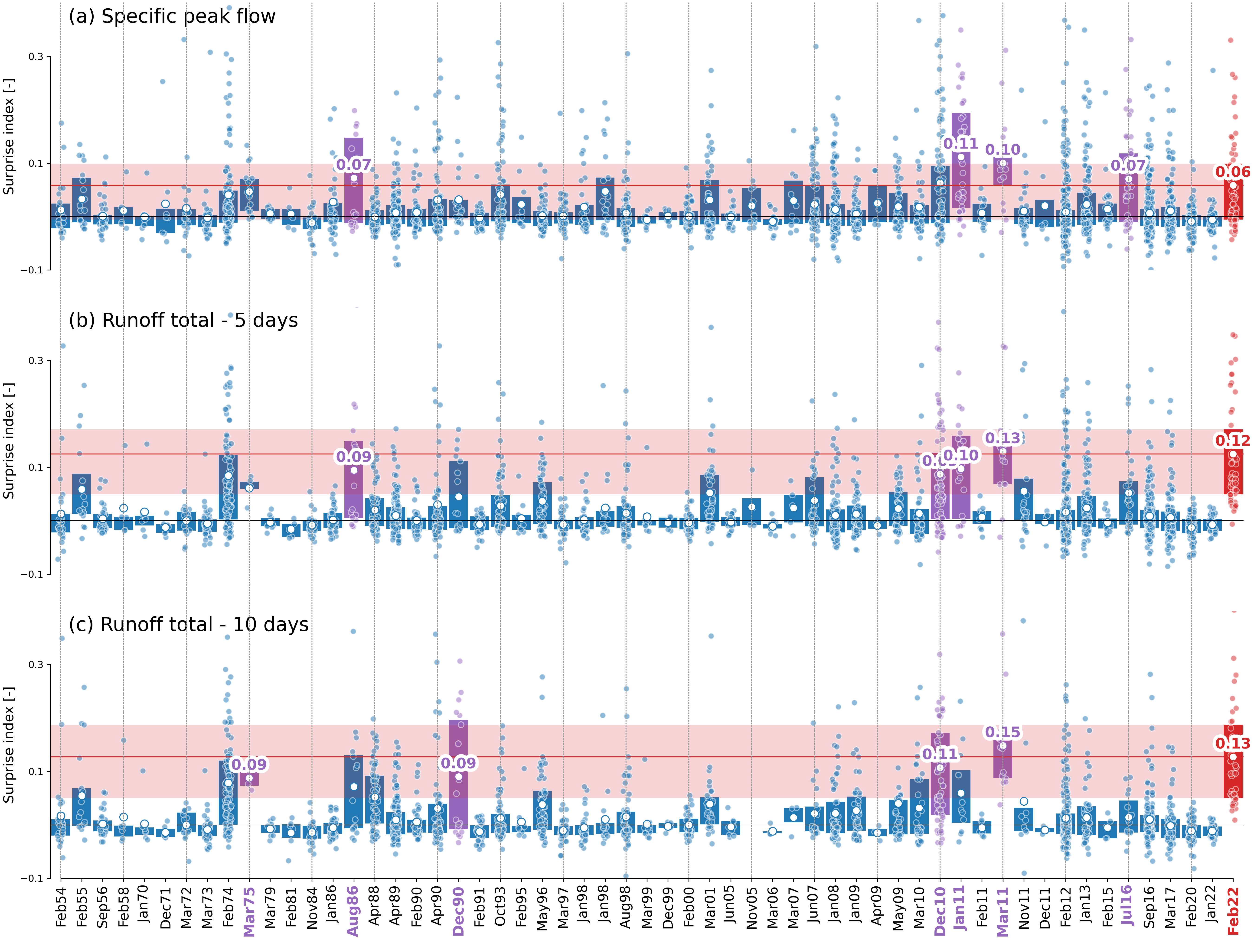
Figure 2: Surprise index using the GEV distribution and 20th percentile censoring threshold

References
1. Haddad, K., Rahman, A., Weinmann, P. E., Kuczera, G. & Ball, J. Streamflow data Preparation for Regional Flood Frequency Analysis: Lessons from Southeast Australia. Australasian Journal of Water Resources 14, 17–32 (2010).
2. Ishak, E. H., Rahman, A., Westra, S., Sharma, A. & Kuczera, G. Evaluating the non-stationarity of Australian annual maximum flood. Journal of Hydrology 494, 134–145 (2013).
3. Vaze, J. et al. The Australian water resource assessment modelling system (AWRA). 20th International Congress on Modelling and Simulation, Adelaide, Australia vol. 16 (2013).

