Supplementary Information
A molecular specimen bank for contemporary and future study captures landscape-scale biodiversity baselines before Klamath River dam removal
A molecular specimen bank for contemporary and future study captures landscape-scale biodiversity baselines before Klamath River dam removal

Authors and Affiliations
*Dylan J. Keel, Resource Environmental Solutions, LLC. Sacramento, CA, 95818. ORCID: 0009-0006-8445-7033 - dkeel@res.us
Katie Karpenko, Genidaqs Laboratory of Cramer Fish Sciences, West Sacramento, CA, 95691 – katie.karpenko@fishsciences.net
Scott M. Blankenship, Genidaqs Laboratory of Cramer Fish Sciences, West Sacramento, CA, 95691- scott.blankenship@fishsciences.net
Gregg Schumer, Genidaqs Laboratory of Cramer Fish Sciences, West Sacramento, CA, 95691 - greggs@fishsciences.net
Oshun O’Rourke, Yurok Tribal Fisheries Department, Klamath, CA, U.S.A., 95548 - oorourke@yuroktribe.nsn.us
Carl O. Ostberg, U.S. Geological Survey, Western Fisheries Research Center, Seattle, WA, 98115. ORCID: 0000-0003-1479-8458 –costberg@usgs.gov
*Daniel A. Chase, Resource Environmental Solutions, LLC. San Francisco, CA, 94111 – dchase@res.us
Jeffrey J. Duda, U.S. Geological Survey, Western Fisheries Research Center, Seattle, WA, 98115. ORCID: 0000-0001-7431-8634 – jduda@usgs.gov

This PDF file includes:
- Supplemental Material 1 – Statistical Methods
- Supplemental Table 1 – Metabarcoding Species Data
- Supplemental Table 2 – Molecular Library Metadata Requirements

Supplementary Material 1 – Statistical Methods

Model Specification
We utilized a stochastic partial differential equations approach (SPDE) to introduce Gaussian spatial random field effects, fitted using the integrated nested Laplace approximation (INLA). The INLA method uses a Bayesian framework and is implemented in R software. INLA provides a relatively fast inference by means of analytical approximations of the posterior model and therefore is more expedient for resampling approaches than simulation-based Bayesian approaches such as Markov chain Monte Carlo. The fitted model for species richness followed the form
$$Y_{i}∼\text{Poisson}\left(λ_{i}\right)$$
$$\log\left(λ_{i}\right)=β_{0}+β_{1}⋅X_{1}i+⋯+β_{z}i⋅X_{z}i+ε_{i}+α_{i}$$
$$ε_{i}∼\text{normal}{\left(0,σ^{2}\right)}_{}$$
$$α_{i}∼\text{Matérn}\left(\text{range,}K,σ_{α}^{2}\right)$$
Where 𝛌_{i} is the shape parameter, Y_{i} is the number of native fish species per site (richness), 𝛽_{z} is a vector of regression coefficients, X_{z} is a vector of variables, and 𝛽₀ + ε_{i} is the intercept to which observations at site i belong. The random effect of site, ε_{i,} has a mean of zero and variance of σ², and ⍺_{i} the spatial random field has range and Κ parameters with variance of σ²_{α}. A log link-function was used.

The fitted model for diversity (extreme low diversity sites (Shannon-Wiener diversity index < 0.05) and normal or high diversity sites (Shannon-Wiener diversity index > 0.05)) followed the form:
$$Y_{i}∼\text{Bernoulli}\left(π_{i}\right)$$
$$\text{logit}\left(π_{i}\right)=\log\left(\frac{π_{i}}{1-π_{i}}\right)=β_{0}+β_{1}X_{1i}+…+β_{z}X_{zi}+ε_{i}+α_{i}$$
$$ε_{i}∼\text{Normal}\left(0,σ^{2}\right)$$
$$α_{i}∼\text{Matérn}\left(\text{range,}K,σ_{α}^{2}\right)$$
Where π_{i} is the probability of non-low native fish diversity (Shannon Diversity Index < 0.05), Y_{i} i is the binary outcome indicating low native fish diversity (0) or non-low native fish diversity (1) per site, 𝛽_{z} is a vector of regression coefficients, X_{z} is a vector of variables, and 𝛽₀ + ε_{i} is the intercept to which observations at site j belong. The random effect of site, ε_{i,} has a mean of zero and variance of σ², and ⍺_{i} the spatial random field has range and Κ parameters with variance of σ²_{α.} A logit link-function was used.

Methods for Assessing Spatial Autocorrelation
Preamble: The purpose of this appendix is to provide additional information on the methods for assessing spatial autocorrelation in the residuals, provide justification for the use of spatial models, and assessing model fit following methods referenced in the main text. The following is the workflow for the species richness count GLMMs. For additional model assessment or for additional details regarding analysis see complete published code at: https://github.com/Dylan-Keel/KRRC_Molecular_Library_Temporary

Model Assessment
Following the main text, first a relatively full count model was fit with a Poisson distribution. Using the dispersion_check function in R Package: inlatools, we assess overdispersion.
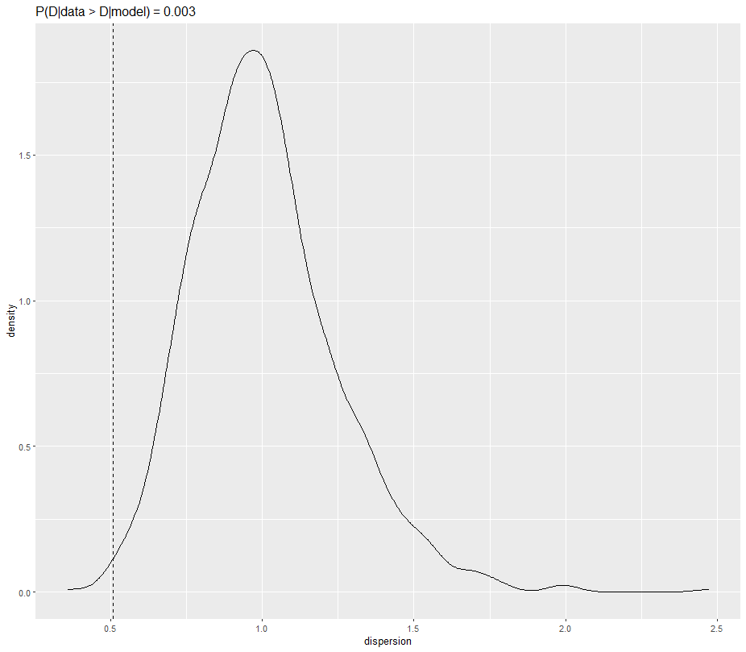
Figure A1: Simulated probability density function of overdispersion from 1000 samples from full, non-spatial, Poisson GLMM. Dispersion given the data = 0.510, dispersion given the model = 1.006, and the probability of the overdispersion is taken to be 0.003 or a near certainty that the model is under-dispersed. However, under-dispersion can arise from spatial autocorrelation.
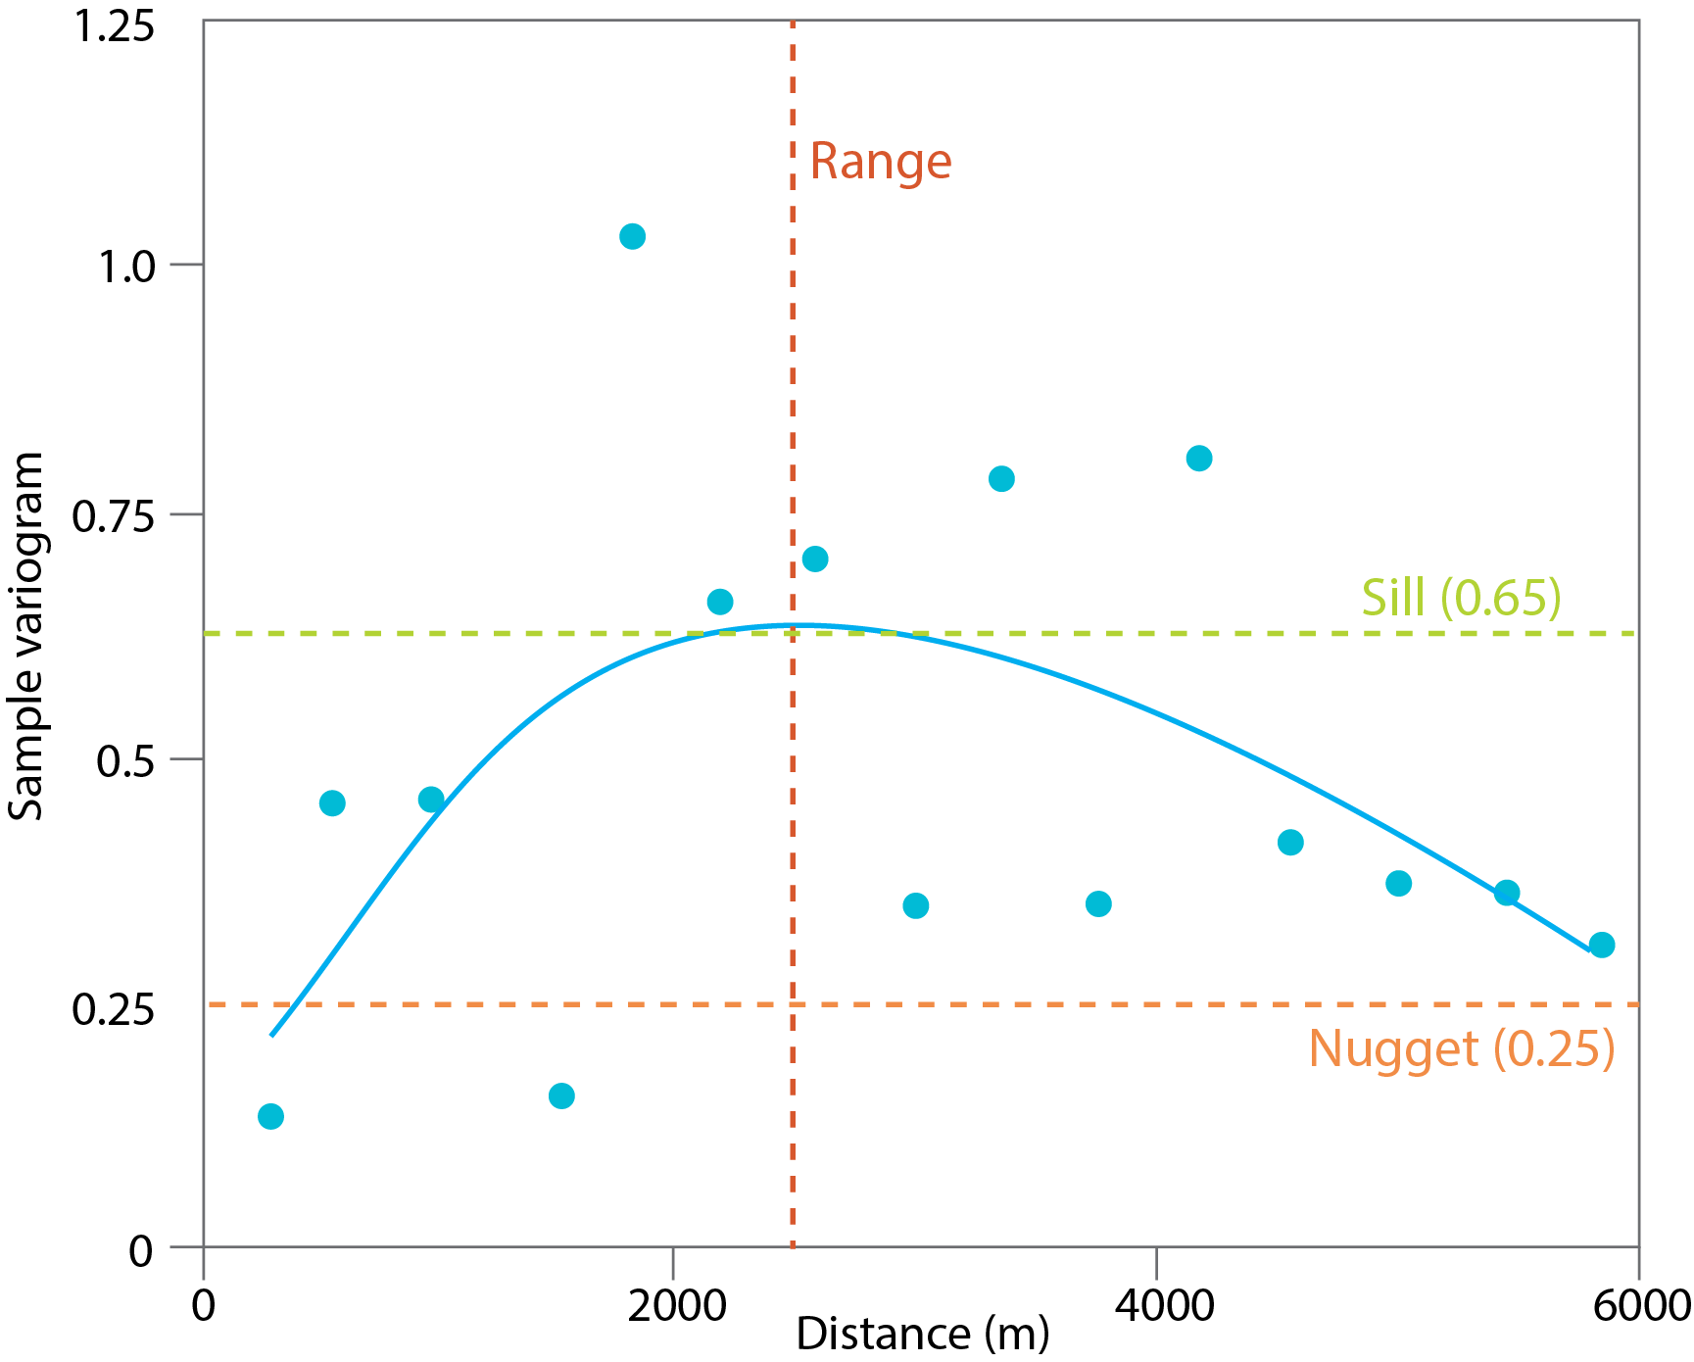
Figure A2: Semivariance of the Pearson residuals of a non-spatial Poisson GLMM over distance (m). Sill is estimated at 0.625, nugget is estimated at 0.25, and the estimated range of spatial autocorrelation is 2500 meters. 60% residual variance is spatial.

The semivariogram (Figure A3) shows a high degree of spatial autocorrelation in the residuals, indicating that ~60% of the residual variance is spatially structured. Figure A4 shows another way to view spatial Pearson residuals.

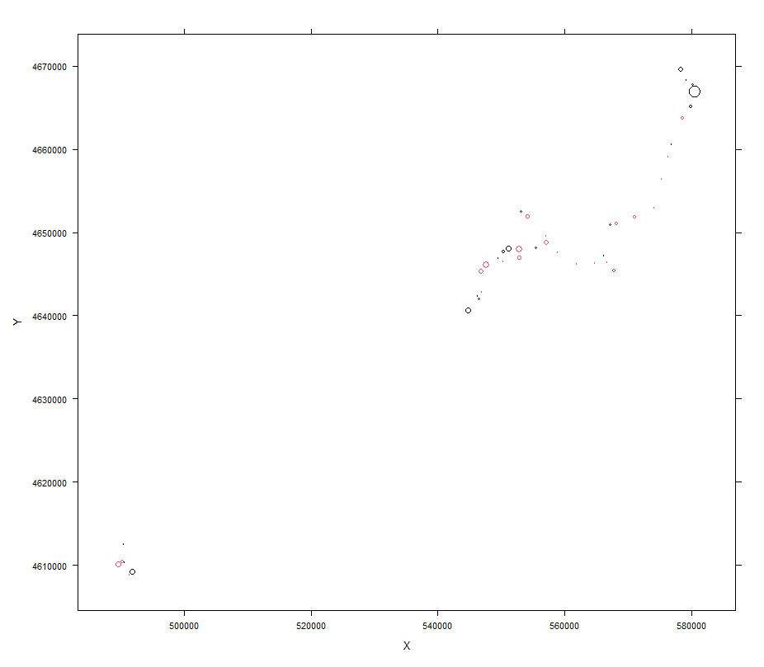
Figure A3: Spatial Pearson residuals plotted in pseudo-space. Red (lighter shade) indicates positive residuals, black (darker shade) indicates negative residuals, and size of circle indicates size of residual.
Finding strong evidence of spatial autocorrelation in the residuals spatial models were fit following the text using the estimated range from Fig. 3 as the informative prior mean (mean=2.5 Km, standard deviation = 1 Km). Following model selection, the selected model was assessed for residual spatial autocorrelation as above.

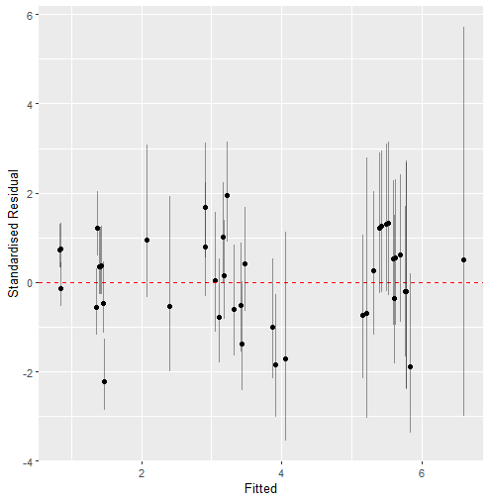
Figure A4: Standardized Residuals of selected model vs. fitted values. Residual error structure is compatible with Poisson distributed data.
Model fit was assessed with posterior predictive checks by simulating data to compare with the raw data, the Bayesian p-value (0.45). No evidence of overdispersion or residual spatial autocorrelation, reasonable fit, and standardized-residual structure compatible with model error assumptions suggest that the model is correctly specified and passes goodness of fit.
Model fitting and assessment for the diversity model followed a similar format.
Supplemental Table 1 – Metabarcoding Species Data: List of common names of species used in the main text, the exotic/native status of the fishes to the Klamath River and tributaries, and their associated scientific names, as well as other herptiles, birds, and mammals detected.
Status | Common name | Scientific name
Exotic Fishes | Black Crappie | Pomoxis nigromaculatus
Exotic Fishes | Black/Brown Bullhead | Ameiurus spp.
Exotic Fishes | Bluegill Sunfish | Lepomis macrochirus
Exotic Fishes | Brown Trout | Salmo trutta
Exotic Fishes | Carps, Minnows | Cyprinidae spp.
Exotic Fishes | Goldfish | Carassius auratus
Exotic Fishes | Fathead Minnow | Pimephales promelas
Exotic Fishes | Golden Shiner | Notemigonus crysoleucas
Exotic Fishes | Green Sunfish | Lepomis cyanellus
Exotic Fishes | Largemouth Bass | Micropterus salmoides
Exotic Fishes | Pumpkinseed Sunfish | Lepomis gibbosus
Exotic Fishes | Yellow Bullhead | Ameiurus natalis
Exotic Fishes | Yellow Perch | Perca flavescens
Native Fishes | Klamath Large Scale/Klamath Small Scale, Shortnose, Lost River Sucker* | Catostomidae
Native Fishes | Lamprey | Entosphenus spp.
Native Fishes | Rainbow Trout/steelhead | Oncorhynchus mykiss
Native Fishes | Chinook Salmon | Oncorhynchus tshawytscha
Native Fishes | Coho Salmon | Oncorhynchus kisutch
Native Fishes | Sculpin | Cottus spp.
Native Fishes | Speckled Dace | Rhinichthys osculus
Native Fishes | Tui Chub | Siphateles bicolor
Herptiles | American Bullfrog | Lithobates catesbeianus
Herptiles | Coastal Giant Salamander | Dicamptodon tenebrosus
Herptiles | Pacific Giant Salamander | Dicamptodon sp.
Herptiles | Mole salamanders | Ambystoma sp.
Herptiles | Pacific Tree Frog | Pseudacris regilla
Herptiles | Southern Alligator Lizard | Elgaria multicarinata
Herptiles | Tailed Frog | Ascaphus sp.
Herptiles | Western fence lizard | Sceloporus occidentalis
Herptiles | Western Pond Turtle | Actinemys marmorata
Herptiles | Western Toad | Anaxyrus boreas
Birds | American Robin | Turdus migratorius
Birds | California Scrub Jay | Aphelocoma californica
Birds | Crows, Ravens | Corvidae
Birds | Double-Crested Cormorant | Phalacrocorax auritus
Birds | Ducks, Geese, Swans | Anatidae spp.
Birds | Mallard | Anas spp.
Birds | New World Sparrows | Passerellidae
Birds | Thrushes | Turdidae spp.
Birds | True Finches | Passeriformes sp.
Birds | White-Winged Scoter | Melanitta deglandi
Birds | Wood Duck | Aix sponsa
Mammals | American Beaver | Castor canadensis
Mammals | American Black Bear | Ursus americanus
Mammals | American Shrew Mole | Neurotrichus gibbsii
Mammals | Common Shrew | Sorex cinereus
Mammals | Deer | Odocoileus spp.
Mammals | Mouse-eared bats | Myotis spp.
Mammals | Muskrat | Ondatra zibethicus
Mammals | North American River Otter | Lontra canadensis
Mammals | Northern broad-footed Mole | Scapanus latimanus
Mammals | Pack rat | Neotoma sp.
Mammals | Raccoon | Procyon lotor
Mammals | Striped Skunk | Mephitis mephitis
Mammals | Voles, Muskrats | Cricetidae
Mammals | Yuma Bat | Myotis yumanensis
*All species known to be present at time of sampling. Taxonomic identification described in the text.
Supplementary Table 2: List and descriptions of metadata associated with the Klamath River Renewal Project Molecular Library sample collections.
Section | Variable Name | Description
Site Information | Project.Name | The title of the project under which the samples were collected
Site Information | PI_Contact_Name | Project point of contact.
Site Information | PI_Contact_email | Email address for the project point of contact.
Site Information | Survey.Date.and.Time | Month-day-year and time of sampling.
Site Information | X.Coordinate | Latitude in decimal degrees.
Site Information | Y.Coordinate | Longitude in decimal degrees.
Site Information | Waterbody.Name | The name of the river, stream, or reservoir where sampling occurred.
Site Information | Sub.Site.Locations | Site-level description of where the sample was collected (e.g., Right bank, left bank, center channel).
Site Information | Sample.Depth | A qualitative description of where the water sample was collected (e.g., surface, benthos).
Sample Information | Sample.ID | A persistent identifying accession number used to individually track each sample, containing the site name, the sample date, and the replicate number.
Sample Information | Replicate.Number | The filter replicate taken at sample date-time and site.
Sample Information | Sample.Volume | Water sample volume passed through the filter (mL).
Sample Information | Sample.Collection.Method | The method used to collect each sample from the river or stream (e.g., pooled, individual).
Sample Information | Filter.Preservation.Method | The methods and reagents used to preserve the filter.
Sample Information | Sample.Archive.Location | The current location of the sample archive.
Sample Information | Filter.Type | Description of the filter used (e.g., PVDF Sterivex).
Sample Information | Filter.Pore.Size | The filter mesh size in microns (e.g., 0.45 µm).
Sample Processing | Extraction.Method | The method used to extract nucleic acids from filter.
Sample Processing | Extraction.Status | Specifies compatibility: DNA extraction, RNA extraction, or not extracted.
Sample Processing | Location.Storage.Method | Description of how samples are stored for long-term preservation (e.g., frozen at -20°C).
Environmental Parameters | Air.Temperature | Measured air temperature at the time of sampling, in degrees Celsius.
Environmental Parameters | Water.Temperature | Measured water temperature at the time of sampling, in degrees Celsius.
Environmental Parameters | Dissolved.Oxygen | Dissolved oxygen measured during sampling (mg/L)
Environmental Parameters | Specific.Conductance | Measured specific conductance during sampling; units are µS/cm (micro-Siemens per centimeter).
Analysis Details* | Processing | How the sample was processed or analyzed (e.g., eDNA metabarcoding, archived).
Analysis Details* | Remaining Volume | Remaining volume of NAs for analysis (e.g., DNA/RNA)
Analysis Details* | Processing.Year | The year in which the sample was processed.
Analysis Details* | Processing.Lab.Contact | Information for the processing laboratory (name and email).

