Appendix A1: Research on Chess Planning Depth

Authors | Number of Moves | Type of Measure | Type of Task | Remarks
De Groot, 1946 | 3-5 | Qualitative analysis of chess players' decision-making processes | Chess move planning | Estimation that may varies due to qualitative insights. Skill range: grandmasters and experts
Charness, 1981 | 2-5 | Qualitative analysis of chess players' decision-making processes | Chess move planning | Estimation that may varies due to qualitative insights. Skill range: Class B to Masters
Gobet, 1998 | 3-5 | Qualitative analysis of chess players' decision-making processes | Chess move planning | Estimation that may varies due to qualitative insights. Skill range: Class B to Masters
Bilalić et al., 2009 | 3-5 | Qualitative analysis of chess players' decision-making processes | Chess move planning | Estimation that may varies due to qualitative insights. Skill range: Candidate Masters to Grandmasters
Connors et al., 2011 | 5-6 | Qualitative analysis of chess players' decision-making processes | Chess move planning | Estimation that may varies due to qualitative insights
Ferreira, 2013 | 6 | Estimate search depth based on engine rating | Chess game via self-playing chess engine | Engine depths estimated player levels from 6 plies (~1950 Elo) to 20 plies (~2900 Elo). Skill range: approximately 2300 Elo Rating
Snider et al., 2015 | 2-5 | Estimate planning depth by comparing human choices to model's computational decisions | Forced-choice task | Likely represents planning depth but not chess player experience and pattern recognition.
Biswas & Regan, 2015 | 3-5 | Estimate planning depth by comparing error rates across depths between engine and player evaluations | Chess games by players | Depth of satisficing ranges from 6 to 10 plies (3 to 5 moves), increasing with player skill level.
Krusche et al., 2018 | 3-5 | Estimate planning depth by comparing human choices to model's computational decisions | Foraging task on a grid | Likely represents planning depth but not chess player experience and pattern recognition.
Krivec et al., 2021 | 3-4 | Identified through reconstruction tasks, measuring time intervals between moves, and agreement on factors such as performance and key positions. | Reconstruction tasks in chess | High-skilled chess players recall 3-4 chunks when order matters; 7-9 chunks when it does not. 3-4 moves selected as planning ahead requires sequence.
van Opheusden et al., 2023 | 4-6 | Estimated planning depth by comparing human choices to model's computational decisions | Board game (four-in-a-row) similar to tic-tac-toe | Likely represents planning depth but not chess player experience and pattern recognition.

Appendix A2: Literature Review for Studies examining Chess Complexity

Study | Complexity Dimension | Complexity Measure | Game Phase | Results | Data | Engine
Guid & Bratko, 2006 | Difficulty | Sum of absolute differences between the best and second-best move evaluations whenever the best move changes as search depth increases from 2 to 12 plies | Middle and End | Spearman correlation of ρ = 0.89 (p < 0.0001) between the calculated player errors and actual game outcomes | 1,397 games and 37000 positions from Championship matches from 1886 to 2006 | Modified Crafty
Guid, Perez, & Bratko, 2008 | Difficulty | Sum of absolute differences between the best and second-best move evaluations at different final search depths, specifically from 2 to 12 plies | Middle and End | Focus on the rankings produced from average deviations between player moves and Crafty’s suggestions at various search depths. Found that rankings of players were consistent across search depths | Same dataset as Guid & Bratko (2006) with some slight deviation for specific players | Modified Crafty
Guid & Bratko, 2011 | Difficulty | Sum of absolute differences between the best and second-best move evaluations at different final search depths, specifically from 2 to 12 plies | Middle and End | Focus on the rankings of players across chess programmes, showing that heuristic search can reliably estimate skill levels despite varying program strength and search depth | Games of Capablanca, Euwe,  and Steinitz and 20000 additional positions from World Chess Championship matches from 1886 to 2006 | Multiple (CRAFTY, RYBKA, SHREDDER, etc.)
Guid & Bratko, 2013 | Difficulty | Sum of absolute differences between the best and second-best move evaluations at different search depths from 2 to 20 plies, accounting for changes in best move evaluation across depths | Middle and End | Spearman correlation of ρ = 0.93 (p < 0.001) between difficulty scores and mean player errors, showing that higher difficulty scores predict more severe player mistakes | 40,000 positions from World Chess Championship matches | Houdini 1.5a (64-bit)
Biswas & Regan, 2015a | Difficulty | Changes in move evaluations at various depths and the relative depth at which these significant changes occur | Entire game | Focus on the statistical significance of the decreasing probability of finding the best move as swing values increase. Empirical frequency analysis demonstrated that players across all levels struggled significantly more with high-swing positions. | Games in standard round-robin tournaments from 2006–2009 between players near Elo mileposts (2200, 2300, 2400, 2500, 2600, 2700), and 900 games from the 2013 World Blitz Championship. | Stockfish
Regan, Biswas, & Zhou, 2014 | Difficulty | Average error per move and its relation to the player's advantage or disadvantage | Entire game | Focus on the statistical significance of the increased error rate when players were ahead or behind. The study also highlighted a 2-3% worse scoring expectation for humans (compared to computers) when it was their turn to move, validated through logistic regression and confidence intervals. | 10,317 human games with 726,120 analysed moves and 3,226 games from human-computer tandems | Komodo6, Stockfish, Houdini4, Rybka3
Anderson et al., 2017 | Difficulty | Blunder potential (ratio of blunder moves to total legal moves) | Endgames | Achieved 75% accuracy in predicting human blunders using blunder potential, skill, and time. Blunder potential strongly correlated with the likelihood of errors, and time and skill alone yielded 55% and 53% accuracy, respectively. | Chess endgames with at most six pieces, from databases of recorded games | Tablebases
Bratko et al., 2021 | Difficulty  Optionality | Player ratings (Difficulty)  Attributes such as number of meaningful moves, legal moves, branching factor and forced moves (Optionality) | Tactical problems | Negative correlation between Chess Tempo problem ratings and player success (r = -0.60, p = 0.0383), and 60% accuracy in predicting problem difficulty using Gradient Boosting Trees. Strong positive correlation (r = 0.94) between players' perceived difficulty and automatically predicted difficulty by the classifier. | Utilise dataset from Hristova, Guid, & Bratko (2014) | Stockfish  Chess Tempo
Hristova et al., 2014 | Difficulty  Optionality | Player ratings, accuracy, time (Difficulty)  Move variations considered via eye-tracking data (Optionality) | Tactical Problems | Moderate positive correlation (r = 0.44, p = 0.15) between problem-solving success and difficulty estimation. Success rates, solution times, and eye-tracking data were used to assess difficulty and compare with Chess Tempo ratings. | 12 chess problems with 12 participants | Chess Tempo
Salant and Spenkuch, 2023 | Optionality | Depth to mate (DTM) and width (number of legal moves after the current move), reflecting the challenge of distinguishing between the best and other alternatives due to the branching factor of the decision tree | Endgame | Focus on the significant impact of increasing complexity (measured by depth and width) on reducing the probability of selecting the best move. A one standard deviation increase in depth led to a 9% rise in errors, while width caused a 2% increase, with depth being the stronger predictor, as shown by an R-squared value up to 0.263. | 227 million chess endgame moves by 237,000 experienced players on Lichess | Nalimov and Syzygy endgame tablebases
Strittmatter et al., 2020 | Optionality | Time taken by Stockfish to reach a search depth of 21 moves and number of branches (nodes) in the game-tree to reach that depth | Entire game | Performance measured via OLS regression. Significant negative impact of fatigue and time pressure on performance (p < 0.01). Complexity (time to search depth) positively associated with human error. | Move-by-move data from professional chess games | Stockfish 8
De Marzo & Servedio, 2023 | Rarity | Frequencies of chess openings played via a modified Economic Fitness and Complexity (EFC) algorithm | Opening | Best F1 Score of 0.16 for predicting new opening choices. Spearman correlation coefficient of 0.64 between player fitness and rating, indicating a strong link between opening repertoire and player skill level. | 472,183 blitz games with 982 unique openings across 2513 players between 2015-2016 from Lichess | Nil

Appendix A3: Evaluation of the variability across varying and fixed depths

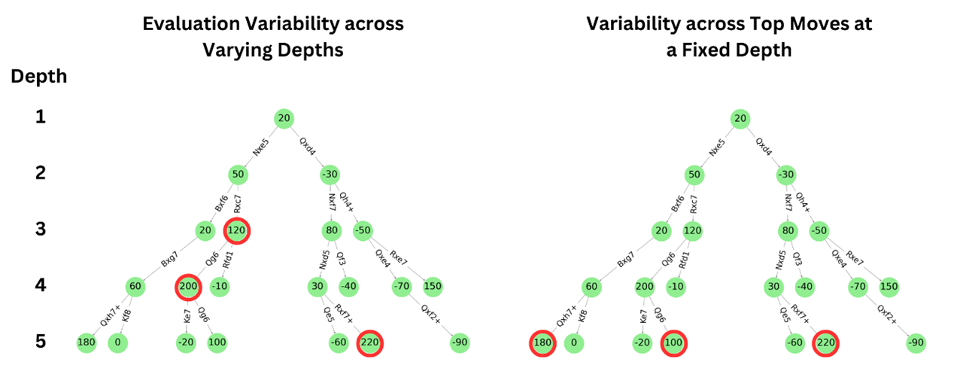
Note: The decision trees represent chess engine move evaluations with moves highlighted by the arrows and centipawn scores given in the nodes.

Left Tree - Evaluation Variability Across Varying Depths.
The red circles on the left tree (120, 200, 220) demonstrate how move assessments change at different search depths. This shows the fluctuation of evaluation with deeper search, illustrating the evaluation variability across search depths utilised by studies from Biswas & Regan (2015a) and Guid et al. (2006; 2008; 2011, 2013).

Right Tree - Variability Across Top Moves at a Fixed Depth.
The red circles on the right tree (180, 100, 220) highlight the variability across top moves at a fixed depth (depth 5). This represents the engine's confidence or certainty in evaluating board difficulty at a specific level of analysis. By focusing on a fixed depth, we can assess how certain the engine is about the best moves in a given position without the confounding factor of variable search depths.

As noted in the literature review, the evaluation variability across depths combines board difficulty with search effort, obscuring their distinct contributions. To address this, we use variability across top moves at a fixed depth to assess the engine's confidence in evaluating board difficulty. This variability represents the engine's certainty or uncertainty in its evaluations, giving us an assessment of the accuracy of the difficulty measure. A narrow evaluation spread indicates high certainty and clear move distinctions, while a wider spread suggests lower certainty and complex variations. This method focuses on the engine's evaluation confidence, providing a better measure of position complexity by reflecting how certain or uncertain a player might feel about their move evaluation or assessment of the board difficulty.

Appendix A4: Middle game definition

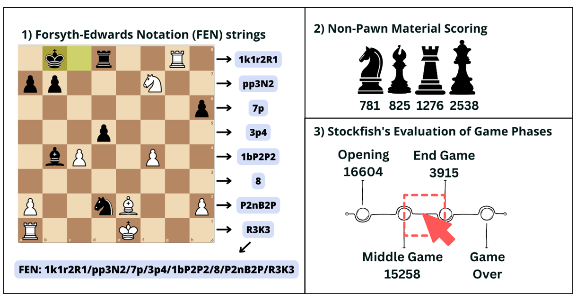
Forsyth-Edwards Notation (FEN) Strings:
In FEN, piece placement describes the board row by row from 8th to 1st rank, using letters (uppercase for White, lowercase for Black) for pieces and numbers for empty squares, separated by slashes. For example, 1k1r2R1/pp3N2/7p/3p4/1bP2P2/8/P2nB2P/R3K3 details the positions of all pieces and empty squares on the board.

Non-Pawn Material Scores:
These are the total values of all chess pieces on the board, excluding pawns. Each piece has a specific value: Knight (781), Bishop (825), Rook (1276), and Queen (2538).

Stockfish’s Evaluation of Game Phases:
First, non-pawn material scores were calculated by extracting information from the FEN strings of each move. Using Stockfish's phase evaluation, scores of 15258 were identified as the start of the middle game, and 3915 as the start of the endgame. This allows filtering and focusing on the middle game phase, tailoring the analysis to each game's progress. For instance, a game with many early captures transitions to the middle game faster than a game where both players are more defensive.

Appendix A5: Lichess move classification

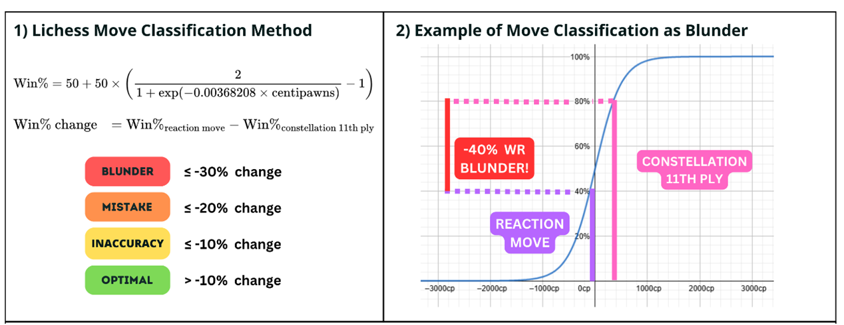

Lichess calculates win rates based on data collected from past Lichess high-rated games (2300+ ELO). They utilize a scaling factor formula with Stockfish evaluations in centipawns to derive the win percentage (1st equation). For this study, the change in win rate is determined by the difference between the centipawn evaluation of the reaction move and the centipawn evaluation at the constellation 11th ply (2nd equation).

The win % change is then used to classify move types, with a larger negative change indicating more sub-optimal moves. This classification system normalizes error rates across different game contexts and fits the model to actual win/loss outcomes from past games. In the example, the win rate change from 80% (constellation 11th ply) to 40% (Reaction Move) results in a move classification of Blunder (-40%).

APPENDIX A6: Outliers visualisation

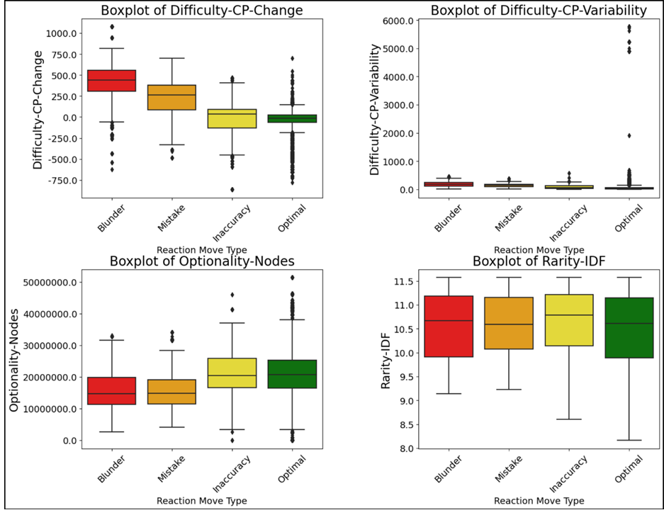

Outliers are present across all reaction move types for the variables Difficulty-CP-Change, Difficulty-CP-Variability, and Optionality-Nodes, with a higher prominence for optimal moves. Statistically unusual instances, such as losing a queen in an advantageous position or delivering a checkmate in a difficult situation, likely lead to significant swings in centipawn evaluation (Difficulty-CP-Change) and variability (Difficulty-CP-Variability).

Outliers in nodes searched (Optionality-Nodes) likely represent extensive calculations in complex positions, as chess engines systematically explore decision trees step by step. Thus, these outliers likely reflect the real-world variability of chess gameplay and the increased computational effort required in complex positions, and do not indicate errors or issues for subsequent analysis.

Appendix A7: Features, Implications and Potential Training Strategies for Different Move-type-prone Constellation.

