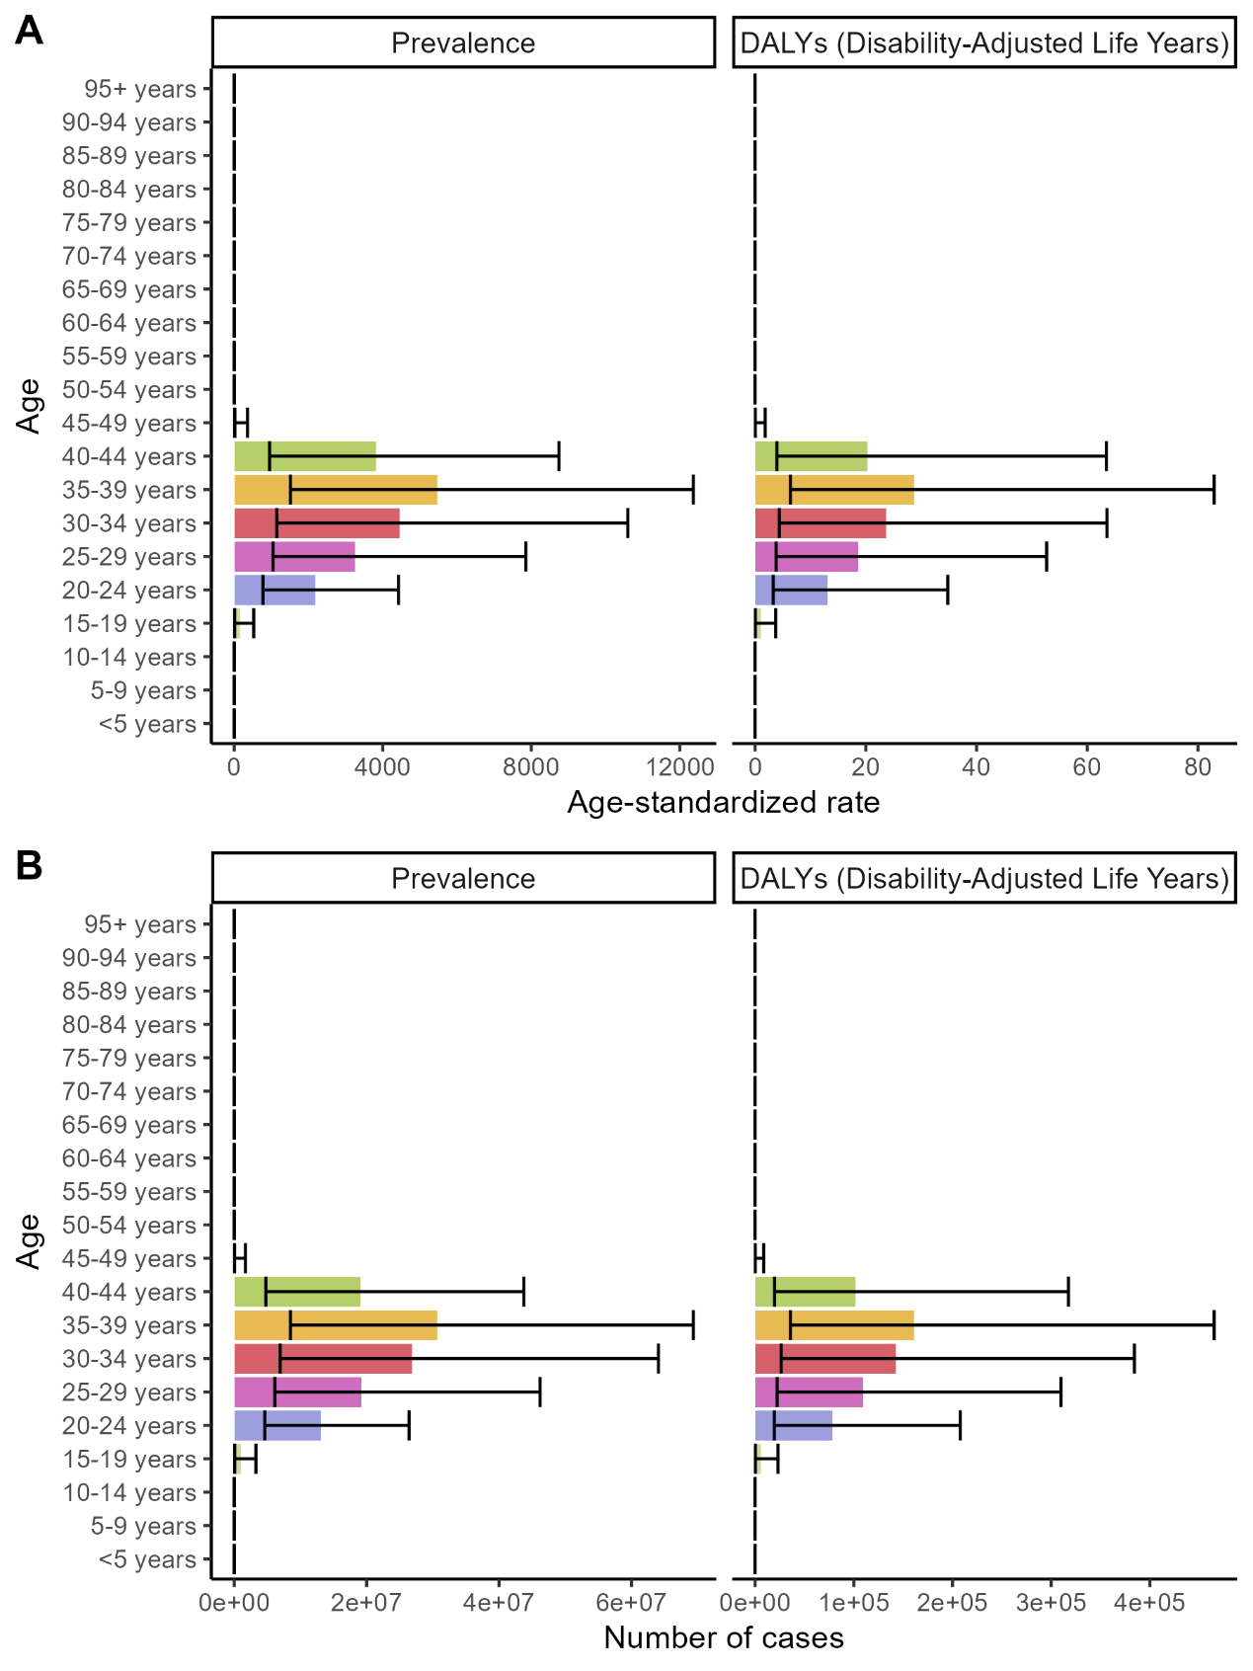
Figure S1. Age-standardized rates and Numbers of female infertility prevalence and DALYs for different age groups in 2021. Abbreviations: DALYs, disability-adjusted life years.

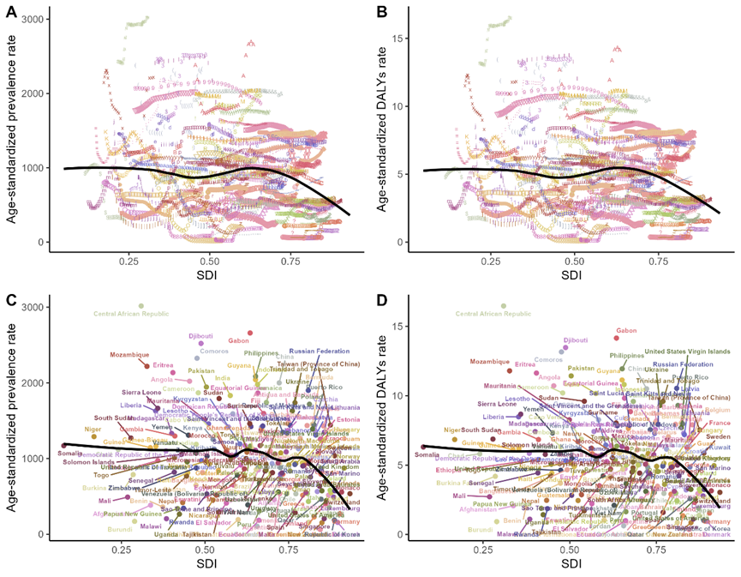
Figure S2. Age-standardized prevalence rates (ASPR) and age-standardized DALY rates attributable to female infertility across countries and territories by Socio-Demographic Index (SDI) from 1990 to 2021. The black line represents an adaptive association fitted using adaptive LOESS regression based on all data points. Symbols and colors in the figure correspond to different countries and territories. Abbreviations: DALYs, disability-adjusted life years; ASPR, age-standardized prevalence rate.

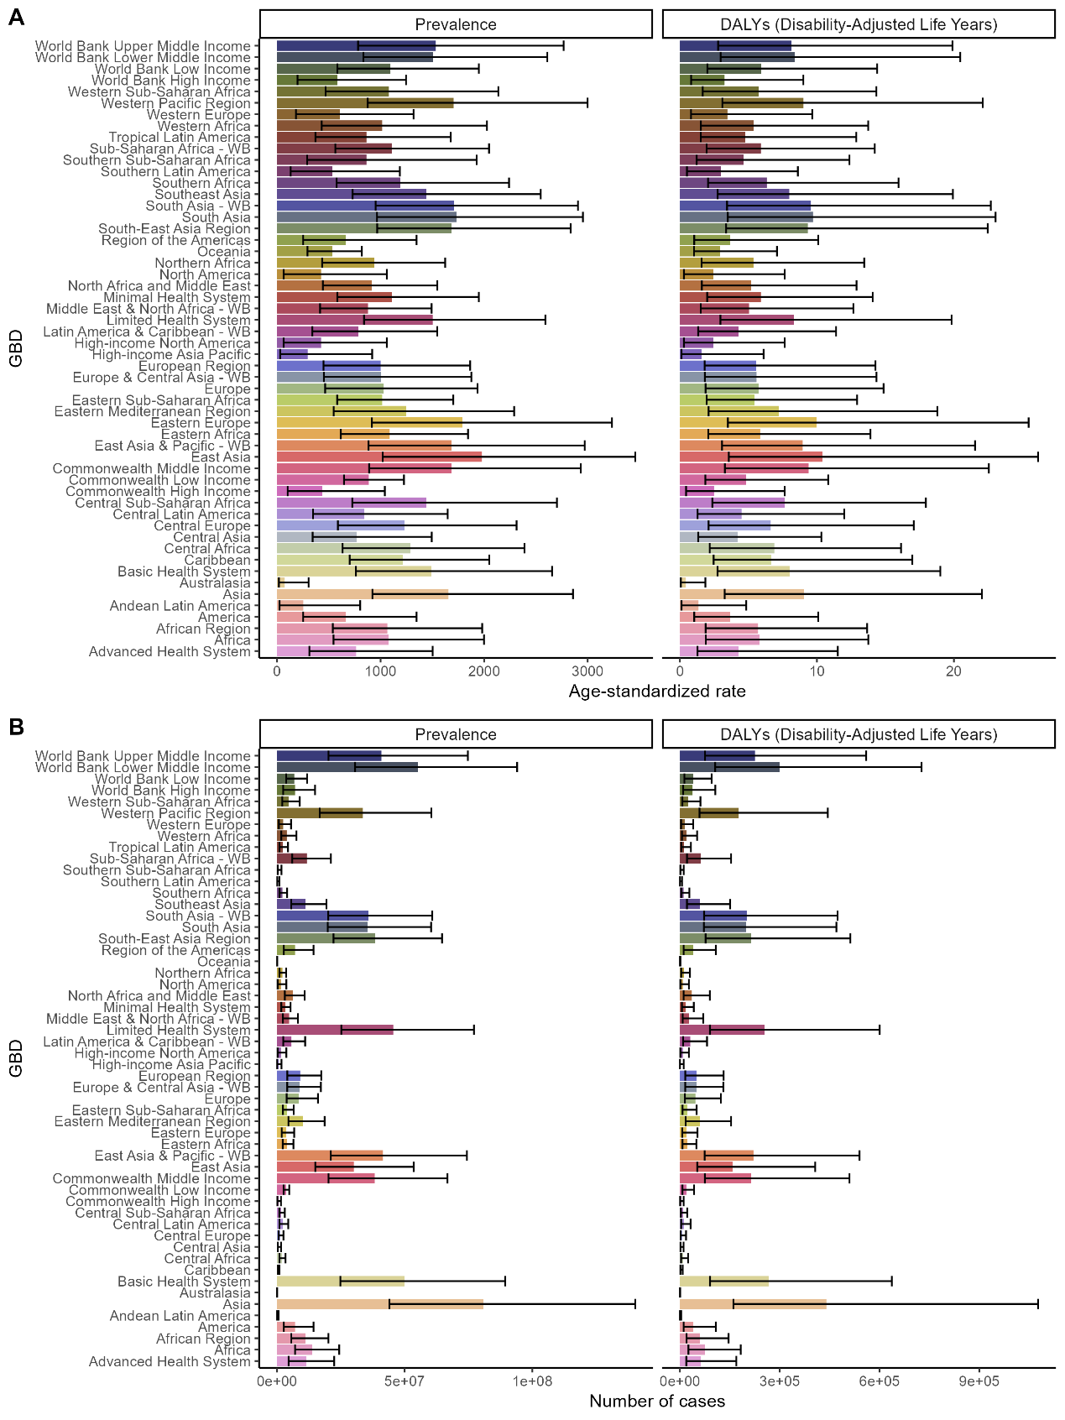
Figure S3. Age-standardized rates and Numbers of female infertility prevalence and DALYs for different GBD regions in 2021. Abbreviations: DALYs, disability-adjusted life years.

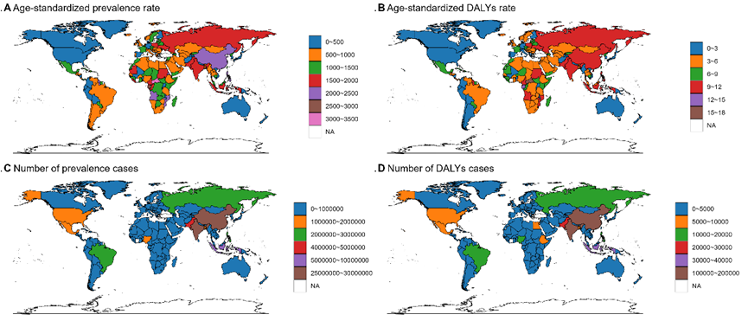
Figure S4. Numbers and age-standardized rates of female infertility prevalence and DALYs across countries and territories in 2021. Abbreviations: DALYs, disability-adjusted life years.

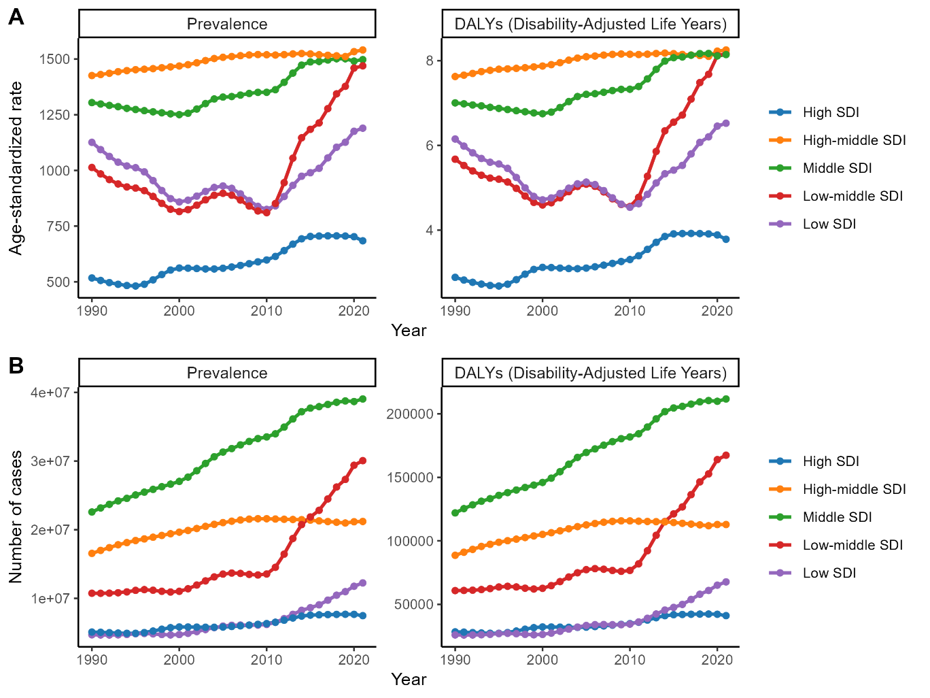
Figure S5. Age-standardized rates and Numbers of female infertility prevalence and DALYs for different SDI regions from 1990 to 2021, and its trends from 1990 to 2021 globally. Abbreviations: ASPR: age-standardized prevalence rate; DALYs: disability-adjusted life years; SDI, socio-demographic index

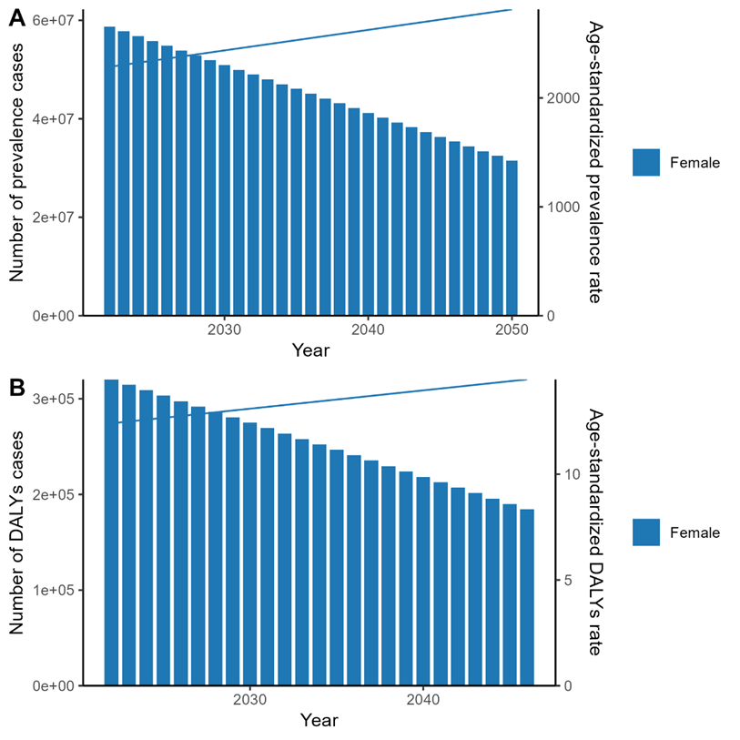

Figure S6. Predicted trends in female infertility prevalence numbers, age-standardized prevalence rates, and DALYs globally from 2022 to 2046 based on the ARIMA model. Abbreviations: DALYs: disability-adjusted life years

