Supplementary Materials for
SARS-CoV-2 spike protein activates NOX2-p66SHC axis via inhibiting SLAMF8 to promote thrombogenesis

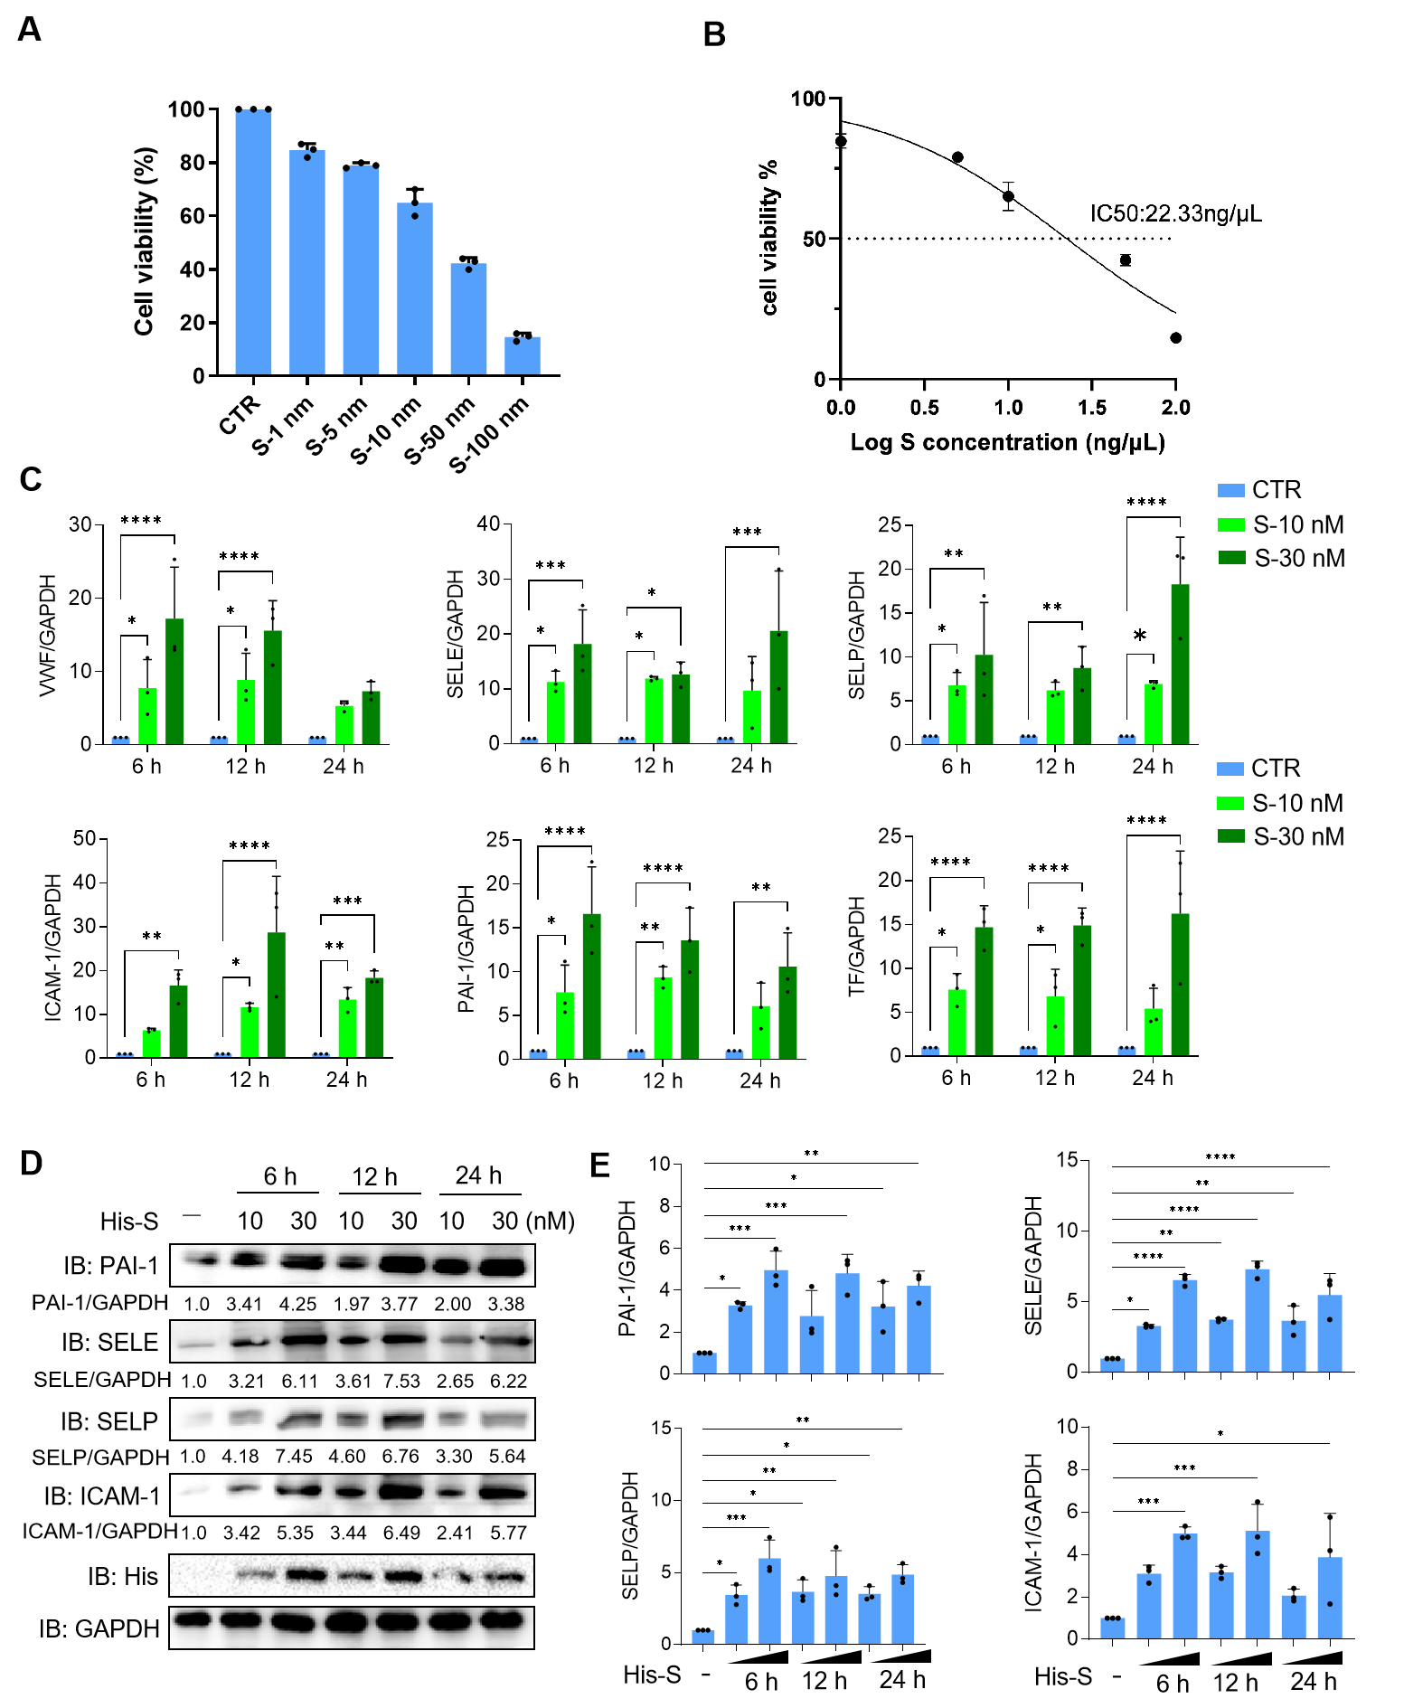
Fig. S1 SARS-CoV-2 S protein induce the expression of thrombotropic factor in endothelial cells.
(A) Human airway epithelial cells (HAECs) were left untreated (CTR) or treated with varying concentrations of S protein (1-100 nM) for 6 h. Cell viability was assessed using the CCK8 assay. Data are expressed as the mean ± SD of three independent experiments.
(B) The 50% inhibitory concentration (IC₅₀) of the S protein in HAECs was determined.
(C-E) HAECs were left untreated (CTR) or treated with different doses of S protein for varying time periods. The mRNA expression levels of thrombotropic factors, including PAI-1, SELE, SELP, ICAM-1, VWF, and TF, were quantified using quantitative PCR (qPCR), with GAPDH serving as the internal reference control (C) and the protein levels were analyzed by immunoblotting with the indicated antibodies (D). Grayscale statistical analysis of PAI-1, SELE, SELP, and ICAM-1 relative to GAPDH in (D) is shown (E). Data are expressed as the mean ± SD of three independent experiments, with asterisks indicating significant differences (*P < 0.05, **P < 0.01, ***P < 0.001, and ****P < 0.0001).

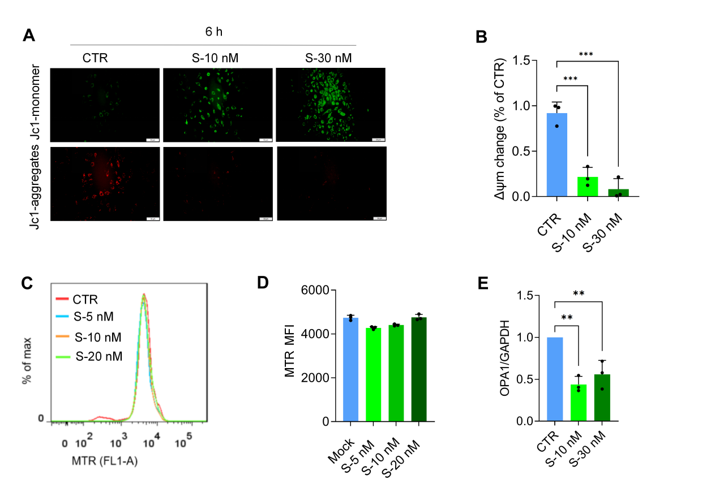
Fig. S2 SARS-CoV-2 S protein causes mitochondrial damage in endothelial cells.
(A and B) HAECs were either left untreated (CTR) or treated with different doses of S protein for 6 h. Viable cells were stained with fluorescent probe JC-1 to assess the mitochondrial membrane potential (MMP) (A). The degree of mitochondria depolarization was quantified by calculating the ratio of red to green fluorescence intensity (B).
(C and D) HAECs that either untreated or treated with S protein for 12 h were stained with MitoTracker Red (MTR) and detected by flow cytometry (C). The mean fluorescence intensity (MFI) of MTR was quantified, with results shown for more than 3 independent experiments (D).
(E) Grayscale analysis of OPA1 levels relative to GAPDH, as indicated in (Fig1. G), is presented. Data are expressed as the mean ± SD of three independent experiments, with asterisks indicating significant differences (**P < 0.01, and ***P < 0.001).

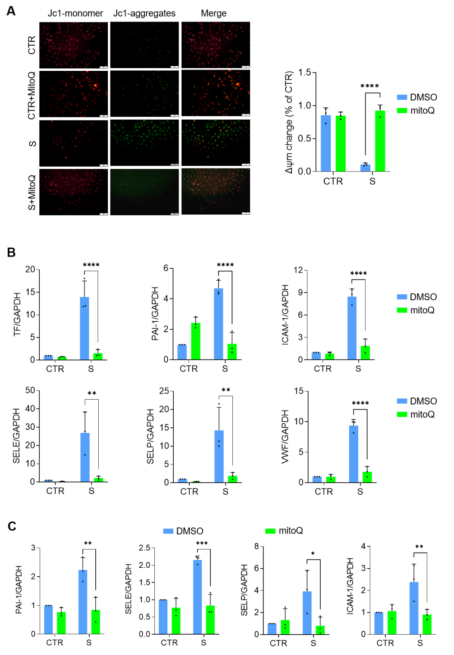
Fig. S3 S protein induces oxidative stress in endothelial cells.
(A) HAECs were incubated with S protein for 6 h and then treated with either 10 μM MitoQ or DMSO for additional 6 h. Viable cells were stained with fluorescent probe JC-1 to assess mitochondria depolarization, which was quantified by measuring the ratio of red to green fluorescence intensity.
(B) HAECs were treated as indicated in (A), and the mRNA levels of thrombotropic factors, including PAI-1, SELE, SELP, ICAM-1, VWF, and TF, were quantified using qPCR, with GAPDH serving as the internal reference control.
(C) Grayscale statistical analysis of PAI-1, SELE, SELP, and ICAM-1 levels relative to GAPDH is presented, as indicated in (Fig. 2C). Data are expressed as the mean ± SD of three independent experiments, with asterisks indicating significant differences (*P < 0.05, **P < 0.01, ***P < 0.001, and ****P < 0.0001).
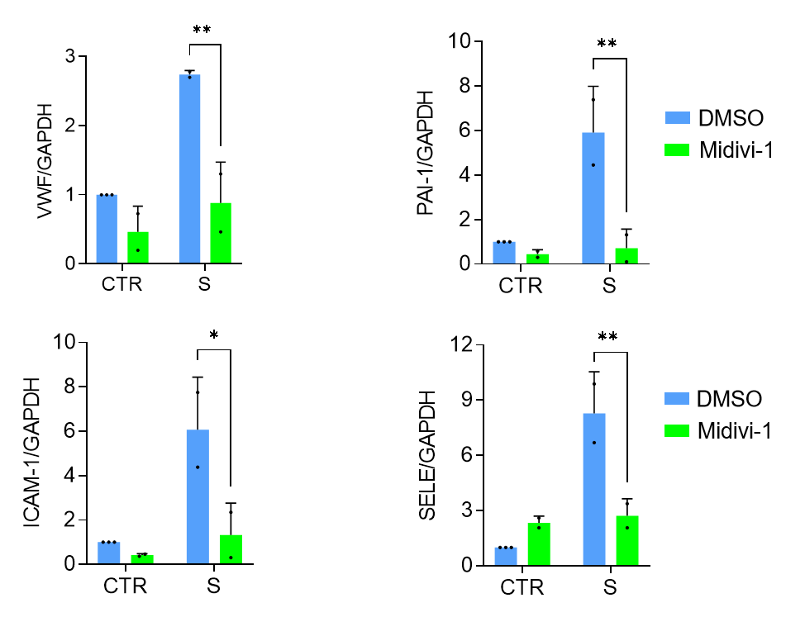
Fig. S4 Inhibition of mitochondrial fission alleviates coagulation abnormalities induced by S protein.
Human airway epithelial cells (HAECs) were incubated with S protein for 6 h and subsequently treated with 10 μM mitochondrial division inhibitor 1 (Mdivi-1) or DMSO for an additional 6 h. The mRNA expression levels of VWF, PAI-1, ICAM-1, and SELE were quantified using qPCR. Data are expressed as the mean ± SD of three independent experiments, with asterisks indicating significant differences (*P < 0.05, **P < 0.01).

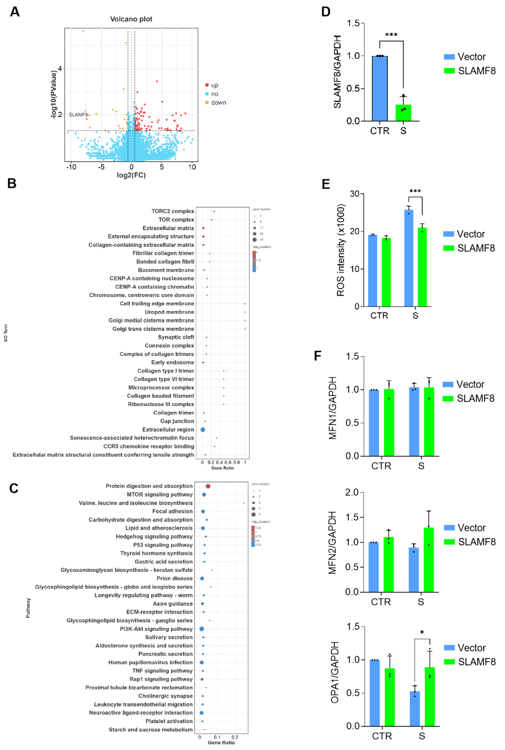
Fig. S5 S protein inhibits SLAMF8 expression to promote thrombosis.
(A-C) HAECs were either untreated or treated with 10 nM SARS-CoV-2 S protein for 24 h, then the cells were collected for RNA sequencing. Differentially expressed genes (DEGs) between S protein- treated and untreated cells are presented in a volcano plot (A). Gene Ontology (GO) enrichment analysis (B) and Kyoto Encyclopedia of Genes and Genomes (KEGG) pathway analysis (C) of the DEGs are shown.
(D) HAECs were either untreated or treated with S protein for 24 h. The mRNA level of SLAMF8 relative to GAPDH was quantified using qPCR.
(E) HAECs were transfected with Flag-tagged SLAMF8 or vector control plasmids. At 48 hpt, cells were either untreated or treated with S protein for 6 h. The viable cells stained with DCFH-DA, and ROS levels were measured using a fluorescent microplate reader.
(F) Grayscale statistical analysis of MFN1, MFN2 and OPA1 expression relative to GAPDH from data presented in (Fig. 3C) is displayed. Data are expressed as the mean ± SD of three independent experiments, with asterisks indicating significant differences (*P < 0.05, **P < 0.01, ***P < 0.001, and ****P < 0.0001).

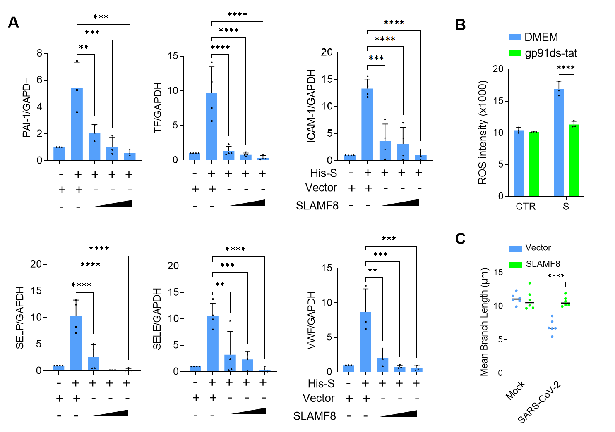
Fig. S6 S protein enhances ROS production to promote thrombosis.
(A) HAECs were transfected with Flag-tagged SLAMF8 or vector control plasmids. At 48 hours post-transfection (hpt), cells were either untreated or treated with S protein (10 nM) for 6 h. The mRNA levels of VWF, SELP, SELE, ICAM-1, PAI-1, and TF relative to GAPDH were quantified using qPCR.
(B) HAECs were incubated with NOX2 inhibitor gp91ds-tat for 12 h and then treated with S protein for 6 h. The viable cells were stained with DCFH-DA, and reactive oxygen species (ROS) levels were measured using a fluorescent microplate reader.
(C) The statistical analysis of the mean branch length of mitochondria performed in (Fig. 6F) by ImageJ (n ≥ 6). Data are expressed as the mean ± SD, with asterisks indicating significant differences (**P < 0.01, ***P < 0.001, and ****P < 0.0001).

