Supplementary Material
Figure S1. Euler diagram that shows the relationships between recent phylogenomic sets of proteins used to address the phylogenetic placement of mitochondria. Data sets include those comprised by mitochondrion- and nucleus-encoded proteins in this study, Wang and Wu (2015), and Martijn et al. (2018).
Figure S2. Summary of genome features for novel MAGs for MarineProteo1 and the Rickettsiales. The Magnetococcia is at the base of the tree as an outgroup. pHMM searches were done using hmmsearch of the HMMER suite and the Pfam pHMM for Mic60 (Mitofilin; PF09731) and 17 custom pHMMs for bacteriochlorophyll biosynthesis enzymes.
Figure S3. Variation in support values for the placement of mitochondria outside of the Alphaproteobacteria (SH-aLRT and UFBoot2+NNI) throughout the progressive removal of compositionally heterogenous sites according to the ɀ and χ². Support for the branch that groups mitochondria with all alphaproteobacteria (but excludes MarineProteo1 and the Magnetococcia) is always maximal (i.e., 100% SH-aLRT /100% UFBoot2+NNI). (A) Nucleus-encoded protein data set. (B) Mitochondrion-encoded protein data set.
Figure S4. Schematic tree topologies used for the likelihood calculations using the MAM60+GFmix model. Tree topologies derived from analyses of the untreated data set of mitochondrion-, and nucleus-encoded proteins (A), and a compositionally homogenized data set through the removal of 50% ɀ sites (B). Tree topologies derived from analyses of the untreated data set of nucleus-encoded proteins (C), and a compositionally homogenized data set through the removal of 50% ɀ sites (D). Tree topologies derived from analyses of the untreated data set of mitochondrion-encoded proteins (E), and a compositionally homogenized data set through the removal of 50% ɀ sites (F).
Figure S5. UPGMAs dendrograms for G A R P/F I M N K Y distances among the marker proteins of alphaproteobacterial origin in eukaryotes used in this study. (A) Mitochondrion- and nucleus-encoded genes. (B) Mitochondrion-encoded genes. (C). Nucleus-encoded genes.
Table S1. Gene names, cellular compartment where genes are encoded, and functional annotations for the 108 mitochondrial proteins of alphaproteobacterial origin in eukaryotes.
Table S2. Microbial mat and sediment metagenomes from which alphaproteobacterial MAGs were assembled in this study.
Table S3. Summary of major features for each of the 154 alphaproteobacterial MAGs reconstructed from diverse metagenomes sequenced in this study. pHMM searches were done using hmmsearch of the HMMER suite and a set of 17 custom pHMMs for bacteriochlorophyll biosynthesis enzymes.
Table S4. Summary of major features for genomes and MAGs that belong to the Magnetococcia, MarineProteo1 clade, and Rickettsiales. The dashed rectangle points to the secondary higher G+C content of the genera Anaplasma and Neorickettsia in the family Anaplasmataceae.
Table S5. G A R P/F I M N K Y ratios across taxa as compositionally heterogeneous sites are removed according to the ɀ metric. The range of G A R P/F I M N K Y ratios across taxa is minimized after the removal of the 50% most compositionally biased ɀ sites.
Table S6. (A) Analyses on the untreated data set of mitochondrion- and nucleus-encoded proteins (116 taxa and 108 proteins) using the MAM60+GFmix model. (B). Analyses on the untreated data set of nucleus-encoded proteins (116 taxa and 64 proteins) using the MAM60+GFmix model. (C) Analyses on the untreated data set of mitochondrion-encoded proteins (116 taxa and 44 proteins) using the MAM60+GFmix model.
Table S7. Eukaryotes used in this study for which both nuclear and mitochondrial genomes are available. The eukaryotic species Nitella sp. and Malawimonas sp. are synthetic chimeras whose nuclear and mitochondrial predicted proteomes come from different species within the genus.
Figure S1.
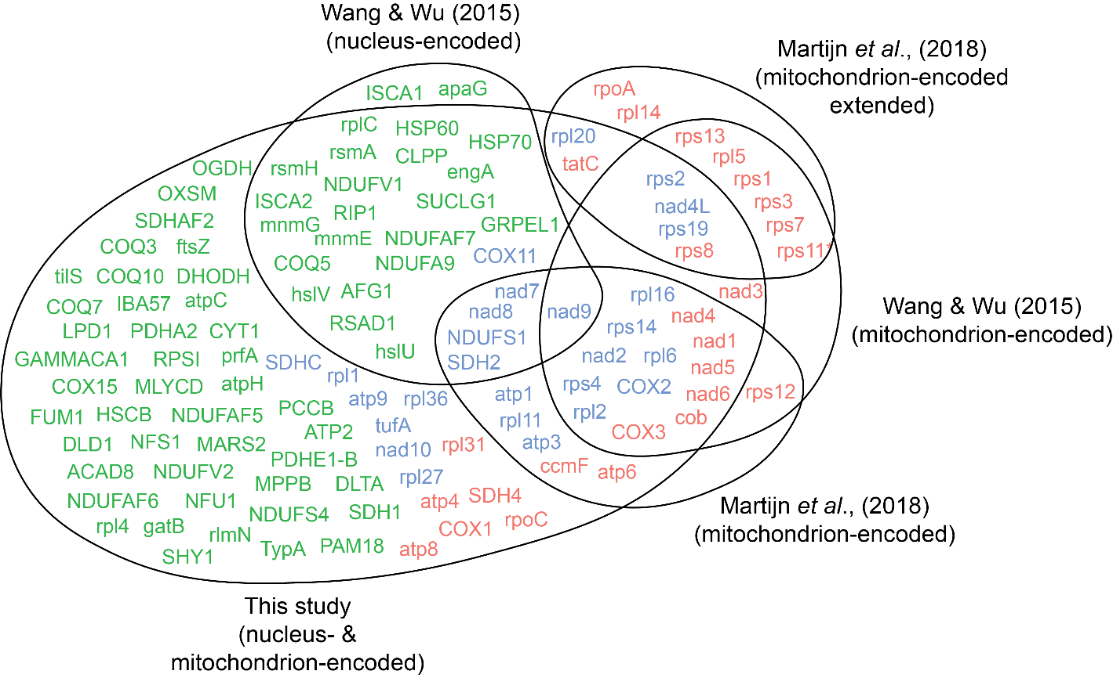

Figure S2.
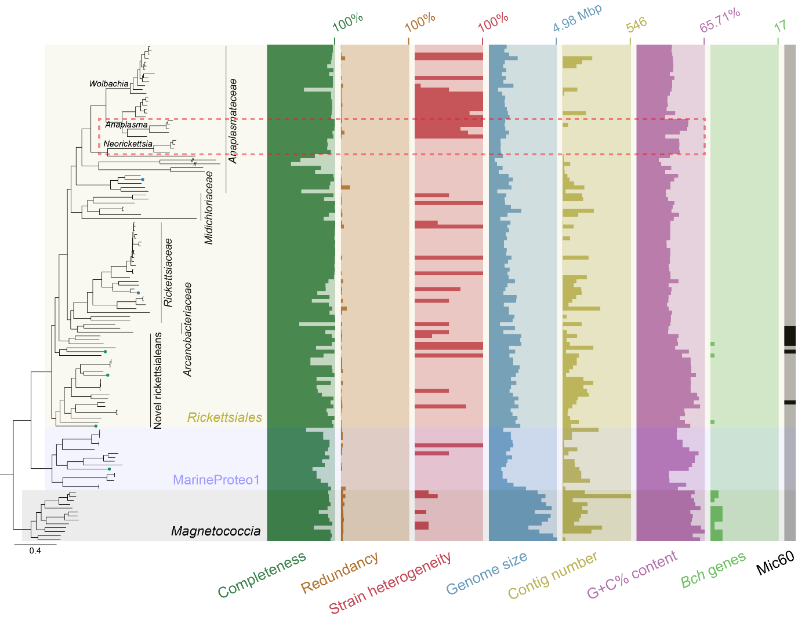

Figure S3.
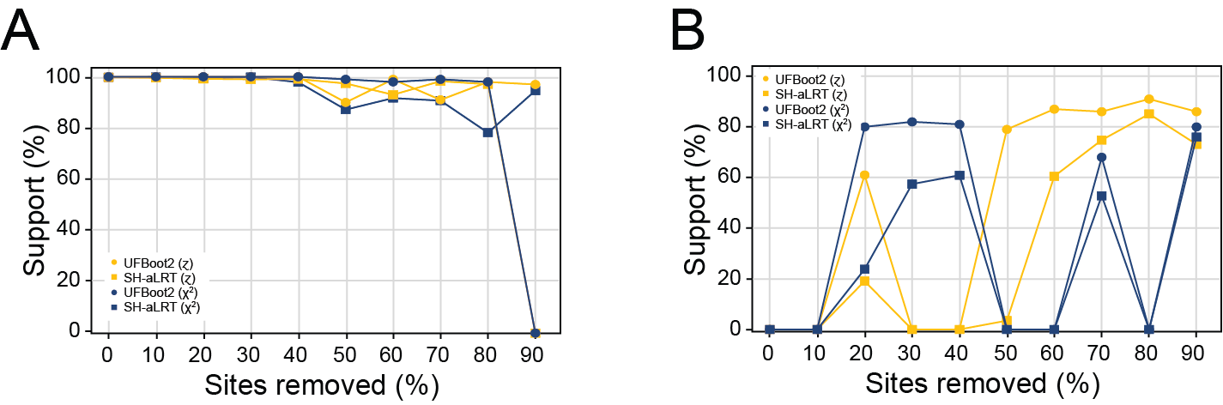

Figure S4.
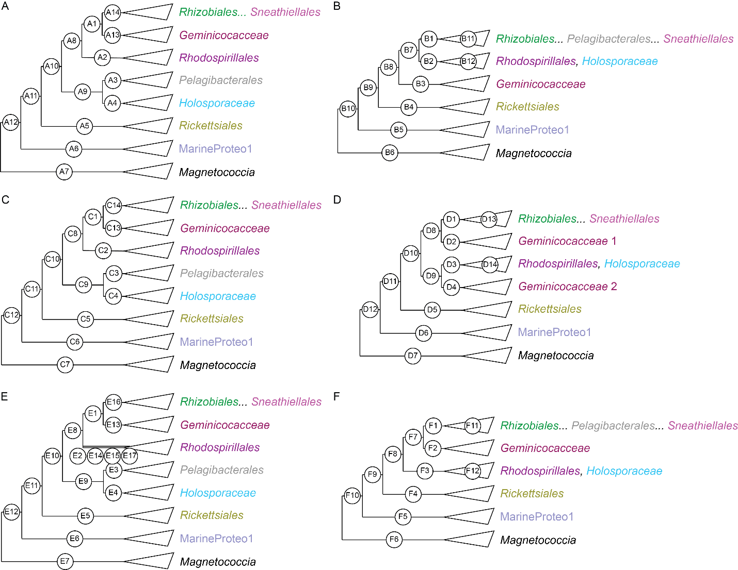

Figure S5.
