UTransBPNet for Cuffless and Calibration-free Blood Pressure Estimation under Dynamic Conditions
Yali Zheng^{1*}, Hongda Huang¹, Jiasheng Gao¹, Jingyuan Hong², Shenghao Wu¹,
Yuanting Zhang³, IEEE Fellow, Qing Liu^{4*}
¹ Yali Zheng, Hongda Huang, Jiasheng Gao and Shenghao Wu are with the Department of Biomedical Engineering, College of Health Science and Environmental Engineering, at Shenzhen Technology University, Shenzhen, China.
² Jingyuan Hong is with the Department of Biomedical Engineering, at King's College London, London, UK.
³ Yuanting Zhang is with the Chinese University of Hong Kong, Hong Kong, China.
⁴ Qing Liu is with the Department of Communication and Networking, at Xi’an Jiaotong-Liverpool University, Suzhou, China.
*Corresponding authors: Qing Liu, Qing.Liu@xjtlu.edu.cn; Yali Zheng, zhengyali@sztu.edu.cn .

Supplementary Table.S1 Three fine-tuning schemes to estimate SBP and DBP
DeepTune, FinalTune and AllTune Schemes
Data：Training set（$x_{i},$ $y_{i}$）, $i=1, 2, …, N;$ $y$ is the continuous BP waveform; $z$ is the beat-to-beat SBP and DBP;
Training hyperparameters: Training epochs $T,$ patience parameter $P$ for early stopping, training samples $N,$batch number $M$;
Model: UTransBPNet $f\left(θ\right)$, fully connected layer $g\left(ϕ\right)$;
Phase 1——Train UTransBPNet $f\left(θ\right)$
1 Initialize $θ$
4 While $t < T$ do
5 For$n=1$ to $N$ do
7 For$m=1$ to $M$ do
8 $\hat{y_{m}}←f({Batch}_{m}\left(x\right); θ)$;
9 $L←({\left(\hat{y_{m}}, y_{m}\right)}^{2}).mean();$
20 $L.backward()$;
21 $update\left(f\left(θ\right)\right);$
$earlystop\left(P\right);$
22 End for
23 End for
26 End while
Phase 2——Train fully connected layer
27 For DeepTune and FinalTune,
Freeze $θ;$
$$L←({\left(\hat{z},z\right)}^{2}).mean();$$
$L.backward()$;
$$update\left(g\left(ϕ\right)\right);$$
For AllTune:
$z←g\left(\hat{y}; ϕ\right)$;
$$L←({\left(\hat{z},z\right)}^{2}).mean();$$
$L.backward()$;
$$update\left(f\left(θ\right),g\left(ϕ\right)\right);$$

Supplementary Table.S2 The contribution of cross attention and different finetune schemes
Model Structure | Individual/General | Mean ± SD, mmHg |  | MAD, mmHg |  | PCC
Model Structure | Individual/General | SBP | DBP | SBP | DBP | SBP | DBP
Dataset_Drink
UTransBPNet-DeepTune | Population | -0.56±9.27* | -0.21*±7.57* | 7.09* | 5.61* | 0.45±0.20 | 0.59±0.17
UTransBPNet-FinalTune | Population | -0.83±11.04* | 0.10±7.32* | 8.39* | 5.48* | 0.60±0.19 | 0.63±0.16
UTransBPNet-Crossattn-Det | Population | -1.93±10.80* | -0.45±7.42* | 7.96* | 5.71* | 0.56±0.27 | 0.67±0.20
UTransBPNet-Crossattn-DeepTune | Population | -1.55±10.30* | -0.02±8.05* | 8.24* | 6.25* | 0.34±0.32 | 0.27±0.25
UTransBPNet-Crossattn-FinalTune | Population | -0.92±9.13*† | -0.19±6.28† | 6.74*† | 4.69† | 0.61±0.17 | 0.62±0.13
UTransBPNet-Crossattn-AllTune | Population | -0.74±8.72 | -0.23±6.31 | 6.59 | 4.99 | 0.59±0.19 | 0.60±0.17
Dataset_Exercise
UTransBPNet-DeepTune | Population | -1.61±15.21* | -2.06±10.88* | 11.69* | 8.68* | 0.67±0.13 | 0.54±0.19
UTransBPNet-FinalTune | Population | -2.07±14.03* | -1.86±10.68* | 10.68* | 8.52* | 0.77±0.11 | 0.62±0.22
UTransBPNet-Crossattn-Det | Population | -1.98±12.86* | -1.93±10.35* | 9.14* | 7.49* | 0.74±0.19 | 0.61±0.23
UTransBPNet-Crossattn-DeepTune | Population | 0.08±16.34* | 0.36±10.13* | 12.91* | 7.94* | 0.57±0.19 | 0.33±0.34
UTransBPNet-Crossattn-FinalTune | Population | -1.76±11.30*† | -0.85±8.65*† | 8.23† | 6.42*† | 0.75±0.20 | 0.66±0.21
UTransBPNet-Crossattn-AllTune | Population | -0.18±10.52 | -0.77±8.11 | 8.51 | 6.22 | 0.82±0.11 | 0.72±0.18
Dataset_MIMIC
UTransBPNet-DeepTune | Population | -0.14±13.47* | 0.26±5.63* | 10.26* | 4.23* | 0.46±0.17 | 0.42±0.11
UTransBPNet-FinalTune | Population | 0.78±12.40* | 0.05±5.64* | 9.74* | 4.34* | 0.54±0.12 | 0.47±0.12
UTransBPNet-Crossattn-Det | Population | -0.92±9.33* | 0.04±4.19* | 6.06* | 3.04* | 0.68±0.18 | 0.63±0.14
UTransBPNet-Crossattn-DeepTune | Population | 0.94±17.66* | 0.66±8.86* | 14.05* | 7.05* | 0.35±0.33 | 0.31±0.26
UTransBPNet-Crossattn-FinalTune | Population | 0.14±8.62*† | -0.34±4.11*† | 6.54*† | 3.22*† | 0.71±0.08 | 0.64±0.09
UTransBPNet-Crossattn-AllTune | Population | 0.40±6.21 | -0.11±3.10 | 4.38 | 2.25 | 0.78±0.07 | 0.69±0.09
(*) indicates that the SD or MAD of UTransBPNet-Crossattn-AllTune was significantly lower than other tested models. (†) indicates a significant contribution of cross attention in the performance gain. The bold values represent the best results among the models.

Supplementary Fig.S1 The Bland-Altman plots of SBP and DBP predicted by UTransBPNet_Crossattn_AllTune under scenario-specific validation. (a-b) Drink scenario; (c-d) Exercise scenario; (e-f) MIMIC scenario.

Supplementary Fig.S2 The correlation plots of the reference and predicted SBP and DBP by UTransBPNet_Crossattn_AllTune under scenario-specific validation. (a-b) Drink scenario; (c-d) Exercise scenario; (e-f) MIMIC scenario.
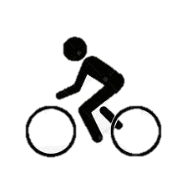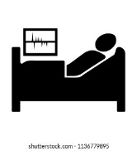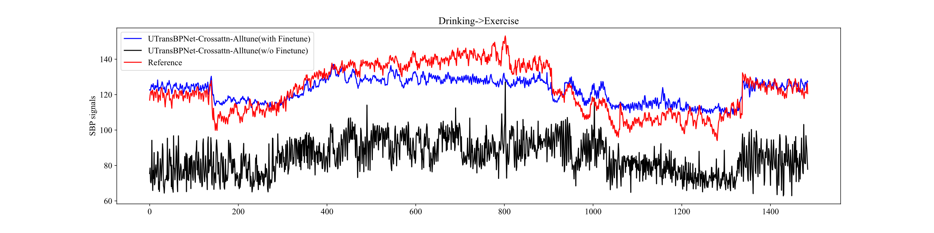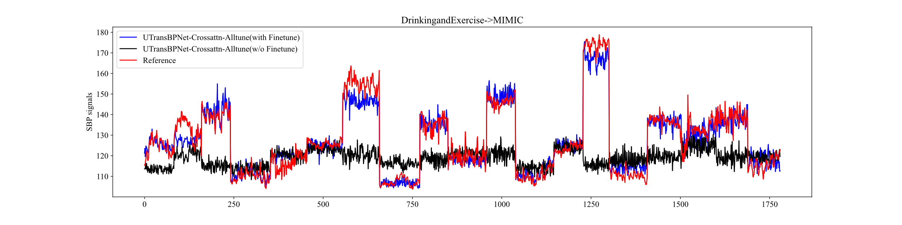
Drinking
Exercise
Predict
Predict
Drinking
Exercise
+
MIMIC
10% scenario-specific subjects for
finetuning
10% scenario-specific
instances for finetuning
Time, beats
(a)
(b)
No. 1
2
3
4
5
6
7
8
9
10
11
12
13
14
15
16
17
18
19
Supplementary Fig.S3 Representative results under cross-scenario settings. (a) Train with Dataset_Drink and test with Dataset_Exercise. The MADs of SBP of one subject from Dataset_Exercise are 13.33 and 3.59 mmHg for the model w/o and with scenario-specific finetuning, respectively. (b) Train with Dataset_Drink combining Dataset_Exercise and test with Dataset_MIMIC. The MADs of SBP of 19 instances from Dataset_MIMIC are 38.47 and 6.87 mmHg for the model w/o and with scenario-specific finetuning, respectively.

