Tables:
Table 1: Most influential articles for digital banking research
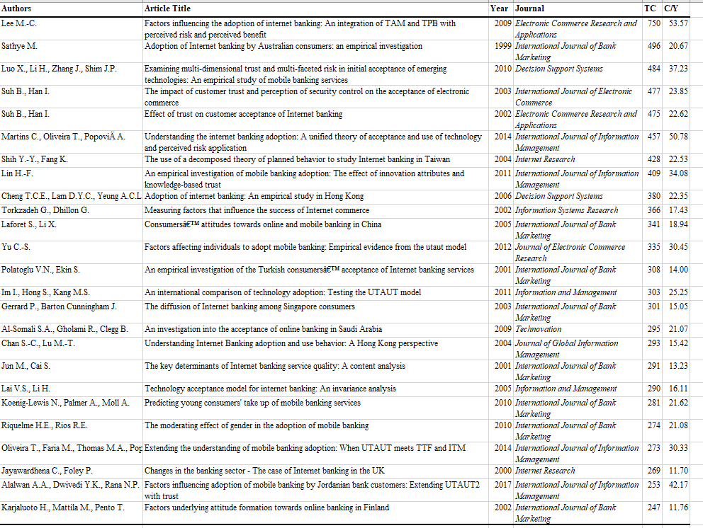
Note(s): TC = total citations. C/Y = average citations per year
TABLE 2 Top contributing journals for digital banking research
Most Prolific Journals
Journals | TP | Journals | TC
International Journal of Bank Marketing | 115 | International Journal of Bank Marketing | 7174
Journal of Internet Banking and Commerce | 97 | International Journal of Information Management | 2922
International Journal of Scientific and Technology Research | 34 | Internet Research | 1790
International Journal of Electronic Finance | 30 | Electronic Commerce Research and Applications | 1587
Journal of Retailing and Consumer Services | 27 | Decision Support Systems | 1065
International Journal of Information Management | 26 | Journal of Internet Banking and Commerce | 960
Sustainability | 26 | Journal of Retailing and Consumer Services | 806
International Journal of Recent Technology and Engineering | 26 | Information and Management | 703
Banks and Bank Systems | 25 | International Journal of Electronic Commerce | 589
Electronic Commerce Research and Applications | 22 | Journal of Business Research | 580
Internet Research | 21 | Journal of Electronic Commerce Research | 570
International Journal of Applied Business and Economic Research | 21 | Journal of Services Marketing | 549
Economic and Political Weekly | 20 | Service Industries Journal | 477
International Journal of Business Information Systems | 19 | Technovation | 409
Journal of Financial Services Marketing | 16 | Marketing Intelligence and Planning | 406
Journal of Payments Strategy and Systems | 16 | Journal of Global Information Management | 385
Journal of Asian Finance, Economics and Business | 15 | Information Systems Research | 366
International Journal of e-Business Research | 13 | Behaviour and Information Technology | 326
Advanced Science Letters | 13 | International Journal of Electronic Finance | 322
International Journal of Economic Research | 13 | International Journal of Retail & Distribution Management | 293
Economist | 13 | Journal of Banking and Finance | 287
Technological Forecasting and Social Change | 12 | Journal of Enterprise Information Management | 276
Journal of Islamic Marketing | 12 | Industrial Management and Data Systems | 229
Journal of Business Research | 11 | International Small Business Journal | 219
Global Business Review | 11 | Information Development | 217
Note(s): TC = total citations. TP = total publications
Table 3: Top Contributing Authors and Countries for digital banking research
Most Prolific Authors |  |  | Most Prolific Countries
Author | TP | TC | Country | TP | TC
Karjaluoto H. | 11 | 584 | India | 351 | 2637
Rahi S. | 11 | 151 | United States | 269 | 5247
Laukkanen T. | 10 | 1258 | United Kingdom | 223 | 6764
Shaikh A.A. | 9 | 163 | Malaysia | 122 | 1388
Asongu S.A. | 9 | 160 | China | 115 | 1738
Rana N.P. | 7 | 608 | Australia | 83 | 2167
Hwang Y. | 7 | 124 | South Korea | 69 | 2463
Zolait A.H.S. | 7 | 83 | South Africa | 66 | 599
Arner D.W. | 7 | 65 | Indonesia | 63 | 171
Chawla D. | 7 | 52 | Germany | 57 | 612
Joshi H. | 7 | 52 | Taiwan | 49 | 3229
Wojcik D. | 7 | 21 | Spain | 45 | 1269
Oliveira T. | 6 | 902 | Saudi Arabia | 45 | 851
Alalwan A.A. | 6 | 597 | Finland | 43 | 2130
Dwivedi Y.K. | 6 | 584 | Pakistan | 43 | 503
Raza S.A. | 6 | 152 | France | 40 | 611
Durkin M. | 6 | 143 | Netherlands | 37 | 432
Chaouali W. | 6 | 131 | Iran | 35 | 274
Abd. Ghani M. | 6 | 92 | Hong Kong | 33 | 1560
Shankar A. | 6 | 54 | Turkey | 33 | 1140
Wonglimpiyarat J. | 6 | 51 | Canada | 32 | 1105
Mattila M. | 5 | 445 | Jordan | 31 | 836
Kesharwani A. | 5 | 258 | Italy | 30 | 320
Sharma S.K. | 5 | 180 | Thailand | 29 | 556
Tarhini A. | 5 | 167 | Vietnam | 28 | 93
Table 4: Methodological choice and research context for digital banking research
Panel and Period | 1983-1995 | 1996-2005 | 2006-2015 | 2016-2020 | Overall
Panel A: Research Approach
Qualitative | 100.00% | 35.87% | 20.88% | 31.74% | 28.94%
Quantitative | 0.00% | 64.13% | 78.76% | 67.95% | 70.75%
Mixed | 0.00% | 0.00% | 0.35% | 0.31% | 0.31%
Panel B: Research Design
Empirical | 0.00% | 51.30% | 58.17% | 49.22% | 51.84%
Conceptual | 60.00% | 23.48% | 10.05% | 18.11% | 16.05%
Review | 0.00% | 0.87% | 0.75% | 0.83% | 0.81%
Modelling | 40.00% | 24.35% | 31.03% | 31.83% | 31.30%
Mixed | 0.00% | 0.00% | 0.00% | 0.00% | 0.00%
Panel C: Data Collection Technique
Case Study | 0.00% | 3.19% | 3.08% | 1.06% | 2.16%
Interview | 66.67% | 29.79% | 18.29% | 16.93% | 18.65%
Archival | 0.00% | 6.38% | 8.03% | 8.29% | 8.01%
Survey | 0.00% | 55.32% | 69.57% | 69.31% | 68.21%
Laboratory | 0.00% | 0.00% | 0.00% | 4.41% | 2.00%
No Data Collected/Reported | 33.33% | 5.32% | 1.03% | 0.00% | 0.96%
Panel D: Data Analysis Technique
Descriptive | 75.00% | 60.42% | 71.23% | 69.04% | 69.22%
Regression | 0.00% | 8.33% | 20.72% | 18.03% | 18.26%
Other | 0.00% | 5.56% | 7.29% | 11.57% | 10.03%
No Data Analysis Conducted/Reported | 25.00% | 25.69% | 0.77% | 1.36% | 2.49%
Panel F
Theory Building | 0% | 0% | 2% | 4% | 3%
Theory Verification | 0% | 12.50% | 4.81% | 9.41% | 8.11%
Application | 100% | 88.89% | 93.27% | 87.06% | 88.92%
Panel G
Single Country | 0.00% | 72.00% | 84.82% | 85.25% | 42.81%
Multi Country | 0.00% | 28.00% | 15.18% | 16.83% | 7.71%
Developing Country | 0.00% | 35.00% | 68.40% | 72.90% | 35.03%
Developed Country | 0.00% | 65.00% | 31.60% | 27.10% | 14.45%

