Appendix A: Search strategy in databases

PubMed
Search domain | Search terms/strategy | No of hits
P | ((diabetes) OR (diabetes mellitus) OR (IDDM) OR (hyperglycemia) OR (insulin resistance) OR ("insulin dependent")) | 1038060
I | ((stem cell*) OR (progenitor cell*) OR (hematopoietic stem cell*) OR (bone marrow mononuclear cell*) OR (mesenchymal cell*) OR (stromal cell*) OR (stem cell transplantation) OR (stem cell implantation) OR (bone marrow transplantation) OR (autologous) OR (allogenic) OR (stem cell graft)) | 902171
C | ------Nil-------  (Since standard of care or usual care as reported in studies will be considered, no specific search terms are applied for comparator group.) | -
O | ------Nil-------  (No specific search terms are considered for outcome, as it would be considered during screening of articles.) | -
S | (((randomized controlled trial) OR (randomised controlled trial) OR (controlled clinical trial) OR (clinical trial) OR (multicentric) OR (observational study) OR (follow up study) OR (trial[Title/Abstract]) OR (random* [Title/Abstract]) OR (control[Title/Abstract]) OR (placebo [Title/Abstract]) OR (follow-up[Title/Abstract]) OR (experimental[Title/Abstract]))) NOT ((animals[MeSH Terms]) NOT (humans[MeSH Terms])) | 6261583
P&I&C&O&S | ((diabetes) OR (diabetes mellitus) OR (IDDM) OR (hyperglycemia) OR (insulin resistance) OR ("insulin dependent")) AND ((stem cell*) OR (progenitor cell*) OR (hematopoietic stem cell*) OR (bone marrow mononuclear cell*) OR (mesenchymal cell*) OR (stromal cell*) OR (stem cell transplantation) OR (stem cell implantation) OR (bone marrow transplantation) OR (autologous) OR (allogenic) OR (stem cell graft)) AND (((randomized controlled trial) OR (randomised controlled trial) OR (controlled clinical trial) OR (clinical trial) OR (multicentric) OR (observational study) OR (follow up study) OR (trial[Title/Abstract]) OR (random* [Title/Abstract]) OR (control[Title/Abstract]) OR (placebo [Title/Abstract]) OR (follow-up[Title/Abstract]) OR (experimental[Title/Abstract]))) NOT ((animals[MeSH Terms]) NOT (humans[MeSH Terms])) | 5128

EMBASE
Search domain | Search terms/strategy | No of hits
P | ('diabetes mellitus'/exp OR 'diabetes' OR 'diabetes mellitus' OR 'diabetic' OR 'hyperglycemia'/exp OR 'glucose blood level, elevated' OR 'glycemia, hyper' OR 'hyperglucemia' OR 'hyperglycaemia' OR 'hyperglycemia' OR 'hyperglycemic syndrome' OR 'insulin resistance'/exp OR 'insulin resistance' OR 'resistance, insuline')
I | ('stem cell'/exp OR 'cell, stem' OR 'precursor cell' OR 'progenitor cell' OR 'stem cell' OR 'stem cells' OR 'hematopoietic stem cell'/exp OR 'bone marrow stem cell' OR 'haematopoietic precursor cell' OR 'haematopoietic progenitor cell' OR 'haematopoietic stem cell' OR 'haematopoietic stem cells' OR 'hematocytopoietic stem cell' OR 'hematopoietic precursor cell' OR 'hematopoietic progenitor cell' OR 'hematopoietic stem cell' OR 'hematopoietic stem cells' OR 'hemocytopoietic stem cell' OR 'hemopoietic stem cell' OR 'bone marrow derived mononuclear cell'/exp OR 'bone marrow derived mononuclear cell' OR 'bone marrow mononuclear cell' OR 'mesenchymal stem cell'/exp OR 'mesenchymal progenitor cell' OR 'mesenchymal stem cell' OR 'mesenchymal stem cells' OR 'stem cell, mesenchymal' OR 'stem cell transplantation'/exp OR 'stem cell based therapy' OR 'stem cell therapy' OR 'stem cell transplantation' OR 'transplantation, stem cell' OR 'bone marrow transplantation'/exp OR 'bone marrow cell transfer' OR 'bone marrow graft' OR 'bone marrow grafting' OR 'bone marrow transfusion' OR 'bone marrow transplant' OR 'bone marrow transplantation' OR 'transplantation, bone marrow' OR 'autologous stem cell transplantation'/exp OR 'autologous stem cell therapy' OR 'autologous stem cell transplantation' OR 'allogeneic stem cell transplantation'/exp OR 'allogeneic stem cell transplantation' OR 'allogenic stem cell transplantation'  )
C | ------Nil-------  (Since standard of care or usual care as reported in studies will be considered, no specific search terms are applied for comparator group.) | -
O | ------Nil-------  (No specific search terms are considered for outcome, as it would be considered during screening of articles.) | -
S | ('randomized controlled trial'/exp OR 'controlled trial, randomized' OR 'randomised controlled study' OR 'randomised controlled trial' OR 'randomized controlled study' OR 'follow up study' OR 'observational study' OR 'randomized controlled trial' OR 'trial, randomized controlled' OR 'clinical trial'/exp OR 'clinical drug trial' OR 'clinical trial' OR 'major clinical trial' OR 'trial, clinical')
P&I&C&O&S | ('diabetes mellitus'/exp OR 'diabetes' OR 'diabetes mellitus' OR 'diabetic' OR 'hyperglycemia'/exp OR 'glucose blood level, elevated' OR 'glycemia, hyper' OR 'hyperglucemia' OR 'hyperglycaemia' OR 'hyperglycemia' OR 'hyperglycemic syndrome' OR 'insulin resistance'/exp OR 'insulin resistance' OR 'resistance, insuline') AND ('stem cell'/exp OR 'cell, stem' OR 'precursor cell' OR 'progenitor cell' OR 'stem cell' OR 'stem cells' OR 'hematopoietic stem cell'/exp OR 'bone marrow stem cell' OR 'haematopoietic precursor cell' OR 'haematopoietic progenitor cell' OR 'haematopoietic stem cell' OR 'haematopoietic stem cells' OR 'hematocytopoietic stem cell' OR 'hematopoietic precursor cell' OR 'hematopoietic progenitor cell' OR 'hematopoietic stem cell' OR 'hematopoietic stem cells' OR 'hemocytopoietic stem cell' OR 'hemopoietic stem cell' OR 'bone marrow derived mononuclear cell'/exp OR 'bone marrow derived mononuclear cell' OR 'bone marrow mononuclear cell' OR 'mesenchymal stem cell'/exp OR 'mesenchymal progenitor cell' OR 'mesenchymal stem cell' OR 'mesenchymal stem cells' OR 'stem cell, mesenchymal' OR 'stem cell transplantation'/exp OR 'stem cell based therapy' OR 'stem cell therapy' OR 'stem cell transplantation' OR 'transplantation, stem cell' OR 'bone marrow transplantation'/exp OR 'bone marrow cell transfer' OR 'bone marrow graft' OR 'bone marrow grafting' OR 'bone marrow transfusion' OR 'bone marrow transplant' OR 'bone marrow transplantation' OR 'transplantation, bone marrow' OR 'autologous stem cell transplantation'/exp OR 'autologous stem cell therapy' OR 'autologous stem cell transplantation' OR 'allogeneic stem cell transplantation'/exp OR 'allogeneic stem cell transplantation' OR 'allogenic stem cell transplantation') AND ('randomized controlled trial'/exp OR 'controlled trial, randomized' OR 'randomised controlled study' OR 'randomised controlled trial' OR 'randomized controlled study' OR 'follow up study' OR 'observational study' OR 'randomized controlled trial' OR 'trial, randomized controlled' OR 'clinical trial'/exp OR 'clinical drug trial' OR 'clinical trial' OR 'major clinical trial' OR 'trial, clinical') | 3953

Web of Science
Search domain | Search terms/strategy | No of hits
P | ALL=(diabetes OR diabetes mellites OR hyperglycemia OR insulin dependent) | 1137384
I | ALL=(stem cell OR stem cell transplantation OR stem cell therapy OR mesenchymal stem cells OR hemopoietic stem cell) | 653839
C | ------Nil-------  (Since standard of care or usual care as reported in studies will be considered, no specific search terms are applied for comparator group.) | -
O | ------Nil-------  (No specific search terms are considered for outcome, as it would be considered during screening of articles.) | -
S | ALL=(randomized controlled study OR clinical trial OR observational study OR follow up study OR randomised trial OR randomised controlled trial) | 2370101
P&I&C&O&S | (ALL=(diabetes OR diabetes mellites OR hyperglycemia OR insulin dependent)) AND (ALL=(stem cell OR stem cell transplantation OR stem cell therapy OR mesenchymal stem cells OR hemopoietic stem cell) ) AND (ALL=(randomized controlled study OR clinical trial OR observational study OR follow up study OR randomised trial OR randomised controlled trial)) | 1681

Cochrane library
Search domain | Search terms/strategy | No of hits
P | diabetes (in All Text) | 118048
I | stem cell (in All Text) | 16179
C | ------Nil-------  (Since standard of care or usual care as reported in studies will be considered, no specific search terms are applied for comparator group.) | -
O | ------Nil-------  (No specific search terms are considered for outcome, as it would be considered during screening of articles.) | -
S | trial (in All Text) | 2043531
P&I&C&O&S | diabetes in All Text AND stem cell in All Text AND trial in All Text | 454

Appendix B: List of excluded full-text articles with reasons

S.No | Author et al, year | Title of the study | Reason for exclusion
1 | Liu Y et al, 2013 | Amniotic stem cell transplantation therapy for type 1 diabetes: a case report. | Observational study design
2 | Koh A et al,2013 | Successful treatment of brittle diabetes following total pancreatectomy by islet allotransplantation: a case report. | Observational study design
3 | Zhang C et al, 2019 | Circulating Tissue Factor-Positive Procoagulant Microparticles in Patients with Type 1 Diabetes. | Observational study design
4 | Araujo DB et al, 2020 | Allogenic Adipose Tissue-Derived Stromal/Stem Cells and Vitamin D Supplementation in Patients with Recent-Onset Type 1 Diabetes Mellitus: A 3-Month Follow-Up Pilot Study. | Non-randomized study design
5 | Dubsky M et al,2019 | Impact of severe diabetic kidney disease on the clinical outcome of autologous cell therapy in people with diabetes and critical limb ischaemia. | Non-randomized study design
6 | Zhang J et al, 2018 | Comprehensive assessment of T-cell repertoire following autologous hematopoietic stem cell transplantation for treatment of type 1 diabetes using high-throughput sequencing. | Non-randomized study design
7 | Walicka M et al, 2018 | Lack of persistent remission following initial recovery in patients with type 1 diabetes treated with autologous peripheral blood stem cell transplantation. | Non-randomized study design
8 | Ye L et al, 2017 | Immune response after autologous hematopoietic stem cell transplantation in type 1 diabetes mellitus. | Non-randomized study design
9 | Ulyanova O et al, 2016 | Leptin Level in Patients with Type 2 Diabetes Mellitus after Fetal Pancreatic Stem Cell Transplant. | Non-randomized study design
10 | Dou Y et al, 2015 | A follow-up study on autologous bone marrow mononuclear cells transplantation for critical lower arteriosclerosis obliterans in diabetic patients | Non-randomized study design
11 | Gu Y et al, 2014 | Autologous hematopoietic stem cell transplantation and conventional insulin therapy in the treatment of children with newly diagnosed type 1 diabetes: long term follow-up. | Non-randomized study design
12 | Zhang X et al, 2012 | Acute response of peripheral blood cell to autologous hematopoietic stem cell transplantation in type 1 diabetic patient. | Non-randomized study design
13 | Dantas JR et al, 2023 | Adipose Tissue-Derived Stromal/Stem Cells Transplantation with Cholecalciferol Supplementation in Recent-Onset Type 1 Diabetes Patients: Twelve Months Follow-Up. | Non-randomized study design
14 | Lian XF et al, 2022 | Effectiveness and safety of human umbilical cord-mesenchymal stem cells for treating type 2 diabetes mellitus. | Non-randomized study design
15 | Elhusseiny, K et al, 2023 | Mesenchymal Stem/Stromal Cells: mesenchymal stem cell therapy in diabetic kidney disease: evaluating safety and response predictors | Non-randomized study design
16 | Jawale S et al, 2022 | Stem cell therapy for type1 diabetes with transplantation of stem cells into the Omental pouch, peritoneum, and blood, experimental study. | Non-randomized study design
17 | Tootee A et al, 2022 | Clinical Outcomes of Fetal Stem Cell Transplantation in Type 1 Diabetes Are Related to Alternations to Different Lymphocyte Populations. | Non-randomized study design
18 | Dantas JR et al, 2021 | Adipose tissue-derived stromal/stem cells + cholecalciferol: a pilot study in recent-onset type 1 diabetes patients. | Non-randomized study design
19 | Rios P et al, 2021 | Long-term Persistence of Allosensitization After Islet Allograft Failure. | Non-randomized study design
20 | Lu J et al, 2021 | One repeated transplantation of allogeneic umbilical cord mesenchymal stromal cells in type 1 diabetes: an open parallel controlled clinical study. | Non-randomized study design
21 | Mao H et al, 2019 | Efficacy of autologous bone marrow mononuclear cell transplantation therapy in patients with refractory diabetic peripheral neuropathy. | Non-randomized study design
22 | Gu B et al, 2018 | Clinical benefits of autologous haematopoietic stem cell transplantation in type 1 diabetes patients. | Non-randomized study design
23 | Ulyanova O et al, 2018 | Transforming Growth Factor Î²1 in Patients with Type 2 Diabetes Mellitus After Fetal Pancreatic Stem Cell Transplant. | Non-randomized study design
24 | Al Demour et al, 2018 | Safety and Potential Therapeutic Effect of Two Intracavernous Autologous Bone Marrow Derived Mesenchymal Stem Cells injections in Diabetic Patients with Erectile Dysfunction: An Open Label Phase I Clinical Trial. | Non-randomized study design
25 | Wang H et al, 2018 | Autologous Mesenchymal Stem Cell and Islet Cotransplantation: Safety and Efficacy. | Non-randomized study design
26 | Penaforte-Saboia Saboia et al, 2017 | Microvascular Complications in Type 1 Diabetes: A Comparative Analysis of Patients Treated with Autologous Nonmyeloablative Hematopoietic Stem-Cell Transplantation and Conventional Medical Therapy. | Non-randomized study design
27 | Snarski E et al, 2016 | Immunoablation and autologous hematopoietic stem cell transplantation in the treatment of new-onset type 1 diabetes mellitus: long-term observations. | Non-randomized study design
28 | Thakkar UG et al, 2015 | Insulin-secreting adipose-derived mesenchymal stromal cells with bone marrow-derived hematopoietic stem cells from autologous and allogenic sources for type 1 diabetes mellitus. | Non-randomized study design
29 | Bhansali A et al, 2014 | Efficacy and safety of autologous bone marrow derived hematopoietic stem cell transplantation in patients with type 2 DM: A 15 months follow-up study. | Non-randomized study design
30 | Mesples A et al, 2013 | Early immunotherapy using autologous adult stem cells reversed the effect of anti-pancreatic islets in recently diagnosed type 1 diabetes mellitus: preliminary results. | Non-randomized study design
31 | Zhao Y t et al, 2012 | Reversal of type 1 diabetes via islet Î² cell regeneration following immune modulation by cord blood-derived multipotent stem cells. | Non-randomized study design
32 | Hu J et al, 2012 | Long term effects of the implantation of autologous bone marrow mononuclear cells for type 2 diabetes mellitus. | Non-randomized study design
33 | Dantas, J.R et al, 2020 | Or: Allogenic adipose-derived mesenchymal stem cells (ASCS) and vitamin d supplementation in patients with recent-onset type 1 diabetes mellitus: A 6-month follow-up pilot study | Non-randomized study design
34 | Wei, W et al, 2020 | Autologous Bone Marrow Mononuclear Cell Transplantation Therapy Improved Symptoms in Patients with Refractory Diabetic Sensorimotor Polyneuropathy via the Mechanisms of Paracrine and Immunomodulation: A Controlled Study | Non-randomized study design
35 | Shi, X et al, 2016 | Efficacy and safety of autologous marrow stem cell transplantation in patients with diabetic peripheral neuropathy: A double-blind, randomly paired trial | Non-randomized study design
36 | Dubois-Laforgue, Laforgue et al, 2015 | Autologous stem cell transplantation in new-onset type 1 diabetes: Mixed results | Non-randomized study design
37 | Giannopoulou, E et al, 2014 | Effect of a single autologous cord blood infusion on beta-cell and immune function in children with new onset type 1 diabetes: A non-randomized, controlled trial | Non-randomized study design
38 | ChiCTR-ONRC et al, 2019 | Autologous bone marrow stem cells transplantation for diabetes mellitus | Non-randomized study design
39 | Madani, S et al,, 2020 | Placental mesenchymal stem cell transplantation for treatment of T1DM: A pilot study | Non-randomized study design
40 | Adorable-Wagan, Wagan et al, 2014 | The safety of bone-marrow derived mesenchymal stem cells in patients with type 2 diabetes mellitus | Non-randomized study design
41 | Khan, J et al, 2019 | Stem Cell-Based Therapies: A New Ray of Hope for Diabetic Patients | Duplicate
42 | Kapoor, R et al, 2018 | Randomized case control study for the clinical evaluation of stem cell therapy in patients with type 1 diabetes-one year follow up | Conference abstract
43 | Pereira, M.F.C et al, 2018 | Heterologous adipose derived mesenchymal stem cells and Vitamin D supplementation in patients with recent-onset type 1 diabetes mellitus: Effects on glycemic variability, Joana R. Dantas1 | Conference abstract
44 | Singh, L et al,2017 | Long term safety and efficacy of autologous stem cell transplantation for the treatment of type 2 diabetes mellitus | Conference abstract
45 | Kapoor, R et al, 2018 | Stem cell transplatation in type 1 diabetes-one year randomised case control study | Conference abstract
46 | Feng K, 2011 | [Autologous peripheral blood hematopoietic stem cell transplantation in the treatment of type 1 diabetic mellitus: a report of 16 cases]. | Conference abstract
47 | Li, Z et al, 2018 | Effect of autologous bone marrow stem cell transplantation for diabetic nephropathy IV: A multicenter, open, matched intervention trial | Conference abstract
48 | Li, X.-L et al, 2014 | Umbilical cord mesenchymal stem cell transplantation for treatment of diabetic lower limb vascular disease | Conference abstract
49 | Carlsson, P. et al, 2023 | Mesenchymal Stem/Stromal Cells: A single infusion of protransâ® mesenchymal stromal cell product maintains endogenous insulin production in type 1 diabetes patients a long term follow-up study | Conference abstract
50 | Chacon Quevedo, A et al, 2022 | Autologous bone marrow mononuclear cells in the treatment of chronic limb-threatening ischaemia: a proof-of-concept trial | Conference abstract
51 | Chen P et al, 2016 | [The effect of liraglutide in combination with human umbilical cord mesenchymal stem cells treatment on glucose metabolism and Î² cell function in type 2 diabetes mellitus]. | Conference abstract
52 | Tootee, Ali et al, 2015 | Application of allotransplantation of fetal liver-derived stem-cells for treatment of Type 1 Diabetes: a single-arm, phase 3 clinical trial | Conference abstract
53 | Saltzman, R.G et al, 2021 | A randomized, double blind, clinical trial to evaluate safety and efficacy of allogeneic mesenchymal human stem cells infusion therapy for endothelial dysfunction in diabetic subjects (ACESO) | Conference abstract
54 | Izadi, M et al, 2020 | Mesenchymal Stem Cells Transplantation in newly diagnosed type-1 diabetes patients:a phase I/II Randomized Controlled trial | Conference abstract
55 | De Pina Cabral, D.B.A et al, 2019 | Allogenic adipose derived mesenchymal stem cells and Vitamin D supplementation in patients with recent-onset type 1 diabetes mellitus: A 3-month follow-up study | Conference abstract
56 | Ghodsi, M et al, 2015 | Insulin Independence after Fetal Liver-Derived Cell Suspension Allotransplantation in Patients with Type 1 Diabetes: A Pilot Study | Full text in foreign language, non-translatable
57 | Zhang, SZ et al, 2011 | Promoting Long-Term Survival of Insulin-Producing Cell Grafts That Differentiate from Adipose Tissue-Derived Stem Cells to Cure Type 1 Diabetes | Full text in foreign language, non-translatable
58 | Soria-Juan B et al, 2021 | Efficacy and safety of intramuscular administration of allogeneic adipose tissue derived and expanded mesenchymal stromal cells in diabetic patients with critical limb ischemia with no possibility of revascularization: study protocol for a randomized controlled double-blind phase II clinical trial (The NOMA Trial). | Full text in foreign language, non-translatable
59 | Gu, Xianliang et al, 2018 | Efficacy and safety of autologous bone marrow mesenchymal stem cell transplantation in patients with diabetic retinopathy | No abstract and fulltext
60 | Gao, Shuang et al, 2022 | Mesenchymal stem cells (MSCs): a novel therapy for type 2 diabetes | No abstract and fulltext
61 | Voltarelli, Julio C et al, 2019 | Hematopoietic stem cell transplantation for treatment of type I diabetes | No abstract and fulltext
62 | Jinping Yao et al, 2009 | Efficacy and safety of mesenchyma stem cell transplantation in patients with diabetes mellitus | No abstract and fulltext
63 | NCT01068951 | Treatment of Patients With Newly Onset of Type 1 Diabetes With Mesenchymal Stem Cells | No abstract and fulltext
64 | NCT03343782 | Outcomes of Expanded Autologous Bone Marrow-derived Mesenchymal Stem Cells Therapy in Type II Diabetes | No abstract and fulltext
65 | NCT00690066 | PROCHYMALÂ® (Human Adult Stem Cells) for the Treatment of Recently Diagnosed Type 1 Diabetes Mellitus (T1DM) | No abstract and fulltext
66 | NCT01786707 | Autologous Stem Cell and Hyperbaric Oxygen Therapy in Type 2 Diabetes Mellitus | No abstract and fulltext
67 | IRCT20171021036903N2 | The safety of placental mesenchymal stem cell therapy for the treatment of type 1 diabetes mellitus | No abstract and fulltext
68 | NCT00807651 | Autologous Hematopoietic Stem Cell Transplantation for Early Onset Type 1 Diabetes | No abstract and fulltext
69 | Nassar W.F et al, 2015 | Effect of cell-free mesenchymal stem cells microvesicles (MVS) and exosomes therapy on Î²-cell mass in type 1 diabetes mellitus (T1DM) | Cochrane Library | No abstract and fulltext
70 | NCT02302599 | Mesenchymal Stem Cells to Treat Type II Diabetes | No abstract and fulltext
71 | NCT01413035 | Safety and Efficacy Study of Umbilical Cord/Placenta-Derived Mesenchymal Stem Cells to Treat Type 2 Diabetes | No abstract and fulltext
72 | CTRI/2017/12/010878 | A clinical study to Evaluate the Safety of stem cells in subjects with Type 1 diabetes | No abstract and fulltext
73 | EUCTR2020-004520-42-SE | Mesenchymal Stromal Cells to prevent further loss of own insulin production in case of illness in Type I Diabetes in children and young adults | No abstract and fulltext
74 | Chen L et al, 2012 | [Effects of acupoint injection of autologous blood on symptoms and plasma motilin and gastrin levels of diabetic gastroparesis patients]. | No abstract and fulltext
75 | Frogel M et al, 2017 | Adult stem/progenitor cells derived from peripheral blood as a personalized treatment for critical limb ischemia (CLI) | No abstract and fulltext
76 | Bhansali A et al, 2016 | Assessment of efficacy of autologous stem cells transplantation by clamp studies in patients with T2DM | No abstract and fulltext
77 | IRCT20210925052566N1 | Transplantation of stem cells for the treatment of type 1 diabetes | No abstract and fulltext
78 | Lee J et al, 2022 | Diabetes duration and obesity matter in autologous mesenchymal stem/stromal cell transplantation in type 2 diabetes patients | No abstract and fulltext
79 | Zhu L et al, 2022 | The Therapeutic Potential of Mesenchymal Stem Cells in the Treatment of Diabetes Mellitus | No abstract and fulltext
80 | Husakova, J et al, 2022 | Comparison of Three Methods for Preparation of Autologous Cells for Use in Cell Therapy of Chronic Limb-Threatening Ischemia in People with Diabetes | No abstract and fulltext
81 | Shumkov et al, 2022 | Long-term Results of Surgical Treatment and Cell Therapy in Patients with Type 2 Diabetes and Chronic Lower Limb Ischemia | No abstract and fulltext
82 | Kim j et al, 2018 | Bone marrow mesenchymal stem cells as a new therapeutic approach for diabetes mellitus | No abstract and fulltext
83 | Wehbe T et al, 2016 | Bone marrow derived stem cell therapy for type 2 diabetes mellitus | No abstract and fulltext
84 | Li, LR et al, 2012 | Autologous Hematopoietic Stem Cell Transplantation Modulates Immunocompetent Cells and Improves beta-Cell Function in Chinese Patients with New Onset of Type 1 Diabetes | No abstract and fulltext
85 | Packham, D.K et al, 2015 | Mesenchymal Precursor Cell Therapy for Diabetic Nephropathy: 24 Week Results from a Phase 2A Randomized Controlled Trial | No abstract and fulltext
86 | Zhao, Z.-G et al, 2008 | Combined transplantation of autologous peripheral blood and bone narrow stem cells for the treatment of diabetic lower limb ischaemia: Randomized controlled trial | No abstract and fulltext
87 | Giannetti, B et al, 2007 | Randomised, single-blind, controlled clinical study in two parallel groups comparing a treatment with autologous stem cell transplantation (ASCT) and a standard treatment in patients with diabetes mellitus type II | No abstract and fulltext
88 | Arango-Rodríguez ML et al, 2023 | A novel therapeutic management for diabetes patients with chronic limb-threatening ischemia: comparison of autologous bone marrow mononuclear cells versus allogenic Wharton jelly-derived mesenchymal stem cells. | Wrong population in the study (critical limb ischemia)
89 | Lian XF et al, 2023 | Safety evaluation of human umbilical cord-mesenchymal stem cells in type 2 diabetes mellitus treatment: A phase 2 clinical trial. | Outcome of interest not included in the study
90 | Gibbons, C.H et al, 2021 | Phase 2a randomized controlled study investigating the safety and efficacy of PDA-002 in diabetic peripheral neuropathy | Outcome of interest not included in the study
91 | Zhou HM et al., 2017 | Efficacy, safety and influencing factors of intra-calf muscular injection of bone marrow mononuclear cells in the treatment of type 2 diabetes mellitus-induced lower extremity vascular disease | Stem cell was not cultured or characterized before administration to patients
92 | Estrada EJ et al., 2019 | Efficacy, safety and influencing factors of intra-calf muscular injection of bone marrow mononuclear cells in the treatment of type 2 diabetes mellitus-induced lower extremity vascular disease | Stem cell was not cultured or characterized before administration to patients
93 | Sood V et al., 2017 | Autologous bone marrow derived stem cell therapy in patients with type 2 diabetes mellitus - defining adequate administration methods | Stem cell was not cultured or characterized before administration to patients
94 | WuZ et al., 2014 | Autologous bone marrow mononuclear cell infusion and hyperbaric oxygen therapy in type 2 diabetes mellitus: an open-label, randomized controlled clinical trial | Stem cell was not cultured or characterized before administration to patients
95 | Haller MJ et al., 2013 | Autologous Umbilical Cord Blood Infusion followed by Oral Docosahexaenoic Acid and Vitamin D Supplementation for C-Peptide Preservation in Children with Type 1 Diabetes | Stem cell was not cultured or characterized before administration to patients
96 | Mohammadzadeh L et al., 2013 | Therapeutic Outcomes of Transplanting Autologous Granulocyte Colony-stimulating Factor-mobilised Peripheral Mononuclear Cells in Diabetic Patients with Critical Limb Ischaemia | Stem cell was not cultured or characterized before administration to patients
97 | Huang P et al., 2005 | Autologous Transplantation of Granulocyte Colony–Stimulating Factor–  Mobilized Peripheral Blood Mononuclear Cells Improves Critical Limb Ischemia in Diabetes | Stem cell was not cultured or characterized before administration to patients

Appendix C: Risk of bias of included studies

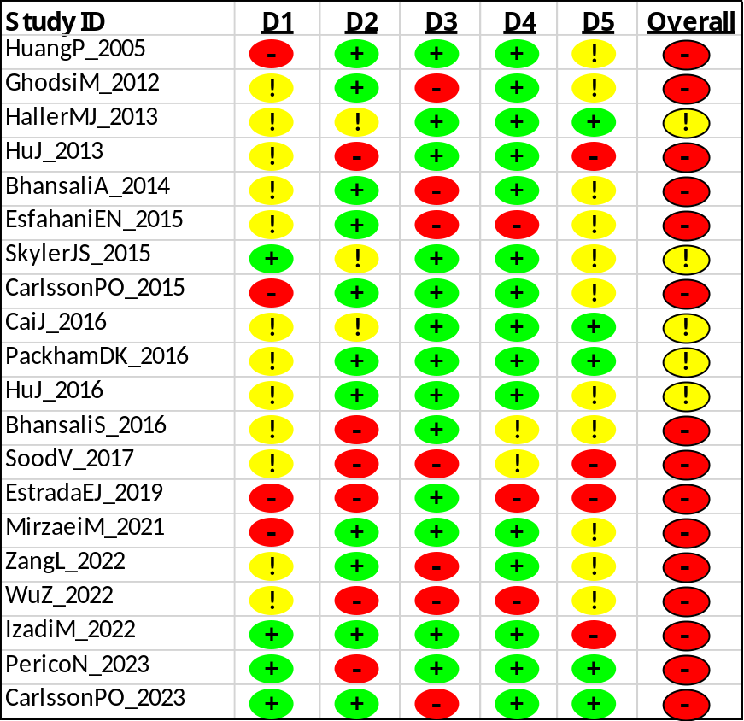

Appendix D: Supplementary figures
Type 1 DM

Fig S1a: Insulin requirement among type 1 DM at 6 months following stem cell therapy

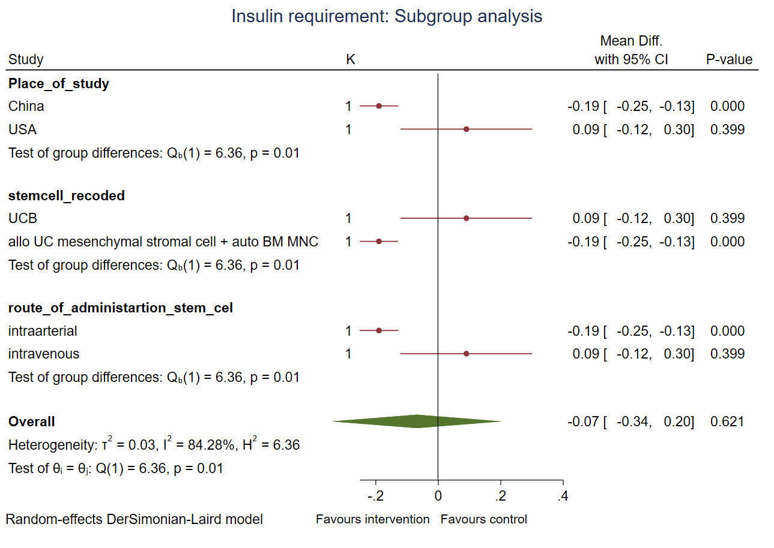
Fig S1b: Subgroup analysis of insulin requirement among type 1 DM at 6 months following stem cell therapy

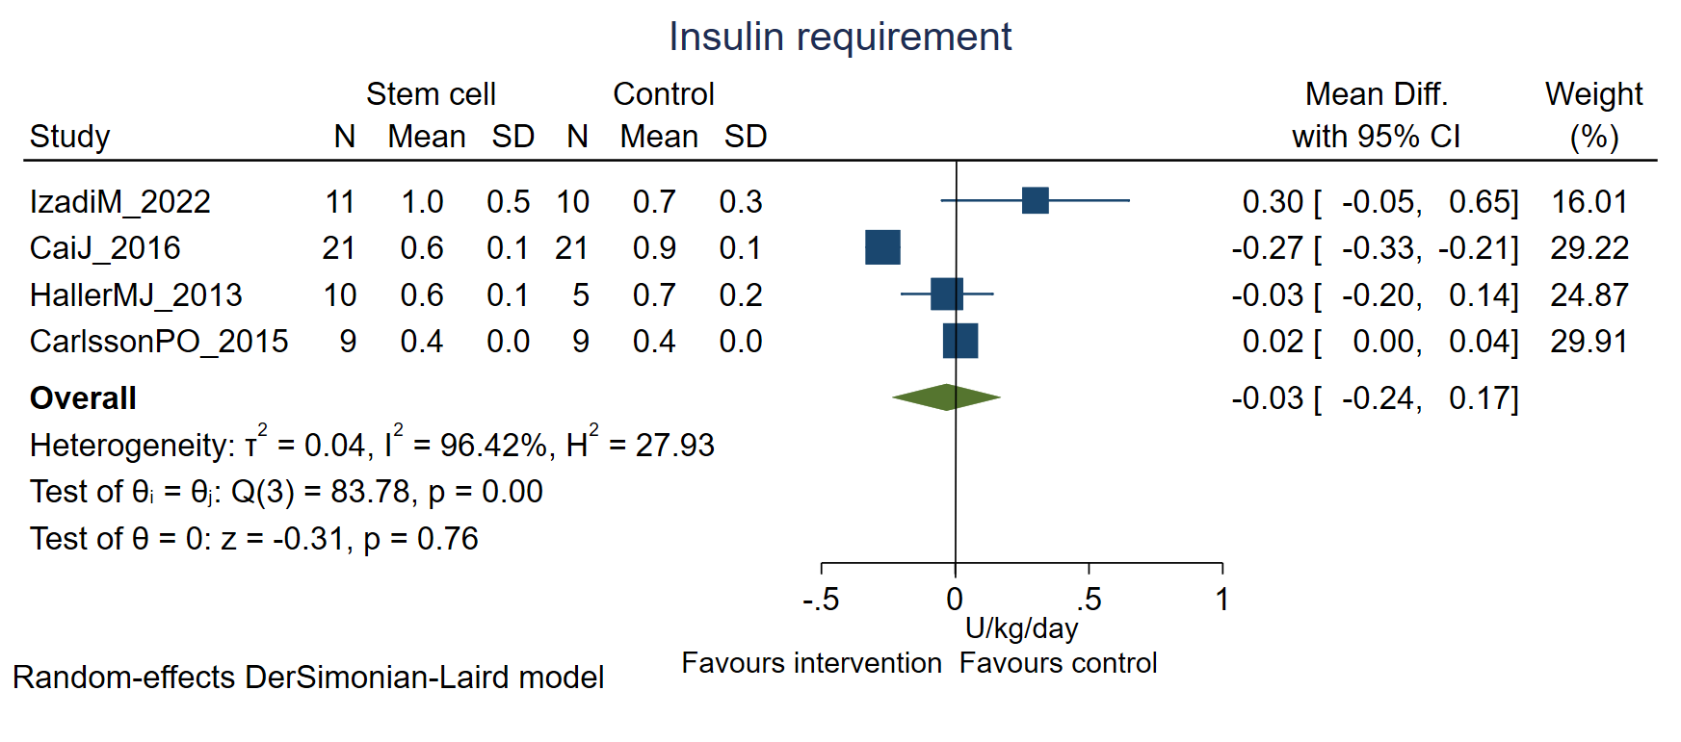Fig S2a: Insulin requirement among type 1 DM at 12 months following stem cell therapy

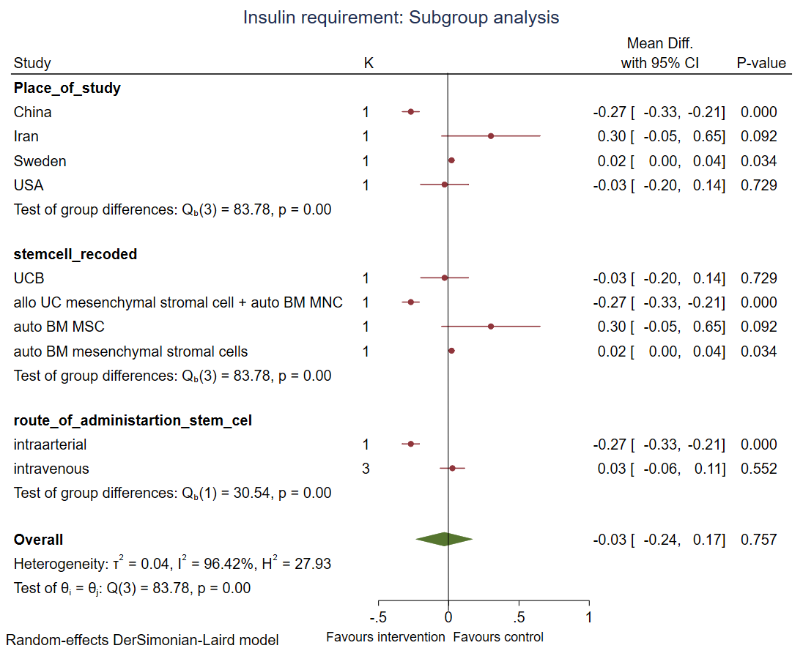
Fig S2b: Subgroup analysis of insulin requirement among type 1 DM at 12 months following stem cell therapy

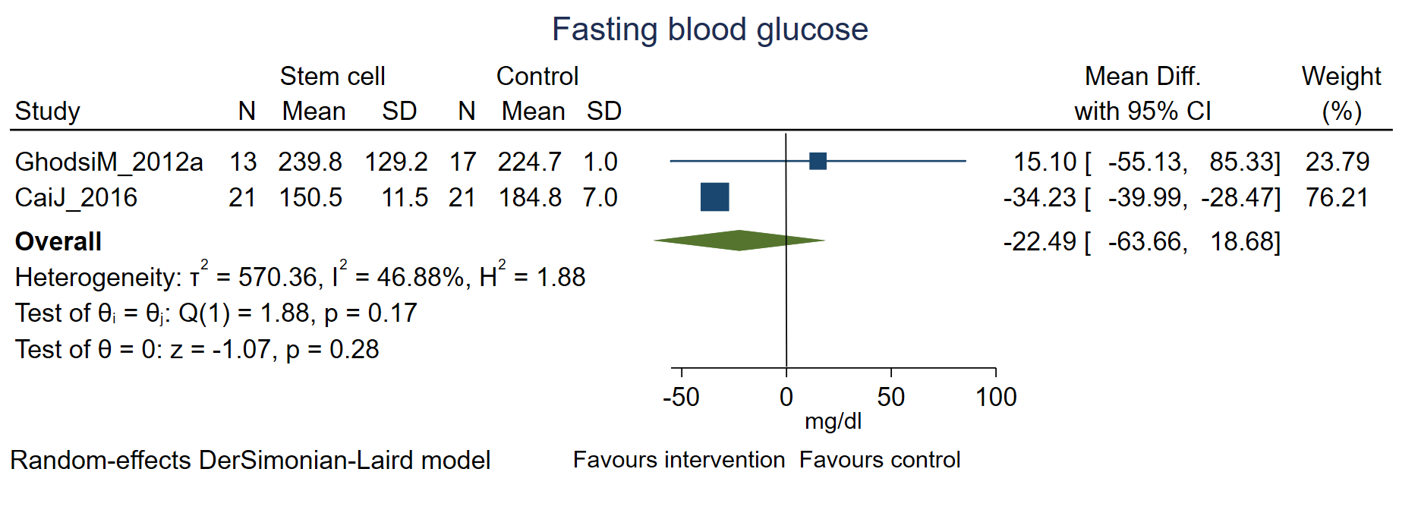

Fig S3a: Fasting blood sugar among type 1 DM at 6 months following stem cell therapy

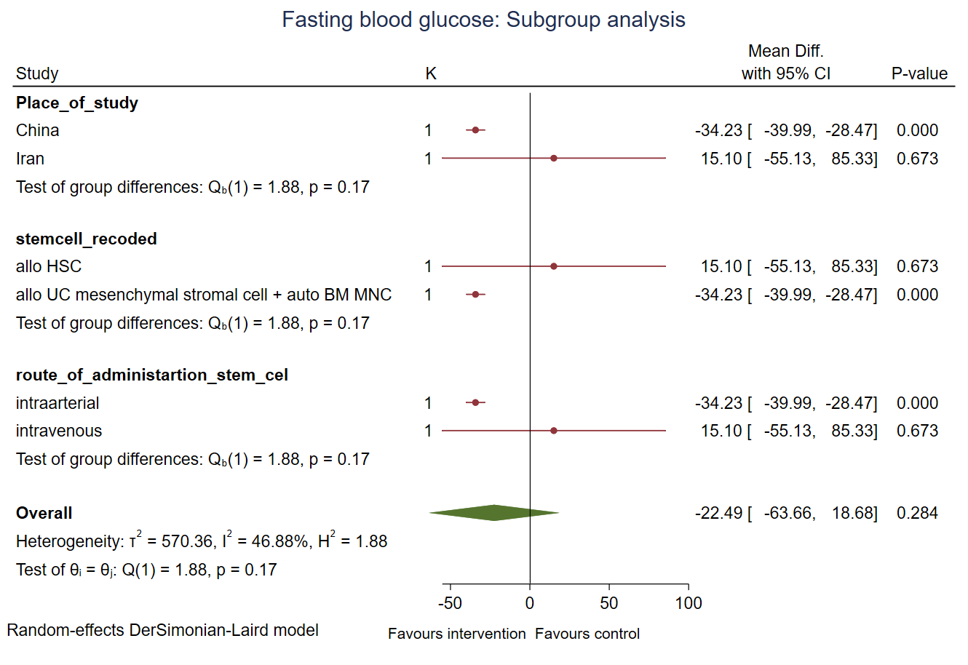

Fig S3b: Subgroup analysis of fasting blood sugar among type 1 DM at 6 months following stem cell therapy

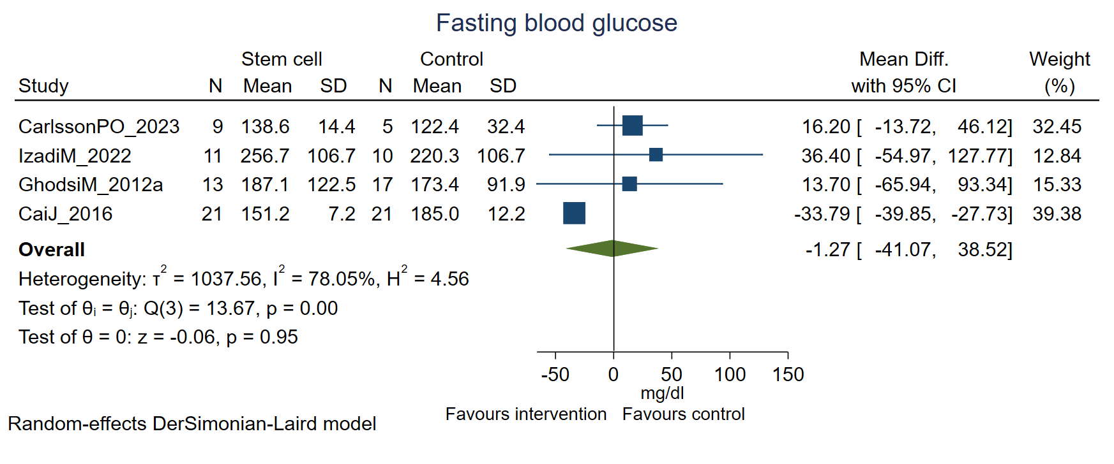

Fig S4a: Fasting blood sugar among type 1 DM at 12 months following stem cell therapy

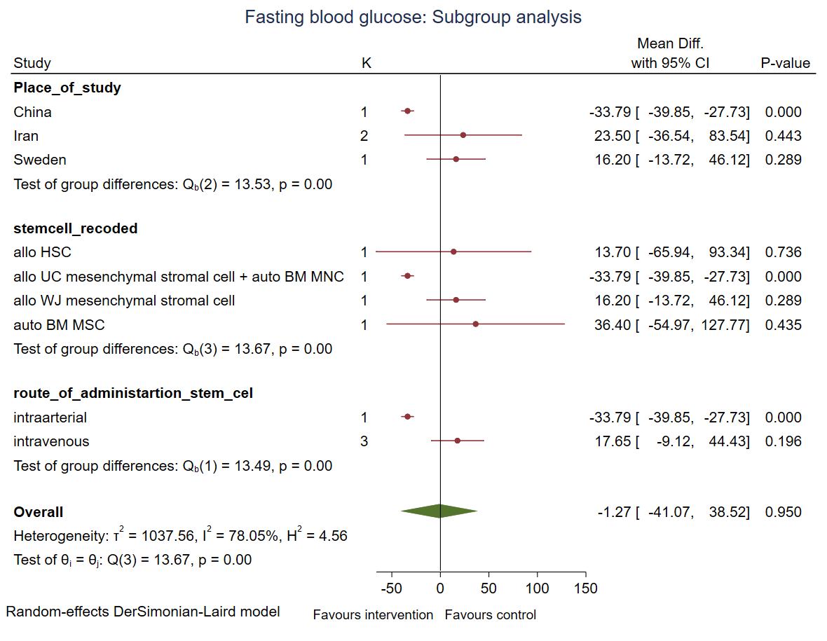

Fig S4b: Subgroup analysis of fasting blood sugar among type 1 DM at 12 months following stem cell therapy

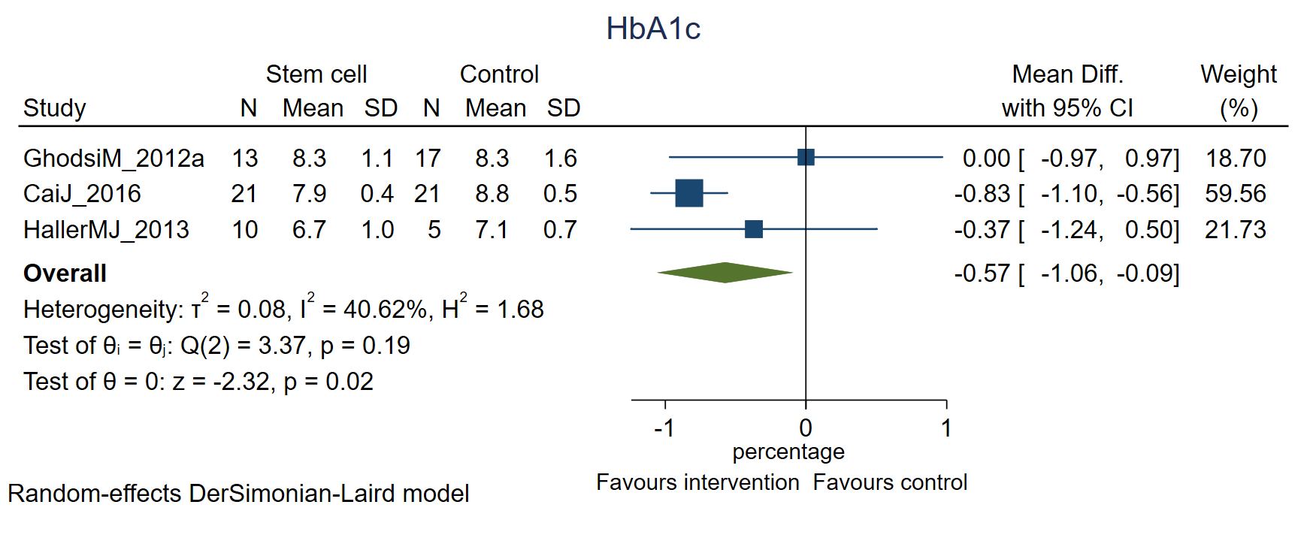

Fig S5a: HbA1C among type 1 DM at 6 months following stem cell therapy

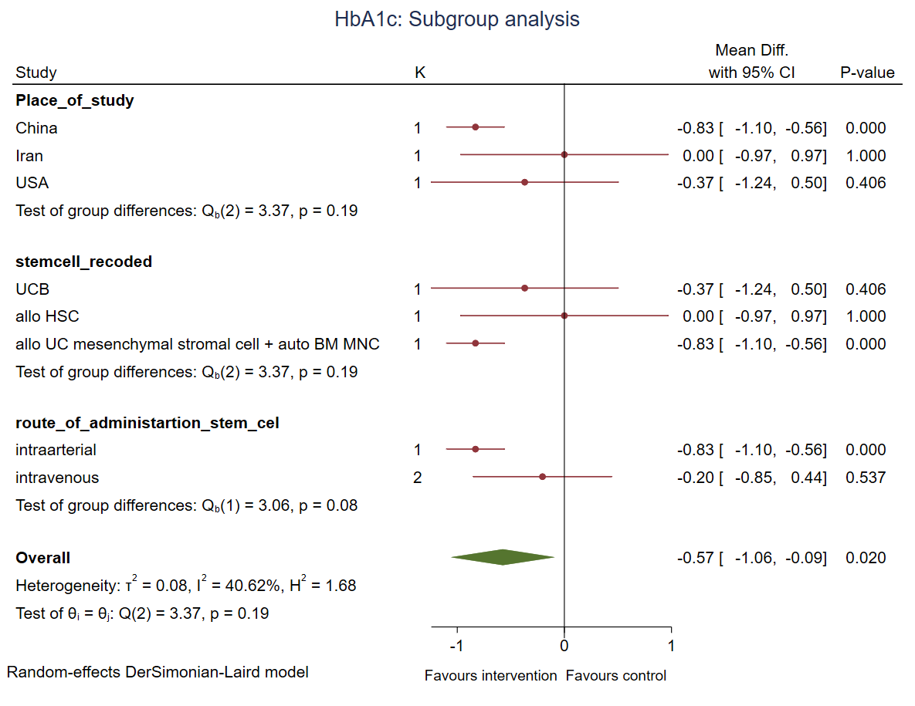

Fig S5b: Subgroup analysis of HbA1C among type 1 DM at 6 months following stem cell therapy

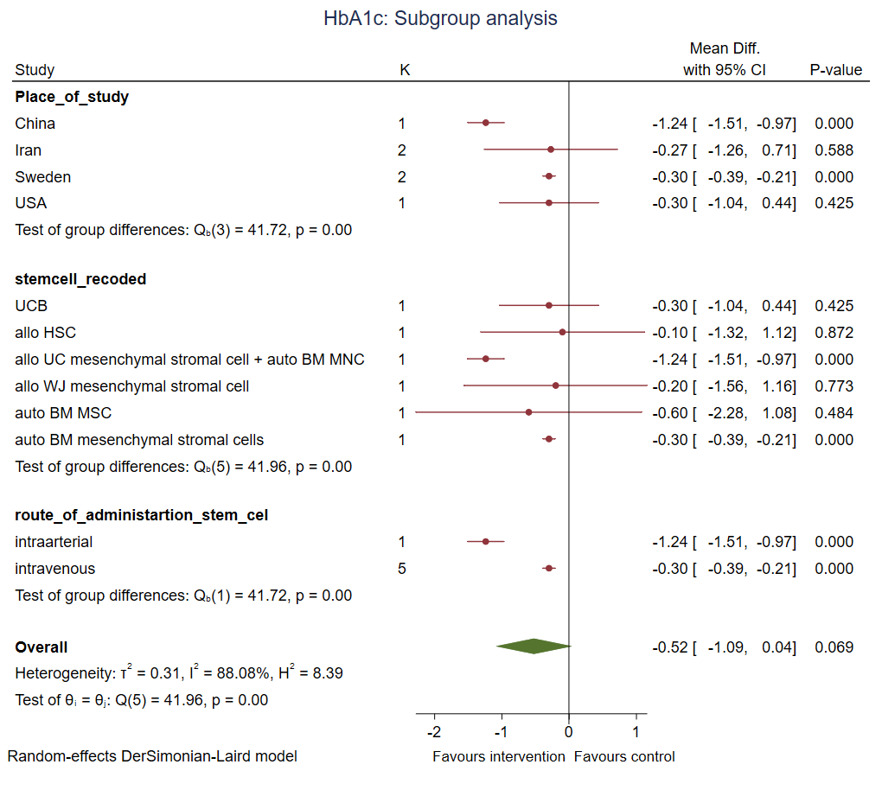 Fig S6: Subgroup analysis of HbA1C among type 1 DM at 12 months following stem cell therapy

Fig S7a: Fasting C-peptide among type 1 DM at 6 months following stem cell therapy
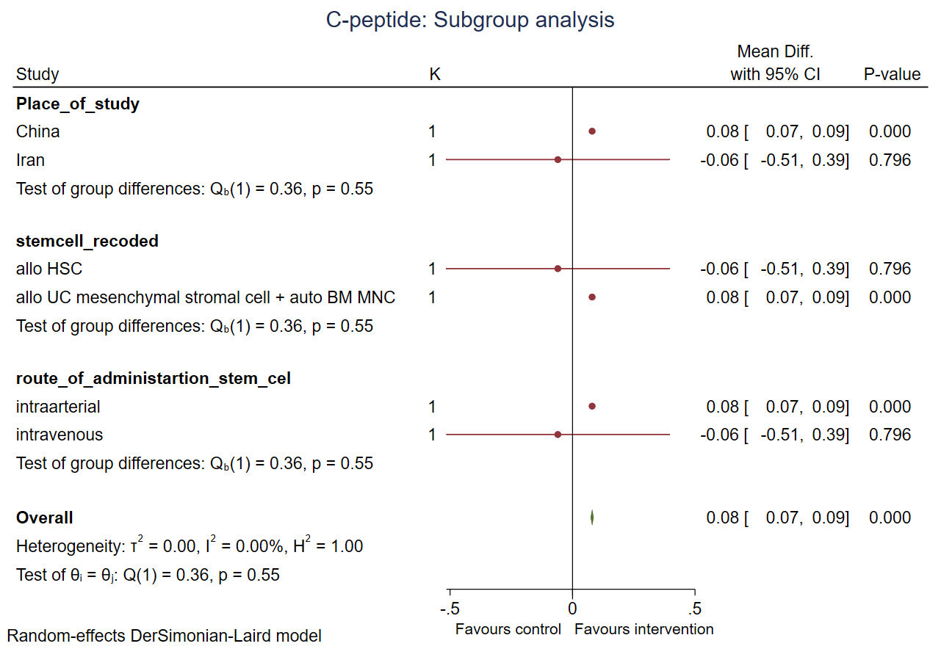
Fig S7b: Subgroup analysis of Fasting C-peptide among type 1 DM at 6 months following stem cell therapy

Fig S8a: Fasting C-peptide among type 1 DM at 12 months following stem cell therapy

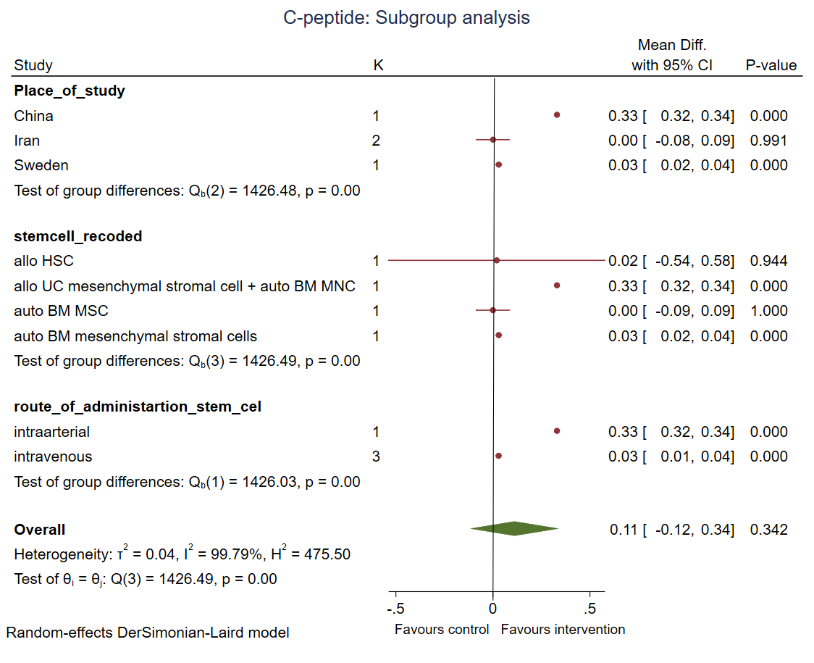
Fig S8b: Subgroup analysis of Fasting C-peptide among type 1 DM at 12 months following stem cell therapy
-------------------------------------------------------------------------------------------------------

Type 2 DM
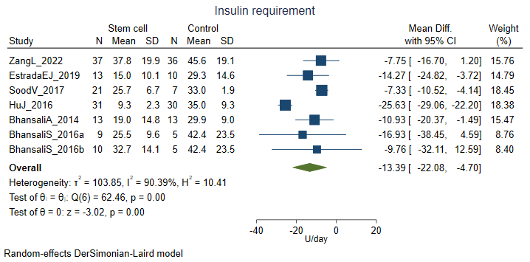
Favours stem cell
Favours control

Fig S9a: Insulin requirement among type 2 DM at 6 months
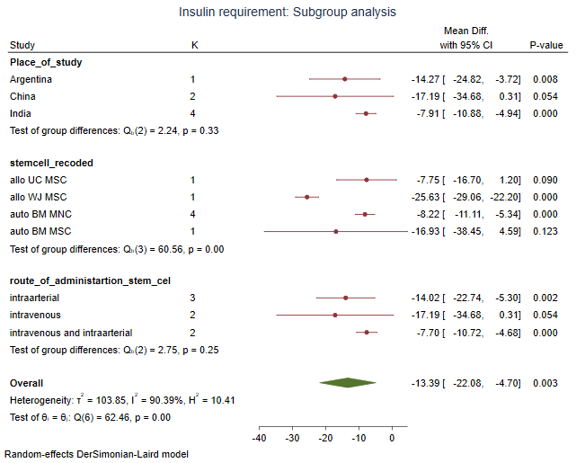
Favours stem cell
Favours control
Fig S9b: Subgroup analysis of insulin requirement among type 2 DM at 6 months

Fig S10: Insulin requirement among type 2 DM at 12 months
Fig S11: Insulin requirement in type 2 DM at 24 months

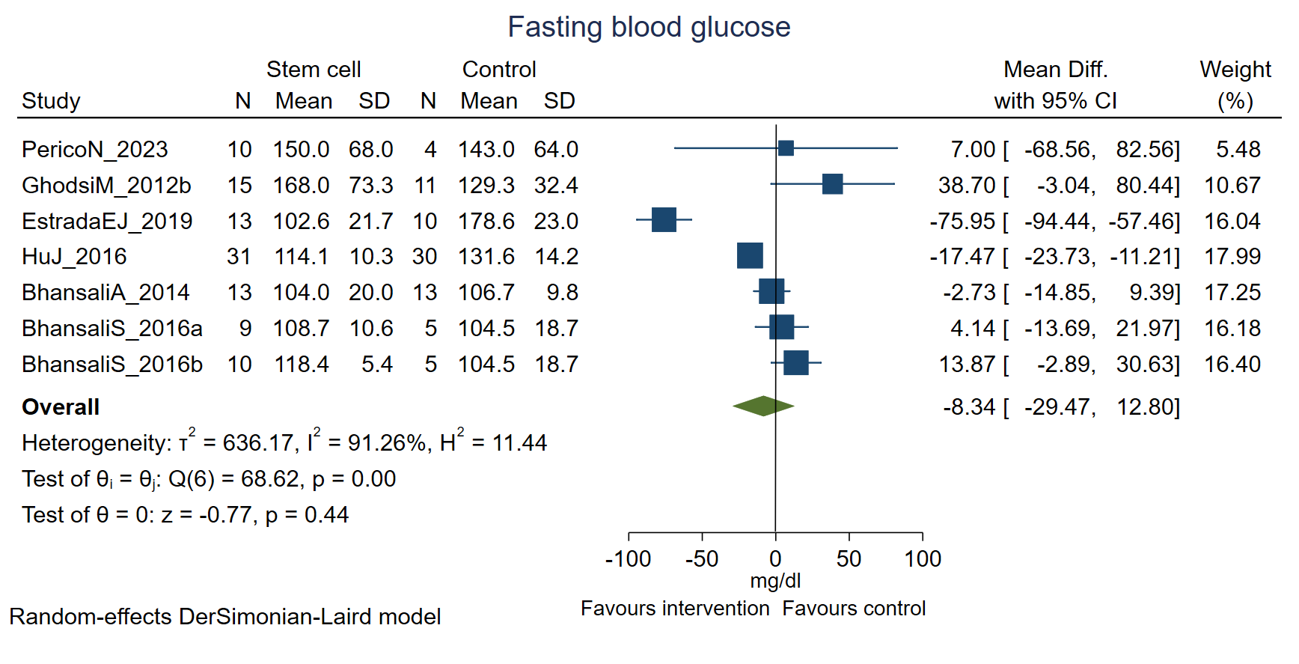
Fig S12a: Fasting blood glucose among type 2 DM at 6 months following stem cell therapy
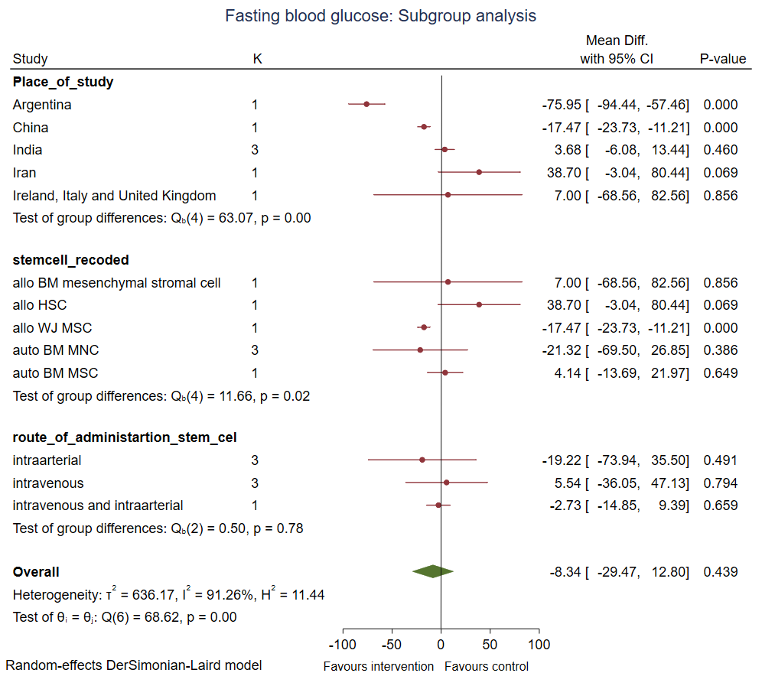 Fig S12b: Subgroup analysis of fasting blood glucose among type 2 DM at 6 months following stem cell therapy
Fig S13a: Fasting blood glucose among type 2 DM at 12 months following stem cell therapy

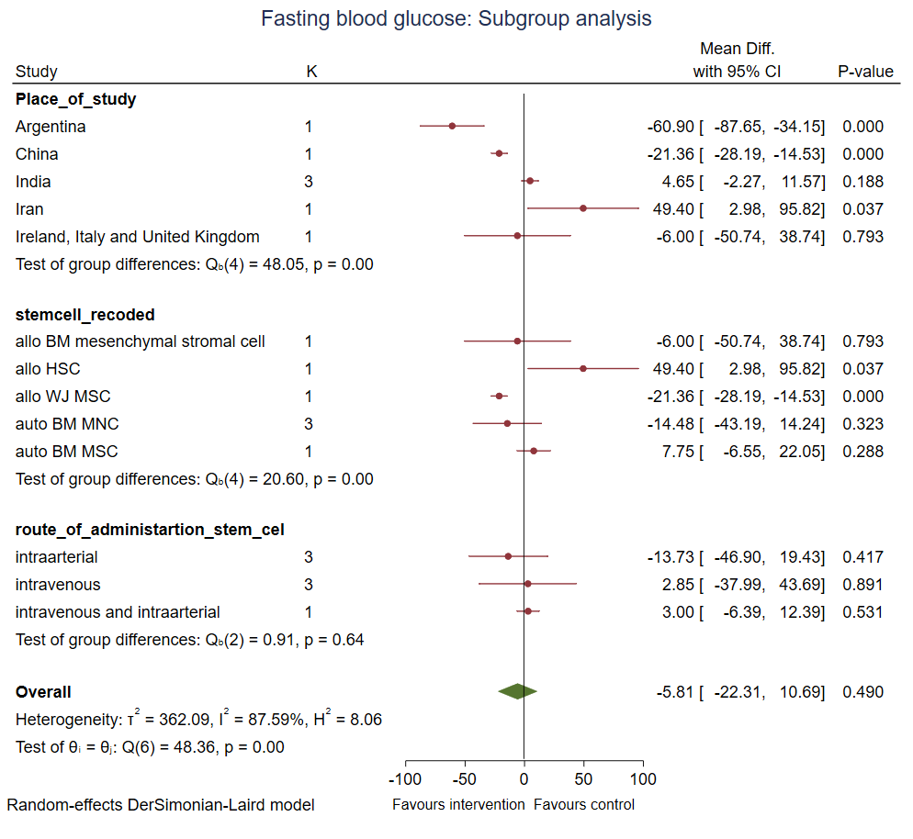
Fig S13b: Subgroup analysis of fasting blood glucose among type 2 DM at 12 months following stem cell therapy

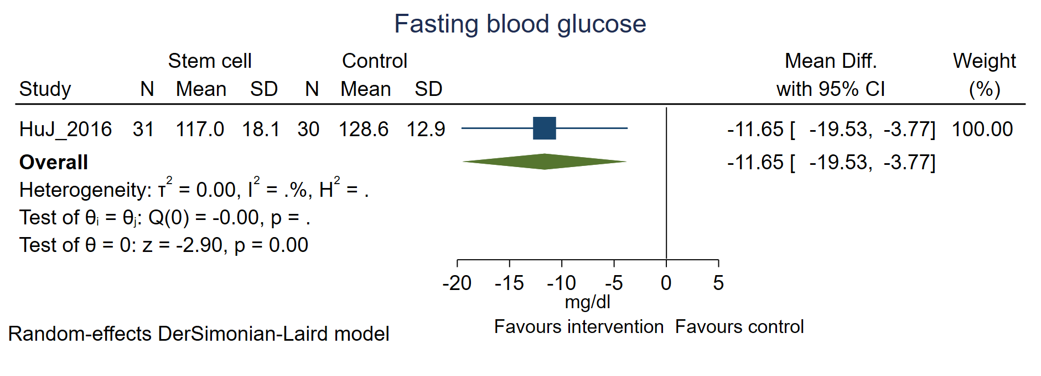
Fig S14a: Fasting blood glucose among type 2 DM at 24 months following stem cell therapy

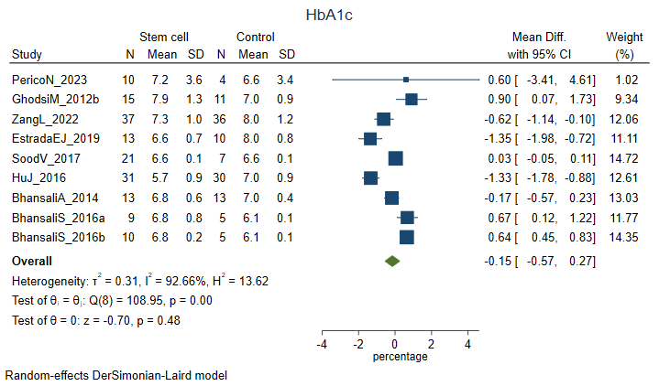
Favours stem cell
Favours control
Fig S15a: HbA1C percentage among type 2 DM at 6 months

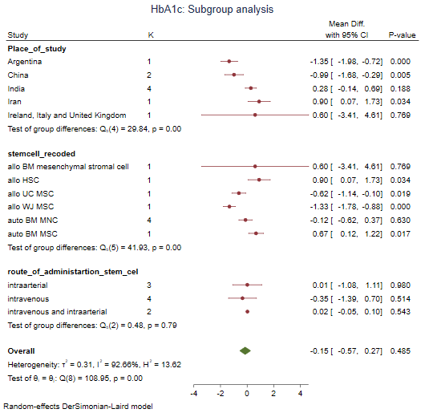
Favours control
Favours stem cell
Fig S15b: Subgroup analysis of HbA1C percentage among type 2 DM at 6 months

Fig S16: Subgroup analysis of HbA1C percentage among type 2 DM at 12 months
Fig S17: HbA1C percentage among type 2 DM at 24 months

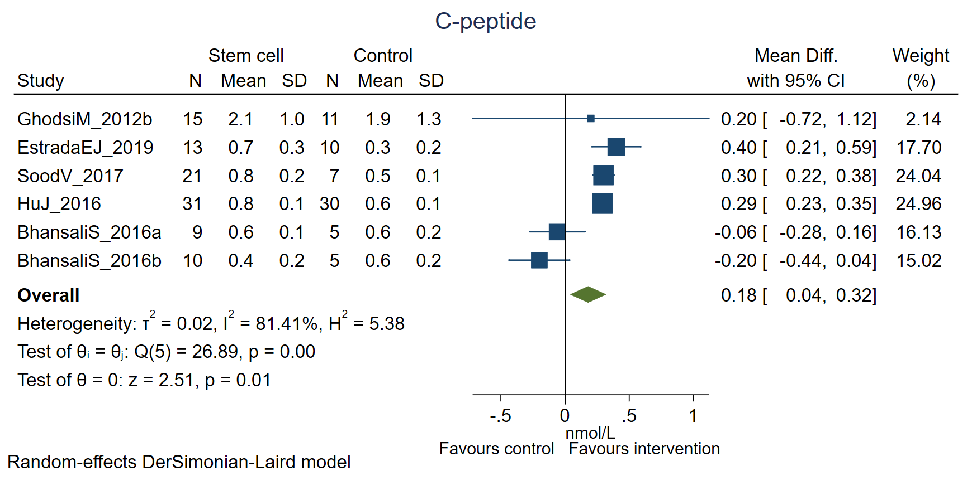
Fig S18a: Fasting C-peptide among type 2 DM at 6 months following stem cell therapy

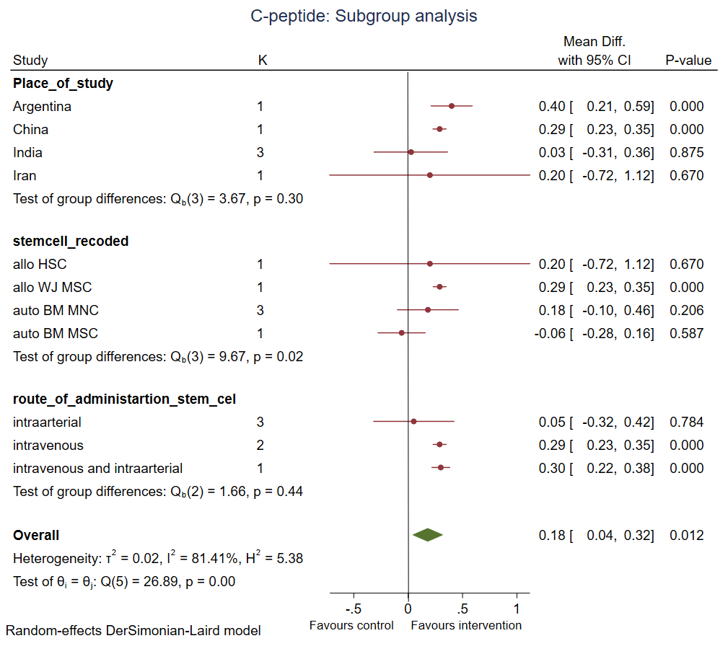
Fig S18b: Subgroup analysis of Fasting C-peptide among type 2 DM at 6 months following stem cell therapy
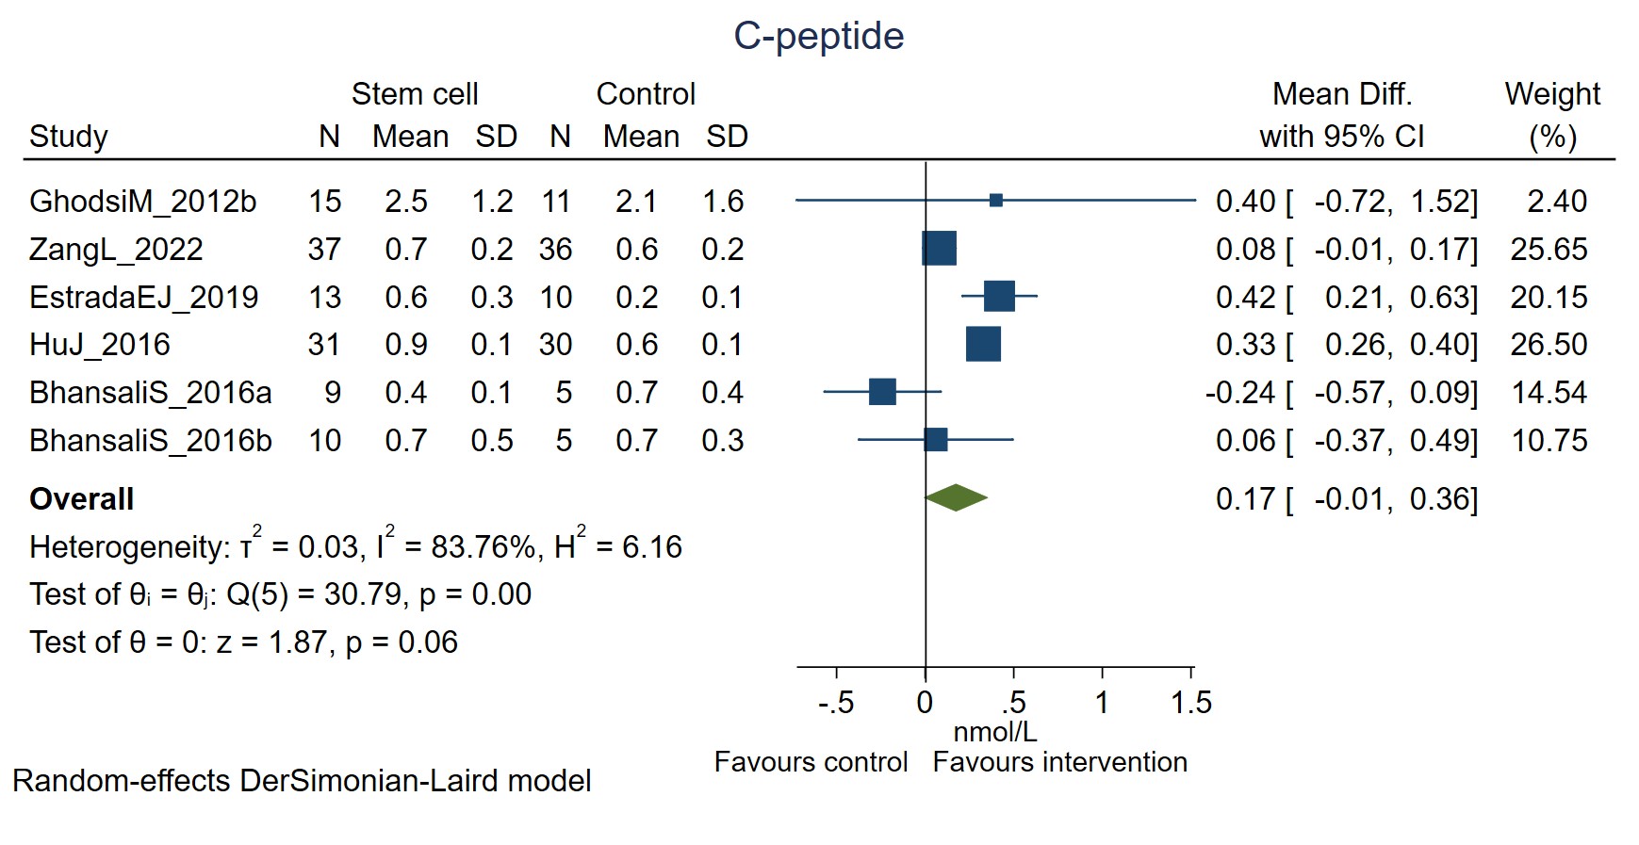
Fig S19a: Fasting C-peptide among type 2 DM at 12 months following stem cell therapy

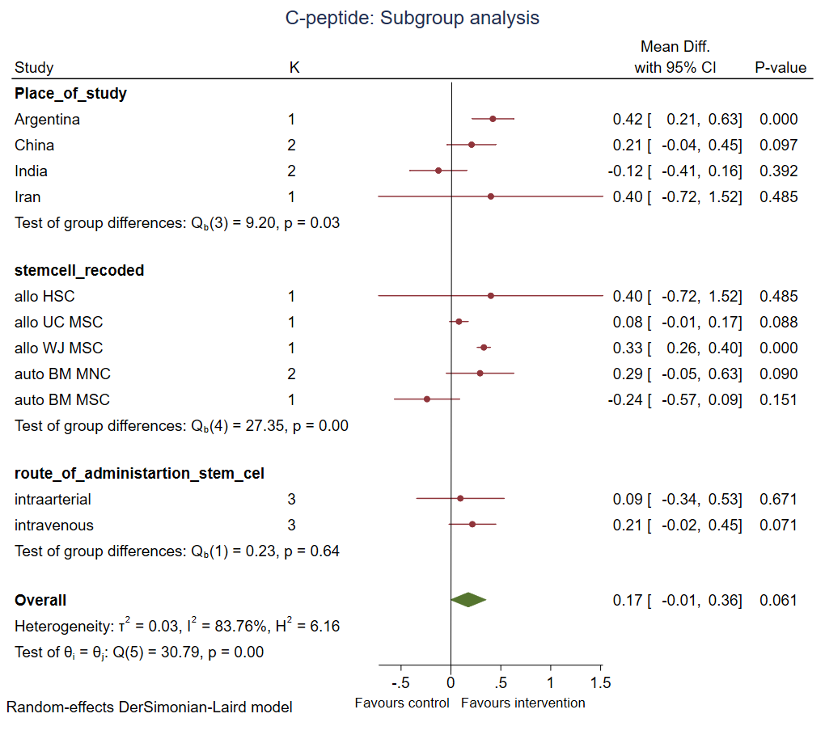
Fig S19b: Subgroup analysis of Fasting C-peptide among type 2 DM at 12 months following stem cell therapy
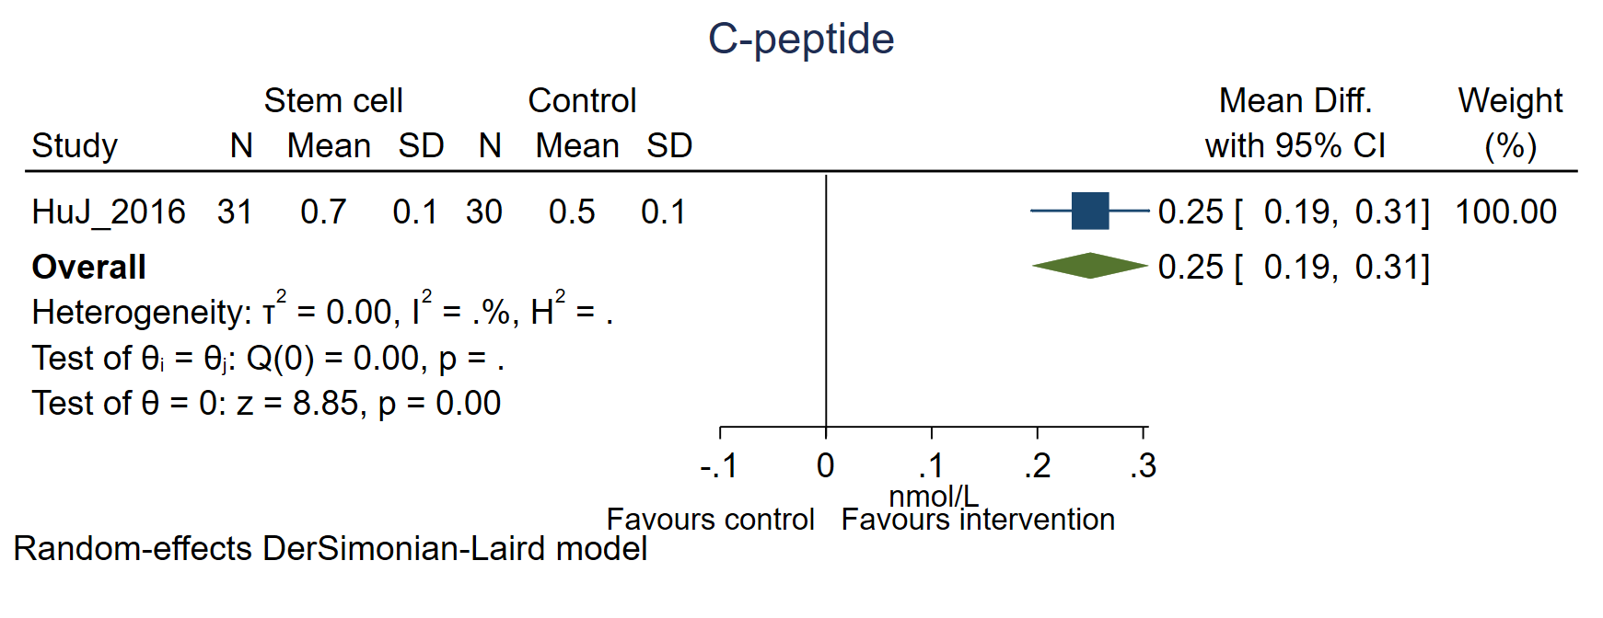
Fig S20: Fasting C-peptide among type 2 DM at 24 months following stem cell therapy

