Supplementary information
Synthetic ratio computation for programming population composition and multicellular morphology

Supplementary methods

Characterization of yeast protein secretion
The Nano-Glo® HiBiT Extracellular Detection System (Promega) was utilized to confirm the secretion of enzymes by engineered yeast. This system relies on the interaction between the HiBiT tag, an 11-amino-acid epitope (sequence: VSGWRLFKKIS), and LgBiT, which generates bioluminescence upon binding¹. For the assay, HiBiT was genetically fused to target proteins or enzymes. Supernatants (100 µL) from cultured yeast were combined with 1 µL of LgBiT protein, 97 µL of reaction buffer, and 2 µL of bioluminescent substrate, yielding a total reaction volume of 200 µL. The mixture was incubated for 5 minutes at room temperature, the bioluminescence was measured using a microplate reader (BioTek). The BY4741 strain, which does not secrete engineered proteins, served as a negative control.

Enzyme activity of secreted α-Galactosidase (Mel1)
A stock solution of X-α-Gal (40 mg/mL, Sigma-Aldrich, 16555) was prepared in dimethyl sulfoxide (DMSO). For activity assessment, 100 µL of this solution was added to 3 mL of YPD medium inoculated with yeast cells at a 1:1000 dilution. After 24 hours of incubation at 30 °C, cultures were collected and imaged.

Enzyme activity of secreted Laccase
As copper-dependent enzymes, laccases require copper supplementation². Stock solutions of 2,2’-azino-bis (3-ethylbenzothiazoline-6-sulphonic acid, ABTS) (Sigma-Aldrich, A1888) and copper sulfate were prepared at final concentrations of 0.1 M and 1 M, respectively. For activity evaluation of the secreted laccase from Coriolopsis trogii, 125 µL of ABTS solution and 25 µL of CuSO₄ solution were added to 3 mL of YPD medium inoculated with yeast cells (1:1000 inoculation). Cultures were incubated at 30 °C for 24 hours and then imaged.

Enzyme activity of secreted Lipase
Yeast strains were cultured in YPD medium supplemented with 1% soybean oil for 48 hours. Fermentation broth (5 mL) was harvested by centrifugation (12,000 rpm, 15 minutes). Lipids were extracted from the supernatant by mixing with 500 μL acetic acid, 500 μL of 12% (w/v) sodium chloride solution, and 2 mL ethyl acetate. The mixture was vortexed for 15 minutes, centrifuged (12,000 rpm, 15 minutes), and the organic phase was collected, dried under nitrogen, and resuspended in chloroform. Lipid separation was performed via thin layer chromatography (TLC) using a solvent system (hexane: diethyl ester: acetic acid = 70:30:1). Lipids were visualized using iodine vapor.

Extraction and characterization of Violacein and β-Carotene
To extract Violacein and β-carotene from cultured yeast, yeast cells (1 mL, OD₇₀₀ = 2.0) were harvested by centrifugation (4,000 rpm, 1 minute). After discarding the supernatant, pellets were resuspended in 500 μL of DMSO and incubated at 37 °C for 30-60 minutes with grinding to accelerate cell lysis and improve extraction efficiency. Following incubation, the mixture was centrifuged (4,000 rpm, 1 minute), and the supernatant containing extracted Violacein and β-carotene, was analyzed via full-spectrum scanning (400-650 nm, 5 nm steps) using a BioTek microplate reader.

Counting ratios of pigment-producing yeast generated by branching devices
Yeast strains with pZ-driven violacein and pPhIF-regulated β-carotene synthesis pathways were transformed with a designed branching circuit using Z₃EV and PhIF-VP16 as reporters. Colonies were grown on agar plates for three days, inoculated into 5 mL of YPD medium supplemented with 1 mM aTc and 1 μM β-estradiol, and cultured at 30 °C with shaking (1,000 rpm) for 8 hours. Cultures were diluted 10,000×, spread onto YPD agar plates (supplemented with 1 μM β-estradiol), and incubated for 3 days. Plates were imaged, and colonies producing orange (β-carotene) and purple (violacein) pigments were counted.

DNS method for measuring cellulose degradation by cellulase
Glucose concentration was determined using a modified DNS method³. Samples (50 µL) were mixed with 100 µL of DNS buffer (Macklin) in 1.5 mL tubes, heated at 100 °C for 5 minutes, and cooled on ice for 1 minute. After cooling, 150 µL of ddH₂O was added, and 200 µL of the solution was transferred to a microplate. Absorbance at 540 nm was measured, and glucose concentrations were determined using a standard curve (0.125-5 g/L) (Fig. S73). Cellulase activity was assessed using 1 mL supernatant of yeast culture (OD₆₀₀=2.0) with 2% Avicel PH-101 (Sigma) in sealed deep-well microtiter plates. Samples were incubated at 35°C with shaking (~300 rpm) for 24 hours, and 50 µL aliquots were analyzed for glucose content using the DNS method.

Construction of the snowflake yeast
Snowflake yeast strains were constructed by deleting ACE2 using the CRISPR-Cas9 system, as previously reported⁴. The commercially available plasmid pMYT095, which contains Cas9 and gRNA cassettes, was employed for this purpose⁵. The guide RNA sequence (TTATTCAAAATATAATTGTCGGG) was selected using the Yeastriction online tool (http://yeastriction.tnw.tudelft.nl/). Plasmids designed for ACE2 deletion were constructed and validated by Sanger sequencing (Sangon Biotech). Donor DNA fragments were synthesized and purified using a DNA Extraction Mini Kit (Vazyme Biotech Co., Ltd) prior to transformation. Both the plasmids and donor DNA were introduced into yeast cells via the lithium acetate transformation method. Transformant colonies were subsequently confirmed by PCR and Sanger sequencing (Sangon Biotech).

Development of a mathematical model for predictive circuit design
To design cell differentiation patterns predictively, a simplified model was constructed to describe the Bxb1-mediated excision of the engineered circuit. The excision process was considered both with and without steric hindrance imposed by the transcription machinery. We hypothesized that compared to the weak promoter, a strong promoter on the differentiation circuit would attract more transcription factors, potentially reducing the cleavage efficiency of Bxb1 recombinase. In the absence of steric hindrance, the left and right arm could be cleaved at the rates $k_{A}$ and $k_{B}$, respectively. The values of $k_{A}$ and $k_{B}$ were determined by the lengths of the left and right arms. A power function was used to describe the relationship between the arm length and the excision rate: $k_{A}=k_{A}^{0}h_{A}^{-β},$ $k_{B}=k_{B}^{0}h_{B}^{-β}$. Here, $h_{A}$ and $h_{B}$ represent the arm lengths, and $β$ is a positive constant.
The promoters on both arms recruit transcription machinery, creating a physical obstruction that reduces the recombination efficiency. The recruitment of transcription machinery on the left arm reduces the cleavage rate of the left arm, changing it from $k_{A}$ to $v_{A}$. Similarly, recruitment on the right arm changes $k_{B}$ to $v_{B}$. We assumed that the steric hindrance of one arm does not affect the recombination of the other arm. We used a variable $α$ to describe the strength of the steric hindrance: $α=\frac{v_{A}}{k_{A}}=\frac{v_{B}}{k_{B}}$. Therefore, the cell differentiation dynamics mediated by the engineered circuit can be described with a group of ordinary differential equations (ODEs):
$$\frac{d[D]}{dt}=-{(k}_{A}+k_{B}+r_{A}+r_{B})[D],$$
$$\frac{d[L_{A}]}{dt}=k_{A}\left[D\right]+v_{A}\left[M_{A}\right]+k_{A}\left[M_{B}\right],$$
$$\frac{d[L_{B}]}{dt}=k_{B}\left[D\right]+v_{B}\left[M_{B}\right]+k_{B}\left[M_{A}\right],$$
$$\frac{d[M_{A}]}{dt}=r_{A}\left[D\right]-v_{A}\left[M_{A}\right]-k_{B}\left[M_{A}\right],$$
$$\frac{d[M_{B}]}{dt}=r_{B}\left[D\right]-v_{B}\left[M_{B}\right]-k_{A}\left[M_{B}\right].$$
Here, $[D]$ presents the population-level concentration of the ‘naked’ genetic device that has been neither cleaved nor bound with transcription machinery $[L_{A}]$ and $[L_{B}]$ are the concentrations of the recombination products. Excision of the left arm produces $L_{A}$, while cutting off the right arm produces $L_{B}$. $M_{A}$ and $M_{B}$ describe the concentrations of the circuit bound with transcription machineries. $r_{A}$ and $r_{B}$ are the binding rates of the transcription machineries.
If all the parameters were given, this model would allow us to predict the ratios of left or right arm excision. However, we didn’t have the luxury since many of the parameters were challenging to directly measure. Therefore, we sought to estimate these parameters by fitting our model with a finite number of experimental measurements. We hypothesized that the optimal parameters should be those minimizing the discrepancy between the predicted and measured ratios. To this end, we defined an objective function $ϕ=\sum_{i=1}^{m}{{(y_{i}-x_{i})}^{2}}$ where $x_{i}$ is experimentally determined ratio, $y_{i}$ the predicted value and $i$ the index of the data. The parameters can then be estimated by searching for the minimum of the objective function in the defined parameter space.
In experiments, we varied the lengths of left and right arms and measured the ratio of Venus and mScarlet cells resulting from different arm length combinations (Fig. 2d). We used these data to fit our model (Fig. S39-S40). In particular, we screened the parameters in the following ranges: $0<k_{A}^{0}<0.3$ $h^{-1}$, $0<k_{B}^{0}<0.3 h^{-1}$, $0<r_{A}<0.3 h^{-1}$, $0<r_{B}<0.3 h^{-1}$, $0<α<0.1$, $0<β<2$. For each chosen parameter combination, we calculated the corresponding $ϕ$ value. We then obtained the optimal parameter combination that best fit the experimental measures: $k_{A}^{0}=0.38 h^{-1}$, $k_{B}^{0}=0.14 h^{-1}$, $r_{A}=0.56 h^{-1}$, $r_{B}=0.01 h^{-1}$, $α=0.01$, $β=1.3$.
These parameters can be further applied to determine the $k_{A}^{0}$ or $k_{B}^{0}$ of the attP variant. For instance, for an attP variant on the left arm, the new $k_{A}^{0}$ can be determined by fitting our model with the new measurements while keeping all other parameters unchanged. The new $k_{B}^{0}$ for the attP variant on the right arm can be estimated similarly (Table. S1). The same approach can also be used to determine the $r_{A}$ and $r_{B}$ values corresponding to different promoters (Table. S2). After the parameter associated with each condition (arm's length, attP variant, and promoter type) was estimated, the further enables the prediction of green-to-red ratios under different condition combinations (Table. S3).

Supplementary figures

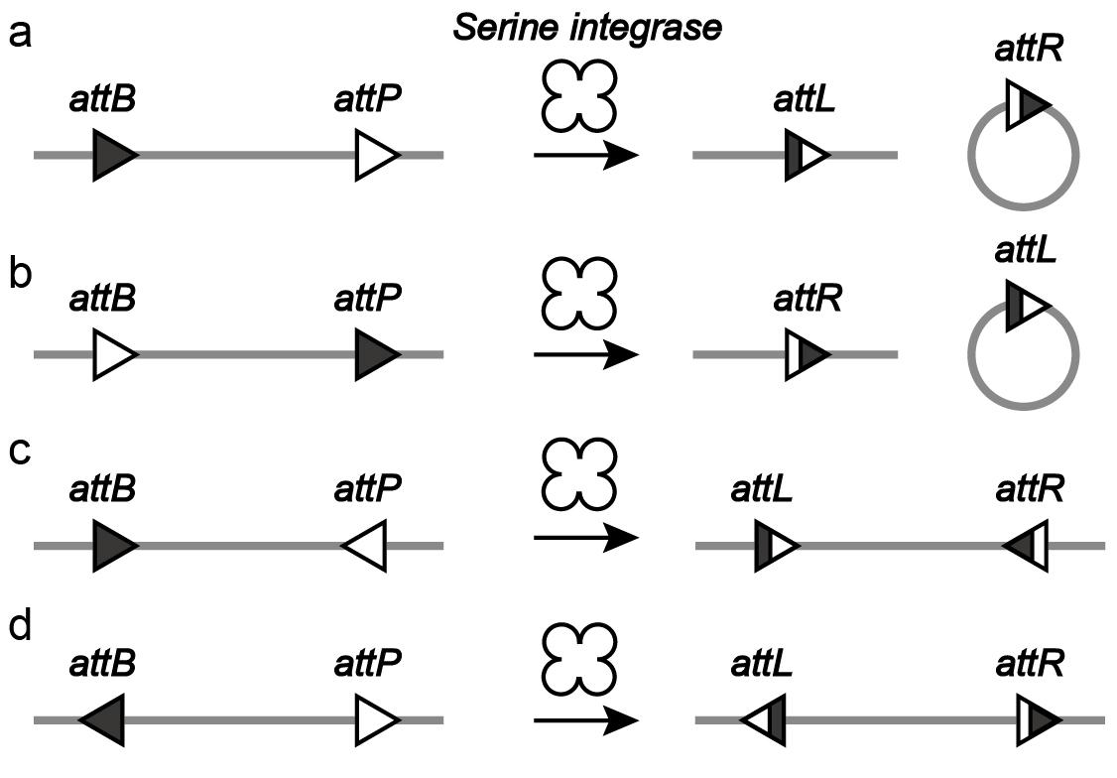

Fig. S1 | Recombination patterns of serine recombinase. Serine integrase/recombinase specifically recognizes two att site types, attB, and attP. When aligned in the same orientation (Fig. S1a and Fig. S1b), the serine recombinase facilitates DNA excision by removing sequences between the attB and attP sites, producing new attL and attR sites. Conversely, oppositely oriented attB and attP sites (Fig. S1c and Fig. S1d) led to DNA inversion, flipping the DNA between att sites.

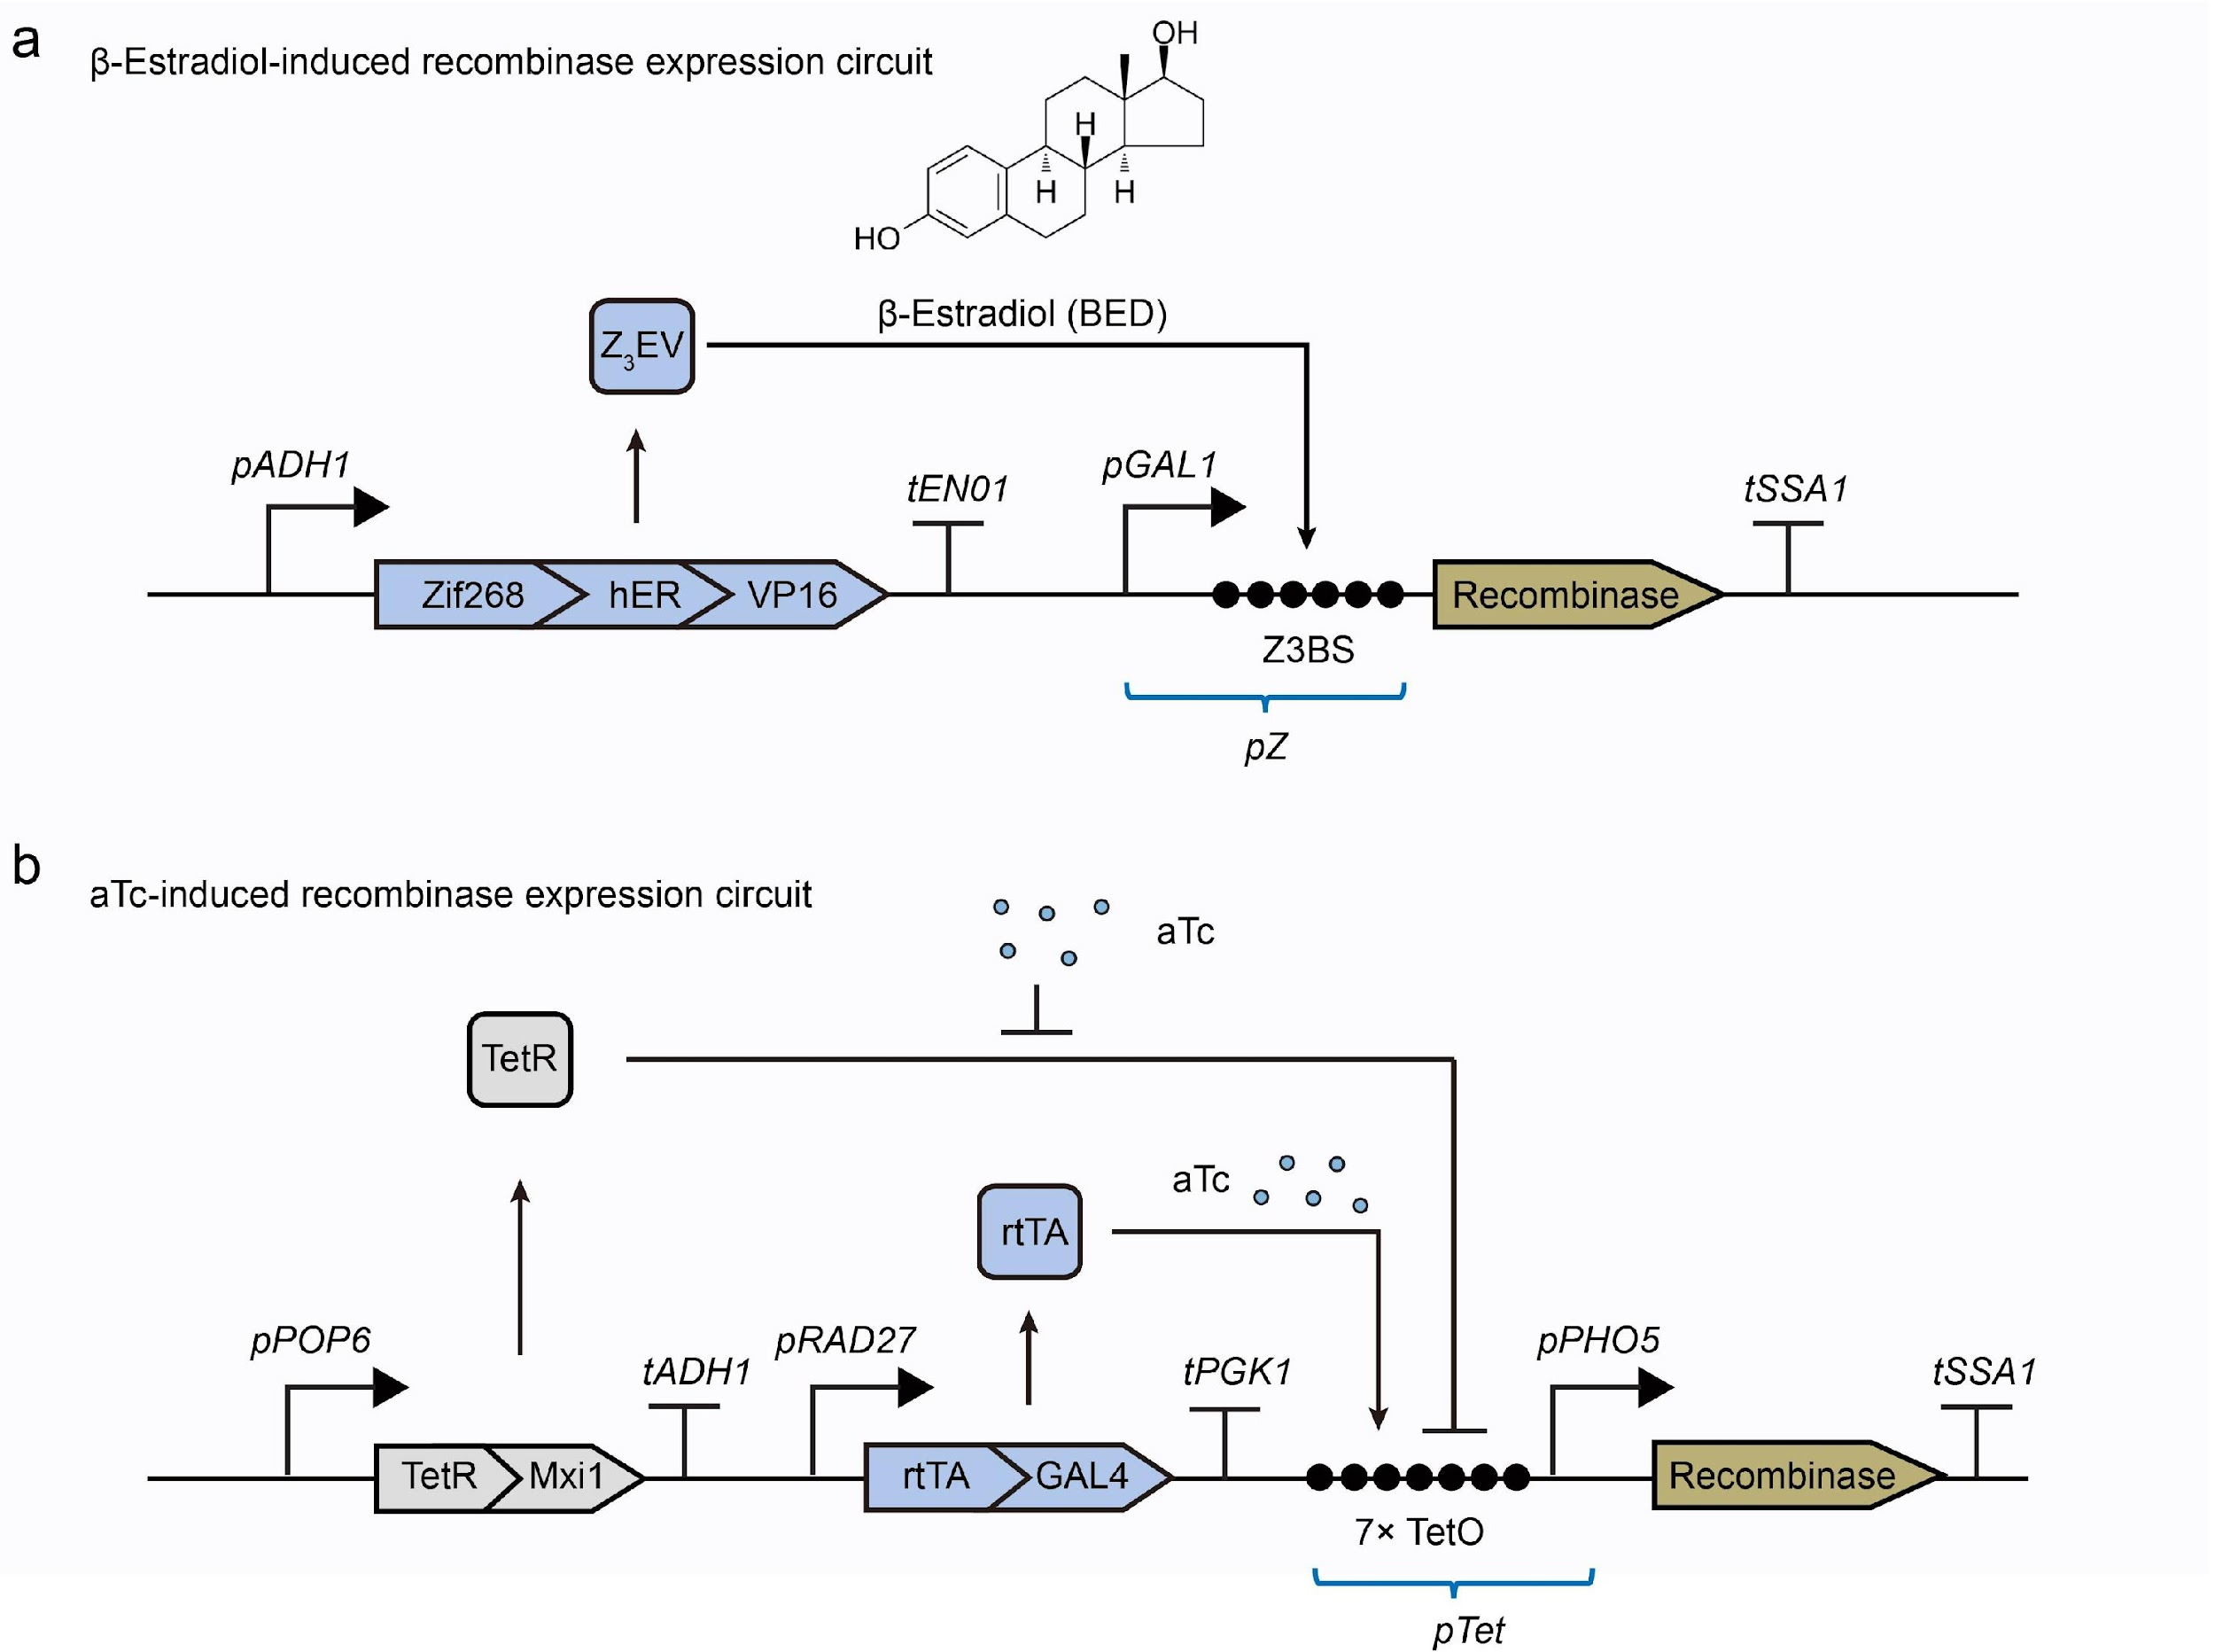
Fig. S2 | Inducible gene circuits for recombinase expression control. a. β-estradiol-induced recombinase expression system². The circuit utilizes the constitutively expressed transcription factor Z₃EV transcription factor in yeast. Upon binding β-estradiol, Z₃EV attaches to the Z₃BS site on the pZ promoter, initiating recombinase production. b. Anhydrotetracycline (aTc)-induced recombinase expression system⁶. In the absence of aTc, TetR-Mxi1 fusion proteins bind to the TetO operator within the pTet promoter, repressing transcription. When aTc is present, it disrupts TetR-TetO binding, allowing the reverse tetracycline transactivator (rtTA) to bind to TetO. The rtTA-GAL4 fusion protein subsequently activates the downstream pTet promoter.

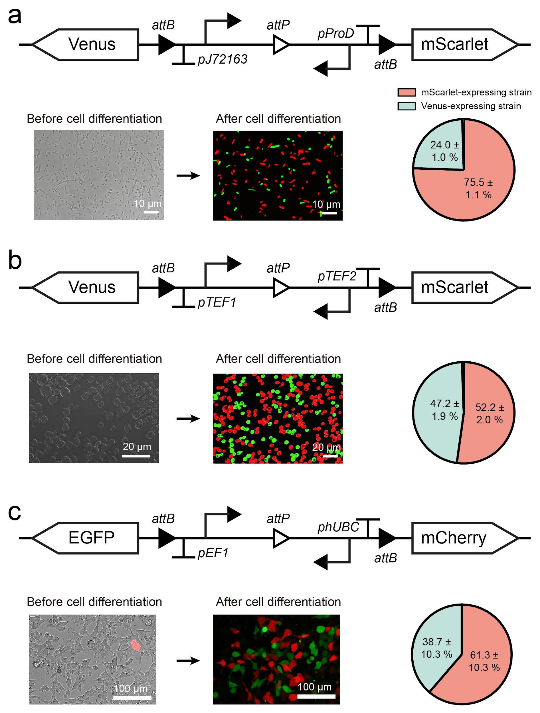
Fig. S3 | Binary cell fate branching device in E. coli (a), yeast (b), and HEK293 cells (c). Upon Bxb1 recombinase expression, the engineered circuits undergo probabilistic cleavage, resulting in two distinct progeny cell populations with different genetic profiles. Progeny ratios were quantified via flow cytometry and fluorescence analysis.
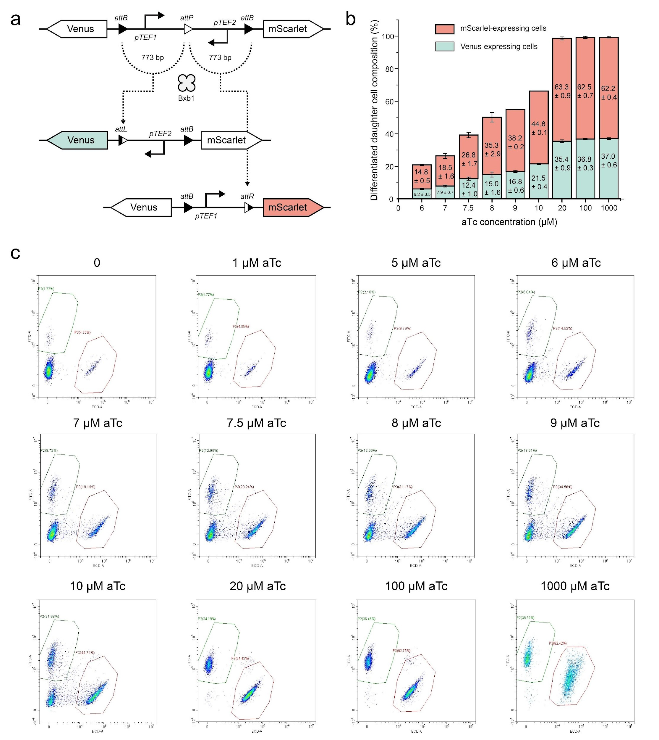
Fig. S4 | Effect of aTc concentrations on binary cell differentiation. a. Schematic of the gene circuit. b. Statistical analysis of differentiated progeny populations exposed to varying aTc concentrations (n = 8, mean ± SD). Low aTc concentrations (e.g., 6 μM) resulted in most yeast cells remaining undifferentiated. c. Representative flow cytometry data illustrate the correlation between aTc concentrations and differentiation efficiency.

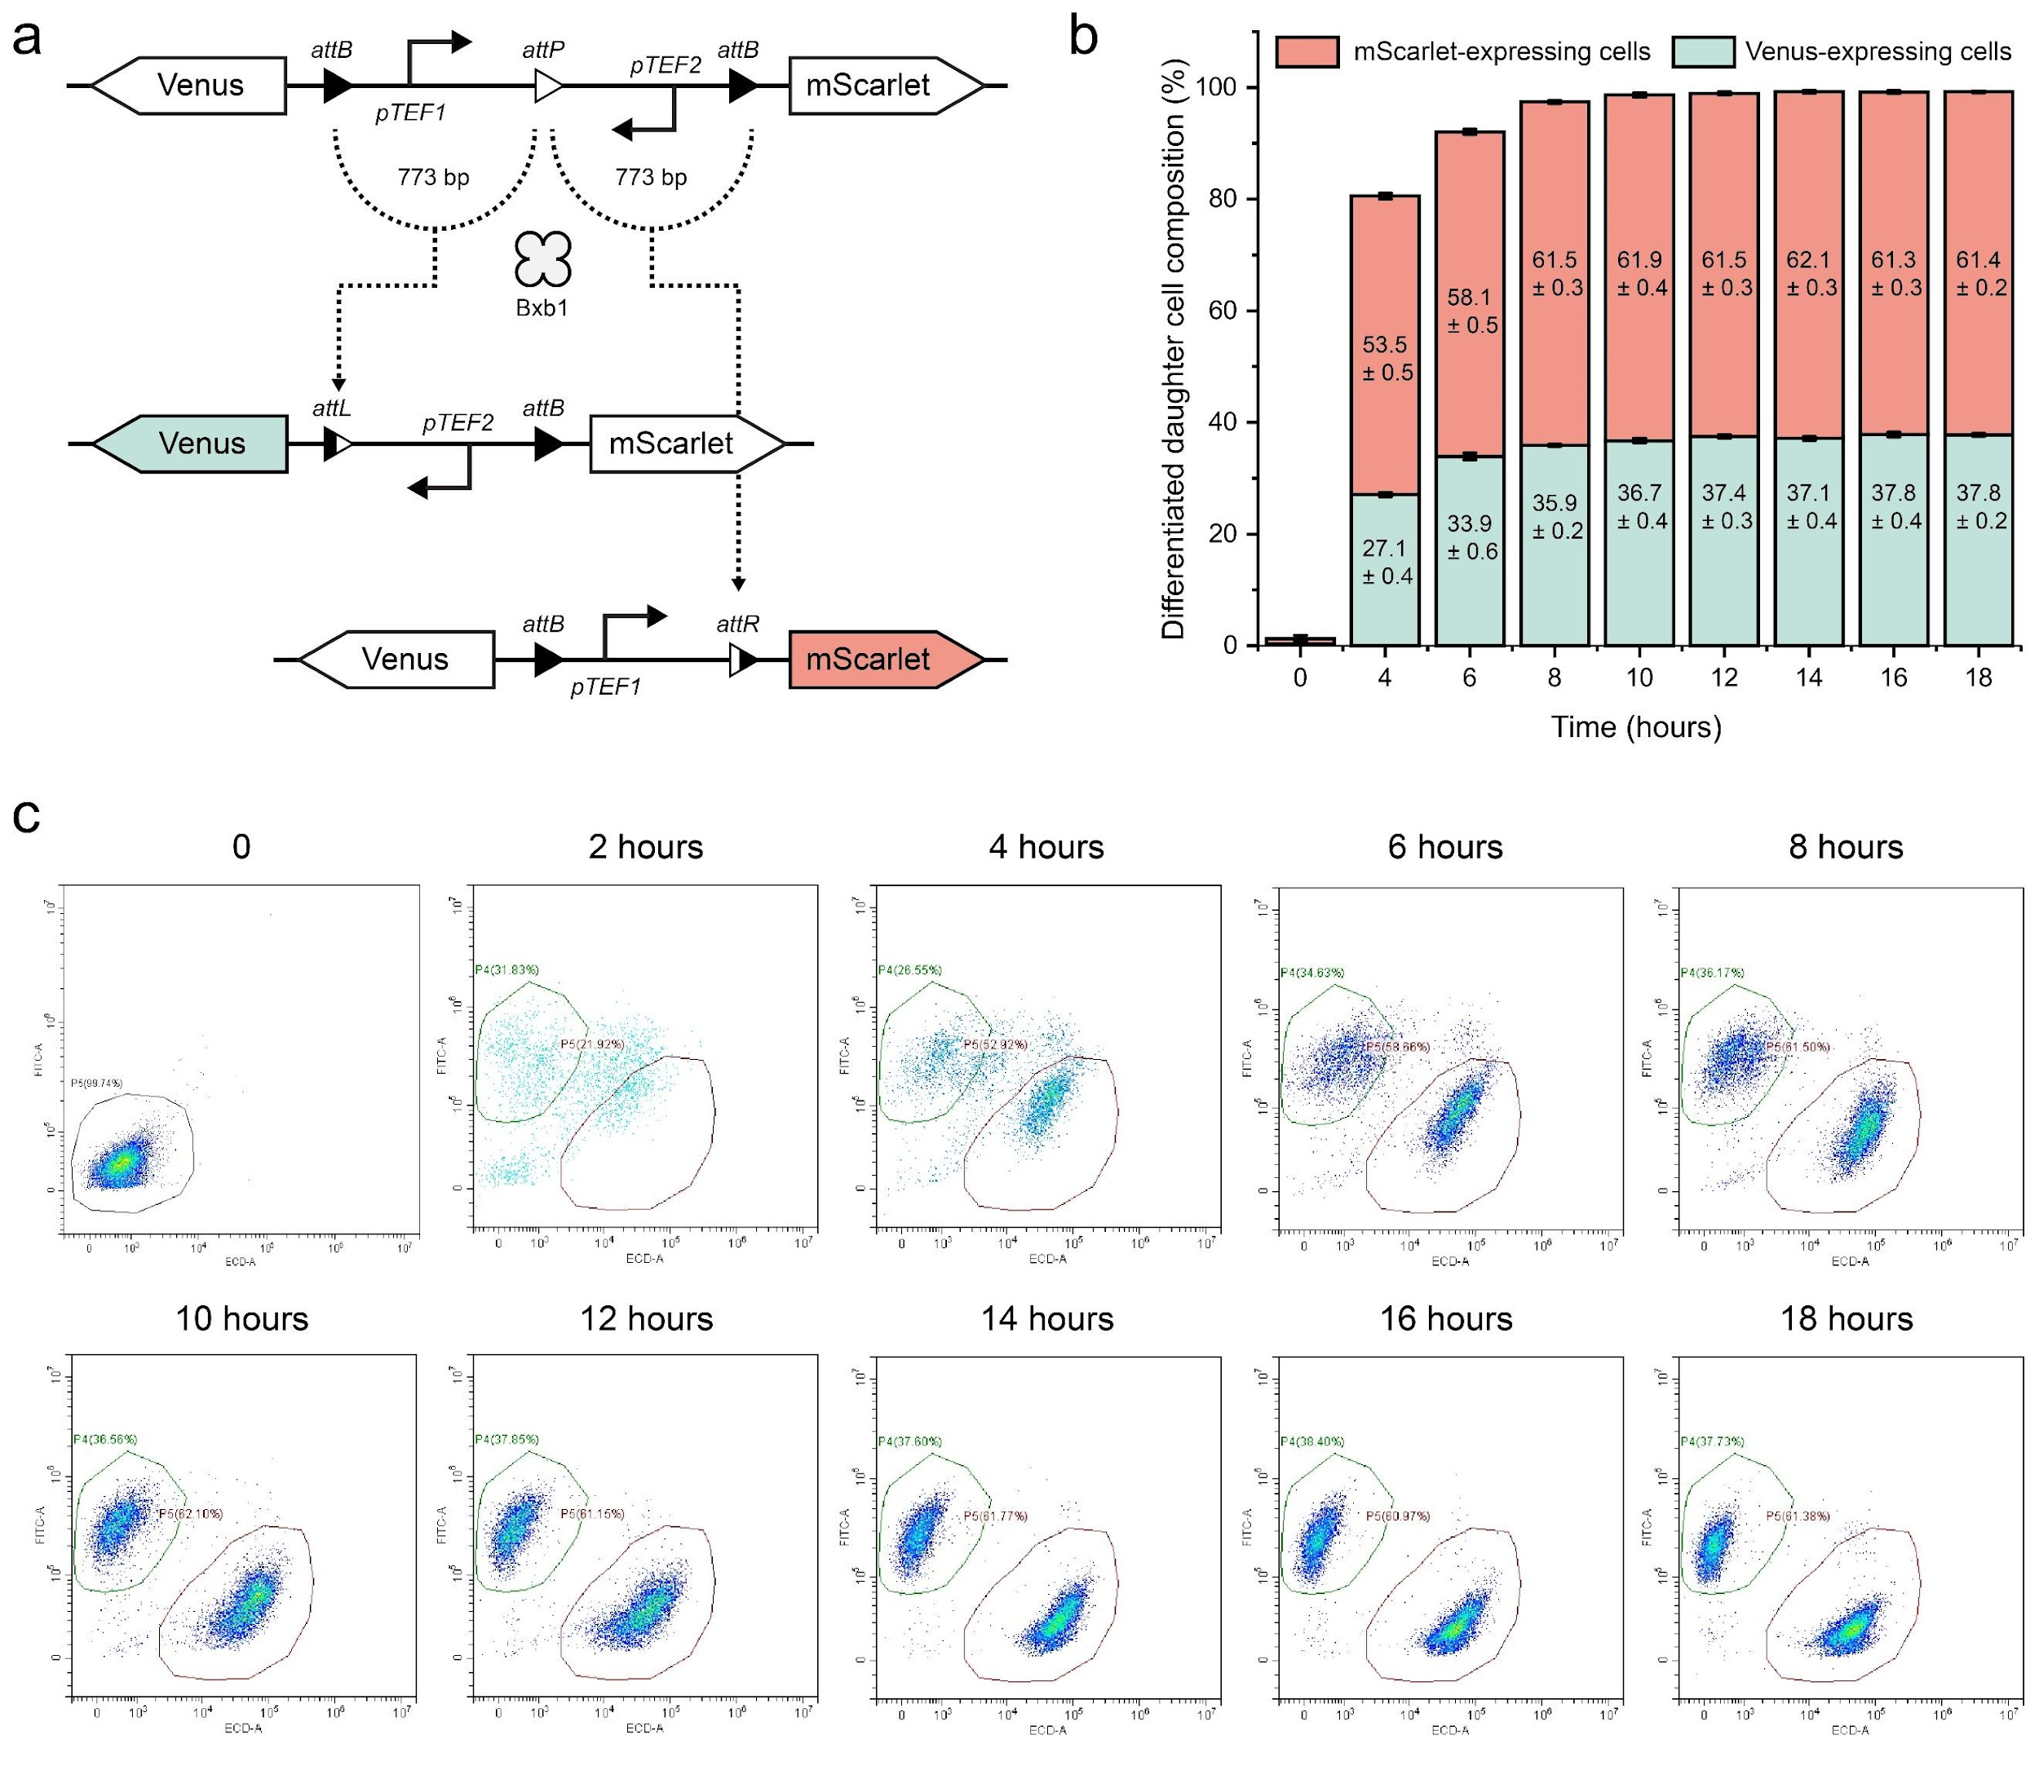
Fig. S5 | Stable yeast progeny cell populations are generated within 8-10 hours of Bxb1 induction. a. Gene circuit schematic. b. Statistical data showing progeny cell population dynamics over 18 hours with a final aTc inducer concentration of 1 mM (n = 8, mean ± SD). c. Flow cytometry was data collected at 2-hour intervals.

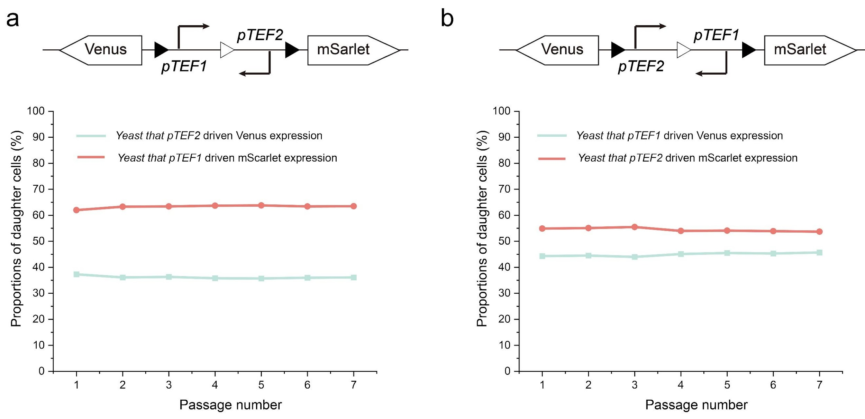
Fig. S6 | Stability of progeny cell populations in microbial consortia. Stability progeny ratios were maintained over multiple generations of co-culture: a. Red fluorescent yeast (63%) and green fluorescent yeast (37%) remained consistent over seven passages. b. Red (55%) and green (45%) fluorescent yeast showed stable ratios over seven days. Each experiment was repeated in triplicate.

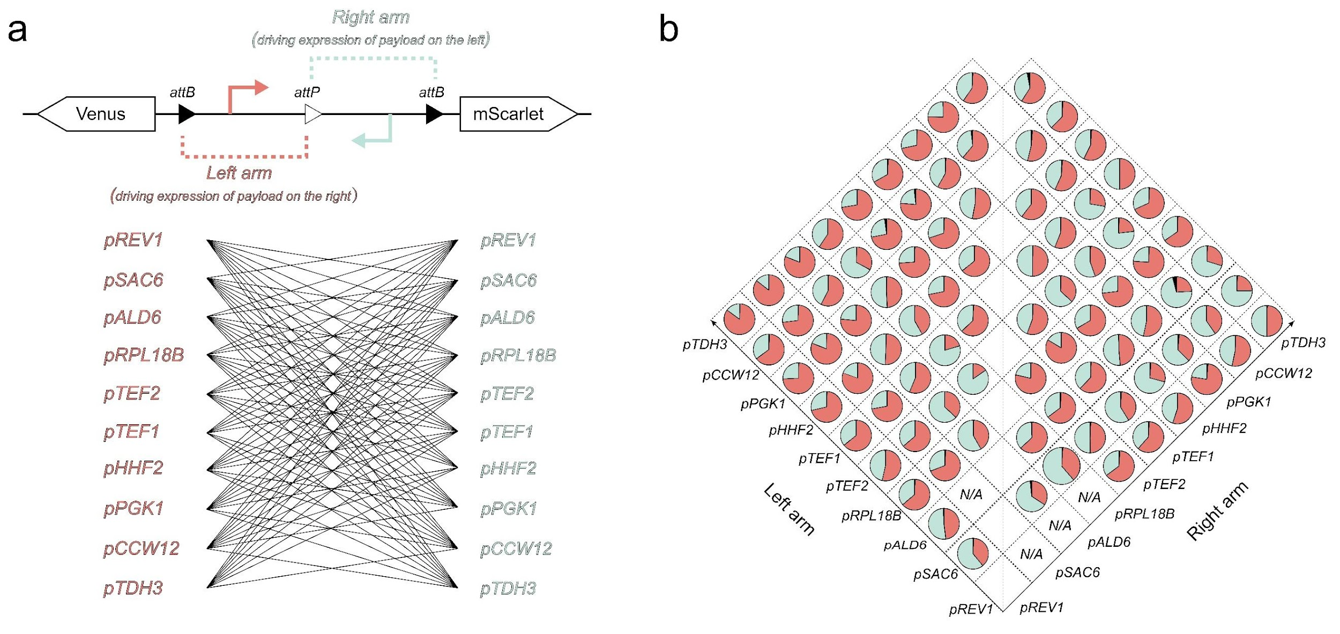
Fig. S7 | Effects of DNA sequences between att sites on branching device performance. a. Ten different yeast constitutive promoters, each 773 bp and varying in transcriptional strength, were integrated into both circuit arms, generating 90 unique gene circuits. b. Progeny proportions from these circuits were quantified, with "N/A" indicating that could not be statistically quantified through flow cytometry. Promoter sequences are provided in Table. S4.

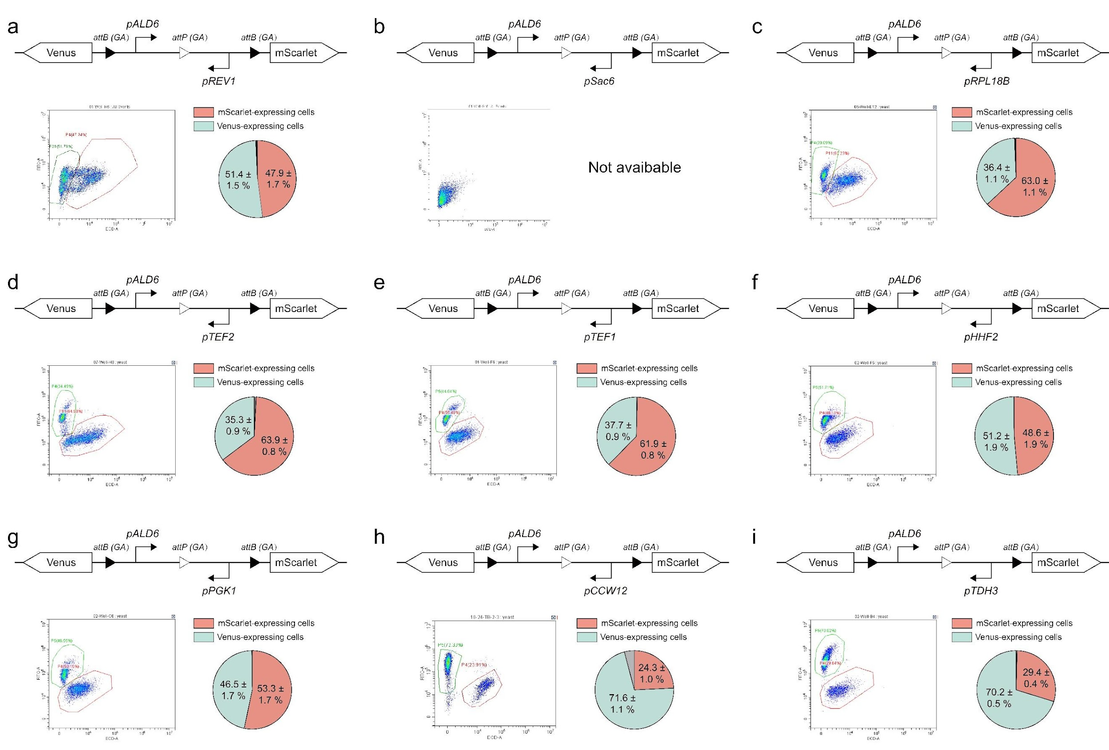
Fig. S8 | Circuit design with a fixed pALD6 promoter on the left arm and varying right arms. Each panel shows the gene circuit design, flow cytometry results, and data on progeny cell distributions. All experiments were performed in triplicate with five samples per iteration.

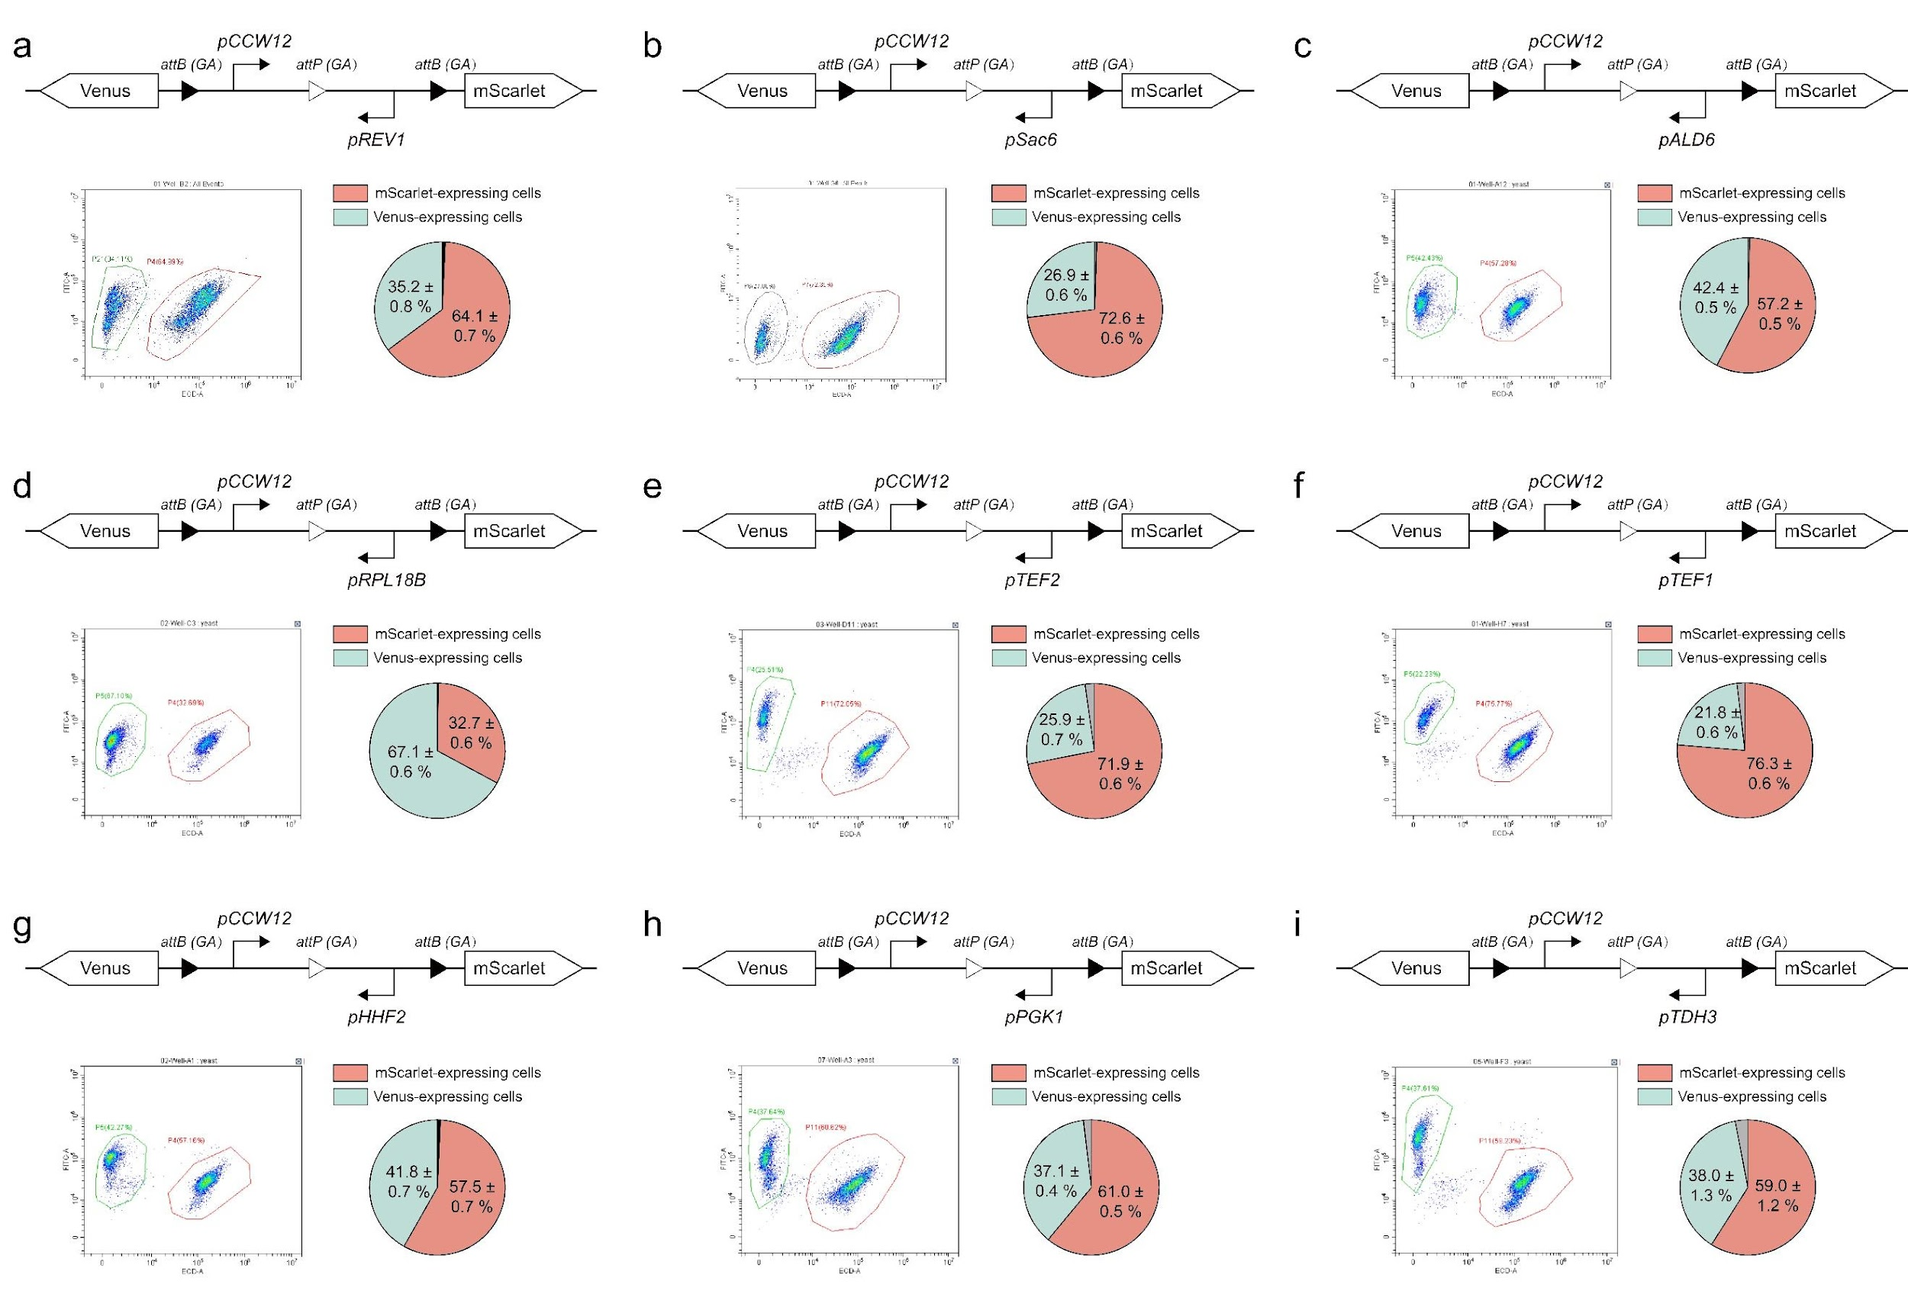
Fig. S9 | Circuit design with a fixed pCCW12 promoter on the left arm and varying right arms. Each panel shows the gene circuit design, flow cytometry results, and data on progeny cell distributions. All experiments were performed in triplicate with five samples per iteration.

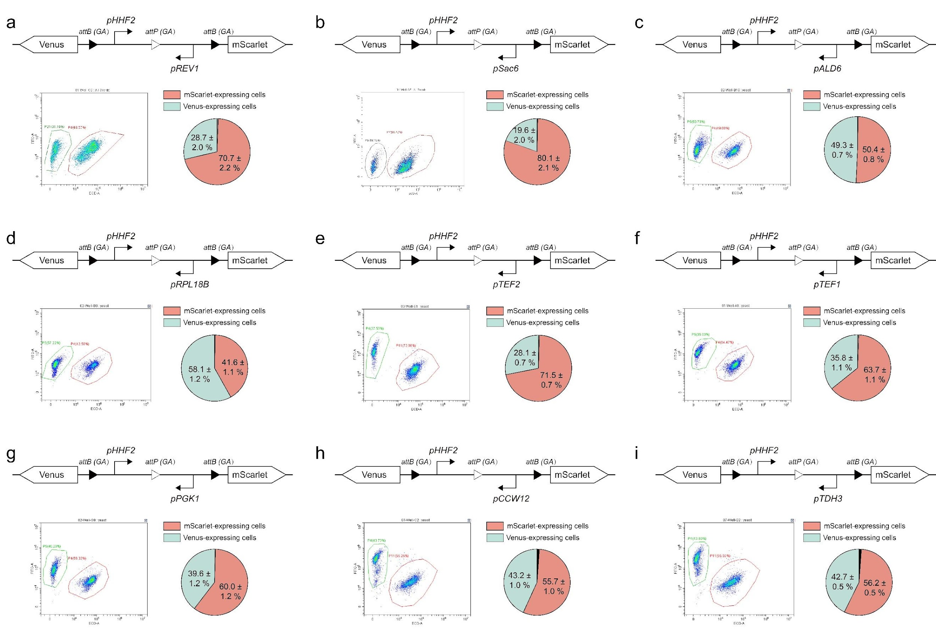
Fig. S10 | Circuit design with a fixed pHHF2 promoter on the left arm and varying right arms. Each panel shows the gene circuit design, flow cytometry results, and data on progeny cell distributions. All experiments were performed in triplicate with five samples per iteration.

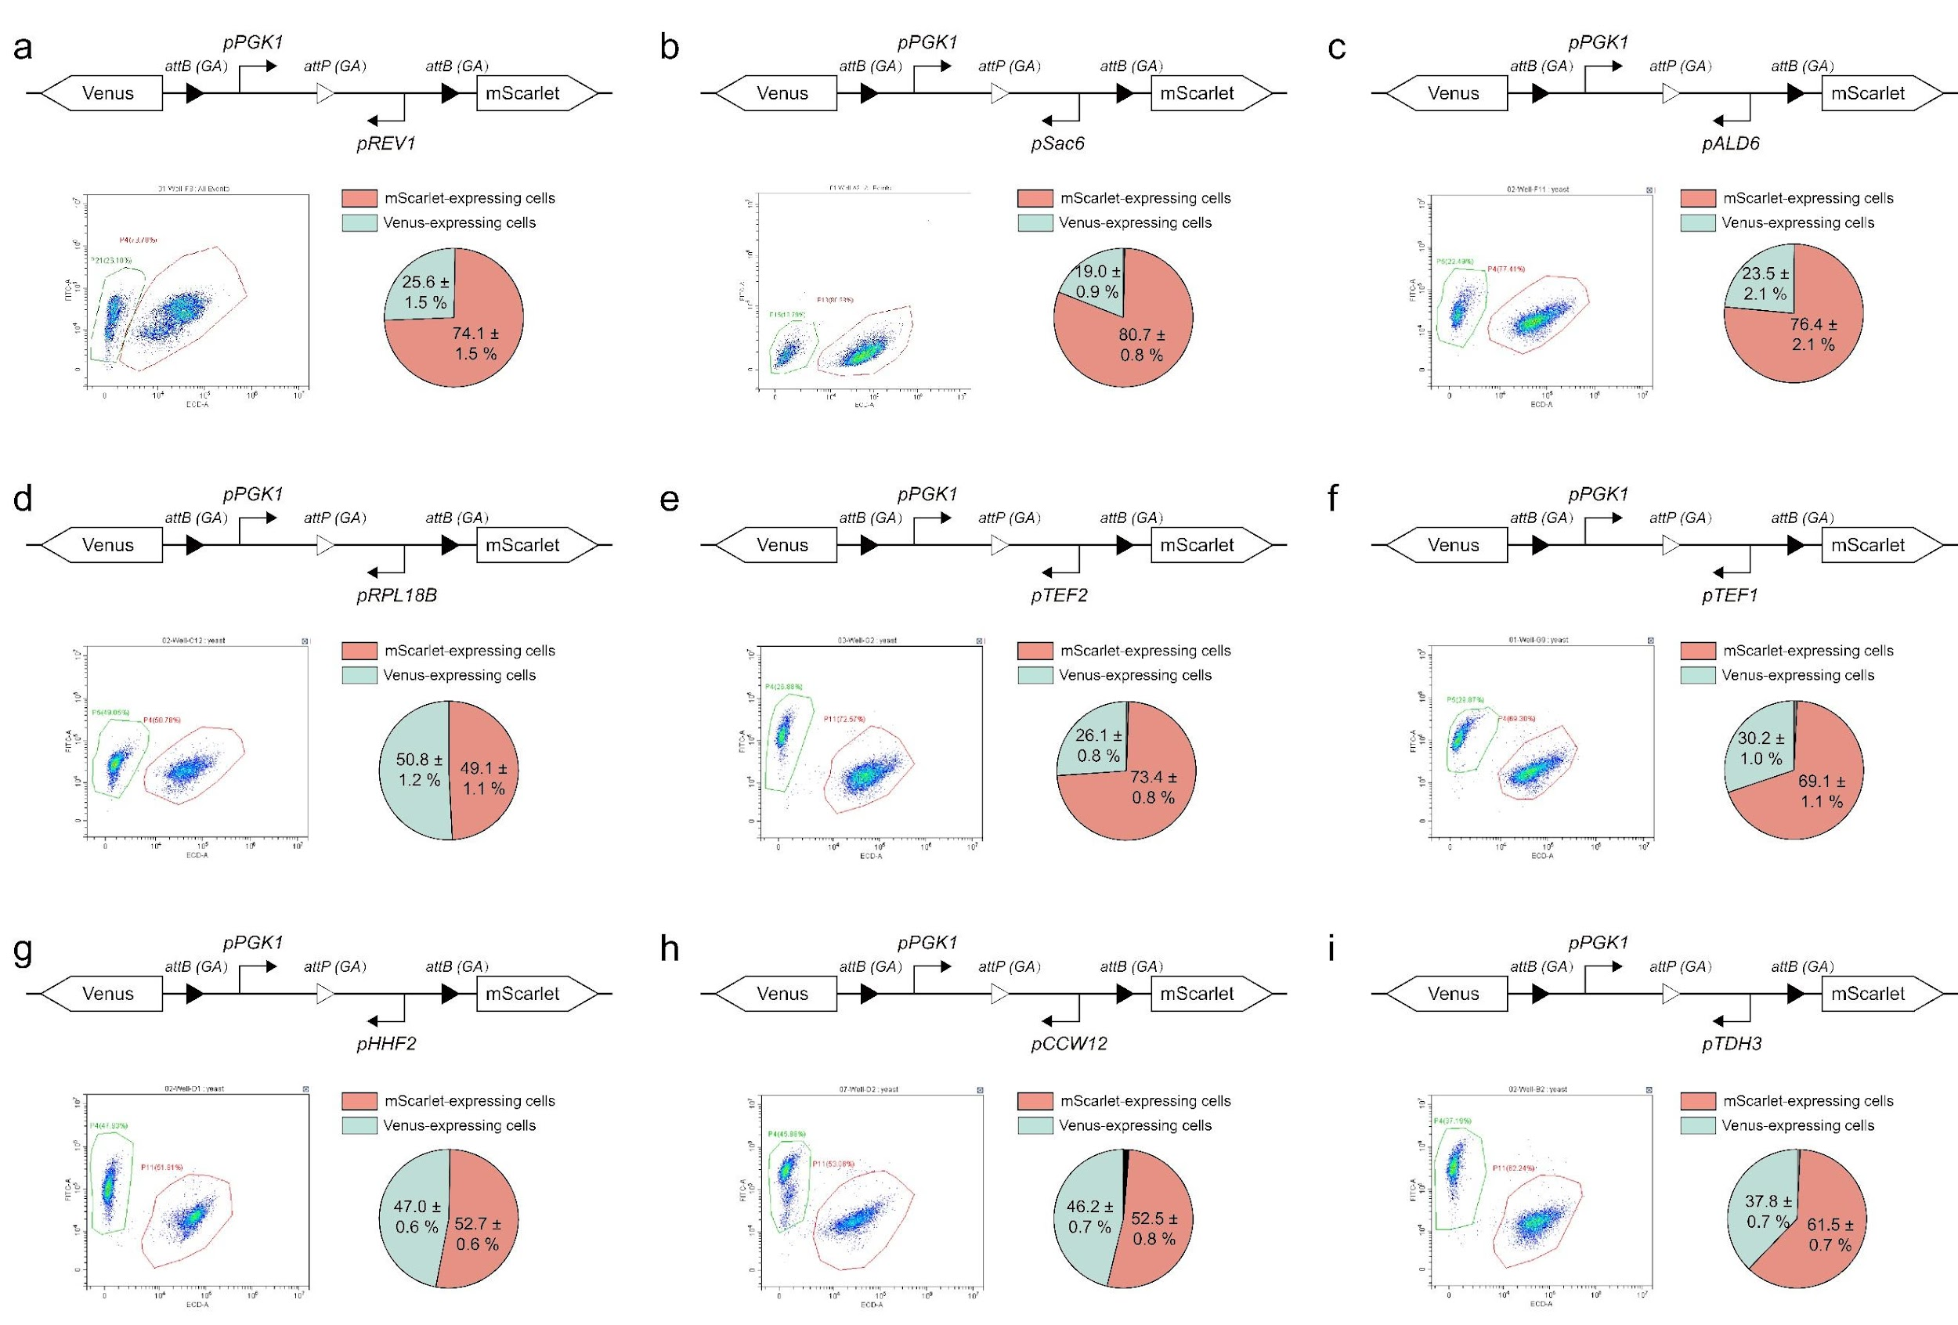
Fig. S11 | Circuit design with a fixed pPGK1 promoter on the left arm and varying right arms. Each panel shows the gene circuit design, flow cytometry results, and data on progeny cell distributions. All experiments were performed in triplicate with five samples per iteration.

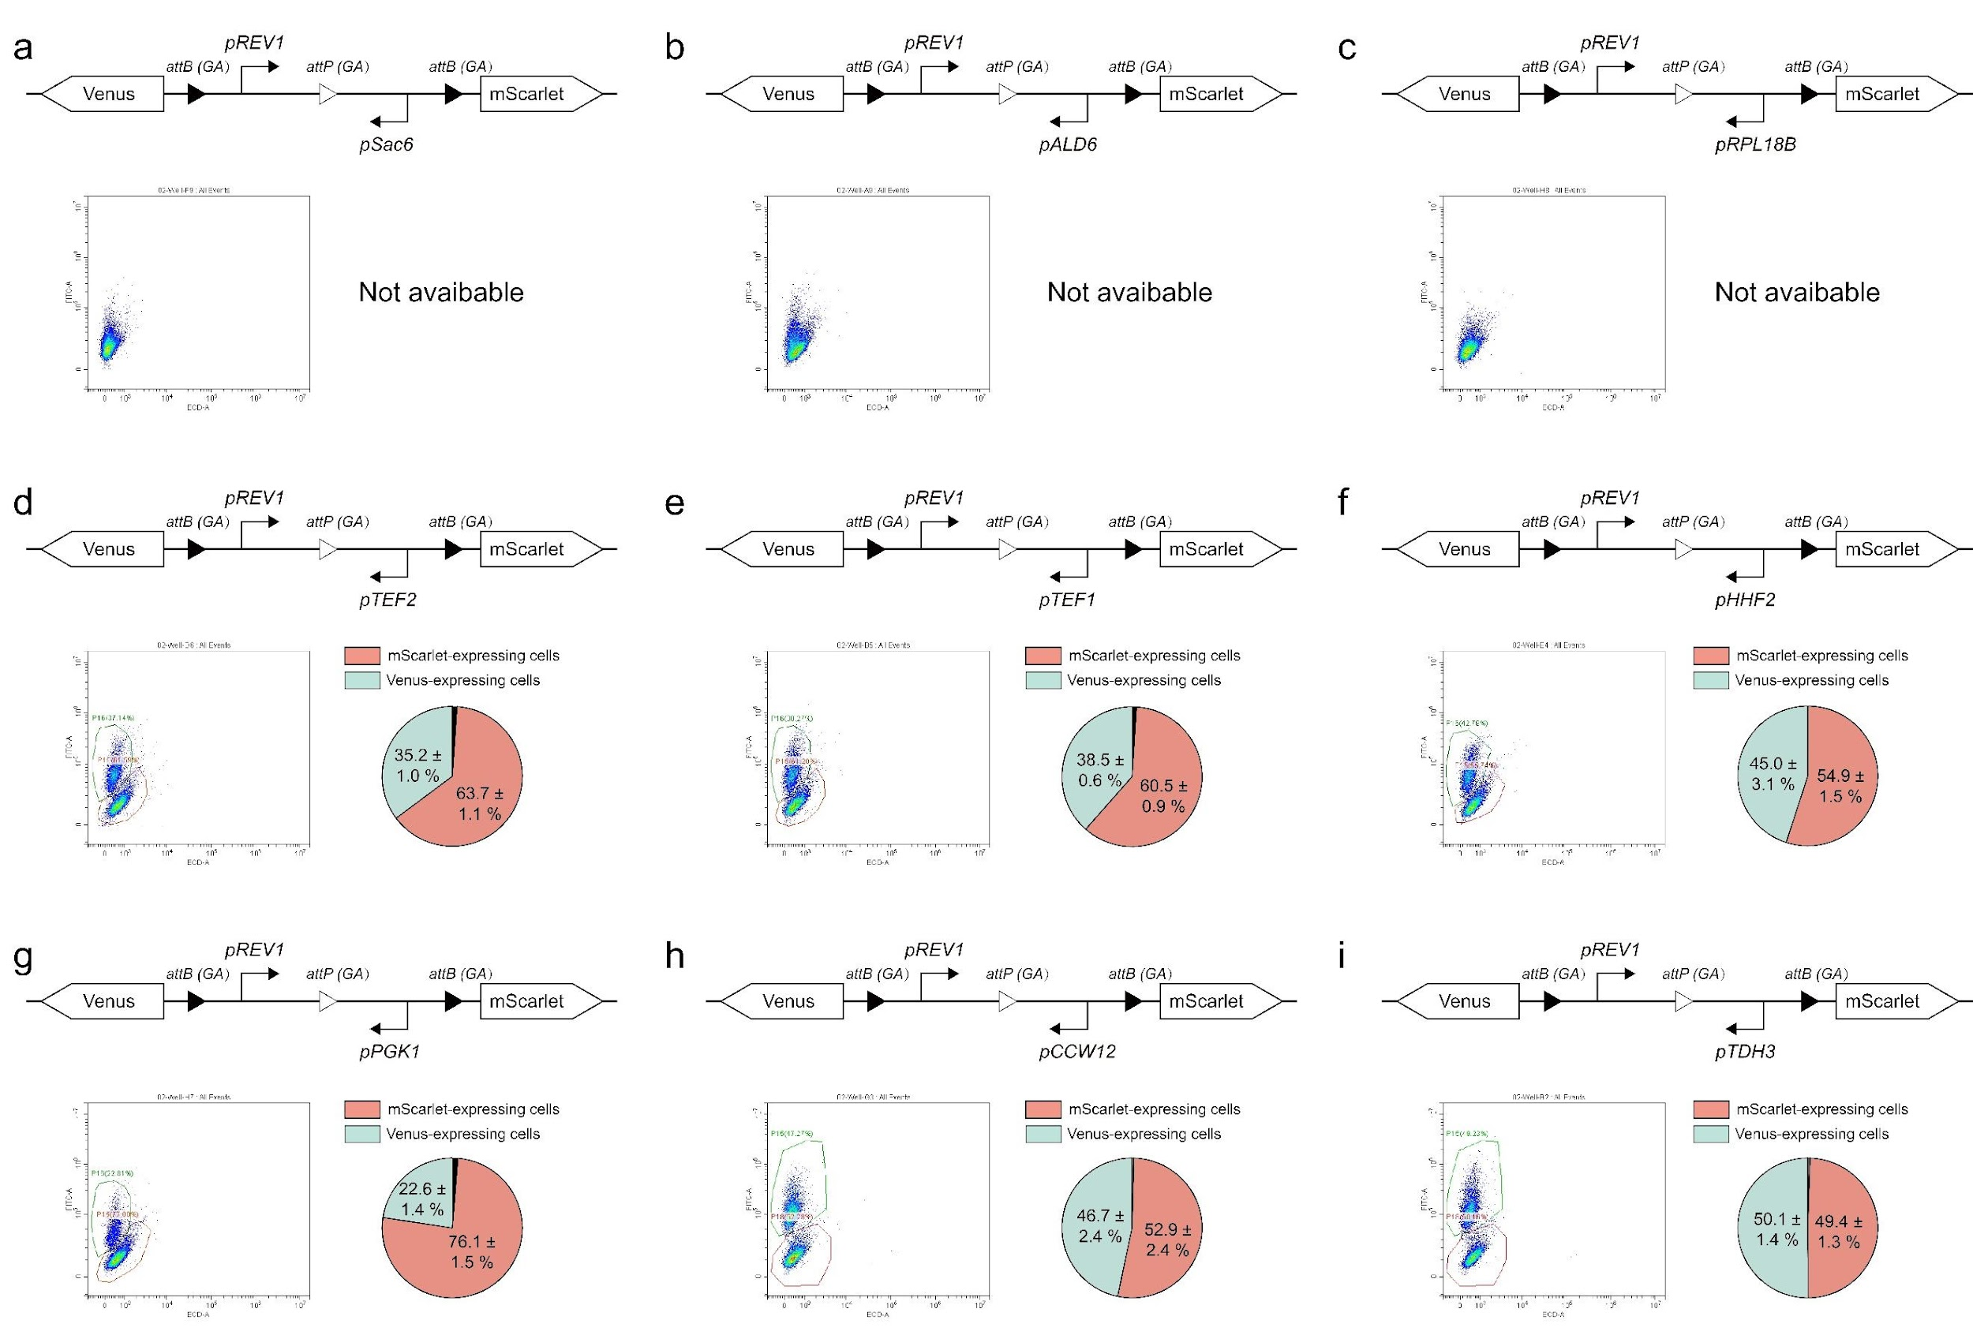
Fig. S12 | Circuit design with a fixed pREV1 promoter on the left arm and varying right arms. Each panel shows the gene circuit design, flow cytometry results, and data on progeny cell distributions. All experiments were performed in triplicate with five samples per iteration.

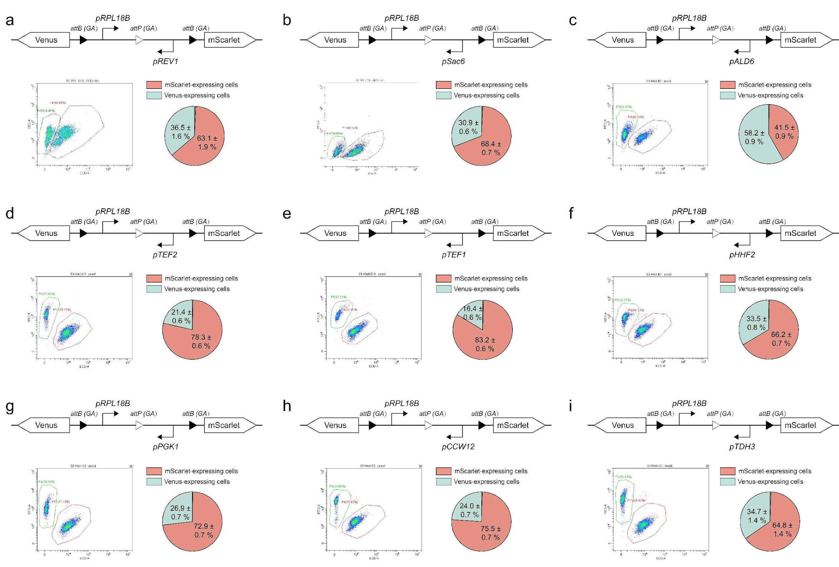
Fig. S13 | Circuit design with a fixed pRPL18B promoter on the left arm and varying right arms. Each panel shows the gene circuit design, flow cytometry results, and data on progeny cell distributions. All experiments were performed in triplicate with five samples per iteration.

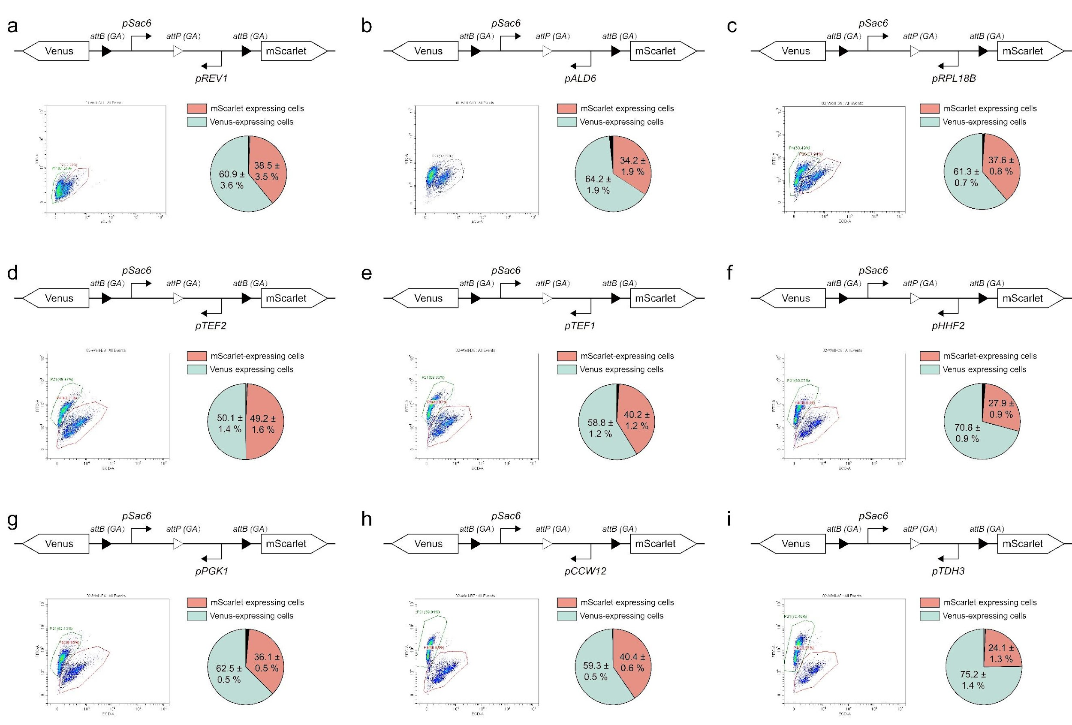
Fig. S14 | Circuit design with a fixed pSac6 promoter on the left arm and varying right arms. Each panel shows the gene circuit design, flow cytometry results, and data on progeny cell distributions. All experiments were performed in triplicate with five samples per iteration.

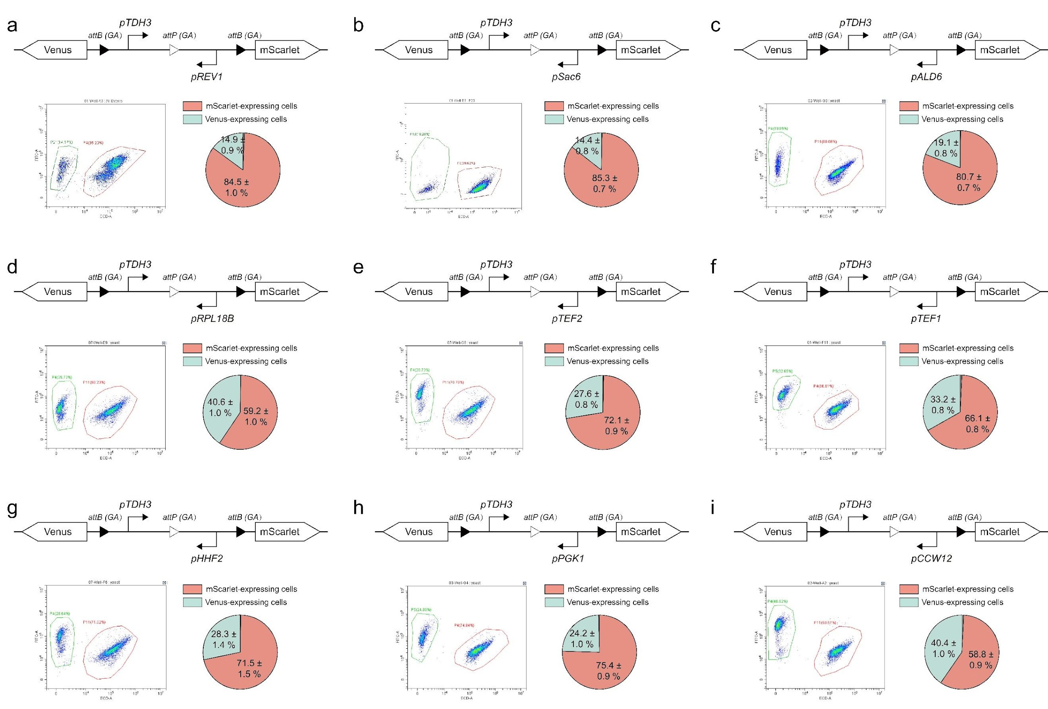
Fig. S15 | Circuit design with a fixed pTDH3 promoter on the left arm and varying right arms. Each panel shows the gene circuit design, flow cytometry results, and data on progeny cell distributions. All experiments were performed in triplicate with five samples per iteration.

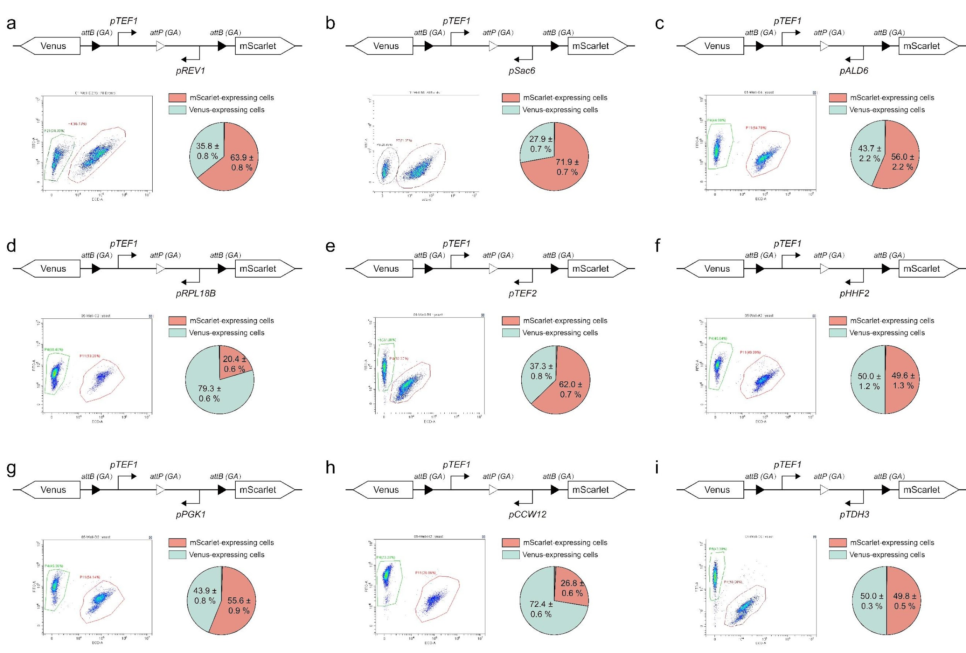
Fig. S16 | Circuit design with a fixed pTEF1 promoter on the left arm and varying right arms. Each panel shows the gene circuit design, flow cytometry results, and data on progeny cell distributions. All experiments were performed in triplicate with five samples per iteration.

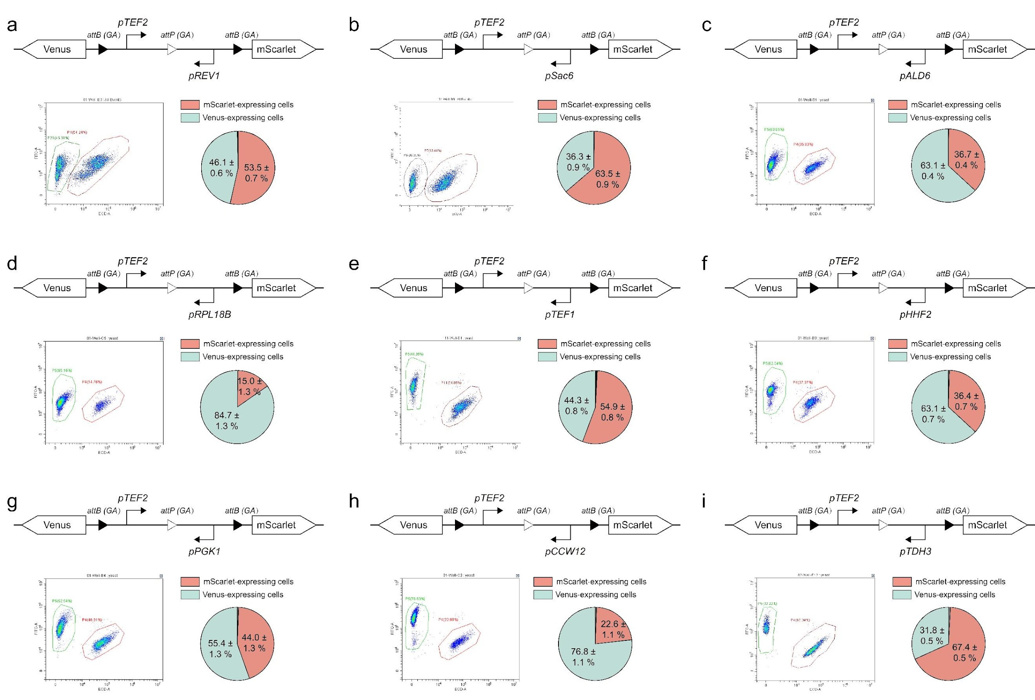
Fig. S17 | Circuit design with a fixed pTEF2 promoter on the left arm and varying right arms. Each panel shows the gene circuit design, flow cytometry results, and data on progeny cell distributions. All experiments were performed in triplicate with five samples per iteration.

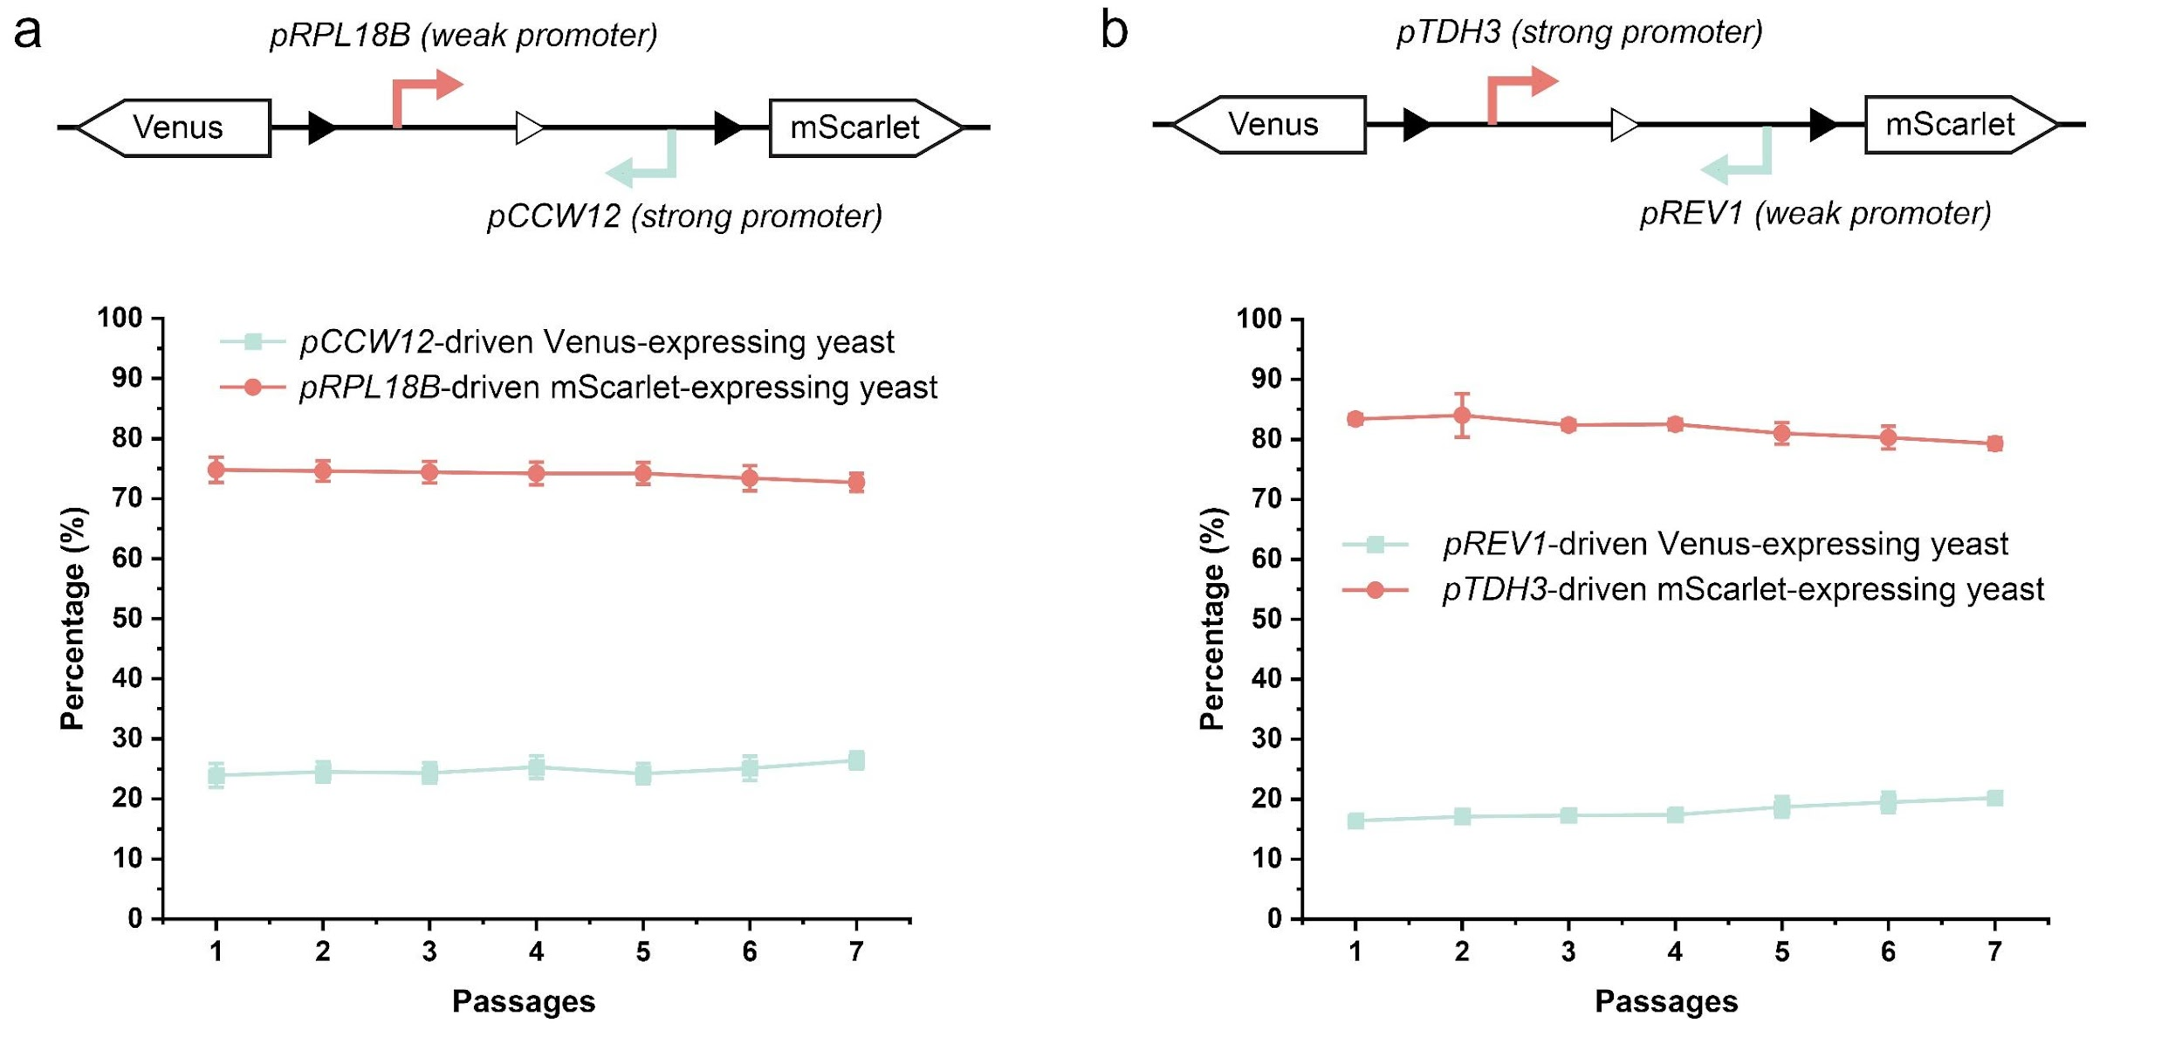
Fig. S18 | Fluorescent protein expression from strong or weak promoters does not significantly affect the composition of yeast consortia over seven passages. Results represent mean ± SD from n = 4 independent experiments.

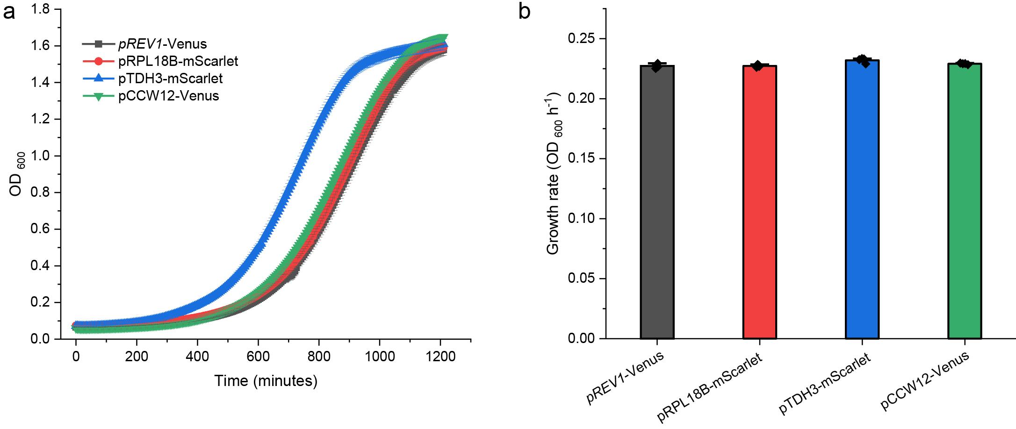
Fig. S19 | Growth rate comparison between yeast expressing fluorescent proteins from weak and strong promoters. a. Representative growth curves of 4 progeny cells generated from the circuit shown in Figure S18. b. All four progeny cells exhibited similar growth rates of approximately 0.23 OD₆₀₀ h⁻¹. Results represent the mean ± SD from n = 4 independent experiments.

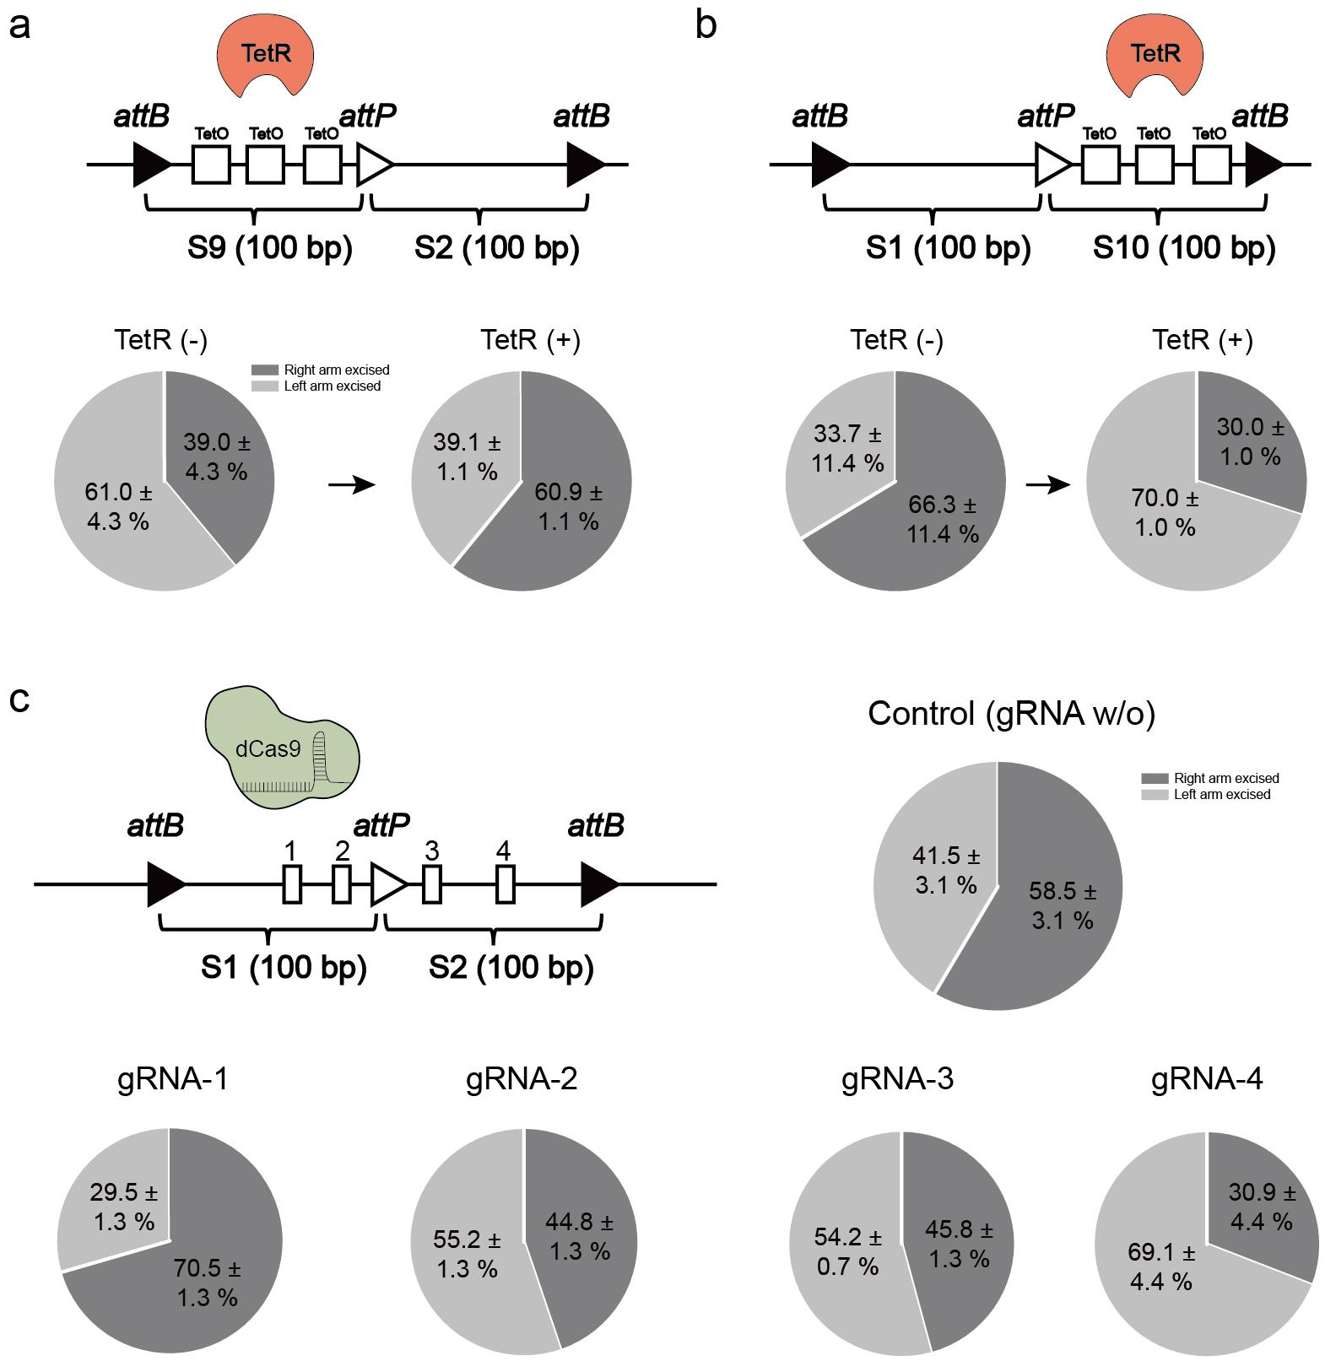
Fig. S20 | Effects of steric hindrance on Bxb1 recombinase activity assessed using NGS. a. Integration of three TetO operator sequences into the left arm of the branching device resulted in a Bxb1 excision probability of 61.0 ± 4.3% without TetR repressor. When TetR was present, binding TetO sequences reduced the excision probability to 39.1 ± 1.1%. b. The inclusion of three TetO sites between attP and attB also affected recombinase activity. c. The impact of dCas9 binding on Bxb1 activity depended on the positioning of the gRNA guiding dCas9 binding. All experiments were repeated three times. The sequences of S1-S10 are listed in Table. S4.

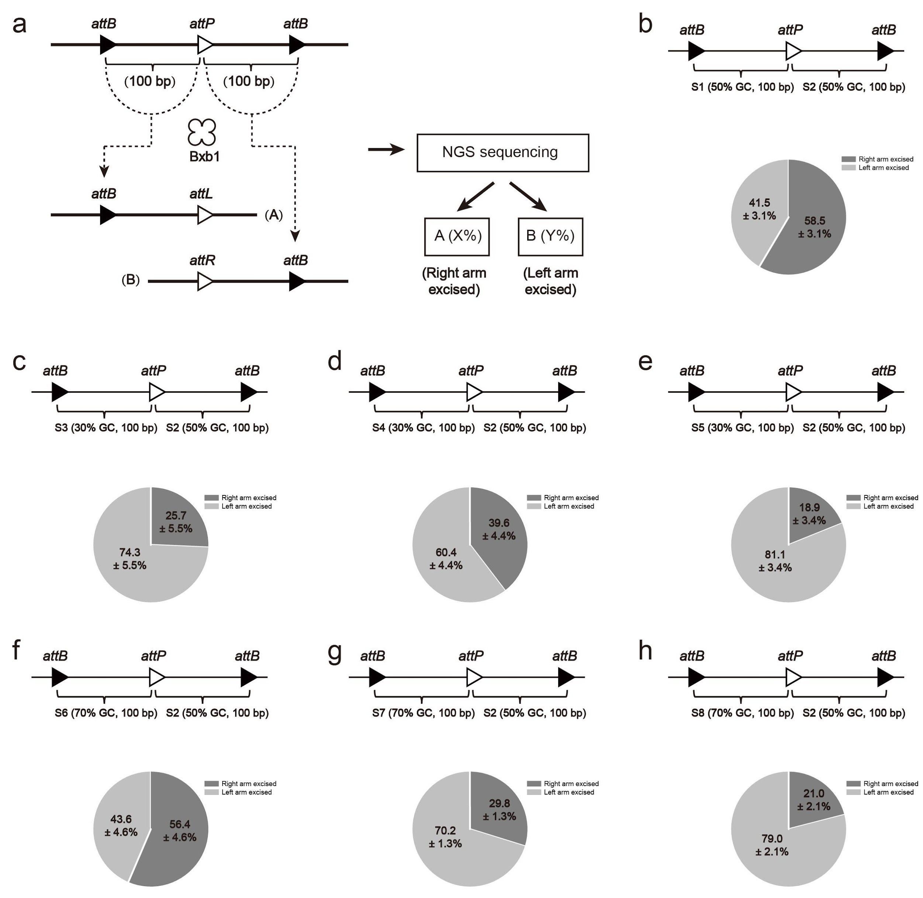
Fig. S21 | Characterization of branching circuits via NGS. a. Schematic of circuit design featuring two 100-bp random DNA sequences between attB-attP and attP-attB sites. NGS was used to analyze progeny distributions following cellular differentiation. b-h. Eight 100-bp sequences (S1 to S8) with varying GC content were incorporated into the circuit design: S1 and S2 (50% GC), S3-S5 (30% GC), and S6-S8 (70% GC). GC content influenced Bxb1 catalytic preferences, resulting in varied progeny distributions. This underscores the critical role of DNA sequences in modulating Bxb1 activity. All experiments were performed in triplicate. The sequences of S1-S10 are listed in Table. S4.

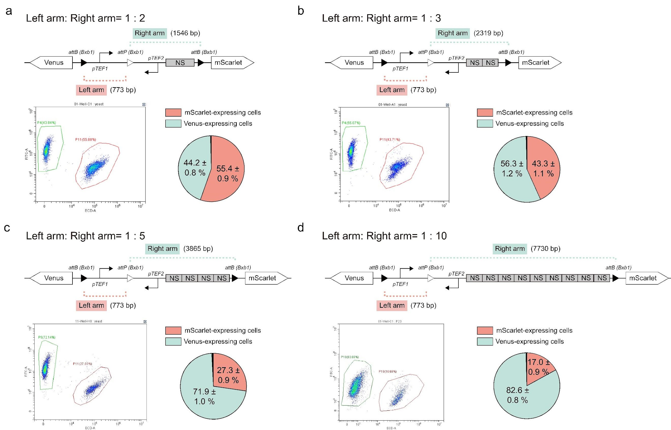
Fig. S22 | Quantitative characterization of progeny differentiation as DNA length ratios between the left and right arms of engineered branching devices progressively shift from 1:2 to 1:10 (a-d). All experiments were conducted three times, with five samples tested per iteration.

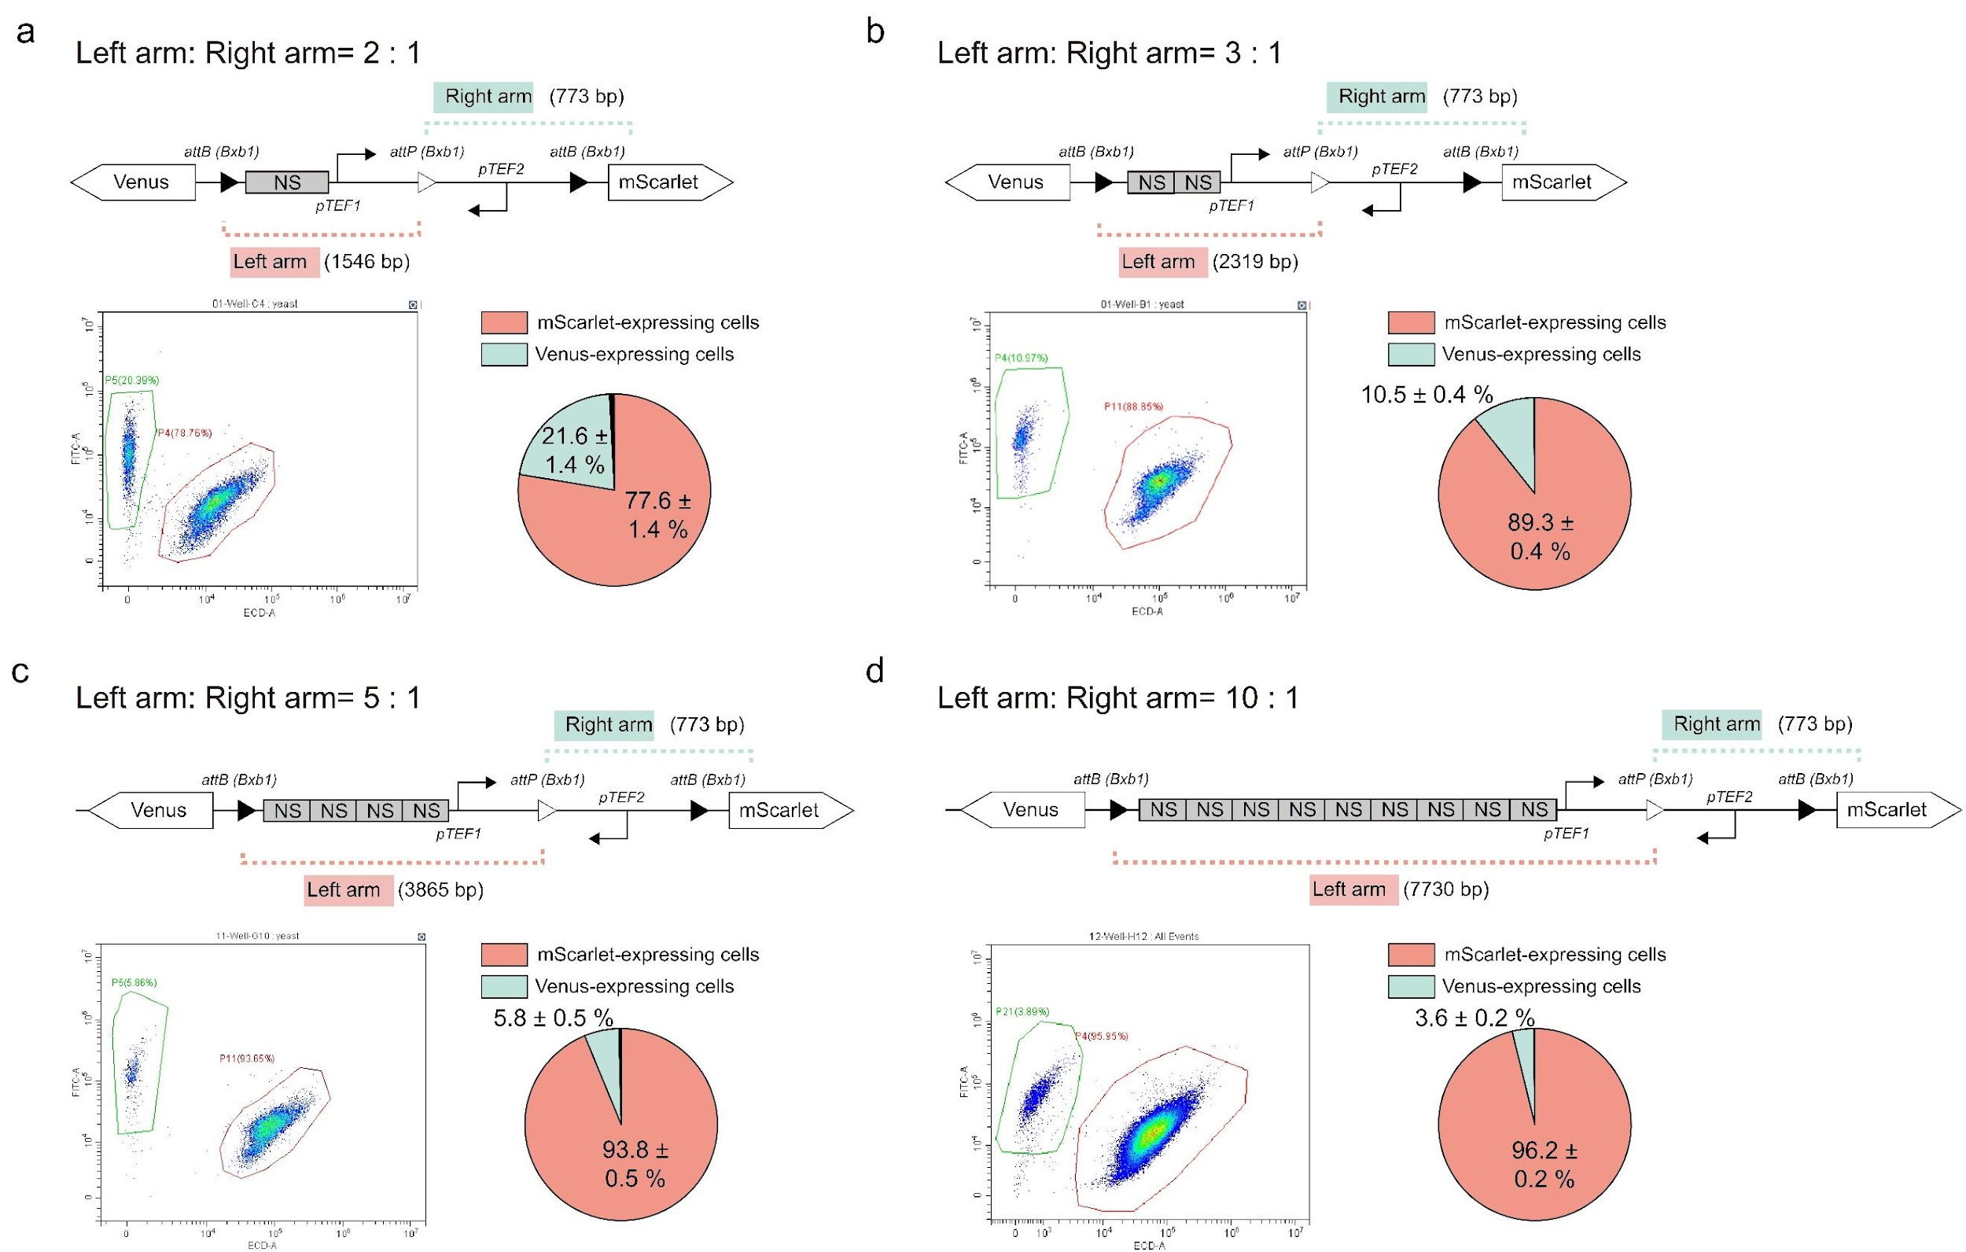
Fig. S23 | Quantitative characterization of progeny differentiation as DNA length ratios between the left and right arms of engineered branching devices progressively shift from 2:1 to 10:1 (a-d). All experiments were conducted three times, with five samples tested per iteration. The sequences of NS are listed in Table. S4.

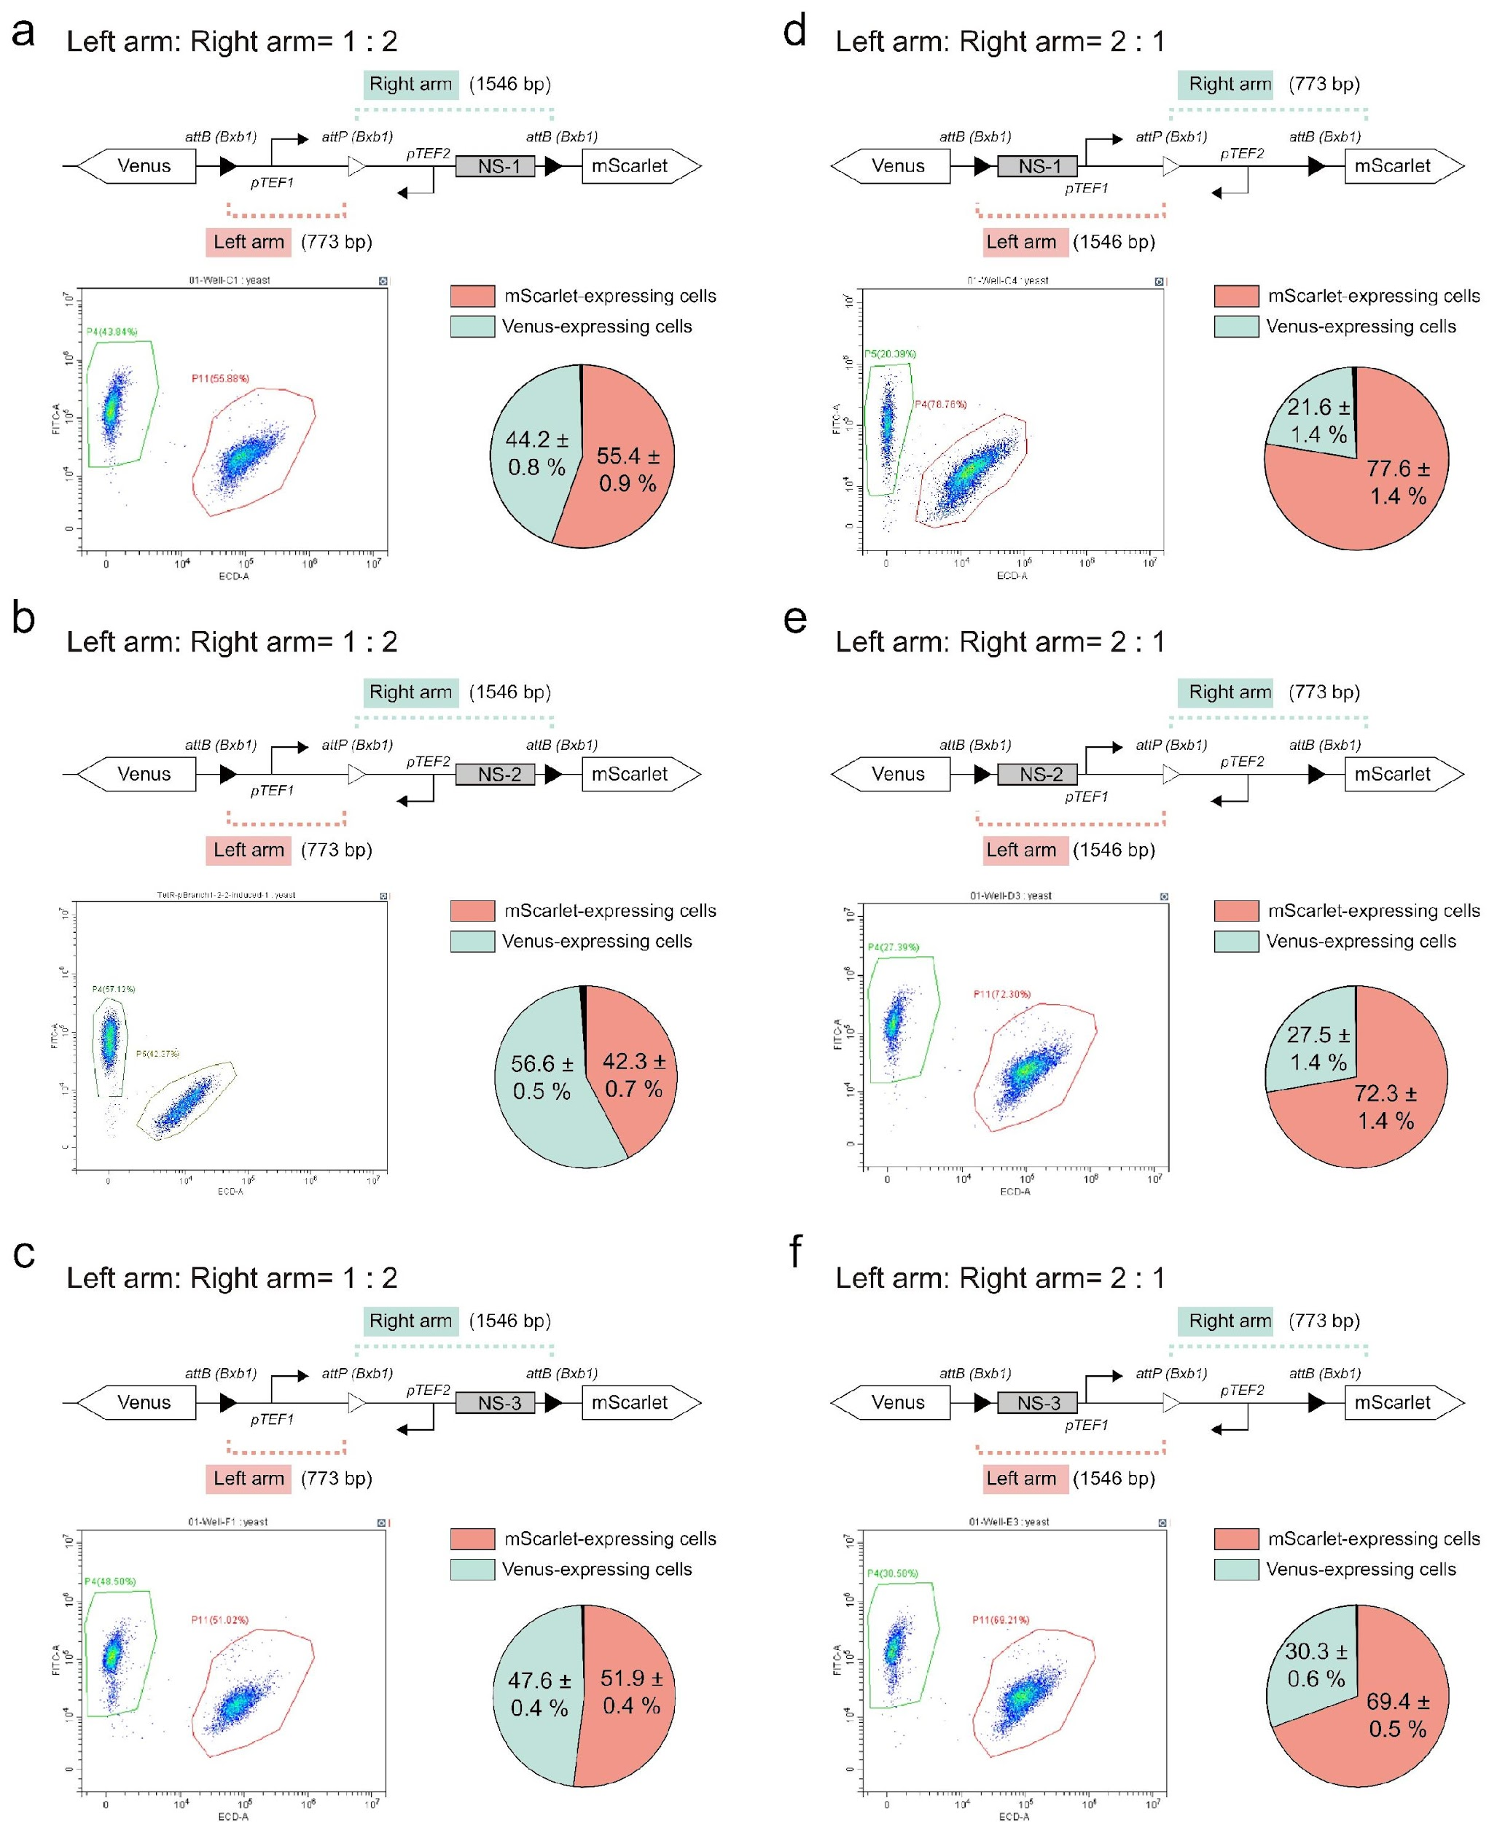
Fig. S24 | Quantitative analysis of progeny differentiation in yeast with varying DNA length ratios and nonsense sequences (NS). a-c. Quantitative analysis of yeast progeny differentiation with a 1:2 DNA length ratio between left and right arms, incorporating different 773-bp nonsense sequences (NS-1, NS-2, NS-3). d-f. Quantitative analysis of yeast progeny differentiation with a 2:1 DNA length ratio between the left and right arms. All experiments were performed in triplicate, with five samples per iteration.

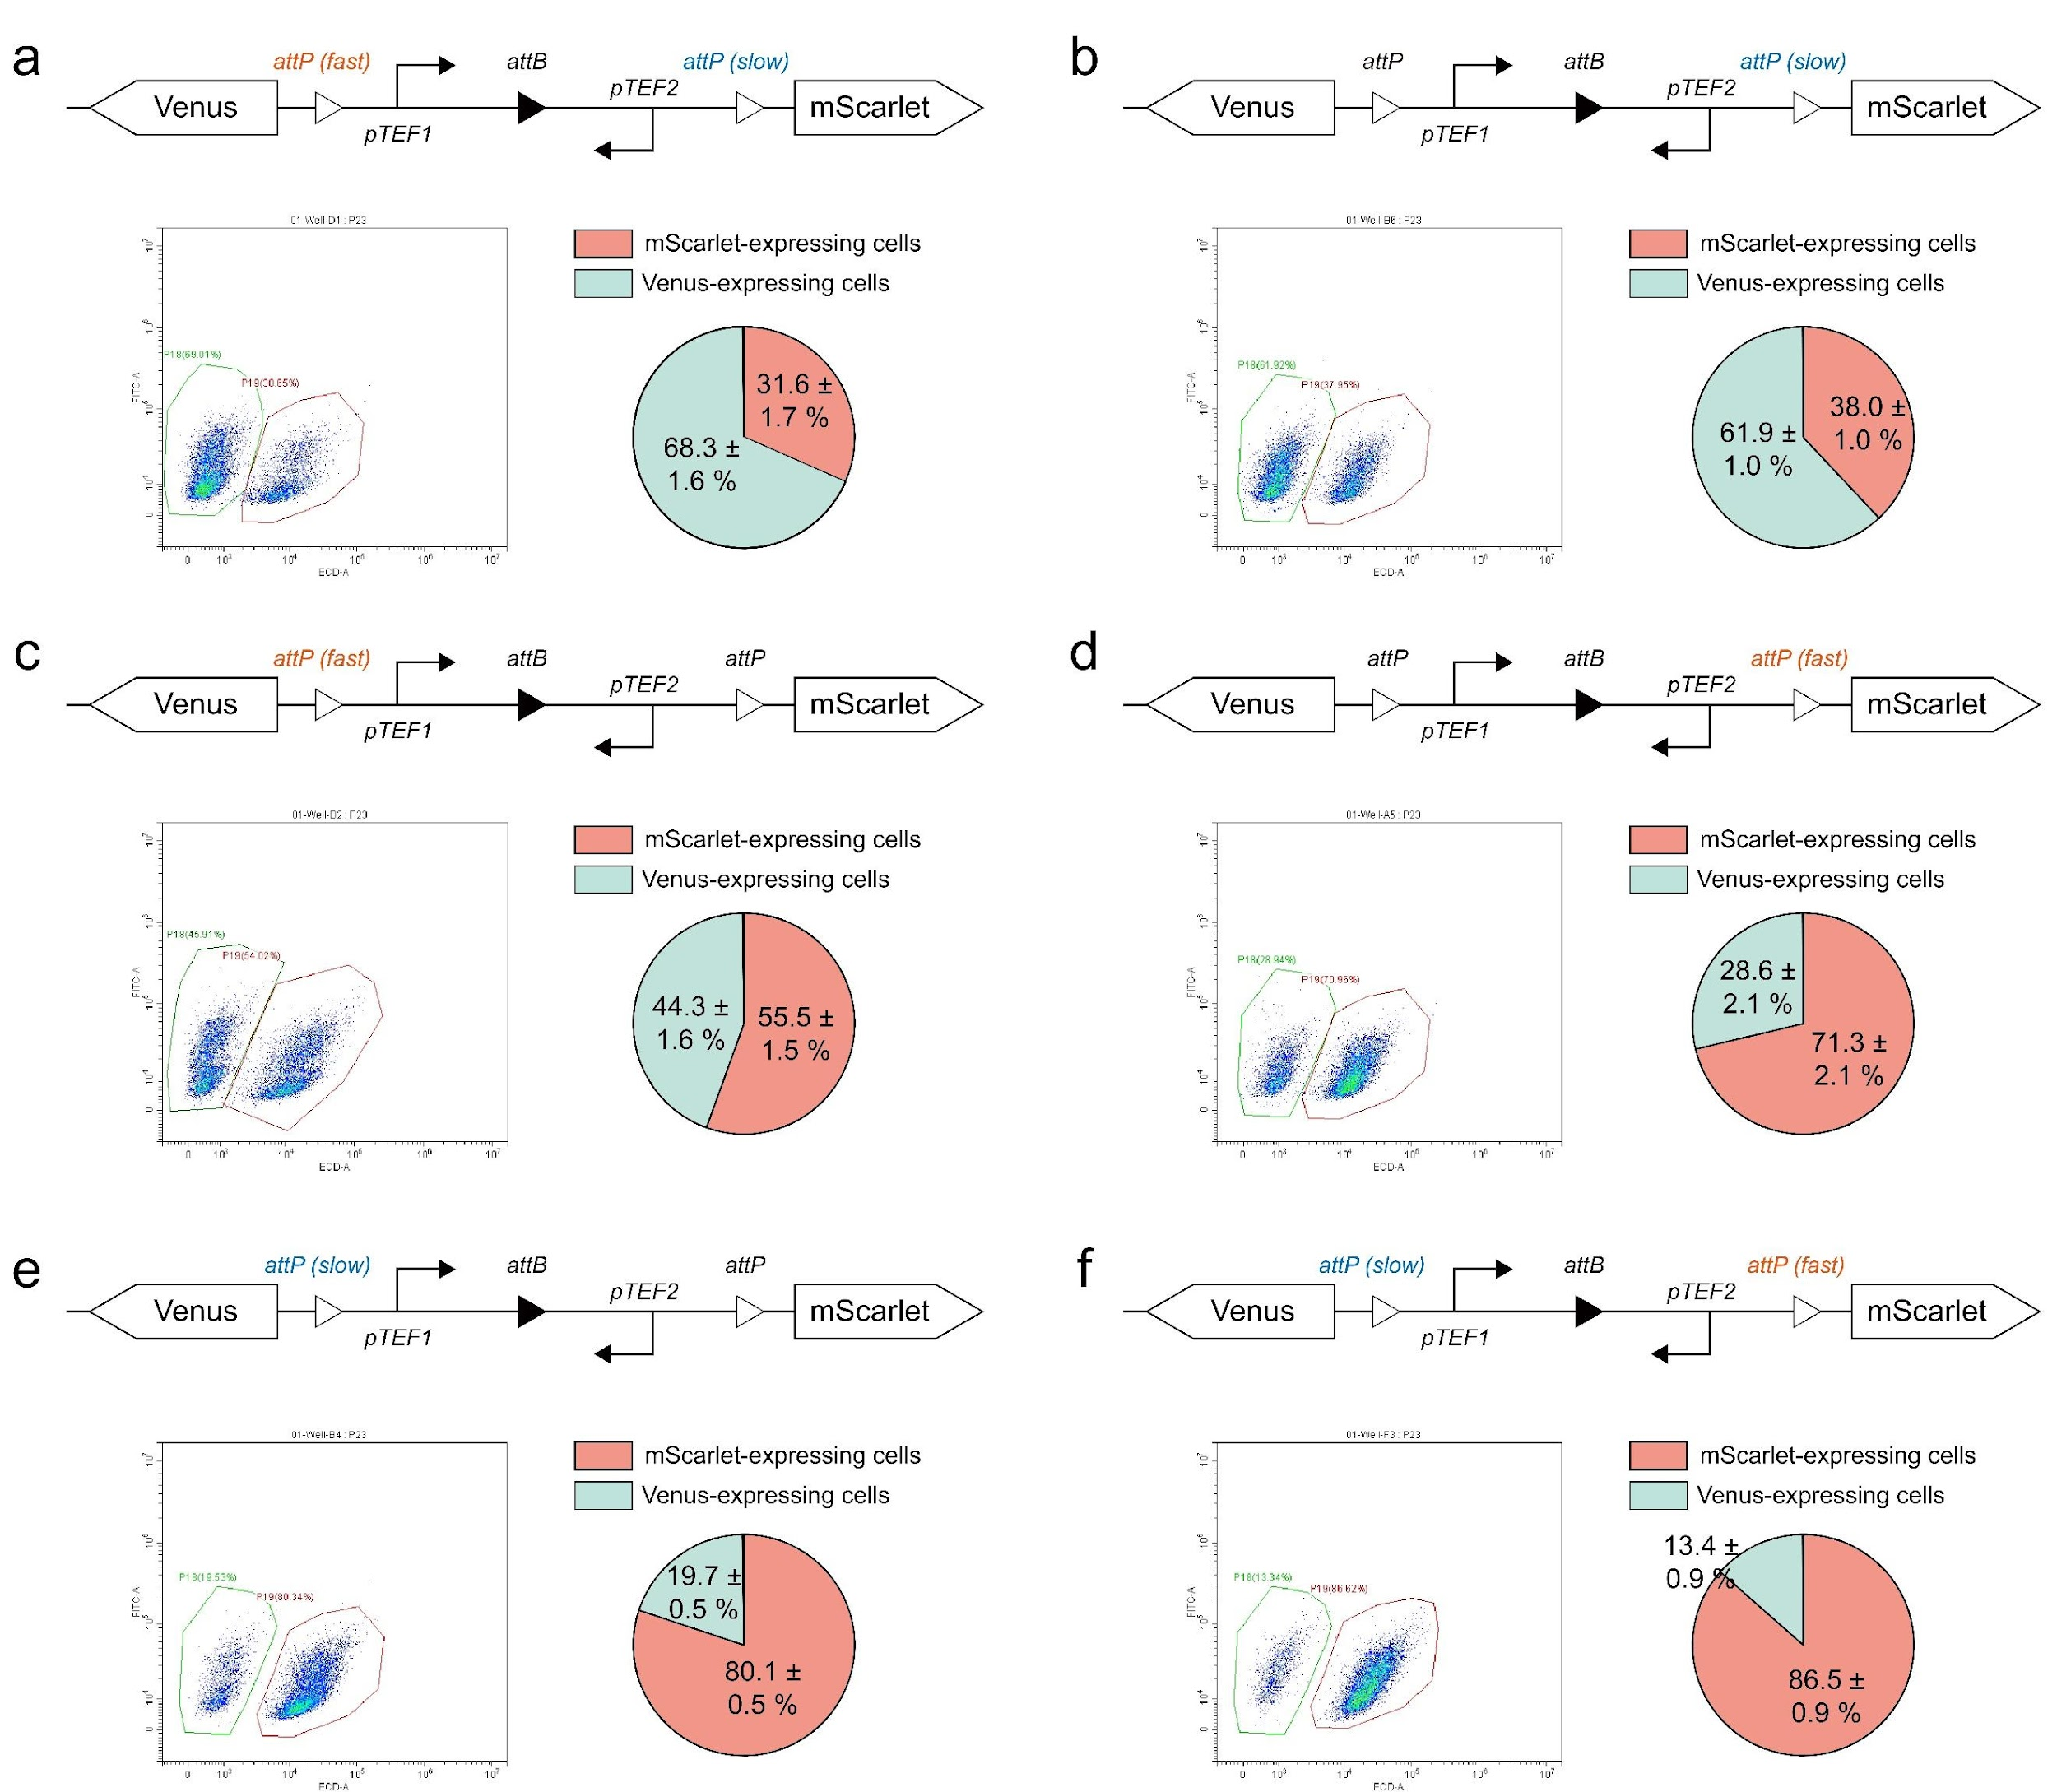
Fig. S25 | Tuning cellular differentiation using branching circuits with attP variants exhibiting predictable catalytic rates. a-f. Representative genetic circuits, flow cytometry data, and progeny distribution statistics. All experiments were repeated three times, with five samples per iteration.

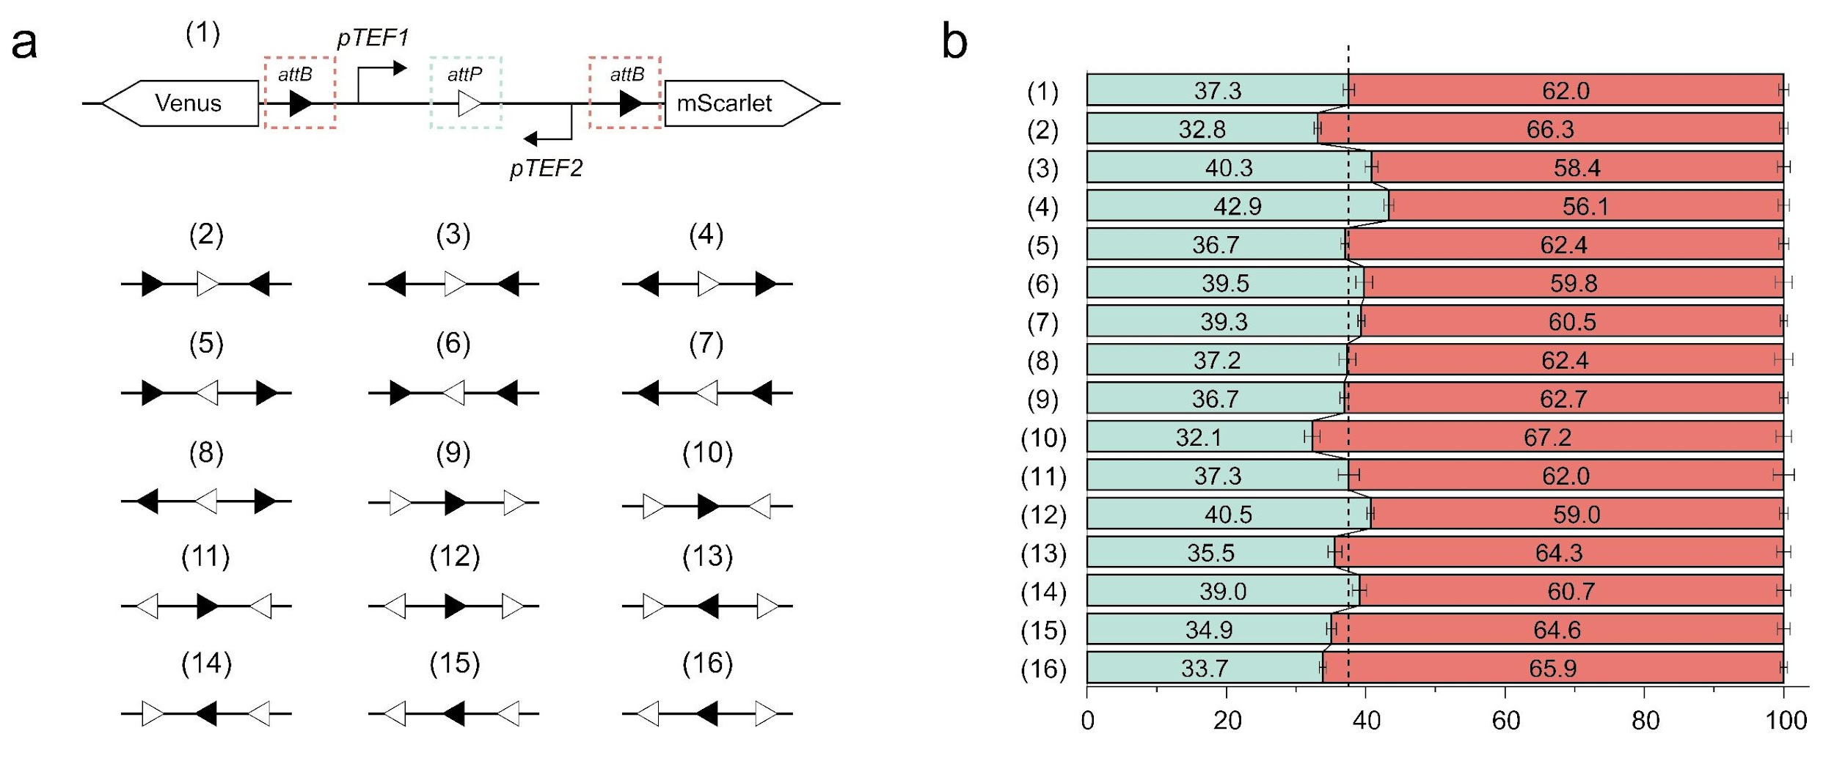
Fig. S26 | Impact of att site orientation on circuit-driven cellular differentiation. a. Schematic of a branching device with three att sites arranged in sixteen distinct combinations. b. Progeny ratios generated by the designed circuits were generally stable, with minor deviations observed.

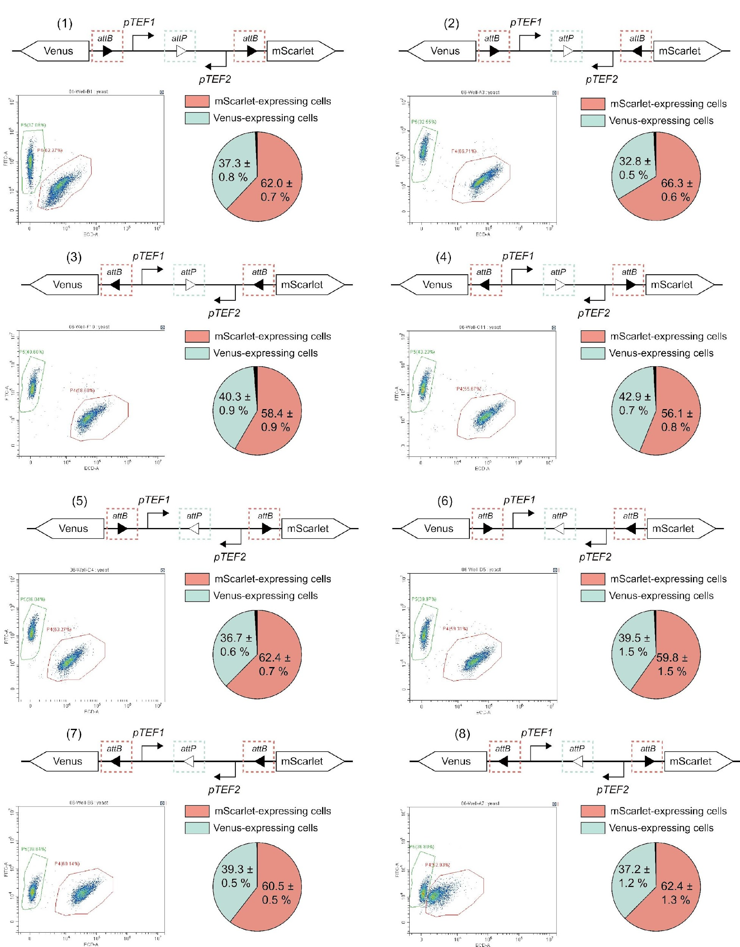
Fig. S27 | Effect of att site orientation on cellular differentiation. Representative circuit designs, flow cytometry data, and progeny distribution statistics. All experiments were repeated three times, with five samples per iteration.

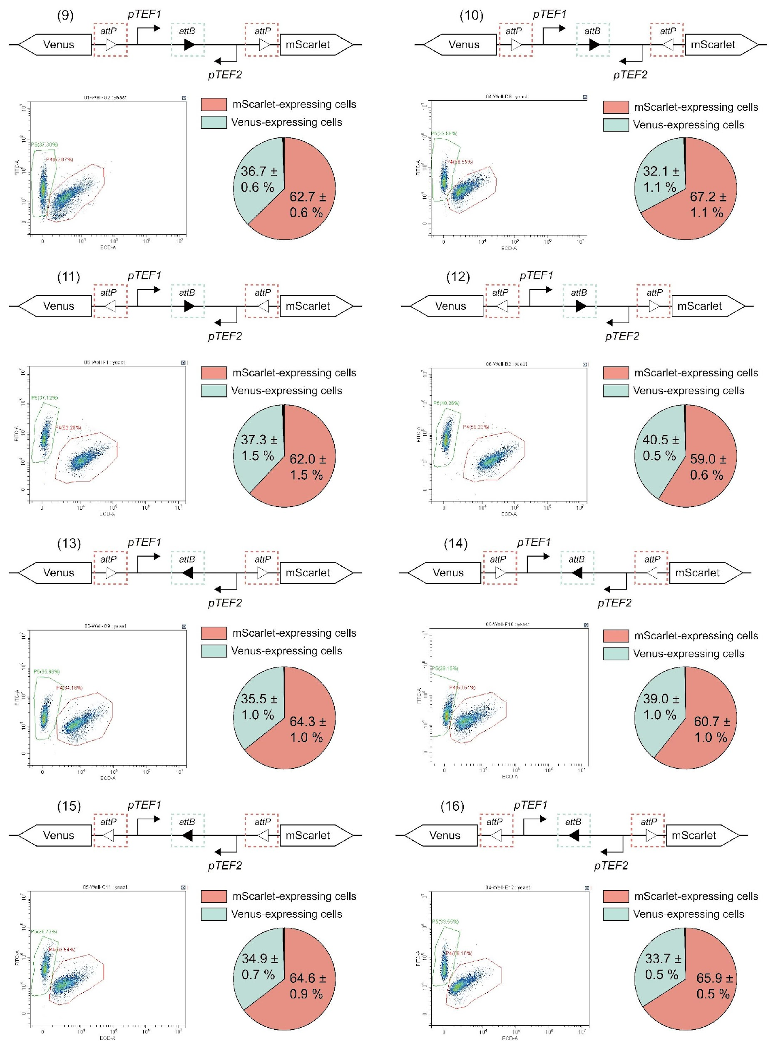
Fig. S28 | Impact of att site orientation on cellular differentiation. Circuit design, flow cytometry data, and progeny distribution statistics. All experiments were repeated three times, with five samples per iteration.

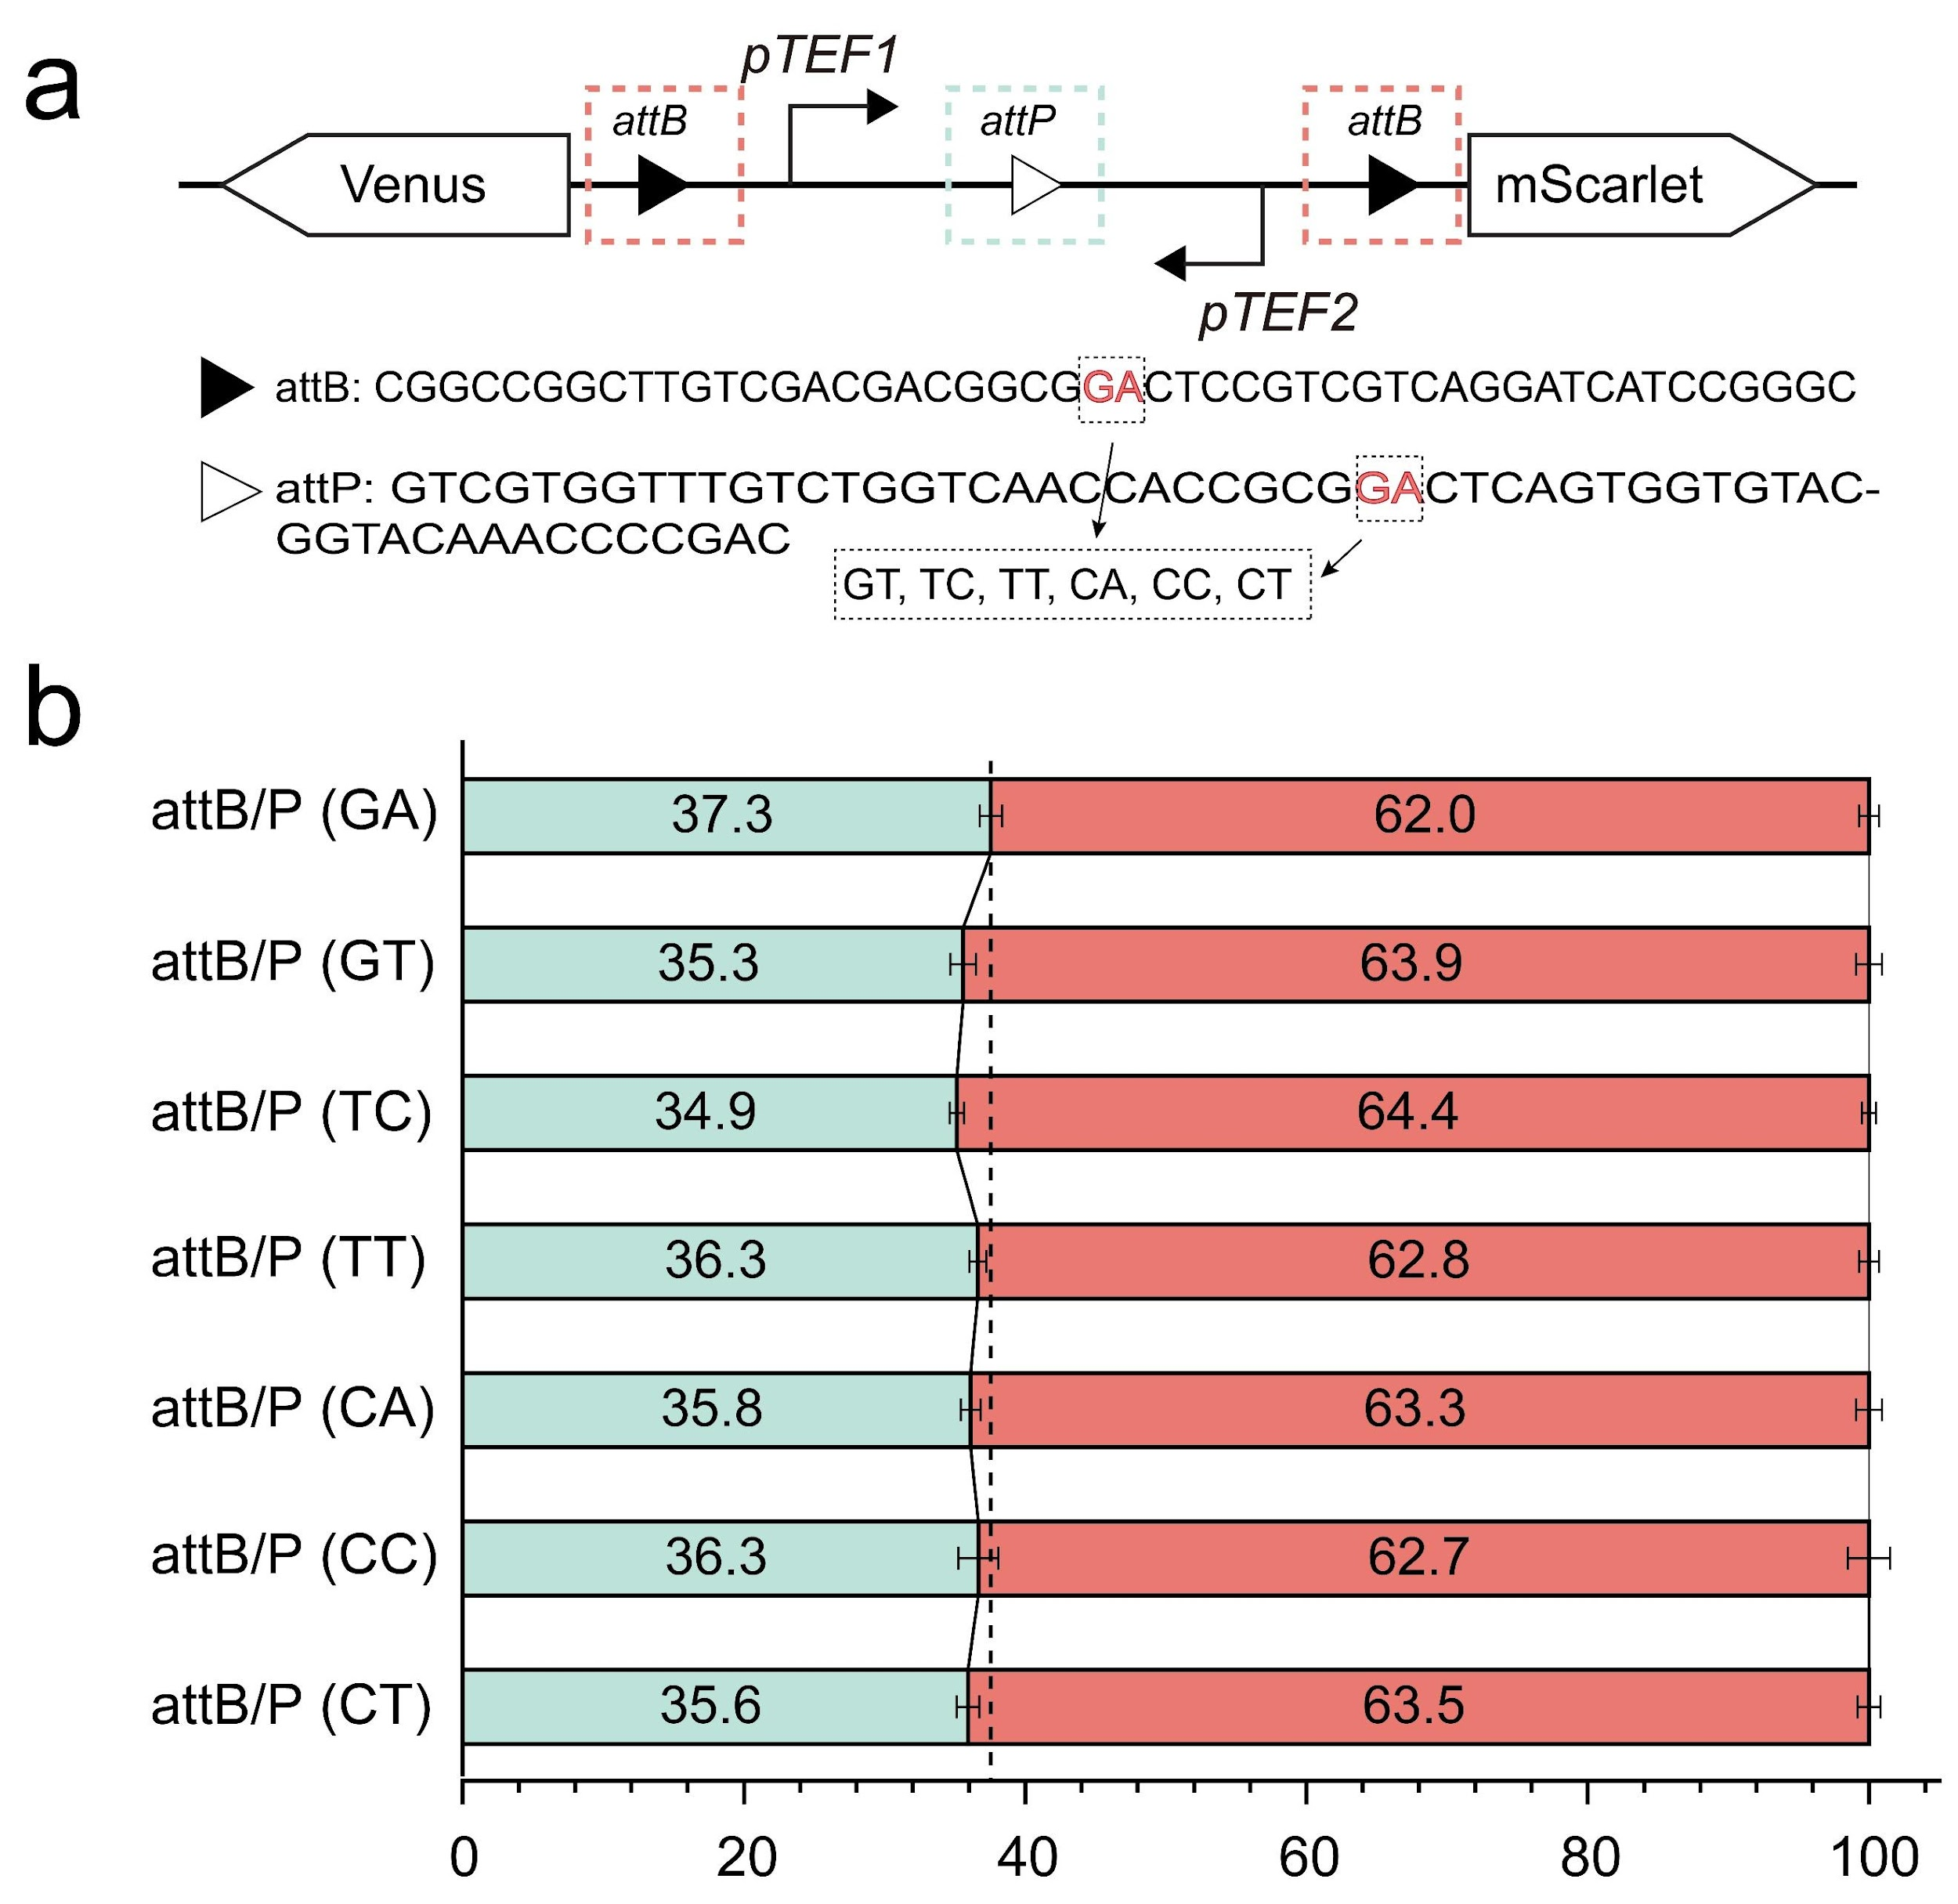
Fig. S29 | Influence of orthogonal att variants on circuit-driven cellular differentiation. a. Design of Bxb1 att sites incorporating orthogonal variants with core dinucleotide sequences (e.g., GA, GT, TC, TT, CA, CC, and CT). b. Comparison of progeny proportions generated by genetic circuits with these variants revealed a minimal impact on recombinase activity, resulting in negligible changes in progeny distribution.

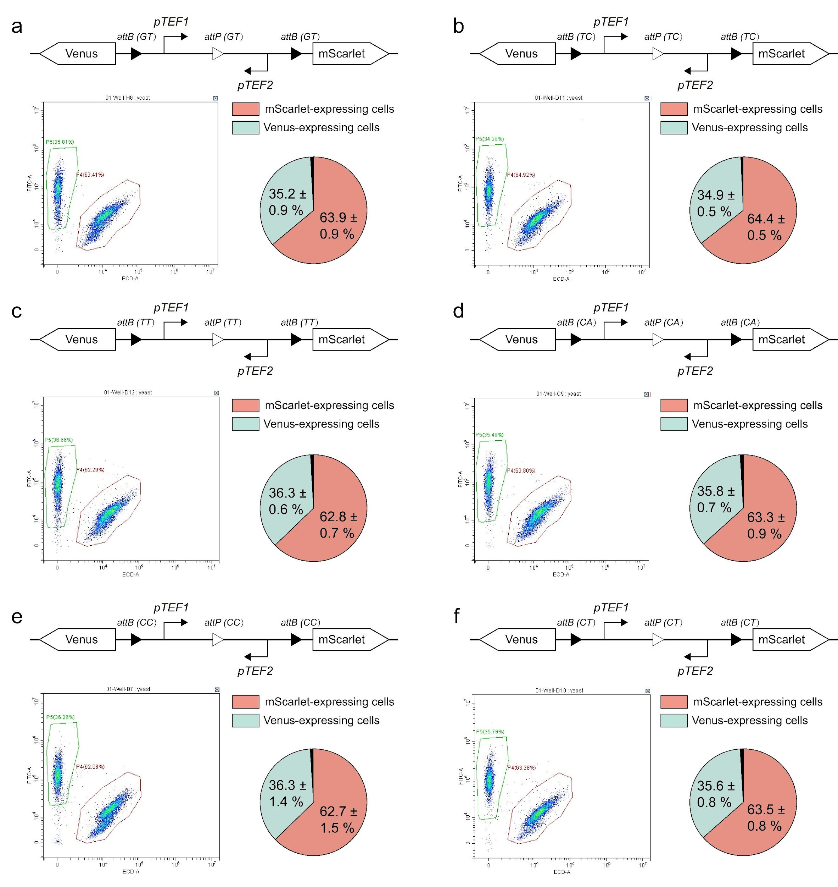
Fig. S30 | Impact of orthogonal att variants on cellular differentiation. Circuit designs, flow cytometry, and progeny distribution statistics. All experiments were conducted three times, with five samples tested in each iteration.

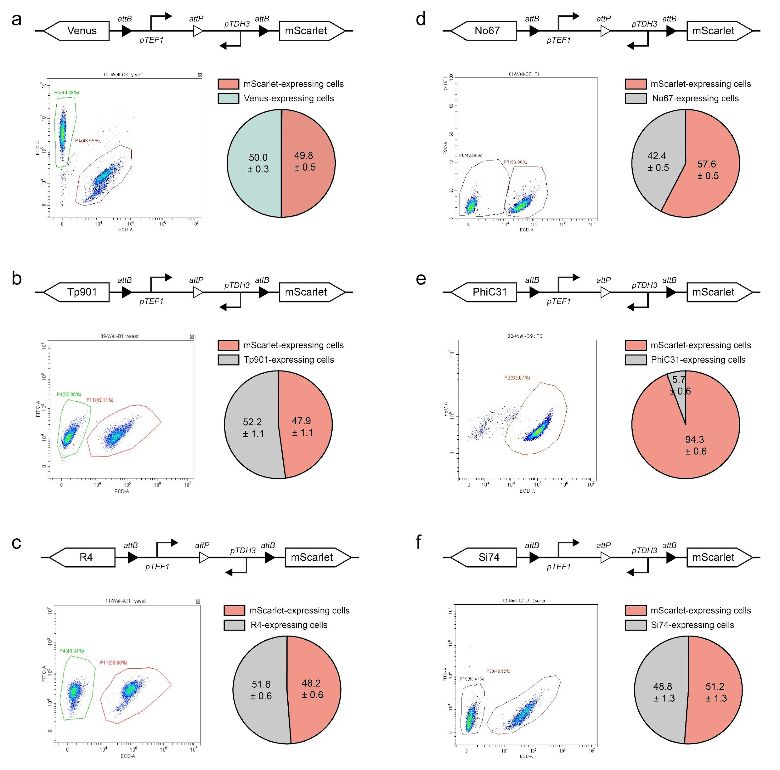
Fig. S31 | Impact of varying outputs on progeny distribution in branching device designs. a-f. Substitution of the left-arm reporter protein Venus (a) with alternative recombinases—Tp901 (b), No67 (c), R4 (d), PhiC31 (e), and Si74 (f)—altered progeny ratio distributions. All experiments were conducted three times, with five samples tested in each iteration.

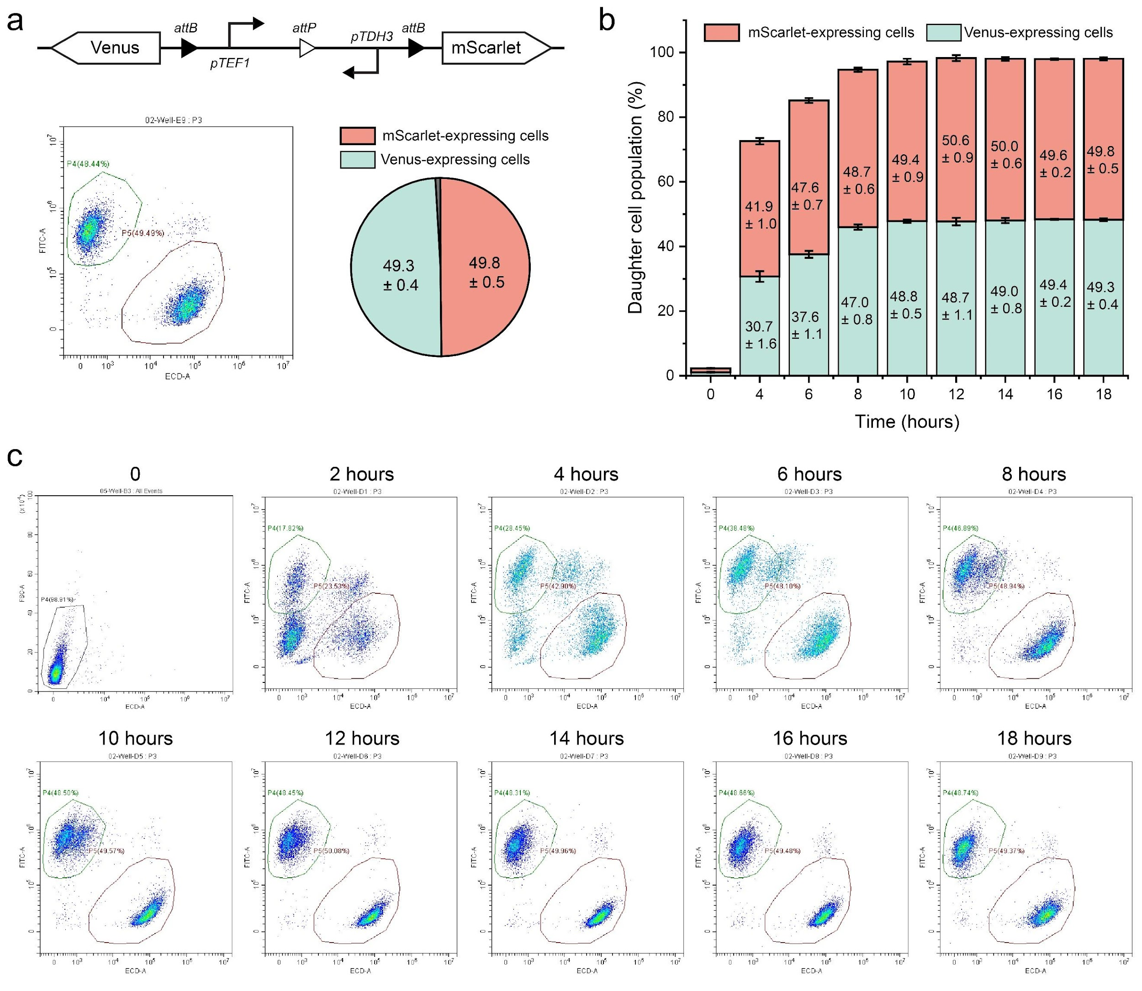
Fig. S32 | Temporal dynamics of progeny populations during 18 hours of culturing. a. Representative flow cytometry data and progeny distribution statistics for the genetic circuit following utilizing Venus and mScarlet as output proteins. b. Statistical data showing progeny dynamics over time with a final aTc inducer concentration of 1 mM (n = 4, mean ± SD). c. Flow cytometry results measured at 2-hour intervals from 0 to 18 hours.

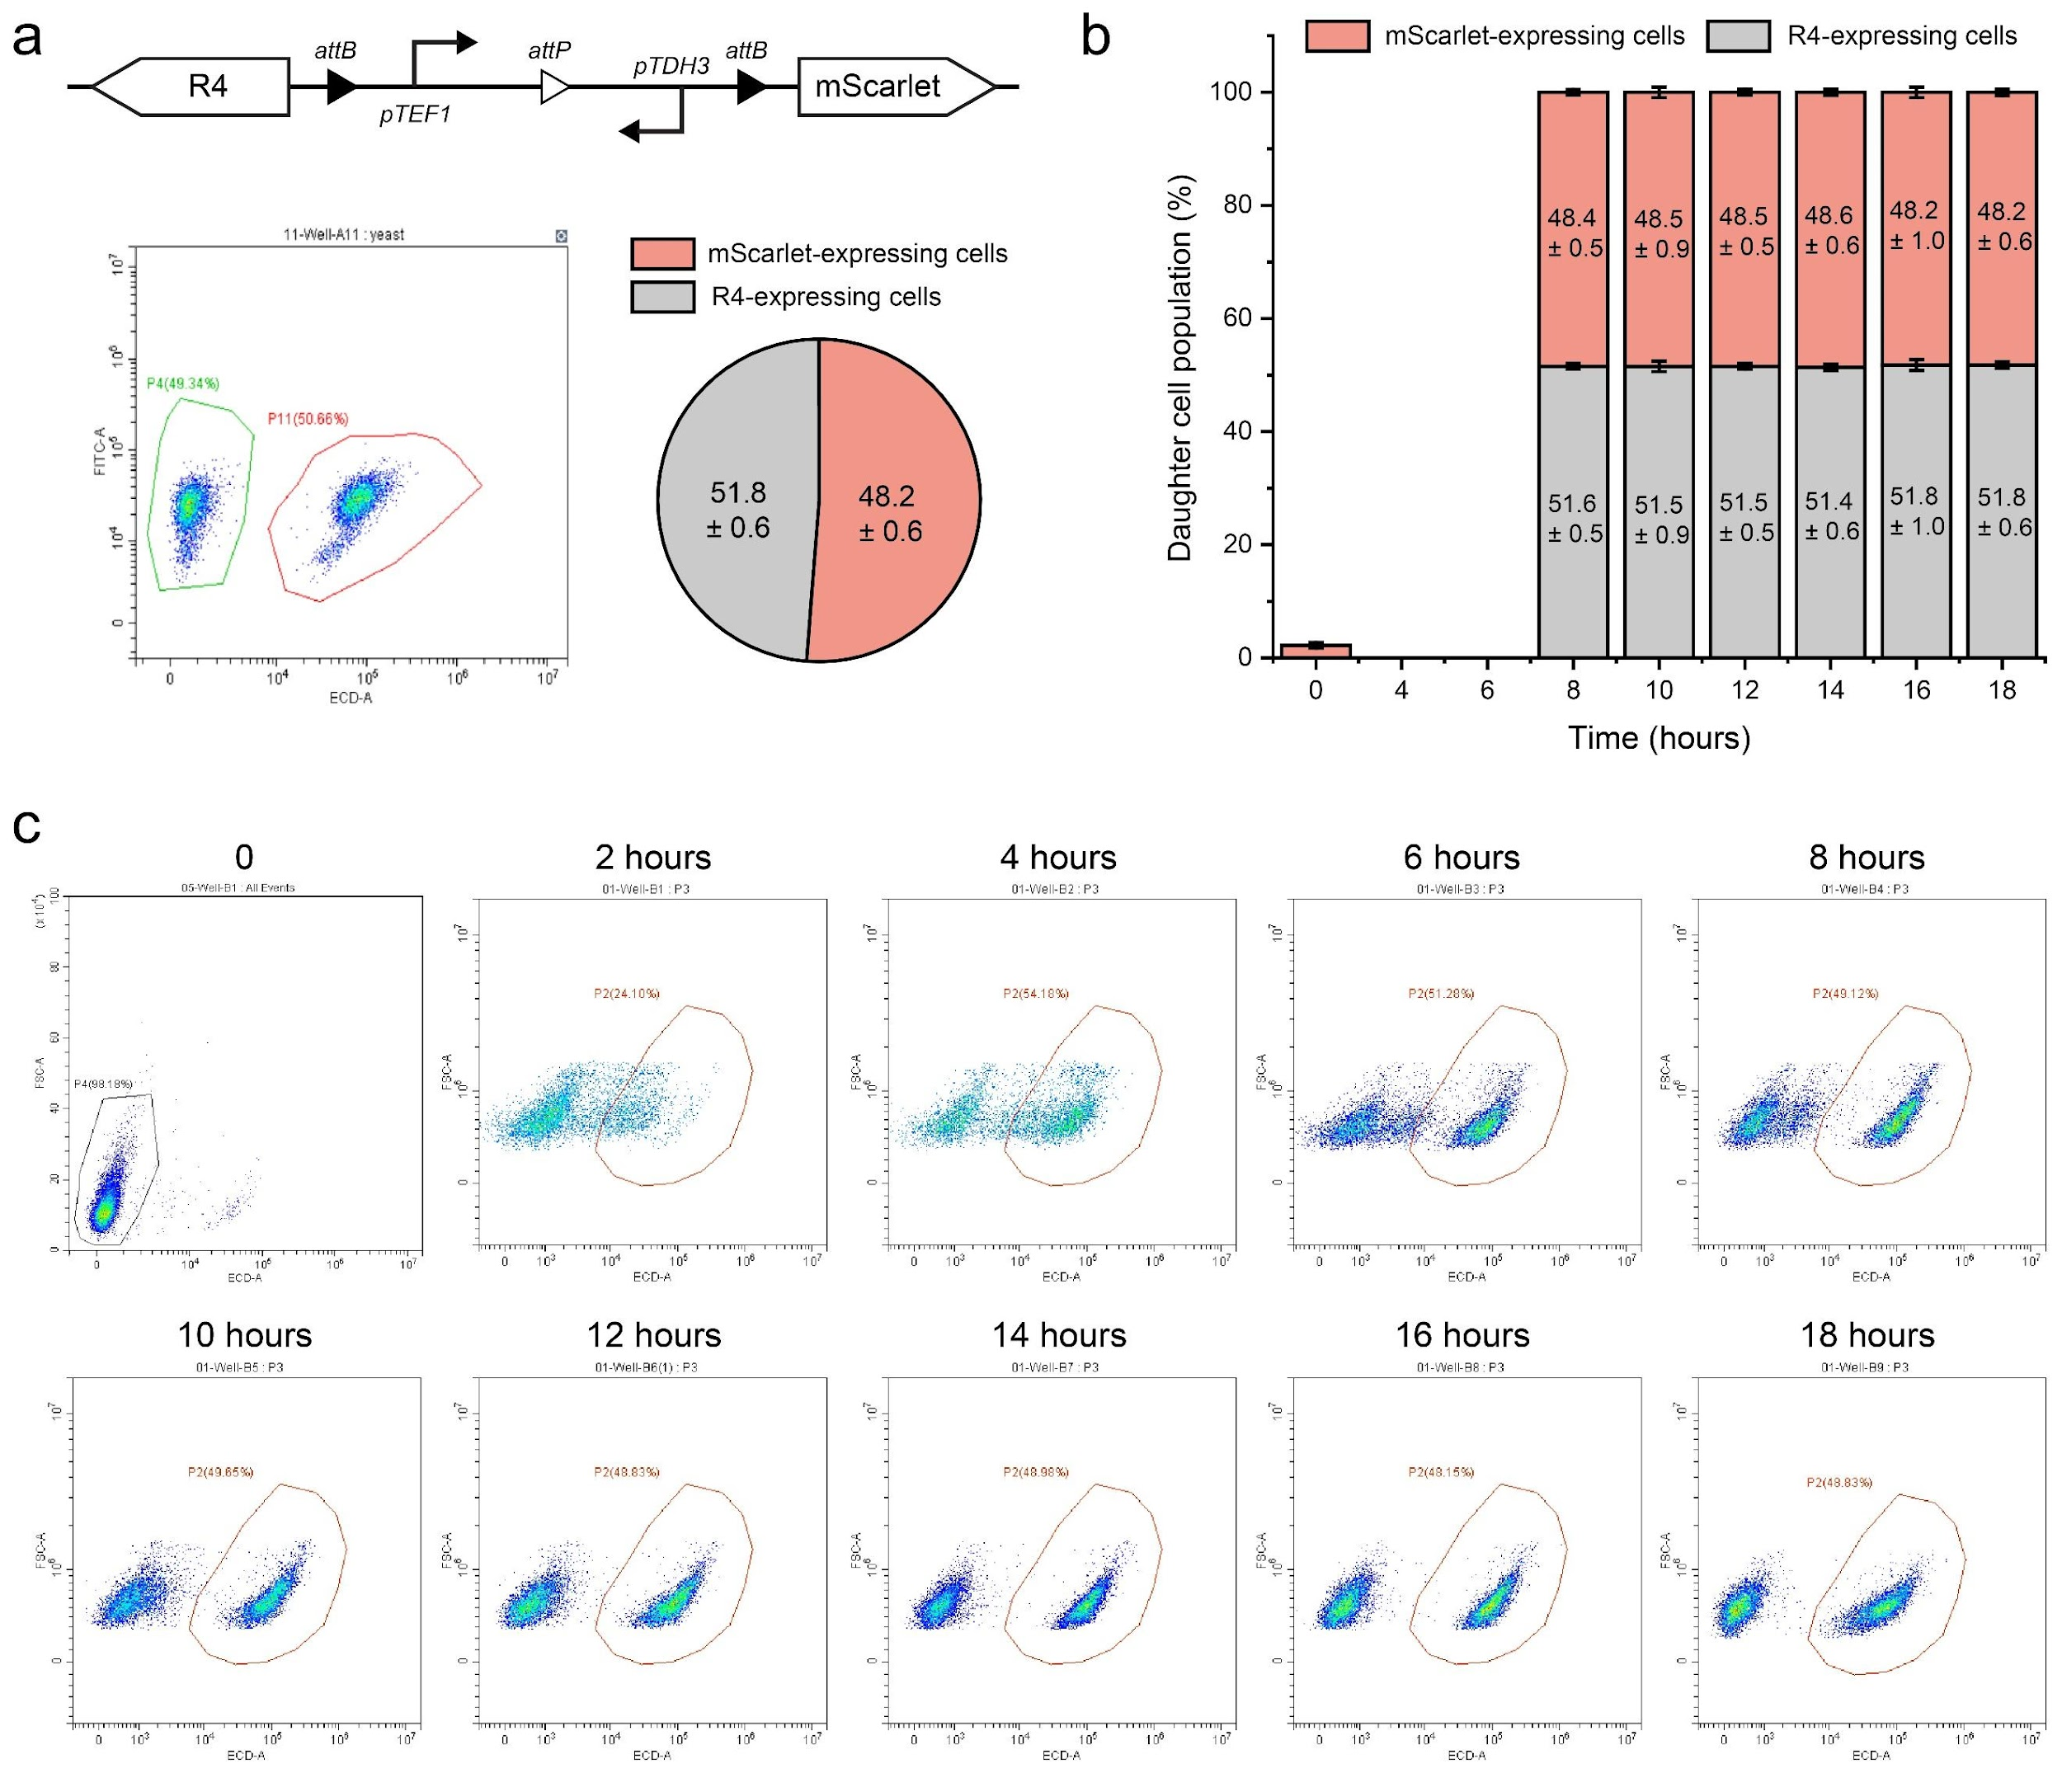
Fig. S33 | Temporal dynamics of progeny populations during 18 hours of culturing. a. Representative flow cytometry data and progeny distribution statistics for the genetic circuit using recombinase R4 and mScarlet as output proteins. b. Data showing progeny dynamics over time with a final aTc inducer concentration of 1 mM (n = 4, mean ± SD). c. Flow cytometry results measured at 2-hour intervals from 0 to 18 hours.

Fig. S34 | Temporal dynamics of yeast progeny populations during 18 hours of culturing. a. Representative flow cytometry data and progeny distribution statistics for the genetic circuit utilizing recombinase No67 and mScarlet as output proteins. b. Data showing progeny dynamics over time with a final aTc inducer concentration of 1 mM (n = 4, mean ± SD). c. Flow cytometry results measured at 2-hour intervals from 0 to 18 hours.

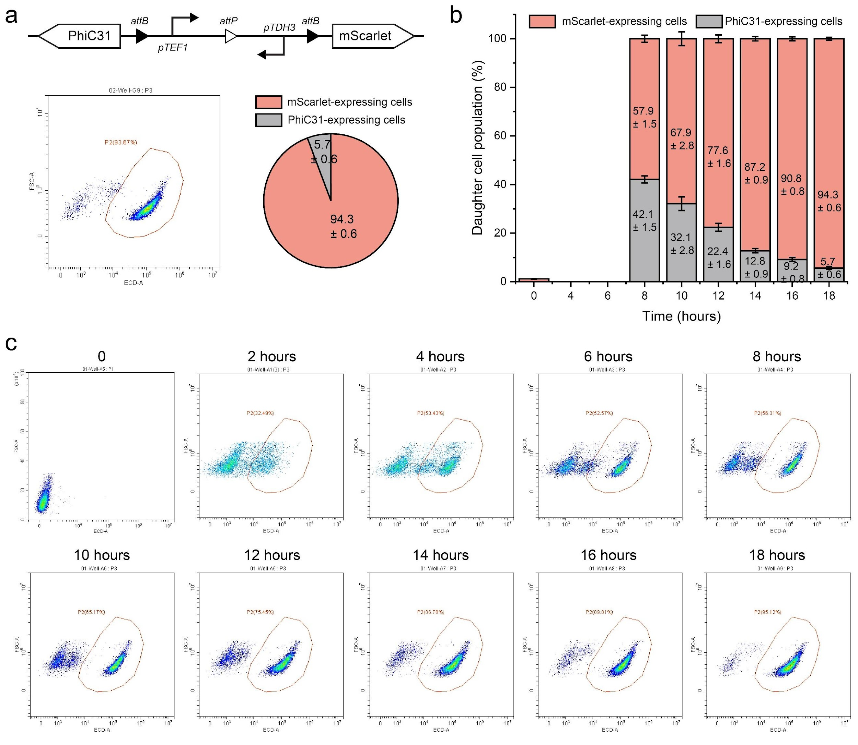
Fig. S35 | Temporal dynamics of yeast progeny populations during 18 hours of culturing. a. Representative flow cytometry data and progeny distribution statistics for the genetic circuit utilizing recombinase PhiC31 and mScarlet as output proteins. b. Statistical data showing progeny dynamics over time with a final aTc inducer concentration of 1 mM (n = 4, mean ± SD). c. Flow cytometry results measured at 2-hour intervals from 0 to 18 hours.

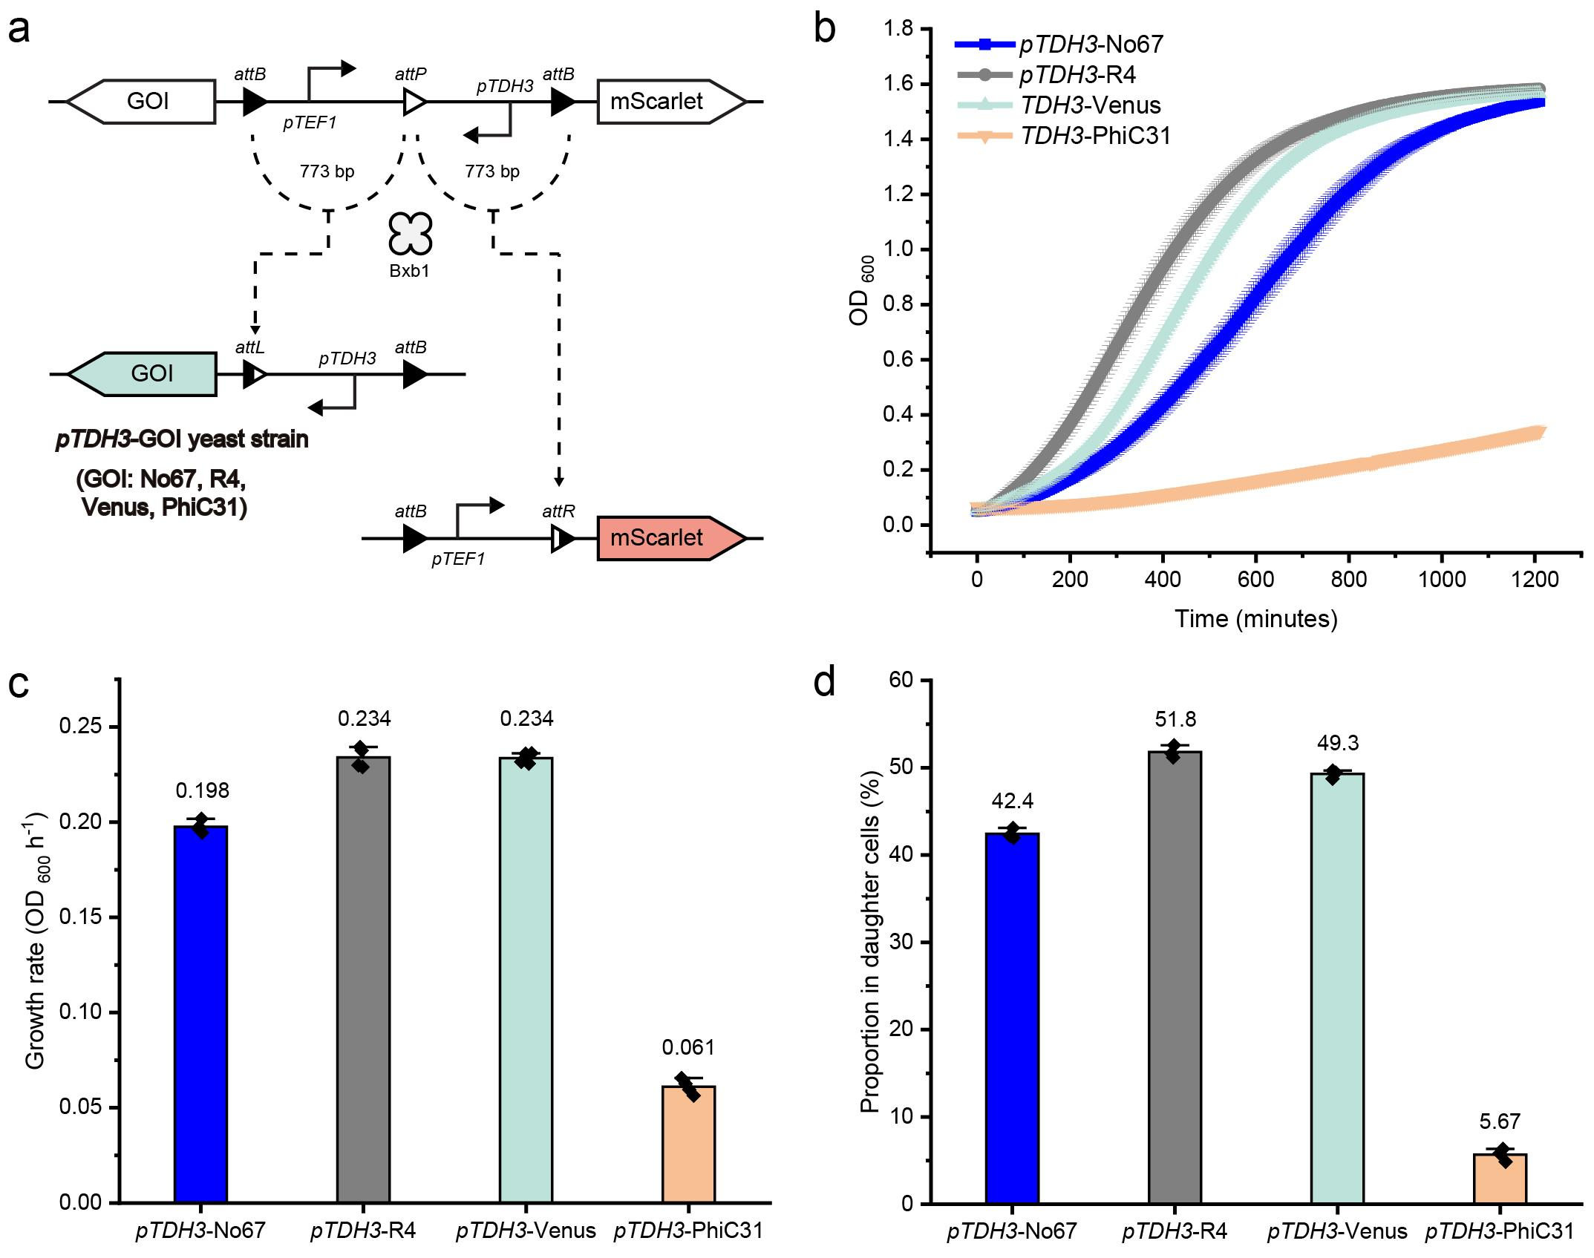
Fig. S36 | Influence of progeny growth rates on consortia proportions. a. Genetic circuits used. Founder cells differentiate into two subgroups: one expressing mScarlet via the pTEF1 promoter and the other expressing a gene of interest (Venus, No67, R4, or PhiC31) via the pTDH3 promoter. b. Growth curves of the four types of progeny yeast, with pTDH3-driven expression of Venus, No67, R4, or PhiC31 (n = 4, mean ± SD). c. Average growth rates of the four yeast types (n = 4, mean ± SD). d. Progeny distribution in yeast consortia generated by the circuit as depicted in Fig. S36a (n = 4, mean ± SD).

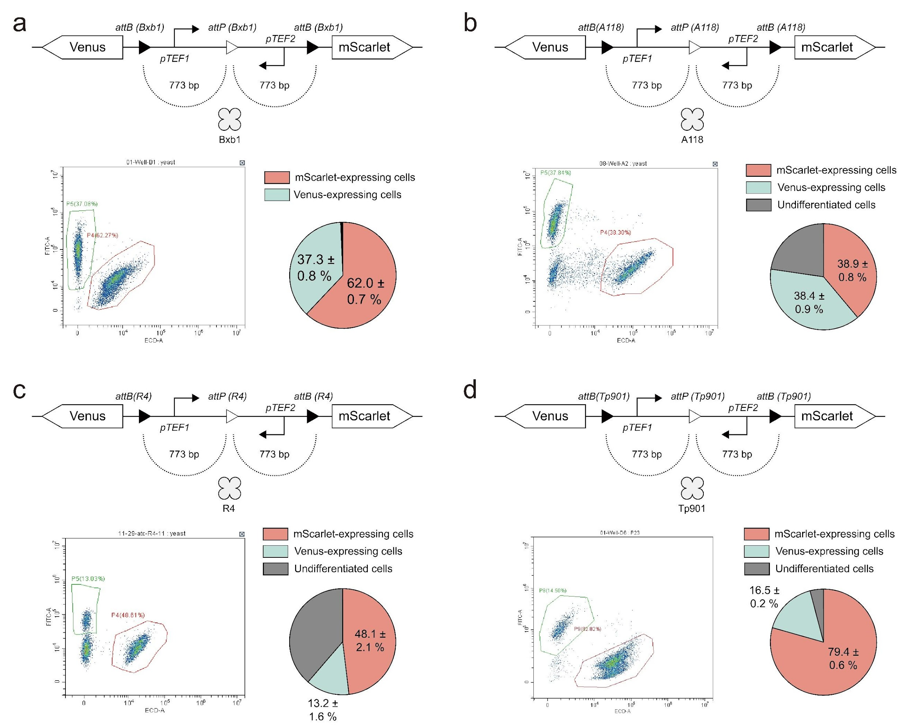
Fig. S37 | Comparison of the recombinase performance in branching devices. a-d. Schematics of circuit designs catalyzed by Bxb1, A118, R4, and Tp901, with representative flow cytometry data and progeny cell distribution statistics. Experiments were performed in triplicate and repeated three times.

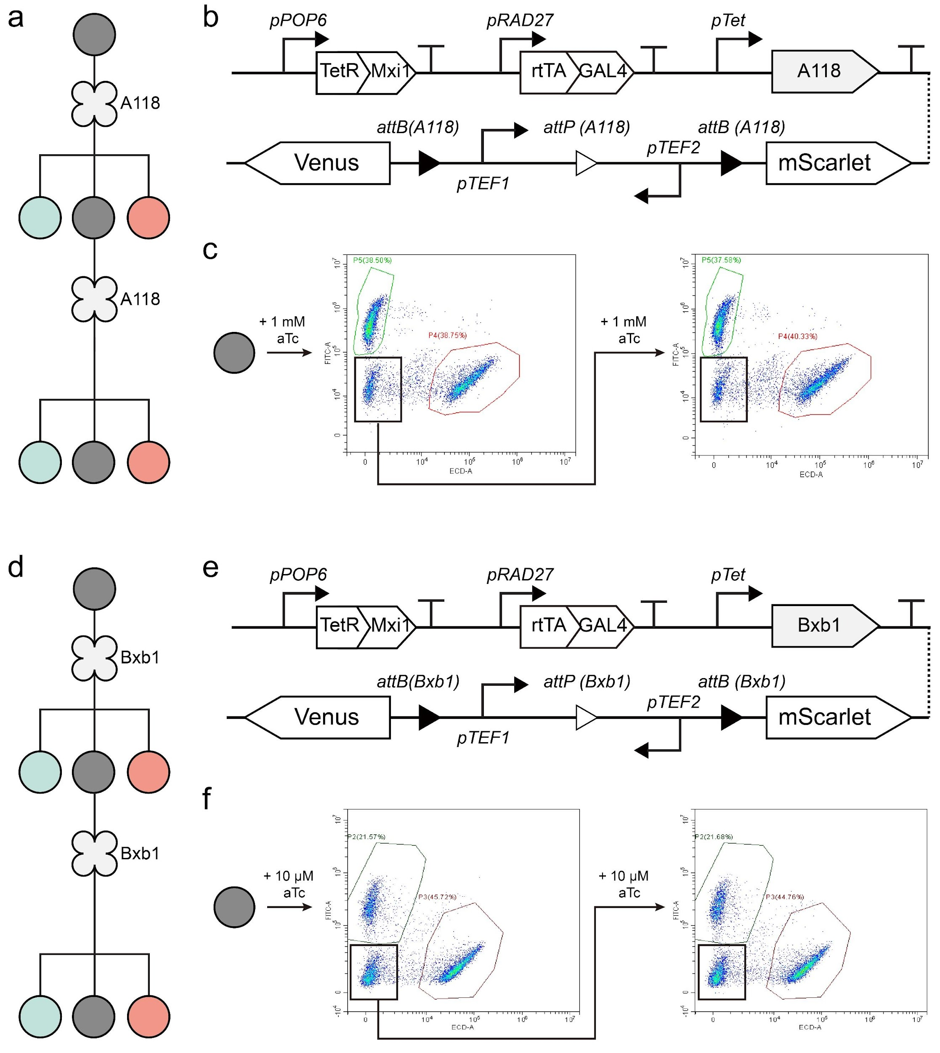
Fig. S38 | Differentiation potential of partially differentiated yeast progeny. a. Construction of an asymmetric differentiation system using A118 recombinase with low catalytic activity in yeast cells. b. Schematic of the genetic circuit. c. Induction with 1 mM aTc generates three types of progeny cells: red fluorescent, green fluorescent, and non-fluorescent populations. Re-induction of non-fluorescent cells with 1 mM aTc produces the same three progeny types. d. Partial induction of Bxb1 expression also enables asymmetric differentiation. e. Schematic of the genetic circuit used in the Bxb1 experiment. f. Representative flow cytometry data of the asymmetric differentiation system.

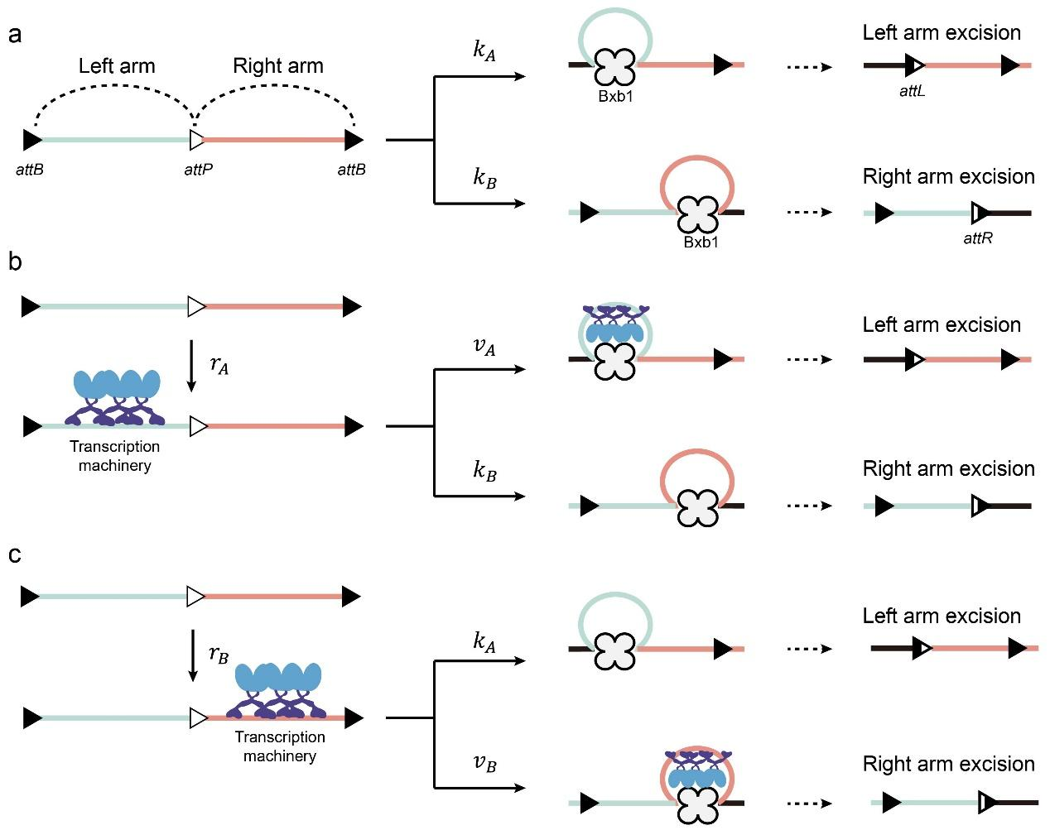
Fig. S39 | Mathematical model predicting cell differentiation outcomes. a. Schematic of genetic device with left and right arms cleaved by Bxb1 at rates of${ k}_{A}$ and $k_{B}$influenced by the att sites and DNA arm lengths. b-c. Promoters on the left or right arm recruit transcription machinery, introducing steric hindrance that reduces recombinase efficiency. The recruitment of more transcription machinery on the left arm reduces its cleavage rate from $k_{A}$ to $v_{A}$. Similarly, increased transcription machinery recruitment on the right arm changes its cleavage rate from $k_{B}$ to $v_{B}$. $r_{A}$ and $r_{B}$ are the binding rates of the transcription machinery. A variable $α$ was used to describe the strength of the steric hindrance: $α=\frac{v_{A}}{k_{A}}=\frac{v_{B}}{k_{B}}$.

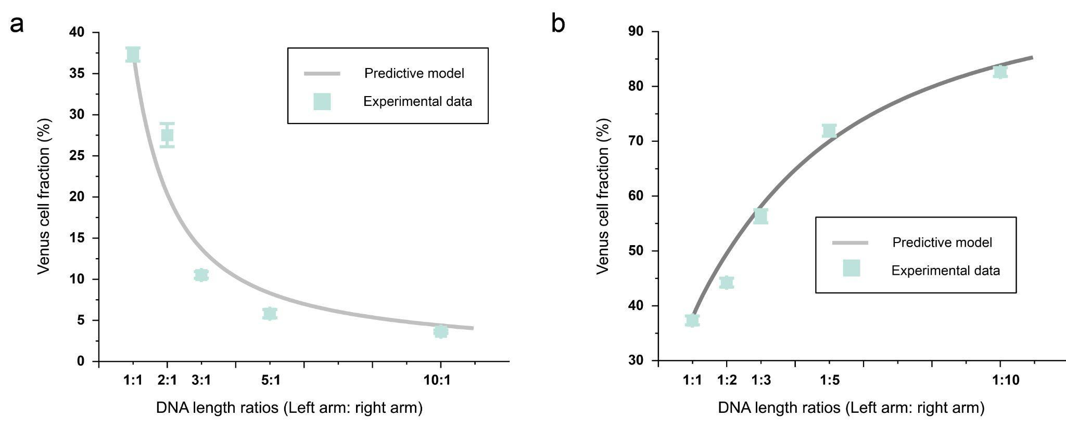
Fig. S40 | Predictive modeling of arm length effects on differentiation. a. Comparison of model predictions with experimental data for Venus-expressing cell ratios across DNA length ratios (left to right arm) from 1:1 to 10:1, based on circuits in Fig. S23. b. A similar comparison for DNA length ratios ranging from 1:1 to 1:10 based on circuits in Fig. S22. Gray lines represent model predictions, and green dots indicate experimental data.

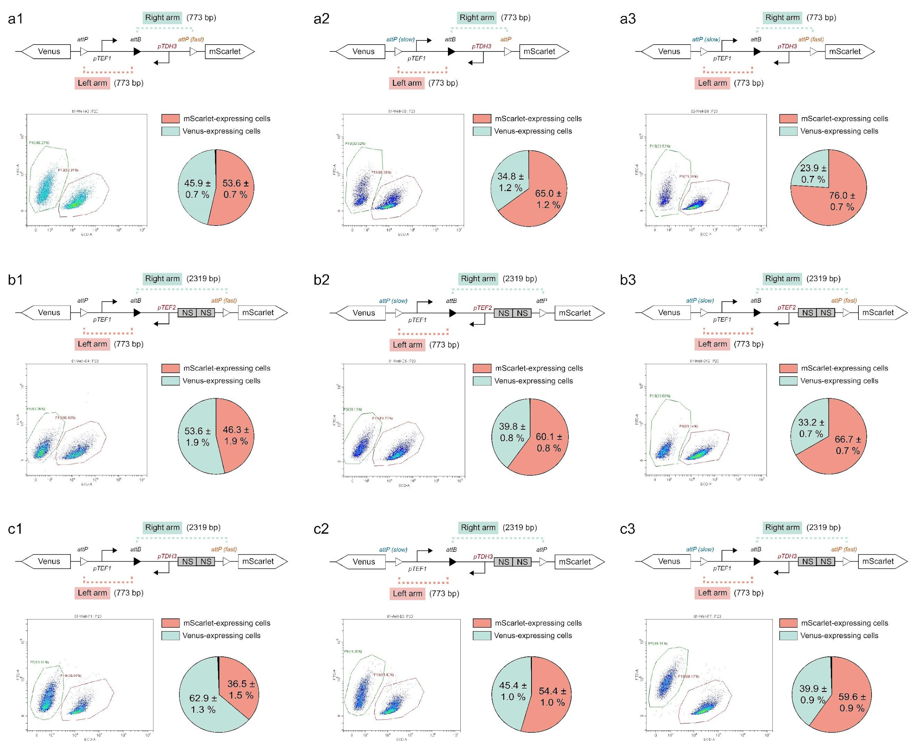
Fig. S41 | Design of nine circuits for predictive modeling. (a1-c3) Designs incorporate variables such as arm length, attP variants, and promoter types. Experiments were performed in triplicate.

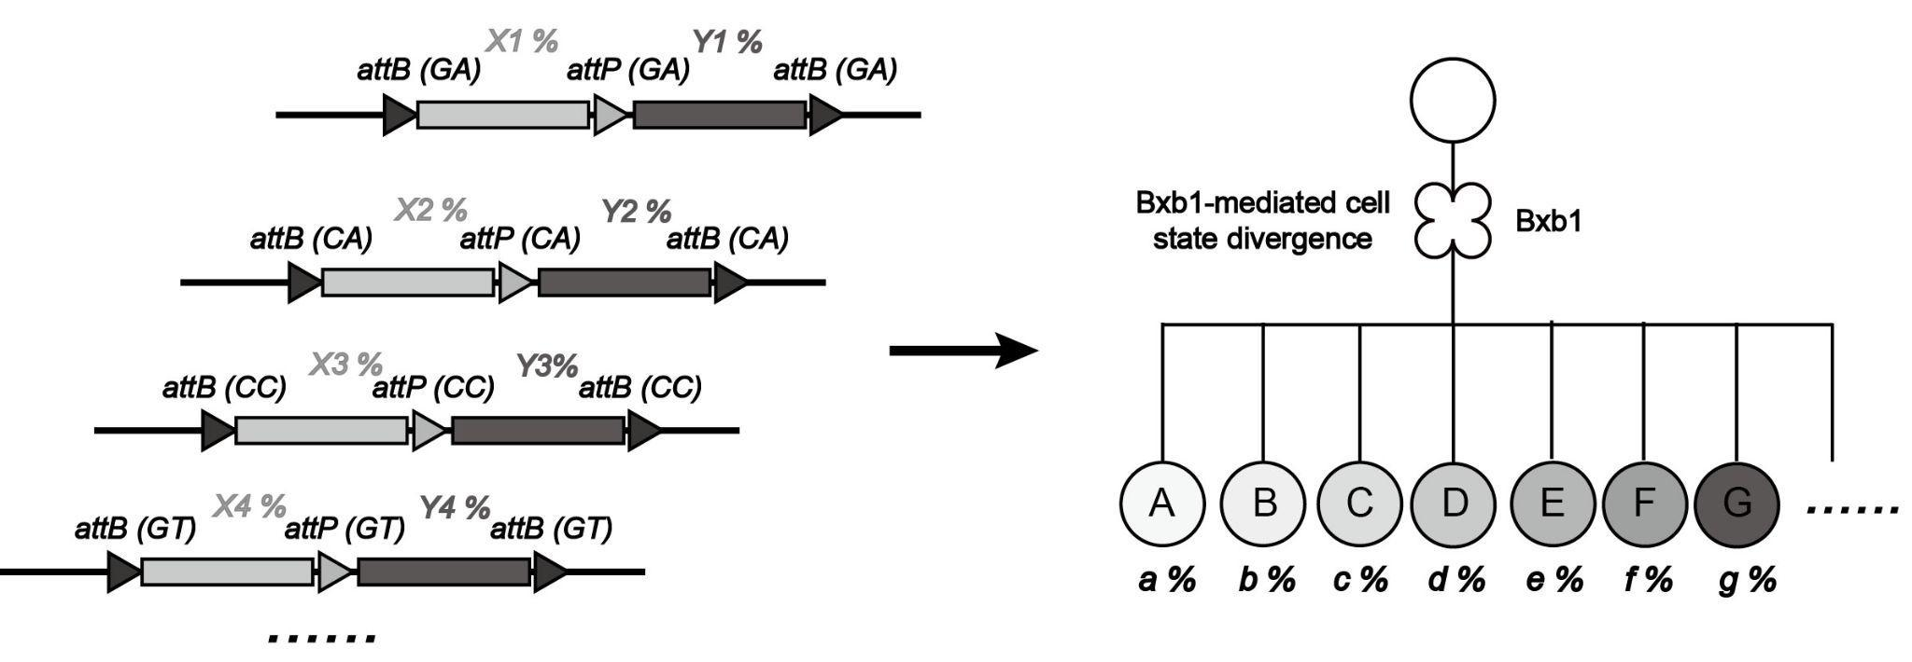
Fig. S42 | Design principles for generating yeast multicellularity with parallel circuits. Integration of multiple orthogonal recombinase circuits allows precise control over progeny phenotypes. With “n” orthogonal circuits, 2^{n} distinct progeny phenotypes can be generated.

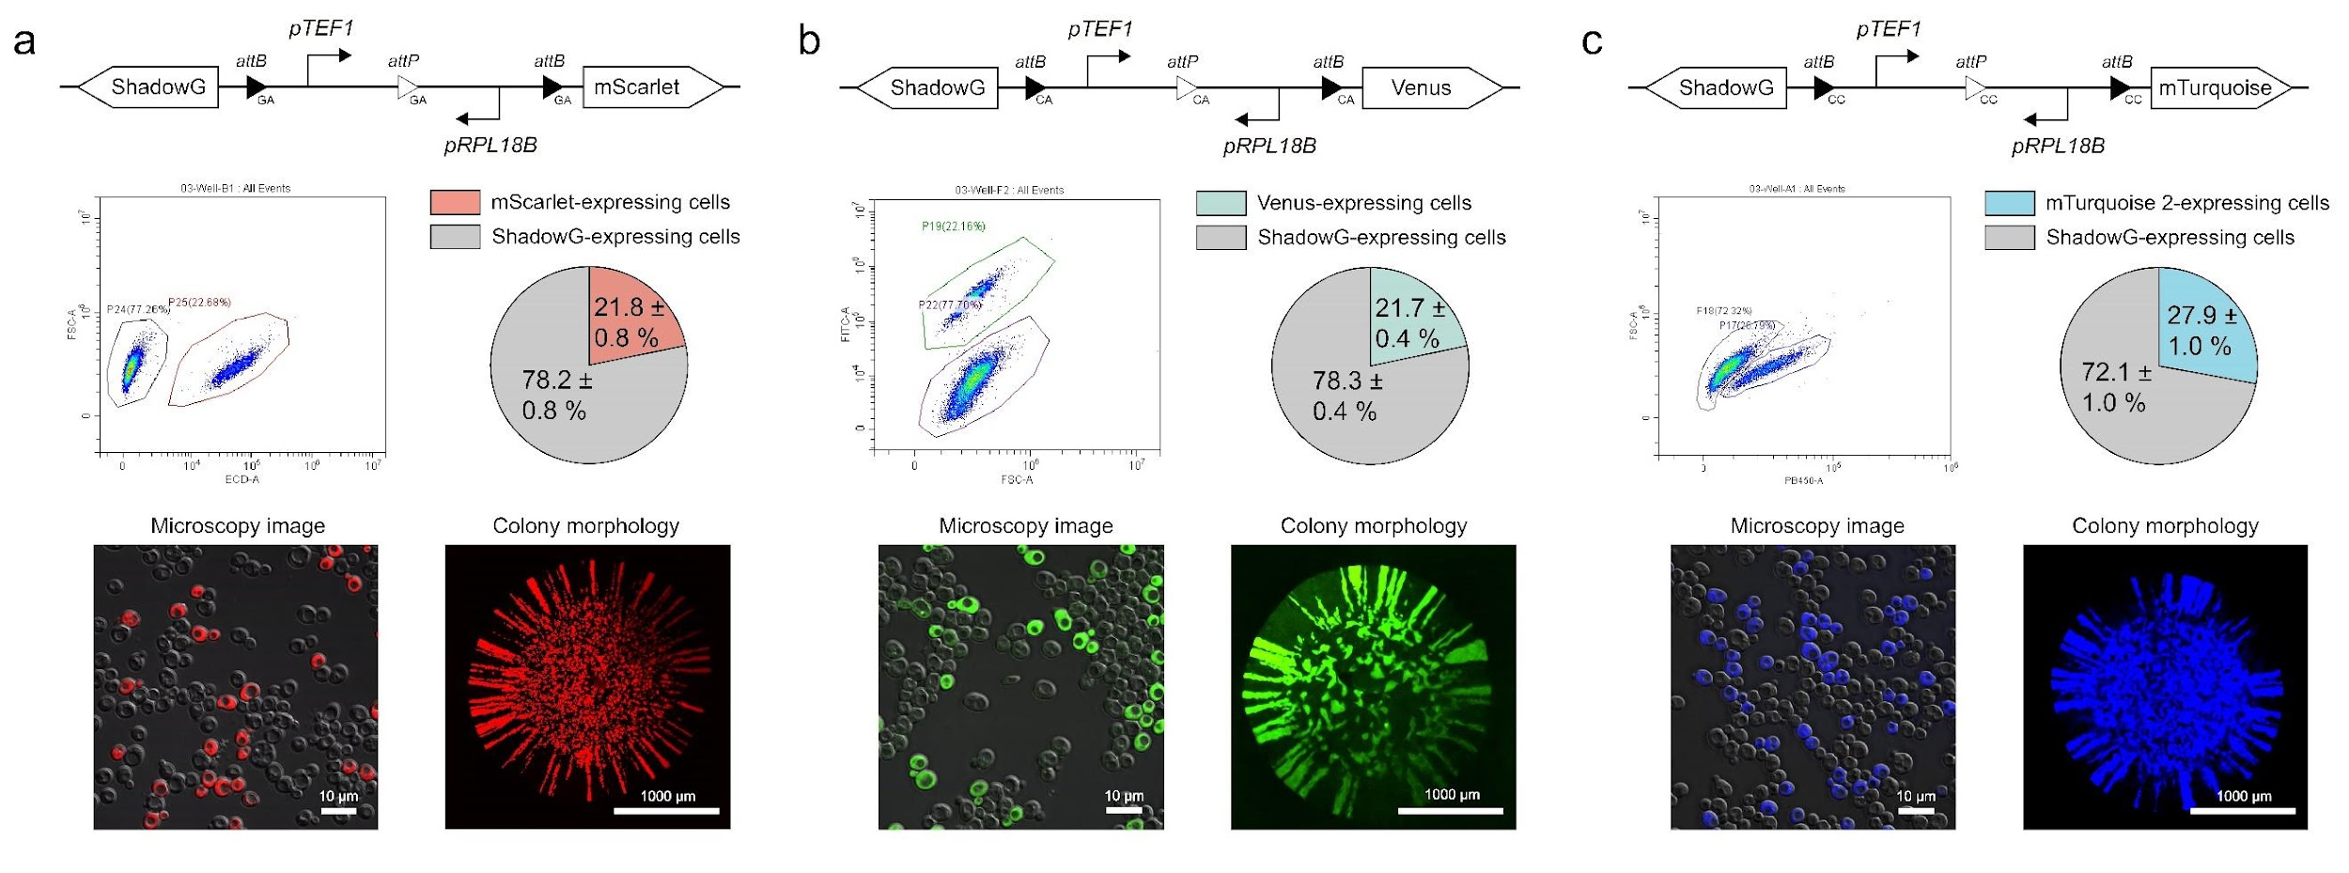
Fig. S43 | Characterization of representative 1-layer orthogonal circuits. Designs incorporate pTEF1 and pRPL18B promoters, with reporters mScarlet (a), Venus (b), or mTurquoise 2 (c). Experiments were performed in triplicate.

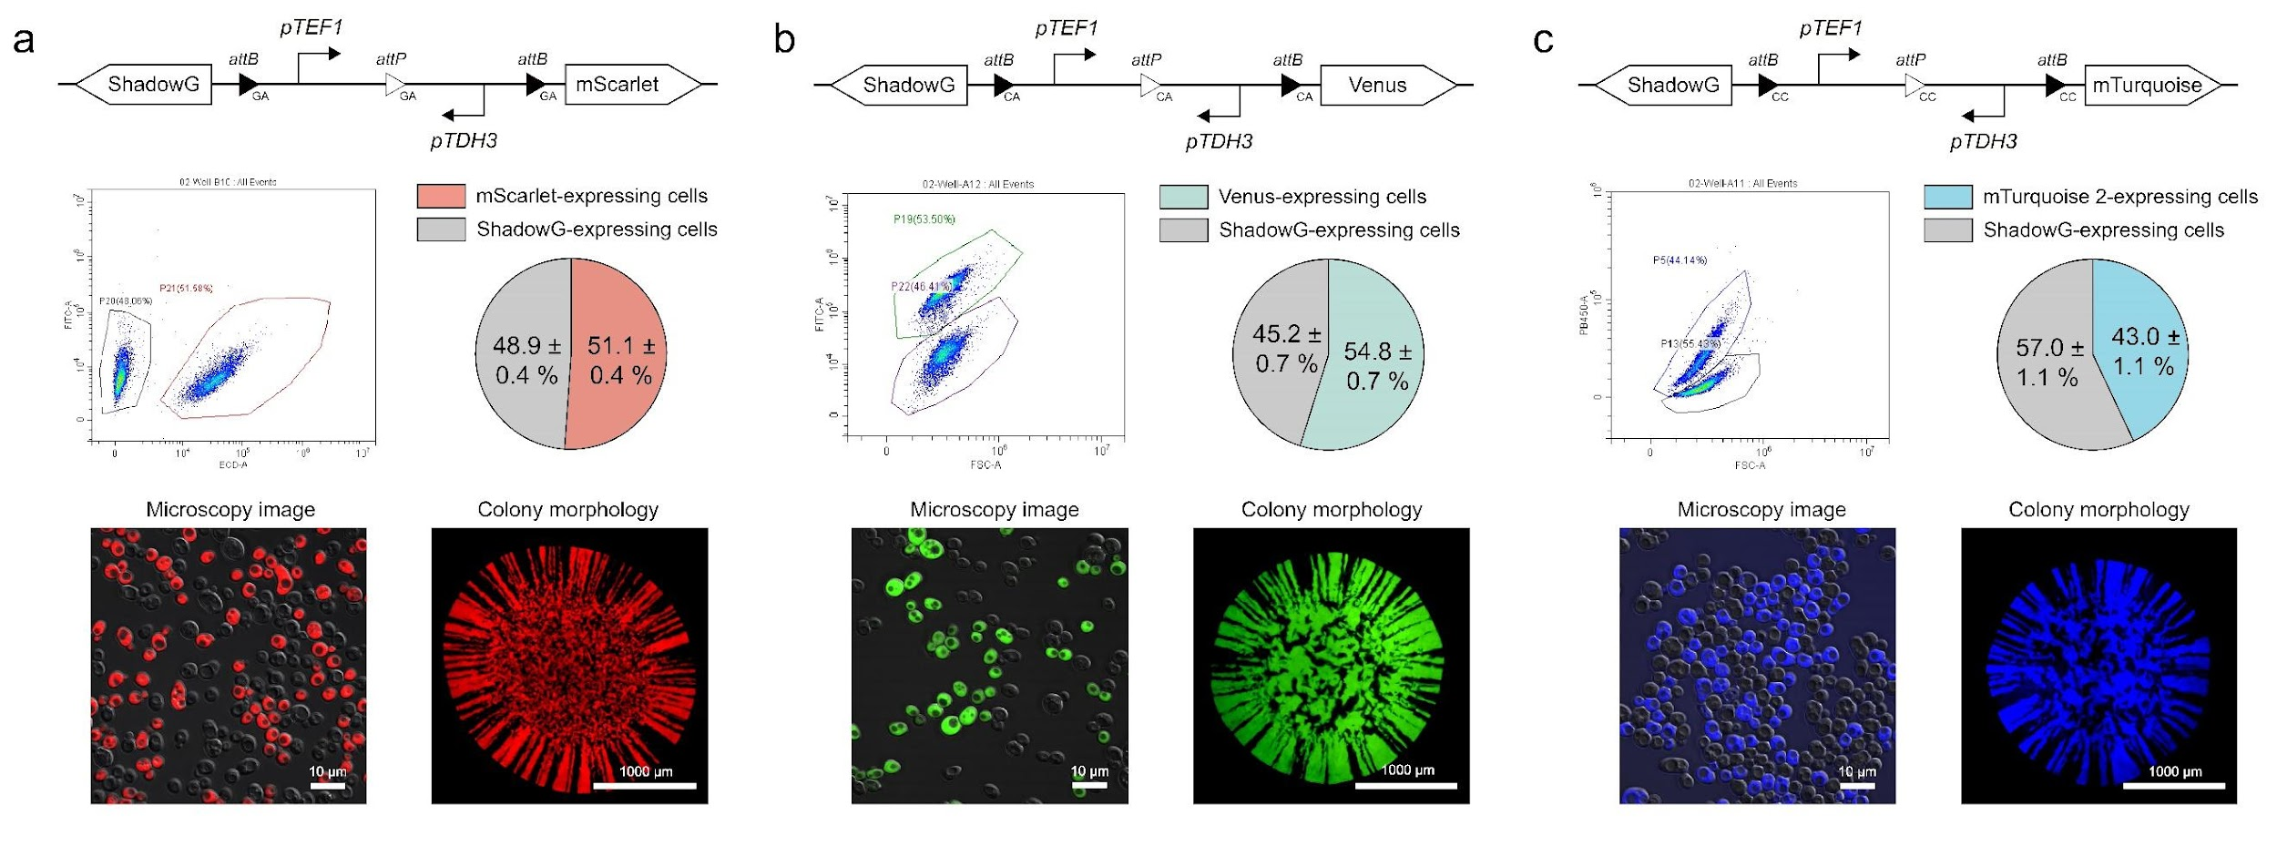
Fig. S44 | Characterization of representative 1-layer orthogonal circuits using pTEF1 and pTDH3 as promoters. Experiments were performed in triplicate.

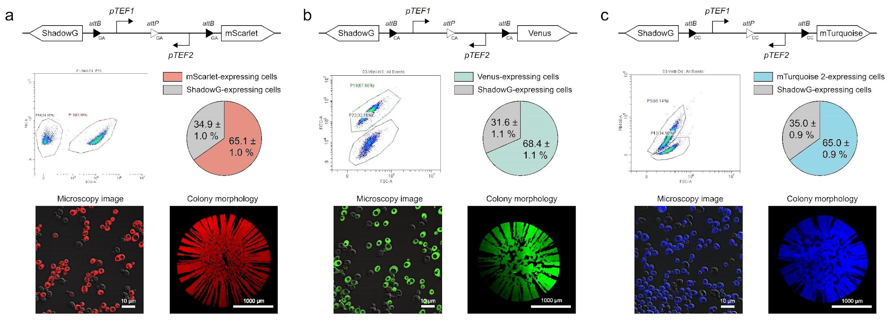
Fig. S45 | Characterization of representative 1-layer orthogonal circuits using pTEF1 and pTEF2 as promoters. Experiments were performed in triplicate.

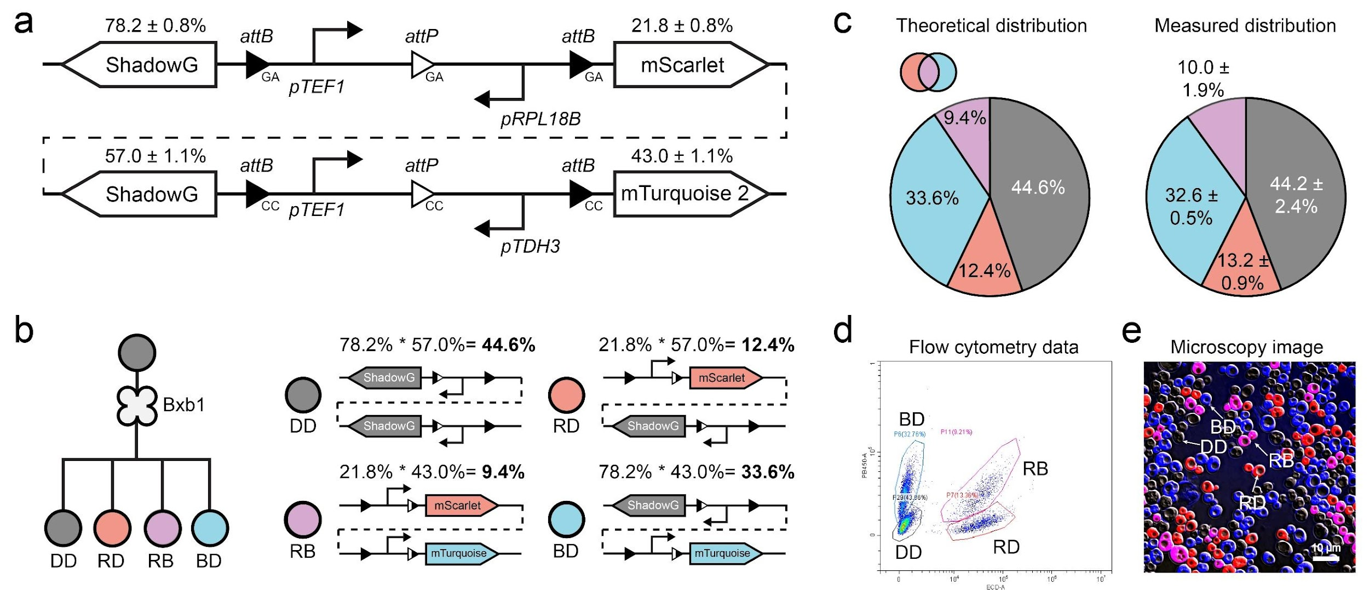
Fig. S46 | Design and characterization of a representative 2× orthogonal circuit. a. Schematic of a 2× orthogonal genetic device. b. Theoretical progeny types and proportions generated by the circuits. c. Comparison of theoretical progeny proportions with flow cytometry data. d. Flow cytometry identifies 4 distinct cell populations. e. Fluorescence microscopy confirms the presence of 4 distinct progeny types. Experiments were performed in triplicate.

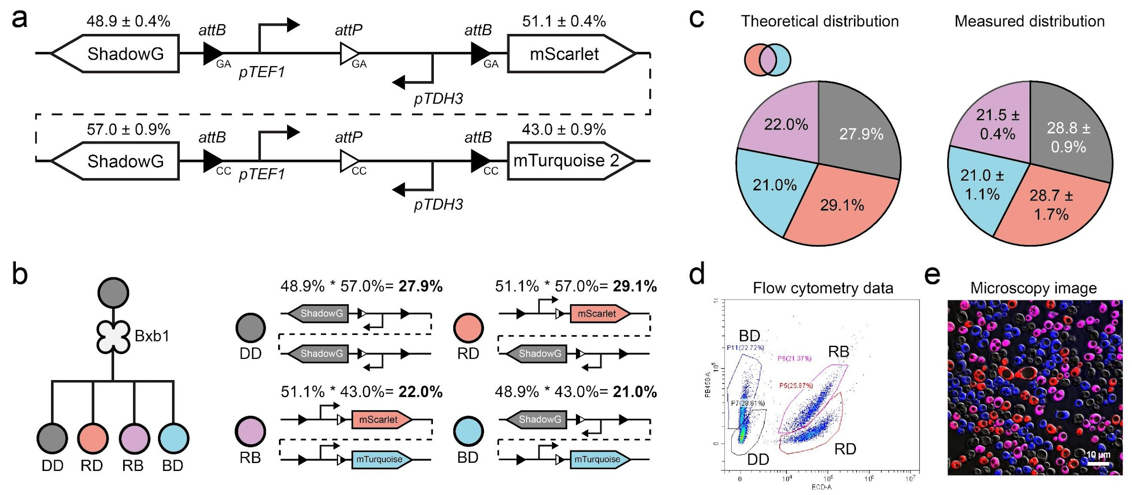
Fig. S47 | Characterization of a 2× orthogonal circuit with modified promoter usage. Compared to Fig. S46, changes in promoter design altered progeny distributions. Experiments were performed in triplicate.

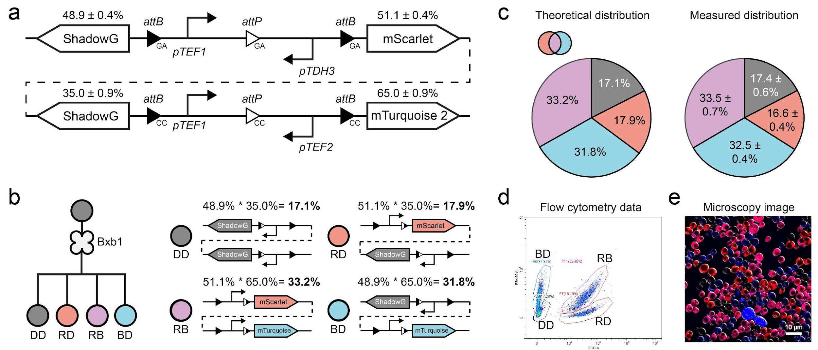
Fig. S48 | Characterization of a 2× orthogonal circuit with modified promoter usage. Compared to Fig. S46, changes in promoter design altered progeny distributions. Experiments were performed in triplicate.

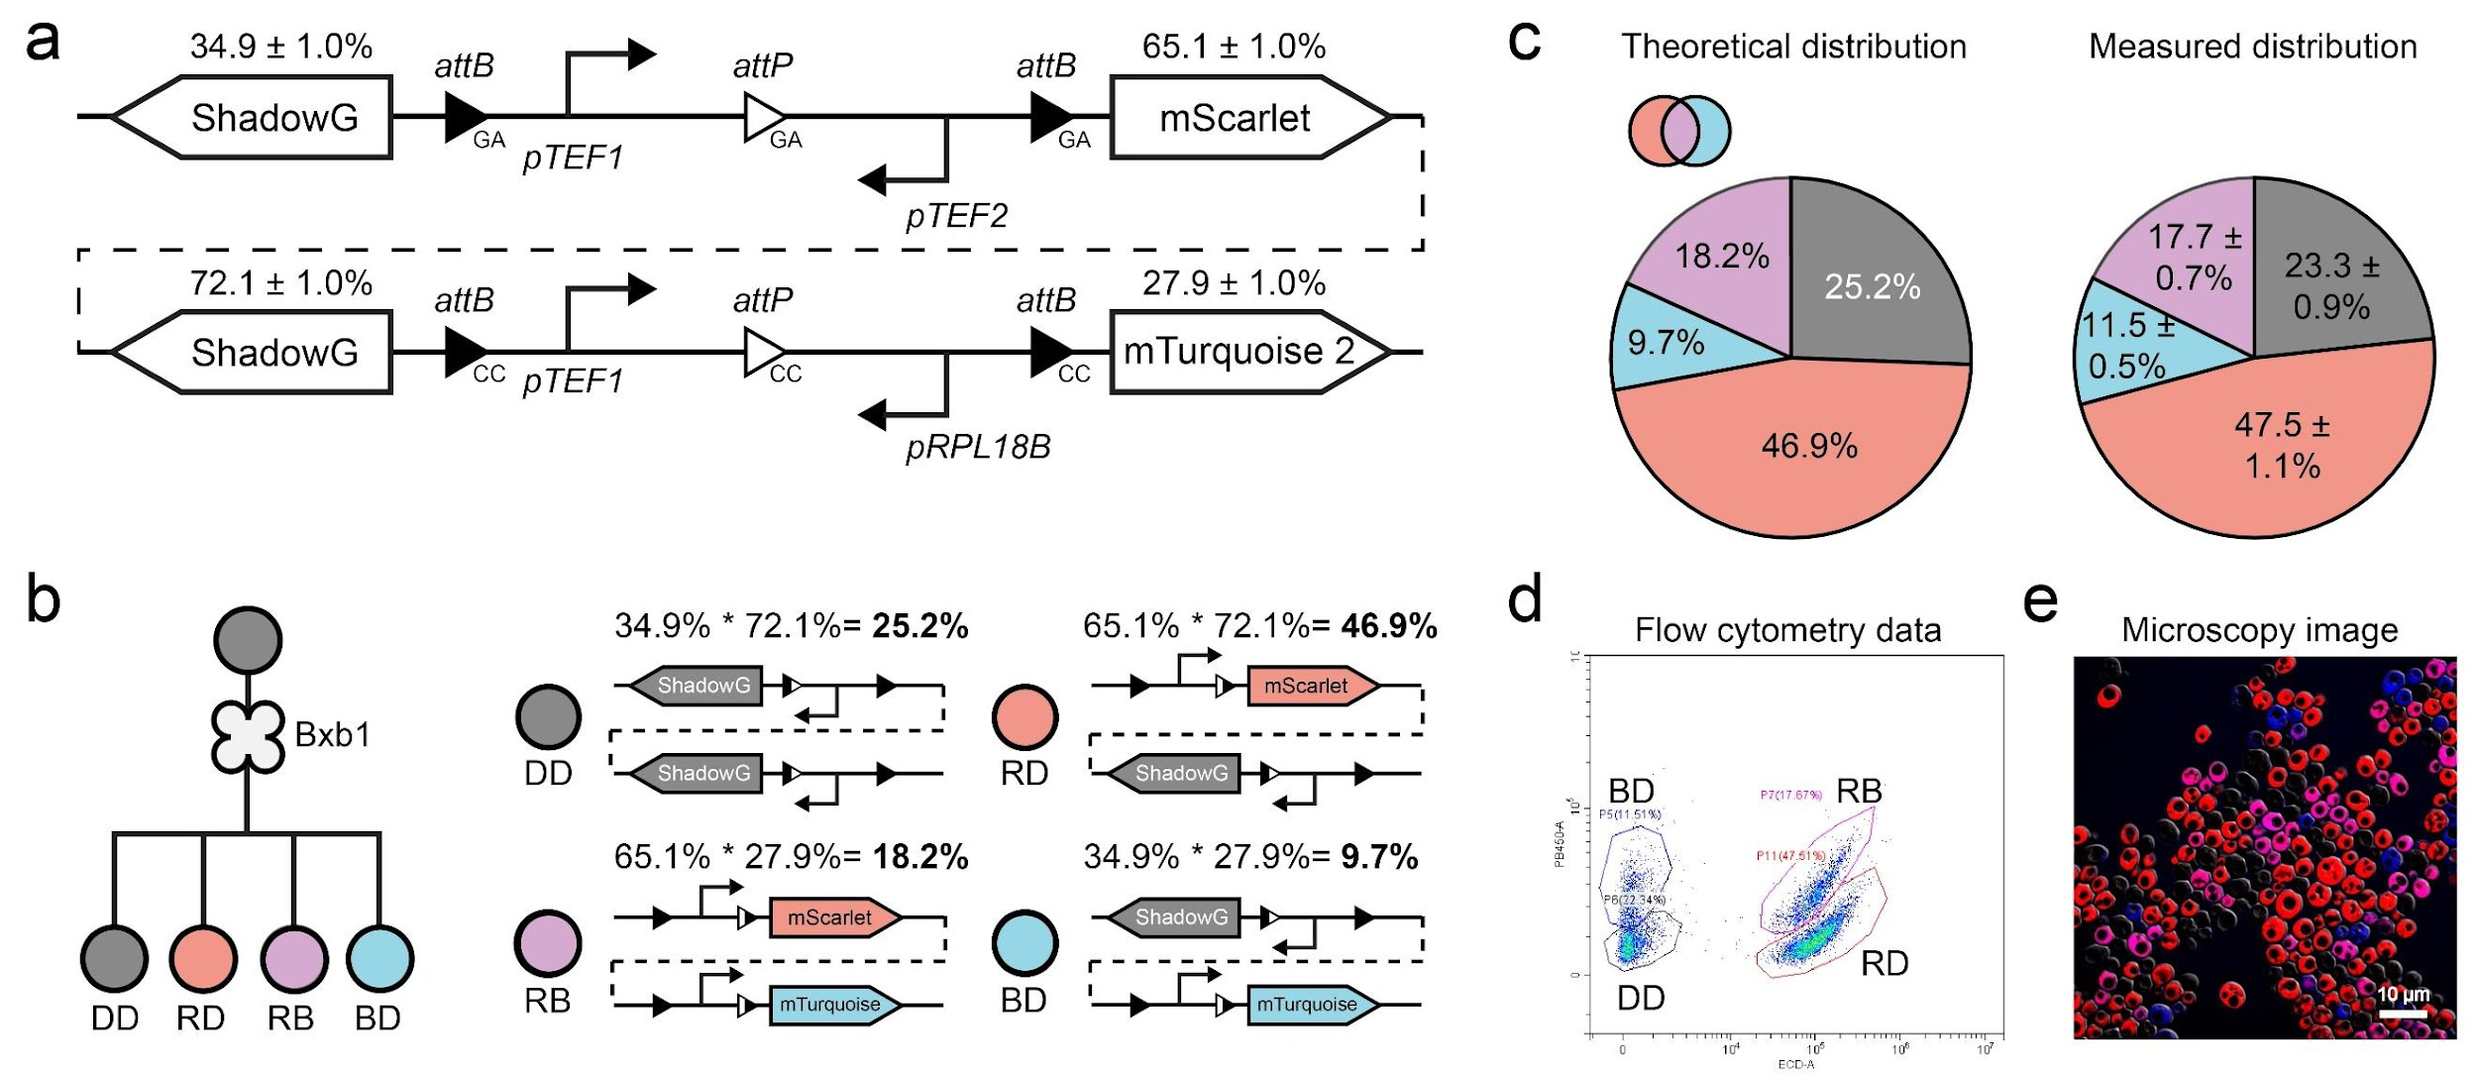
Fig. S49 | Characterization of a 2× orthogonal circuit with modified promoter usage. Compared to Fig. S46, changes in promoter design altered progeny distributions. Experiments were performed in triplicate.

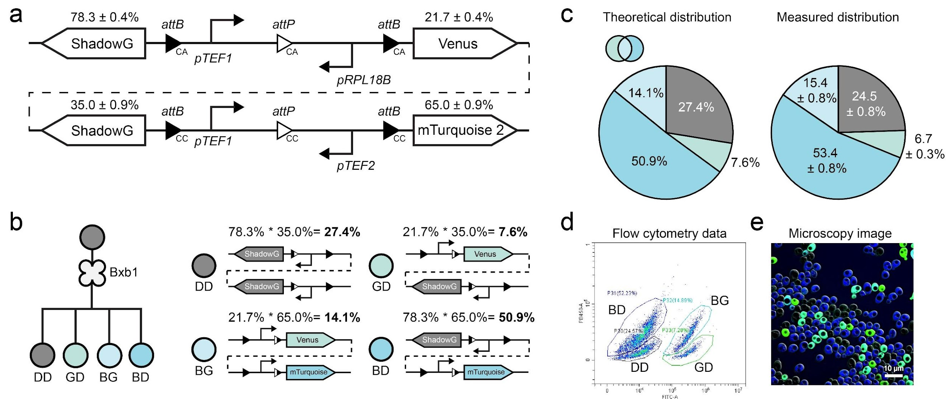
Fig. S50 | Characterization of a 2× orthogonal circuit using three reporters. The circuit was designed with ShadowG, Venus, and mTurquoise 2 reporters. Experiments were performed in triplicate.

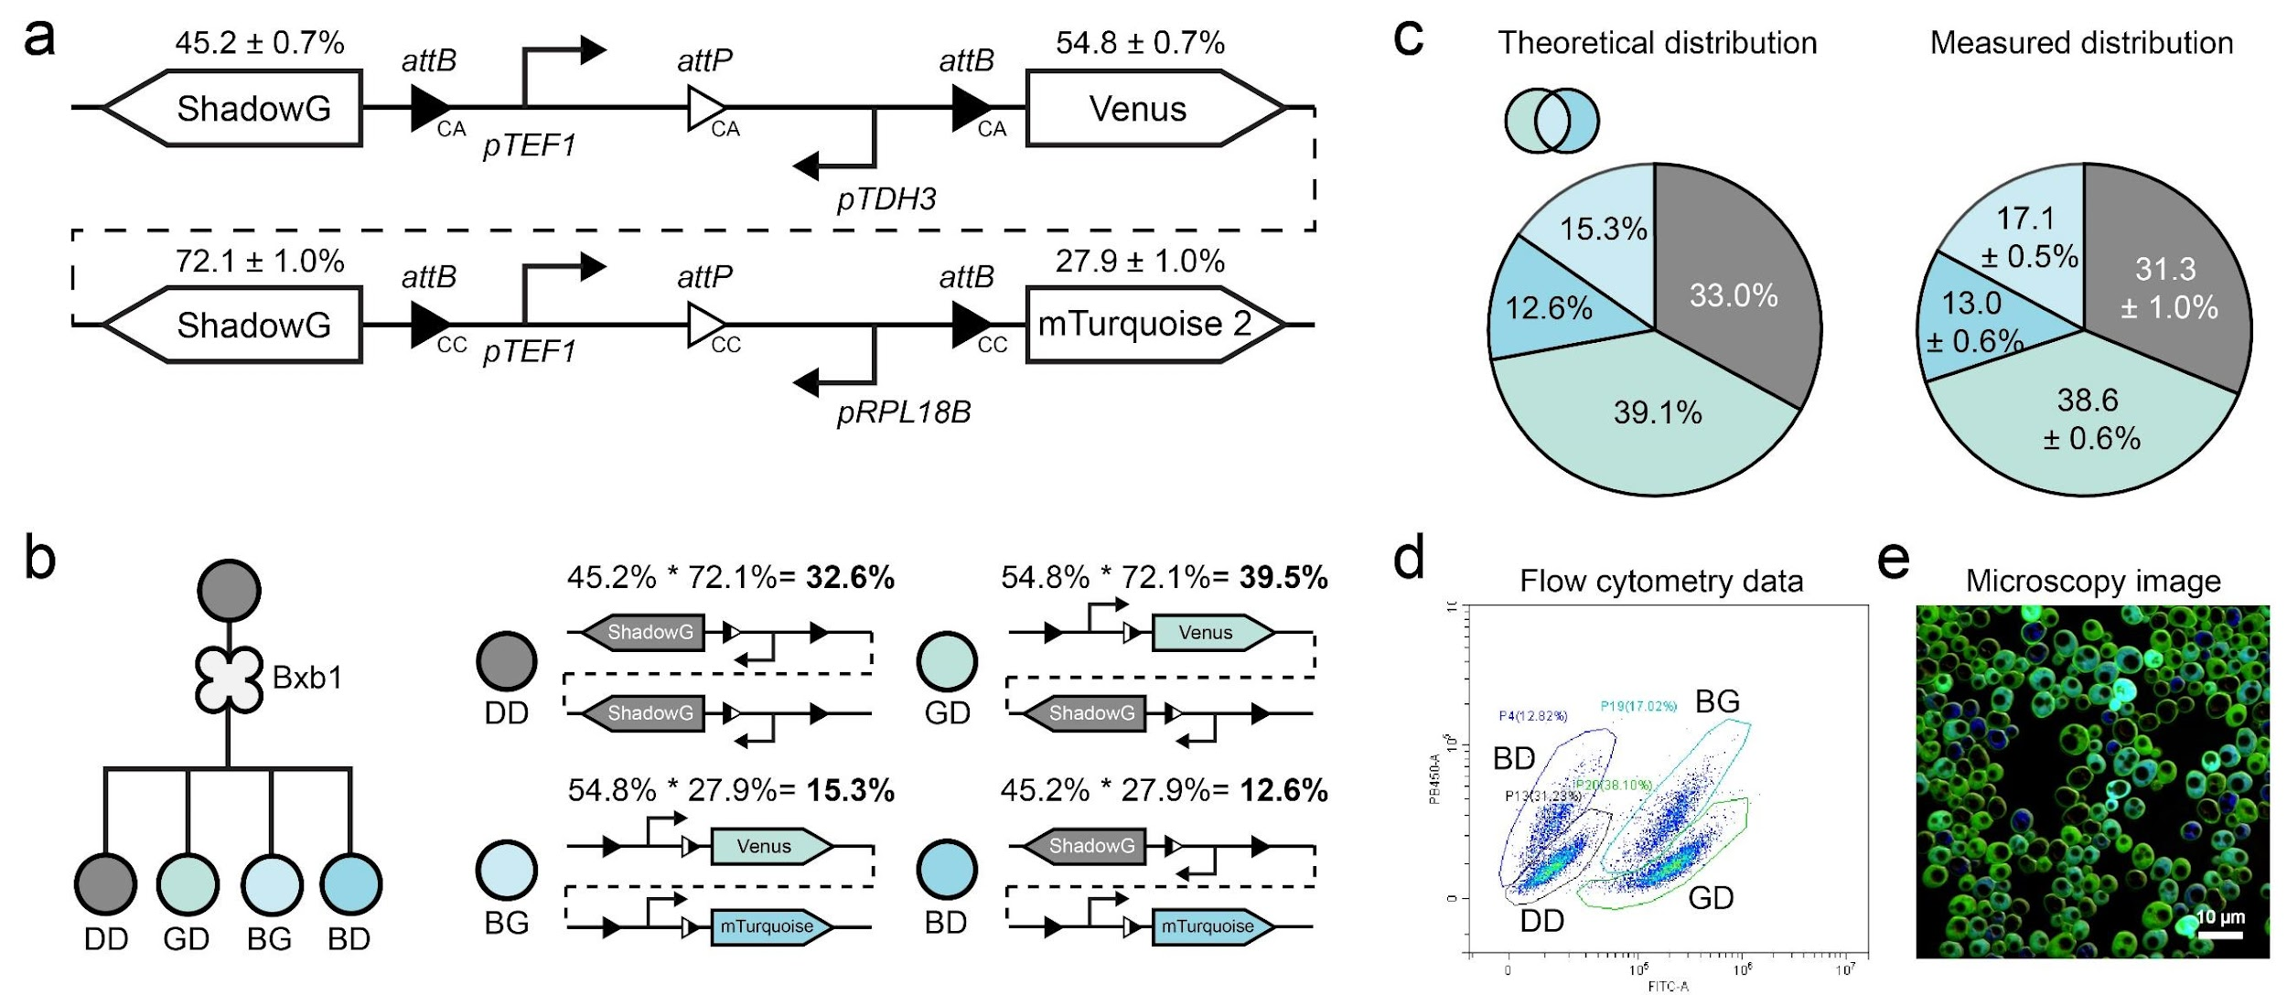
Fig. S51 | Characterization of a 2× orthogonal circuit with modified promoter usage. Compared to Fig. S50, changes in promoter design altered progeny distributions. Experiments were performed in triplicate.

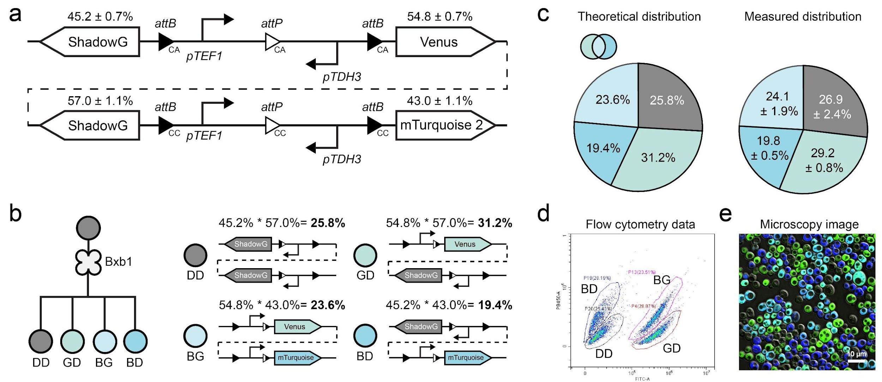
Fig. S52 | Characterization of a 2× orthogonal circuit with alternative promoter configurations. Compared to Fig. S50, changes in promoter design altered progeny distributions. Experiments were performed in triplicate.

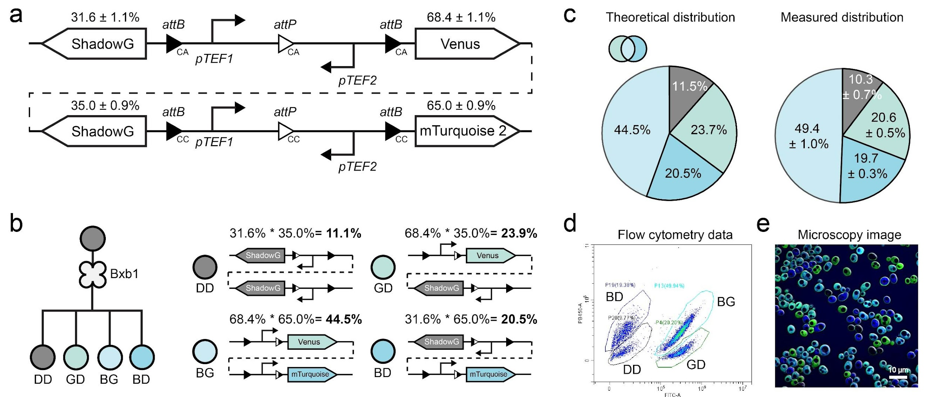
Fig. S53 | Characterization of a 2× orthogonal circuit with alternative promoter configurations. Compared to Fig. S50, changes in promoter design altered progeny distributions. Experiments were performed in triplicate.

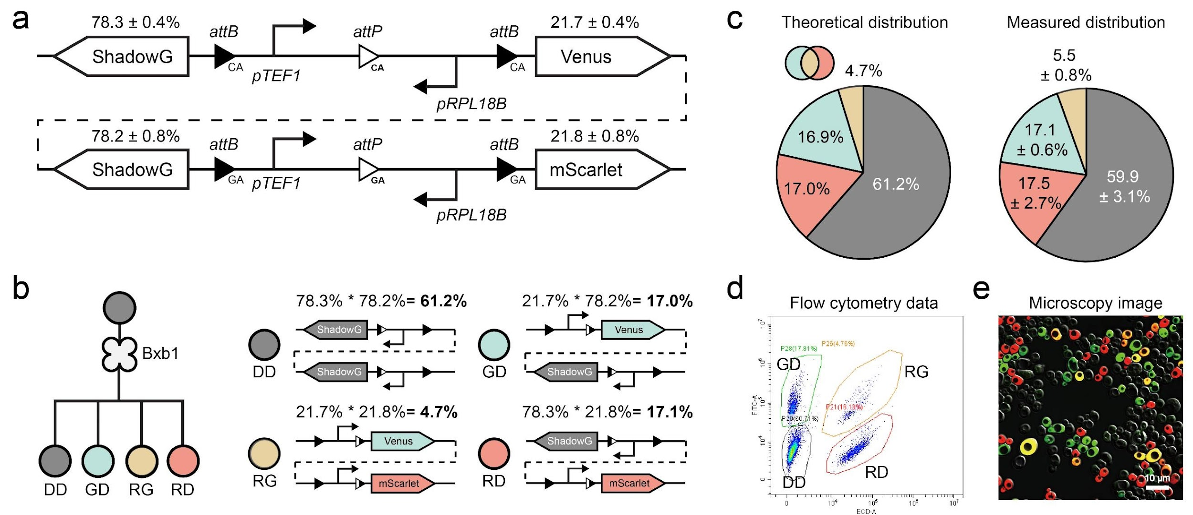
Fig. S54 | Characterization of a 2× orthogonal circuit using three reporters. The circuit was designed with ShadowG, Venus, and mScarlet reporters. Experiments were performed in triplicate.

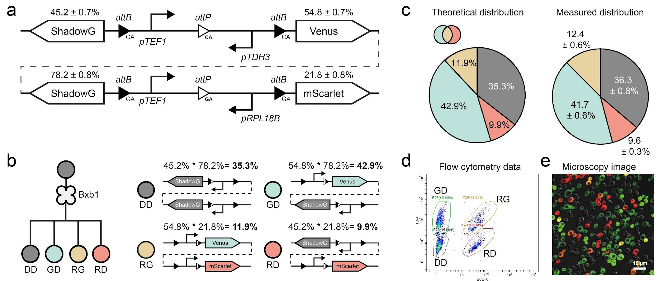
Fig. S55 | Characterization of a 2× orthogonal circuit with modified promoter configurations. Compared to Fig. S54, changes in promoter design altered progeny distributions. Experiments were performed in triplicate.

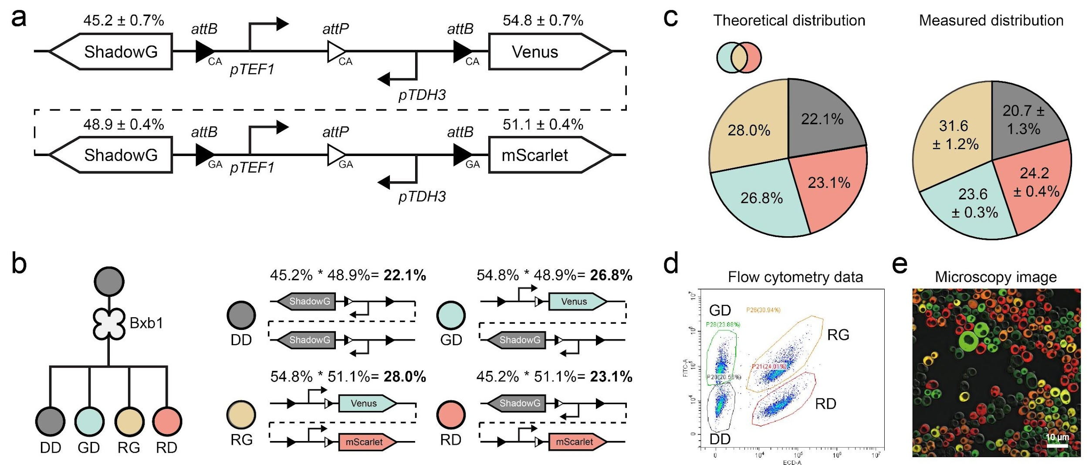
Fig. S56 | Characterization of a representative 2× orthogonal circuit with modified promoter configuration. Compared to Fig. S54, changes in promoter design altered progeny distributions. Experiments were performed in triplicate.

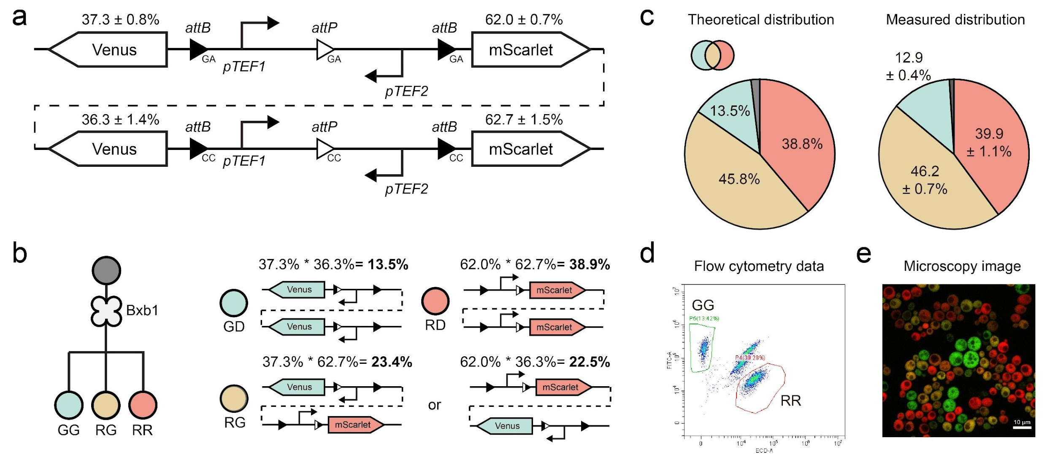
Fig. S57 | Characterization of a 2× orthogonal circuit using two reporters. The circuit was designed with Venus and mScarlet reporters. Experiments were performed in triplicate.

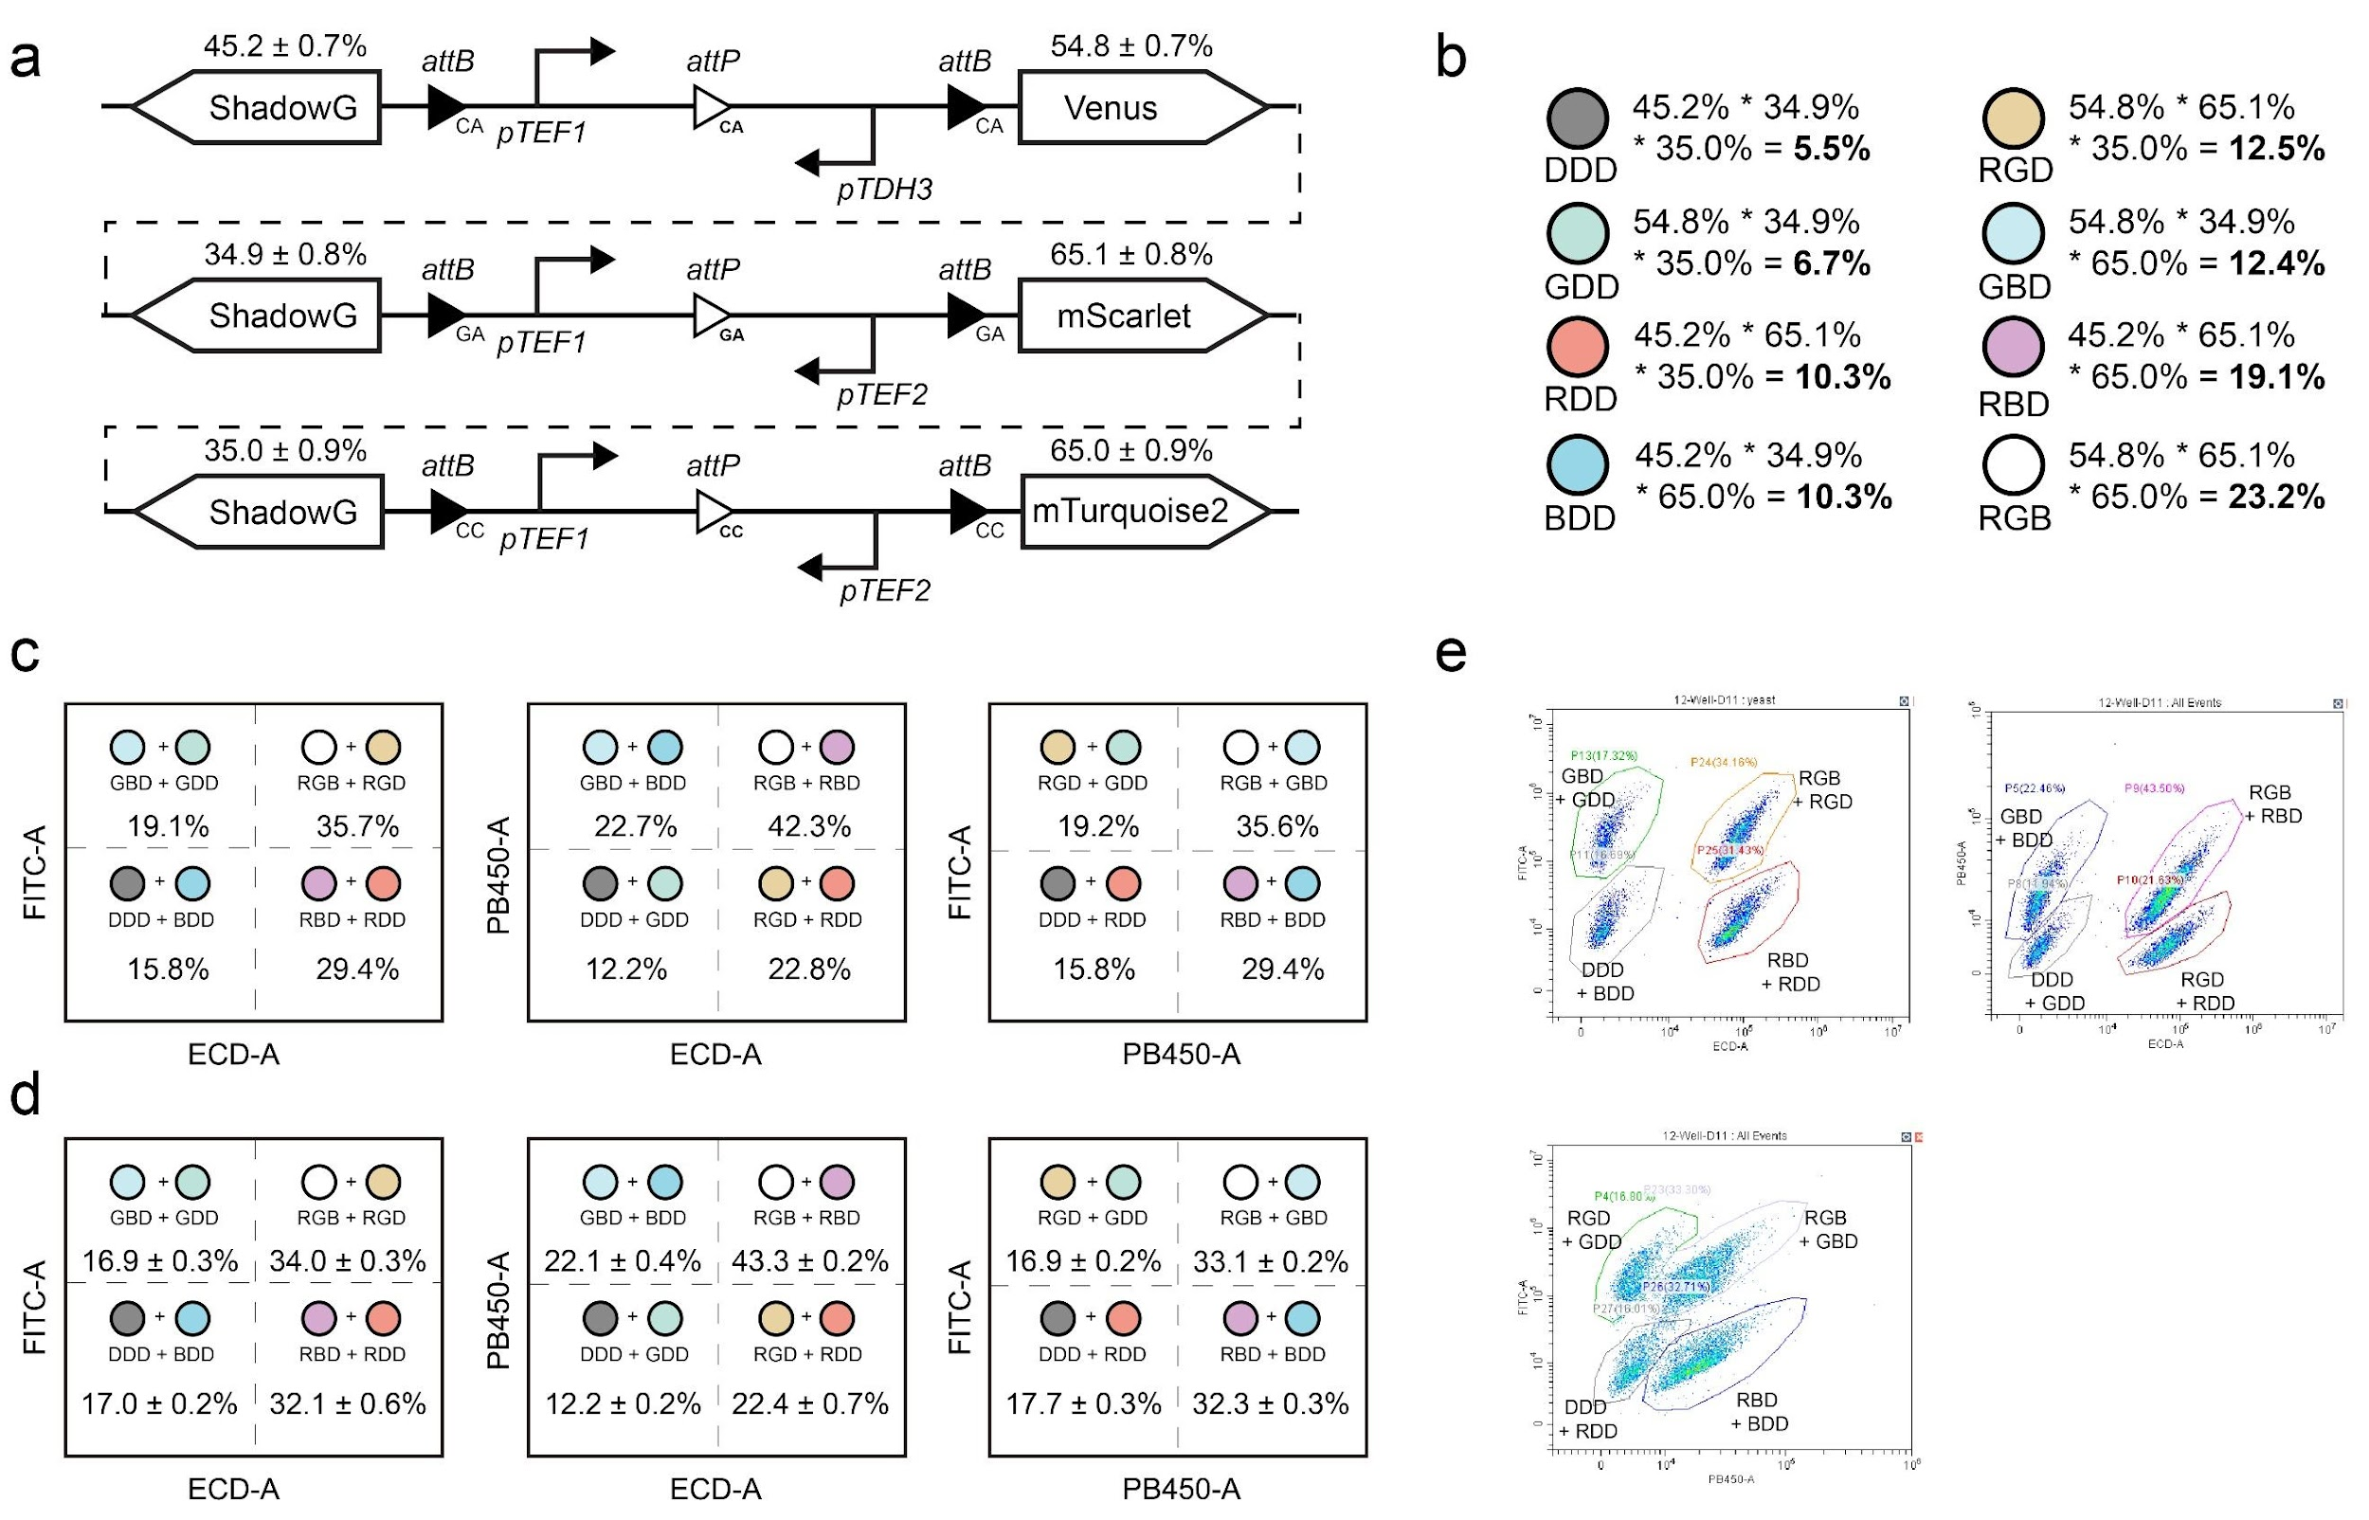
Fig. S58 | Design and characterization of a representative 3× orthogonal circuit. a. The 3× orthogonal gene circuits were designed, with the first circuit using CA versions of att sites, and pTEF1 and pTDH3 promoters to express ShadowG and Venus reporter genes. The second circuit employed GA att site versions and pTEF1 and pTEF2 as promoters, with ShadowG and mScarlet as reporters. The third circuit used CC att site versions and pTEF1 and pTEF2 as promoters, expressing ShadowG and mTurquoise 2. The progeny cell proportions represented the probabilities of reporter gene expression in the branching device. b. Theoretical proportions of progeny cell types generated by the designed branching device. c. Theoretical yeast consortia distributions as detected by flow cytometry. d. Experimentally measured progeny cell distributions using flow cytometry. e. Representative flow cytometry data showing progeny cell distributions from the 3× orthogonal circuit. Experiments were performed in triplicate.

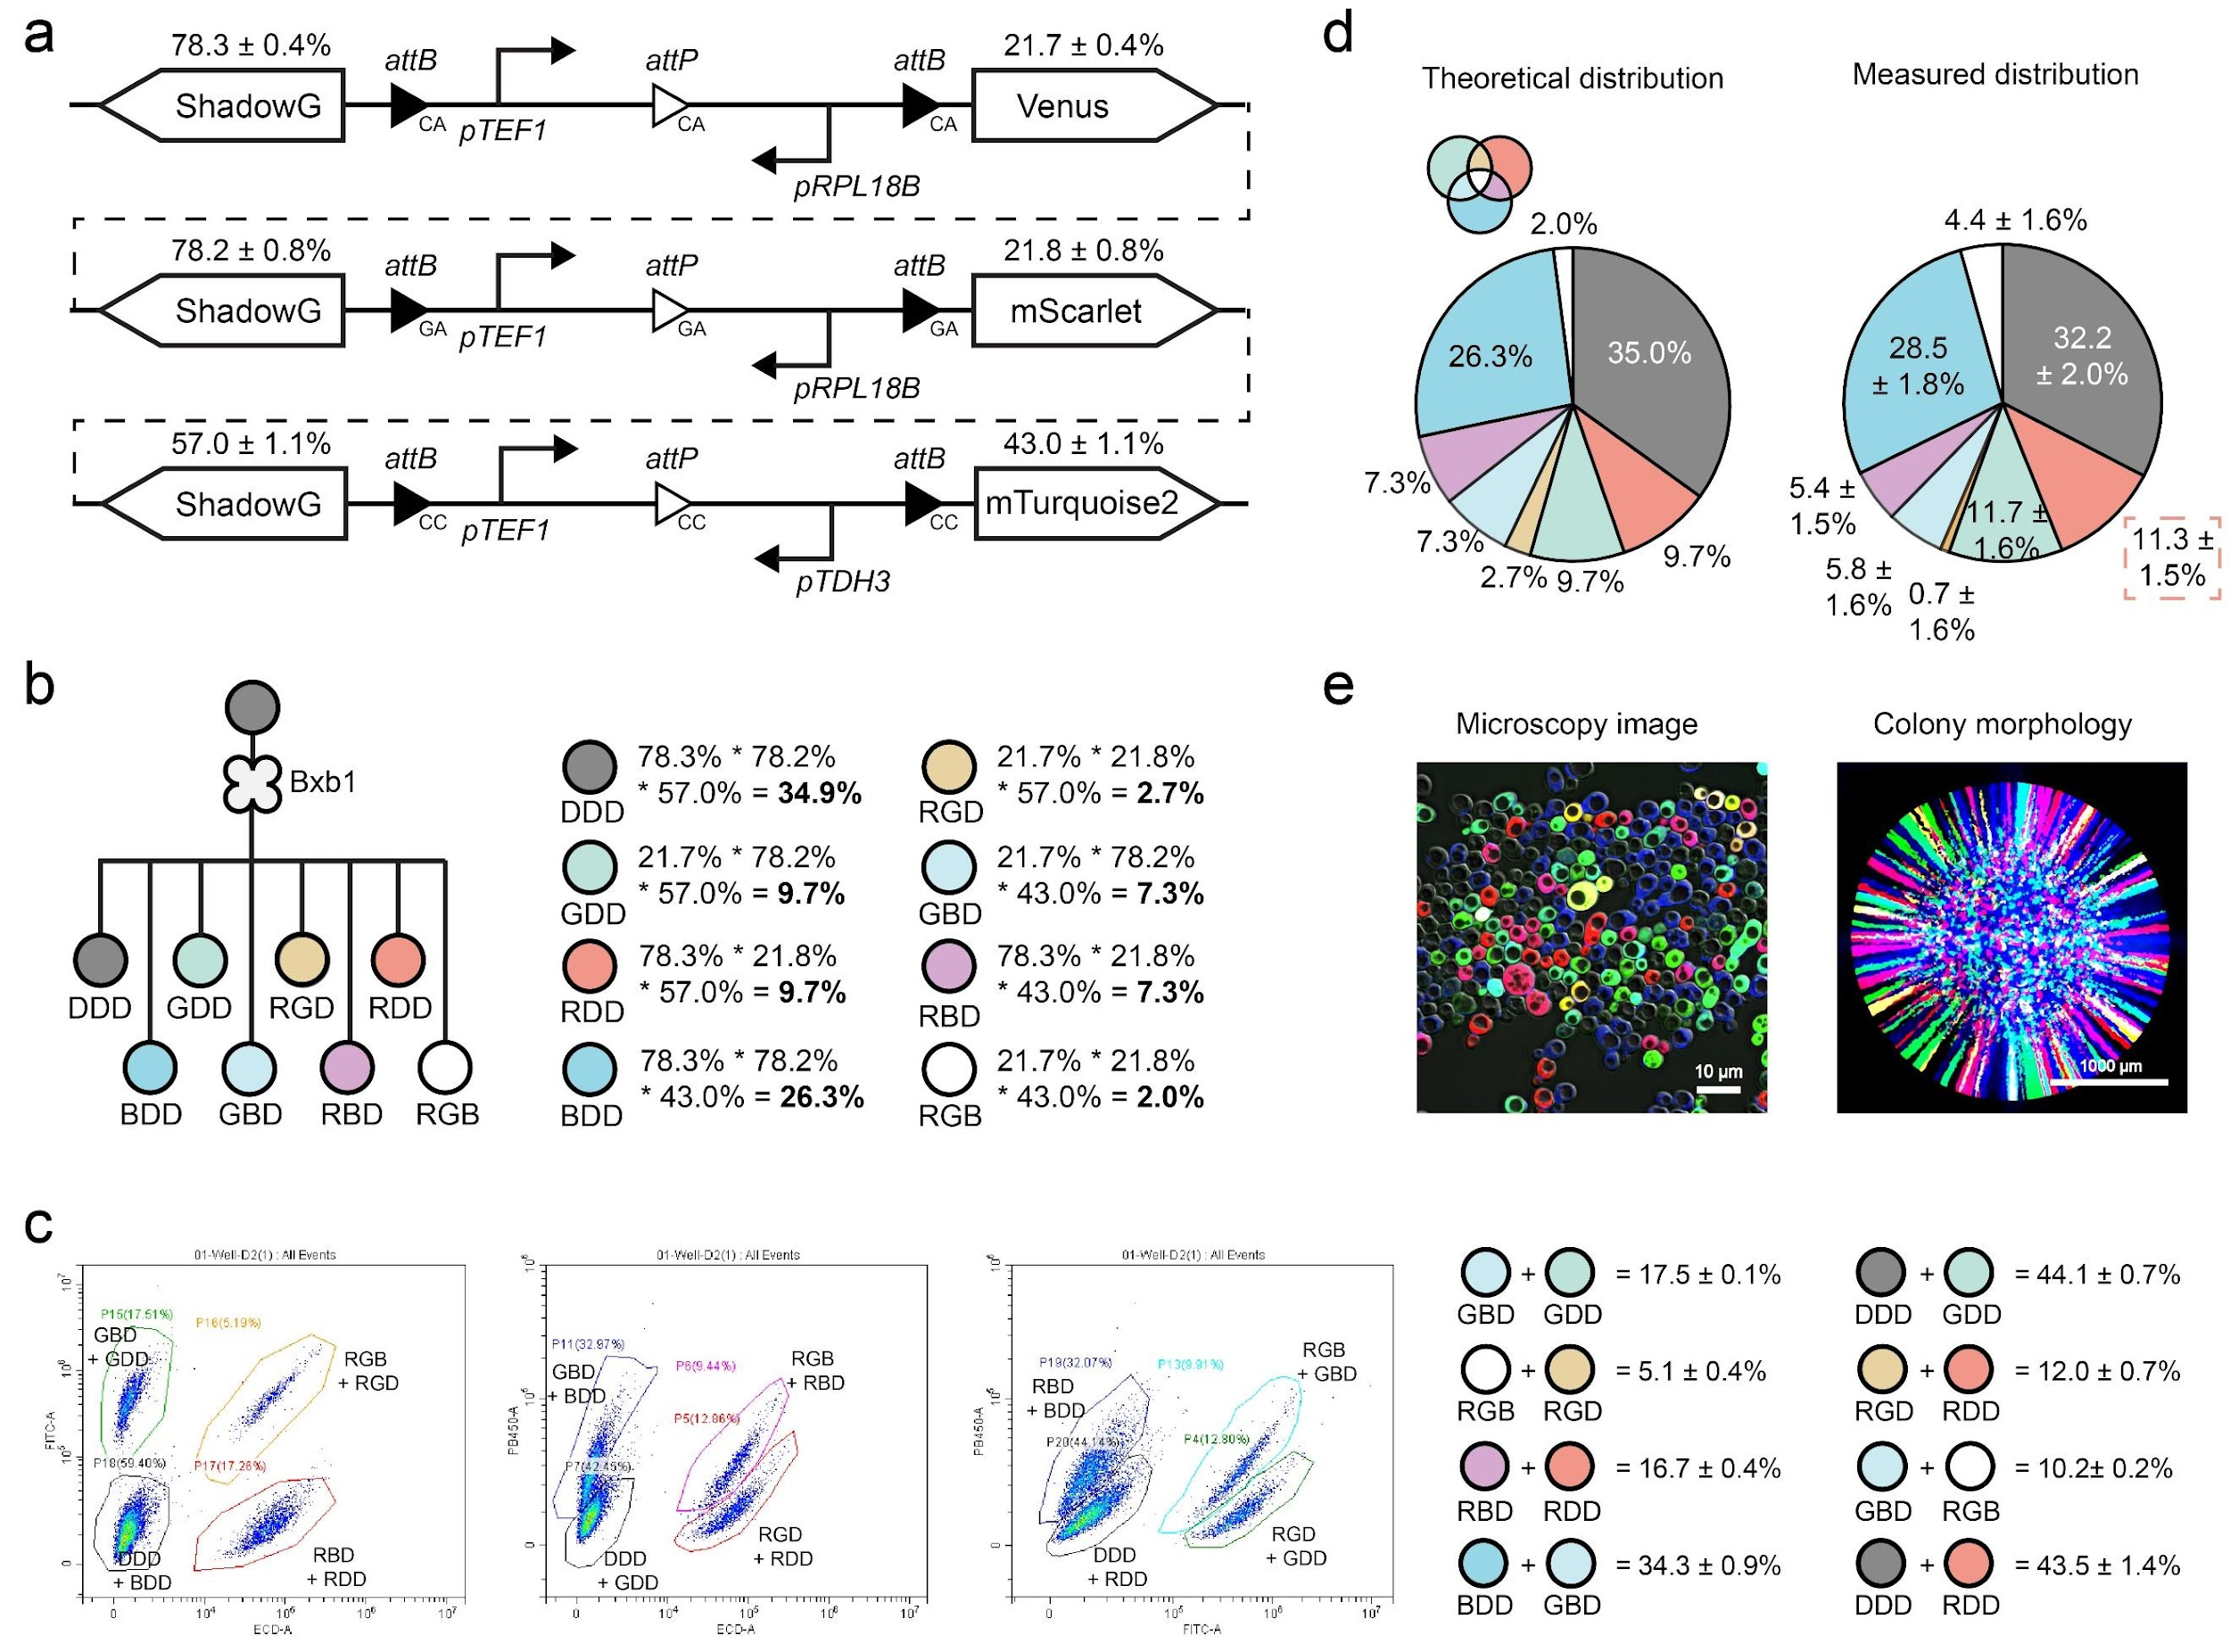
Fig. S59 | Design and characterization of a representative 3× orthogonal circuit. a. Design of the circuit. b. Theoretical types and proportions of progeny cells generated by the 3× orthogonal circuits. c. Representative flow cytometry images and statistical data showing progeny cell distributions. d. Theoretical yeast progeny proportions were compared to experimental values. Fluorescence imaging was used to determine the proportion of RDD cells, and these values were combined with flow cytometry data to estimate detailed progeny percentages. e. Fluorescence microscopy images display eight distinct yeast populations. Experiments were performed in triplicate.

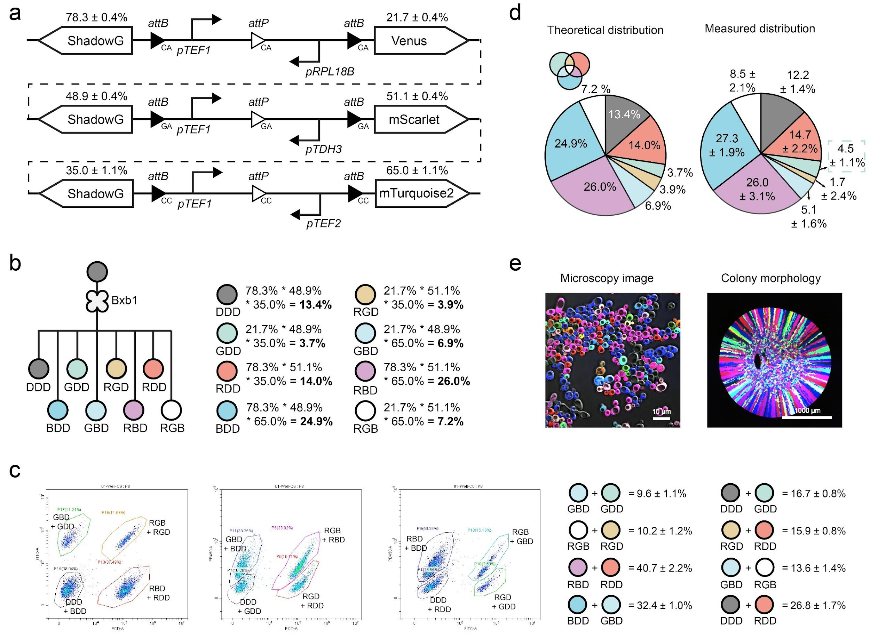
Fig. S60 | Design and characterization of a representative 3× orthogonal circuit. a. Design of the circuit. b. Theoretical types and proportions of progeny cells generated by the circuits. c. Representative flow cytometry images and statistical data showing progeny cell distributions. d. Theoretical yeast progeny proportions were compared to experimental values. Fluorescence imaging was used to estimate the proportion of GDD cells, and these values were combined with equations presented in Fig. S60c to calculate the distribution of all progeny strains. e. Fluorescence microscopy images display eight distinct yeast populations. Experiments were performed in triplicate.

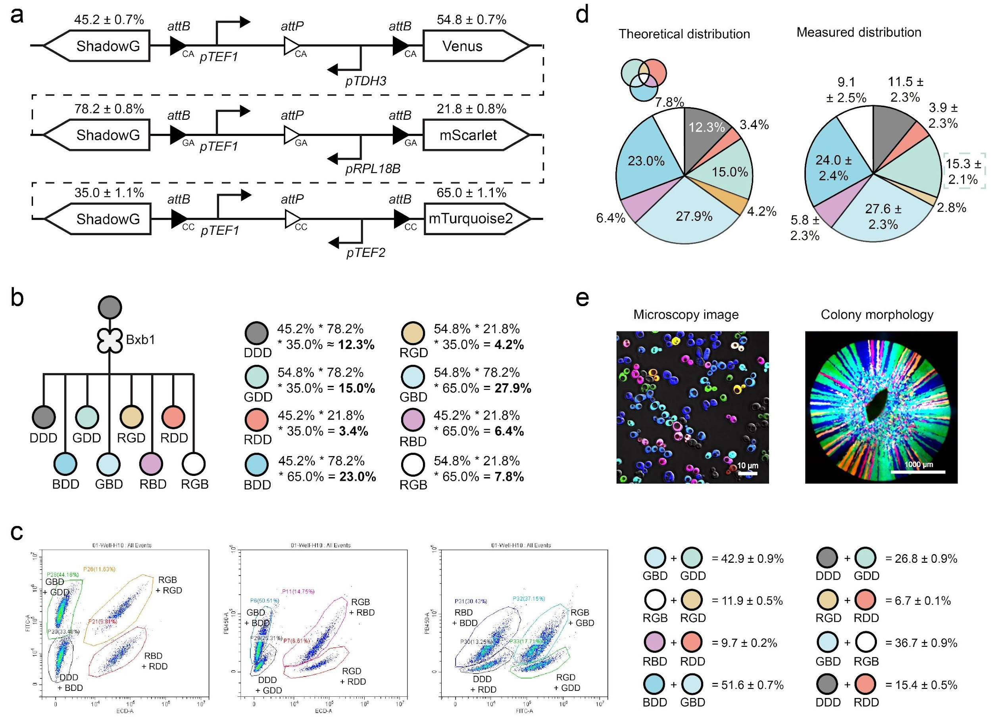
Fig. S61 | Design and characterization of a representative 3× orthogonal circuit. a. Design of the circuit. b. Theoretical types and proportions of progeny cells generated by the circuits. c. Representative flow cytometry images and statistical data showing progeny cell distributions. d. Theoretical yeast progeny proportions were compared to experimental values. Fluorescence imaging was used to estimate the proportion of GDD cells, and these values were combined with the equations presented in Fig. S61c to calculate the distribution of all progeny strains. e. Fluorescence microscopy images display eight distinct yeast populations. Experiments were performed in triplicate.

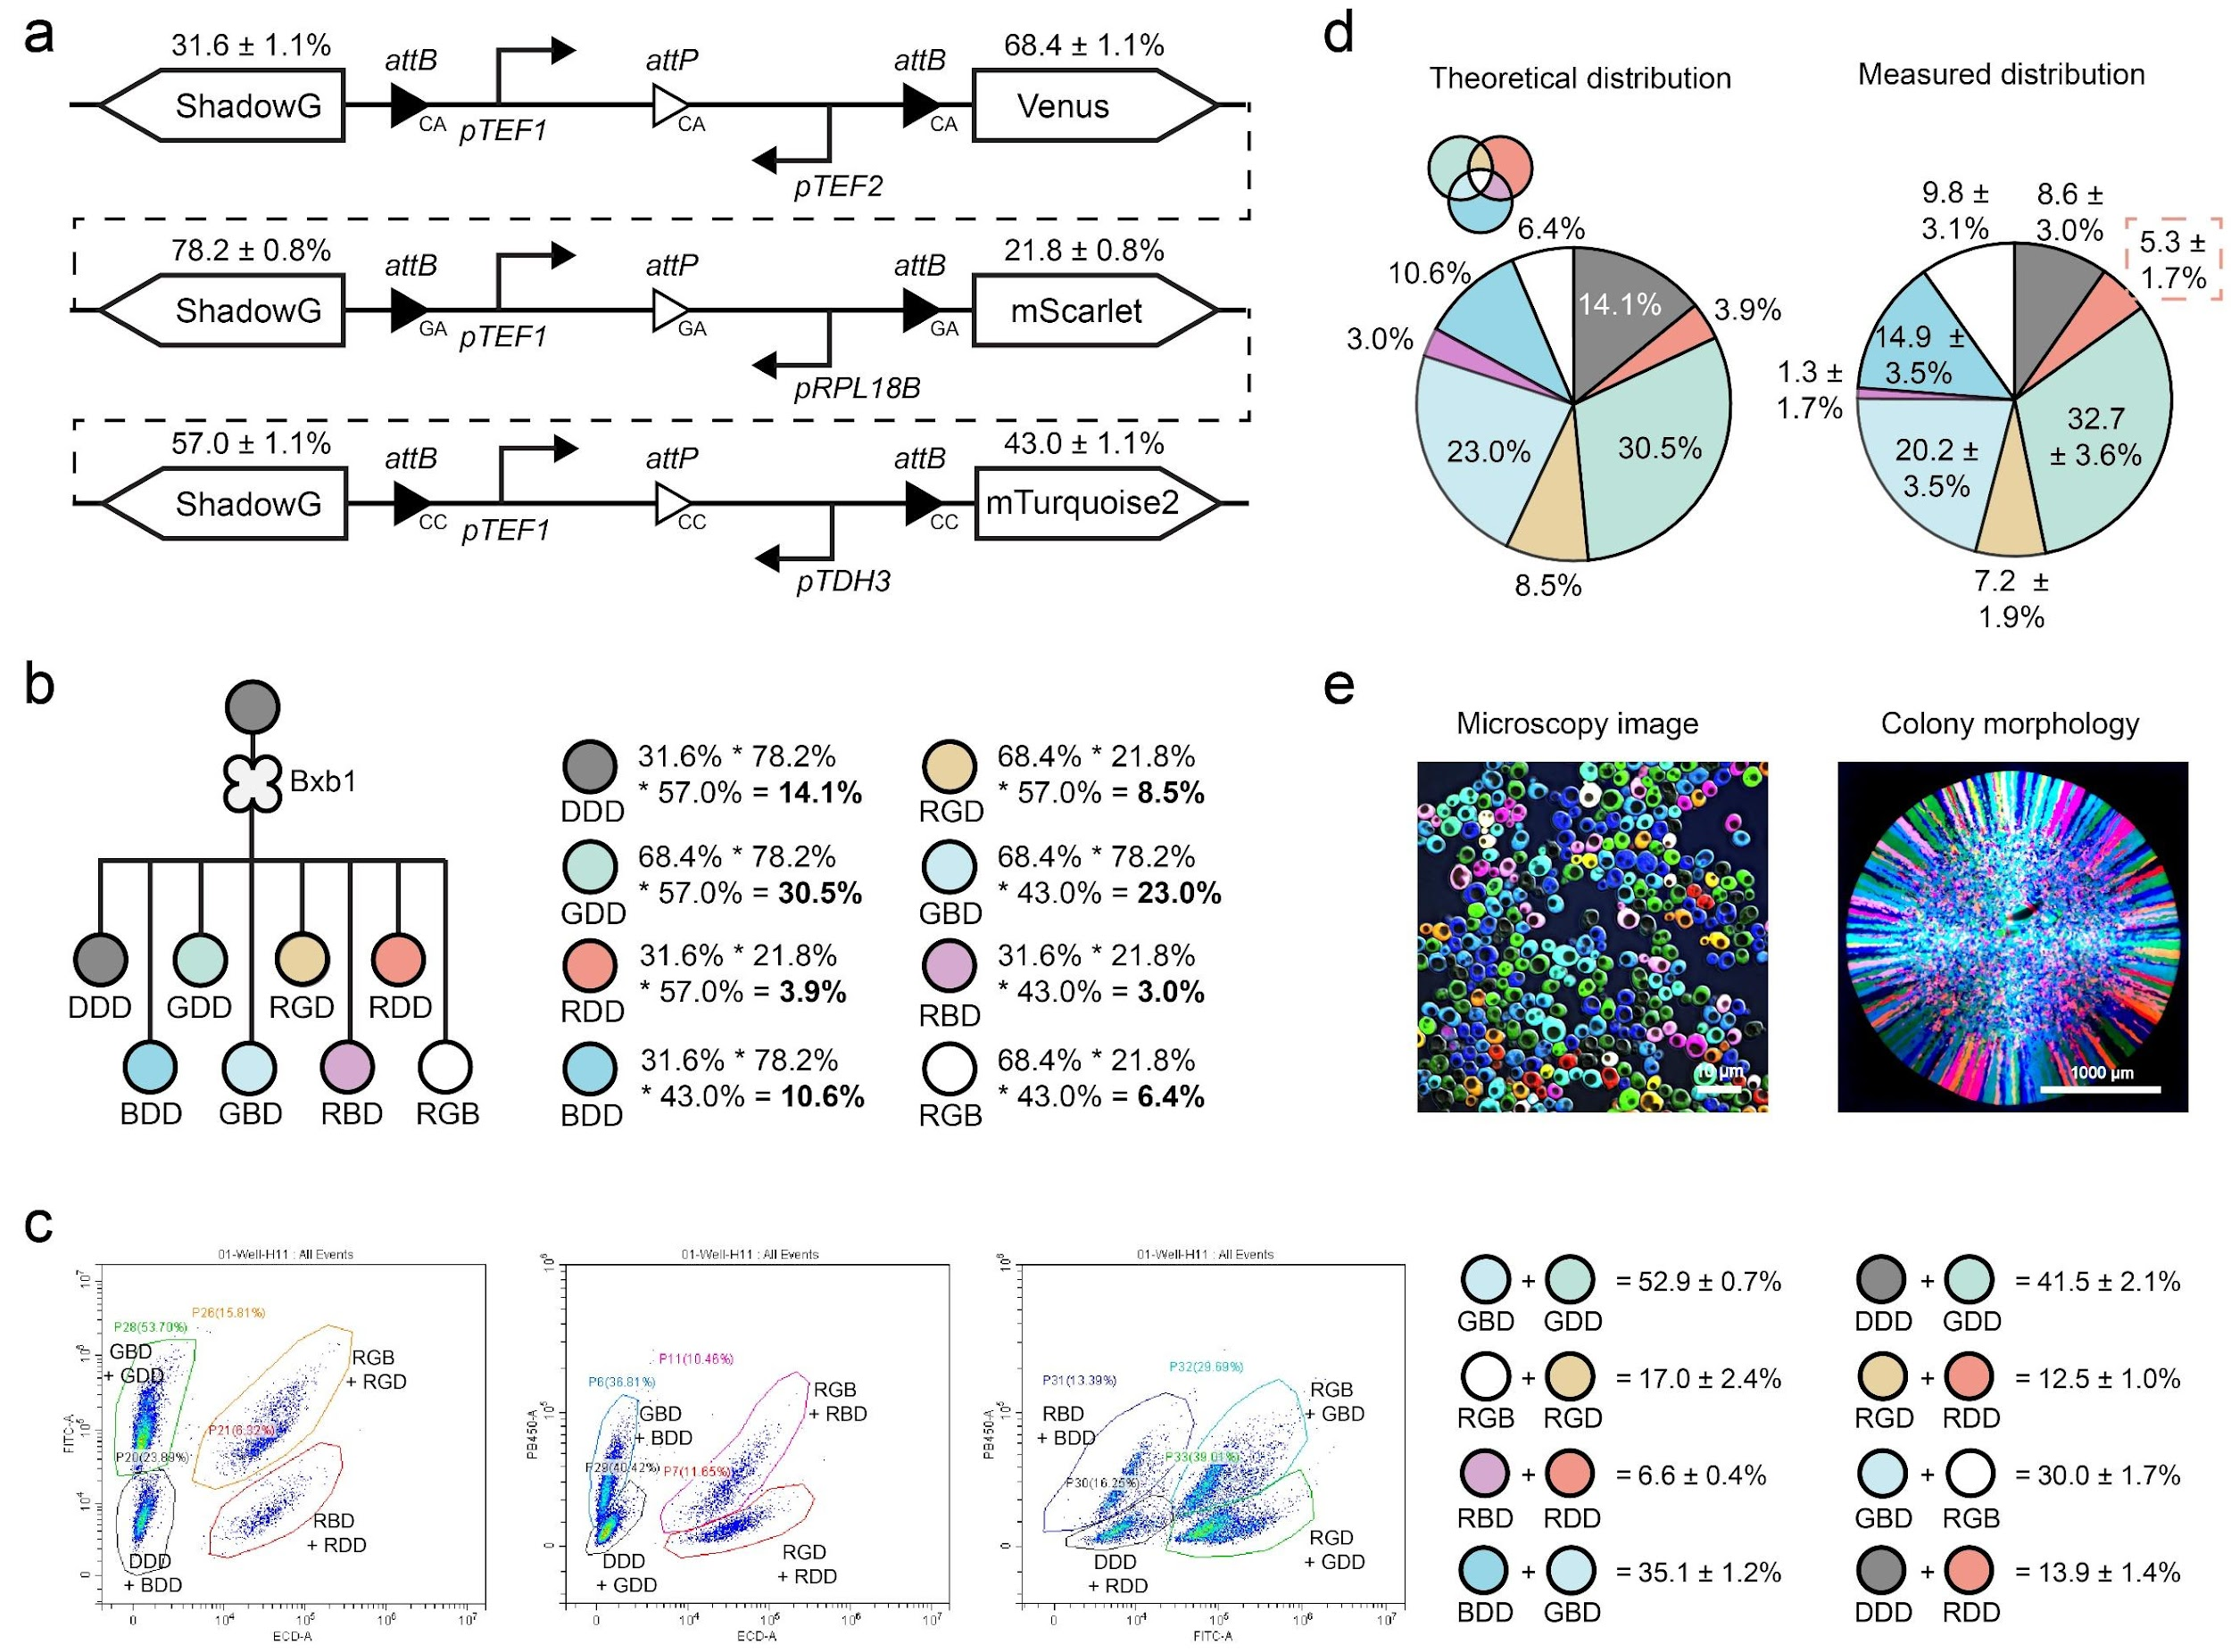
Fig. S62 | Design and characterization of a representative 3× orthogonal circuit. a. Design of the circuits. b. Theoretical types and proportions of progeny cells generated by the circuits. c. Representative flow cytometry images and statistical data showing progeny cell distributions. d. Theoretical yeast progeny proportions were compared to experimental values. Fluorescence imaging was used to estimate the proportion of RDD cells, and these values were combined with equations presented in Fig. S62c to calculate the distribution of all progeny strains. e. Fluorescence microscopy images display eight distinct yeast populations. Experiments were performed in triplicate.

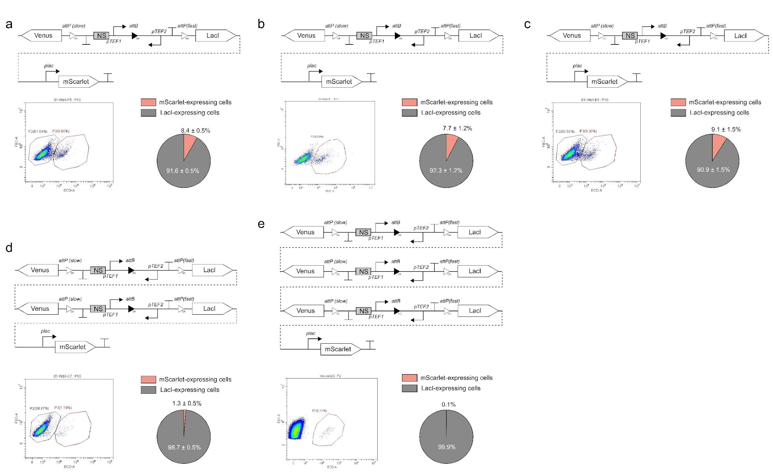
Fig. S63 | Design and characterization of parallel branching devices for achieving extreme ratios. a-c. Three gene circuits were designed using orthogonal att site variants (GA, CA, and CC), each using pTEF1 and pTEF2 promoters with Venus and LacI as reporter genes. LacI expression inhibits the pLac promoter, enabling only progeny yeast with left-arm excision to produce mScarlet. The probabilities of generating mScarlet-producing strains across these circuits vary from 7.7 ± 1.2% to 9.1 ± 1.5%. d. With mScarlet expression probabilities of 8.4 ± 0.5% and 7.7 ± 1.2%, the calculated probability for mScarlet expression in strains with the 2× orthogonal circuits is approximately 0.6%, closely aligning with the observed experimental value of 1.3 ± 0.5%. e. For strains with 3× orthogonal gene circuits, the probabilities of mScarlet expression in each were 8.4 ± 0.5%, 7.7 ± 1.2%, and 9.1 ± 1.5%. This results in a combined mScarlet expression probability of around 0.1% in theory, consistent with the observed experimental value. Experiments were performed in triplicate.

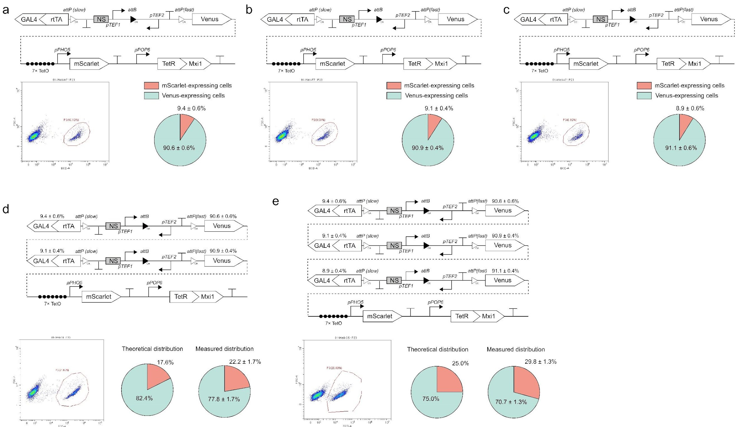
Fig. S64 | Design and characterization of parallel branching devices for controlling progeny cell compositions. a-c. Gene circuits were designed using three orthogonal att site variants (GA, CA, and CC), respectively. Due to the presence of repressor TetR-Mxi1, the expression of mScarlet was inhibited. In each circuit, there is approximately a 9% probability of producing rtTA-GAL4, which interacts with aTc molecules to trigger mScarlet expression, producing mScarlet and emit red fluorescence. d. The progeny cell composition is generated from the founder cell encoding two orthogonal gene circuits. The likelihood of not expressing mScarlet is the chance neither circuit produces rtTA-GAL4. Thus, in these two orthogonal circuits, the probability of mScarlet expression in progeny cells is (1 − 0.906 × 0.909) × 100% ≈ 17.6%. The statistical data from flow cytometry revealed that the proportion of mScarlet-expressing yeast was 22.2 ± 1.7%, closely aligning with the theoretical values. e. The progeny cell composition arising from mother cells encoding three orthologous gene circuits. The likelihood of not expressing mScarlet is the chance that none of these three circuits produces TetA-GAL4. The probability of mScarlet expression in progeny cells is (1 − 0.906 × 0.909 × 0.911) × 100% ≈ 25.0%. The statistical data from flow cytometry revealed that the proportion of mScarlet-expressing yeast was 29.8 ± 1.3%, closely aligning with the theoretical values. Experiments were performed in triplicate.

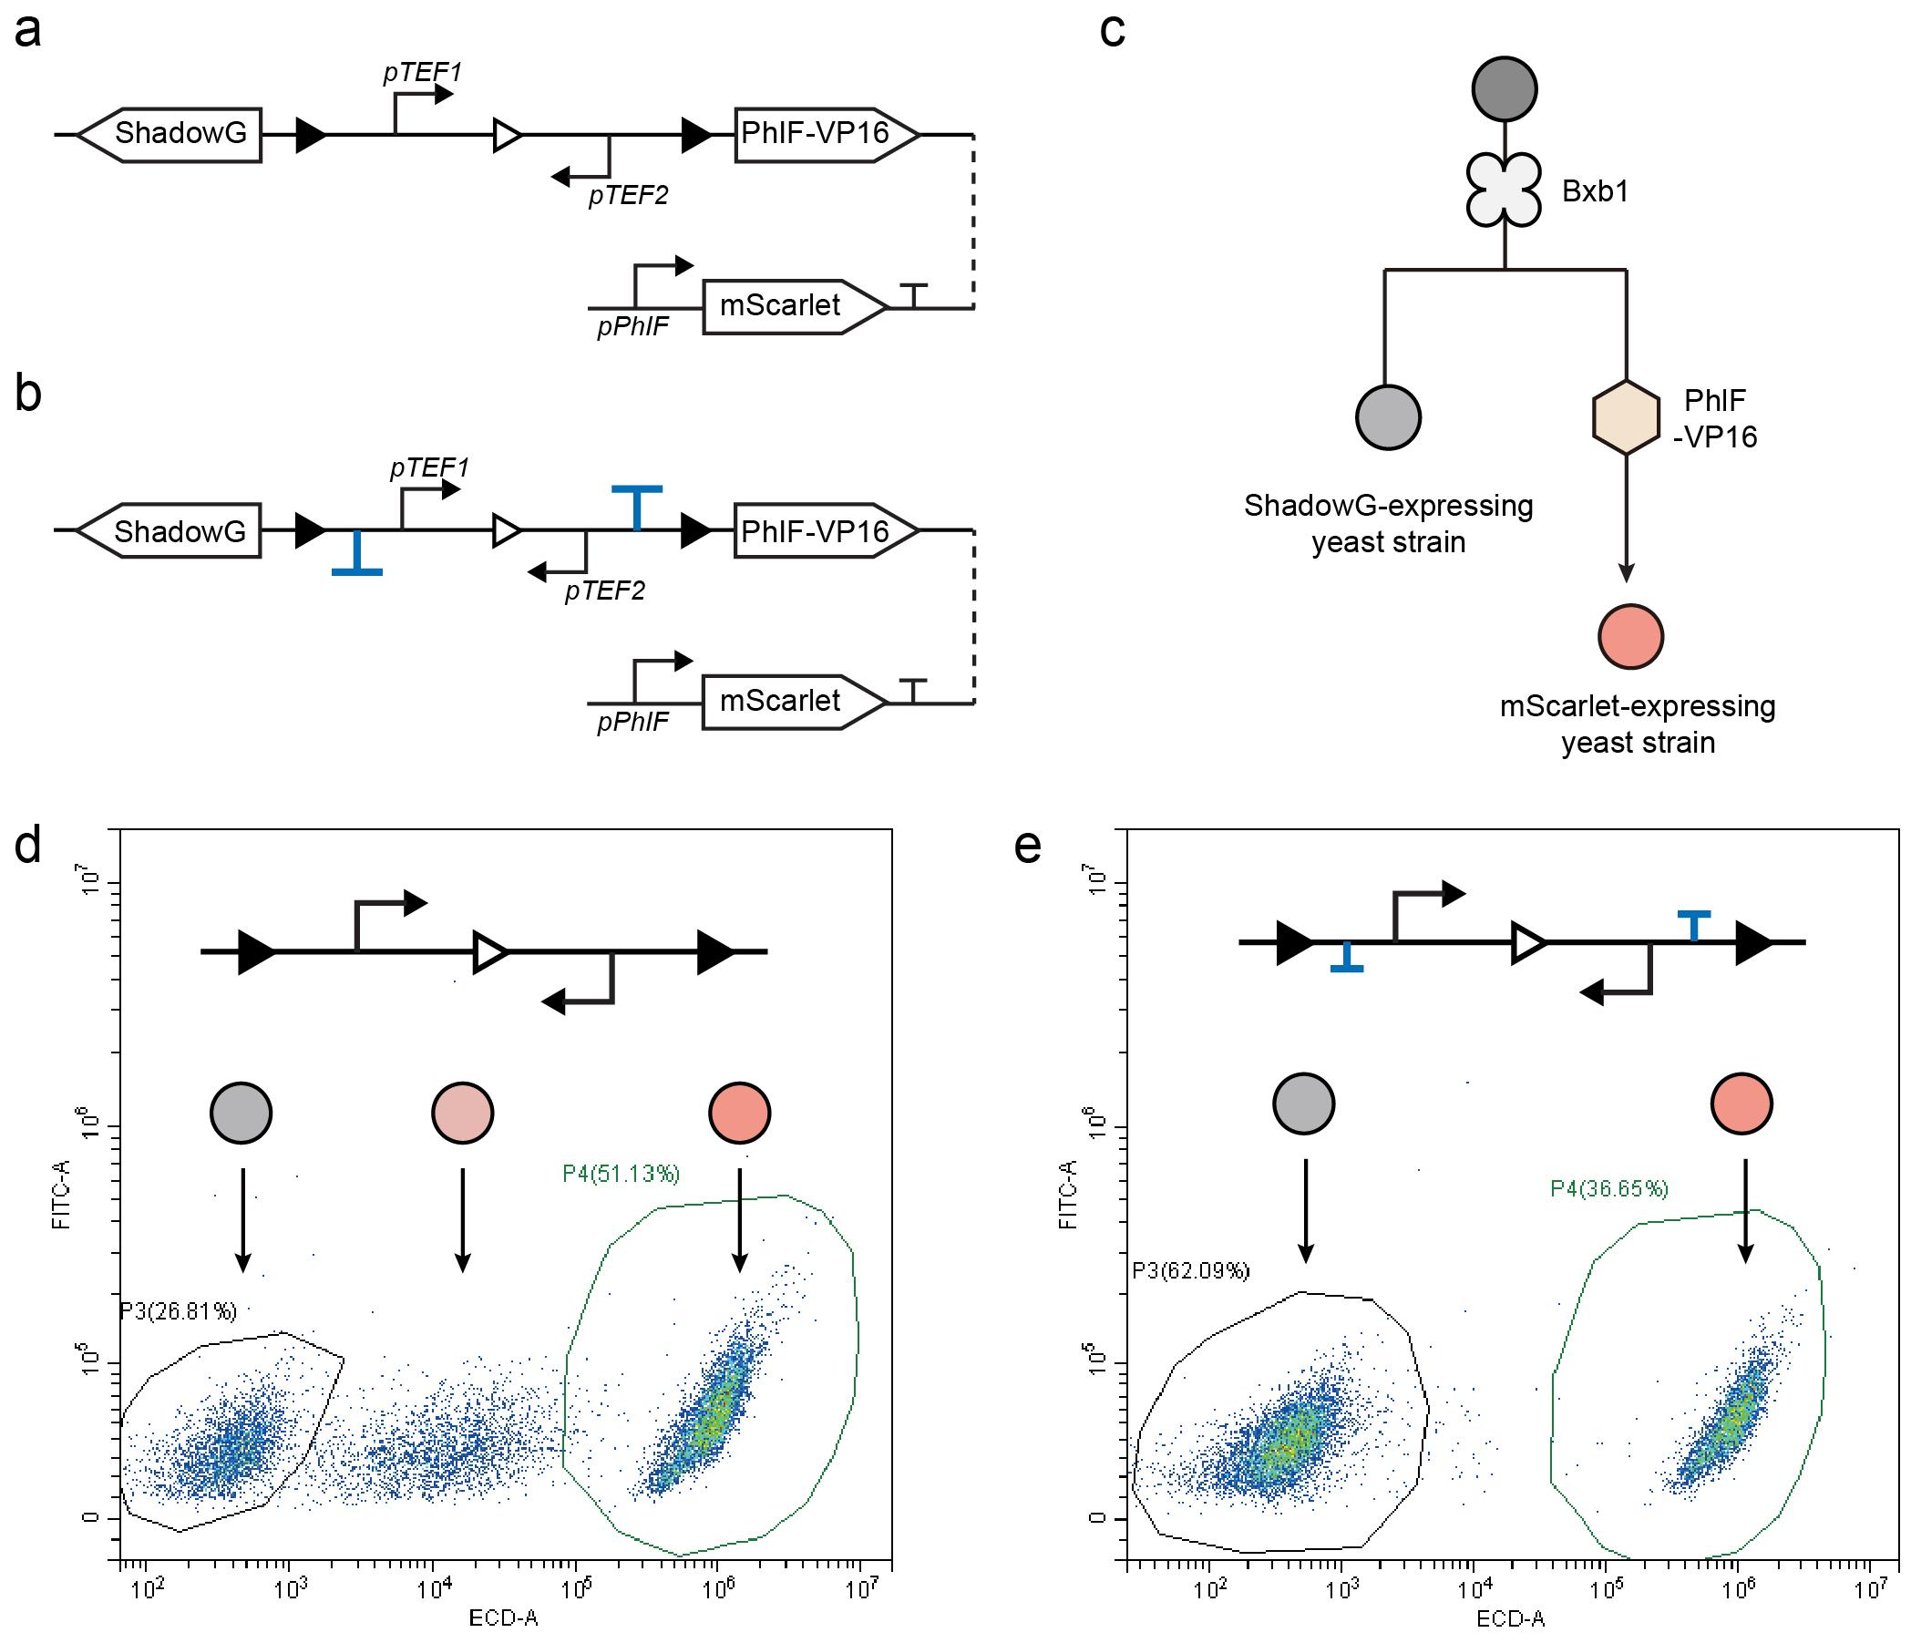
Fig. S65 | Enhancing gene circuit performance by incorporating terminators between att sites. a. The branching circuit in this experiment was designed to produce yeast progeny expressing either ShadowG or PhIF-VP16, a transcriptional factor that induces mScarlet expression via the pPhIF promoter. Leaky expression of PhIF-VP16 could convert non-fluorescent ShadowG-expressing yeast into red fluorescent cells. b. To prevent leaky expression of the PhIF-VP16, two yeast terminators were inserted between att sites in the genetic circuit. c. Founder cells gradually differentiate into strains expressing either ShadowG or mScarlet. d. Representative flow cytometry data show that some cells in the original circuit (a) exhibit unintended red fluorescence. e. Flow cytometry data show that incorporating terminators into the circuit (b) successfully reduces cells with unintended red fluorescence. Experiments were performed in triplicate.

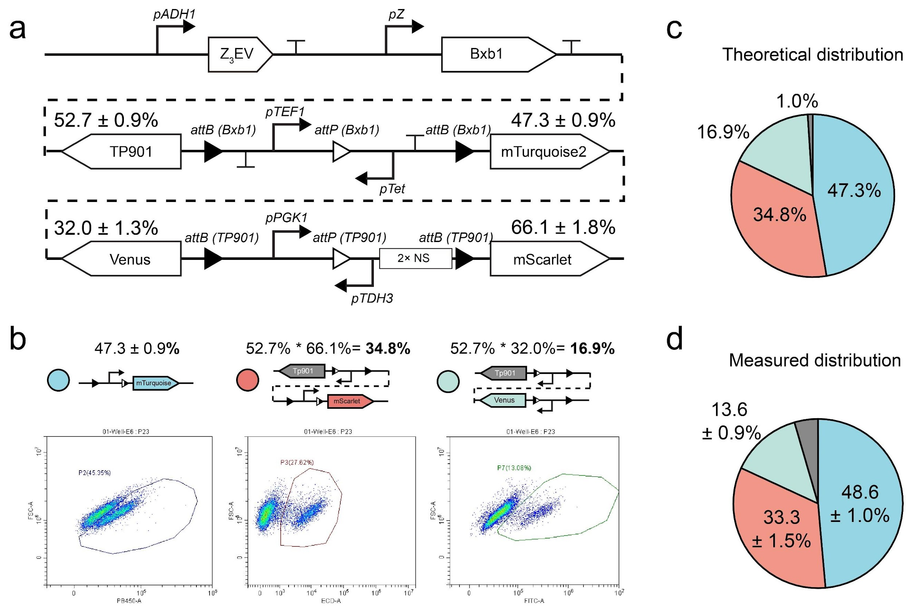
Fig. S66 | Characterization of a representative cascading branching device. a. Schematic of the 2-layer branching circuit design. b. The theoretical proportion of progeny cell outcomes is calculated by multiplying the expression probabilities of relevant genes in each circuit. c. Theoretical distribution of progeny cell proportions. The 1.0% of non-fluorescent cells is likely due to the inefficient catalysis of the Tp901-recognized circuit, as shown in Fig. S37d. d. Experimental measurements of progeny proportions align well with theoretical predictions. Experiments were performed in triplicate.

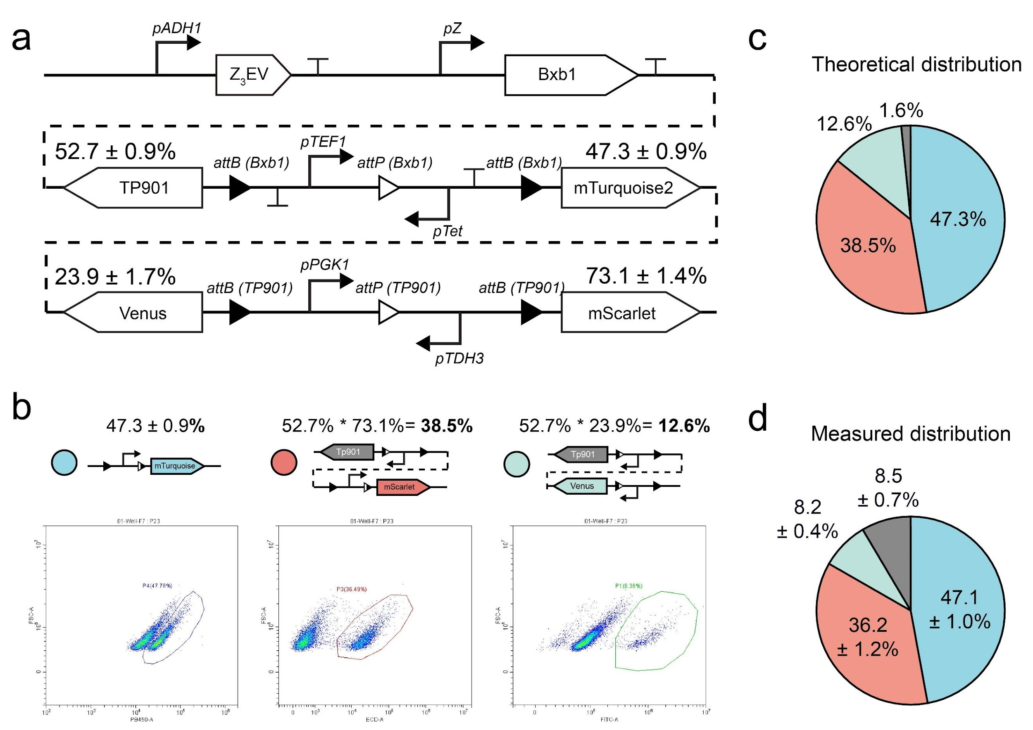
Fig. S67 | Characterization of a representative cascading branching device. a. Schematic of the 2-layer branching circuit design. b. The theoretical proportion of progeny cell outcomes is calculated by multiplying the expression probabilities of relevant genes in each circuit. c. Theoretical distribution of progeny cell proportions. d. Experimental measurements of progeny proportions. Experiments were performed in triplicate.

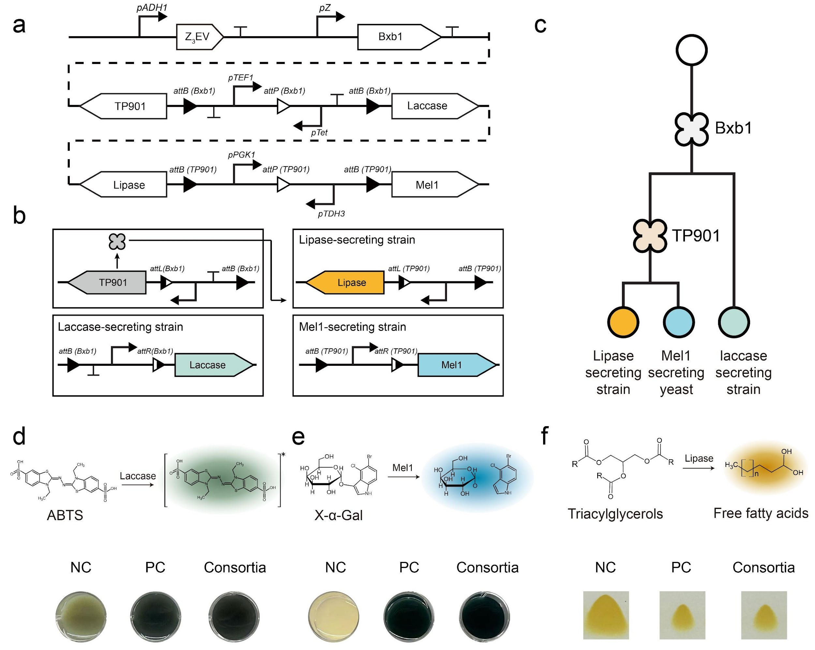
Fig. S68 | Generating multifunctional microbial consortia using the designed cascading branching device. a. Gene circuit design for a synthetic microbial consortium capable of degrading multiple pollutants. b. The first gene circuit, catalyzed by Bxb1 recombinase, produces progeny yeast expressing Tp901 and secreting laccase. The yeast expressing Tp901 further catalyzes the recombination of a second gene circuit, resulting in progeny that secrete lipase and Mel1. c. Schematic showing a single type of cell undergoing successive differentiation processes to produce a yeast consortium containing three enzyme-secreting strains. d. Degradation of ABTS by the yeast consortia. 'NC' represents the negative control, (wild-type BY4741 yeast without laccase secretion), and 'PC' represents the positive control (engineered yeast constitutively secreting laccase). e. Degradation of ABTS by the yeast consortia. f. Transformation of triacylglycerols into free fatty acids by the yeast consortia. Experiments were performed in triplicate.

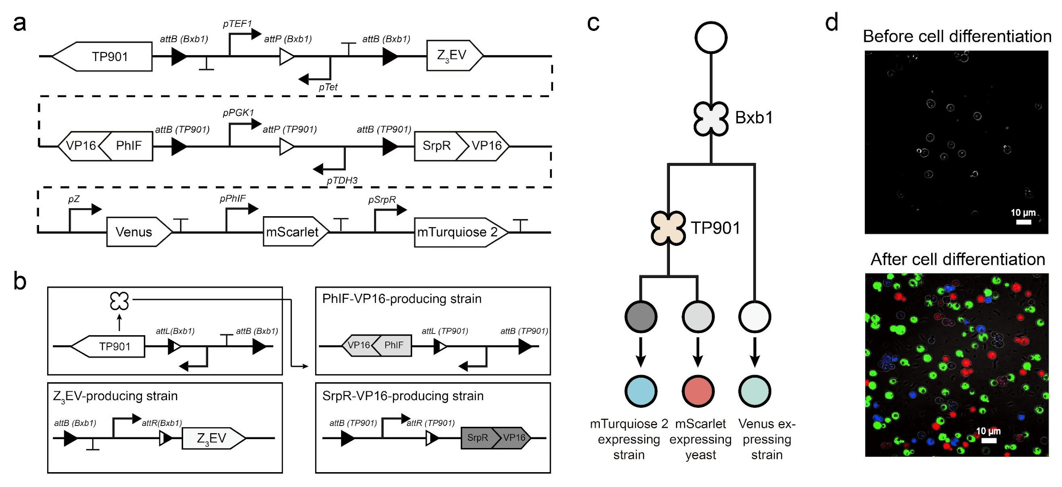
Fig. S69 | Incorporating transcription factors (TFs) into a designed cascading branching device for precise cell fate regulation. a. Design of a cascading branching device incorporating three TFs: Z₃EV, PhIF-VP16, and SrpR-VP16. b. The initial gene circuit, driven by Bxb1 recombinase, generates progeny cells expressing Tp901 and Z₃EV. Yeast expressing Tp901 then initiates recombination of a second gene circuit, producing two distinct progeny types that express proteins PhIF-VP16 and SrpR-VP16, respectively. A third circuit utilizes these proteins to activate a cassette containing Venus, mScarlet, and mTurquoise 2, controlled by specific promoters (pZ, pPhIF, pSrpR), activated by Z₃EV, PhIF-VP16, and SrpR-VP16. c. Schematic illustration showing sequential differentiation in a single cell, leading to the production of three fluorescent yeast cell types. d. Fluorescence microscopy images before and after cellular differentiation, highlighting the transitions driven by the gene circuits. Experiments were performed in triplicate.

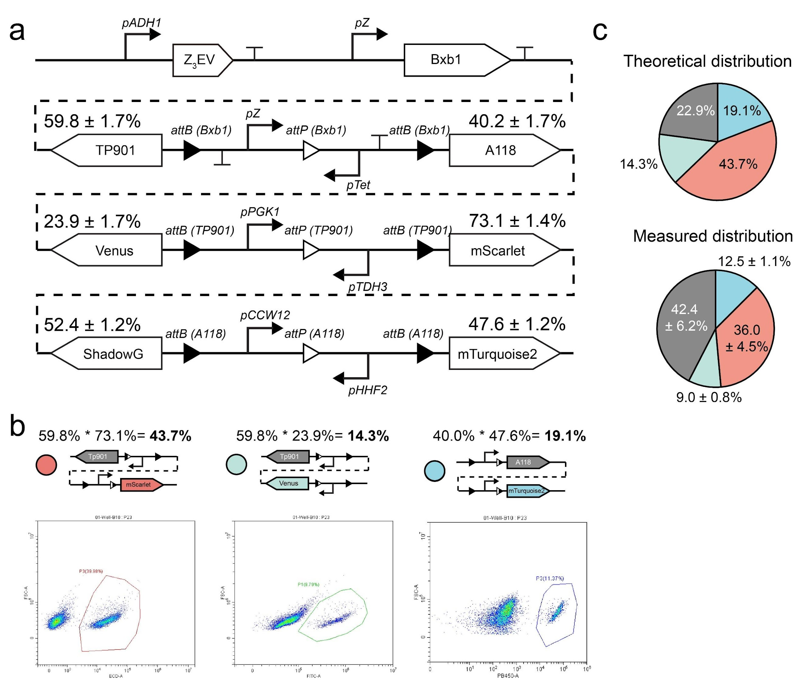
Fig. S70 | Design and characterization of a 2-layer branching device recognized by three recombinases. a. Schematic of the 2-layer branching circuit design. b. Theoretical probabilities of progeny cell outcomes and representative flow cytometry data of each progeny cell type. c. Comparison of theoretical and experimentally measured progeny cell proportions. Asymmetric differentiation due to inefficient catalysis of A118 in a population of undifferentiated (non-fluorescent) cells (Fig. S37b). This deviation is reflected in the distribution of blue and non-fluorescent cells. Experiments were performed in triplicate.

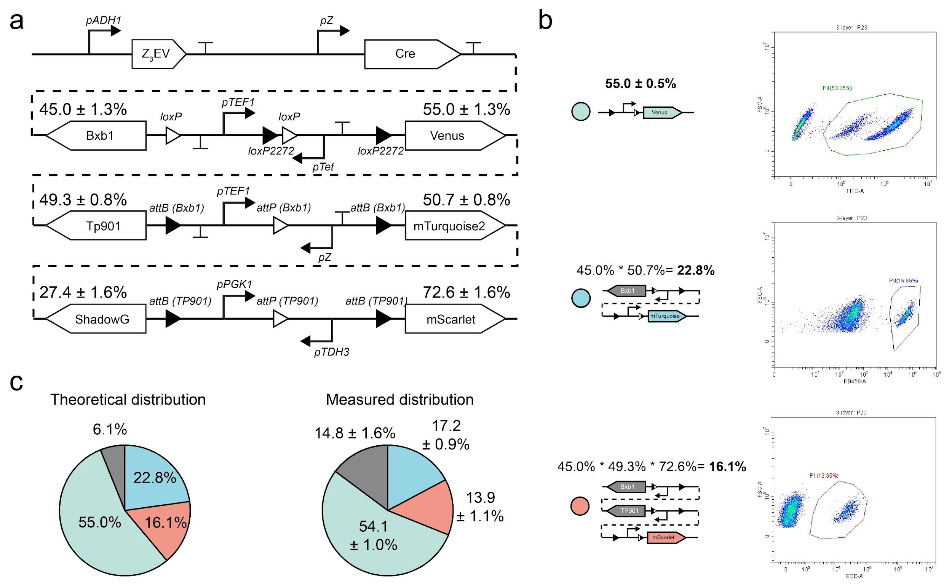
Fig. S71 | Design and characterization of a 3-layer branching device recognized by three recombinases. a. Design of a 3-layer sequential gene differentiation circuit. In the first layer, catalyzed by Cre recombinase, there is a 45.0 ± 1.3% probability of producing Bxb1-expressing strains and a 55.0 ± 1.3% chance of generating Venus-expressing yeast. In the second layer, catalyzed by Bxb1, there is a 49.3 ± 0.8% probability of producing Tp901-expressing progeny and a 50.7 ± 0.8% probability of generating mTurquoise 2-expressing strains. The third layer, catalyzed by Tp901, results in a 27.4 ± 1.6% probability of producing ShadowG-expressing strains and a 72.6 ± 1.6% chance of generating mScarlet-expressing yeast. b. Theoretical progeny distribution and representative flow cytometry data for each progeny cell type. c. Comparison of theoretical distribution and experimentally measured progeny distributions. Experiments were performed in triplicate.

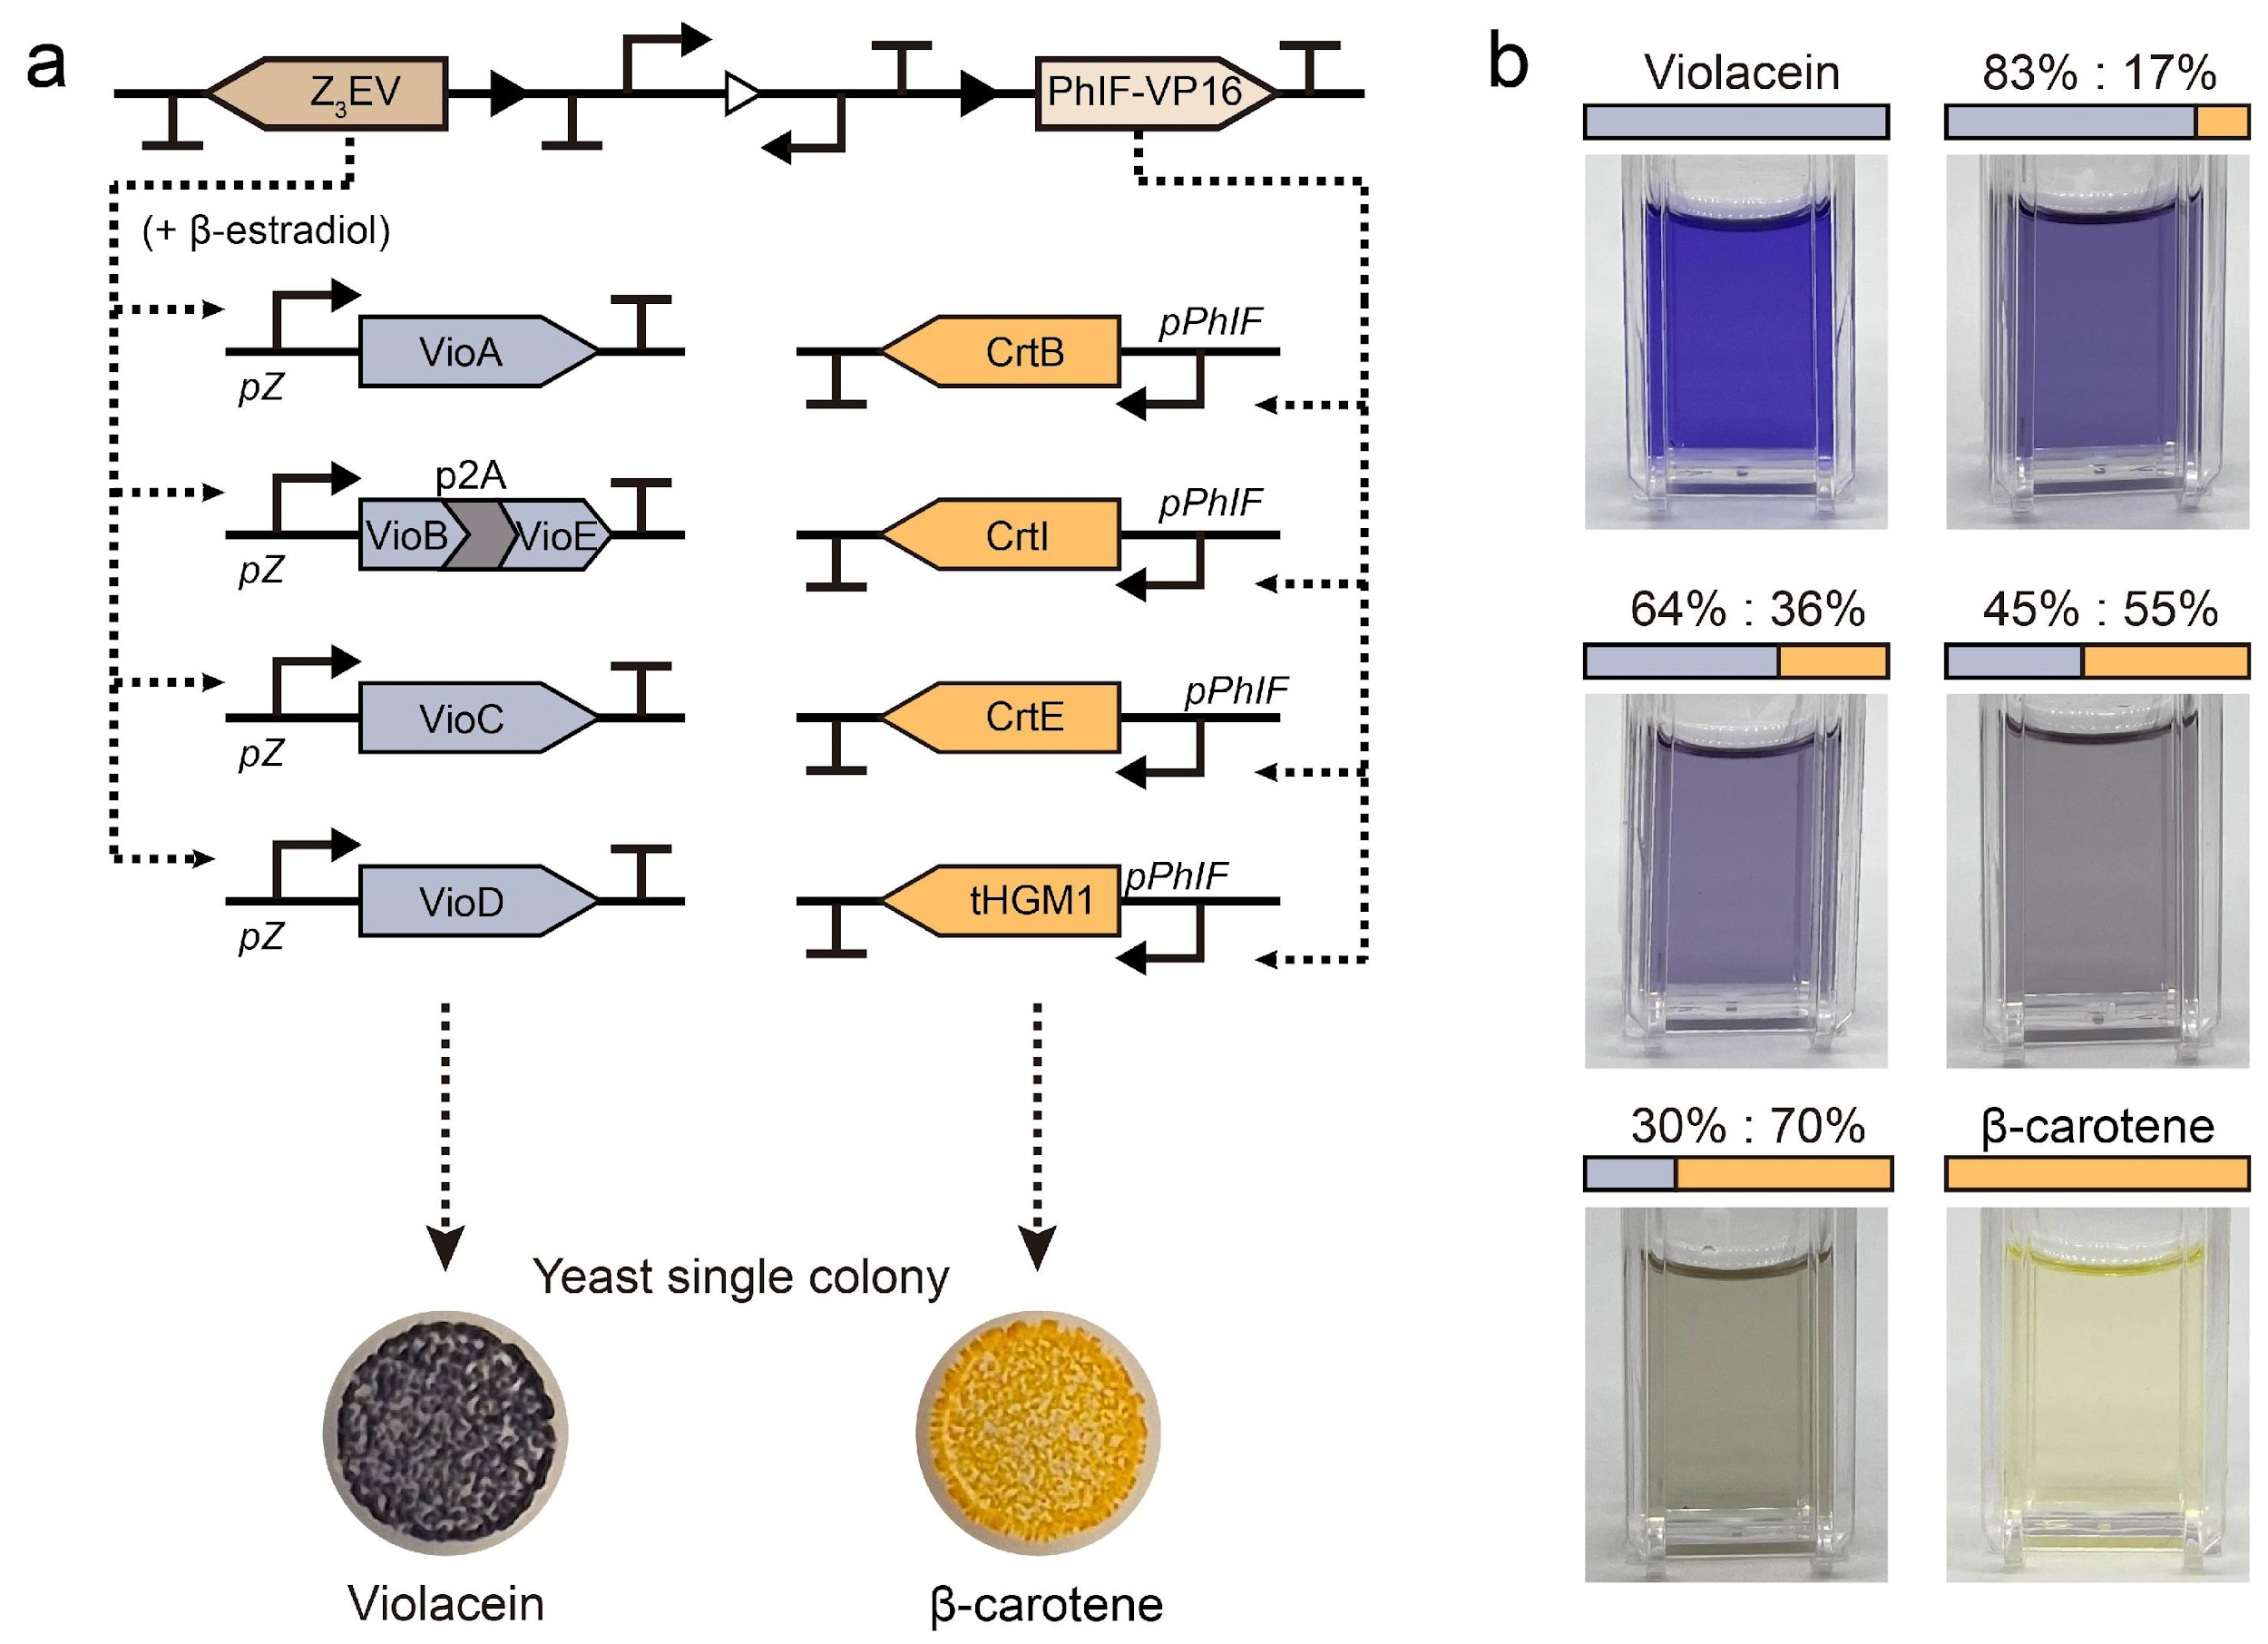
Fig. S72 | Genetic circuits for violacein and β-carotene synthesis a. Violacein synthesis, driven by the pZ promoter, integrates five enzymes (VioA, VioB, VioC, VioD, and VioE), into four yeast loci. Induction by Z₃EV and β-estradiol triggers violacein production. Β-carotene synthesis circuits integrate four enzymes (CrtE, CrtI, CrtB, and tHGM1) into four different loci, driven by pPhIF promoters. PhIF-VP16 production initiates β-carotene synthesis, producing yellow-to-orange pigments. b. Photograph of pigments extracted from yeast consortia using DMSO. Proportions of daughter cells were quantified by colony counting on agar plates after Bxb1 and β-estradiol induction. Genetic constructions are listed in Table. S7. Experiments were conducted in triplicate.

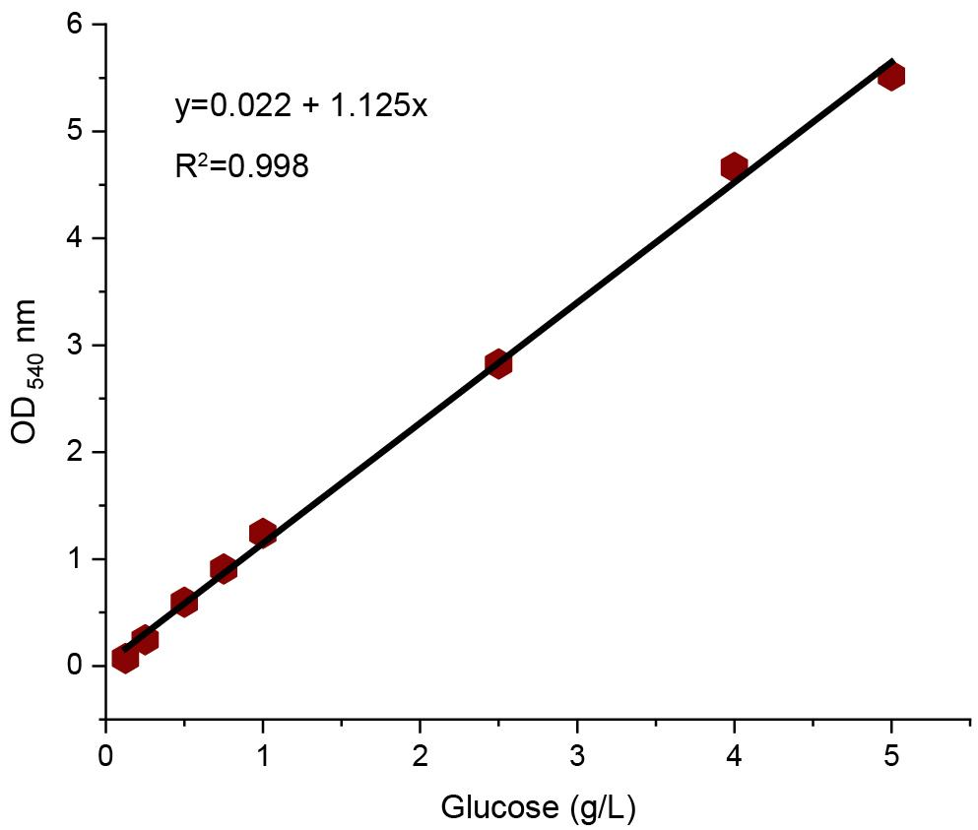
Fig. S73 | Standard curve for glucose concentration measured by the DNS method.

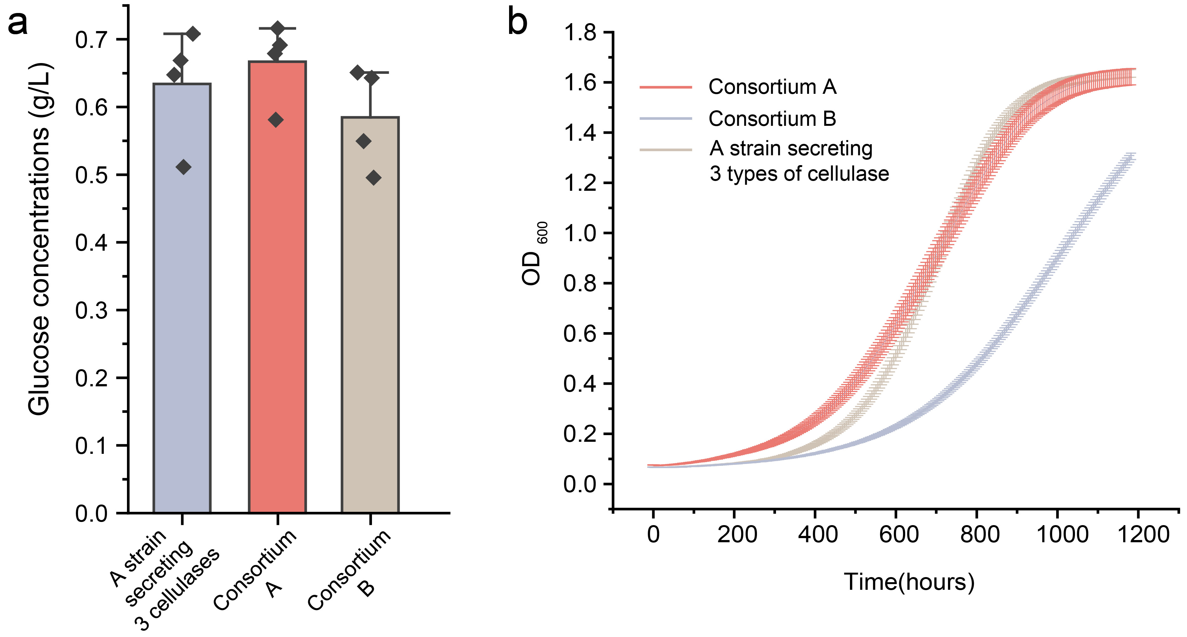
Fig. S74 | Reducing sugar production and growth curves for cellulase-secreting yeast consortia. a. Reducing sugar production from cellulose by yeast consortia compared to an engineered strain secreting BGL1, EG2, and CBH2 simultaneously. Consortium A comprises approximately 20% BGL1, 30% EG2, and 50% CBH2-secreting strains, while Consortium B comprises approximately 50% BGL1, 20% EG2, and 30% CBH2-secreting strains. (n = 4, mean ± SD). b. Growth curves of three cellulase-secreting yeast systems. Growth rates are Consortium A (≈0.23 OD₆₀₀/h), Consortium B (≈0.24 OD₆₀₀/h), and the strain secreting all three cellulases (≈0.17 OD₆₀₀/h).

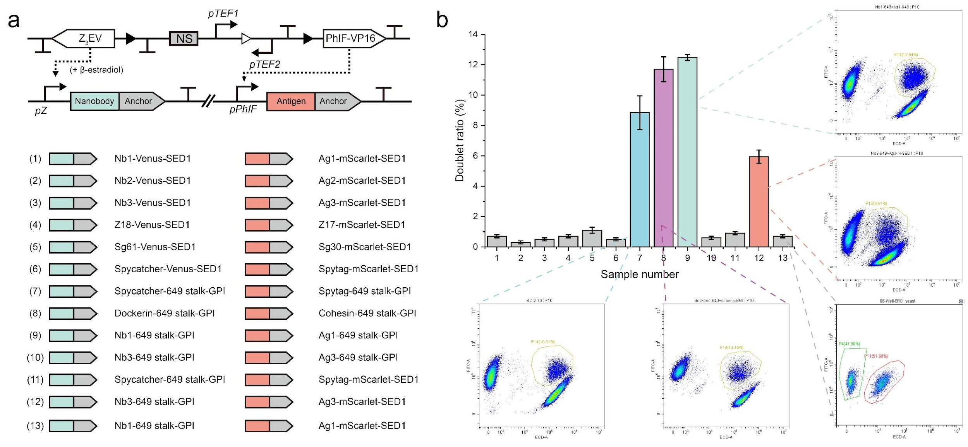
Fig. S75 | Screening protein pairs for yeast surface display and cellular morphogenesis. a. Schematic of the branching circuit and 13 protein pair candidates. b. Flow cytometry analysis identified four designs with increased doublet ratios, indicating successful protein display and strong binding interactions between the two progeny cell types. Protein sequences are listed in Table. S5 and genetic constructions are listed in Table. S7.

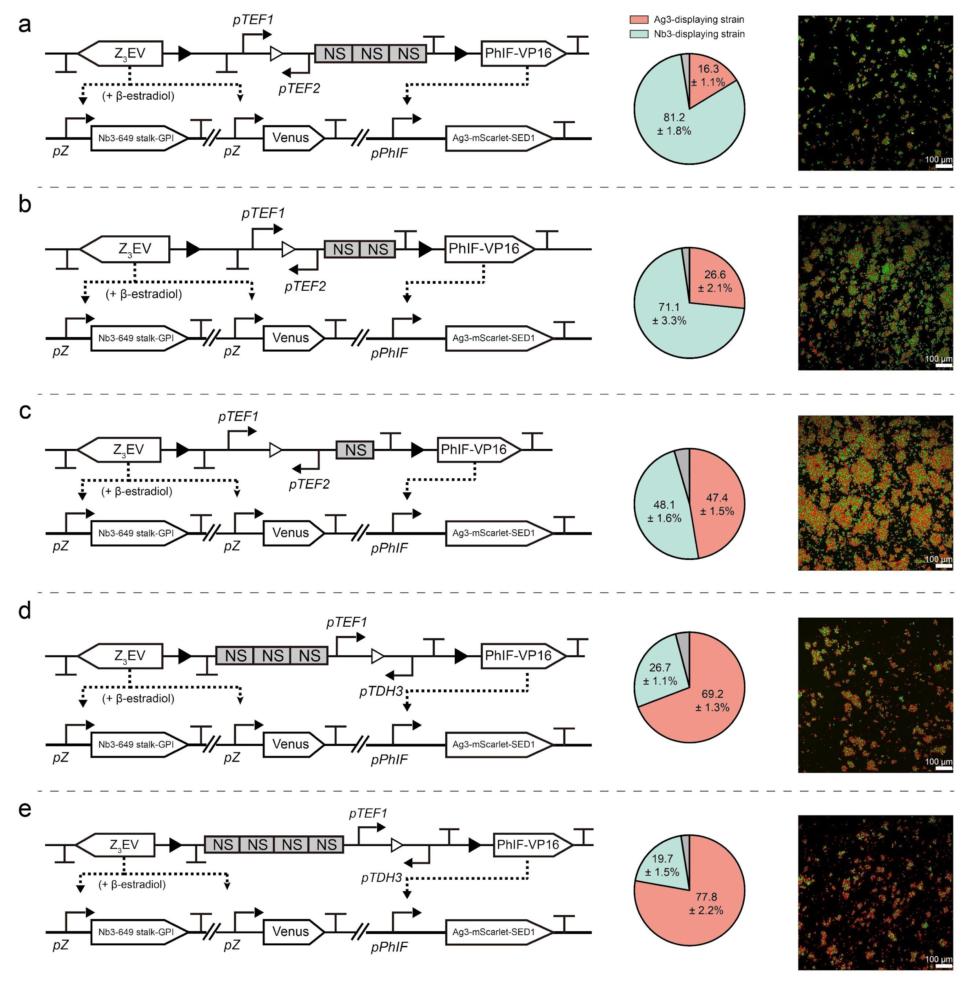
Fig. S76 | Progeny cell distribution and fluorescence images of cellular morphogens. a-e. Ratios of progeny cells (Nb3-expressing yeasts and Ag3-displaying strains) were adjusted to approximately 1:4 to 4:1.

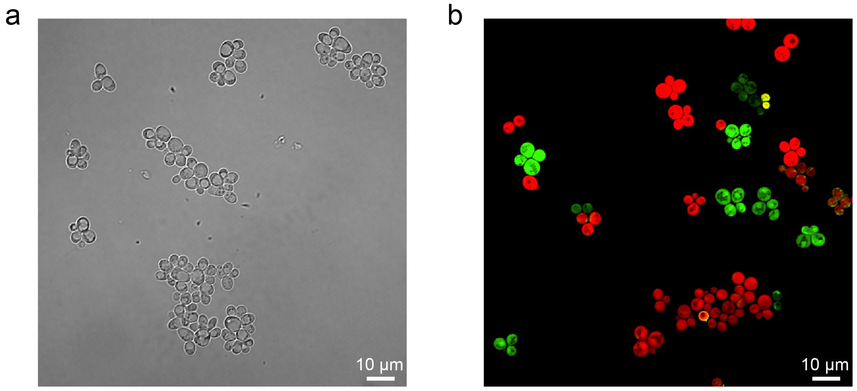
Fig. S77 | Representative images of snowflake yeast. a. Bright-field images of snowflake yeast. b. Fluorescence microscopy images showing green and red fluorescent yeast form cellular aggregating into genotype-specific clusters.

Table. S1 | The predicted $k_{A}^{0}$ and $k_{B}^{0}$ for various att site mutations.
Scheme of genetic circuit | Measured Venus Cell Fraction | $$k_{A}^{0}$$ | $$k_{B}^{0}$$ | Predicted Venus Cell Fraction
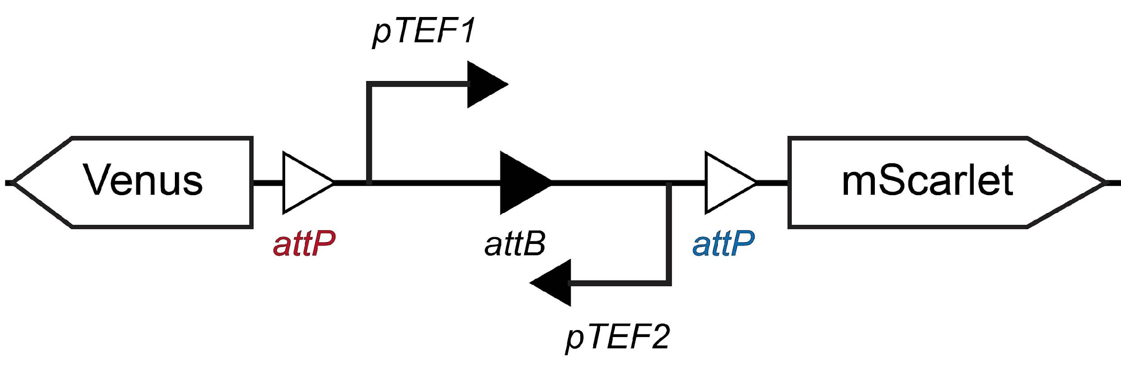 | 36.7 ± 0.6% | 0.38 | 0.14 | 37.8%
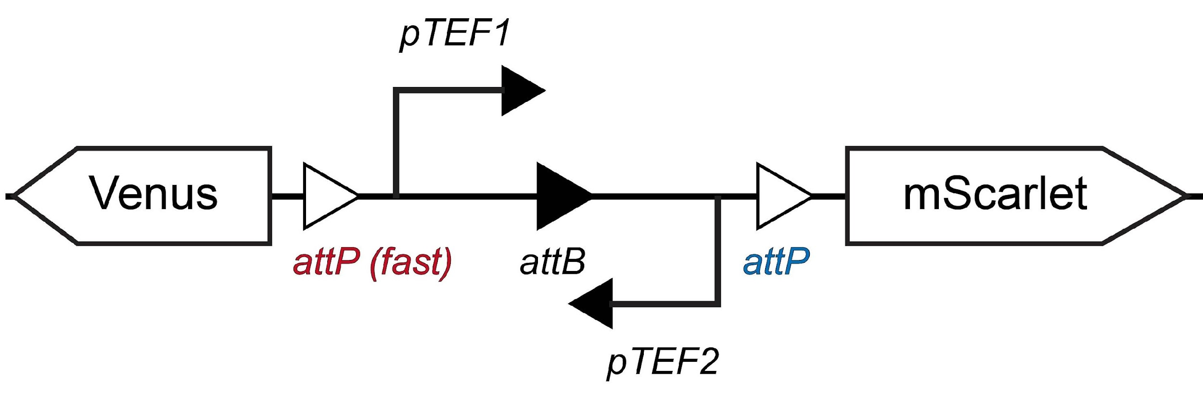 | 44.3 ± 1.6% | 0.50 | 0.14 | 44.4%
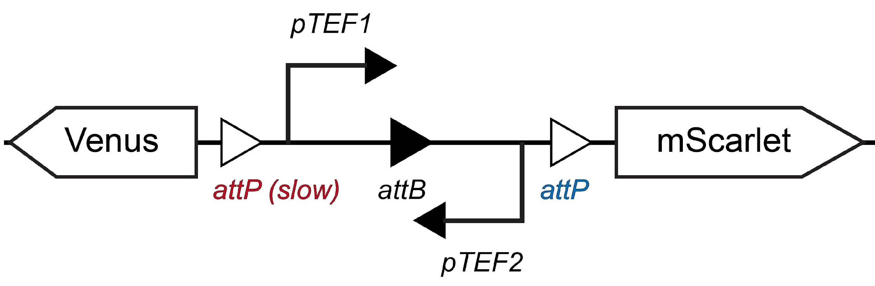 | 19.7 ± 0.5% | 0.15 | 0.14 | 19.7%
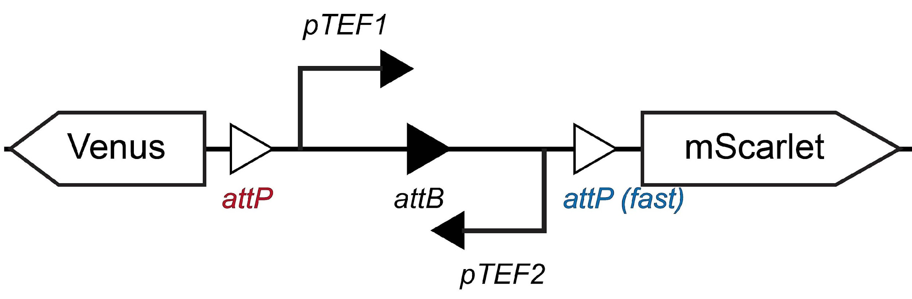 | 28.6 ± 2.1% | 0.38 | 0.43 | 28.6%
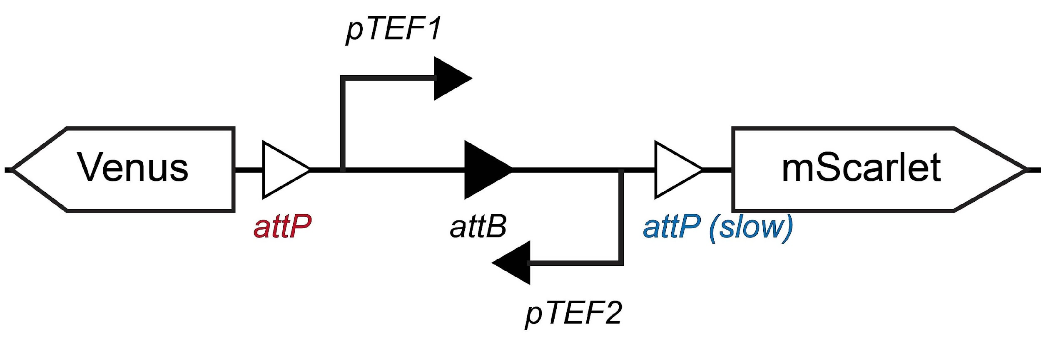 | 61.9 ± 1.0% | 0.38 | 0.03 | 58.7%

Table. S2 | Predicted $r_{A}$ and $r_{B}$ values for different promoter types.
Scheme of genetic circuit | Measured Venus Cell Fraction | $$r_{A}$$ | $$r_{B}$$ | $$r_{A}$$ | $$r_{B}$$ | Predicted Venus Cell Fraction
 | 36.7 ± 0.6% | 0.38 | 0.14 | 0.56 | 0.01 | 37.8%
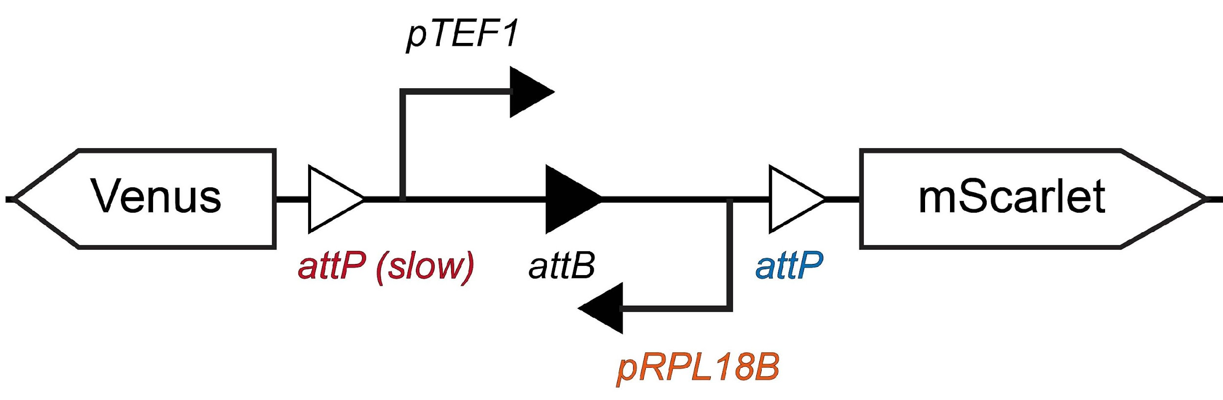 | 68.3 ± 1.2% | 0.15 | 0.14 | 0.56 | 1.37 | 68.2%
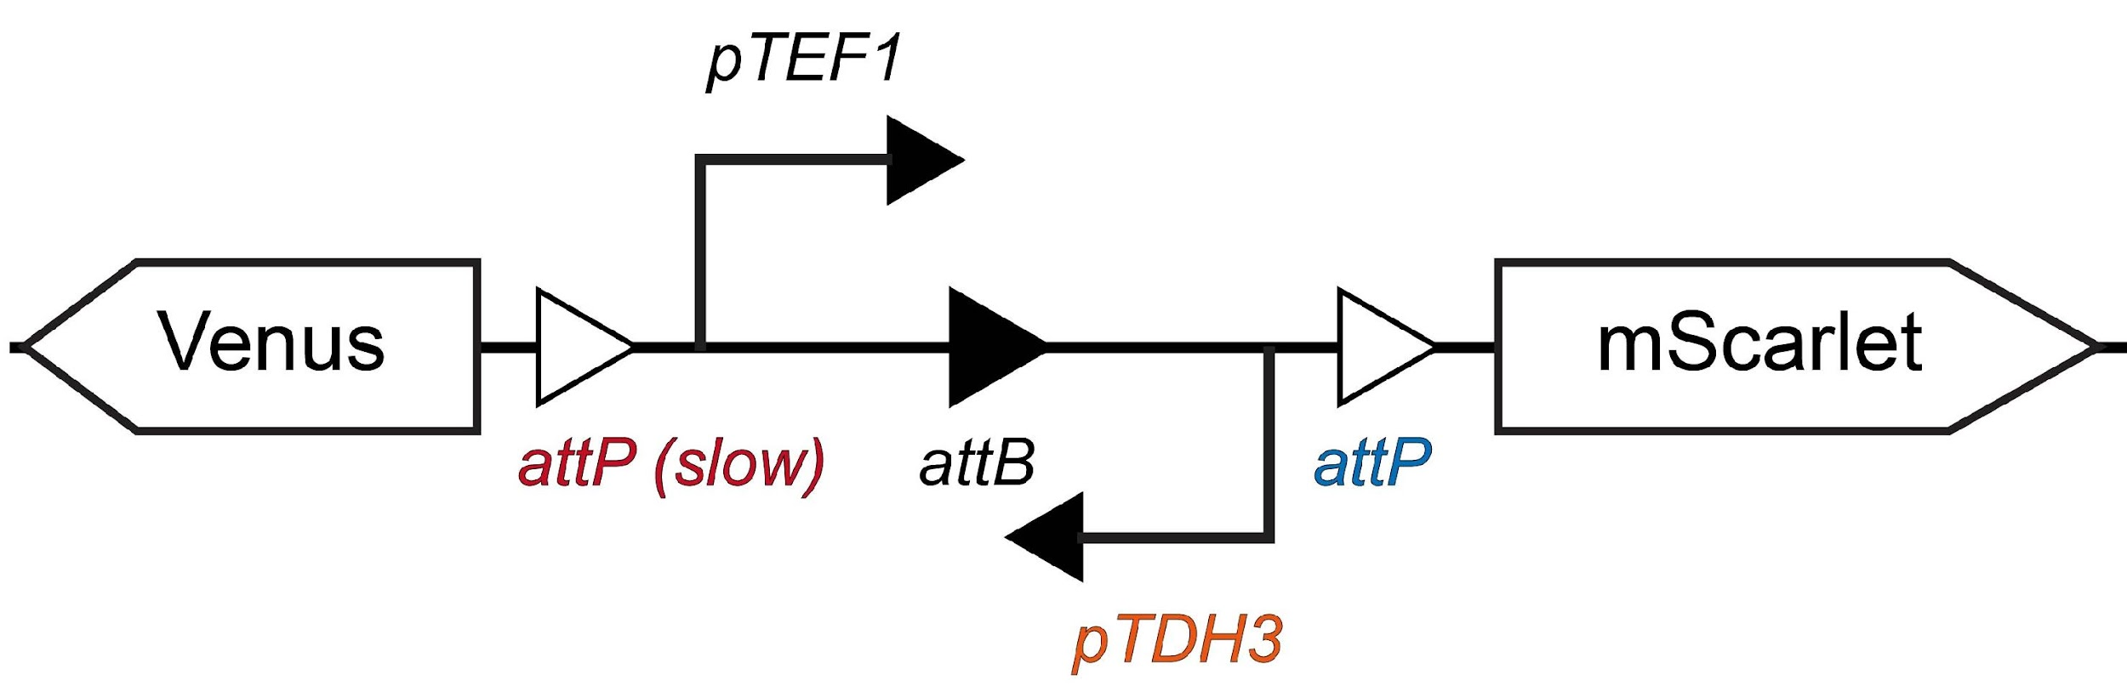 | 34.8 ± 1.2% | 0.15 | 0.14 | 0.56 | 0.21 | 34.6%

Table. S3 | Mathematical model predictions of green-to-red progeny cell ratios.
Scheme of Genetic Circuit | Measured Venus Cell Fraction | $$r_{A}$$ | $$r_{B}$$ | $$r_{A}$$ | $$r_{B}$$ | Predicted Venus Cell Fraction
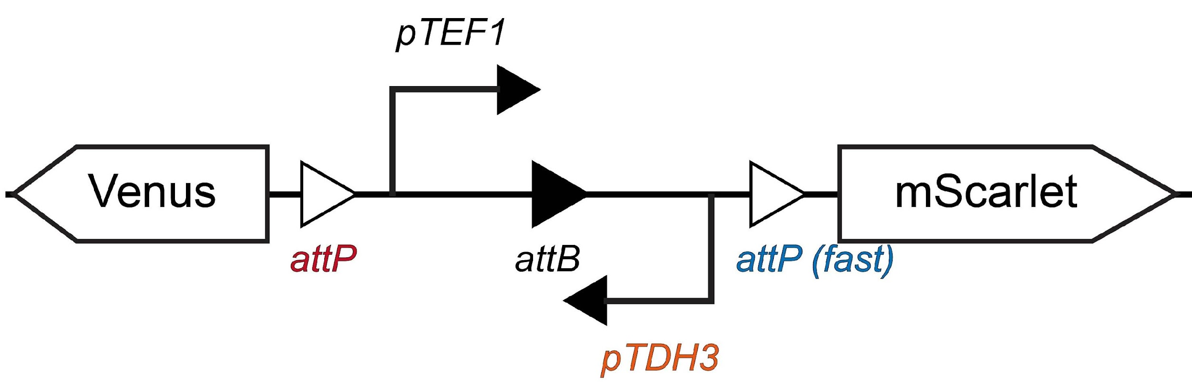 | 45.9 ± 0.7% | 0.38 | 0.25 | 0.56 | 0.14 | 39.7%
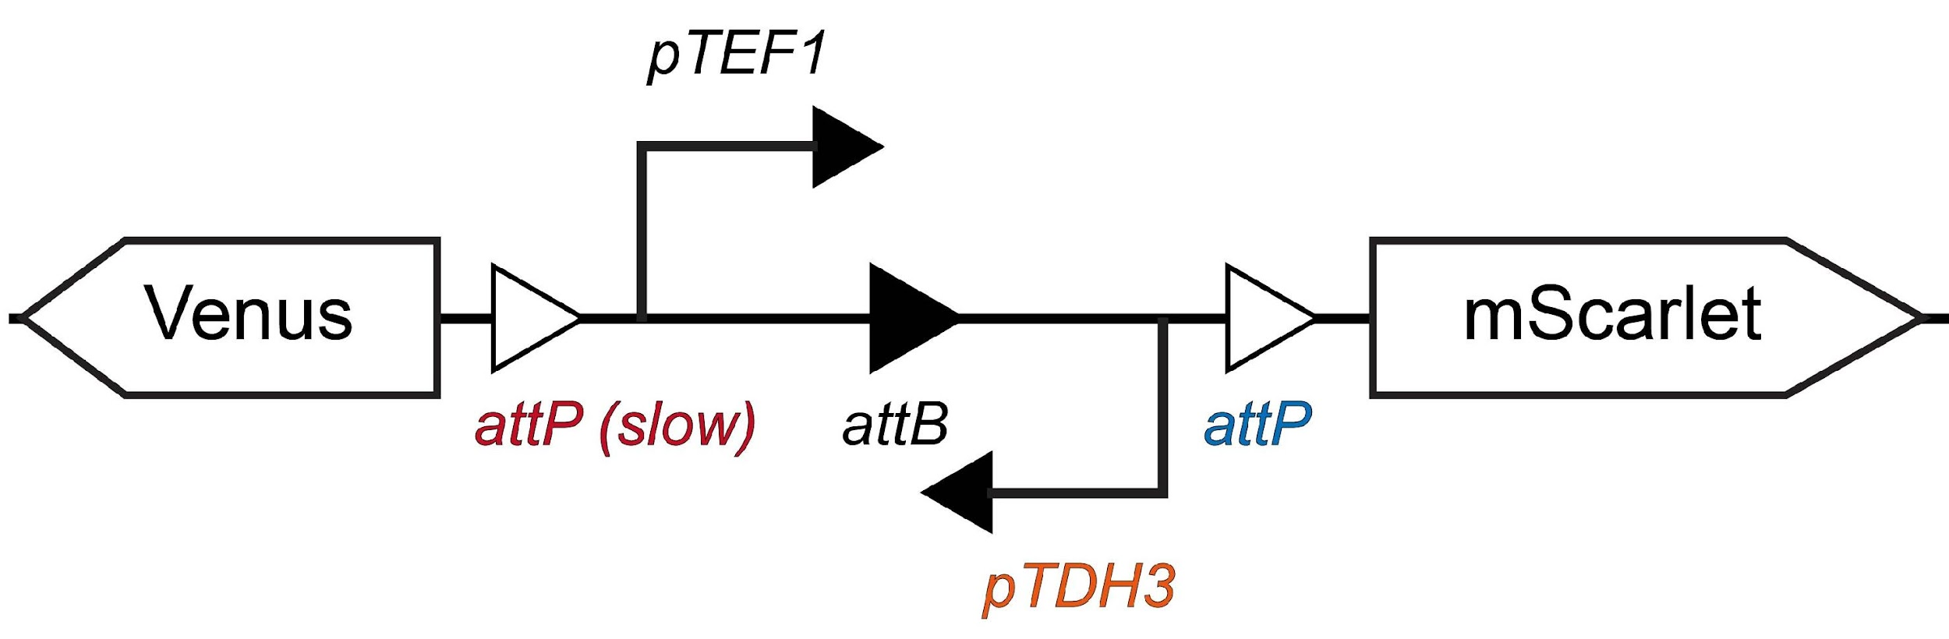 | 34.8 ± 1.2% | 0.15 | 0.14 | 0.56 | 0.14 | 30.1%
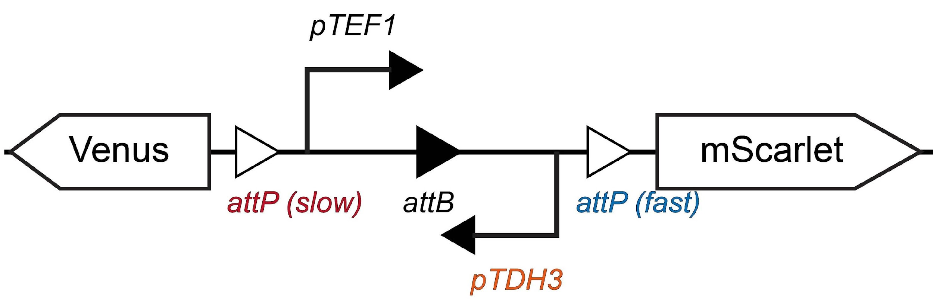 | 23.9 ± 0.7% | 0.15 | 0.25 | 0.56 | 0.14 | 26.2%
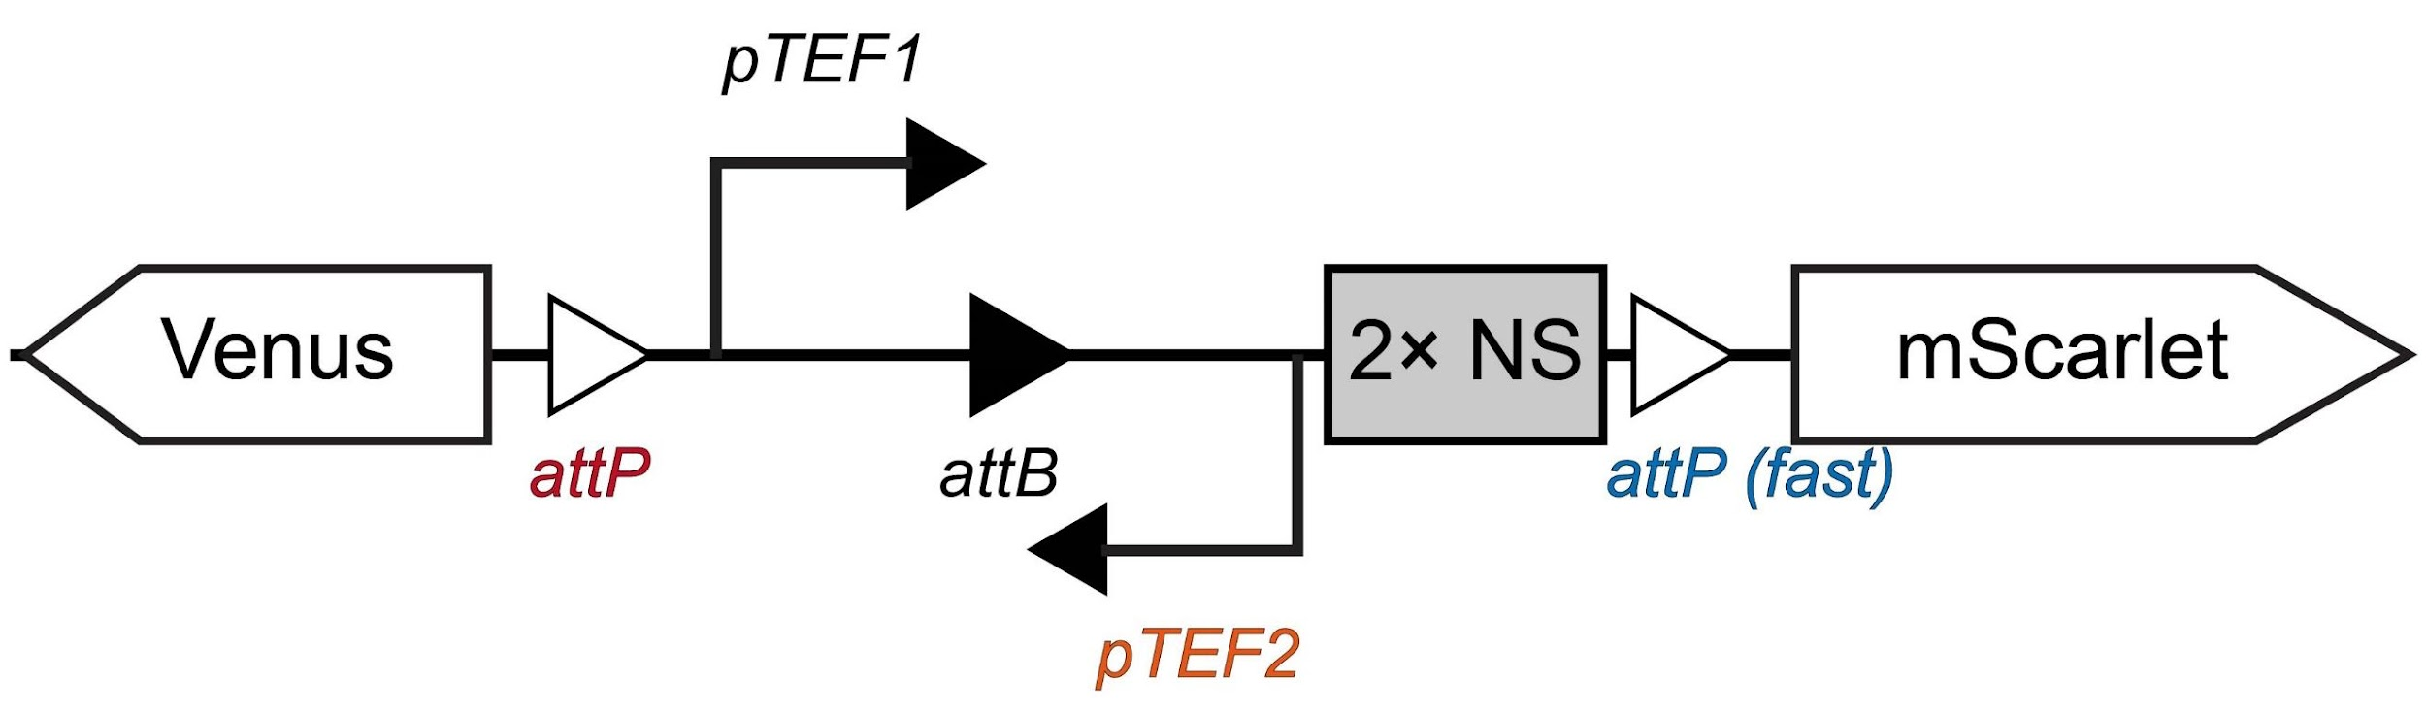 | 53.6 ± 1.9% | 0.38 | 0.25 | 0.56 | 0.01 | 47.2%
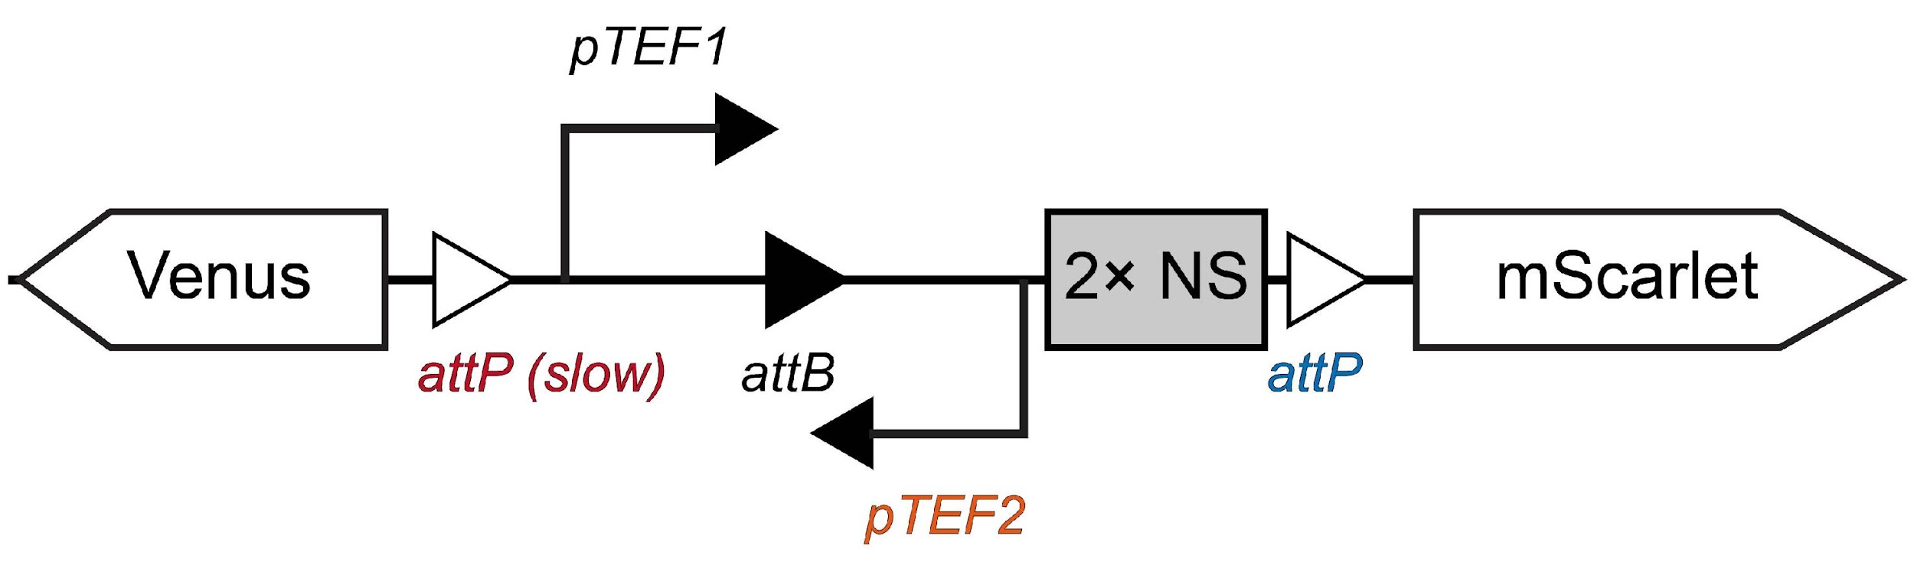 | 39.8 ± 0.8% | 0.15 | 0.14 | 0.56 | 0.01 | 34.5%
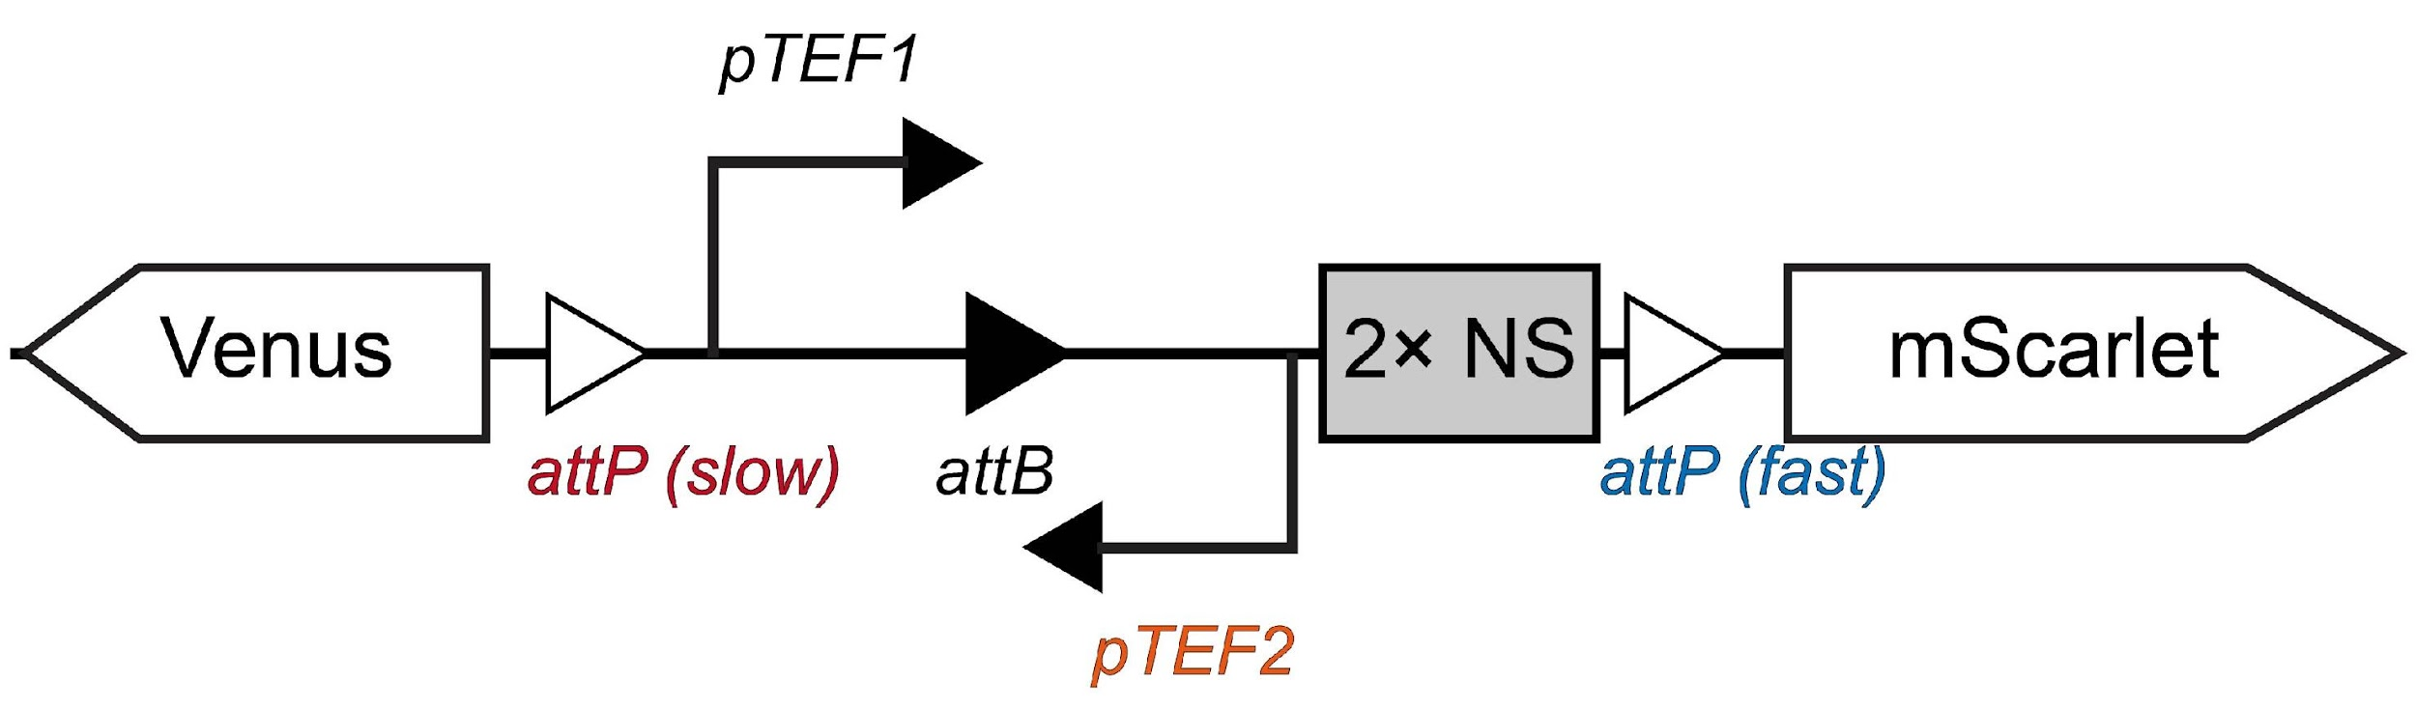 | 33.2 ± 0.7% | 0.15 | 0.25 | 0.56 | 0.01 | 26.5%
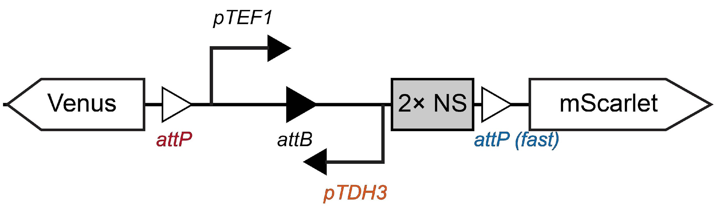 | 62.9 ± 1.3% | 0.38 | 0.25 | 0.56 | 0.14 | 54.0%
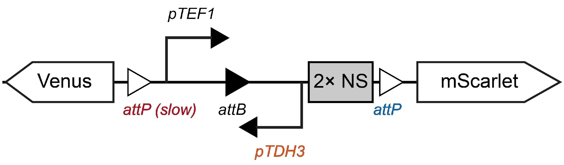 | 45.4 ± 1.0% | 0.15 | 0.14 | 0.56 | 0.14 | 47.5%
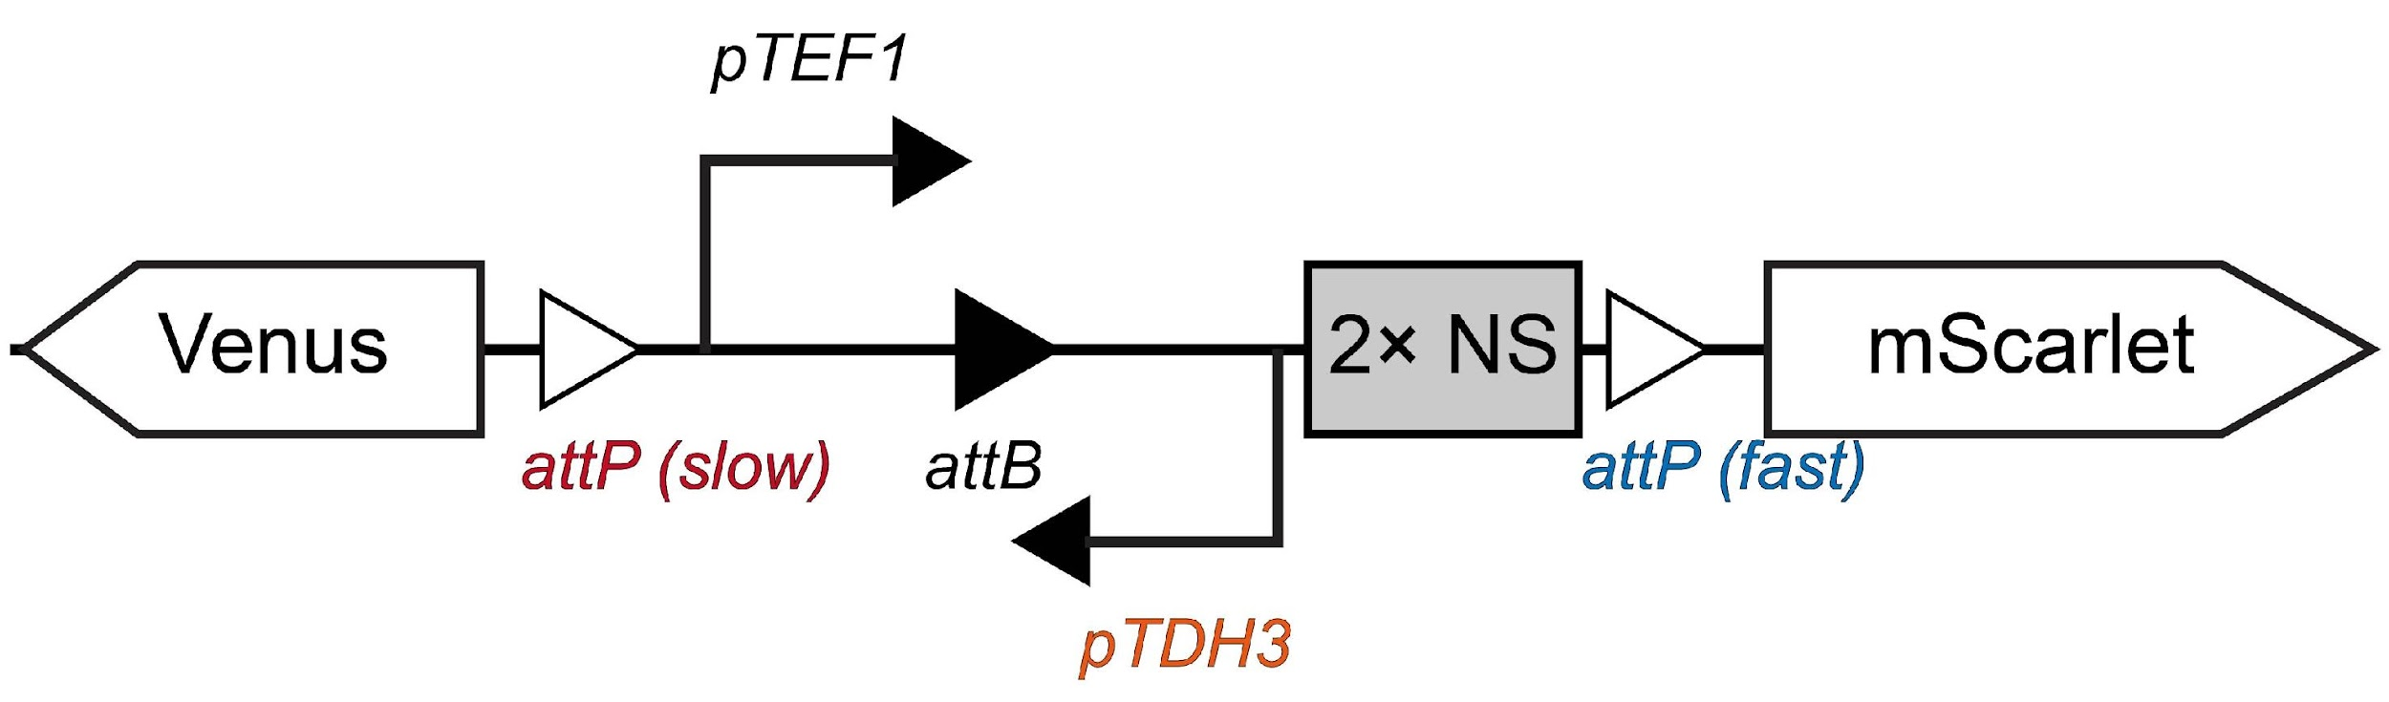 | 39.9 ± 0.9% | 0.15 | 0.25 | 0.56 | 0.14 | 38.4%

Table. S4 | DNA sequences of genetic parts used in this study.

Type | Genetic parts | Description
promoter | pTEF1 | Yeast constitutive promoters
promoter | pTEF2 | Yeast constitutive promoters
promoter | pALD6 | Yeast constitutive promoters
promoter | pHHF2 | Yeast constitutive promoters
promoter | pPGK1 | Yeast constitutive promoters
promoter | pREV1 | Yeast constitutive promoters
promoter | pRPL18B | Yeast constitutive promoters
promoter | pSac6 | Yeast constitutive promoters
promoter | pTDH3 | Yeast constitutive promoters
promoter | pCCW12 | Yeast constitutive promoters
promoter | pPOP6 | Yeast constitutive promoters
promoter | pADH1 | Yeast constitutive promoters
promoter | pRAD27 | Yeast constitutive promoters
promoter | pTet | Yeast promoter induced by aTc
promoter | pZ | Yeast promoter induced by β-estradiol
promoter | pLac | Yeast promoter impressed by LacI
promoter | pSrpR | Yeast promoter induced by SrpR-VP16
promoter | pPhIF | Yeast promoter induced by PhIF-VP16
promoter | pJ72163 | E. coli constitutive promoters
promoter | pProD | E. coli constitutive promoters
promoter | pEF1 | HEK293 mammalian cell’s constitutive promoters
promoter | phUBC | HEK293 mammalian cell’s constitutive promoters
att sites | attB (Bxb1_GA) | att sits for Bxb1
att sites | attP (Bxb1_GA) | att sits for Bxb1
att sites | attB (TP901) | att sits for TP901
att sites | attP (TP901) | att sits for TP901
att sites | attB (A118) | att sits for A118
att sites | attP (A118) | att sits for A118
att sites | attB (R4) | att sits for R4
att sites | attP (R4) | att sits for R4
att sites | Cre (loxP) | att sits for Cre
att sites | Cre (loxP2272) | att sits for Cre
att sites | attP (Bxb1_fast) | Bxb1 attP sits with predictive recombination rates
att sites | attP (Bxb1_slow) | Bxb1 attP sits with predictive recombination rates
Non-sense DNA sequence | 1× NS | Non-sense sequence (773 bp)
Non-sense DNA sequence | 2× NS | Non-sense sequence (2 × 773 bp)
Non-sense DNA sequence | 3× NS | Non-sense sequence (3 × 773 bp)
Non-sense DNA sequence | 4× NS | Non-sense sequence (4 × 773 bp)
Non-sense DNA sequence | 9× NS | Non-sense sequence (9 × 773 bp)
Non-sense DNA sequence | S1 | Designed 100 bp sequence (50% GC contents) for NGS sequencing
Non-sense DNA sequence | S2 | Designed 100 bp sequence (50% GC contents) for NGS sequencing
Non-sense DNA sequence | S3 | Designed 100 bp sequence (30% GC contents) for NGS sequencing
Non-sense DNA sequence | S4 | Designed 100 bp sequence (30% GC contents) for NGS sequencing
Non-sense DNA sequence | S5 | Designed 100 bp sequence (30% GC contents) for NGS sequencing
Non-sense DNA sequence | S6 | Designed 100 bp sequence (70% GC contents) for NGS sequencing
Non-sense DNA sequence | S7 | Designed 100 bp sequence (70% GC contents) for NGS sequencing
Non-sense DNA sequence | S8 | Designed 100 bp sequence (70% GC contents) for NGS sequencing
Non-sense DNA sequence | S9/S10 | Designed 100 bp sequence with 3 TetO inserted for NGS sequencing

Table. S5 | Sequences of proteins in this study.

Type | Protein | Description
Fluorescent proteins | Venus | Green fluorescent protein
Fluorescent proteins | mScarlet | Red fluorescent protein
Fluorescent proteins | mTurquoise2 | Blue fluorescent protein
Fluorescent proteins | Crimson | Far-red light-activated fluorescent protein
Fluorescent proteins | ShadowG | GFP mutant without fluorescence
Recombinases | Bxb1 | Serine recombinase
Recombinases | Si74 | Serine recombinase
Recombinases | PhiC31 | Serine recombinase
Recombinases | R4 | Serine recombinase
Recombinases | Tp901 | Serine recombinase
Recombinases | Cre-EBD | Tyrosine recombinase
Recombinases | A118 | Serine recombinase
Recombinases | No67 | Serine recombinase
Transcription factors (TFs) | Z₃EV | TF for pZ promoter
Transcription factors (TFs) | LacI | TF for pLac promoter
Transcription factors (TFs) | SrpR-VP16 | TF for pSrpR promoter
Transcription factors (TFs) | PhIF-VP16 | TF for pPhIF promoter
Transcription factors (TFs) | TetR-Mxi1 | TF for pTet promoter
Transcription factors (TFs) | rtTA-GAL4 | TF for pTet promoter
Enzyme | Lipase | Lipase catalyzes the hydrolysis of fats (lipids) into glycerol and free fatty acids
Enzyme | Mel1 | α-galactosidase hydrolyzes α-galactosidic
Enzyme | Laccase | Laccase catalyzes the oxidation of phenolic compounds
Enzyme | VioA | Violacein synthesis-related enzyme
Enzyme | VioB | Violacein synthesis-related enzyme
Enzyme | VioC | Violacein synthesis-related enzyme
Enzyme | VioD | Violacein synthesis-related enzyme
Enzyme | VioE | Violacein synthesis-related enzyme
Enzyme | CrtI | Carotene synthesis-related enzyme
Enzyme | CrtE | Carotene synthesis-related enzyme
Enzyme | CrtYB | Carotene synthesis-related enzyme
Enzyme | tHGM1 | Carotene synthesis-related enzyme
Enzyme | BGL1 | β-glucosidase that catalyzes the hydrolysis of glycosidic bonds in β-glucosides
Enzyme | EG2 | Endoglucanase that breaks down the internal β-1,4-glycosidic bonds in cellulose
Enzyme | CBH2 | Cellobiohydrolase 2 catalyzes the hydrolysis of cellulose by cleaving off cellobiose units from the non-reducing ends of cellulose chains
Signal peptides | SP_{sed1} | Yeast signal peptide
Signal peptides | SP_{werid} | Yeast signal peptide
Signal peptides | SP_{Mfα} | Yeast signal peptide
Signal peptides | SP_{a factor} | Yeast signal peptide
Signal peptides | SP_{albumin} | Yeast signal peptide
Signal peptides | SP_{amylase} | Yeast signal peptide
Anchor proteins | SED1 | Surface-anchoring protein for yeast display
Anchor proteins | 649 stalk-GPI | Surface-anchoring protein for yeast display
Antigen-antibody | Ag1 | Ag1 specifically interacts with Nb1
Antigen-antibody | Ag2 | Ag2 specifically interacts with Nb2
Antigen-antibody | Ag3 | Ag3 specifically interacts with Nb3
Antigen-antibody | Nb1 | Nb1 specifically interacts with Ag1
Antigen-antibody | Nb2 | Nb2 specifically interacts with Ag2
Antigen-antibody | Nb3 | Nb3 specifically interacts with Ag3
Antigen-antibody | Z17 | Z17 specifically interacts with Z18
Antigen-antibody | Z18 | Z18 specifically interacts with Z17
Antigen-antibody | Sg30 | Sg30 specifically interacts with Sg61
Antigen-antibody | Sg61 | Sg61 specifically interacts with Sg30
Antigen-antibody | Dockerin | Dockerin specifically interacts with cohesion
Antigen-antibody | Cohesion | Cohesion specifically interacts with dockerin
Antigen-antibody | Spycatcher | Spycatcher specifically interacts with Spytag
Antigen-antibody | Spytag | Spytag specifically interacts with Spycatcher
Antigen or antibody fused with anchor proteins for yeast surface display | Ag3-mScarlet-SED1 | Protein that was displayed on the yeast surface
 | Nb3-649 stalk-GPI | Protein that was displayed on the yeast surface
 | Ag1-649 stalk-GPI | Protein that was displayed on the yeast surface
 | Nb1-649 stalk-GPI | Protein that was displayed on the yeast surface
 | Dockerin -649 stalk-GPI | Protein that was displayed on the yeast surface
 | Cohesion -649 stalk-GPI | Protein that was displayed on the yeast surface
 | Spycatcher -649 stalk-GPI | Protein that was displayed on the yeast surface
 | Spytag -649 stalk-GPI | Protein that was displayed on the yeast surface

Table. S6 | Background plasmids employed in this study. Links to annotated plasmid sequences are provided for all constructs.
Plasmid | Construct details | Source
pYTK001 | Entry vector designed for cloning new DNA fragments via BsmBI Golden Gate reactions | Lee et al⁷
pYTK096 | Pre-assembled plasmid equipped with genetic elements for cloning in E. coli and subsequent integrative transformation into the URA3 locus of S. cerevisiae. DNA fragments can be inserted into this plasmid using BsaI Golden Gate reactions. | Lee et al⁷
pYTK097 | Pre-assembled plasmid equipped with genetic elements for cloning in E. coli and subsequent integrative transformation into the LEU2 locus of S. cerevisiae. DNA fragments can be inserted into this plasmid using BsaI Golden Gate reactions. | This study
pYTK098 | Pre-assembled plasmid equipped with genetic elements for cloning in E. coli and subsequent integrative transformation into the HO locus of S. cerevisiae. DNA fragments can be inserted into this plasmid using BsaI Golden Gate reactions. | This study
pYTK099 | Pre-assembled plasmid equipped with genetic elements for cloning in E. coli and subsequent integrative transformation into the HIS3 locus of S. cerevisiae. DNA fragments can be inserted into this plasmid using BsaI Golden Gate reactions. | This study
pYTK100 | Pre-assembled plasmid equipped with genetic elements for cloning in E. coli and subsequent integrative transformation into the MET15 locus of S. cerevisiae. DNA fragments can be inserted into this plasmid using BsaI Golden Gate reactions. | This study
pMYT095 | Pre-assembled plasmid equipped with genetic elements for cloning in E. coli and Cas9 protein for genome editing in S. cerevisiae. gRNA cassettes can be inserted into this plasmid using BsaI Golden Gate reactions. | Shaw et al⁵
pMYT076 | Pre-assembled plasmid equipped with genetic elements for cloning in E. coli and subsequent integrative transformation into S. cerevisiae genome (Int.2 site) with the assistance of Cas9. DNA fragments can be inserted into this plasmid using BsaI Golden Gate reactions. | Shaw et al⁵
pMYT078 | Pre-assembled plasmid equipped with genetic elements for cloning in E. coli and subsequent integrative transformation into S. cerevisiae genome (Int.4 site) with the assistance of Cas9. DNA fragments can be inserted into this plasmid using BsaI Golden Gate reactions. | Shaw et al⁵
pMYT079 | Pre-assembled plasmid equipped with genetic elements for cloning in E. coli and subsequent integrative transformation into S. cerevisiae genome (Int.5 site) with the assistance of Cas9. DNA fragments can be inserted into this plasmid using BsaI Golden Gate reactions. | Shaw et al⁵
pMYT080 | Pre-assembled plasmid equipped with genetic elements for cloning in E. coli and subsequent integrative transformation into S. cerevisiae genome (Int.6 site) with the assistance of Cas9. DNA fragments can be inserted into this plasmid using BsaI Golden Gate reactions. | Shaw et al⁵
pMYT081 | Pre-assembled plasmid equipped with genetic elements for cloning in E. coli and subsequent integrative transformation into S. cerevisiae genome (Int.7 site) with the assistance of Cas9. DNA fragments can be inserted into this plasmid using BsaI Golden Gate reactions. | Shaw et al⁵
pMYT082 | Pre-assembled plasmid equipped with genetic elements for cloning in E. coli and subsequent integrative transformation into S. cerevisiae genome (Int.8 site) with the assistance of Cas9. DNA fragments can be inserted into this plasmid using BsaI Golden Gate reactions. | Shaw et al⁵
pMYT083 | Pre-assembled plasmid equipped with genetic elements for cloning in E. coli and subsequent integrative transformation into S. cerevisiae genome (Int.9 site) with the assistance of Cas9. DNA fragments can be inserted into this plasmid using BsaI Golden Gate reactions. | Shaw et al⁵
pMYT084 | Pre-assembled plasmid equipped with genetic elements for cloning in E. coli and subsequent integrative transformation into S. cerevisiae genome (Int.10 site) with the assistance of Cas9. DNA fragments can be inserted into this plasmid using BsaI Golden Gate reactions. | Shaw et al⁵

Table. S7 | Representative plasmids employed in this study. Links to annotated plasmid sequences are provided for all constructs.

Plasmid | Construct details | Scheme
pTet-Bxb1 | Expression of Bxb1 induced by aTc. Construct was designed for propagation in E. coli and integration at the HIS3 locus in S. cerevisiae. | 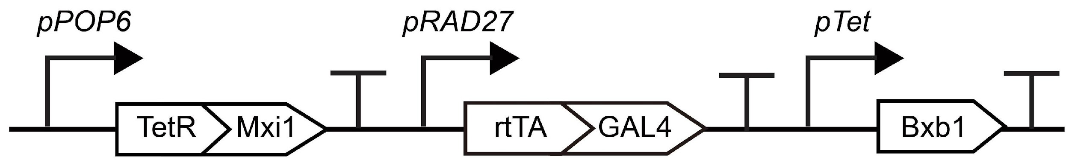
pZ-Bxb1 | Expression of Bxb1 induced by β-estradiol. Construct was designed for propagation in E. coli and integration at the HIS3 locus in S. cerevisiae. | 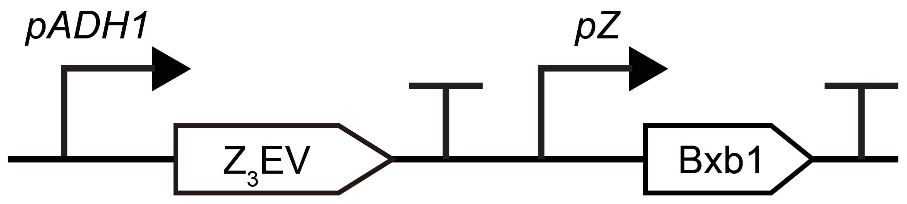
pBranch 01 | Construct for controlled yeast cell differentiation. Designed for propagation in E. coli and integration at the URA3 locus in S. cerevisiae. | 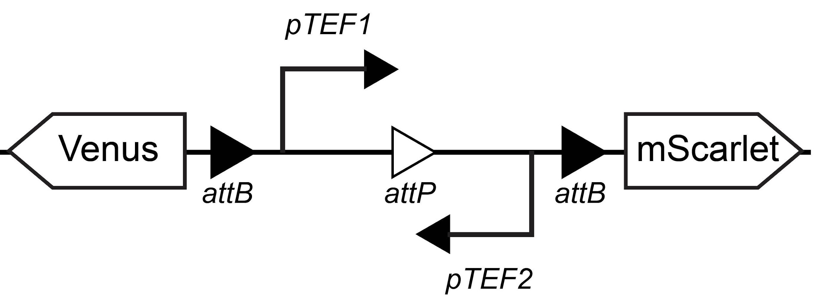
pBranch 02 | Construct for investigating the effects of att site arrangements on yeast cell differentiation. Designed for propagation in E. coli and integration at the URA3 locus in S. cerevisiae. | 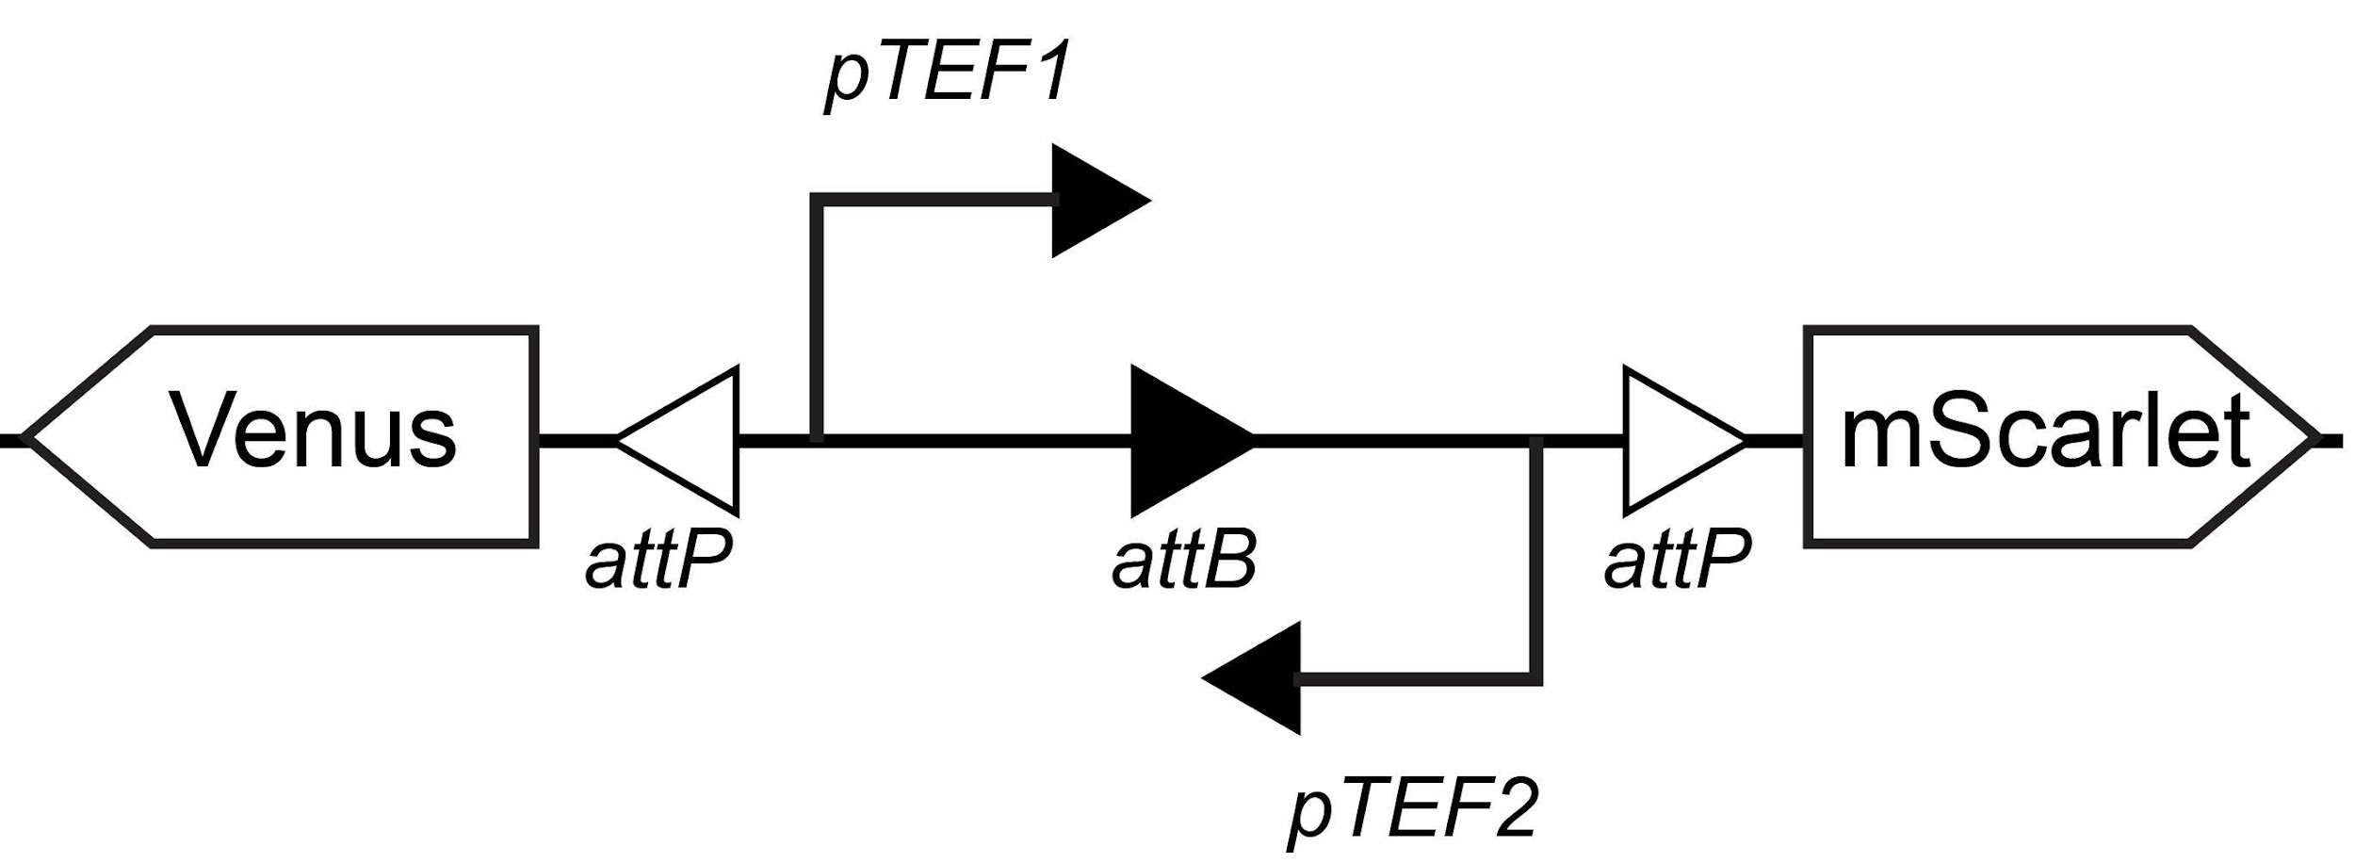
pBranch 03 | Construct for investigating the effects of DNA length between att sites on yeast cell differentiation. Designed for propagation in E. coli and integration at the URA3 locus in S. cerevisiae. | 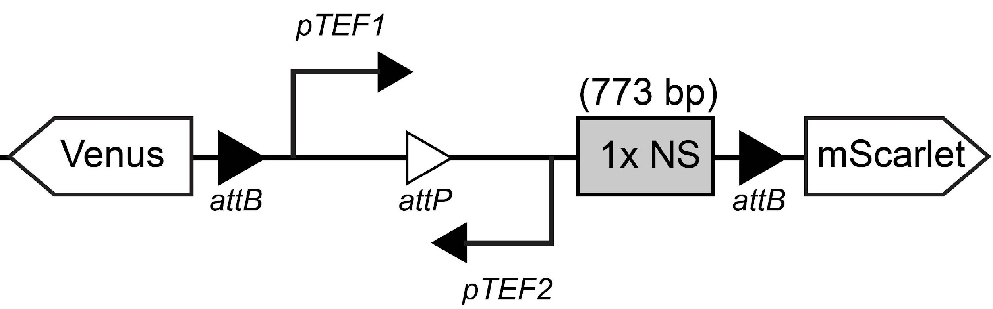
pBranch 04 | Construct for investigating the effects of DNA length between att sites on yeast cell differentiation. Designed for propagation in E. coli and integration at the URA3 locus in S. cerevisiae. | 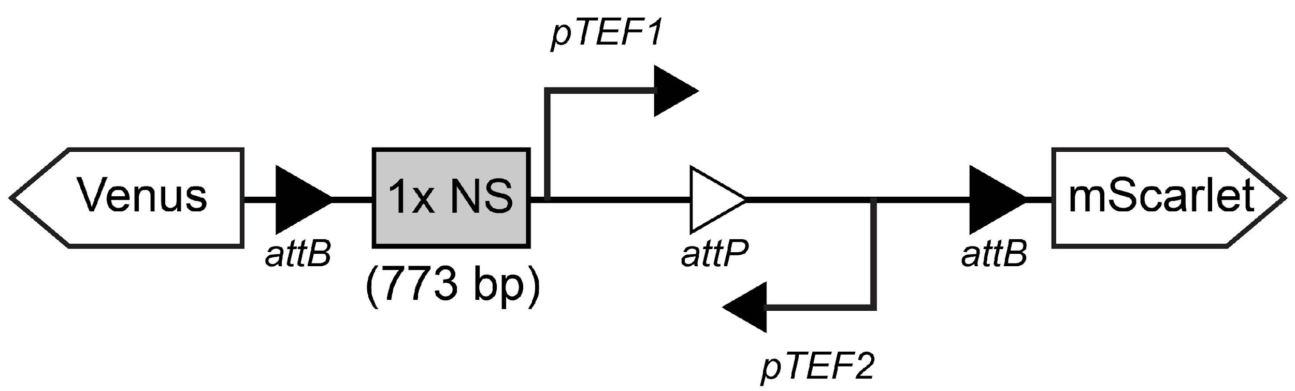
pBranch 05 | Construct for investigating the effects of att sites with predictive recombination rates on yeast cell differentiation. Designed for propagation in E. coli and integration at the URA3 locus in S. cerevisiae. | 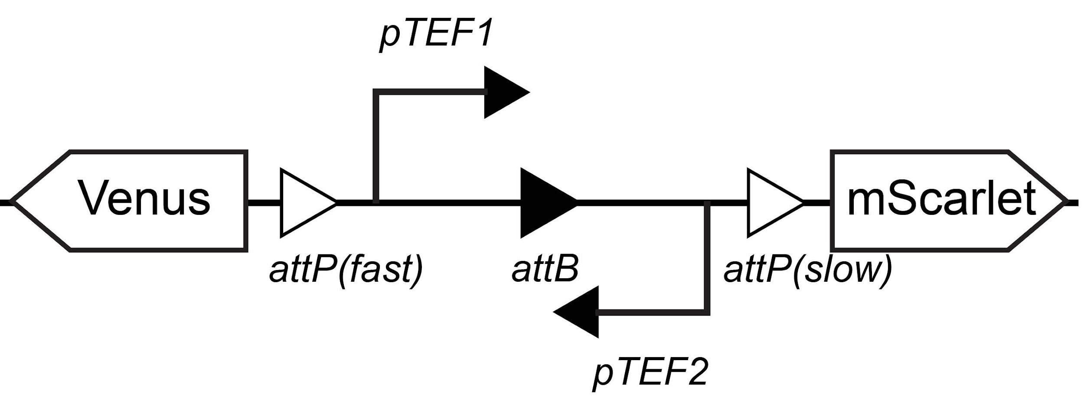
pBranch 06 | Construct incorporating various factors to influence yeast cell differentiation. Designed for propagation in E. coli and integration at the URA3 locus in S. cerevisiae. | 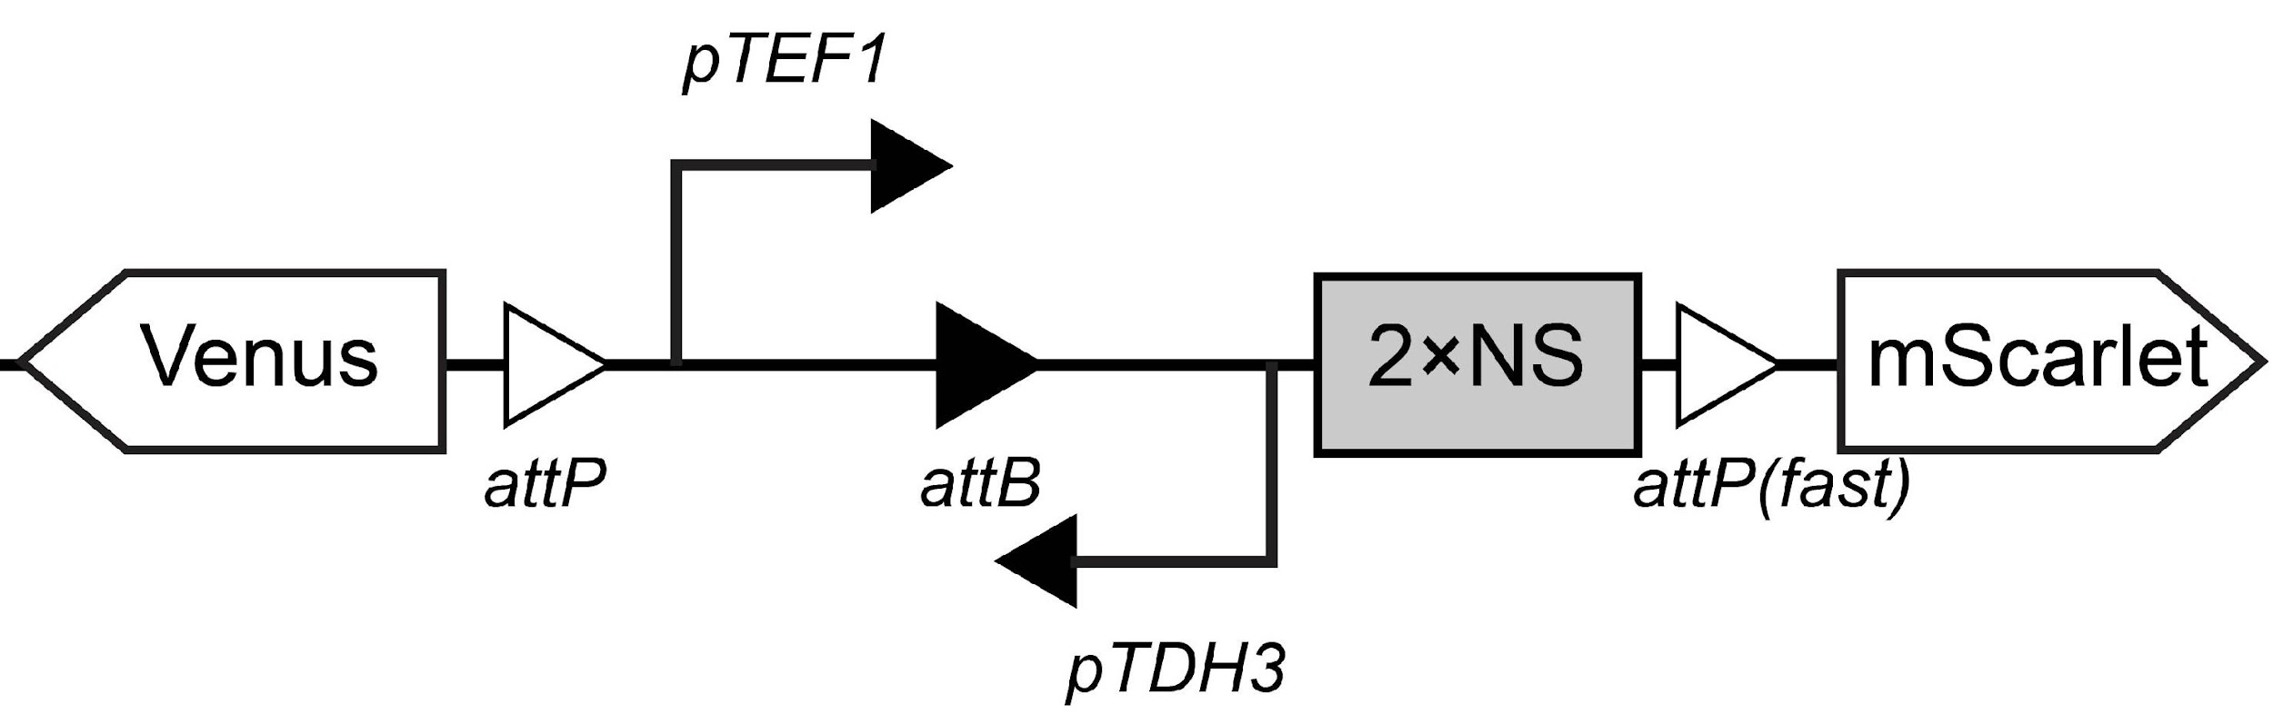
pBranch 07 | Construct for designing multiple parallel and orthogonal circuits. Designed for propagation in E. coli and integration at the URA3 locus in S. cerevisiae. | 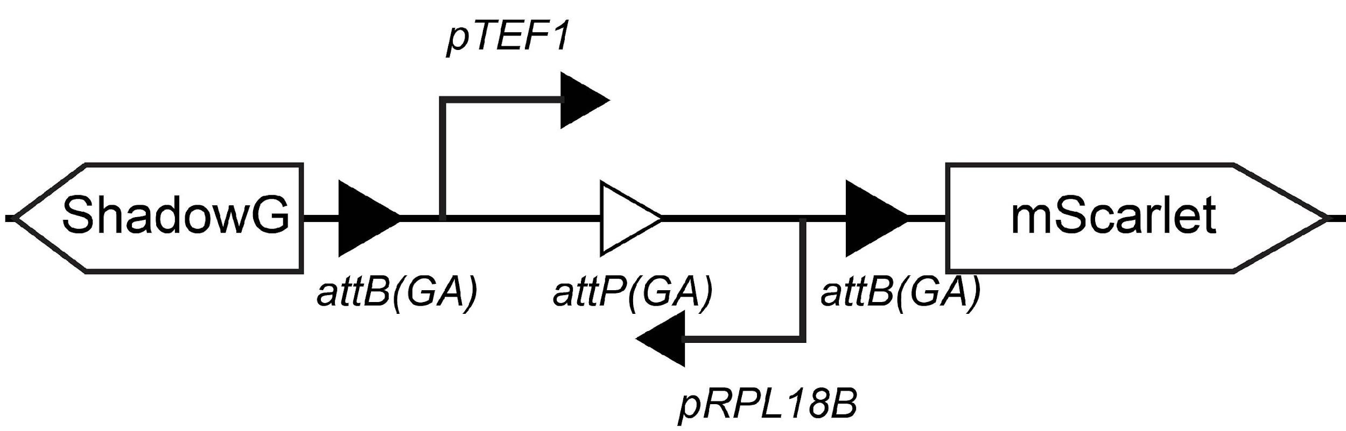
pBranch 08 | Construct for designing multiple parallel and orthogonal circuits. Designed for propagation in E. coli and integration at the HO locus in S. cerevisiae. | 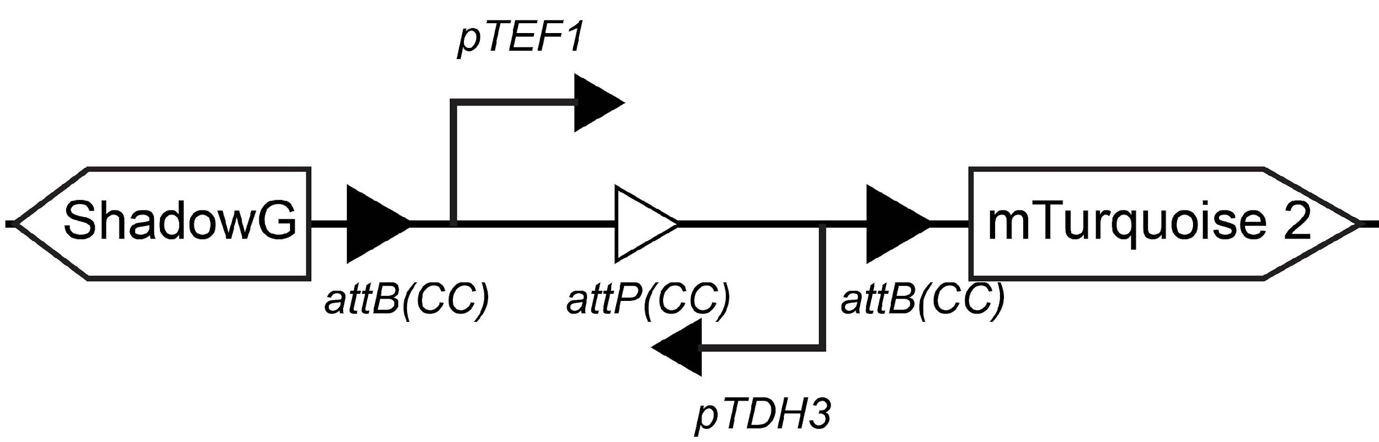
pBranch 09 | Construct for designing multiple parallel and orthogonal circuits. Designed for propagation in E. coli and integration at the LEU2 locus in S. cerevisiae. | 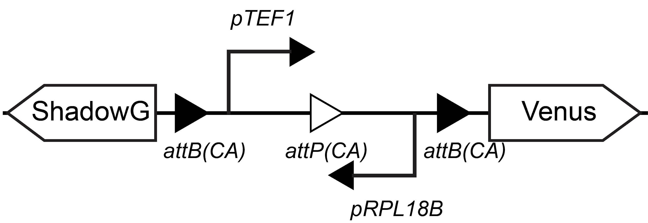
pBranch 10 | Construct for designing multiple parallel and orthogonal circuits. Designed for propagation in E. coli and integration at the URA3 locus in S. cerevisiae. | 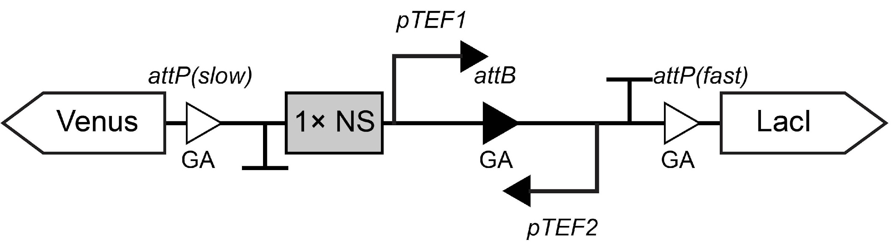
pBranch 11 | Construct for designing multiple parallel and orthogonal circuits. Designed for propagation in E. coli and integration at the LEU2 locus in S. cerevisiae. | 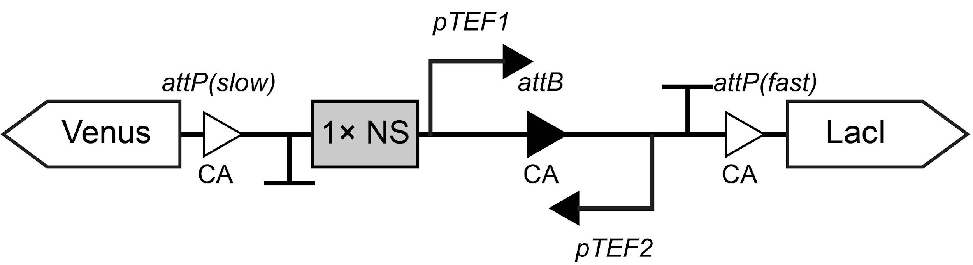
pBranch 12 | Construct for designing multiple parallel and orthogonal circuits. Designed for propagation in E. coli and integration at the HO locus in S. cerevisiae. | 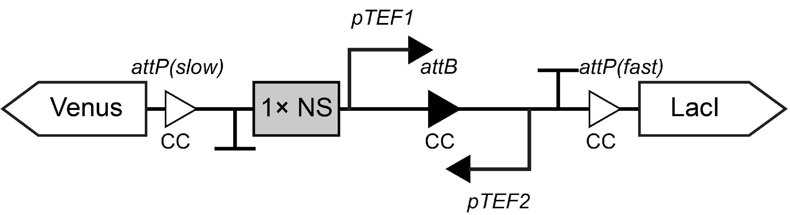
pLac-mScarlet | Construct that drove mScarlet expression via promoter pLac. Designed for propagation in E. coli and integration at the MET15 locus in S. cerevisiae. | 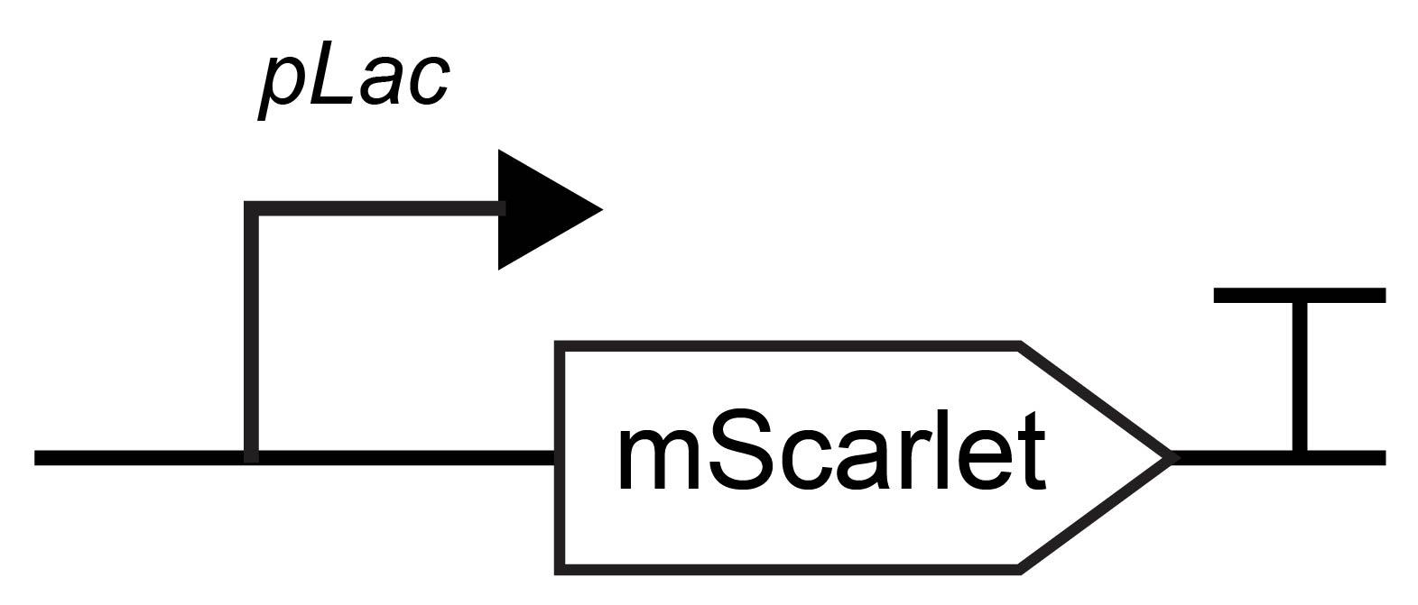
pBranch 13 | Construct for designing multiple sequential circuits. Designed for propagation in E. coli and integration at the URA3 locus in S. cerevisiae. | 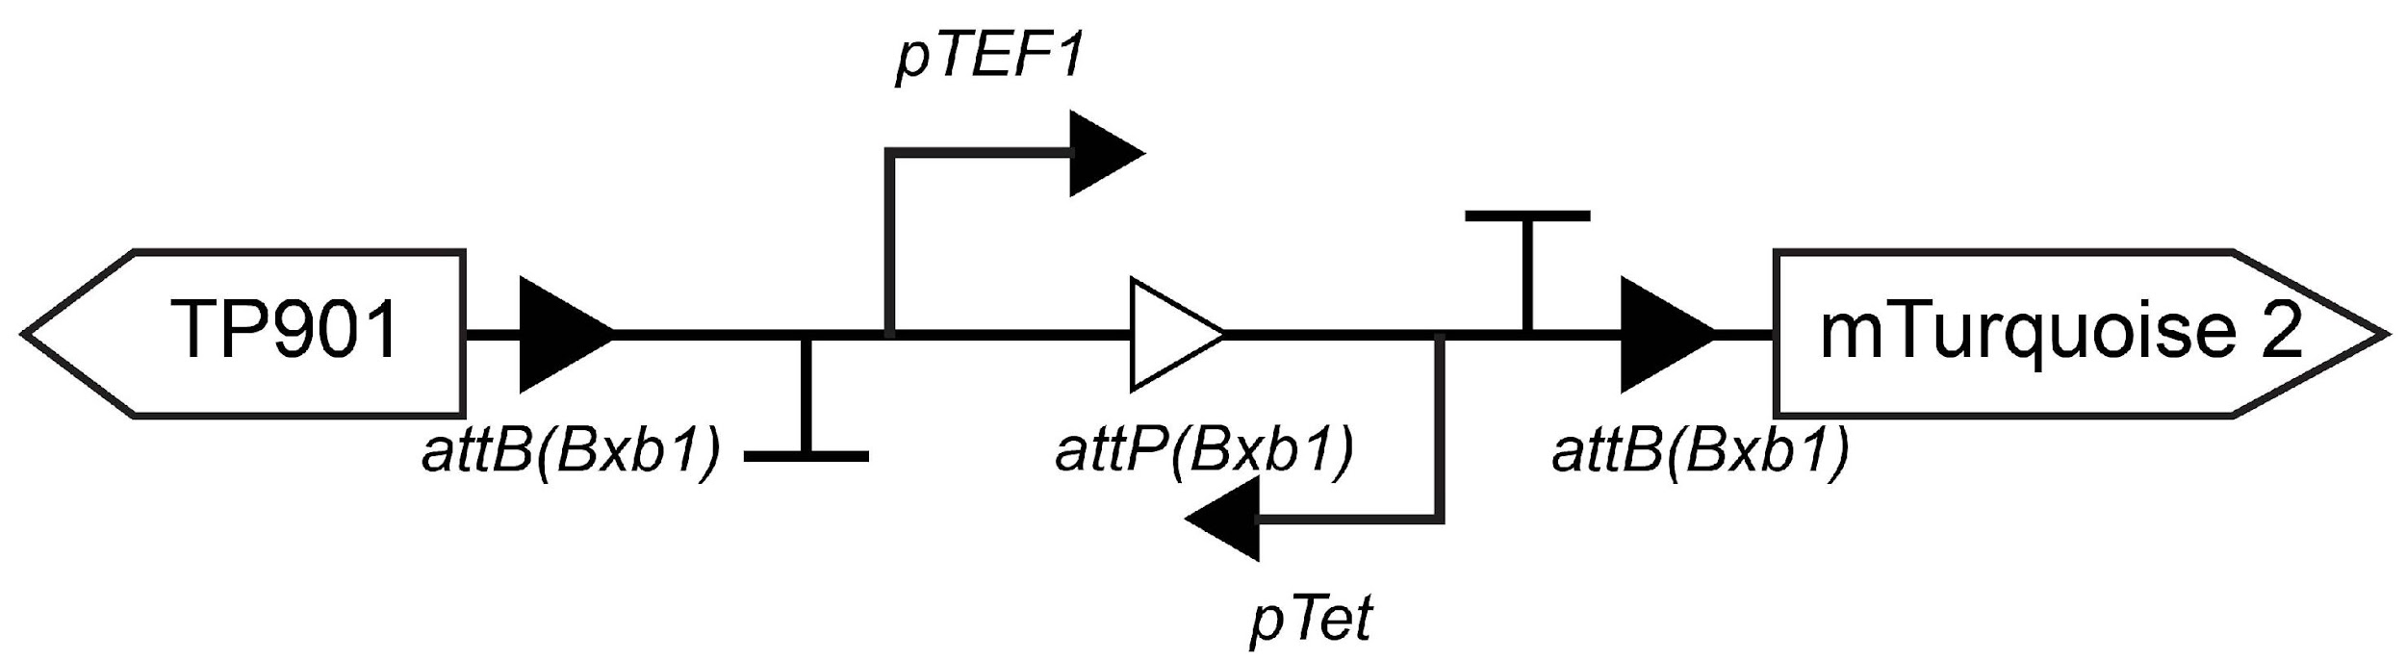
pBranch 14 | Construct for designing multiple sequential circuits. Designed for propagation in E. coli and integration at the HO locus in S. cerevisiae. | 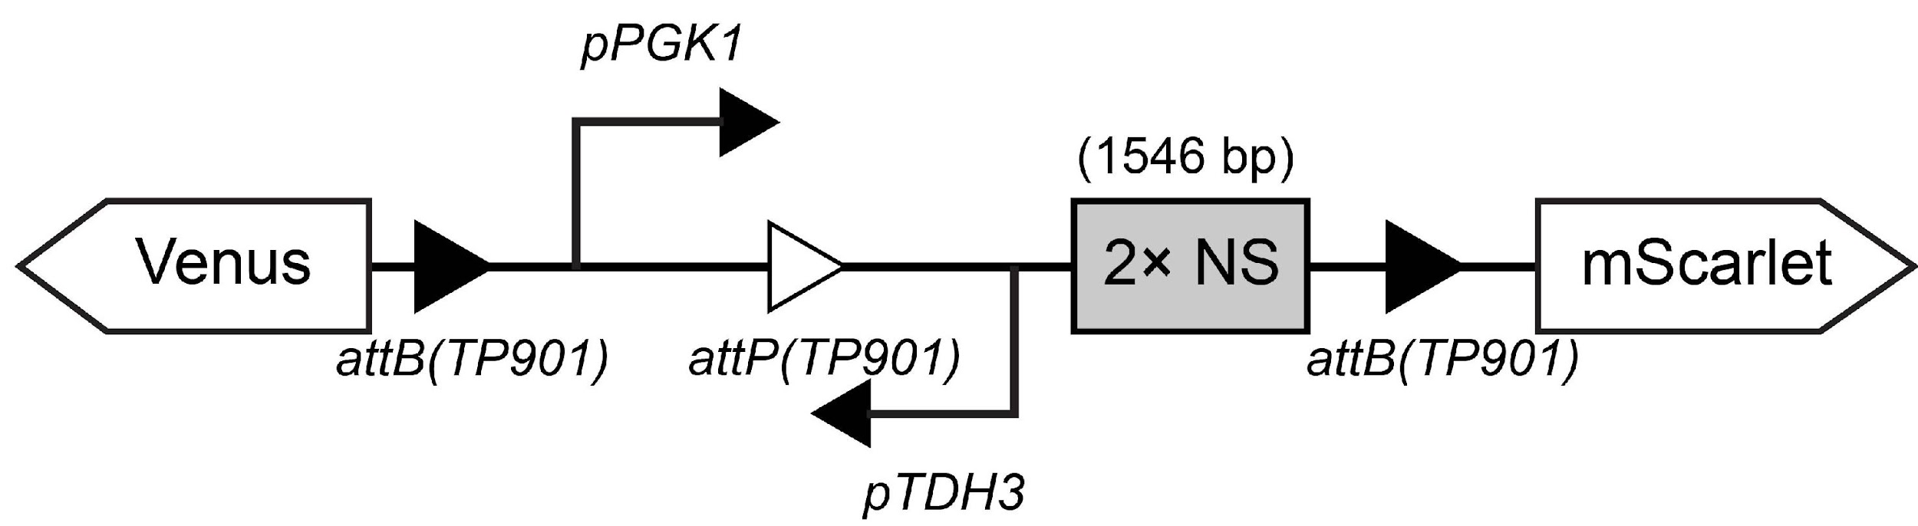
pBranch 15 | Construct producing 2 progeny cells, each expressing a transcription factor. Designed for propagation in E. coli and integration at the URA3 locus in S. cerevisiae. | 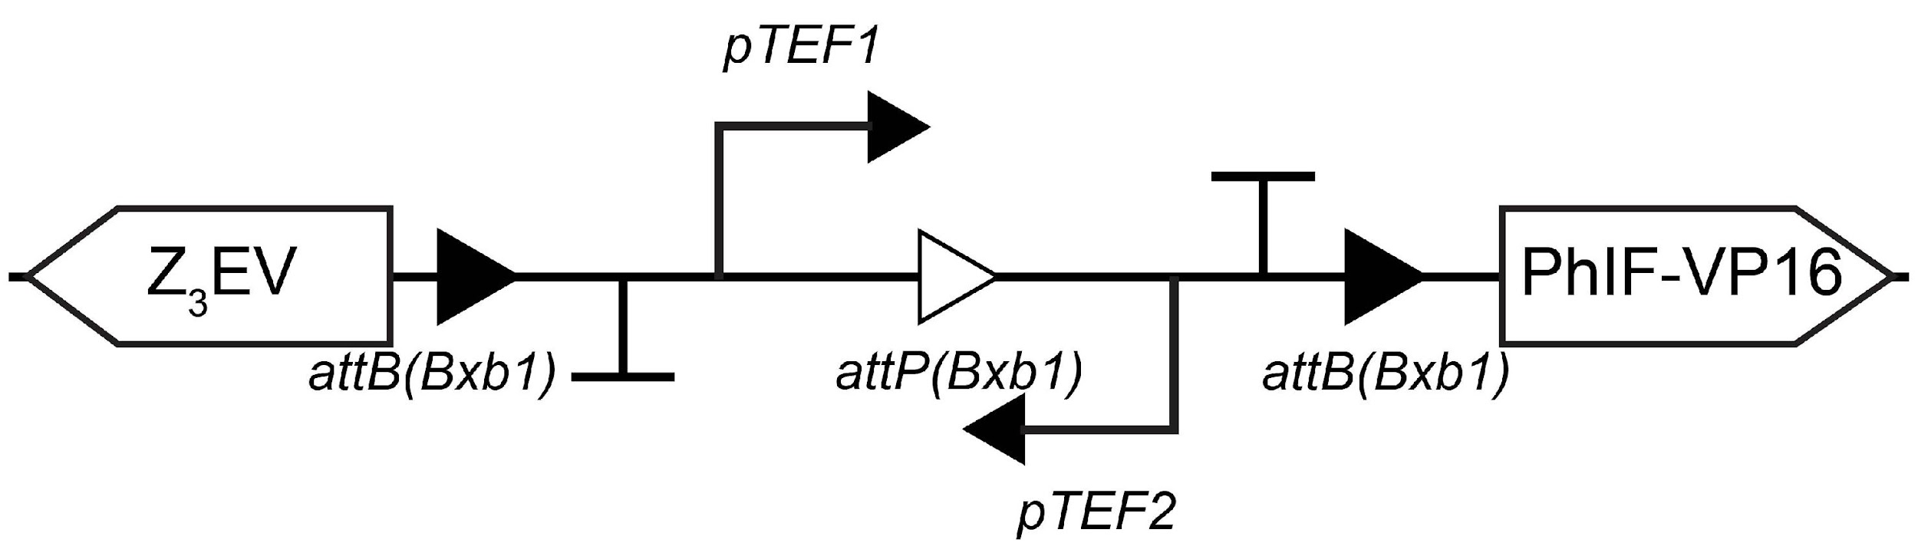
pMYT076-pPhIF-CrtI | Construct that drove CrtE expression via promoter pPhIF. Designed for propagation in E. coli and integration at locus 2 (Int.2 site) in S. cerevisiae. | 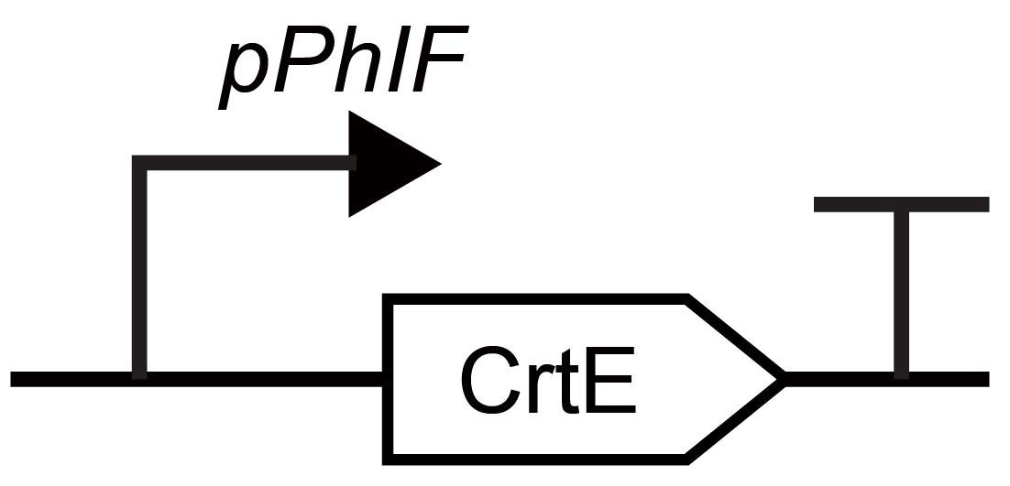
pMYT078-pPhIF-tHGM1 | Construct that drove tHGM1 expression via promoter pPhIF. Designed for propagation in E. coli and integration at locus 4 (Int.4 site) in S. cerevisiae. | 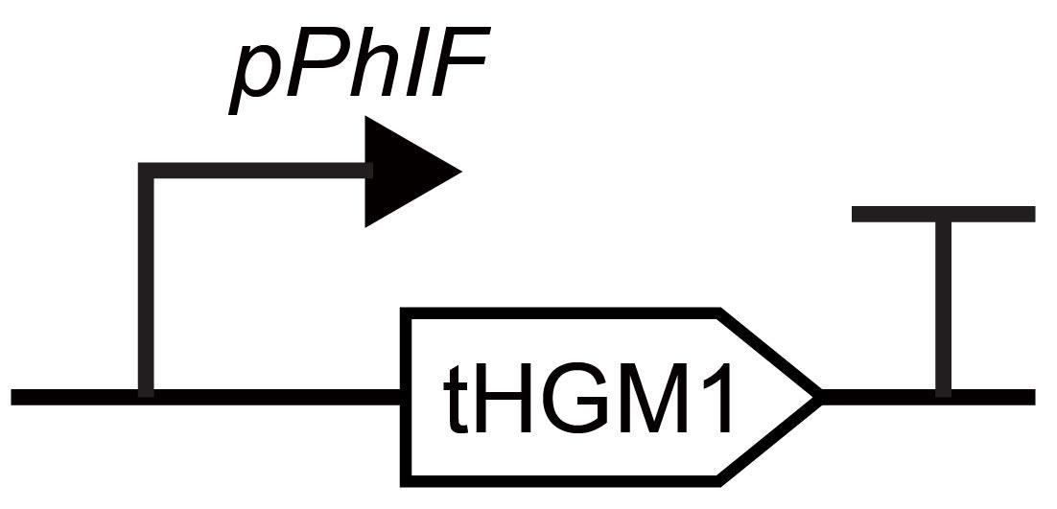
pMYT079-pPhIF-CrtYB | Construct that drove CrtYB expression via promoter pPhIF. Designed for propagation in E. coli and integration at locus 5 (Int.5 site) in S. cerevisiae. | 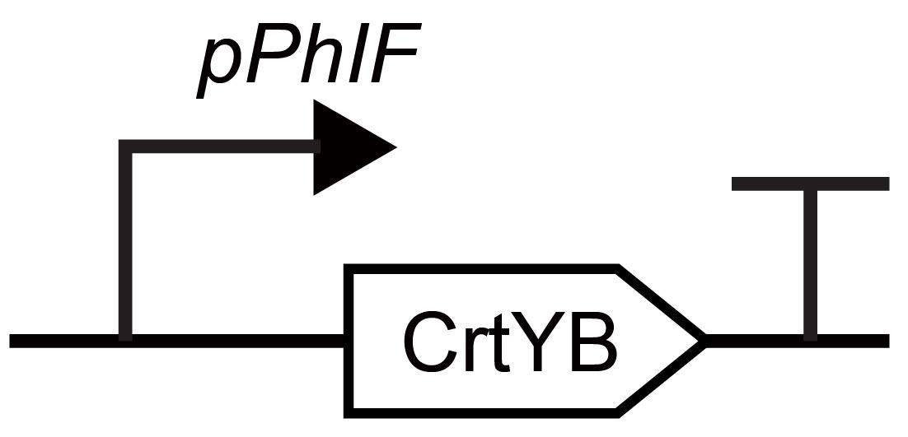
pMYT080-pPhIF-CrtE | Construct that drove CrtE expression via promoter pPhIF. Designed for propagation in E. coli and integration at locus 6 (Int.6 site) in S. cerevisiae.
pMYT081-pZ-VioA | Construct that drove VioA expression via promoter pZ. Designed for propagation in E. coli and integration at locus 7 (Int.7 site) in S. cerevisiae. | 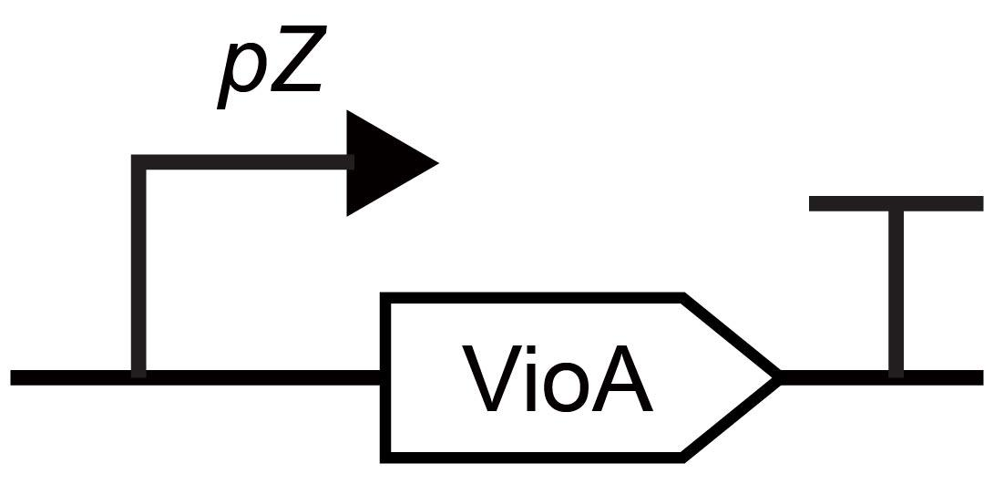
pMYT082-pZ-VioB-p2A-VioE | Construct that drove VioB and VioE expression via promoter pZ. Designed for propagation in E. coli and integration at locus 8 (Int.8 site) in S. cerevisiae. | 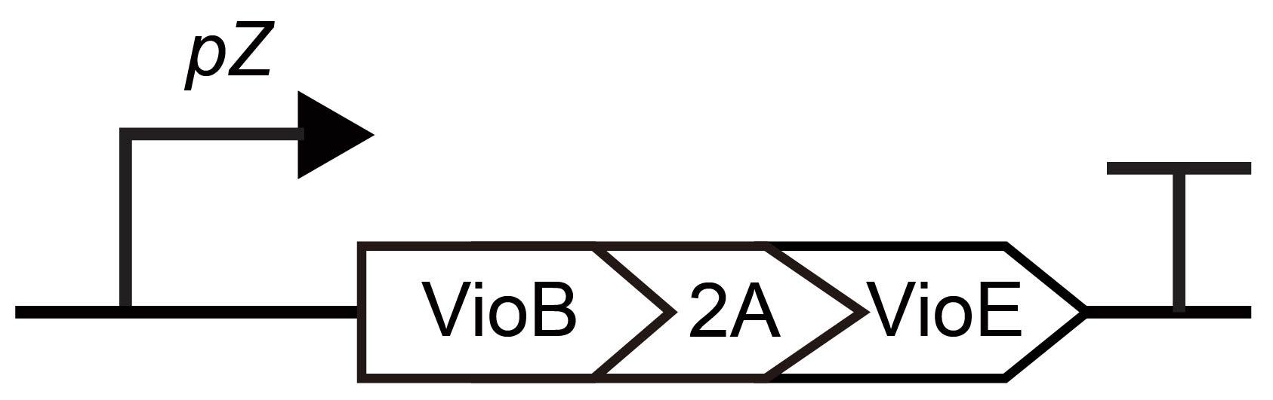
pMYT083-pZ-VioC | Construct that drove VioC expression via promoter pZ. Designed for propagation in E. coli and integration at locus 9 (Int.9 site) in S. cerevisiae. | 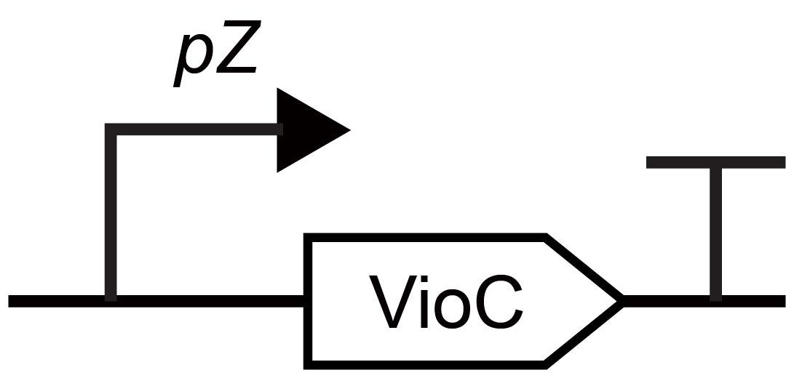
pMYT084-pZ-VioD | Construct that drove VioD expression via promoter pZ. Designed for propagation in E. coli and integration at locus 10 (Int.10 site) in S. cerevisiae. | 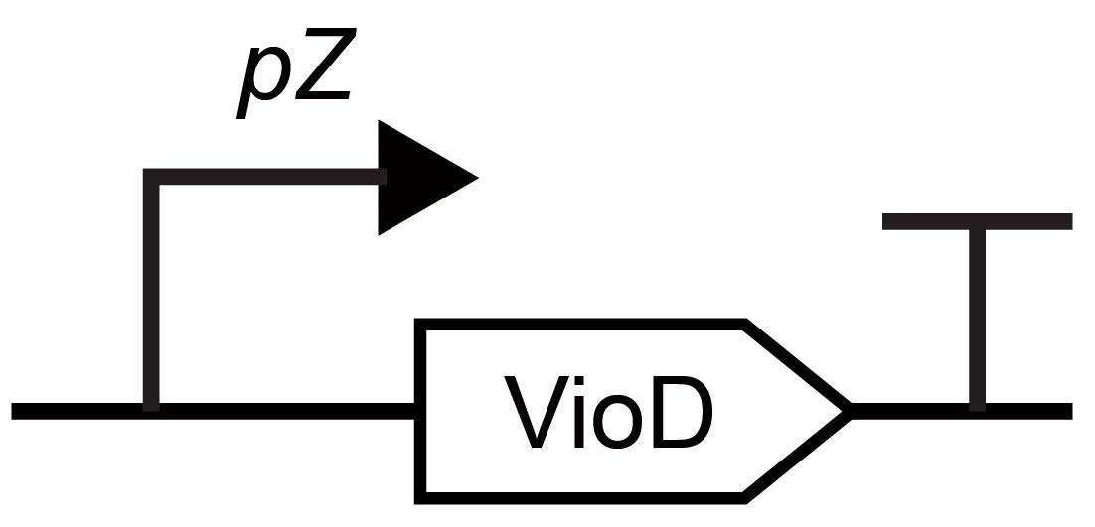
pMYT095-gRNA2456 | Construct encoding Cas9 and gRNAs for genome integration at loci 2, 4, 5, and 6. | 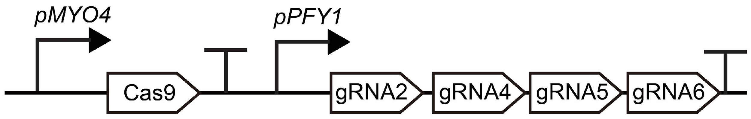
pMYT095-gRNA78910 | Construct encoding Cas9 and gRNAs for genome integration at loci 7, 8, 9, and 10. | 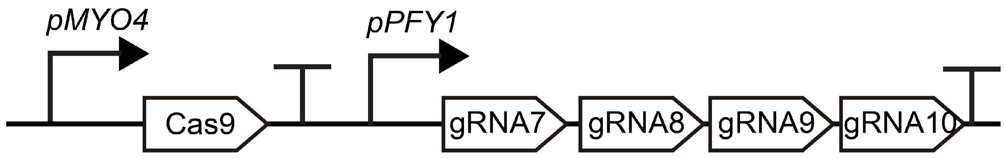
pZ-Nb3-Venus | Construct that drove the surface-displaying of Nb3 via promoter pZ. Designed for propagation in E. coli and integration at LEU2 locus in S. cerevisiae. | 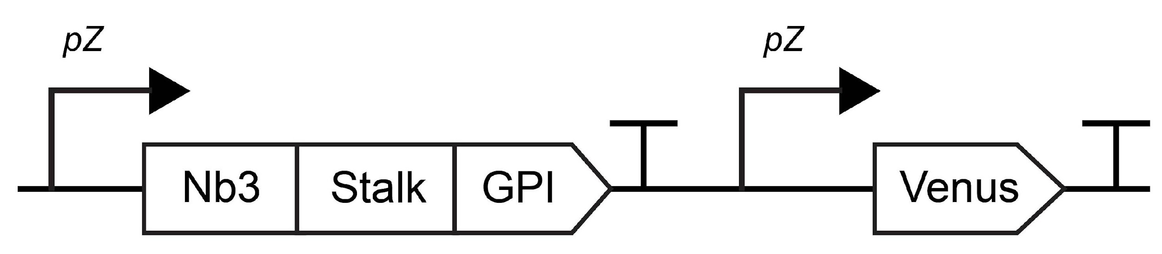
pPhIF-Ag3 | Construct that drove the surface-displaying of Ag3 via promoter pPhIF. Designed for propagation in E. coli and integration at HO locus in S. cerevisiae. | 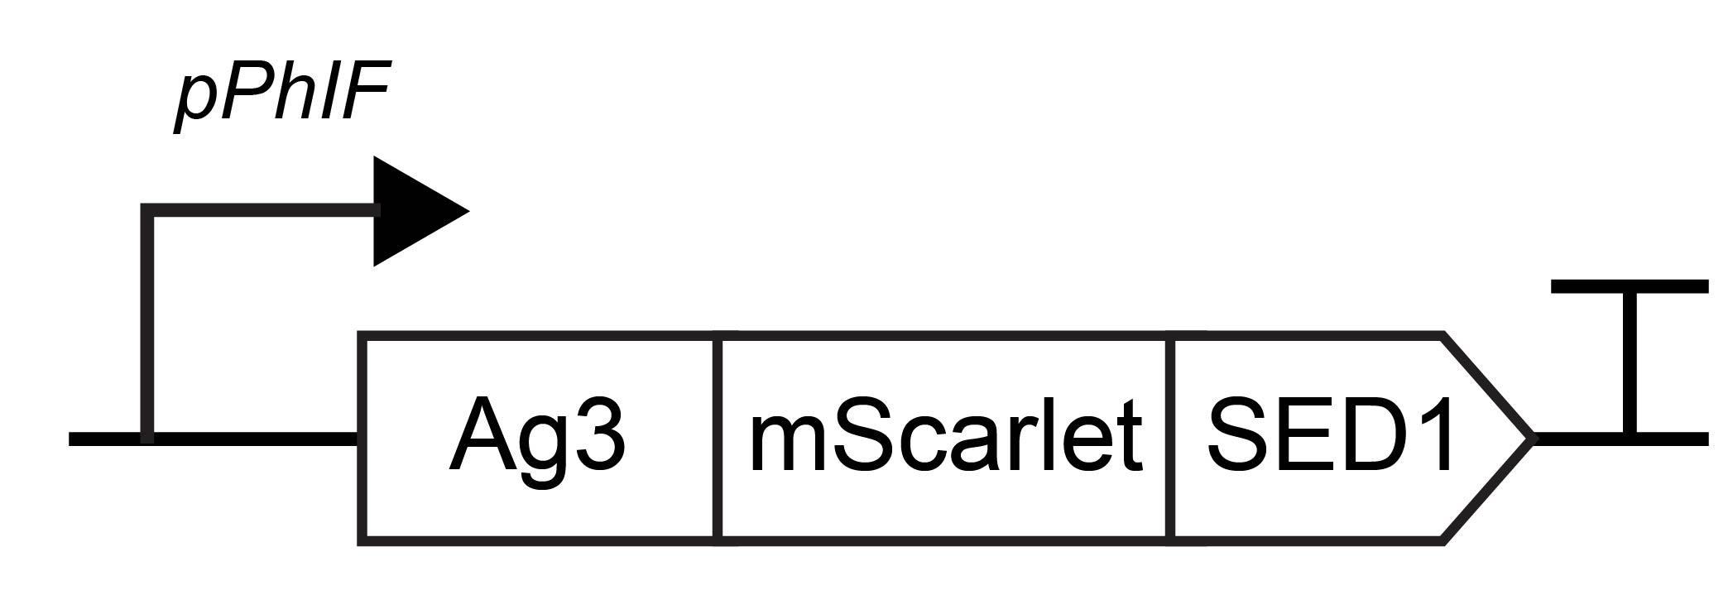

References

1. Schwinn, M.K. et al. CRISPR-Mediated Tagging of Endogenous Proteins with a Luminescent Peptide. ACS Chemical Biology 13, 467-474 (2018).
2. Gilbert, C. et al. Living materials with programmable functionalities grown from engineered microbial co-cultures. Nature Materials 20, 691-700 (2021).
3. Miller, G.L., Blum, R., Glennon, W.E. & Burton, A.L.J.A.B. Measurement of carboxymethylcellulase activity. Analytical Biochemistry 1, 127-132 (1960).
4. Bozdag, G.O. et al. De novo evolution of macroscopic multicellularity. Nature 617, 747-754 (2023).
5. Shaw, W.M., Khalil, A.S. & Ellis, T. A Multiplex MoClo Toolkit for Extensive and Flexible Engineering of Saccharomyces cerevisiae. ACS Synthetic Biology 12, 3393-3405 (2023).
6. Shaw, W.M. et al. Inducible expression of large gRNA arrays for multiplexed CRISPRai applications. Nature Communications 13, 4984 (2022).
7. Lee, M.E., DeLoache, W.C., Cervantes, B. & Dueber, J.E. A Highly Characterized Yeast Toolkit for Modular, Multipart Assembly. ACS Synthetic Biology 4, 975-986 (2015).

