A new point of care diagnostic for the sensitive and specific diagnosis of drug-induced liver injury using a surface enhanced Raman scattering lateral flow immunoassay (SERS-LFIA)
Supplementary information
SERS active conjugates
A schematic showing the synthesis of the Au-DIPY-SiO₂-Ab NP conjugate is shown in Supplementary Figure 1.

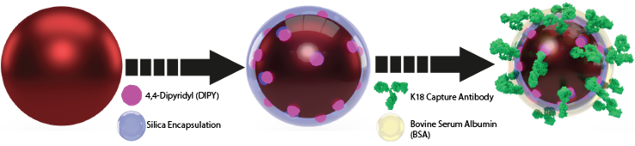
Supplementary Figure 1. Schematic showing synthesis of Au-DIPY-SiO₂ -Ab NP conjugates. Gold nanoparticles (Au NP) were functionalised with the Raman reporter DIPY and then encapsulated in a silica shell. The silica shell was then functionalised with K18 capture antibody and BSA.

The Au NP must remain stable after the addition of SiO₂ and Ab to be used in the SERS LFIA; therefore, every step of the synthesis was characterised using UV/Vis spectroscopy dynamic light scattering and using 785 nm laser excitation. UV/Vis spectroscopy characterisation provided information on the optical properties of the NP by producing an extinction spectrum, illustrated in Supplementary Fig. 2A. Analysis with a 785 nm laser measured the SERS signal produced by the NP, shown in Supplementary Fig. 2B. Data for the dynamic light scattering, a technique that measures the size of the NP, are presented in Supplementary Table 1. As expected, there was a change in the extinction spectra maxima, also known as the localised surface plasmon resonance (LSPR), between the Au NP and Au-DIPY-SiO₂ NP. This was due to the change in refractive index surrounding the NP secondary to the SiO2 encapsulation. The size of the NP also increased after each addition, confirming the successful conjugation. A strong SERS signal was produced by the Au-DIPY-SiO₂ NP, which confirmed that the Raman reporter has bound to NP surface. The SERS signal was still present after the addition of AB, with a small drop in SERS signal observed due to dilution. The characterisation data demonstrate that the conjugates were stable, small enough in size to travel through the LFIA strip and produced an intense DIPY SERS signal, allowing them to be used and detected in the SERS-LFIA.
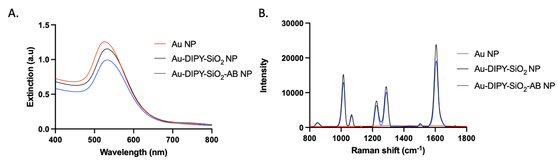
Supplementary Figure 2. UV/Vis spectroscopy and SERS characterisation of Au NP gives information about the optical and SERS properties of NP and assesses for any changes when SiO₂ and Ab were added. Extinction (A) and SERS spectra (B) of Au NP (red), Au-DIPY-SiO₂ NP (black) and Au-DIPY-SiO₂-Ab NP (blue). SERS spectra collected using 785 nm laser excitation, 80 mW laser power, 0.5 second acquisition.

Supplementary Table 1 presents the results of the characterisation of the Au-DIPY-SiO₂-Ab NP used in the K18 LFIA and demonstrates that the conjugates were stable, small enough in size to travel through the LFIA strip and produced an intense DIPY SERS signal.

Supplementary Table 1. Characterisation data of Au-DIPY-SiO₂-Ab NP synthesis. LSPR-Localised surface plasmon resonance is a property of the extinction spectrum which gives information about the optical properties of NP and assesses for any changes when SiO₂ and Ab were added. Dynamic light scattering measures the size of the Au NP and provides information about NP size after the addition of SiO₂ and Ab. Analysing the NP with a 785 nm laser produces information on the SERS signal. It should remain strong after the addition of Ab.
Sample | LSPR (nm) | Size (nm) | SERS Intensity at 1612 cm⁻¹
Au NP | 530 | 55 | N/A
Au-DIPY-SiO₂ NP | 535 | 65 | 25000
Au-DIPY-SiO₂-Ab NP | 535 | 86 | 18000

Calibration curve developed for Study A
The calibration curve was produced out in triplicate using serum three separate healthy donors to ensure robust results. Supplementary Fig. 3 represents the visual results from donor 1, obtained for the calibration curve developed for study A.

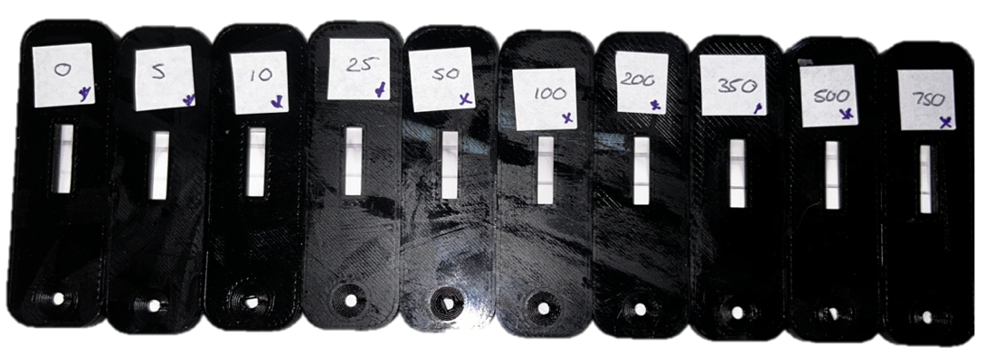
Supplementary Figure 3. Representative image of the calibration curve developed for study A. Serum samples were spiked with 0, 5 10, 25, 50, 100, 200, 350, 500, and 750ng/mL of K18.

Test and control lines were analysed using a Wasatch Photonics (WP) handheld Raman reader (HRR) with a 3D printed accessory designed to hold the SERS-LFIA cassette in front of the laser (HRR version 3A). The average SERS signal from the test line obtained from the three healthy donors is presented in Supplementary Fig. 4A. As expected, an increase in the characteristic peaks of DIPY was observed as the concertation of K18 increased. This is due to the increase in the number of immunoassays and immobilised Au-DIPY-SiO₂-Ab NP. However, if the intensity of the 1612 cm⁻¹ DIPY peak at each concentration is plotted separately for each donor, large variations are observed. This is illustrated in Supplementary Fig. 4B which indicates the error in the R² value for each donor. The difference in SERS spectra at the test line is hypothesised to be due to a ‘serum effect’ and is the result of the differences in serum composition between donors and how this affects the binding of the immunoassay and flow through the nitrocellulose. This, in turn, can lead to variations in the SERS signal.

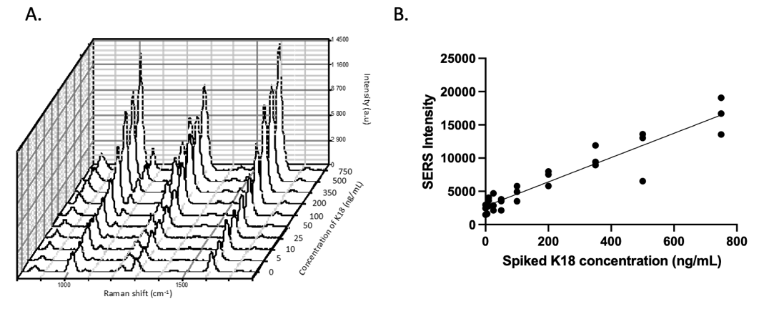
Supplementary Figure 4. A. Baselined SERS spectra obtained by averaging the signal of the test line from 3 healthy donors of serum A, B and C. B. Graph of spiked K18 concentration and the SERS intensity of the 1612 cm⁻¹ peak of DIPY obtained from each donor’s test line at that given concentration. R squared values at the end of each linear line. The SERS signal was collected on the HRR 3A with a 785 nm laser excitation, 3.5 mW laser power, 1-second acquisition and 5 averages. Three replicates of each test line were taken. Spectra baseline corrected on Wasatch Photonics (WP) software.

To overcome this, the output can be standardised by comparing the SERS signal of the test line to the SERS signal of the control line. As the test and control line binding are both affected by serum composition, standardising them against each other mitigates the ‘serum effect’. We have chosen to standardise the output of the test and control line using a linear regression approach which produced a slope when the intensity of the test spectrum was plotted against the intensity of the control spectrum. As the concentration of K18 increased, so did the slope output. The calibration curve obtained using the linear regression approach is shown in Supplementary Fig. 5.

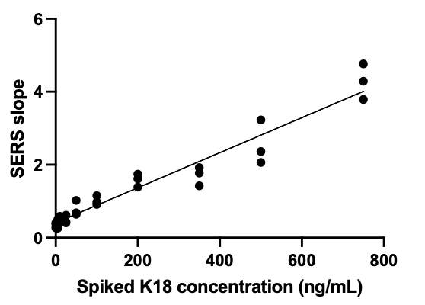
Supplementary Figure 5. Graph of spiked K18 concentration and the slope obtained when standardising the output from each donor at that given concentration.

The linear regression method reduced the variation between donors and produced a linear calibration curve which was used to find the K18 concentration in patient samples in Study A.

Clinical Study A
To assess the sensitivity and specificity of the POC-DILI Diagnostic, the novel assay was used to determine the concentration of K18 in 100 patient samples (50 with DILI and 50 without DILI). Each sample was run on the LFIA, analysed on the HRR, the slope output was calculated and the K18 concentration was determined by plotting the slope on the calibration curve (Supplementary Fig. 5B). Each sample was run in triplicate by three individual users and analysed on the HRR 3A three times. This resulted in 9 seperate K18 concentrations for each sample. The K18 concentrations were then uploaded to the Research Electronic Data Captire (REDCap) database (blinded to the DILI status) and analysed by Statisticians from Edinburgh Clinical Trials Unit.

The visual results of selected samples run as part of study A, along with their ALT, ELISA K18 and POC-DILI K18 values are shown in Supplementarty Fig. 6.

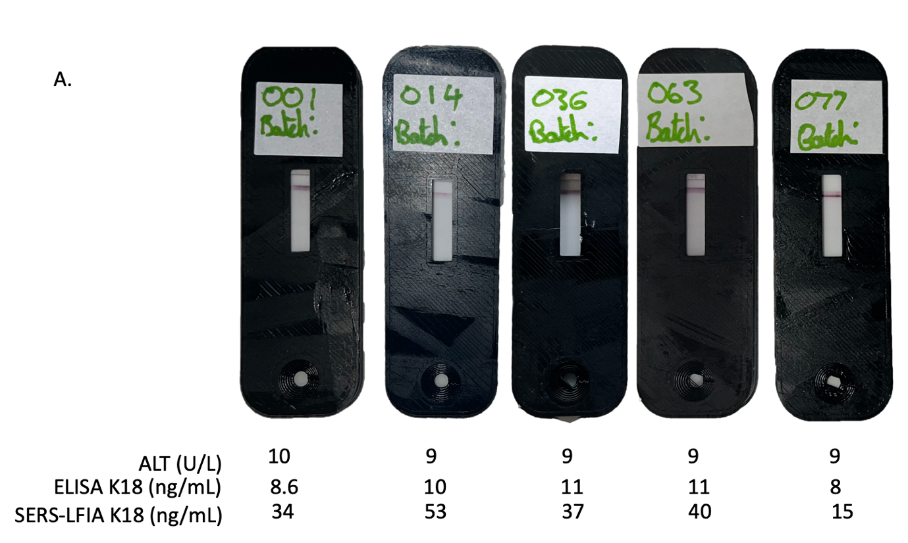
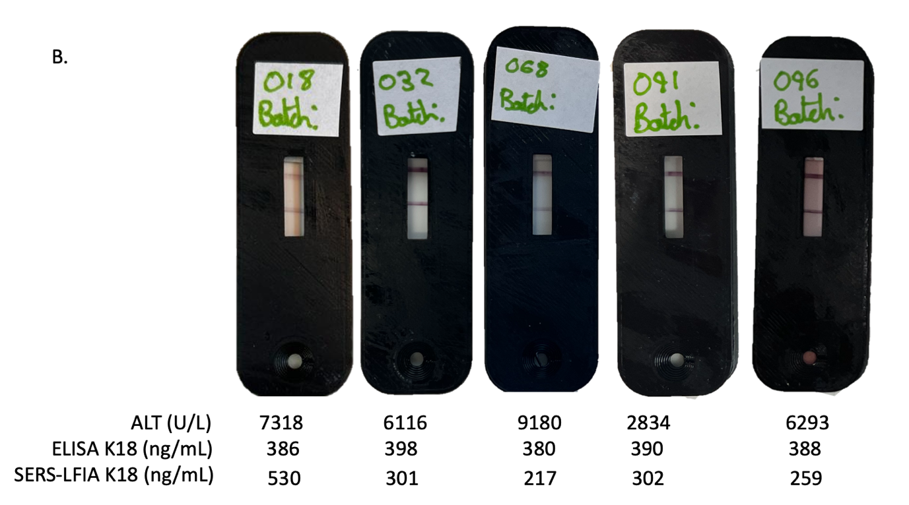
Supplementary Figure 6. LFIA from patients with the associated ALT values and K18 concentrations (calculated using ELISA and SERS-LFIA) A. samples without DILI and B. samples with DILI.

Supplementary Table 2. K18 concentration using POC-DILI with the geometric mean of the K18 measurements obtained by analysers (n=3 measurements by 3 analysers for study A, n=3 measurements by one user for study B). DILI, drug-induced liver injury; GSD, geometric standard deviation; LLQ, lower limit of quantification.
 | Study A |  |  |  |  |  | Study B
 | Non-DILI |  |  | DILI |  |  | Non-DILI | DILI
Analyser | W | X | Y | W | X | Y | Z | Z
N | 50 | 50 | 50 | 49 | 49 | 49 | 50 | 50
Geometric Mean (GSD) | 35 (1.94) | 47 (1.89) | 43 (1.78) | 148 (1.74) | 137 (1.91) | 154 (1.84) | 48 (2.51) | 204 (1.53)
Median [Q1, Q3] | 42  [21, 52] | 53  [29, 68] | 44  [31, 62] | 149  [108, 225] | 145  [98, 213] | 157 [100,240] | 56  [34, 71] | 213  [146, 200]
Minimum, Maximum | 8, 180 | 11, 168 | 11, 145 | 29, 526 | 41, 625 | 44, 636 | 1, 208 | 81, 437

Visual analysis
Three independent reviewers scored the DILI status of the test visually. The reviewers assigned a score of negative, if there was a weak test line when compared to the control, positive (+) if the test line was visible but weaker than the control or positive (++) if the test line was strong and had similar intensity as the control line.
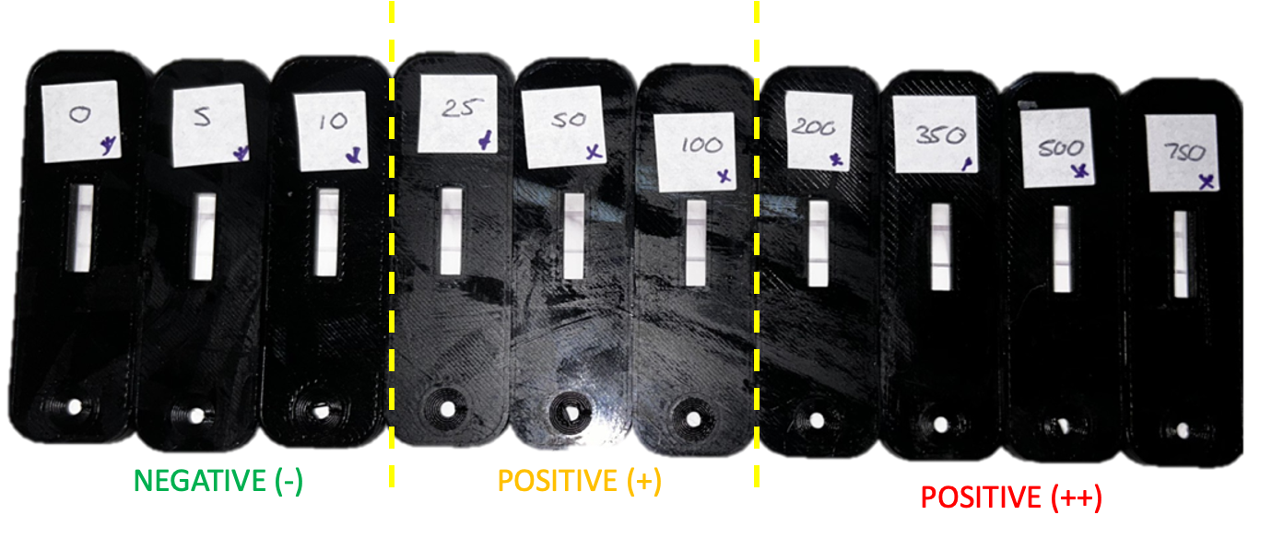
Supplementary Figure 7. Reference images for visual scoring of LFIAs. The images are ranked from low K18 concentration to high concentration and categorised as negative (-), weakly positive (+) and positive (++).

Supplementary Table 3. Previous clinical studies demonstrating that K18 is a sensitive and accurate biomarker of DILI in large patient cohorts. The results of study A and B with the POC-DILI Diagnostic are presented in red.
Study​ | Cause of liver injury​ | N​ | ROC-AUC (95% CI)​ | Reference​
Hepatology​ 2013¹ | Paracetamol​ | 129​ | 0.94 (0.87-1.00)​ | Hepatology 2013 PMID 23390034​
MAPP​² | Paracetamol​ | 985​ | 0.94 (0.89-0.99)​ | The Lancet Gastroenterology & Hepatology 2018  PMID 29146439​
BIOPAR​² | Paracetamol​ | 202​ | 0.93 (0.81-1.00)​ | The Lancet Gastroenterology & Hepatology 2018  PMID 29146439​
Hepatology 2019³ | Non-paracetamol DILI | 689 | 0.95 (0.93-0.97) | Hepatology 2019  PMID 29357190
Edinburgh/Pfizer 2020​⁴ | Paracetamol​ | 198​ | 0.98 (0.95-0.99)​ | Toxicological Sciences 2021  PMID 33483742​
Nature Communications⁵ | Non-paracetamol DILI | 142 | 0.96 (0.92-0.99) | Nature Communications 2023  PMID 36869085
Nature Communications⁵ | Non-paracetamol DILI | 75 | 0.97 (0.94-1.00) | Nature Communications 2023  PMID 36869085
Spanish DILI Registry⁶ | Non-paracetamol DILI | 109 | 0.96 (0.91-1.00) | British Journal of Clinical Pharmacology 2023  PMID 36965054
Study A | Paracetamol | 99 | 0.95 (0.91-0.99)
Study B | Paracetamol​ | 100​ | 0.97 (0.93 – 1.00)​

Supplementary Table 4. STARD (Standards for Reporting Diagnostic accuracy studies) checklist.
 | Section & topic | No | Item | Reported on page #
 | Title or abstract
 |  | 1 | Identification as a study of diagnostic accuracy using at least one measure of accuracy  (such as sensitivity, specificity, predictive values, or AUC) | 1 (Title and Abstract)
 | Abstract
 |  | 2 | Structured summary of study design, methods, results, and conclusions  (for specific guidance, see STARD for Abstracts) | N/A
 | Introduction
 |  | 3 | Scientific and clinical background, including the intended use and clinical role of the index test | 1 – 4 (Introduction)
 |  | 4 | Study objectives and hypotheses | 4 (Introduction)
 | Methods
 | Study design | 5 | Whether data collection was planned before the index test and reference standard  were performed (prospective study) or after (retrospective study) | 7 (Results), 19 (Methods)
 | Participants | 6 | Eligibility criteria | 19 (Methods)
 |  | 7 | On what basis potentially eligible participants were identified  (such as symptoms, results from previous tests, inclusion in registry) | 19 (Methods)
 |  | 8 | Where and when potentially eligible participants were identified (setting, location and dates) | 19 (Methods)
 |  | 9 | Whether participants formed a consecutive, random or convenience series | 19 (Methods)
 | Test methods | 10a | Index test, in sufficient detail to allow replication | 20 – 21 (Methods)
 |  | 10b | Reference standard, in sufficient detail to allow replication | 19 (Methods – ELISA)  20 (Methods – ALT)
 |  | 11 | Rationale for choosing the reference standard (if alternatives exist) | 19 (Methods)
 |  | 12a | Definition of and rationale for test positivity cut-offs or result categories  of the index test, distinguishing pre-specified from exploratory | 11 – 13 (Results) and 21 (Methods)
 |  | 12b | Definition of and rationale for test positivity cut-offs or result categories  of the reference standard, distinguishing pre-specified from exploratory | 19 (Methods)
 |  | 13a | Whether clinical information and reference standard results were available  to the performers/readers of the index test | 20 – 21 (Methods)
 |  | 13b | Whether clinical information and index test results were available  to the assessors of the reference standard | 20 – 21 (Methods)
 | Analysis | 14 | Methods for estimating or comparing measures of diagnostic accuracy | 21 (Methods)
 |  | 15 | How indeterminate index test or reference standard results were handled | 21 (Methods)
 |  | 16 | How missing data on the index test and reference standard were handled | 21 (Methods)
 |  | 17 | Any analyses of variability in diagnostic accuracy, distinguishing pre-specified from exploratory | 21 (Methods)
 |  | 18 | Intended sample size and how it was determined | 20 (Methods)
 | Results
 | Participants | 19 | Flow of participants, using a diagram | 10 (Results – Fig. 4)
 |  | 20 | Baseline demographic and clinical characteristics of participants | 8 (Results – Table 1)
 |  | 21a | Distribution of severity of disease in those with the target condition | 8 (Results – Table 1)
 |  | 21b | Distribution of alternative diagnoses in those without the target condition | N/A
 |  | 22 | Time interval and any clinical interventions between index test and reference standard | N/A
 | Test results | 23 | Cross tabulation of the index test results (or their distribution)  by the results of the reference standard | 10 (Results – Fig. 3)
 |  | 24 | Estimates of diagnostic accuracy and their precision (such as 95% confidence intervals) | 13 (Results – Table 2)
 |  | 25 | Any adverse events from performing the index test or the reference standard | N/A
 | Discussion
 |  | 26 | Study limitations, including sources of potential bias, statistical uncertainty, and generalisability | 14 – 15 (Discussion)
 |  | 27 | Implications for practice, including the intended use and clinical role of the index test | 14 – 15 (Discussion)
 | Other information
 |  | 28 | Registration number and name of registry | 19 (Methods – MAPP2 study)
 |  | 29 | Where the full study protocol can be accessed | 16 – 21 (Methods)
 |  | 30 | Sources of funding and other support; role of funders | 21 (Acknowledgements)
Supplementary References

1. Antoine, D.J., et al. Mechanistic biomarkers provide early and sensitive detection of acetaminophen-induced acute liver injury at first presentation to hospital. Hepatology 58, 777-787 (2013).
2. Dear, J.W., et al. Risk stratification after paracetamol overdose using mechanistic biomarkers: results from two prospective cohort studies. Lancet Gastroenterol Hepatol 3, 104-113 (2018).
3. Church, R.J., et al. Candidate biomarkers for the diagnosis and prognosis of drug-induced liver injury: An international collaborative effort. Hepatology 69, 760-773 (2019).
4. Llewellyn, H.P., et al. Evaluating the Sensitivity and Specificity of Promising Circulating Biomarkers to Diagnose Liver Injury in Humans. Toxicological Sciences 181, 23-34 (2021).
5. Ravindra, K.C., et al. Tandem mass tag-based quantitative proteomic profiling identifies candidate serum biomarkers of drug-induced liver injury in humans. Nat Commun 14, 1215 (2023).
6. Cueto-Sánchez, A., et al. Evaluation of diagnostic and prognostic candidate biomarkers in drug-induced liver injury vs. other forms of acute liver damage. Br J Clin Pharmacol 89, 2497-2507 (2023).

