Supplemental Information
Molecular Diversity of Dissolved Organic Matter Reflects Macroecological Patterns in River Networks
Authors: Erika C. Freeman^{1,2}, Maruti K. Mudunuru³, Kelli L.Feeser⁴, Emily Ann McClure⁵, Ricardo González-Pinzón⁶, Christopher S. Ward⁷, Eric M. Bottos⁸, Stefan Krause^{9,10}, Jasquelin Peña^{11,12}, Michelle E. Newcomer*¹³
¹Department of Plant Sciences, University of Cambridge, Cambridge, United Kingdom.
(erika.freem@gmail.com), ORCID: 0000-0001-7161-6038
²Department of Aquatic Ecology, Swiss Federal Institute of Aquatic Science and Technology
(Eawag), Überlandstrasse 133, CH-8600 Dübendorf, Switzerland
³Pacific Northwest National Laboratory, Richland, Washington, USA (maruti@pnnl.gov),
ORCID: 0000-0002-2158-7723
⁴Los Alamos National Laboratory, Bioscience Division, Los Alamos, New Mexico, USA
(kfeeser@lanl.gov), ORCID: 0000-0002-4144-0294
⁵ Geisel School of Medicine at Dartmouth, Hanover, NH USA
(EmilyA.McClure@dartmouth.edu), ORCID: 0000-0002-4401-0724
⁶Gerald May Department of Civil, Construction and Environmental Engineering, University of
New Mexico, Albuquerque, New Mexico, USA (gonzaric@unm.edu), ORCID:
0000-0001-9387-6885
⁷Center for Great Lakes and Watershed Studies, Bowling Green State University, Bowling
Green, Ohio, USA (chrward@bgsu.edu), ORCID: 0000-0002-9887-232X
⁸Department of Biological Sciences, Thompson Rivers University, Kamloops, British Columbia,
Canada (ebottos@tru.ca), ORCID: 0000-0001-9671-5657
^{9,10}University of Birmingham, Birmingham, UK. (s.krause@bham.ac.uk), ORCID:
0000-0003-2521-2248
¹¹Ecologie des Hydrosystèmes Naturels et Anthropisés (LEHNA), Université Claude Bernard
Lyon 1, 69622 Villeurbanne, France
¹²University of California, Davis. (pena@ucdavis.edu, jpena@lbl.gov), ORCID:
0000-0001-7081-3873
¹³Lawrence Berkeley National Laboratory, Berkeley, California, USA (mnewcomer@lbl.gov),
ORCID: 0000-0001-5138-9026
(*corresponding author)
Supplementary Materials:
Methods S1: WHONDRS Sample Collection and Analysis
Methods S2: WHONDRS Sample Collection and Analysis
Fig. S1-5
Table S1-3

Methods S1: WHONDRS Sample Collection and Analysis
Sediment and surface water samples were collected following the protocol of the National Ecological Observatory Network program (NEON) (NEON.DOC.001193; Jensen, 2022). Surface water samples were collected in triplicate and filtered through 0.22 μm SterivexTM filters (EMD Millipore) into pre-acidified 40 mL glass vials (I-Chem amber VOA glass vials; ThermoFisher, pre-acidified with 10 µL of 85% phosphoric acid). Sediment samples were collected from a depositional zone upstream, midstream, or downstream within the sampling site. For sediments, a 125 mL of surface (1-3 cm) sediment samples were collected using a sterilised stainless-steel scoopula (Garayburu-Caruso et al., 2020; Goldman et al., 2020). Samples were collected only from sediment saturated with water. Samples were shipped to Pacific Northwest National Laboratory’s Environmental Molecular Sciences Laboratory, USA on blue ice within 24 h of collection. Once in the lab, surface water samples were frozen at −20 °C until analysis. Sediment samples were individually sieved to <2 mm, subsampled, and stored at −20 °C. Before analyses, all samples were thawed in the dark at 4°C for 72 hours. Water soluble (i.e. < 0.22 μm filter size) organic matter (i.e. DOM) from sediments was extracted prior to analysis by shaking the sediments with MilliQ water for 2h (Tfaily et al., 2017). Non-purgeable organic carbon (NPOC) was determined in the surface water samples and sediment extracts using a combustion carbon analyzer (TOC-L CSH/CSN E100V) with an ASI-L autosampler. NPOC concentrations were normalised via dilution to 1.5 mg C L⁻¹ across all samples before solid phase extraction (SPE) with PPL (Priority PolLutant, Bond Elut) cartridges using methanol for final elution (Dittmar et al., 2008). The normalisation of samples to 1.5 mg/L C allows for FT-ICR MS data comparison across sites within this study and other WHONDRS sampling campaigns.

Methods S2: FTICR Data Processing
An 12 Tesla Bruker SolariX Fourier transform ion cyclotron mass spectrometer (12 T FT-ICR MS; Bruker, SolariX, Billerica, MA, USA, resolution was 220 K at 481.185 m/z) located at the Environmental Molecular Sciences Laboratory in Richland, WA, USA, was used to collect ultrahigh-resolution mass spectra of surface water and sediment extracts (Garayburu-Caruso et al., 2020). Data were collected in negative mode with an ion accumulation of 0.05 s for surface water and 0.1 or 0.2 s (depending on sample quality) for sediment from 100–900 m/z at 4 M. BrukerDaltonik Data Analysis software (version 4.2) was used to convert raw spectra to a list of m/z values by applying a signal-to-noise ratio (S/N) of 7 and an absolute intensity threshold to the default value of 100. Peaks were aligned, and molecular formulae were assigned using the Formularity software (Tolić et al., 2017). Formularity outputs were post-processed using the R package ftmsRanalysis (Bramer et al., 2020). This package removes peaks outside of a high confidence m/z range (200 m/z–900 m/z) and/or with a ¹³C isotopic signature and calculates molecular formula properties and chemical classes (Kim et al., 2003; Koch et al., 2007; LaRowe and Van Cappellen, 2011). Subsequently, molecular formulae were classified into amino sugar-like, carbohydrate-like, condensed aromatic-like, lignin-likes, lipid-like, protein-like, tannin-like, and unsaturated hydrocarbon-like compounds using the assign_class() function (Kim et al., 2003).
Peak intensities were transformed into presence-absence data. The up-, mid-, and downstream sediment samples were treated as triplicates. The peaks and molecular formulae were kept for subsequent analyses if they were found in at least one of the replicates. Peaks that were assigned the same molecular formula due to minor mass differences were merged together. Only peaks with an assigned molecular formula and with an elemental combination of C₁₋₁₃₀ H₁₋₂₀₀ O₁₋₅₀ N₀₋₄ S₀₋₂ and P₀₋₁ were retained (Riedel and Dittmar, 2014). Only molecular formulae in the range of 0.3 ≥ H/C ≤ 2.2 and O/C ≤ 1.2 (Hawkes et al., 2020) and double bond equivalents minus oxygen ≤ 10 were considered reliable based on chemical feasibility (Herzsprung et al., 2014)

Supplementary Figures

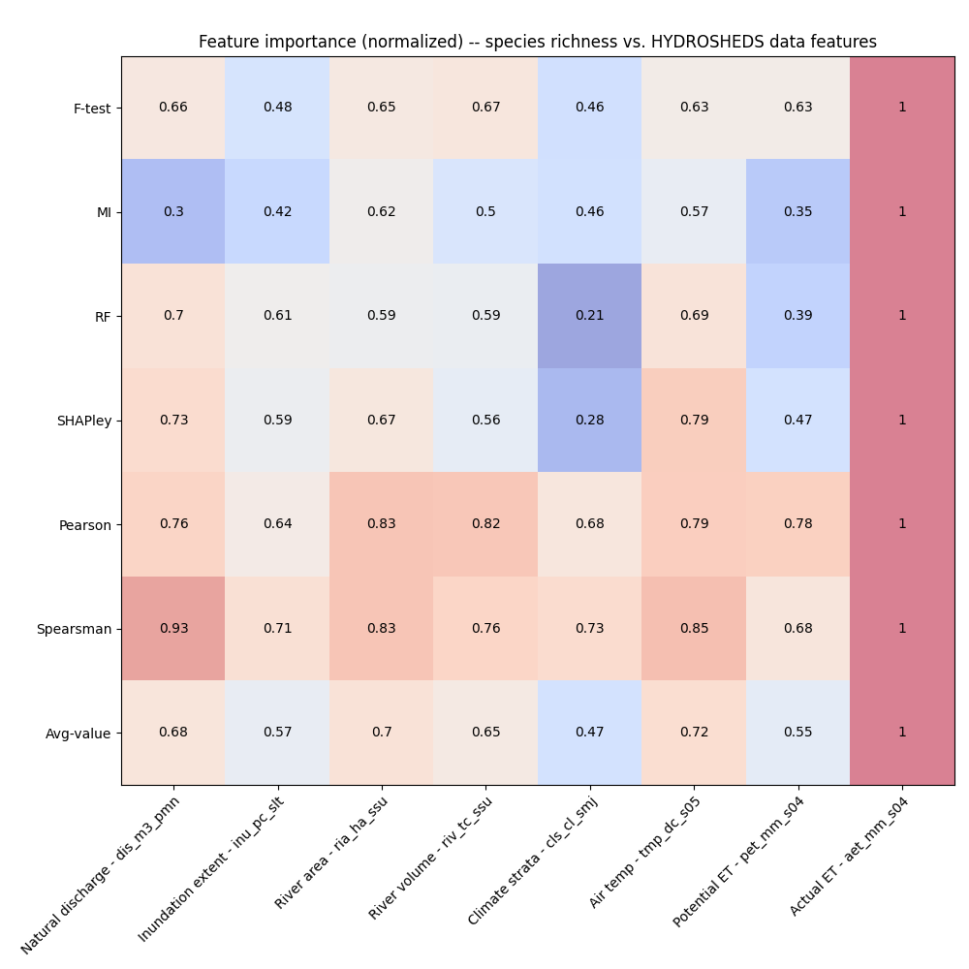

Fig. S1: Normalized feature importance for HydroSHEDS attributes across different feature importance methods. The figure illustrates the relative importance of each HydroSHEDS attribute in predicting species richness based on various approaches. These include F-test, mutual information (MI), random forest (RF), SHAPley values, Pearson correlation, Spearman correlation, and average values across all the methods. The color intensity represents the magnitude of the normalized importance, with darker red shades indicating higher importance and lower values in darker blue. Overall, ‘Actual ET’ is the most consistently important feature across multiple methods.

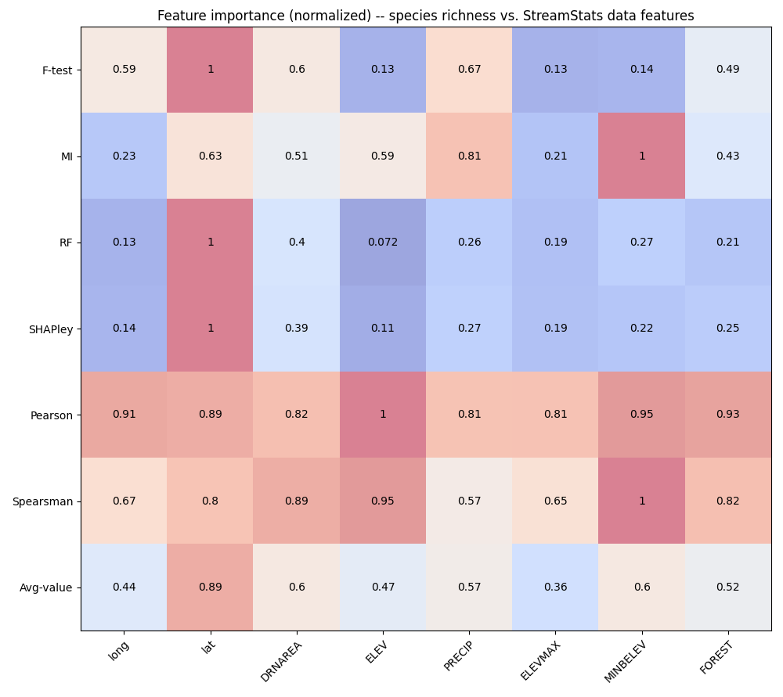

Fig. S2: This heatmap figure displays the normalized feature importance scores for different data features from StreamStats in relation to species richness, as evaluated by various methods. The feature importance scores are color-coded, with higher importance values shown in darker red and lower values in darker blue. Overall, ‘latitude’ is the most consistently important feature across multiple methods.

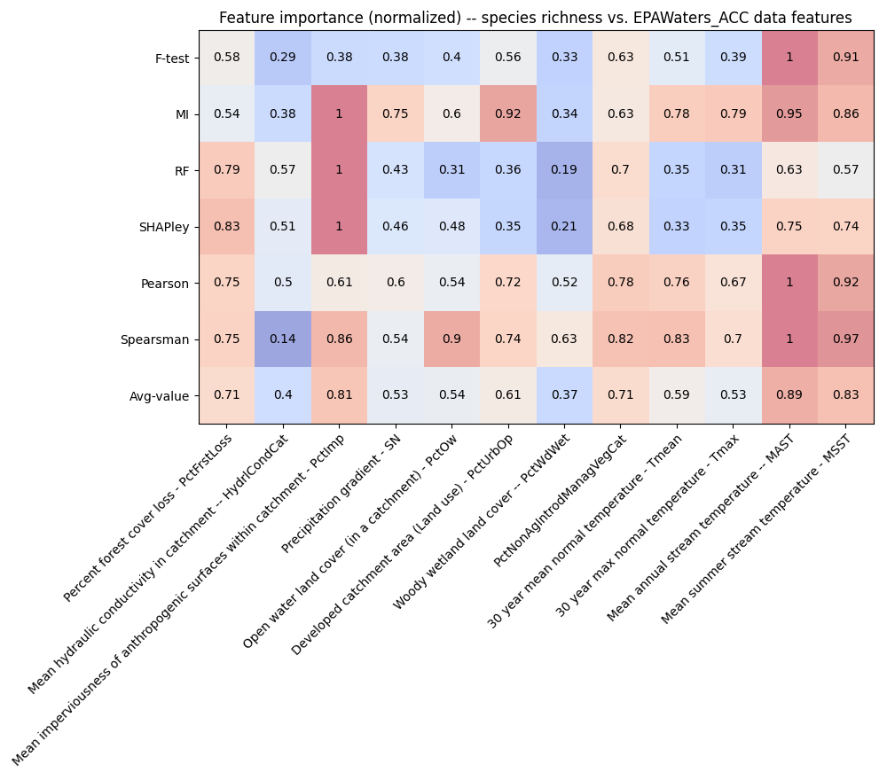
Fig. S3: The figure shows the relative importance of each EPA-Waters Catchment attribute in predicting species richness using different methods. Darker shades of red indicate higher significance, while darker shades of blue indicate lower importance. The ‘mean annual stream temperature’ is consistently the most important feature across multiple methods.

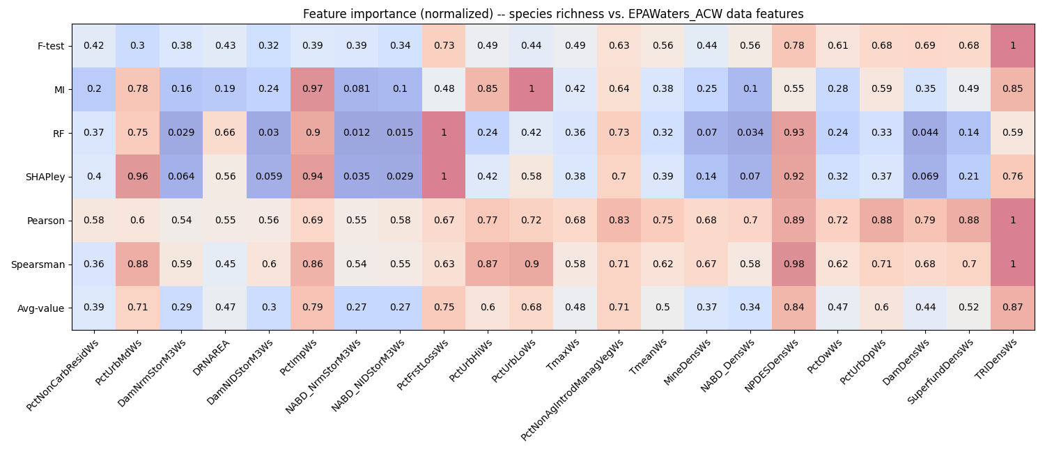
Fig. S4: The heatmap illustrates the importance of different features in the EPA-Waters Watershed data for species richness. The colors on the heatmap, from darker red to darker blue, indicate the relative importance of each feature. This analysis emphasizes the importance of different features for species richness. Notably, urban and percent impervious areas emerge as significantly important attributes across various methods.

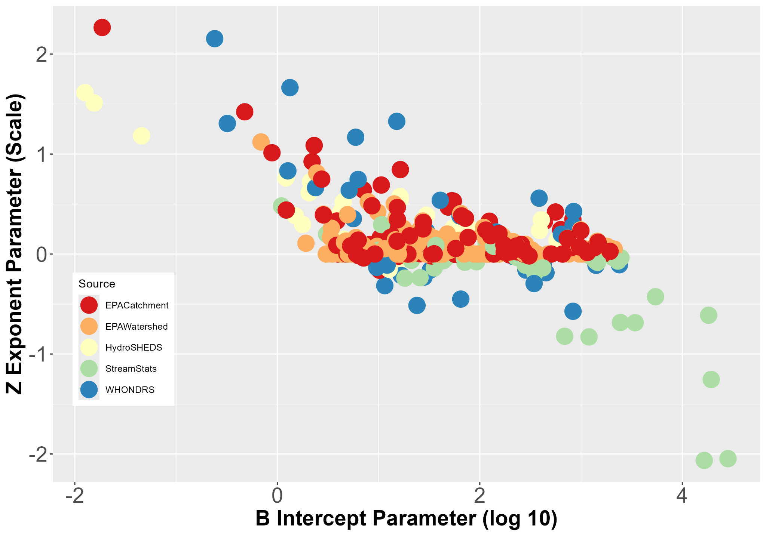
Fig. S5: Scaling parameters B (intercept, x-axis) and Z (exponent, y-axis) for species richness coloured by the different data sources (WHONDRS, StreamStats, HydroSHEDS, EPA-Watershed, and EPA-Catchment). Lines represent linear models fit to each compound class

Table S1: Average feature importance for predicting species richness across multiple environmental datasets. This table presents the average feature importance scores for the top contributing attributes (i.e., for a reduced set of features) within each environmental dataset (WHONDRS, StreamStats, HydroSHEDS, EPAWaters-Catchment, EPAWaters-Watersheds) in predicting species richness. Feature importance was assessed using a multi-step approach and averaged across methods for a robust ranking. The scores range from 0 to 1, with higher values indicating greater importance for predicting species richness. The reduced set of features presented here represents the most influential attributes within each dataset for understanding the ecological drivers of species diversity.

Dataset name | Reduced set of features | Average feature importance
WHONDRS | Surface Water Temperature (degree C) | 0.83
WHONDRS | Dissolved oxygen (mg/L) | 0.68
WHONDRS | Downstream water column height (cm) | 0.66
WHONDRS | Upstream water column height (cm) | 0.6
WHONDRS | Surface water pH | 0.52
StreamStats | Latitude | 0.89
StreamStats | Drainage area | 0.6
StreamStats | Minimum basement elevation | 0.6
StreamStats | Precipitation | 0.57
StreamStats | Forest coverage | 0.52
HydroSheds | Actual ET | 1.0
HydroSheds | Air temperature | 0.72
HydroSheds | River area | 0.7
HydroSheds | Natural discharge | 0.68
HydroSheds | River volume | 0.65
HydroSheds | Inundation extent | 0.57
HydroSheds | Potential ET | 0.55
EPAWaters-Catchment | Mean annual stream temperature within the catchment | 0.89
EPAWaters-Catchment | Mean summer stream temperature within the catchment | 0.83
EPAWaters-Catchment | Mean imperviousness of anthropogenic surfaces within catchment | 0.81
EPAWaters-Catchment | Percent forest cover loss within the catchment | 0.71
EPAWaters-Catchment | Percent Nonagriculture nonnative introduced or managed vegetation landcover type reclassed from LANDFIRE Existing Vegetation Type (EVT), within catchment | 0.71
EPAWaters-Catchment | Land use | 0.61
EPAWaters-Catchment | 30 year mean maximum temperature within the catchment | 0.59
EPAWaters-Catchment | Percent of open water land cover within the catchment | 0.54
EPAWaters-Catchment | 30 year mean normal temperature within the catchment | 0.53
EPAWaters-Catchment | Precipitation gradient | 0.53
EPAWaters-Watersheds | Density of TRI (Toxic Release Inventory) sites within watershed (sites/square km) | 0.87
EPAWaters-Watersheds | Density of permitted NPDES (National Pollutant Discharge Elimination System) sites within watershed (sites/square km) | 0.84
EPAWaters-Watersheds | Percent of mean imperviousness of anthropogenic surfaces within watershed | 0.79
EPAWaters-Watersheds | Percent of forest cover loss within watershed | 0.75
EPAWaters-Watersheds | Percent of watershed area classified as developed, medium-intensity land use | 0.71
EPAWaters-Watersheds | Percent of watershed area classified as developed, low-intensity land use | 0.68
EPAWaters-Watersheds | Percent of watershed area classified as developed, high-intensity land use | 0.6
EPAWaters-Watersheds | Percent of watershed area classified as developed, open space land use | 0.6
EPAWaters-Watersheds | Density of Superfund sites within watershed (sites/square km) | 0.52
EPAWaters-Watersheds | Mean temperature (°C) within the watershed | 0.5

Table S2: Z values for the compounds and important features shown in Figure 4b.

 | AminoSugar | Carb | ConcHC | Lignin | Lipid | Protein | Tannin | UnsatHC
Latitude | -0.83 | -2.05 | -1.25 | -0.43 | -0.82 | -0.68 | -0.69 | -2.06
ActualET | 0.72 | 1.61 | 0.25 | 0.14 | 0.76 | 0.57 | 0.13 | 0.15
SW_Temp_degC | 0.75 | 1.31 | 0.38 | 0.20 | 0.64 | 0.54 | 0.22 | -0.11
MSST Mean SUMMER stream temperature | 1.09 | 2.27 | 0.47 | 0.33 | 0.92 | 0.84 | 0.21 | -0.10
AirTemp | 0.52 | 1.18 | 0.26 | 0.14 | 0.42 | 0.39 | 0.11 | -0.11
PotentialET | 0.72 | 1.51 | 0.54 | 0.24 | 0.61 | 0.55 | 0.28 | 0.38
Tmean8110Ws | 0.329767 | 0.810356 | 0.185386 | 0.080861 | 0.362956 | 0.266664 | 0.076359 | 0.164768
Avg_Water.Column.Height_cm | 0.23 | 0.35 | 0.14 | 0.07 | 0.18 | 0.18 | 0.11 | 0.01
Mean imperviousness of anthropogenic surfaces within catchment - PctImp | 0.08 | 0.14 | 0.02 | 0.02 | 0.07 | 0.06 | 0.02 | 0.00
Discharge | 0.11 | 0.17 | 0.05 | 0.02 | 0.11 | 0.09 | 0.03 | 0.00
DrainageArea | 0.05 | 0.07 | 0.02 | 0.01 | 0.04 | 0.03 | 0.02 | 0.01

Table S3: R² and p-values for the linear models shown in Figure 5b and 5c.

Compound | R² | pval
AminoSugar | 0.599485418 | 1.67E-11
Carb | 0.849637945 | 3.26E-22
ConcHC | 0.354778909 | 3.19E-06
Lignin | 0.006423554 | 5.72E-01
Lipid | 0.708748155 | 5.35E-15
Other | 0.495115952 | 5.95E-09
Protein | 0.235177005 | 2.69E-04
SumAllCompounds | 0.01874838 | 3.33E-01
Tannin | 0.122639284 | 1.09E-02
UnsatHC | 0.809696268 | 1.20E-19

References

Bramer, L. M., White, A. M., Stratton, K. G., Thompson, A. M., Claborne, D., Hofmockel, K., et al. (2020). ftmsRanalysis: An R package for exploratory data analysis and interactive visualization of FT-MS data. PLoS Comput Biol 16, e1007654. doi: 10.1371/journal.pcbi.1007654
Dittmar, T., Koch, B., Hertkorn, N., and Kattner, G. (2008). A simple and efficient method for the solid-phase extraction of dissolved organic matter (SPE-DOM) from seawater: SPE-DOM from seawater. Limnol. Oceanogr. Methods 6, 230–235. doi: 10.4319/lom.2008.6.230
Garayburu-Caruso, V. A., Danczak, R. E., Stegen, J. C., Renteria, L., Mccall, M., Goldman, A. E., et al. (2020). Using Community Science to Reveal the Global Chemogeography of River Metabolomes. Metabolites 10, 518. doi: 10.3390/metabo10120518
Goldman, A. E., Arnon, S., Bar-Zeev, E., Chu, R. K., Danczak, R. E., Daly, R. A., et al. (2020). WHONDRS Summer 2019 Sampling Campaign: Global River Corridor Sediment FTICR-MS, Dissolved Organic Carbon, Aerobic Respiration, Elemental Composition, Grain Size, Total Nitrogen and Organic Carbon Content, Bacterial Abundance, and Stable Isotopes. doi: 10.15485/1729719
Hawkes, J. A., D’Andrilli, J., Agar, J. N., Barrow, M. P., Berg, S. M., Catalán, N., et al. (2020). An international laboratory comparison of dissolved organic matter composition by high resolution mass spectrometry: Are we getting the same answer? Limnology & Ocean Methods 18, 235–258. doi: 10.1002/lom3.10364
Herzsprung, P., Hertkorn, N., Von Tümpling, W., Harir, M., Friese, K., and Schmitt-Kopplin, P. (2014). Understanding molecular formula assignment of Fourier transform ion cyclotron resonance mass spectrometry data of natural organic matter from a chemical point of view. Anal Bioanal Chem 406, 7977–7987. doi: 10.1007/s00216-014-8249-y
Kim, S., Kramer, R. W., and Hatcher, P. G. (2003). Graphical Method for Analysis of Ultrahigh-Resolution Broadband Mass Spectra of Natural Organic Matter, the Van Krevelen Diagram. Anal. Chem. 75, 5336–5344. doi: 10.1021/ac034415p
Koch, B. P., Dittmar, T., Witt, M., and Kattner, G. (2007). Fundamentals of Molecular Formula Assignment to Ultrahigh Resolution Mass Data of Natural Organic Matter. Anal. Chem. 79, 1758–1763. doi: 10.1021/ac061949s
LaRowe, D. E., and Van Cappellen, P. (2011). Degradation of natural organic matter: A thermodynamic analysis. Geochimica et Cosmochimica Acta 75, 2030–2042. doi: 10.1016/j.gca.2011.01.020
Riedel, T., and Dittmar, T. (2014). A Method Detection Limit for the Analysis of Natural Organic Matter via Fourier Transform Ion Cyclotron Resonance Mass Spectrometry. Anal. Chem. 86, 8376–8382. doi: 10.1021/ac501946m
Tfaily, M. M., Chu, R. K., Toyoda, J., Tolić, N., Robinson, E. W., Paša-Tolić, L., et al. (2017). Sequential extraction protocol for organic matter from soils and sediments using high resolution mass spectrometry. Analytica Chimica Acta 972, 54–61. doi: 10.1016/j.aca.2017.03.031
Tolić, N., Liu, Y., Liyu, A., Shen, Y., Tfaily, M. M., Kujawinski, E. B., et al. (2017). Formularity: Software for Automated Formula Assignment of Natural and Other Organic Matter from Ultrahigh-Resolution Mass Spectra. Anal. Chem. 89, 12659–12665. doi: 10.1021/acs.analchem.7b03318

