SUPPLEMENTARY INFORMATION
Appendix S1. Nonsignificant Findings
Appendix S2. Search Strings Related to Schizophrenia and TMS Used for the Other Databases
Appendix S3. List of Excluded Studies From the Standard Meta-Analysis
Appendix S4. List of Excluded Studies From the FEM Simulations
Figure S1. PRISMA algorithm
Figure S2. Forest Plot of Effect Sizes (SMD) of TMS in Schizophrenia across all symptoms
Figure S3. Forest Plot of Effect Sizes (SMD) of TMS Targeting Negative Symptoms in Schizophrenia
Figure S4. Forest Plot of Effect Sizes (SMD) of TMS Targeting Cognitive Symptoms in Schizophrenia
Figure S5. Forest Plot of Effect Sizes (SMD) of TMS Targeting Positive Symptoms in Schizophrenia
Figure S6. Funnel Plot Analysis for Publication Bias Assessment Across Symptom-General and Symptom-Specific Domains of Schizophrenia
Table S1. Study Overview of Included Randomized Controlled Trials in Negative Symptoms
Table S2. Study Overview of Included Randomized Controlled Trials in Cognitive Symptoms
Table S3. Study Overview of Included Randomized Controlled Trials in Positive Symptoms
Table S4. Risk-of-Bias Assessments
This supplemental material has been provided by the authors to give readers additional information about their work.
Appendix S1. Nonsignificant Findings
- Meta-analysis of TMS effects on negative symptoms of schizophrenia
  - Low-frequency TMS (1 Hz) stimulation sub-group
Six sham-controlled studies delivered low-frequency stimulation TMS (1 Hz) targeting negative symptoms in schizophrenia via stimulation of the left prefrontal cortex (L-PFC) and left temporo-parietal cortex (L-TPC). The confidence interval was wide: 95% CI: -0.31 to 0.44 with no significant effect size over TMS (p=0.75).
  - Left temporo-parietal target sub-group
Six sham-controlled studies investigated the effects of TMS on the negative symptoms of schizophrenia by targeting the left temporo-parietal cortex (L-TPC).The confidence interval was wide: 95% CI: -0.27 to 0.42 with no significant effect size over TMS (p=0.67).
  - Cerebellum target sub-group
Five sham-controlled studies investigated the effects of TMS on the negative symptoms of schizophrenia by targeting vermis in the cerebellum. The confidence interval was wide: 95% CI : -0.64 to 0.90 with no significant effect size over TMS (p=0.74).
- Meta-analysis of TMS effects on positive symptoms of schizophrenia
  - Main group
Eighteen sham-controlled studies targeted positive symptoms in schizophrenia irrespective of target and protocol. The confidence interval was wide: 95% CI: -0.24 to 0.51 with no significant effect size over TMS (p=0.47).
  - Low-frequency TMS (1 Hz) stimulation sub-group
Eleven sham-controlled studies delivered low-frequency stimulation TMS (1 Hz) targeting positive symptoms in schizophrenia. The confidence interval was wide: 95% CI: -0.65 to 0.57 with no significant effect size over TMS (p=0.81).
- Association between optimal targets and actual study sites
  - Left motor (M1) optimal target across symptom domains
The association between treatment response and the distance of actual TMS study sites to the optimal target in the left motor across symptom domains was not significant (r = -0.07, p = 0.6 ).
  - Left premotor optimal target in negative symptoms
The association between treatment response and the distance of actual TMS study sites to the optimal target in the left premotor in the negative symptom domain was not significant (r = -0.27, p = 0.3).

Appendix S2. Search Strings Related to Schizophrenia and TMS Used for the Other Databases
PubMed:
(“schizophreni*” OR "schizoaffective disorder" OR "schizophreniform disorder" OR "schizophrenia"[MeSH Terms] OR “CHR” OR “Clinical High Risk” OR “Ultra High Risk” OR “UHR” OR "Psychotic Disorders"[MeSH Terms] OR "Psychotic Disorder*") AND ("transcranial magnetic stimulation" OR "TMS" OR "rTMS" OR "theta burst" OR "iTBS" OR “cTBS” OR "transcranial Magnetic Stimulation*"[MeSH Terms])
884 hits

EMBASE:
('schizophreni*':ab,kw,ti OR 'schizoaffective disorder':ab,ti,kw OR 'schizophreniform disorder':ab,kw,ti OR 'schizophrenia spectrum disorder'/exp OR 'psychotic disorder*':ab,kw,ti OR ‘CHR’:ab,kw,ti OR ‘Clinical High Risk’:ab,kw,ti OR ‘Ultra High Risk’:ab,kw,ti OR ‘UHR’:ab,kw,ti) AND ('transcranial magnetic stimulation':ab,kw,ti OR 'tms':ab,kw,ti OR 'rtms':ab,kw,ti OR 'theta burst':ab,kw,ti OR 'itbs':ab,kw,ti OR 'cTBS':ab,kw,ti OR 'transcranial magnetic stimulation'/exp) AND ('article'/it OR 'article in press'/it OR 'review'/it)
1,039 hits

PsycINFO:
(schizophreni* OR "schizoaffective disorder" OR "schizophreniform disorder" OR "Psychotic Disorder*" OR “CHR” OR “Clinical High Risk” OR “Ultra High Risk” OR “UHR”) AND ("transcranial magnetic stimulation" OR "TMS" OR "rTMS" OR "theta burst" OR "iTBS" OR “cTBS”)
Source type: Scholarly Journals
864 hits

Web of Sciences (Web of Science, Core Database Collection):
(schizophreni* OR "schizoaffective disorder" OR "schizophreniform disorder" OR "Psychotic Disorder*" OR “CHR” OR “Clinical High Risk” OR “Ultra High Risk” OR “UHR”) AND ("transcranial magnetic stimulation" OR "TMS" OR "rTMS" OR "theta burst" OR "iTBS" OR “cTBS”)
Search type: “Topic”. Document type: Article, review, proceedings paper, early access
1,482 hits

In total 4,269 hits
After removal of 2,013 duplicates: 2,256 final hits

Appendix S3. List of Excluded Studies From the Standard Meta-Analysis
1. Studies not in TMS
Negative Symptoms (N=2 studies):
Lisoni et al. (2022) doi: 10.1016/j.jpsychires.2022.09.011
Palm et al. (2016) doi: 10.1093/schbul/sbw041
Cognitive Symptoms (N=1 study):
Jeon et al. (2018) doi: 10.1016/j.schres.2017.12.009
Positive Symptoms (N=4 studies):
Brunelin et al. (2012) doi: 10.1176/appi.ajp.2012.11071091
Chang et al. (2018) doi: 10.1093/ijnp/pyy071
Fitzgerald et al. (2014) doi: 10.1016/j.brs.2014.07.036
Koops et al. (2018) doi: 10.1016/j.schres.2018.06.058

2. Studies with no full report of baseline/endpoint scores
Negative Symptoms (N=11 studies):
Gan et al. (2014a) doi: PMID: 27337795
Gan et al. (2014b) doi: PMID: 27337795
Gan et al. (2015) doi: PMID: 27337795
Goyal et al. (2007) doi: 10.1176/jnp.2007.19.4.464
Güleken et al. (2020) doi: 10.1016/j.scog.2020.100183
Novak et al. (2006) doi: PMID: 16648775
Prikryl et al. (2007) doi: 10.1016/j.schres.2007.06.019
Rosa et al. (2007) doi: 10.4088/jcp.v68n1009
Schneider et al. (2008a) doi: 10.1016/j.jpsychires.2005.02.008
Schnieder et al. (2008b) doi: 10.1016/j.jpsychires.2005.02.008
Wen-Xiang et al. (2012) doi: 10.1016/j.neulet.2014.10.029
Cognitive Symptoms (N=1 study):
Voineskos et al. (2021) doi: 10.1016/j.bpsc.2020.11.011
Positive Symptoms (N=1 study):
Vercammen et al. (2009) doi: 10.1176/appi.neuropsych.21.3.260

3. Studies without end of treatment scores
Negative Symptoms (N=1 study):
Quan et al. (2015a) doi: 10.1016/j.neulet.2014.10.029

4. Studies with primary outcome in another domain
Negative Symptoms (N=2 studies):
Guan et al. (2020) doi: 10.1038/s41398-020-0745-6, primary outcome is cognitive dysfunction.
Rosenberg et al. (2012) doi: 10.1186/1744-859X-11-13, primary outcome is auditory hallucinations.

Appendix S4. List of Excluded Studies From the FEM Simulations
1. Studies not retained due to no report of coil type
Negative Symptoms (N=12 studies):
Bai et al. (2015) doi: Chin. J. Health Psychol. 2015;23:649–653
Duan et al. (2013) doi: 10.1038/s41537-022-00248-6
Liu et al. (2008) doi: 10.3969/j.issn.1672-0458.2008.03.002
Ma et al. (2016) doi: 10.3877/cma.j.issn.1674-0785.2016.14.007
Ren et al. (2011) doi: 10.3969/j.issn.1000-6729.2011.02.003
Tikka et al. (2017) doi: 10.1097/YCT.0000000000000343
Wang et al. (2015) doi: 10.11919/j.issn.1002-0829.217024
Wang et al. (2020) doi: 10.1016/j.schres.2019.12.008
Xu et al. (2006) doi: 10.3321/j.issn:1673-8225.2006.46.012
Xu et al. (2015) doi: NA
Zhang et al. (2010) doi: 10.3969/j.issn.1002-0829.2010.05.002
Zhang et al. (2015) doi: 10.3969/j.issn.1672-9463.2015.09.008

2. Studies not retained due to no report of method of targeting and inferred coordinates
Negative Symptoms (N=8 studies):
Li et al. (2016) doi: 10.1016/j.psychres.2016.04.046
Prikryl et al. (2012) doi: 10.1017/S1461145712000508
Zhao et al. (2014a) doi: 10.3969/j.issn.1002-0829.2014.01.003
Zhao et al. (2014b) doi: 10.3969/j.issn.1002-0829.2014.01.003
Zhao et al. (2014c) doi: 10.3969/j.issn.1002-0829.2014.01.003
Zheng et al. (2012a) doi: PMID: 23073583
Zheng et al. (2012b) doi: PMID: 23073583
Zheng et al. (2012c) doi: PMID: 23073583

3. Studies not retained due to coil type not supported in SimNIBS
Negative Symptoms (N=5 studies):
De Jesus et al. (2011) doi: 10.1016/j.psychres.2010.11.022 (Neurosoft Ltd.)
Huang et al. (2016) doi: 10.11919/j.issn.1002-0829.216044 (YRDCCY-I)
Klein et al. (1999) doi: 10.1016/s0006-3223(99)00182-1 (Cadwell)
Quan et al. (2015b) doi: 10.1016/j.neulet.2014.10.029 (Cadwell)
Wen et al. (2021) doi: PMID: 27337795 (YRDCCY-I)
Cognitive Symptoms (N=1 study):
Wen et al. (2021) doi: PMID: 27337795 (YRDCCY-I)
Positive Symptoms (N=1 study):
Lee et al. (2004) doi: 10.1016/j.neulet.2004.11.048 (Neotonus)

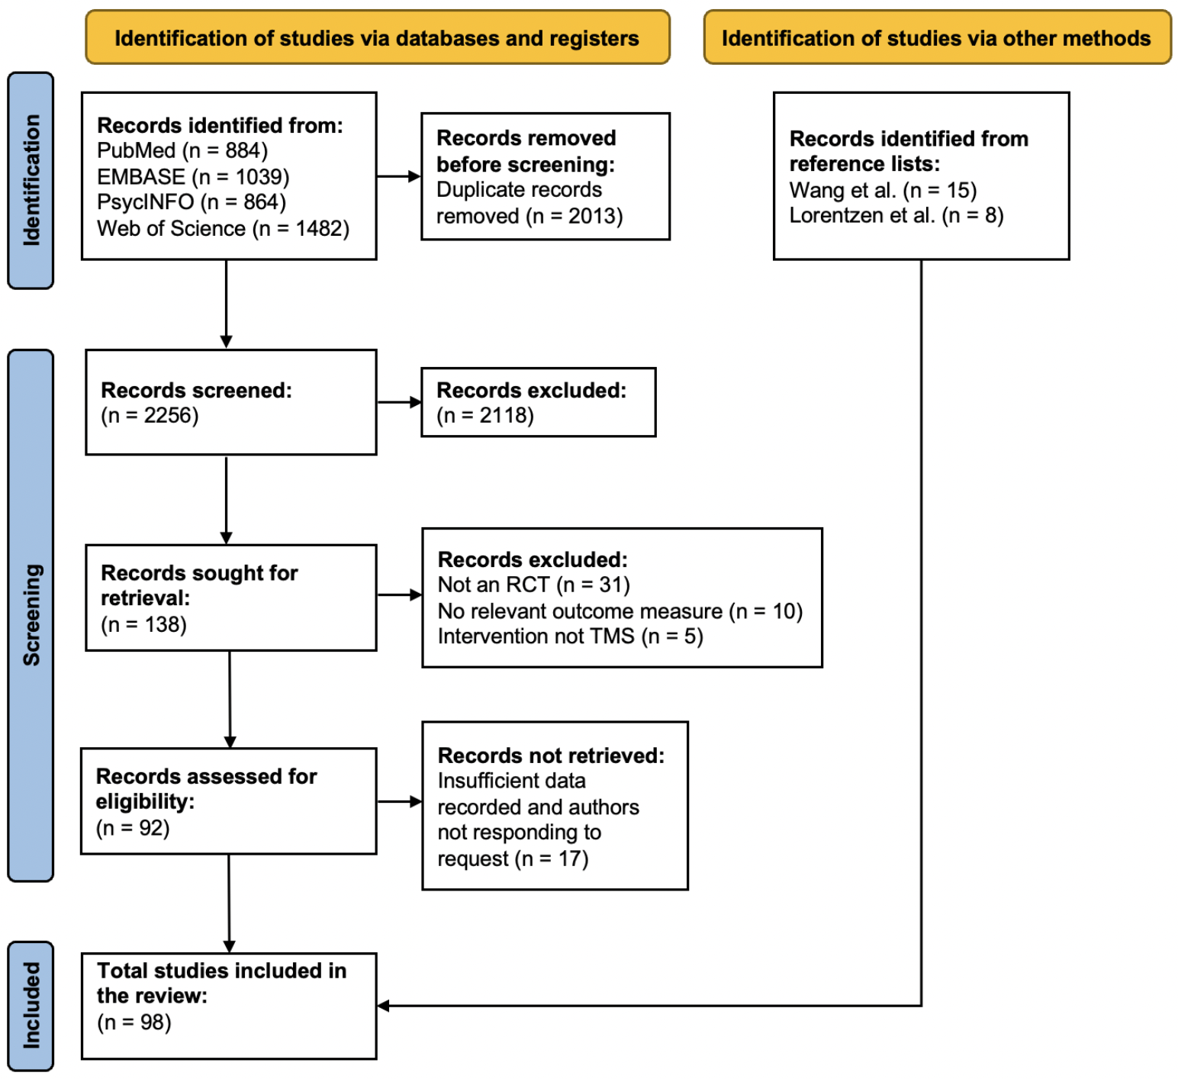
Figure S1. Preferred Reporting Items for Systematic Reviews and Meta-Analyses (PRISMA) flow chart. Abbreviations: EMBASE = Excerpta Medica Database; PsycINFO = Psychological Information Database; Web of Science = Web of Science, Core Database Collection.
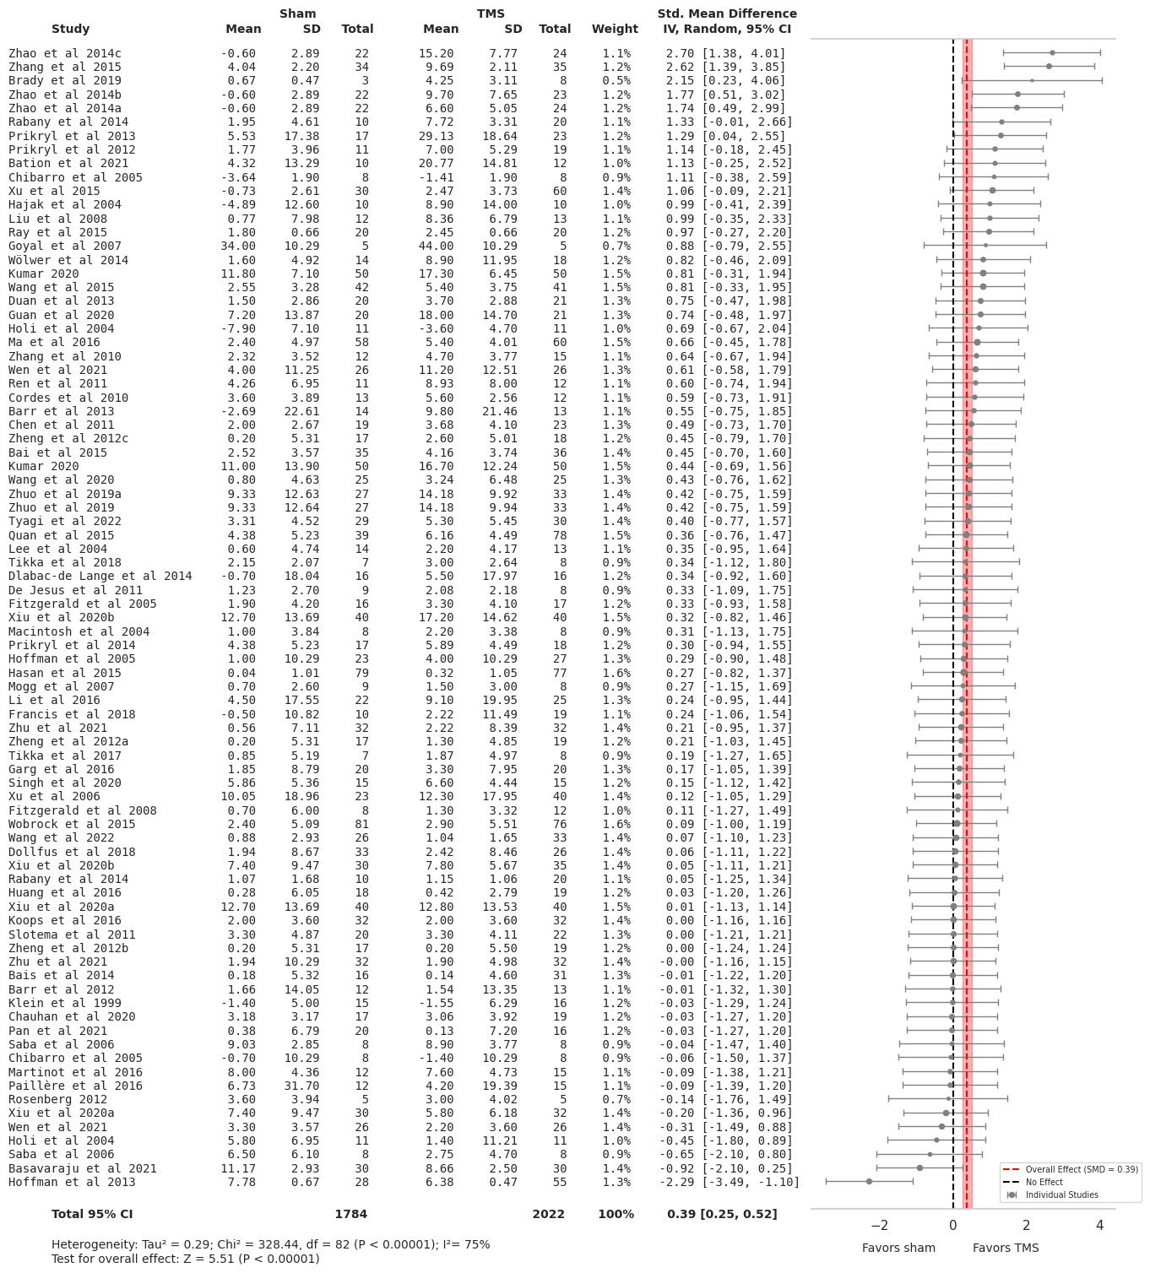
Figure S2. Forest Plot of Effect Sizes (SMD) of TMS in Schizophrenia Across all Symptoms
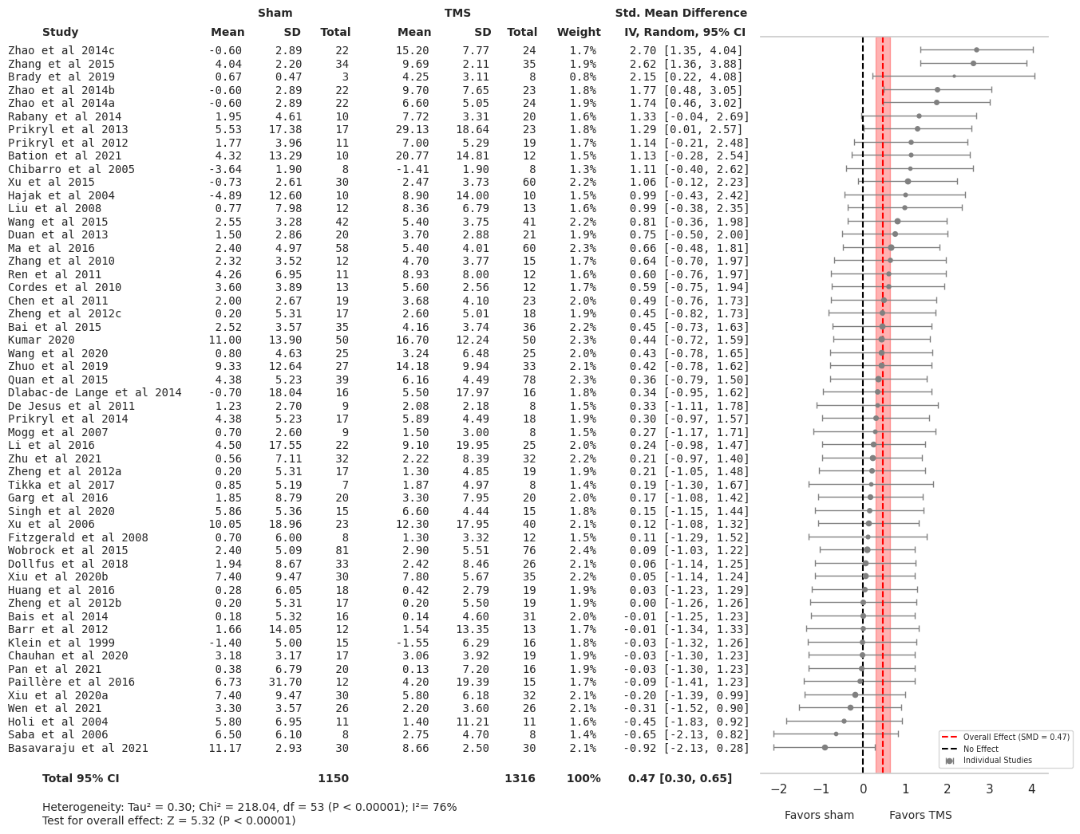
Figure S3. Forest Plot of Effect Sizes (SMD) of TMS Targeting Negative Symptoms in Schizophrenia

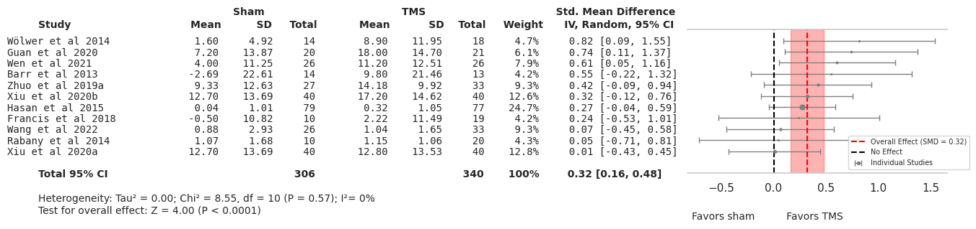
Figure S4. Forest Plot of Effect Sizes (SMD) of TMS Targeting Cognitive Symptoms in Schizophrenia

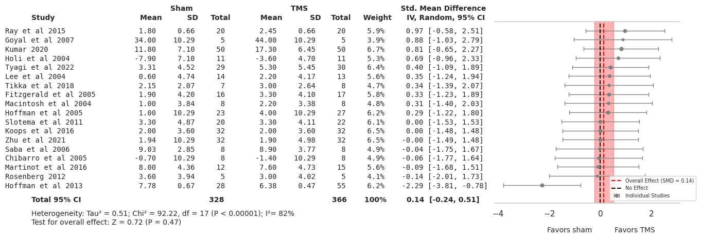
Figure S5. Forest Plot of Effect Sizes (SMD) of TMS Targeting Positive Symptoms in Schizophrenia

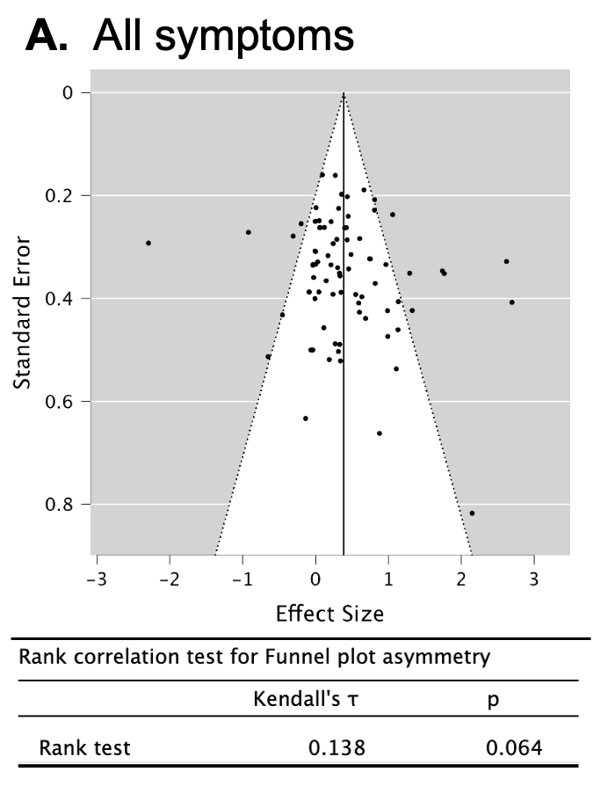
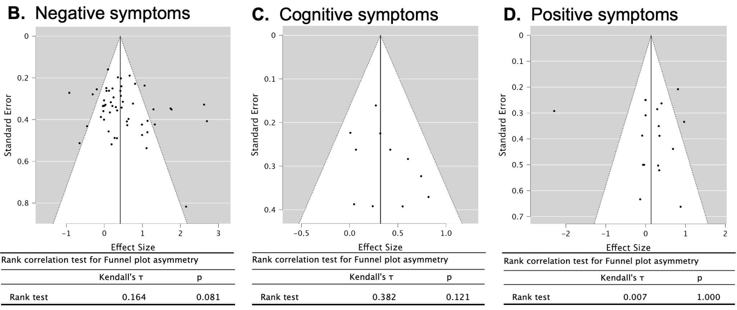
Figure S6. Funnel Plot Analysis for Publication Bias Assessment in Symptom-General and Symptom-Specific Domains of Schizophrenia. Each plot compares the standard error against the effect size of studies, with the vertical line indicating the overall effect size (SMD) determined by the meta-analysis. The dashed lines represent the expected distribution of studies in the absence of bias. Points falling outside these lines suggest potential asymmetry, indicating possible bias or heterogeneity. The asymmetry in the plot is evaluated using Kendall’s rank correlation test.

Table S1. Study Overview of Included Randomized Controlled Trials in Negative Symptoms

Table S2. Study Overview of Included Randomized Controlled Trials in Cognitive Symptoms


Table S3. Study Overview of Included Randomized Controlled Trials in Positive Symptoms

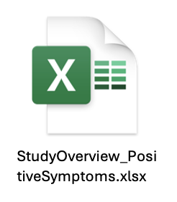
Table S4. Risk-of-Bias Assessments
NEGATIVE SYMPTOMS: Study | Random sequence generation (selection bias) | Allocation concealment (selection bias) | Blinding of participants and personnel (performance bias) | Blinding of outcome assessment (detection bias) | Incomplete outcome data (attrition bias) | Selective reporting (reporting bias) | Other bias
1. Bai et al 2015 | Low | Some concerns | Low | Some concerns | Some concerns | Low | Low
2. Bais et al 2014 | Low | Low | Low | Low | Low | Low | Low
3. Barr et al 2012 | Low | Low | Low | Low | Low | Low | Low
4. Basavaraju et al 2021 | Low | Low | Low | Low | Some concerns | Low | Low
5. Bation et al 2021 | Low | Low | Some concerns | Low | Low | Low | Some concerns
6. Brady et al 2019 | Low | Low | Low | Low | Low | Low | Low
7. Chauhan et al 2020 | Low | Low | Some concerns | Some concerns | Low | Low | Low
8. Chen et al 2011 | Low | Low | Low | Low | Low | Low | Some concerns
9. Chibarro et al 2005 | Low | Some concerns | Low | Low | Low | Low | Some concerns
10. Cordes et al 2010 | Low | Low | Low | Low | Low | Low | Low
11. De Jesus et al 2011 | Low | Low | Low | Low | Low | Low | Some concerns
12. Dlabac-de Lange et al 2014 | Low | Low | Low | Low | Low | Low | Low
13. Dollfus et al 2018 | Low | Low | Low | Low | Some concerns | Low | Some concerns
14. Duan et al 2013 | Some concerns | Some concerns | Some concerns | Some concerns | Some concerns | Some concerns | Some concerns
15. Fitzgerald et al 2008 | Low | Low | Some concerns | Low | Low | Low | Some concerns
16. Gan et al 2014a | Low | Some concerns | Some concerns | Low | Some concerns | Low | Some concerns
17. Gan et al 2014b | Low | Some concerns | Some concerns | Low | Some concerns | Low | Some concerns
18. Gan et al 2015 | Low | Some concerns | Some concerns | Low | Low | Low | Some concerns
19. Garg et al 2016 | Low | Some concerns | Some concerns | Low | Low | Low | Low
20. Goyal et al 2007 | Low | Some concerns | Low | Low | Low | Low | Some concerns
21. Güleken et al 2020 | Low | Some concerns | Low | Low | Some concerns | Low | Some concerns
22. Hajak et al 2004 | Low | Low | Low | Low | Some concerns | Low | Low
23. Holi et al 2004 | Low | Low | Low | Low | Some concerns | Low | Some concerns
24. Huang et al 2016 | Low | Low | Low | Low | Low | Low | Low
25. Klein et al 1999 | Low | Low | Low | Some concerns | Low | Low | Low
26. Kumar 2020 | Low | Low | Low | Low | Low | Low | Low
27. Li et al 2016 | Low | Low | Low | Low | Low | Low | Low
28. Lisoni et al 2022 | Low | Low | Low | Some concerns | Low | Low | Low
29. Liu et al 2008 | Some concerns | Some concerns | Some concerns | Low | Some concerns | Some concerns | Low
30. Ma et al 2016 | Low | Some concerns | Some concerns | Low | Low | Some concerns | Low
31. Mogg et al 2007 | Low | Some concerns | Low | Low | Low | Low | Low
32. Novak et al 2006 | Some concerns | High | High | Low | Low | Low | High
33. Paillère et al 2016 | Low | Low | Low | Low | Low | Low | Low
34. Palm et al 2016 | Low | Low | Low | Low | Low | Low | Low
35. Pan et al 2021 | Some concerns | Low | Low | Low | Low | Low | Some concerns
36. Prikryl et al 2007 | Low | Low | Low | Low | Some concerns | Some concerns | Some concerns
37. Prikryl et al 2012 | Some concerns | High | High | Low | High | Some concerns | Low
38. Prikryl et al 2013 | Some concerns | High | High | Low | Some concerns | Some concerns | Low
39. Prikryl et al 2014 | Some concerns | High | High | Low | Some concerns | Some concerns | Some concerns
40. Quan et al 2015 | Low | Low | Low | Low | Low | Low | Low
41. Quan et al 2015 | Low | Low | Low | Low | Low | Low | Low
42. Rabany et al 2014 | Some concerns | Some concerns | Low | Low | Low | Low | Low
43. Ren et al 2011 | Some concerns | Some concerns | Some concerns | Some concerns | Some concerns | Some concerns | Some concerns
44. Rosa et al 2007 | Some concerns | Low | Low | Low | Low | Low | Low
45. Saba et al 2006 | Some concerns | Some concerns | Low | Low | Some concerns | Some concerns | Some concerns
46. Schneider et al 2008a | Low | Some concerns | Low | Low | Low | Low | Low
47. Schneider et al 2008b | Low | Some concerns | Low | Low | Low | Low | Some concerns
48. Singh et al 2020 | Low | Low | Low | Low | Low | Low | Low
49. Tikka et al 2017 | Low | Low | Low | Some concerns | Low | Low | Low
50. Wang et al 2015 | Low | Low | Low | Low | Some concerns | Low | Some concerns
51. Wang et al 2020 | Some concerns | Some concerns | Some concerns | Low | High | Low | Low
52. Wen et al 2021 | Low | Low | Low | Low | Low | Low | Low
53. Wen-Xiang et al 2012 | Low | Some concerns | Low | Low | Low | Low | Some concerns
54. Wobrock et al 2015 | Low | Low | Low | Low | Low | Low | Low
55. Xiu et al 2020a | Low | Some concerns | Low | Low | Some concerns | Low | Some concerns
56. Xiu et al 2020b | Low | Some concerns | Low | Low | Some concerns | Low | Some concerns
57. Xu et al 2006 | Low | Some concerns | Low | Low | Low | Low | Low
58. Xu et al 2015 | Low | Some concerns | Low | Low | Low | Low | Low
59. Zhang et al 2010 | Low | Some concerns | Low | Low | Low | Low | Low
60. Zhang et al 2015 | Low | Some concerns | Some concerns | Some concerns | Low | Low | Some concerns
61. Zhao et al 2014a | Low | Low | Low | Some concerns | Some concerns | Some concerns | Some concerns
62. Zhao et al 2014b | Low | Low | Low | Some concerns | Some concerns | Some concerns | Some concerns
63. Zhao et al 2014c | Low | Low | Low | Some concerns | Some concerns | Some concerns | Some concerns
64. Zheng et al 2012a | Low | Some concerns | Low | Low | Low | Low | Low
65. Zheng et al 2012b | Low | Some concerns | Low | Low | Low | Low | Low
66. Zheng et al 2012c | Low | Some concerns | Low | Low | Low | Low | Low
67. Zhu et al 2021 | Low | Low | Low | Low | Low | Low | Some concerns
68. Zhuo et al 2019 | Low | Some concerns | Low | Low | Some concerns | Low | Low
COGNITIVE SYMPTOMS: Study | Random sequence generation (selection bias) | Allocation concealment (selection bias) | Blinding of participants and personnel (performance bias) | Blinding of outcome assessment (detection bias) | Incomplete outcome data (attrition bias) | Selective reporting (reporting bias) | Other bias
1. Barr et al 2013 | Low | Low | Low | Low | Some concerns | Low | Low
2. Francis et al 2018 | Low | Low | Low | Low | Low | Low | Low
3. Guan et al 2020 | Low | Low | Low | Low | Some concerns | Low | Low
4. Hasan et al 2015 | Low | Low | Low | Low | Low | Low | Low
5. Jeon et al 2018 | Low | Low | Low | Low | Low | Low | Low
6. Rabany et al 2014 | Some concerns | Some concerns | Low | Low | Low | Low | Low
7. Voineskos et al 2021 | Low | Low | Low | Low | Low | Some concerns | Low
8. Wang et al 2022 | Low | Some concerns | Low | Low | Some concerns | Low | Some concerns
9. Wen et al 2021 | Low | Low | Low | Low | Low | Low | Low
10. Wölwer et al 2014 | Low | Some concerns | Low | Low | Low | Low | Some concerns
11. Xiu et al 2020a | Low | Low | Low | Low | Low | Some concerns | Low
12. Xiu et al 2020b | Low | Low | Low | Low | Low | Some concerns | Low
13. Zhuo et al 2019a | Some concerns | Low | Low | Low | Some concerns | Low | Some concerns
POSITIVE SYMPTOMS: Study | Random sequence generation (selection bias) | Allocation concealment (selection bias) | Blinding of participants and personnel (performance bias) | Blinding of outcome assessment (detection bias) | Incomplete outcome data (attrition bias) | Selective reporting (reporting bias) | Other bias
1. Brunelin et al 2012 | Low | Low | Low | Low | Low | Low | Low
2. Chang et al 2018 | Low | Low | Low | Low | Low | Low | Low
3. Chibarro et al 2005 | Low | Low | Low | Low | Low | Low | Low
4. Fitzgerald et al 2005 | Low | Low | Low | Low | Low | Low | Low
5. Fitzgerald et al 2014 | Low | Low | Low | Low | Low | Low | Low
6. Goyal et al 2007 | Low | Low | Low | Low | Low | Low | Low
7. Hoffman et al 2005 | Low | Low | Low | Low | Low | Some concerns | Low
8. Hoffman et al 2013 | Low | Low | Low | Low | Some concerns | Some concerns | Low
9. Holi et al 2004 | Low | Low | Low | Low | Low | Low | Low
10. Koops et al 2016 | Low | Low | Low | Low | Low | Low | Low
11. Koops et al 2018 | Low | Low | Low | Low | Low | Low | Low
12. Kumar 2020 | Low | Low | Low | Low | Low | Low | Low
13. Lee et al 2004 | Low | Some concerns | Low | Low | Low | Low | Some concerns
14. Macintosh et al 2004 | Some concerns | Some concerns | Some concerns | Some concerns | Low | High | High
15. Martinot et al 2016 | Low | Low | Low | Low | Low | Low | Low
16. Ray et al 2015 | Low | Low | Low | Low | Low | Low | Low
17. Rosenberg 2012 | Low | Low | Low | Low | Low | Low | Low
18. Saba et al 2006 | Low | Low | Low | Low | Low | Low | Low
19. Slotema et al 2011 | Low | Some concerns | Some concerns | Low | Low | Low | Low
20. Tikka et al 2018 | Low | Low | Low | Some concerns | Low | Low | Low
21. Tyagi et al 2022 | Low | Low | Low | Some concerns | Low | Low | Low
22.Vercammen et al 2009 | Low | Low | Low | Low | Low | Low | Low
23. Zhu et al 2021 | Low | Low | Low | Low | Low | Low | Low

