Supplemental information
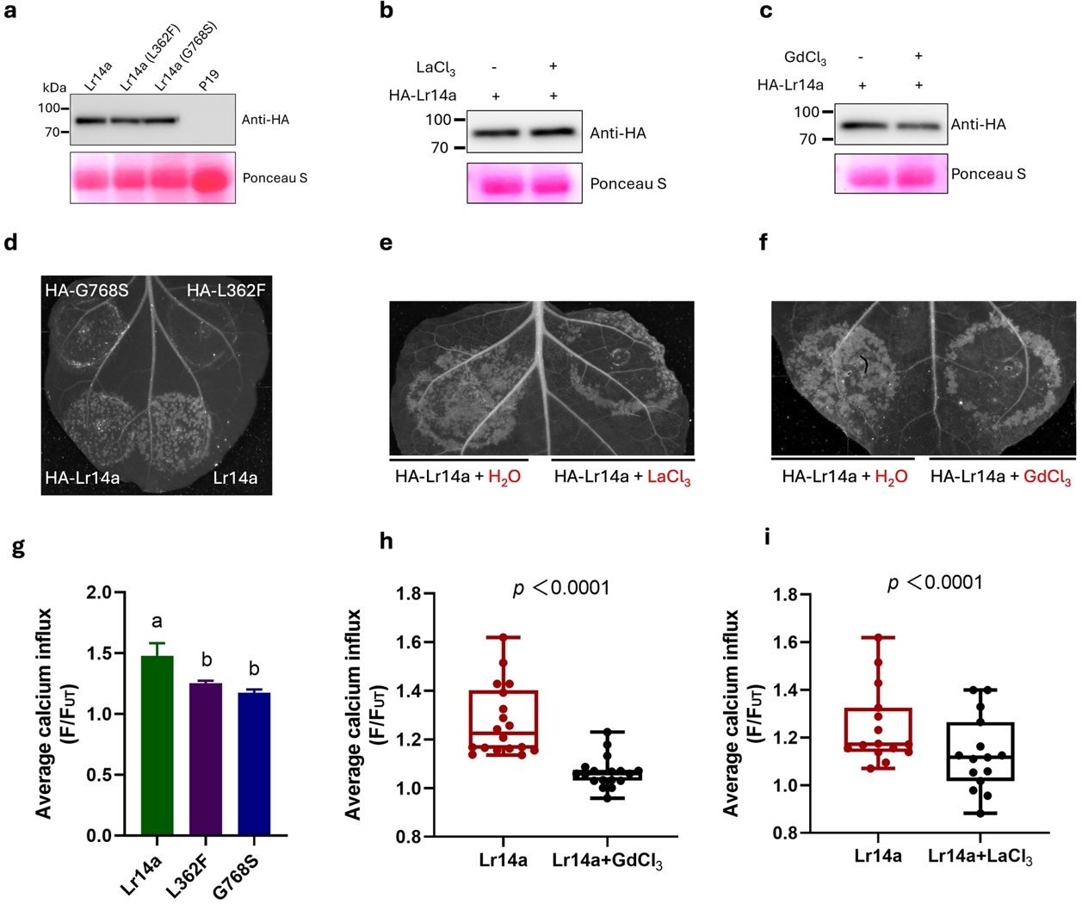
Extended Data Fig. 1|Protein accumulation and water-soaking-like phenotype caused by Lr14a and its mutants. a-c, HA-tagged Lr14a coding sequence was cloned into a pER8 vector under the control of a β-estradiol inducible promotor. Protein accumulation was detected using western blot after 24-hour β-estradiol induction. P19-transformed leaves served as the negative control. Lr14a shows the same expression level with two mutants L362F and G768S (a). Protein accumulation was not influenced by the application of LaCl₃ (b) and GdCl₃ (c). d-f, water-soaking-like phenotype after expressing Lr14a or its mutants (d). The Lr14a-triggered water-soaking-like phenotype was abolished by the application of LaCl₃ (e) and GdCl₃ (f). g, Average calcium influx from all timepoint presented in Fig. 1a. Values are mean ± SE. n = 15-18 leaves, with different letters indicating statistical significance (P < 0.05). h-i, Average calcium influx from all timepoint presented in Fig. 1b (h) and Fig. 1c (i). Values are mean ± SE. Statistical significance was determined using an unpaired, two-tailed t-test.
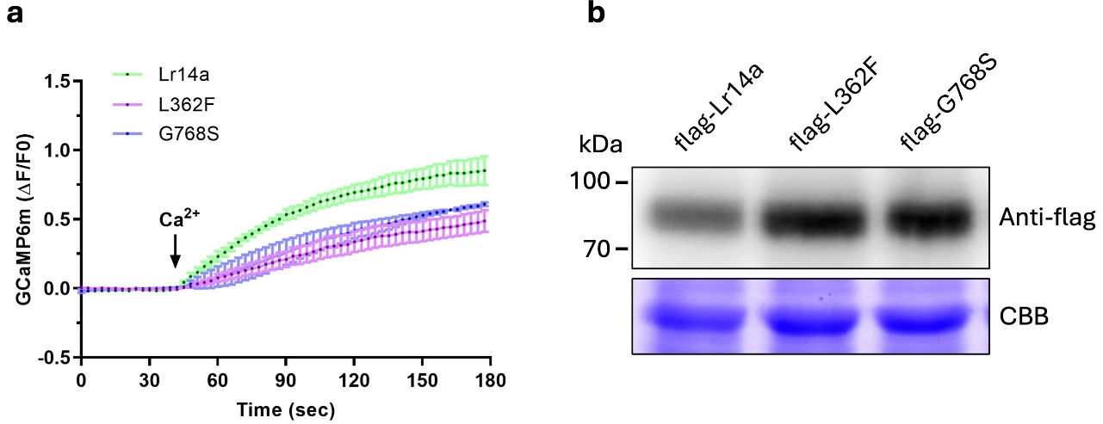 Extended Data Fig. 2|Lr14a-triggered [Ca²⁺]_{cyt} influx in HEK293 cell. a, Time-course recording of [Ca²⁺]_{cyt} influx in response to 5mM Ca²⁺ in HEK293 cells expressing flag-tagged Lr14a, or its mutants L362F and G768S. Changes in [Ca²⁺]_{cyt} were visualized using GCaMP6m. n = 3. b, Protein accumulation in HEK293 cells tested by western blot.

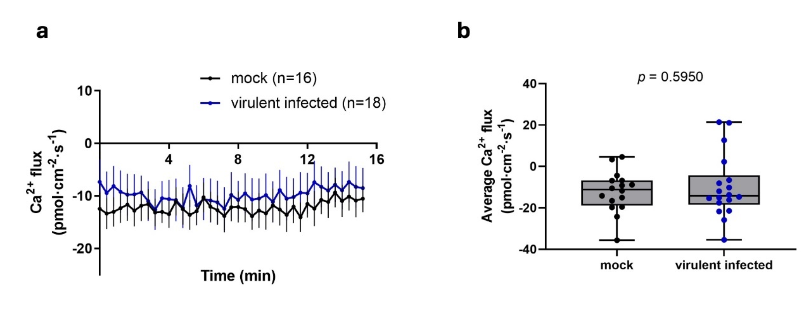
Extended Data Fig. 3|Ca²⁺ flux measurements in ArinaLrFor after virulent P.triticina isolate 95037 infection at 4dpi. a, Time-course recordings of Ca²⁺ flux in mesophyll cells of ArinaLrFor using the NMT technique. Negative values indicate Ca²⁺ influx, and positive values indicate Ca²⁺ efflux. b, Quantitative analysis of average Ca²⁺ fluxes from (a). The data are presented as mean ± SEM. Statistical significance was determined using an unpaired, two-tailed t-test.

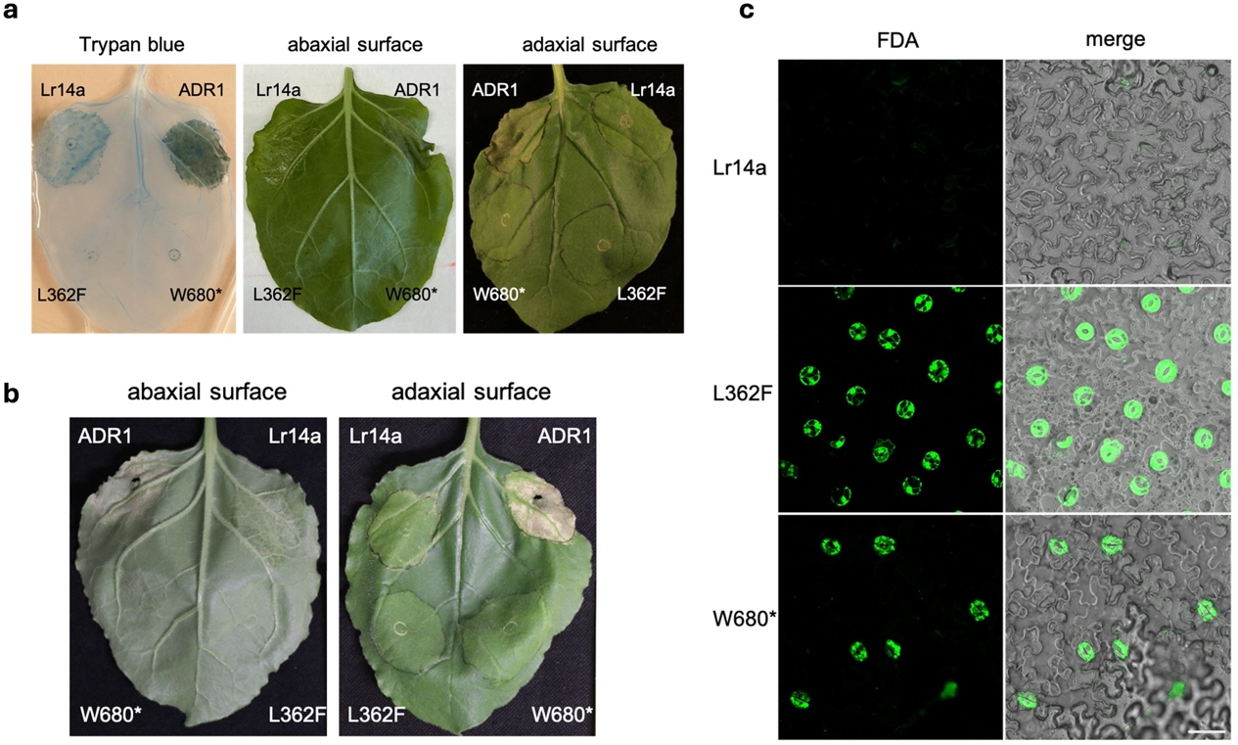
Extended Data Fig. 4|Lr14a induces guard cell death in Nicotiana benthamiana. a, Cell death and water-soaking-like phenotype in N. benthamiana leaves caused by the expression of HA-tagged wild-type (WT) Lr14a, autoactive ADR1, and two loss-of-function Lr14a mutants (L362F and W680*) at 3 days post-infiltration (dpi). Left: Representative image of N. benthamiana leaves stained with trypan blue. Middle: water-soaking-like phenotype on the abaxial leaf surface. Right: water-soaking-like phenotype on the adaxial leaf surface. b, Water-soaking-like phenotype. Abaxial (left) and adaxial (right) leaf surfaces of N.benthamiana after transiently expressing Lr14a and its mutants at 10 dpi. c, FDA staining of epidermal cells for 5min in N. benthamiana leaves at 3 dpi following expression of HA-tagged wild-type (WT) Lr14a and the two loss-of-function mutants Lr14a (L362F and W680*). Scale bar = 50 μm.

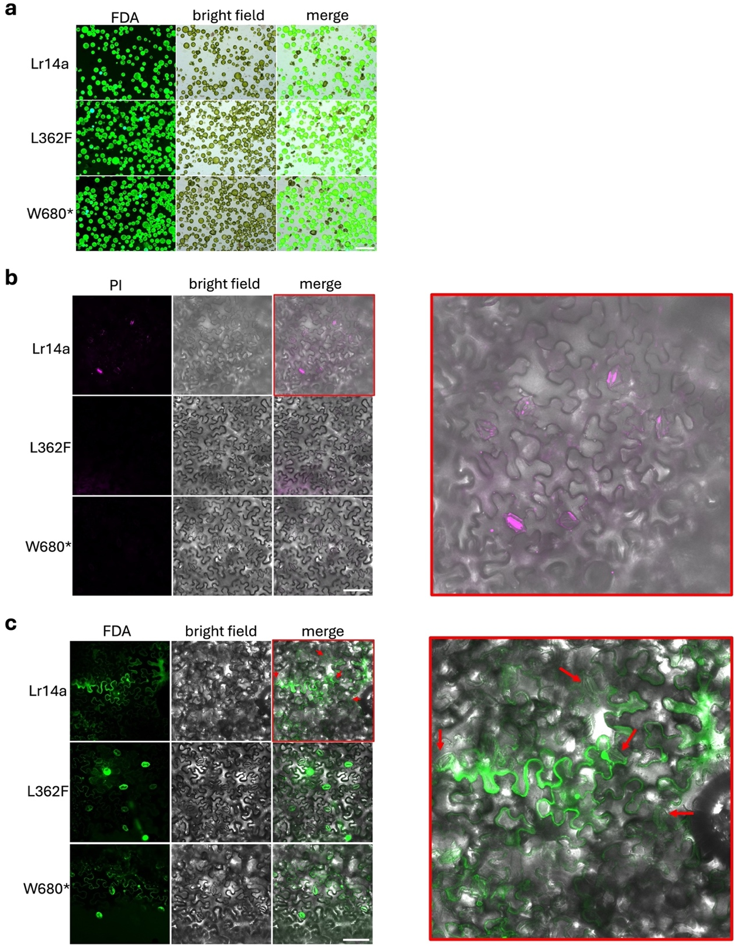
Extended Data Fig. 5|Lr14a triggers guard cell death in N. benthamiana. Cell viability was analyzed after transiently expressing Lr14a and its mutants at 3dpi using different dye. a, Protoplasts were isolated from leaves expressing Lr14a (top), L362F (middle), and W680* (bottom), and stained with FDA for 5 min at room temperature. Scale bar = 100 μm. b, Intact leaves expressing Lr14a (top), L362F (middle), and W680* (bottom) were stained with PI for 30 min at room temperature. The merged image of the Lr14a-expressing leaf was enlarged and marked with red boxes to show more detailed information. Scale bar = 100 μm. c, Intact leaves expressing Lr14a (top), L362F (middle), and W680* (bottom) were stained with FDA for 30 min at room temperature. The merged image of the Lr14a-expressing leaf was enlarged and marked with red boxes to show more detailed information. The wrinkled stomata were indicated with red arrows. Scale bar = 100 μm.
Extended Data Fig. 6|Expression of TaALMT12 in mesophyll cells and epidermis. TaALMT12 is a gene specifically expressed in guard cells. TaALMT12 expression levels in peeled epidermis and isolated mesophyll cells were measured by qRT-PCR at 4 dpi after infection with avirulent isolate 96209 (avi) and virulent isolate 95037 (vir) isolates. n = 4, different letters indicate statistically significant differences (unpaired, two-tailed t-test).

