Supporting Information for

Exposure to Phenanthrene induced Gene expressions and enzyme activities of Cyprinus Carpio in an aquatic ecological environment
Xin Kangª, Dongpeng Liª, Xin Caoª*, Xiaoxiang Zhaoª*, Yanfeng Lvª, Xi Chen^{b}, Xinshan Songª, Xiangyu Liu^{c}, Chenrong Chen^{c}
ª Textile Pollution Controlling Engineering Center of Ministry of Environmental Protection, College of Environmental Science and Engineering, Donghua University, Shanghai 201620, China.
^{b} Agricultural Genomics Institute at Shenzhen, Chinese Academy of Agricultural Sciences, Shenzhen 518124, China.
^{c} Australian Rivers Institute and School of Environment and Science, Griffith University, Nathan, Queensland 4111, Australia

Supporting Information: 4 figures.

FigS1. GST amplified gene sequencing stitching results
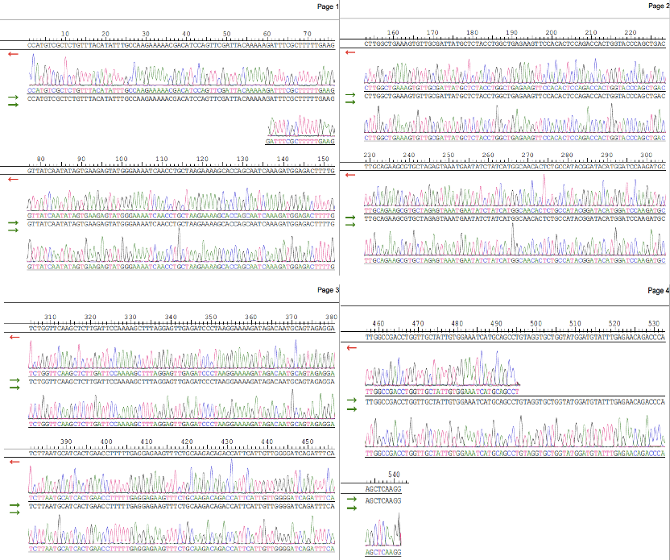

FigS2. CYP1A amplified gene sequencing stitching results
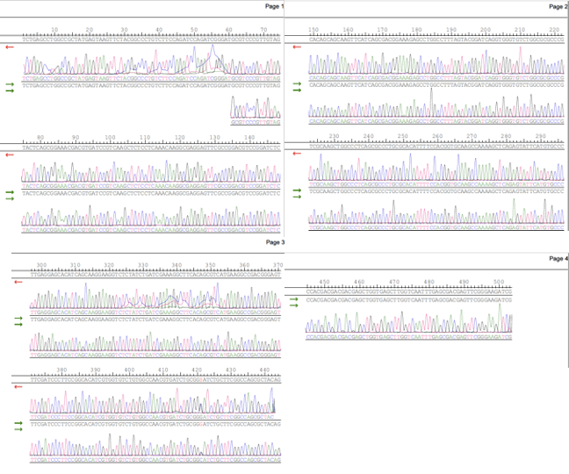

FigS3. Electrophoresis diagram of each gene sample. The expression levels of target genes CYP1A and GST were detected by genomic PCR analysis, and β-ACTIN was used as a template control. From top to bottom are the cDNA gel electrophoresis diagrams of PHE stress concentrations of 0, 0.1, 0.5, 1.0 mg/L.

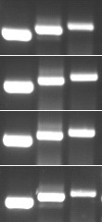
0 mg/L
0.1 mg/L
1.0 mg/L
0.5 mg/L
CYP1A
GST
β-ACTIN

Fig S4. Electrophoresis diagram of RNA sample (Lanes 1 and 2 indicate the electrophoresis of liver and brain RNA of carp domesticated in clean water, and lanes 3 and 4 are the extraction of total RNA from tissues after PHE stress. The time shown in Fig. is the time when the three characteristic bands of the sample RNA electrophoresis appear.)
