Supplemental Materials
Patients
Sepsis and CABG patients………………………………………....... Page 2
Polytrauma patients………………………………………………….. Page 2
COVID-19 patients…………………...…………………………....... Page 2
Assay Measurements and Analyses
Sample Collection………………………………………....………… Page 3
t⁶A analysis………………………………………………..……........ Page 3
PCT analysis……………………………………………………........ Page 3
Statistical analyses (animal data)………………..………………...… Page 4
Animal Experiments
Mouse sepsis……………………………………………………........ Page 5
Pig trauma…………………………………………………………… Page 6
Baboon septic shock…………………………………….…………... Page 6
Normative t⁶A values…………………………………..……………. Page 6
Table S1: Descriptive statistics of biomarkers…………………………....… Page 7
Table S2: Characterization of COVID-19 patients…………………….……. Page 8
Figure S1: Exploratory cohort………………………………………………. Page 9
Figure S2: Validation cohort…...…………………………………………… Page 10
Figure S3: Concentration of t⁶A & PCT in CABG patients ………………... Page 11
Figure S4: t⁶A detecting COVID-19 in patients ………………..................... Page 12
Figure S5: t⁶A concentration in mouse CLP sepsis ………………................ Page 13
Figure S6: t⁶A in pig trauma and normative concentrations…....................... Page 14
References…………………………………………………………………... Page 15
ARRIVE checklist…………………………………………………………... Page 16

Human Patients
Septic and CABG patients in the ICU

Two groups of patients treated at the ICU were included: patients with diagnosis of sepsis and patients after cardiac surgery (control group). Inclusion criteria for septic patients were: age> 18 years; exclusion criteria were: a length of ICU stay less than 24 h. Inclusion criteria for patients after cardiac surgery were: elective, first time coronary artery bypass grafting (CABG) with cardiopulmonary bypass (CBP). Exclusion criteria were: clinical signs of infection at admission, urgent operation, off-pump surgery, a previous coronary artery bypass graft. The median duration of cardiac bypass time was 84 minutes (676–105), and aortic cross-clamp time was 40 minutes (36–55). The median length of ICU stay was 3 days and the ICU and hospital survival rate was 100%. All patients were extubated on the day of surgery or on the first postoperative day. No patient developed sepsis during their ICU stay. The severity of patients’ clinical condition was determined using the APACHE II (Acute Physiology and Chronic Health Evaluation II) score on admission to the ICU. In septic patients, the extent of organ dysfunction/failure was assessed with the SOFA (Sequential Organ Failure Assessment) score. None of the CABG control patients showed signs of infection preoperatively or developed sepsis during postoperative ICU treatment. We list the pooled number of all retrospectively enrolled patients (Table 1) as the basis for the below-shown analyses. Due to some subsequent PCT/t⁶A assay errors, the n in the pooled groups may be smaller than 81.
Polytrauma patients in the ER
Sixty four patients with polytrauma were included in the current analysis (Table 1). Inclusion criteria were trauma-severity score (ISS) > 15, age > 18, consent to take part in the study and admittance to the ER within the first 3 hours after trauma. Exclusion criteria were: autoimmune disease, immune-suppressive or anti-inflammatory medication, pregnancy, breastfeeding and infectious disease within the 14 days preceding inclusion in the study. Four of these patients died during their stay at the hospital, 25 experienced ARDS, 11 required catecholamines, three patients had a PTZ less than 50%, 13 displayed creatinine concentration less than 1.2 mg, 42 had elevated values for AST, 27 had elevated values for ALT, 17 patients had positive microbiological cultures (either bloodstream, tracheal and/or tissue samples).
COVID-19 patients in the ICU
Forty-nine patients with severe COVID-19 infection and 11 healthy volunteers were recruited at the study center of the University Medical Center Göttingen (UMG) from April 2020 to January 2021 during the first and second waves of COVID-19 (SeptImmun Study No. 24/4/19Ü, UMG Ethics Commission). All patients had confirmed SARS-CoV-2 infection, were symptomatic, and hospitalized due to severe oxygenation disorders. A detailed patient characteristic is shown in the Supplementary Table 2.

Assays Measurements and Analyses

Sample Collection

Blood samples (2.7ml) for determining t⁶A levels were collected from the arterial blood catheter to the tubes with 3.2% sodium citrate as an anticoagulant. In the group of patients with sepsis samples were collected on days: 0 (day of the ICU admission), 3, 5, 7, and 10 of the ICU stay. In the group of patients undergoing CABG, samples were collected before surgery (time 0), and then at 6, 12, 24, and 48 hours after surgery. In polytrauma patients, samples were collected at admission (day 0), 24h, 48h and 96h post-trauma. In all cases, plasma was obtained by centrifugation of blood at 2000 rpm for 10 minutes. Samples were stored at 70ºC until analysis.

t⁶A Analysis

50µL of plasma or serum is used for the assay, 20µL of internal standard (in water) is added, and samples are vortexed. Subsequently, 100µL of acetonitrile is added, samples are vortexed again for precipitation purposes, and centrifuged at approx. 4000 × g for two minutes. Part of the clear supernatant is transferred to autosampler vials and diluted with water. 3 µL are injected into the HPLC-MS/MS system. The mobile phase consists of 0.1% formic acid in water vs. 0.1% formic acid in 90% acetonitrile via gradient elution. Column temperature is set at 60°C and the flow rate set at 1 mL/min, where a run lasts for 5.2 minutes. Retention time on a YMC Pro C8 column (3 µm, 100 × 3mm) is 2.6 minutes. A Xevo TQ-XS (Waters Corporation, USA) mass spectrometer was used with a UNISpray ion source in positive ion mode at 600 °C, multiple reaction monitoring (MRM) transitions were 413.3 – 281.0 m/z for the analyte and 418.2 – 286.0 m/z for the internal standard. Calibration range was 5.00 (lower limit of quantification, LLOQ) to 5000ng/mL. Several standard addition samples in plasma (native and native + spiked) were also analyzed to prove correctness of concentration calculations in plasma by a partial validation (precision by the coefficient of variation, CV at three levels with 2.5%, 2.0%, 2.7%) and accuracies for native + spiked with 99.5% and 100.6%. For determination of the assay’s curve fitting, precisions (CV) and accuracies four validation runs were analyzed, each consisting of one set of calibration standards (Std1 – Std8), one zero (Std0) and one blank sample and five sets of quality control samples at four concentration levels (including at the LLOQ).

PCT analysis

PCT levels in patients with sepsis and CABG patients were performed in the certified hospital laboratory of the Wroclaw Medical University, Wroclaw, Poland. PCT levels in polytrauma patients were performed in the certified hospital laboratory of the AUVA Trauma hospital (Unfallkrankenhaus), Salzburg, Austria. An automated chemiluminescent microparticle immunoassay (ARCHITECT BRAHMS PCT, Abbott, Chicago, IL, USA) was used in both locations.

Statistical Analyses of Animal Data
Pharmacokinetic analysis of the mouse, pig and baboon data was performed in Phoenix WinNonlin 8.4.0 (Certara USA, Inc. 2023, Princeton, NJ, USA). The AUC of the mouse data was calculated by the linear-up / logarithmic-down trapezoidal method and the Area Under the Effect Curve (AUEC) of the baboon data by the linear trapezoidal. AUC-, C_{max}-, and AUEC-values were log_{e}-transformed before comparisons. AUCs as well as the maximum concentrations (C_{max}) of sexes of the mouse groups and AUECs of baboon groups were compared by the 95% CI based on the two-sided Welch-Satterthwaite test adjusting for unequal sample sizes and variances.

Animal Experiments
All animal experiments from which samples for t⁶A were obtained, met/exceeded the conditions described in the Guide for the Care and Use of Laboratory Animals as defined by the National Institutes of Health. All respective approval by the Institutional Animal Care and Use Committees are listed below.
Mouse Model of Sepsis
The Supplementary Figure 5 data were obtained from samples originating from another mouse study (1) performed in LBI Traumatology, Vienna, Austria. Three- to six-month-old wild-type CD-1 mice (Mus musculus, Harlan Laboratories Ltd.) of both sexes were kept at 22–24°C with a 12h/12h light/dark cycle. The CLP study was approved by the Viennese legislative committee and was performed in strict accordance with guidelines for animal care and welfare (Animal Use Proposal Permission no: 343130/2013/14). This study followed both ARRIVE and MQTiPSS guidelines. In brief, the CLP surgery was performed under isoflurane anesthesia with perioperative buprenorphine (0.05 mg kg⁻¹) in 1 ml of Ringer’s solution (detailed CLP protocol here (2)). Starting with CLP, all mice received continuous analgesic treatment (0.05 mg/kg buprenorphine) every 6–8 h. All mice were monitored for clinical signs of illness and their status was evaluated using our modified mouse clinical assessment scoring system (M-CASS; relying on body temperature, fur appearance, posture, mobility, alertness, startle, and righting reflex). starting 12h post-CLP (3). Approximately 20 μL of blood was collected via facial vein puncture from each animal as previously described (4), 24h before CLP (baseline), as well as 6 h, 24 h, and 48 h after CLP. The whole blood underwent centrifugation (1,000g, 5min, 22°C) and plasma was stored in -80°C until t⁶A analysis.
Pig Model of Liver Abrasion and Hemorrhage
The Supplementary Figure 6A data were obtained from samples originating from another pig study (5) performed in LBI Traumatology, Vienna, Austria (Animal Use Proposal Permission no: 434320/2020/25). In brief, eight male pigs (Sus scrofa) weighing approximately 35kg each were premedicated with a combination of tiletamine and zolazepam intramuscularly, followed by inhalation anesthesia with isoflurane. Carotid artery and jugular vein, these vessels were cannulated for blood pressure monitoring and intravenous access. A median laparotomy was performed, the liver exposed and circular lesions of about 1.8 cm in diameter and 2 mm in depth were created on the liver surface using a grinding disc to cause a moderate-level bleeding according to the validated intraoperative bleeding scale (VIBe SCALE) not exceeding 10 ml/min. Hydroxyethyl starch (Voluven; Fresenius Kabi, Graz, Austria; 10mL/kg/h) and Norepinephrine (Arterenol; Sanofi Aventis, Frankfurt, Germany; 5μg/kg/h) were administered to maintain the mean arterial blood pressure not lower than 70mmHg. Venous blood samples were collected after cannulation and prior to the laparotomy (control) and after approximately 8 hours after the liver abrasion/hemorrhage was initiated (trauma). The whole blood underwent centrifugation (1,000 g, 5min, 22°C) and plasma was used for t⁶A analysis. Statistical approach is defined in the Statistical Analyses section of the main paper.
Baboon Model of Septic Shock
The Figure 4 data were obtained from samples originating from another non-human primate study (6) performed at the Free State University Bloemfontein, South Africa. The study was approved by the Institutional Animal Care use Committee at Free State University Bloemfontein, South Africa (Animal Use Proposal Permission no: 03/2010). All experiments were performed under the conditions described in the Guide for the Care and Use of Laboratory Animals as defined by the US National Institutes of Health. In brief, twenty-two 3-10 year-old healthy male Chacma baboons (Papio ursinus) with a median weight of 18.1 (16.5–22.3) kg were premedicated with ketamine hydrochloride and pentobarbital, intubated and kept under continuous anesthesia with infusion 0.8 mg/kg/h sodium pentobarbital, 0.8μg/kg/h, sufentanil and 1 mg/kg/h rocuronium. Baboons were ventilated using a tidal volume of 6–8ml/kg and a respiratory rate of 18–20 breaths/minute maintaining an arterial pressure of CO₂ at 35–45mmHg. Septic was induced by 5 × 10⁶ colony-forming units (CFU)/kg E. coli O111:K58(B4):H-(ATCC 33780) infused intravenously over a 2h period via a motor-pump. Ringer’s solution and/or noradrenalin were infused to maintain the mean arterial blood pressure (MAP) at >70 mmHg and CVP and PAOP at >5mmHg. Antibiotics were not used. Fifteen minutes after completion of the E.coli infusion, animals were randomized into three groups to receive a crystalloid solution as vehicle (control; n = 8), low-dose SATI (n = 8) and high-dose SATI (n = 6). Blood samples were collected at baseline, after 1h, 2h, every 2h within the first 8h and every 4h until 24h (the end of the experiment). Blood was centrifuged at (2000g, 10min, 22°C) and plasma was stored in -80°C until t⁶A analysis. Statistical approach is defined in the Statistical Analyses section of the main paper.
Normative Values in Healthy Animals

Additionally, t⁶A was analyzed in the plasma/serum samples collected from seven healthy species: mouse, rat, rabbit, dog, pig, baboon and human. These samples were part of the approved experiments (as baseline; mouse, rat, rabbit, pig, baboon, human) or donated free-of-charge (dog) by the Small Animal Ambulance from the University of Veterinary Medicine, Vienna, Austria.

Supplementary Table 1 CABG as control: Descriptive statistics of biomarkers
Cohort | Marker | Patients | Condition | Patients | Median | Min – Max
Exploratory | t⁶A | 61 | control | 14 | 31.9 | 18.8 | 84.5
 |  |  | sepsis | 47 | 82.6 | 25.7 | 704
 | PCT | 63 | control | 12 | 1.25 | 0.17 | 4.32
 |  |  | sepsis | 51 | 5.41 | 0.42 | 333
Validation | t⁶A | 97 | control | 67 | 23.0 | 16.1 | 69.1
 |  |  | sepsis | 30 | 106 | 25.5 | 302
 | PCT | 63 | control | 33 | 0.30 | 0.03 | 32.4
 |  |  | sepsis | 30 | 9.71 | 0.02 | 180
Pooled | t⁶A | 158 | control | 81 | 24.2 | 16.1 | 84.5
 |  |  | sepsis | 77 | 94.7 | 25.5 | 704
 | PCT | 126 | control | 45 | 0.40 | 0.03 | 32.4
 |  |  | sepsis | 81 | 7.67 | 0.02 | 333
All concentrations in ng/mL

Supplementary Table 2 Polytrauma as control: Descriptive statistics of biomarkers
Cohort | Marker | Patients | Condition | Patients | Median | Min – Max
 | t⁶A | 141 | control | 64 | 20.8 | 15.2 | 88.6
 |  |  | sepsis | 77 | 94.7 | 25.5 | 704
 | PCT | 144 | control | 63 | 0.47 | 0.03 | 37.1
 |  |  | sepsis | 81 | 7.67 | 0.02 | 333

Supplementary Table 3 Characterization of COVID-19 patients
Parameter | Value
Number | 49
Age [years] | 71 (65 – 75)
Female / male ( %) | 14 / 35 (29 / 71)
Length of stay [days] | 14 (6 – 23)
Ventilated (%) | 41 (84)
Extracorporeal Membrane Oxygenation (%) | 8 (16)
Dialysis (%) | 11 (22)
First COVID-19 wave (%) | 19 (39)
Body Mass Index [kg/m²] | 25 (25 – 32)
Died | 13 (27)
Leukocytes [10³/µL] | 10.2 (7.7 – 12.45)
Lymphocytes [10³/µL] | 8.175 (5.488 – 13.32)
Platelets [10³/µL] | 226 (154.5 – 365.3)
Bilirubin [mg/dL] | 0.5 (0.3 – 0.7)
C-reactive Protein [mg/dL] | 115.1 (61.8 – 173.9)
Interleukin-6 [pg/mL] | 75.4 (26.55 – 126.6)
Creatinine [mg/dL] | 0.995 (0.7175 – 1.94)
PCT [ng/mL] | 0.345 (0.1 – 1.413)
Unless otherwise specified, the numbers are median (IQR).

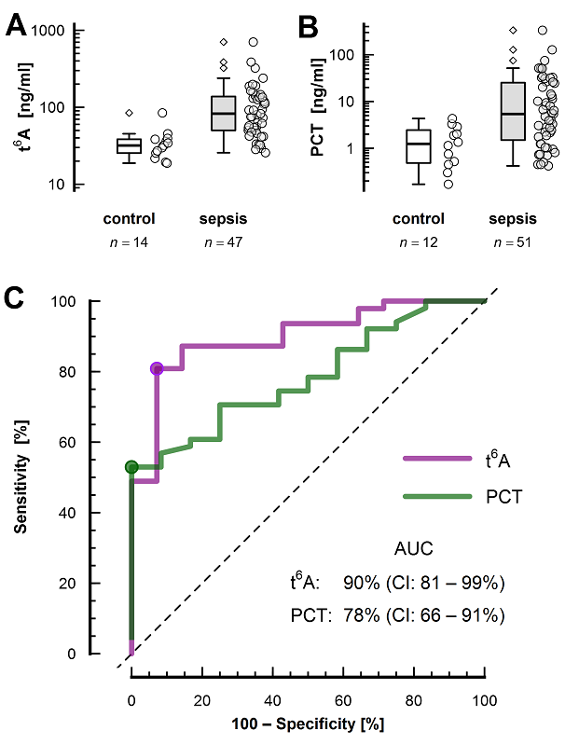

Supplementary Figure 1. Diagnostic performance of t⁶A and PCT for detecting sepsis at ICU admission in the exploratory patient cohort. Distribution of patients for t⁶A (A) and PCT (B) is presented as box plots (left; median, upper/lower quartile, whiskers at ±1.5× of the interquartile range) and jitter plots (right). ROC curves are shown in C. Colored dots on the ROC curves represent optimal thresholds. The statistical methodology is described in Statistical Analyses section in the main paper.

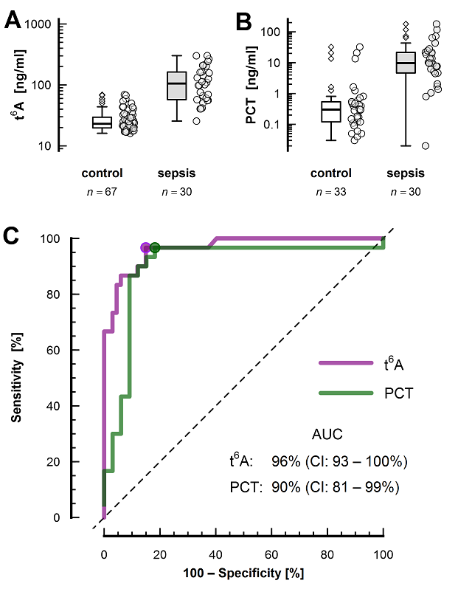

Supplementary Figure 2: Diagnostic performance of t⁶A and PCT for detecting sepsis at ICU admission in validation patient cohorts. Distribution of patients for t⁶A (A) and PCT (B) is presented as box plots (left; median, upper/lower quartile, whiskers at ±1.5× of the interquartile range) and jitter plots (right). ROC curves are shown in C. Colored dots on the ROC curves represent optimal thresholds. The statistical methodology is described in Statistical Analyses section in the main paper.

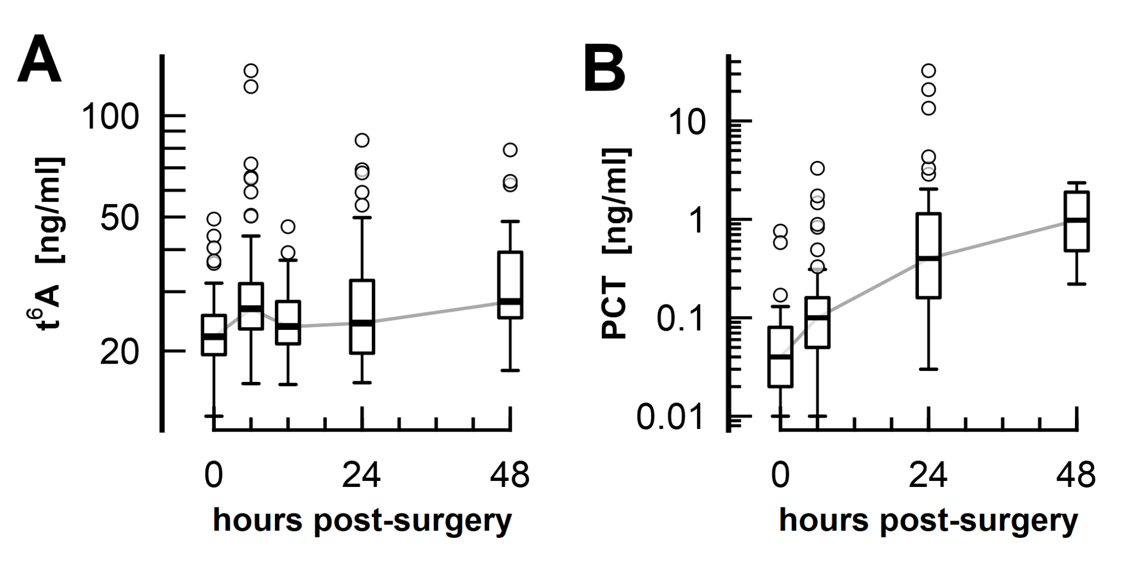
Supplementary Figure 3. Concentration of t⁶A (A) and PCT (B) was measured over 48 h in the CABG control patients to visualize a protracted dynamic of each marker. t⁶A was measured at 0, 6, 12, 24 and 48 hours (number of values n: 77, 81, 40, 81, 26), while PCT at 0, 6, 24, and 48 hours (n: 49, 50, 45, 9). Both markers are presented at each time point as box plots (median, upper/lower quartile, whiskers at ±1.5× of the interquartile range). The statistical methodology is described in Statistical Analyses section in the main paper.

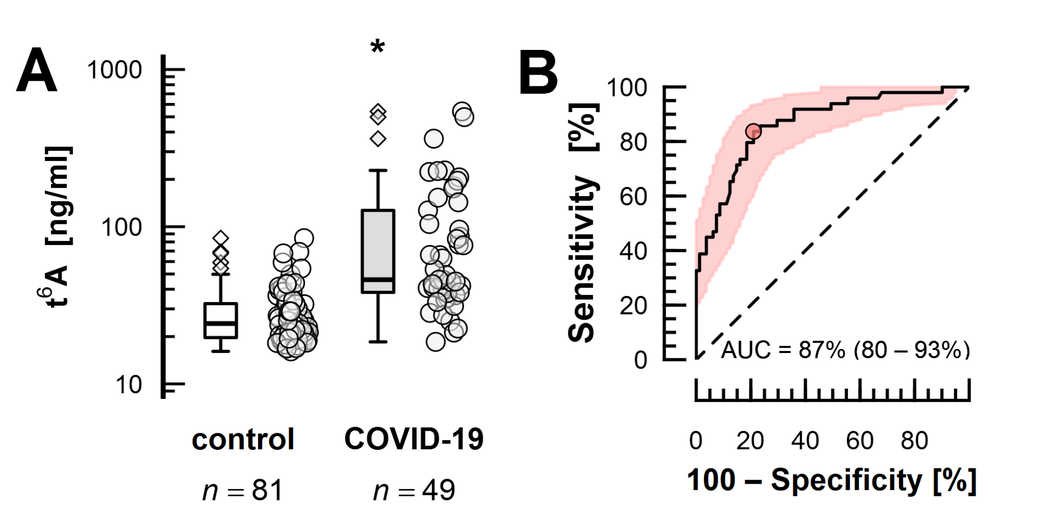

Supplementary Figure 4. Diagnostic performance of t⁶A for detecting COVID-19 in patients admitted to the ICU. Distribution of patients for t⁶A (A) is presented as box plots (left; median, upper/lower quartile, whiskers at ±1.5× of the interquartile range) and jitter plots (right). ROC curve with graphically depicted 95% confidence interval is shown in B. Colored dot on the ROC curve represents the optimal threshold. The statistical methodology is described in Statistical Analyses section in the main paper.

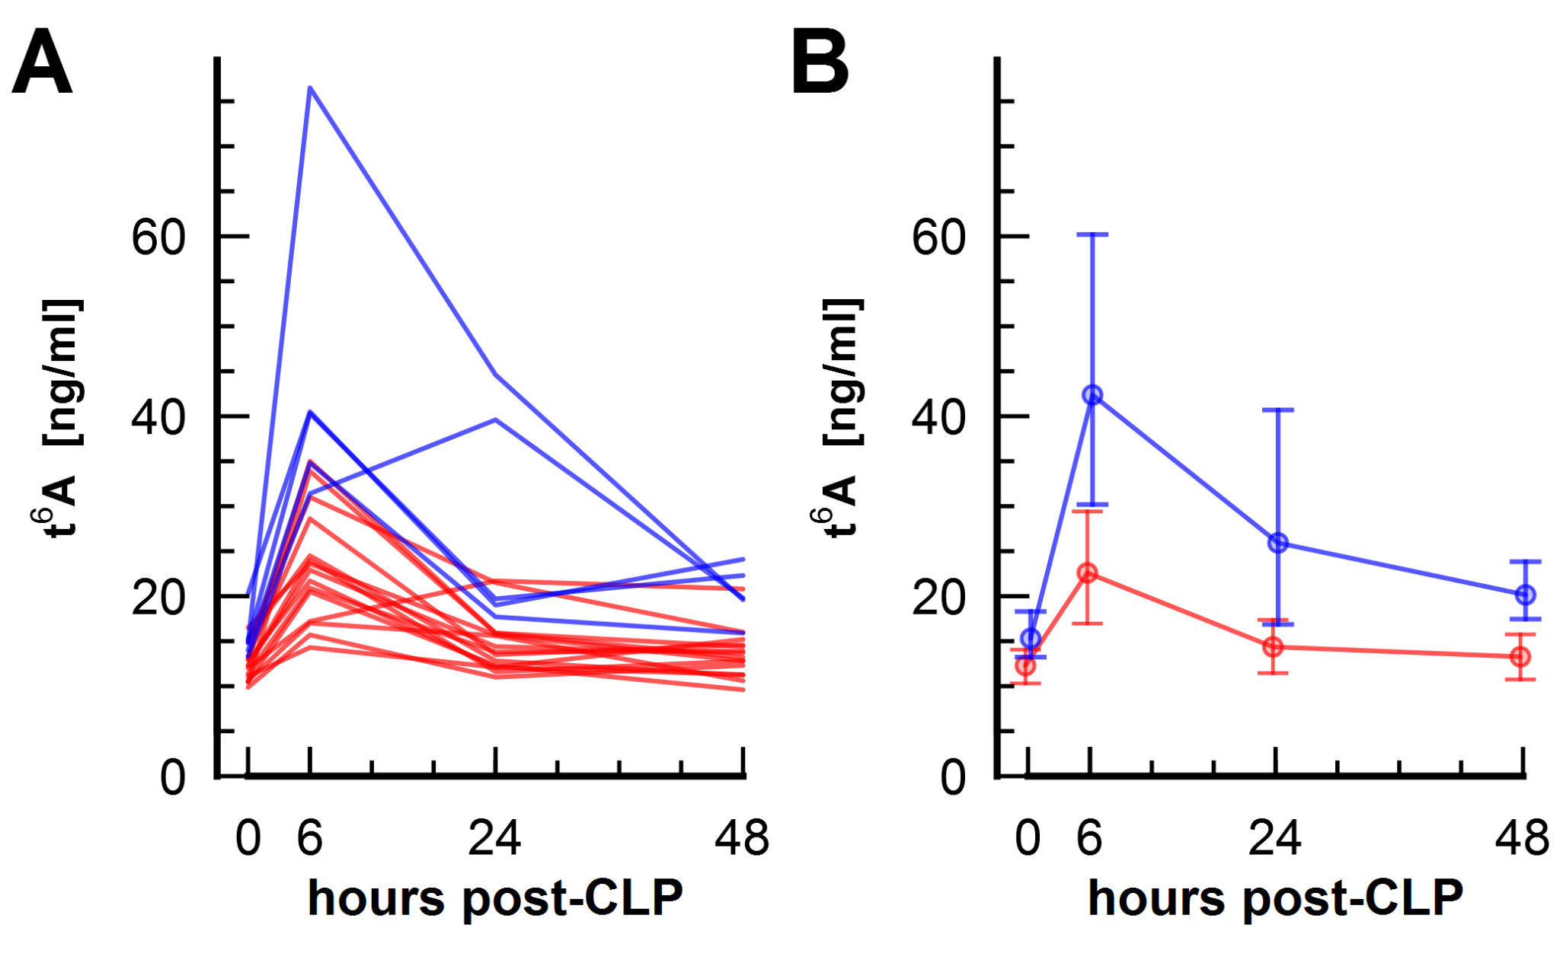
Supplementary Figure 5. Concentration of t⁶A was retrospectively measured over 48 hours in adult 20 (15 female, 5 male) CD-1 mice subjected to cecal ligation and puncture (CLP) with non-lethal outcome. Red = females, blue = males. Individual t⁶A profiles (A) and grouped by sex (B) are shown. In (B) geometric means ±1 SD are displayed. the C_{max} for t6A was higher in males (PE 193%, 95% CI: 133% – 282%) compared to the females, as was their AUEC (PE 175%, 95% CI: 125 – 244%) The statistical methodology is described in Statistical Analyses on page 4 of this supplement.

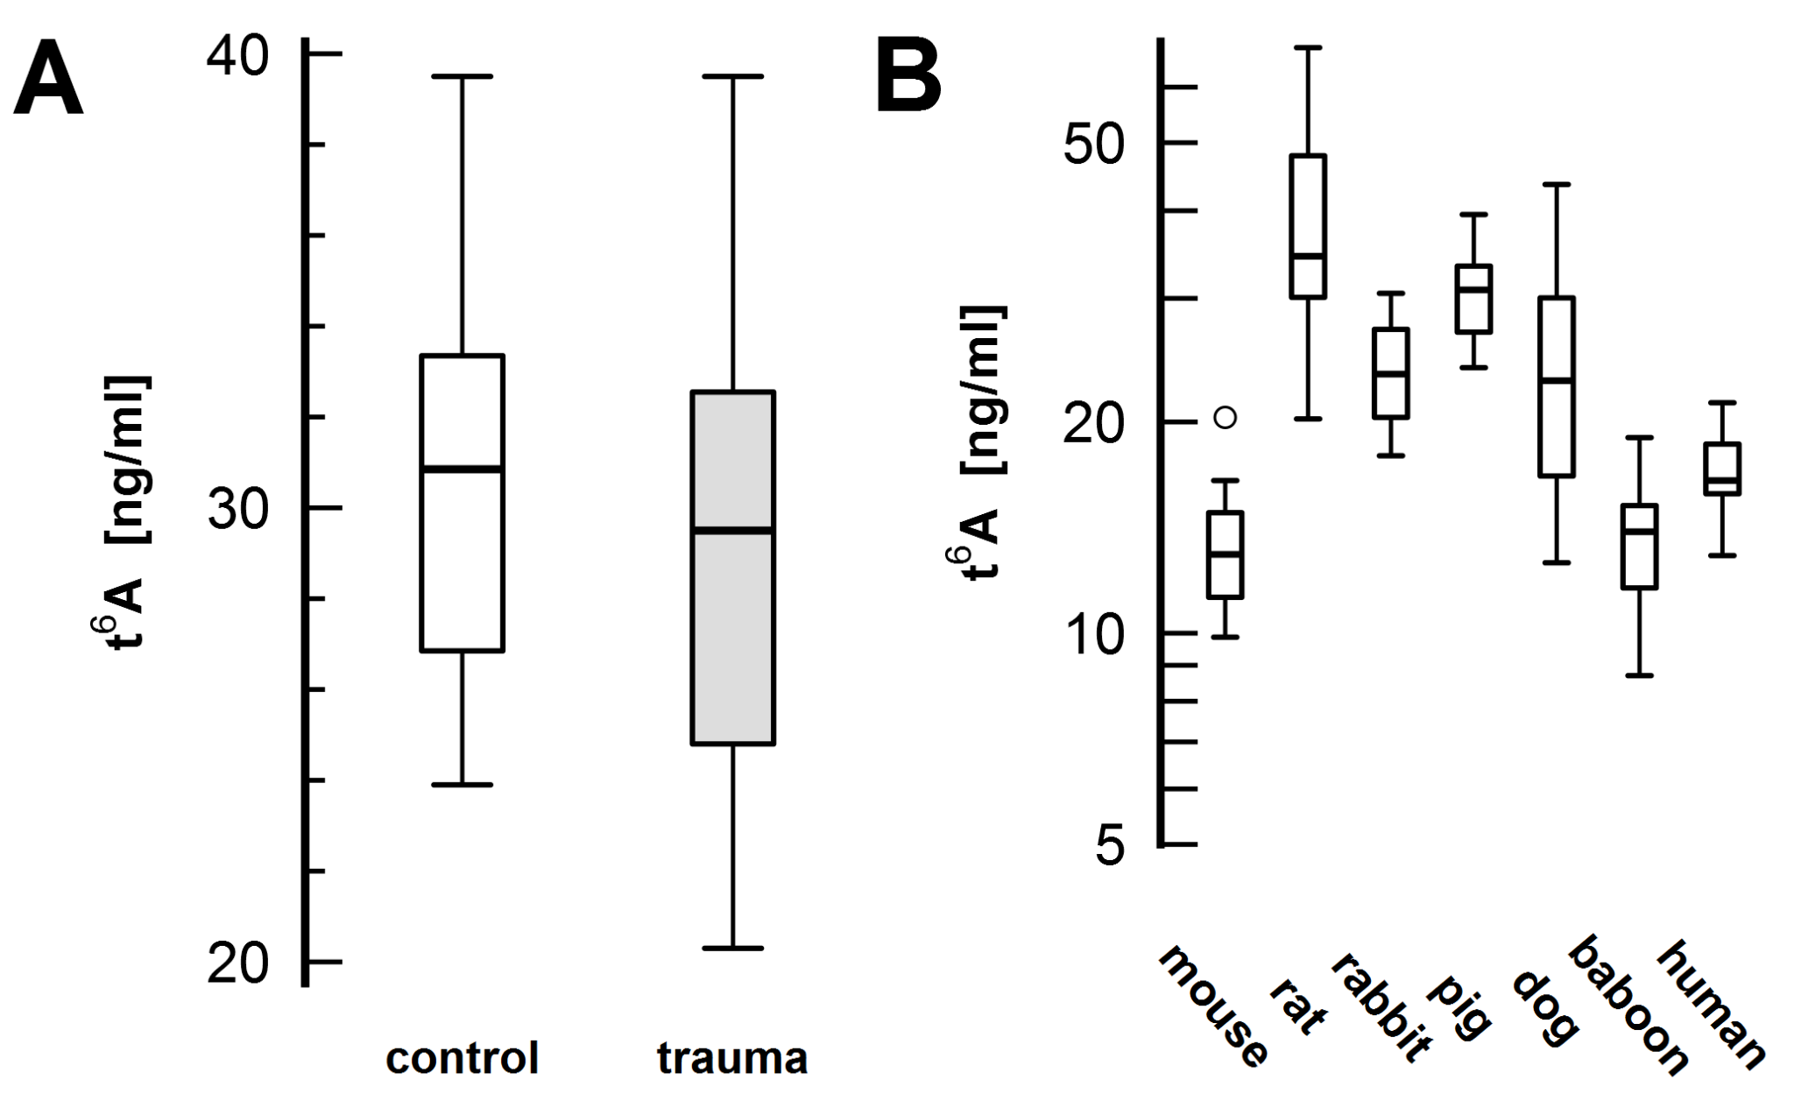

Supplementary Figure 6. Panel A: Concentration of circulating t⁶A was retrospectively measured prior (control; white) and approximately 8 hours after the surgery (trauma; gray) in eight male adult pigs subjected to a liver abrasion and hemorrhage model. Panel B: normative t⁶A circulating concentration in seven healthy species. Normative values of mouse (n=20), pig (n=8) and baboon (n=22) are a repetition of 0h values shown in preceding figures. Samples from the remaining species were either donated free-of-charge (dog; (n=11) or were left-overs from different studies (rat, n=10; rabbit, n=6) performed by LBI and approved by the municipal government of Vienna. t⁶A is presented at each time point as box plots (median, upper/lower quartile, whiskers at ±1.5× of the interquartile range). Median (and range): mouse 13.0ng/mL (9.9 – 20.3ng/mL), rat 34.5ng/mL (20.2 – 68.3ng/mL), rabbit 23ng/mL (17.90 – 30.5ng/mL), pig 30.9ng/mL (23.9 – 39.5ng/mL), dog 22.9ng/mL (12.9 –43.6ng/mL), baboon 14.0ng/mL (8.7 – 19.0ng/mL) and human 16.5ng/mL (12.9 – 21.3ng/mL).

References
1. Bayer J, Vaghela R, Drechsler S, Osuchowski MF, Erben RG, Andrukhova O. The bone is the major source of high circulating intact fibroblast growth factor-23 in acute murine polymicrobial sepsis induced by cecum ligation puncture. PLoS One. 2021;16(5):e0251317. doi:10.1371/journal.pone.0251317
2. Drechsler S, Osuchowski M. Cecal Ligation and Puncture. Methods Mol Biol. 2021;2321:1–8. doi:10.1007/978-1-0716-1488-4_1
3. Rademann P, Weidinger A, Drechsler S, Meszaros A, Zipperle J, Jafarmadar M, et al. Mitochondria-Targeted Antioxidants SkQ1 and MitoTEMPO Failed to Exert a Long-Term Beneficial Effect in Murine Polymicrobial Sepsis. Oxid Med Cell Longev. 2017;2017:6412682. doi:10.1155/2017/6412682
4. Weixelbaumer KM, Raeven P, Redl H, van Griensven M, Bahrami S, Osuchowski MF. Repetitive low-volume blood sampling method as a feasible monitoring tool in a mouse model of sepsis. Shock. 2010 Oct;34(4):420–6. doi:10.1097/SHK.0b013e3181dc0918
5. Slezak P, Keibl C, Labahn D, Schmidbauer A, Genyk Y, Gulle H. A Comparative Efficacy Evaluation of Recombinant Topical Thrombin (RECOTHROM®) With A Gelatin Sponge Carrier Versus Topical Oxidized Regenerated Cellulose (TABOTAMP®/SURGICEL®) In A Porcine Liver Bleeding Model. J Invest Surg. 2021 Aug;34(8):862–8. doi:10.1080/08941939.2019.1705444
6. Schöchl H, van Griensven M, Heitmeier S, Laux V, Kipman U, Roodt J, et al. Dual inhibition of thrombin and activated factor X attenuates disseminated intravascular coagulation and protects organ function in a baboon model of severe Gram-negative sepsis. Crit Care. 2017 Mar 13;21(1):51. doi:10.1186/s13054-017-1636-y

