Supplementary material
Nitrogen-induced acidification increases soil organic carbon accrual by promoting particulate organic carbon and microbial necromass under long-term experiments in the paddy soils of East China

Zhaoming Chen¹, Qiang Wang^{1, *},Jinchuan Ma¹, Feng Wang¹, Junwei Ma¹, Jing Ye¹, Ping Zou¹, Wanchun Sun¹, Qiaogang Yu^{1, **}

¹ State Key Laboratory for Quality and Safety of Agro-products, Key Laboratory of Soil Remediation and Quality Improvement of Zhejiang Province, Institute of Environment, Resource, Soil and Fertilizer, Zhejiang Academy of Agricultural Sciences, Hangzhou 310021, China

* Corresponding author: Qiang Wang, E-mail: wangq@zaas.ac.cn
** Corresponding author: Qiaogang Yu, E-mail: yuqg@zaas.ac.cn

Table S1. The phospholipid fatty acids detected in our study
Category |  | Unique phospholipid fatty acids
Bacteria | Gram-positive bacteria | i13:0, i14:0, i15:0, a15:0, i16:0, i17:0, a17:0, i18:0
Bacteria | Gram-negative bacteria | 16:1ω7c, 16:1ω9c, 17:1ω8c, 18:1ω5c, 18:1ω7c, cy17:0, cy19:0
Fungi |  | 16:1ω5c, 18:1ω9c, 18:3ω6c, 18:2ω6c
Actinomycete |  | 10-methy 16:0, 10-methy 17:0, 10-methyl 18:0
Chen, Z., Wang, H., Liu, X., Zhao, X., Lu, D., Zhou, J., Li, C., 2017. Changes in soil microbial community and organic carbon fractions under short-term straw return in a rice-wheat cropping system. Soil & Tillage Research 165, 121-127.
Fierer, N., Schimel, J.P., Holden, P.A., 2003. Variations in microbial community composition through two soil depth profiles. Soil Biology and Biochemistry 35, 167-176.
Zelles, L., 1999. Fatty acid patterns of phospholipids and lipopolysaccharides in the characterisation of microbial communities in soil: a review. Biology and Fertility of Soils 29, 111-129.
# | Hypothesized mechanism | References
1 | N addition increases root biomass by simulating crop productivity. | Chen et al., 2020; Sun et al., 2023
2 | N addition increases microbial biomass by higher N availability. | Sun et al., 2023
3 | N addition increases soil total N by increasing N input. | Zhang et al., 2023
4 | N addition increases microbial necromass carbon by increasing microbial biomass | Fan et al., 2020; Hu et al., 2022; Schwalb et al., 2024
5 | Increased in N input is known to decrease soil pH. | Ye et al., 2018
6 | Soil total N has a significant effect on root biomass | Duan et al., 2023
7 | Soil total N affects microbial biomass by changing N availability | Chen et al., 2020
8 | It is well known that soil pH impacts root biomass. | Ye et al., 2018
9 | Soil pH plays an important role in microbial biomass | Püspök et al., 2022
10 | Root biomass is an important contributor to POC | Duan et al., 2023
11 | Root biomass increases microbial necromass by increasing microbial biomass | Fan et al., 2020; Zhao et al., 2024
12 | Root biomass affect microbial biomass by supplying C and energy sources | Zhao et al., 2024
13 | Microbial biomass is positively correlated with microbial necromass carbon | Fan et al., 2020; Wang et al., 2023
14 | Microbial biomass plays a vital role in regulating MAOC formation and accumulation | Li et al., 2024; Schwalb et al., 2024
15 | MNC can accumulate in POC | Bian et al., 2024; Li et al., 2024; Yang et al., 2025
16 | MNC is an important contributor to MAOC | Lavalle et al., 2020; Li et al., 2024
Figure S1. A priori structural equation model of environmental variables on particulate and mineral-associated organic carbon.
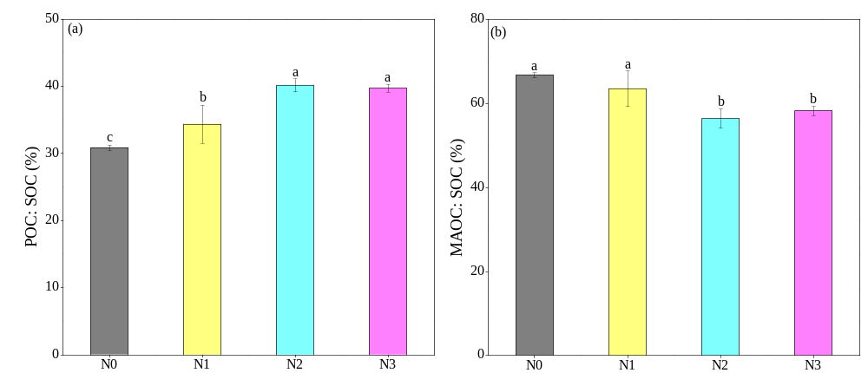
Figure S2. The ratios of particulate organic carbon to soil organic carbon (a) and mineral-associated organic carbon (b) in all treatments. N0, N1, N2 and N3 stand for N addition rates of 0, 300, 450 and 600 kg N ha^{–1} yr^{–1}, respectively. Different letters indicate significant differences among different treatments at P < 0.05.

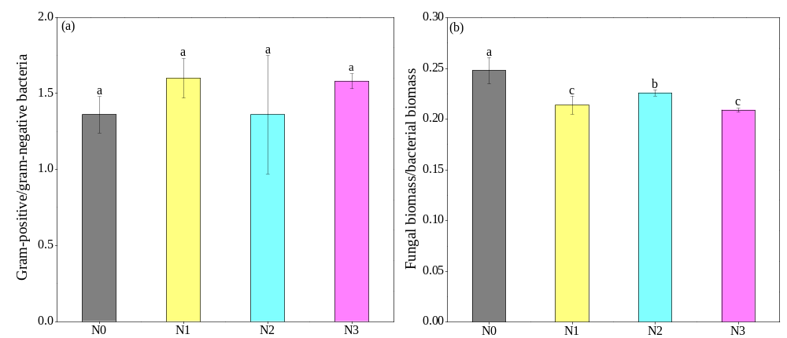
Figure S3. The ratios of gram-positive to gram-negative bacteria (a) and fungal biomass to bacterial biomass in all treatments. N0, N1, N2 and N3 stand for N addition rates of 0, 300, 450 and 600 kg N ha^{–1} yr^{–1}, respectively. Different letters indicate significant differences among different treatments at P < 0.05.

Figure S4. Correlation between abiotic and biotic factors. SOC, soil organic carbon; TN, total nitrogen; AN, available nitrogen; AP, available phosphorus; POC, particulate organic carbon; MAOC, mineral-associated organic carbon; MNC, microbial necromass carbon; NAG, β-N-acetyl-glucosaminidase; LAP, leucine aminopeptidase; BG, β-1, 4-glucosidase; ACP, acid phosphatase; PLFAs, phospholipid fatty acids. *, ** and *** represent P < 0.05, P < 0.01and P < 0.001, respectively.
Figure S5. Correlation between amino sugars and microbial necromass carbon, and environmental factors. GlcN, glucosamine ; GalN, galactosamine; MurA, muramic acid; AS, amino sugars; FNC, fungal necromass carbon; BNC, bacterial necromass carbon; MNC, microbial necromass carbon; SOC, soil organic carbon; TN, total nitrogen; AN, available nitrogen; AP, available phosphorus; POC, particulate organic carbon; MAOC, mineral-associated organic carbon; MNC, microbial necromass carbon; NAG, β-N-acetyl-glucosaminidase; LAP, leucine aminopeptidase; BG, β-1, 4-glucosidase; ACP, acid phosphatase; PLFAs, phospholipid fatty acids. *, ** and *** represent P < 0.05, P < 0.01and P < 0.001, respectively.
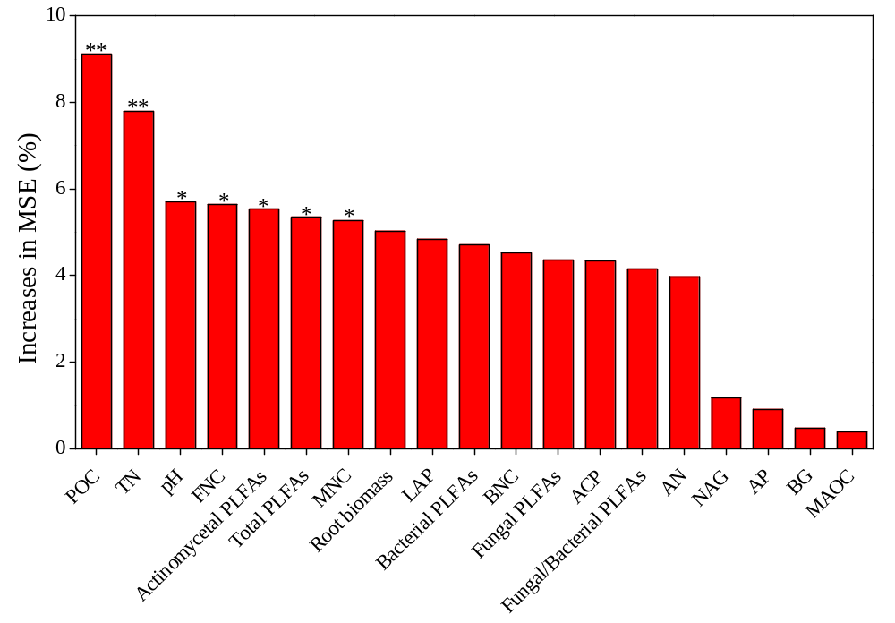
Figure S6. Relative importance of soil abiotic and biotic properties controlling soil organic carbon by the percentage increase of the mean squared error (%IncMSE) using Random Forest analysis. TN, total nitrogen; AN, available nitrogen; AP, available phosphorus; POC, particulate organic carbon; MAOC, mineral-associated organic carbon; MNC, microbial necromass carbon; NAG, β-N-acetyl-glucosaminidase; LAP, leucine aminopeptidase; BG, β-1, 4-glucosidase; ACP, acid phosphatase; PLFAs, phospholipid fatty acids. * P < 0.05, ** P < 0.01.

References:
Bian Q, Zhao L, Cheng K, Jiang Y, Li D, Xie Z, Sun B, Wang X (2024) Divergent accumulation of microbe- and plant-derived carbon in different soil organic matter fractions in paddy soils under long-term organic amendments. Agriculture Ecosystems & Environment 366:108934.
Chen J, Xiao W, Zheng C, Zhu B (2020) Nitrogen addition has contrasting effects on particulate and mineral-associated soil organic carbon in a subtropical forest. Soil Biology and Biochemistry 142:107708.
Chen Y, Liu X, Hou Y, Zhou S, Zhu B (2021) Particulate organic carbon is more vulnerable to nitrogen addition than mineral-associated organic carbon in soil of an alpine meadow. Plant and Soil 458:93-103.
Duan P, Wang K, Li D (2023) Nitrogen addition effects on soil mineral-associated carbon differ between the valley and slope in a subtropical karst forest. Geoderma 430:116357.
Fan Y, Yang L, Zhong X, Yang Z, Lin Y, Guo J, Chen G, Yang Y (2020) N addition increased microbial residual carbon by altering soil P availability and microbial composition in a subtropical Castanopsis forest. Geoderma 375:114470.
Hu J, Huang C, Zhou S, Liu X, Dijkstra FA (2022a) Nitrogen addition increases microbial necromass in croplands and bacterial necromass in forests: A global meta-analysis. Soil Biology and Biochemistry 165:108500.
Lavallee JM, Soong JL, Cotrufo MF (2020) Conceptualizing soil organic matter into particulate and mineral-associated forms to address global change in the 21st century. Global Change Biology 26:261-273.
Li J, Zhao J, Liao X, Hu P, Wang W, Ling Q, Xie L, Xiao J, Zhang W, Wang K (2024) Pathways of soil organic carbon accumulation are related to microbial life history strategies in fertilized agroecosystems. Science of the Total Environment 927:172191.
Li T, Yuan Y, Mou Z, Li Y, Kuang L, Zhang J, Wu W, Wang F, Wang J, Lambers H, Sardans J, Peñuelas J, Ren H, Liu Z (2022) Faster accumulation and greater contribution of glomalin to the soil organic carbon pool than amino sugars do under tropical coastal forest restoration. Global Change Biology 29, 533-546.
Ma T, Yang Z, Shi B, Gao W, Li Y, Zhu J, He, JS (2023) Phosphorus supply suppressed microbial necromass but stimulated plant lignin phenols accumulation in soils of alpine grassland on the Tibetan Plateau. Geoderma 431:116376.
Püspök JF, Zhao S, Calma AD, Vourlitis GL, Allison SD, Aronson EL, Schimel JP, Hanan EJ, Homyak PM (2022) Effects of experimental nitrogen deposition on soil organic carbon storage in Southern California drylands. Global Change Biology 29:1660-1679.
Schwalb SA, Hemkemeyer M, Christensen BT, Heinze S, Oliva RL, Joergensen RG, Wichern F (2024) Disentangling the effects of mineral fertiliser N, P and K on microbial biomass, necromass and ionome in soil from the Askov long-term field experiment. Soil Biology and Biochemistry 195:109449.
Sun T, Mao X, Han K, Wang X, Cheng Q, Liu X, Zhou J, Ma Q, Ni Z, Wu L (2023) Nitrogen addition increased soil particulate organic carbon via plant carbon input whereas reduced mineral−associated organic carbon through attenuating mineral protection in agroecosystem. Science of the Total Environment 899:165705.
Wang C, Wang X, Zhang Y, Morrissey E, Liu Y, Sun L, Qu L, Sang C, Zhang H, Li G, Zhang L, Fang Y (2023) Integrating microbial community properties, biomass and necromass to predict cropland soil organic carbon. ISME Communications 3:86.
Ye C, Chen D, Hall SJ, Pan S, Yan X, Bai T, Guo H, Zhang Y, Bai Y, Hu S, Reynolds H (2018) Reconciling multiple impacts of nitrogen enrichment on soil carbon: plant, microbial and geochemical controls. Ecology Letters 21:1162-1173.
Zeng XM, Feng J, Yu DL, Wen SH, Zhang Q, Huang Q, Delgado-Baquerizo M, Liu YR (2022) Local temperature increases reduce soil microbial residues and carbon stocks. Global Change Biololgy 28, 6433-6445.
Zhang J, Zhou J, Sayer EJ, Lambers H, Liu Z, Lu X, Li Y, Li Y, Li H, Wang F (2022) Nitrogen deposition enhances soil organic carbon and microbial residual carbon in a tropical forest. Plant and Soil 484, 217-235.
Zhao X, Tian P, Wang Q (2024) Roots have greater effects on the accumulation of soil microbial residue carbon in microaggregate fractions than leaf litter in a subtropical forest. Geoderma 442:116803.

