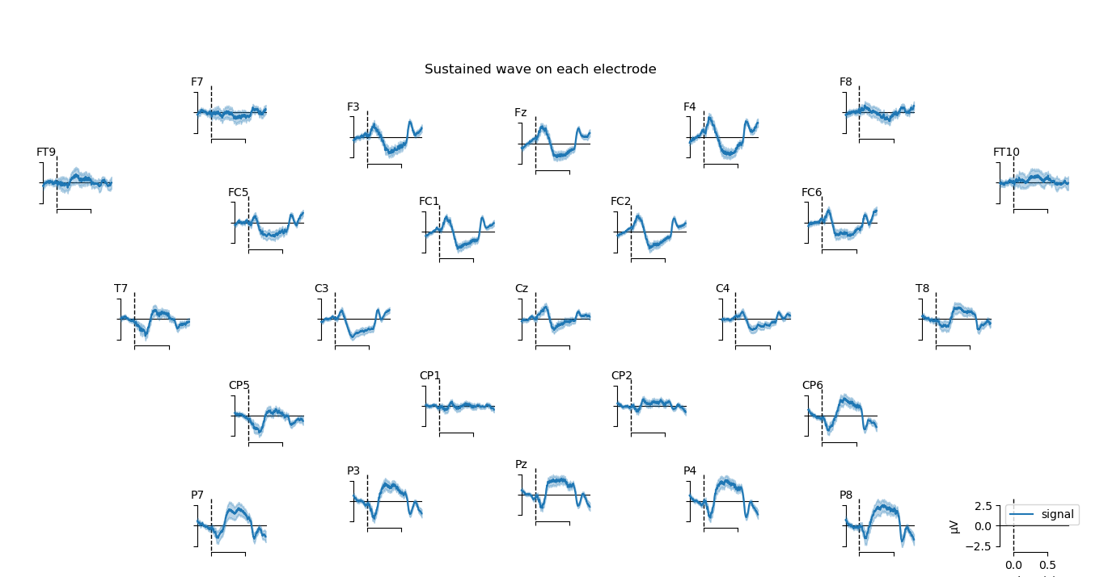
Fig. 1 Sustained wave on each site.

