Supplementary Figures for
Host phylogeny determines the gut microbial landscape of cephalopods

Woorim Kang,† Pil Soo Kim,† Euon Jung Tak, Hojun Sung, Na-Ri Shin, Dong-Wook Hyun, Tae Woong Whon, Hyun Sik Kim, June-Young Lee, Ji-Hyun Yun, Mi-Ja Jung and Jin-Woo Bae*

Department of Life and Nanopharmaceutical Sciences and Department of Biology, Kyung Hee University, Seoul 130-701, Korea

†These authors contributed equally to this study.
*Author for correspondence: Jin-Woo Bae. Tel.: +82 2 961 2312. Fax: +82 2 961 9155. E-mail: baejw@khu.ac.kr
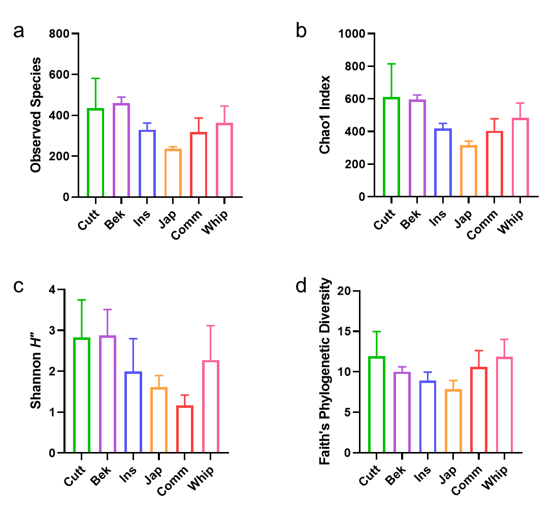
Supplementary Fig. S1. Alpha diversity indices of the cephalopod gut microbiota. (a) Number of observed species. (b) Chao1 index. (c) Shannon diversity. (d) Faith’s phylogenetic diversity.
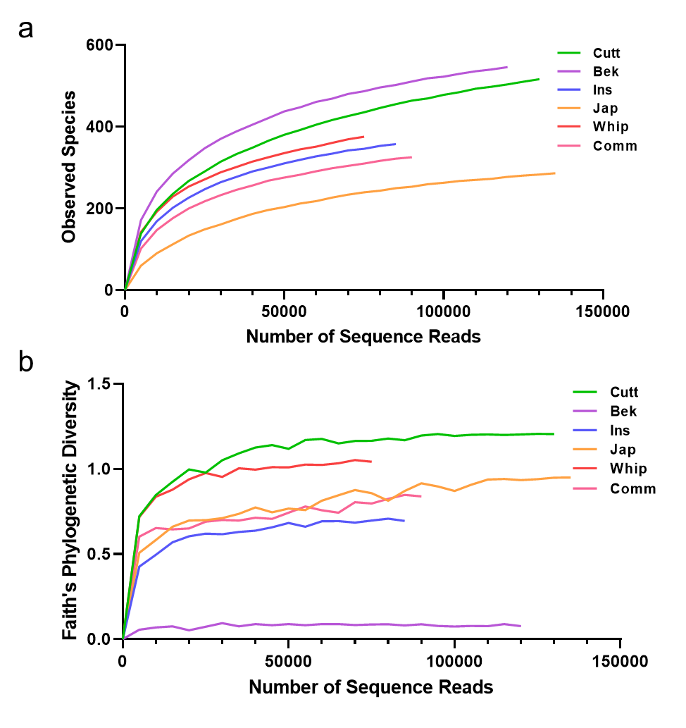
Supplementary Fig. S2. Rarefaction curves of the abundance-based coverage estimation against the cumulative number of identified OTUs. Coverage plots are generated with the number of observed species (a) and Faith’s phylogenetic diversity (b) for individual samples (a) and species (b). Line colors in rarefaction curves represent the host species.

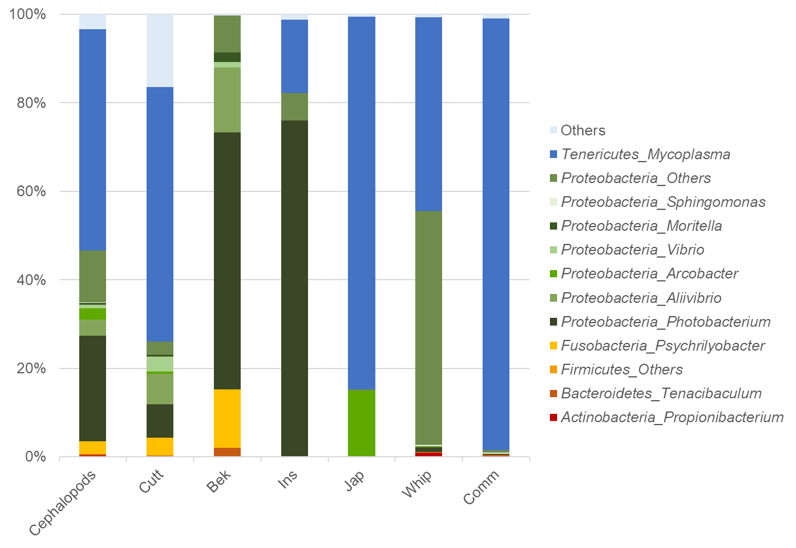
Supplementary Fig. S3. Gut microbial compositions of cephalopods. The bacterial community compositions are displayed at the genus level. Only genera with relative abundance > 0.5% are shown, and others are classified as "Others."

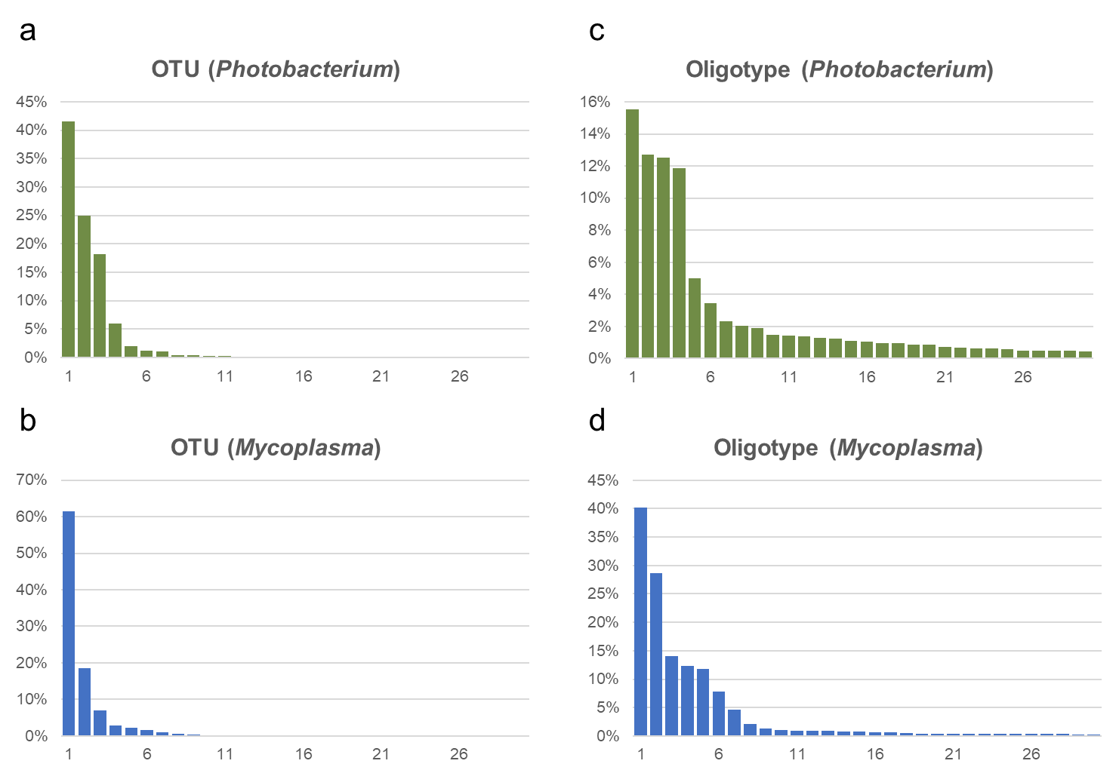
Supplementary Fig. S4. Distributions of Photobacterium and Mycoplasma OTUs and oligotypes in cephalopod gut microbiomes. The distributions of 97% clustered OTUs assigned to Photobacterium and Mycoplasma (a–b) are compared with re-clustered oligotypes, generated using the MED pipeline with aligned sequence reads that originally matched to Photobacterium and Mycoplasma by the QIIME 1.9.1 pipeline.

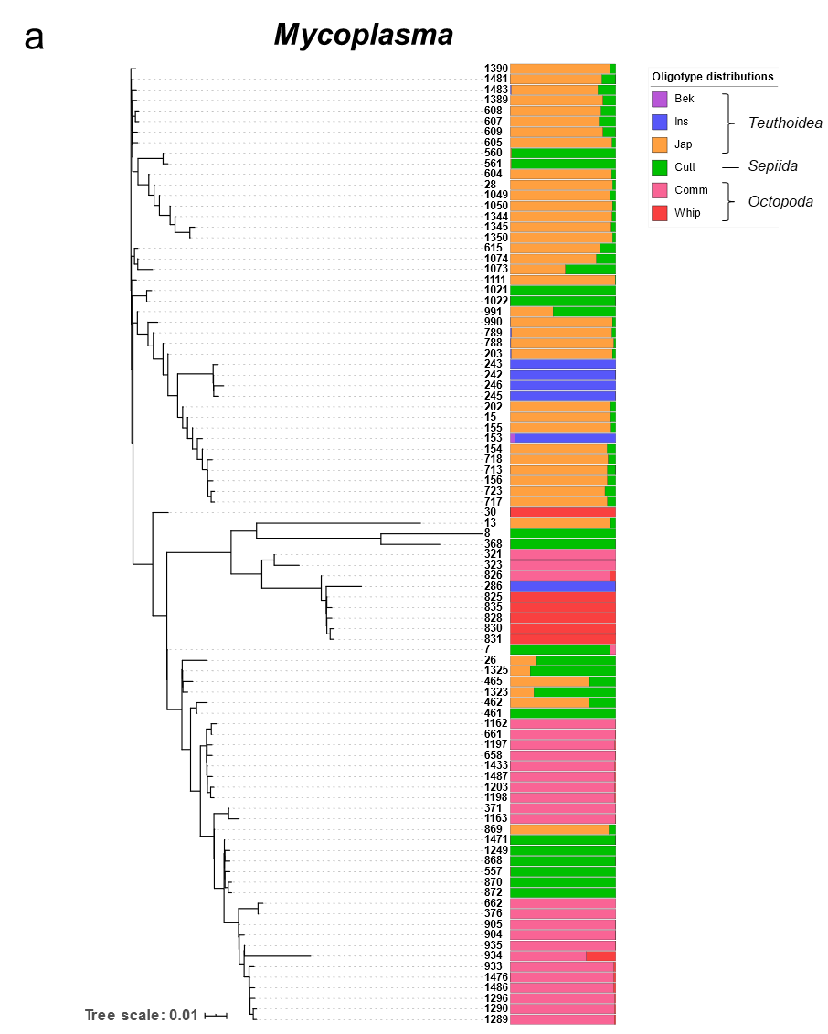

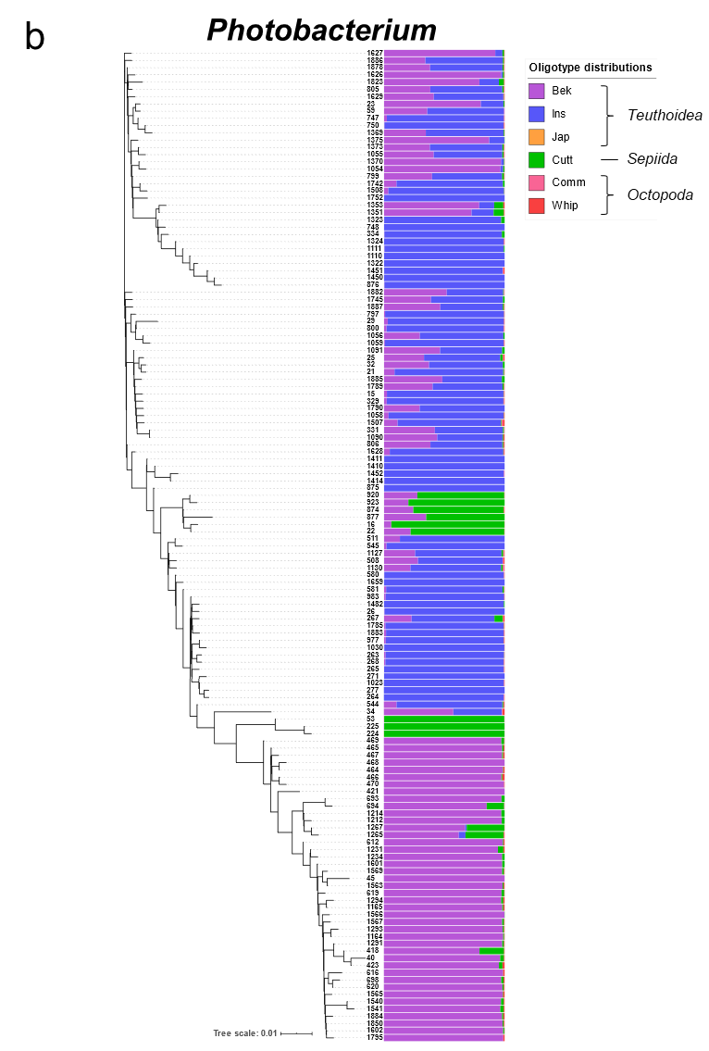

Supplementary Fig. S5. Phylogenetic tree of the genera Photobacterium and Mycoplasma based on oligotypes (maximum likelihood tree with 1000 bootstrap replicates and the GTR + Gamma model). Bar graphs are color coded to show the proportions of oligotypes assigned to Photobacterium (a) and Mycoplasma (b) in each cephalopod species.

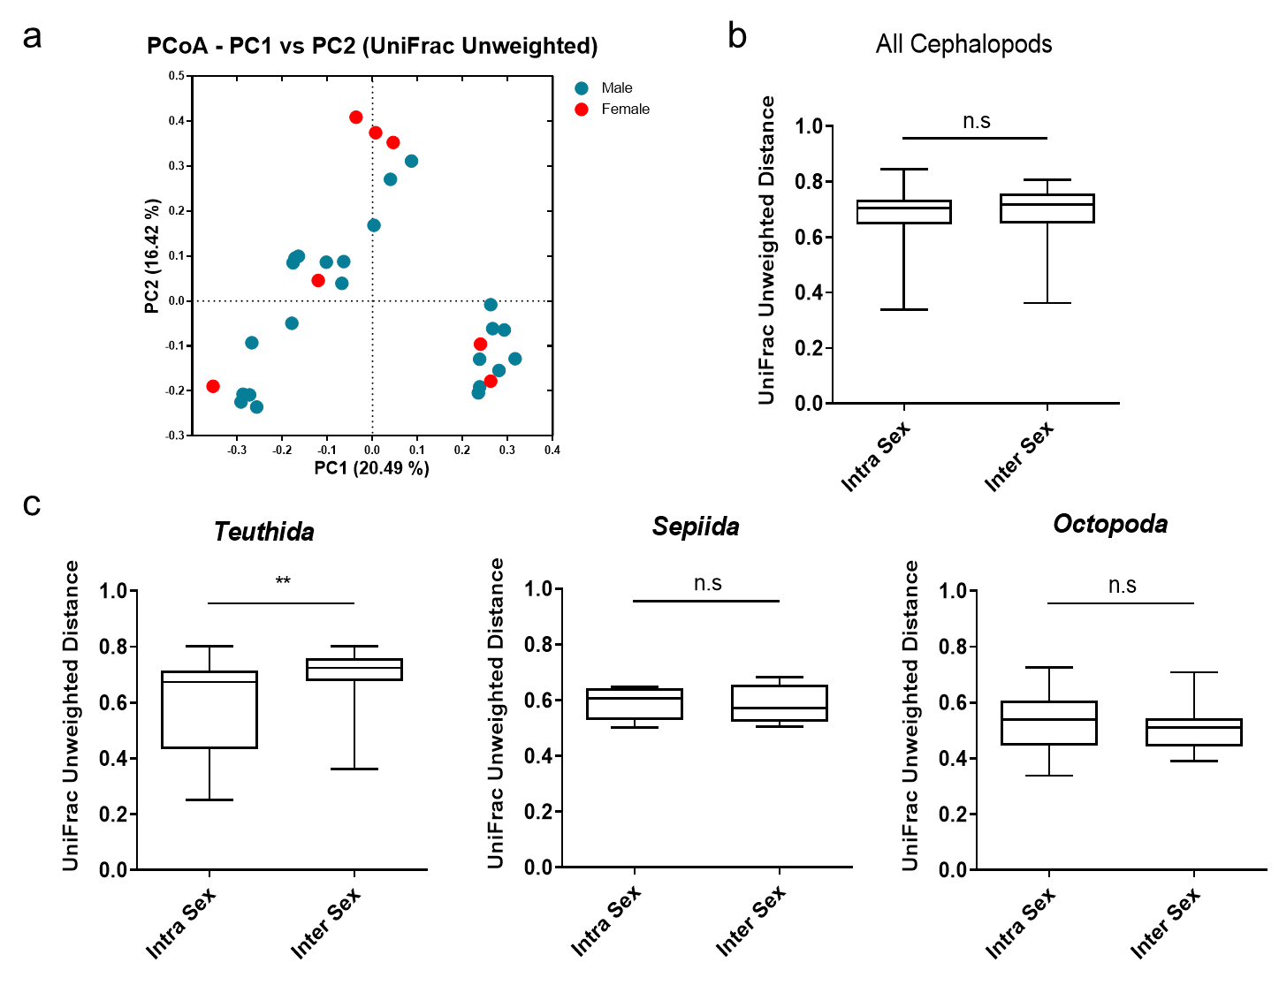
Supplementary Fig. S6. Effects of host sex on the gut microbiota of cephalopods. (a) PCoA of unweighted UniFrac distances between male and female cephalopod samples. The colors of dots represent the sex of host cephalopod species (ANOSIM, R = 0.07, p < 0.150; adonis, R² = 0.04, p < 0.250). (b–c) Comparisons of microbial similarities for all cephalopod members of the same sex and the opposite sex (b) and members belonging to Teuthida, Sepiida, and Octopoda of the same and opposite sex (c) based on unweighted UniFrac distances. Asterisks indicate significant differences between the unweighted UniFrac distances according to two-tailed Mann–Whitney U-tests. *p < 0.05, **p < 0.01; ***p < 0.001.

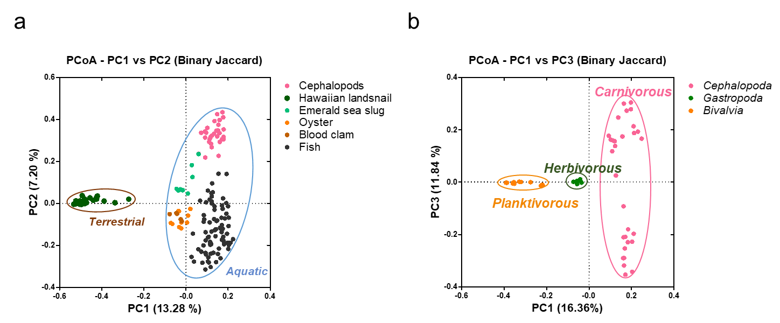
Supplementary Fig. S7. Environmental factors (habitat and dietary preference) shaping the gut microbiome in cephalopods. (a) PCoA of the binary Jaccard index for the gut microbiota of various mollusks (cephalopods, bivalves, and marine and terrestrial gastropods) and marine vertebrates (fishes) for a comparison of microbial structures between samples inhabiting different environments (terrestrial and aquatic). (b) PCoA of the binary Jaccard index for the gut microbiota of various mollusks for a comparison of microbial structures with dietary preferences (carnivory, herbivory and planktivory). The colors of dots and ellipses in PCoAs represent the host species and the respective features of the (a) habitat (terrestrial vs. aquatic; ANOSIM, R = 0.49, p < 0.001; adonis, R² = 0.05, p < 0.001) and (b) dietary preference (ANOSIM, R = 0.95, p < 0.001; adonis, R² = 0.14, p < 0.001).

