Linking Changes in Sulcal Morphology to Cognitive Development from Childhood to Adolescence

Supplemental Information
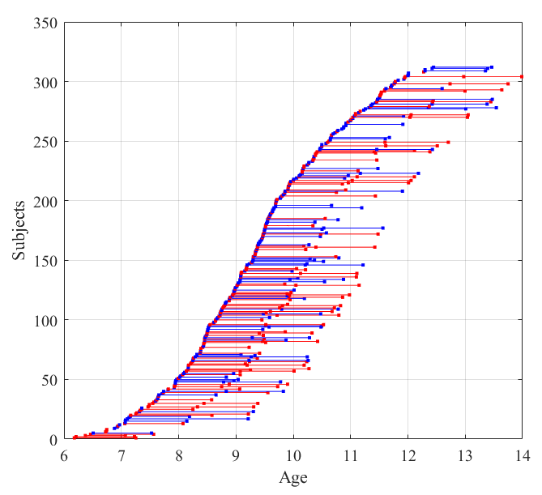
Supplementary Figure 1. Age and Gender Distribution of Participants.
Following data quality control, we utilized a longitudinal sMRI dataset composed of 312 typically developing children aged 6.1 to 13.9 years (F/M = 145/167) from the Childhood Brain Development Project (CBD, Beijing cohort). Among these children, some underwent repeated MRI scans every year, resulting in a total of 490 MRI scans. Specifically, 47 children (F/M = 31/16) had three available scans, 97 children (F/M = 49/48) had two available scans, and 168 children (F/M = 65/103) had one available scan. All participants were recruited from elementary schools in Beijing and were confirmed to have normal cognitive abilities according to a well-validated standardized cognitive assessment in Mandarin¹.

Supplementary Table 1. Definitions and categorization of sulci in the present study
No. | Full Name | Abbreviation | Categorization | Lobes
1 | callosal sulcus | S.Call. | primary | Frontal
2 | olfactory sulcus | S.Olf. | primary | Frontal
3 | calloso-marginal fissure | F.C.M. | primary | Frontal
4 | orbital sulcus | S.Or. | primary | Frontal
5 | precentral sulcus | S.Pe.C. | primary | Frontal
6 | superior frontal sulcus | S.F.sup. | primary | Frontal
7 | inferior frontal sulcus | S.F.inf. | primary | Frontal
8 | calcarine fissure | F.Cal.ant.-Sc.Cal. | primary | Occipital
9 | parieto-occipital fissure | F.P.O. | primary | Occipital
10 | postcentral sulcus | S.Po.C. | primary | Parietal
11 | intraparietal sulcus | F.I.P. | primary | Parietal
12 | superior temporal sulcus | S.T.s. | primary | Temporal
13 | collateral fissure | F.Coll. | primary | Temporal
14 | inferior temporal sulcus | S.T.i. | primary | Temporal
15 | lateral fissure | F.C.L. | primary
16 | central sulcus | S.C. | primary
17 | intermediate frontal sulcus | S.F.inter. | secondary/teritary | Frontal
18 | marginal frontal sulcus | S.F.marginal. | secondary/teritary | Frontal
19 | orbital frontal sulcus | S.F.orbitaire. | secondary/teritary | Frontal
20 | cuneal sulcus | S.Cu. | secondary/teritary | Occipital
21 | posterior intralingual sulcus | S.Li.post. | secondary/teritary | Occipital
22 | internal parietal sulcus | S.Pa.int. | secondary/teritary | Occipital
23 | secondary intermediate ramus of the intraparietal sulcus | F.I.P.r.int.2 | secondary/teritary | Parietal
24 | anterior intralingual sulcus | S.Li.ant. | secondary/teritary | Parietal
25 | transverse parietal sulcus | S.Pa.t. | secondary/teritary | Parietal
26 | sub-parietal sulcus | S.s.P. | secondary/teritary | Parietal
27 | occipito-temporal lateral sulcus | S.O.T.lat. | secondary/teritary | Temporal
28 | anterior terminal ascending branch of the superior temporal sulcus | S.T.s.ter.asc.ant. | secondary/teritary | Temporal
29 | posterior terminal ascending branch of the superior temporal sulcus | S.T.s.ter.asc.post. | secondary/teritary | Temporal
30 | ascending ramus of the lateral fissure | F.C.L.r.asc. | secondary/teritary
31 | retro central transverse ramus of the lateral fissure | F.C.L.r.retroC.tr. | secondary/teritary
32 | central sylvian sulcus | S.C.sylvian. | secondary/teritary
Supplementary Methods 1：Sulcus Categorization
Our primary reference for determining the sequence of sulcus onset was the seminal study by ². This study meticulously examined multiple gross photographs of 507 whole brains and 207 brain slices from infants who died before 44 gestational weeks (GW). It documented the developmental timing of the major sulci and fissures throughout the entire brain. Other referenced studies include the MRI imaging of 173 normal fetuses between 22 and 38 gestational weeks (GW) conducted by ³, as well as the analysis of postnatal magnetic resonance images of 35 preterm infants by ⁴. In conjunction with these studies, cerebral sulci formed before 33 gestational weeks (GW) were classified as primary sulci, while those that appeared later were categorized as secondary and tertiary sulci. The developmental order of sulci was summarized based on each reference, and the specific classifications employed in this study are detailed in TableS1 (left hemisphere only). Segments belonging to the same sulcus were merged, which included the summation of the anterior and posterior rami of the lateral fissure, as well as the integration of the various branches of the precentral and postcentral sulci. Table S1 shows that 16 primary sulci and 16 secondary/tertiary sulci were ultimately selected for subsequent research and the corresponding brain lobes for these sulci.

Supplementary Methods 2：
Outliers are detected using the Local Outlier Factor (LOF) method⁵, which is predicated on the principle that the local density of a point in high-dimensional space is compared to the densities of its surrounding points.
According to the LOF method, if the local density of a point is significantly smaller than that of its neighbors, resulting in a LOF value greater than 1, the point is considered to be in a relatively sparse region relative to its surrounding points, thereby identifying it as an outlier. In our implementation, we specified the number of neighbors as 10 and set the contamination level indicating the expected proportion of outliers in the data to 0.05.

References
1. Fan, F. et al. Development of the default-mode network during childhood and adolescence: A longitudinal resting-state fMRI study. NeuroImage 226, 117581 (2021).
2. Chi, J. G., Dooling, E. C. & Gilles, F. H. Gyral development of the human brain. Ann. Neurol. 1, 86–93 (1977).
3. Garel, C. et al. Fetal Cerebral Cortex: Normal Gestational Landmarks Identified Using Prenatal MR Imaging. Ajnr Am. J. Neuroradiol. 22, 184–189 (2001).
4. Dubois, J. et al. Mapping the early cortical folding process in the preterm newborn brain. Cerebral Cortex (New York, N.Y.: 1991) 18, 1444–1454 (2008).
5. Breunig, M. M., Kriegel, H.-P., Ng, R. T. & Sander, J. LOF: Identifying Density-Based Local Outliers.

