Supplementary Figure
- Figure S1
- Figure S2
- Figure S3
- Figure S4
- Figure S5
- Figure S6
- Figure S7
- Figure S8
- Figure S9
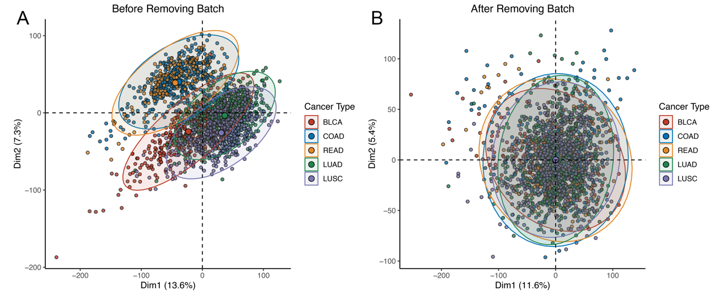
Figure S1. Principal component analysis of transcriptome expression profiles before and after batch effect removal.

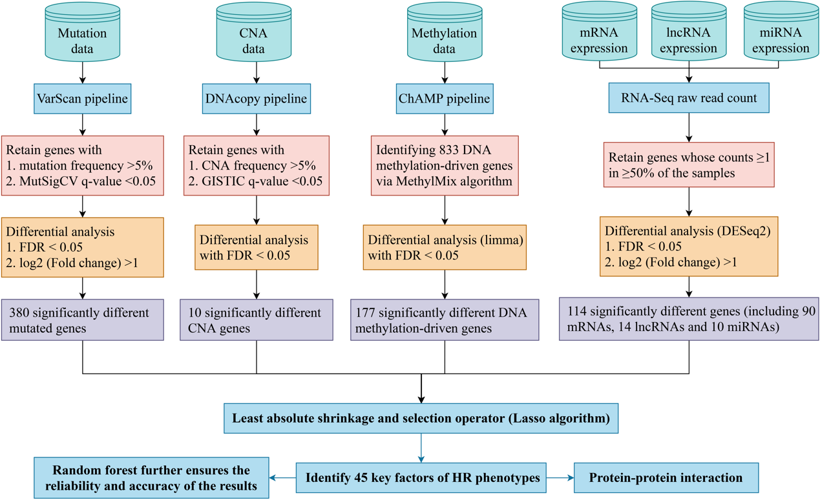
Figure S2. The pipeline to identify key multi-omics events regarding the HR phenotypes.

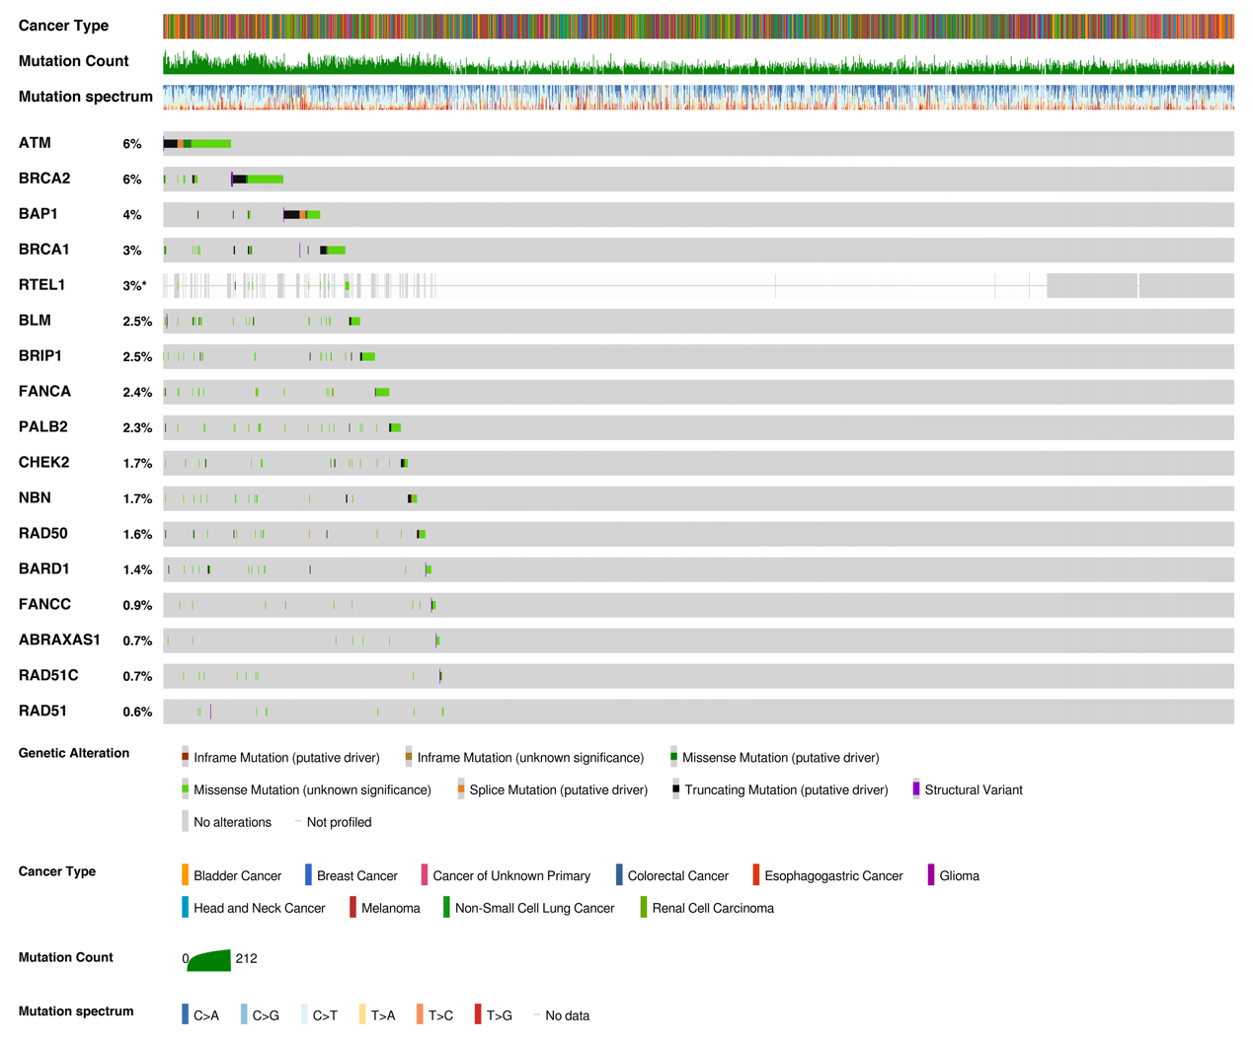
Figure S3. Mutational landscape of 17 HR genes in MSK ICI cohort.

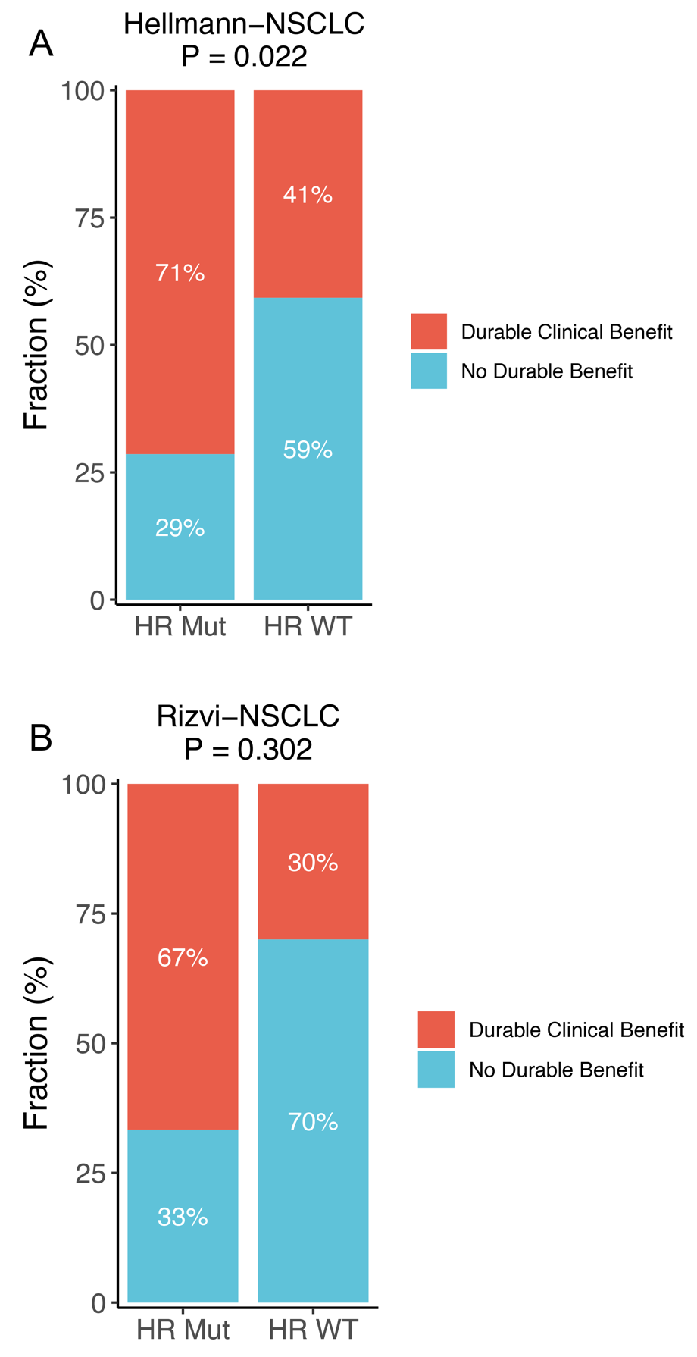
Figure S4. The proportion of DCB in the HR-Mut and HR-WT phenotypes in Hellmann-NSCLC and Rizvi-NSCLC cohorts.

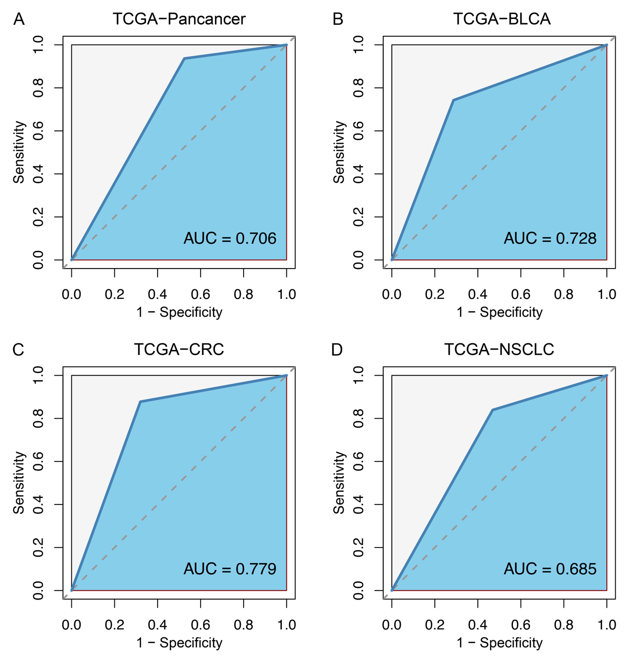
Figure S5. ROC curves of HR mutations to predict higher TMB in TCGA-pan-cancer, TCGA-BLCA, TCGA-CRC, and TCGA-NSCLC.

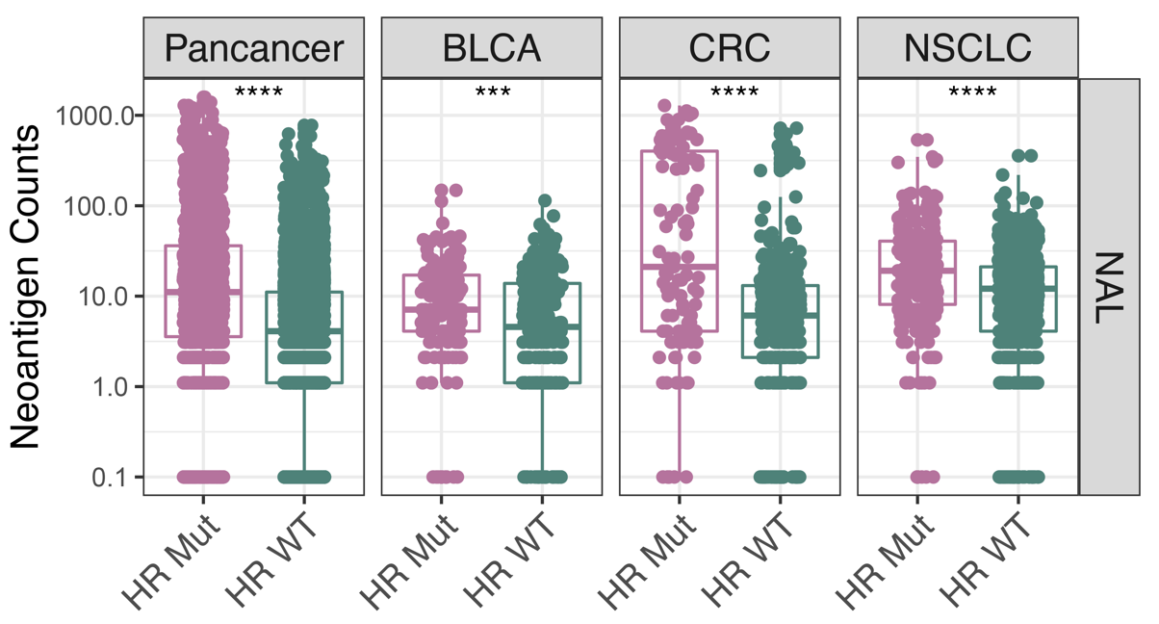
Figure S6. Comparison of NAL between the HR-Mut and HR-WT phenotypes in TCGA-pan-cancer, TCGA-BLCA, TCGA-CRC, and TCGA-NSCLC.
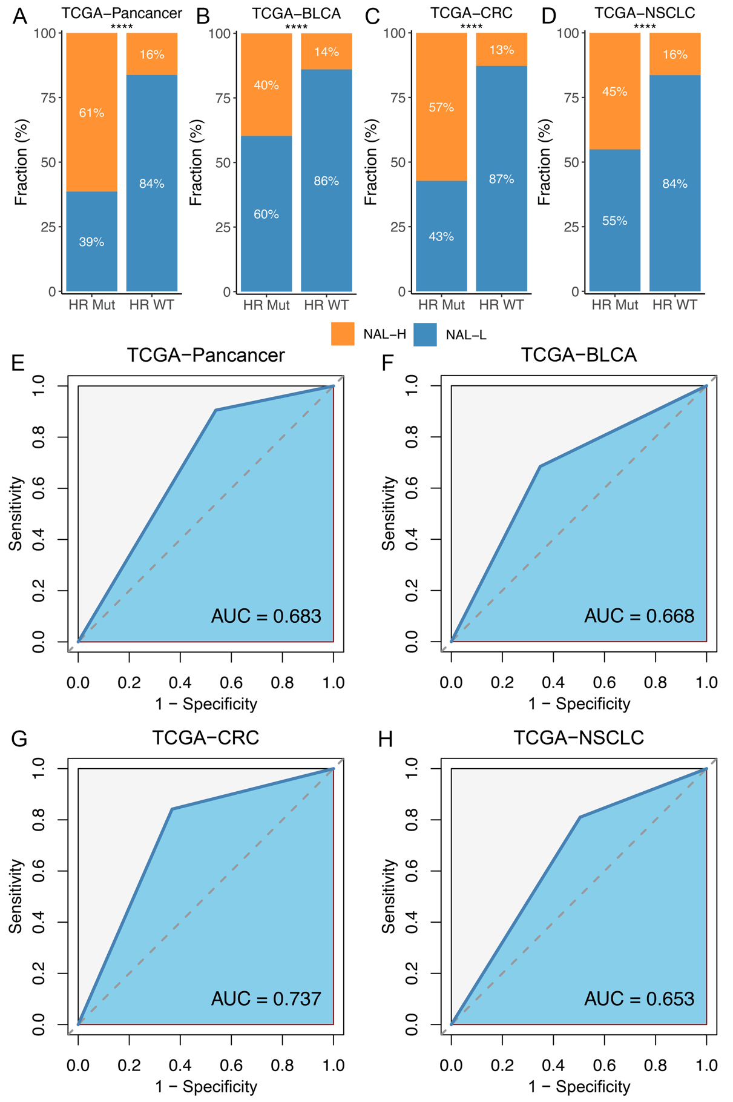
Figure S7. The association between HR mutations and NAL. A-D. The proportion of NAL-high and NAL-low in the HR-Mut and HR-WT phenotypes in TCGA-pan-cancer (A), TCGA-BLCA (B), TCGA-CRC (C), and TCGA-NSCLC (D). E-H. ROC curves of HR mutations to predict higher NAL in TCGA-pan-cancer (E), TCGA-BLCA (F), TCGA-CRC (G), and TCGA-NSCLC (H). ****P <0.0001.

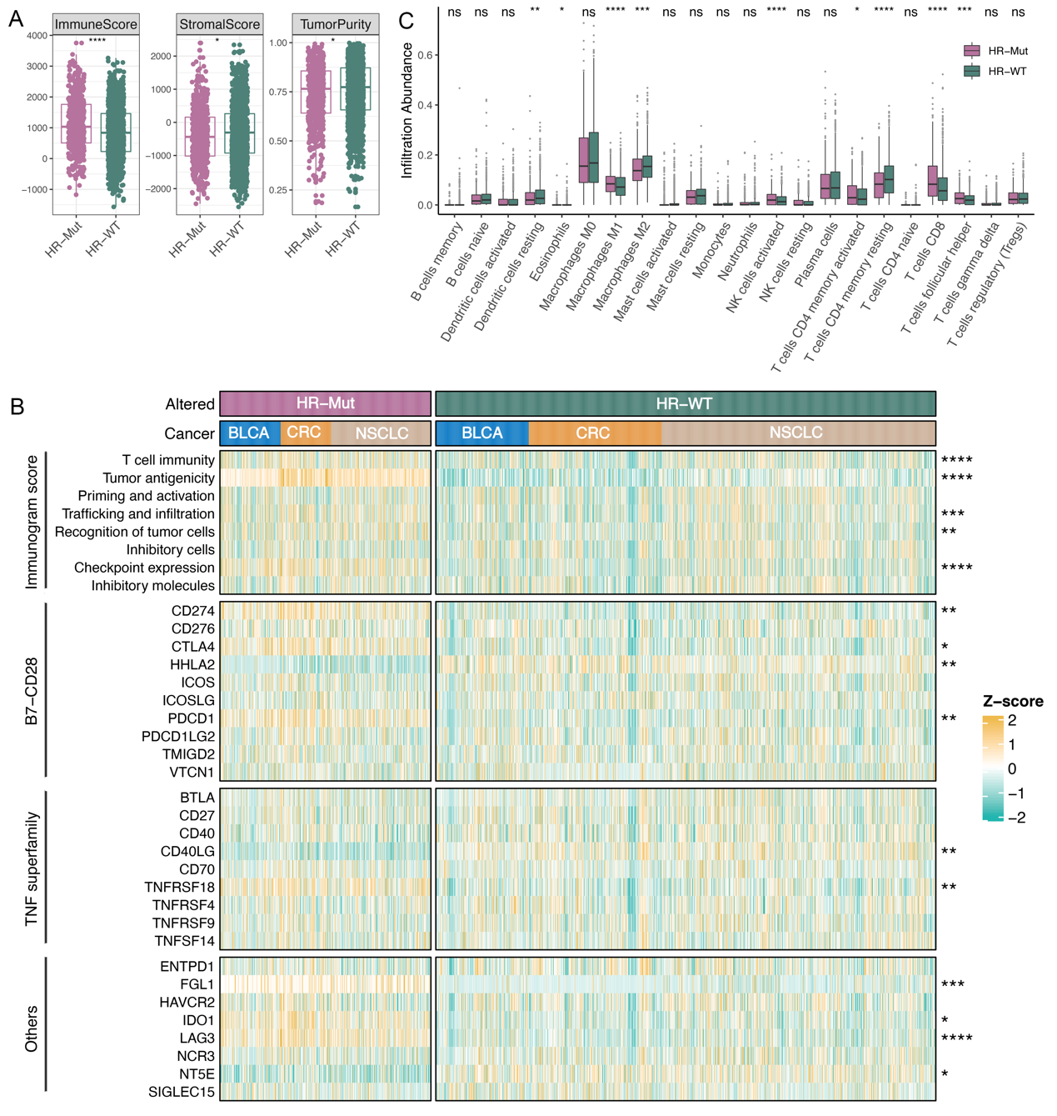
Figure S8. TME and immunity characterization of the HR phenotypes. A. Comparison of immune, stromal score, and tumor purity between the HR-Mut and HR-WT phenotypes. B. Heatmap of 8 immunogram scores and 27 immune checkpoint molecules between the HR-Mut and HR-WT phenotypes. C. Differences in the distribution of 22 immune cells infiltration between two phenotypes. ^{ns}P >0.05, *P <0.05, **P <0.01, ***P <0.001, ****P <0.0001.

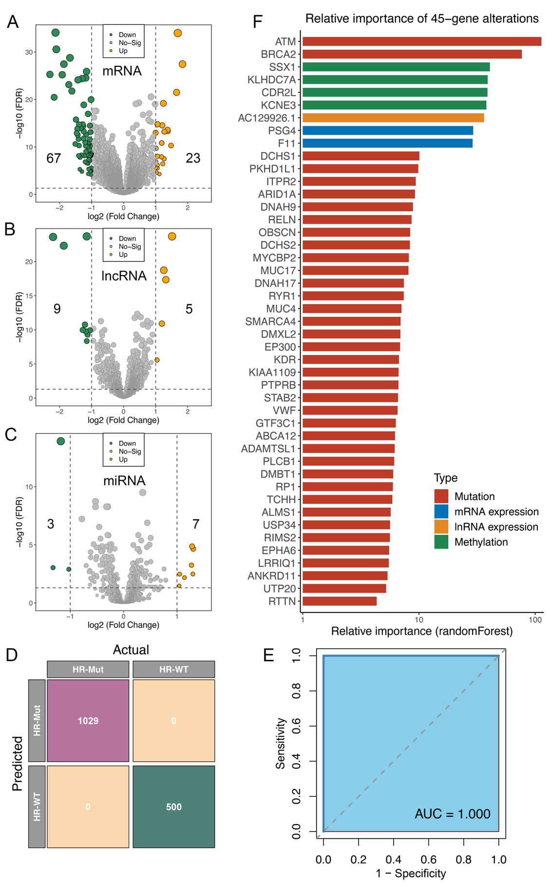
Figure S9. Identification of multi-omics alteration events in the HR phenotypes. A-C. Volcanos of differentially expressed mRNA, lncRNA, and miRNA between two phenotypes. D. Confusion matrix of the random forest model shows that all the classification results are correct. E. ROC curve of the random forest model.

