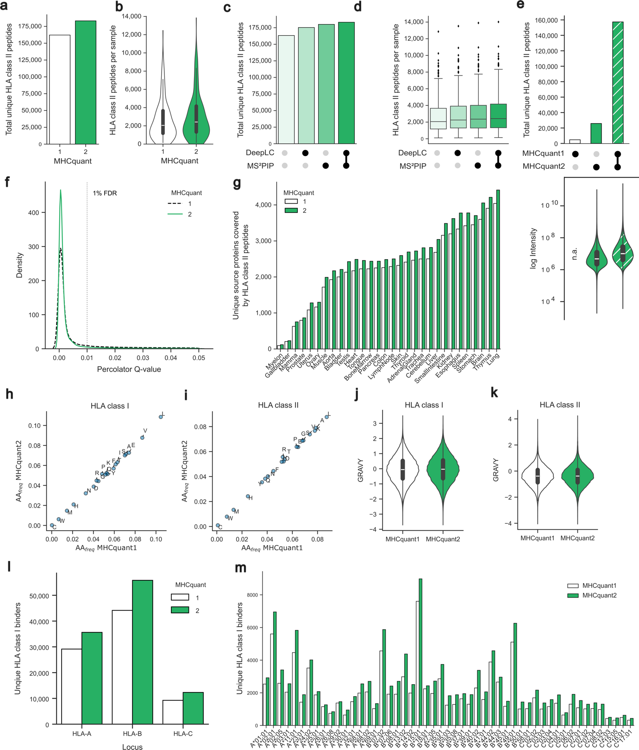
Supplementary Fig. 1 | HLA class II benchmark of MHCquant1 and MHCquant2. The benchmark was conducted using the HLA Ligand Atlas. a Total number of unique HLA class II-presented peptides and b distribution per sample identified in MHCquant1 and MHCquant2. c Total number of unique HLA class II peptides across all samples and d distribution per sample identified with and without using the feature generators DeepLC, MS²PIP, and their combination. Boxplots indicate the first to third quartile. Whiskers are defined as 1.5*IQR (interquartile range) from the first to third quartile. e UpSet plot of total unique HLA class II-presented peptides identified by MHCquant1 and MHCquant2 shown at the top and their respective peptide intensity distribution displayed as a violin plot at the bottom. The inner box of the violin plot depicts the median, first, and third quartile of the distribution. g Unique source proteins of HLA class II-presented peptide per tissue. h Amino acid frequency of HLA class I binder and i HLA class II-presented peptides identified by MHCquant1 and MHCquant2. j Violinplot of GRAVY score distribution of HLA class I binders and k HLA class II-presented peptides. l Peptide-HLA class I annotation by the lowest rank of NetMHCpan 4.1 per locus and m allele. Abbreviations: GRAVY: grand average of hydropathy; HLA: Human leukocyte antigen.

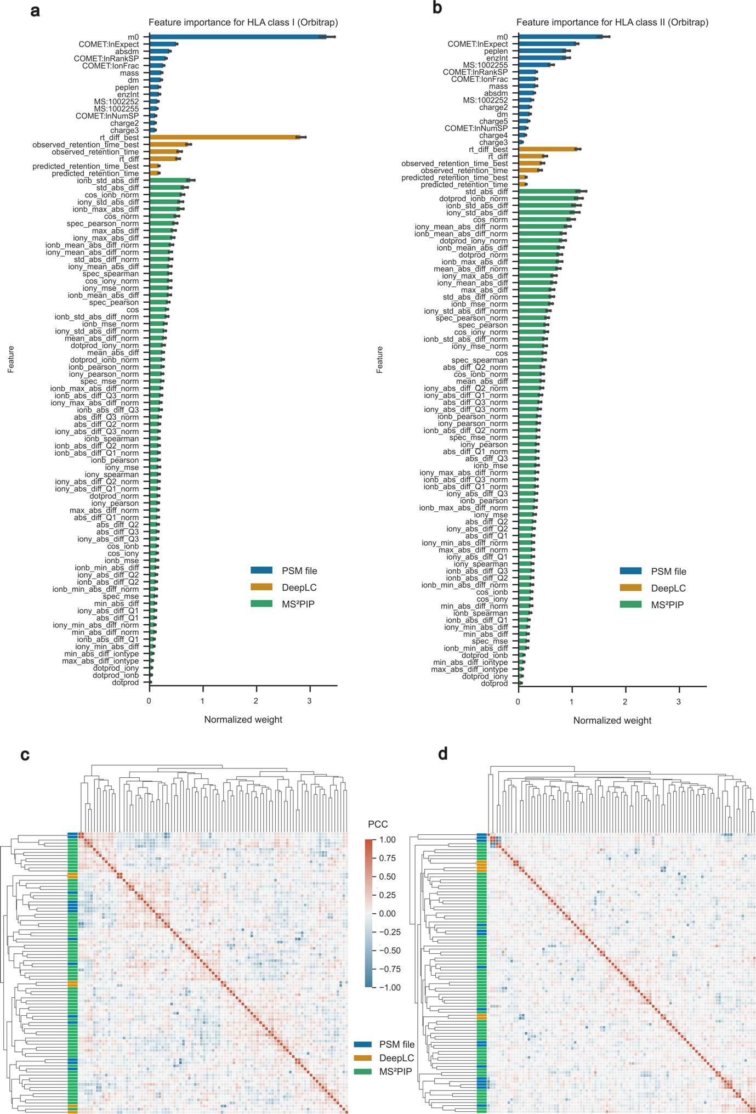
Supplementary Fig. 2 | Percolator feature weight analysis. All data was generated using the HLA Ligand Atlas dataset. a Barplot of normalized feature weights per MS run according to the Comet (PSM file), DeepLC, and MS²PIP for HLA class I and b HLA class II. Each bar is presented with a 95% confidence interval error bar for the mean of each feature. c Hierarchical clustering of Pearson correlation coefficient (PCC) of normalized feature weights per MS run according to Comet (PSM file) DeepLC, and MS²PIP for HLA class I and d HLA class II. Abbreviations: PSM: Peptide-Spectrum match; HLA: Human leukocyte antigen.

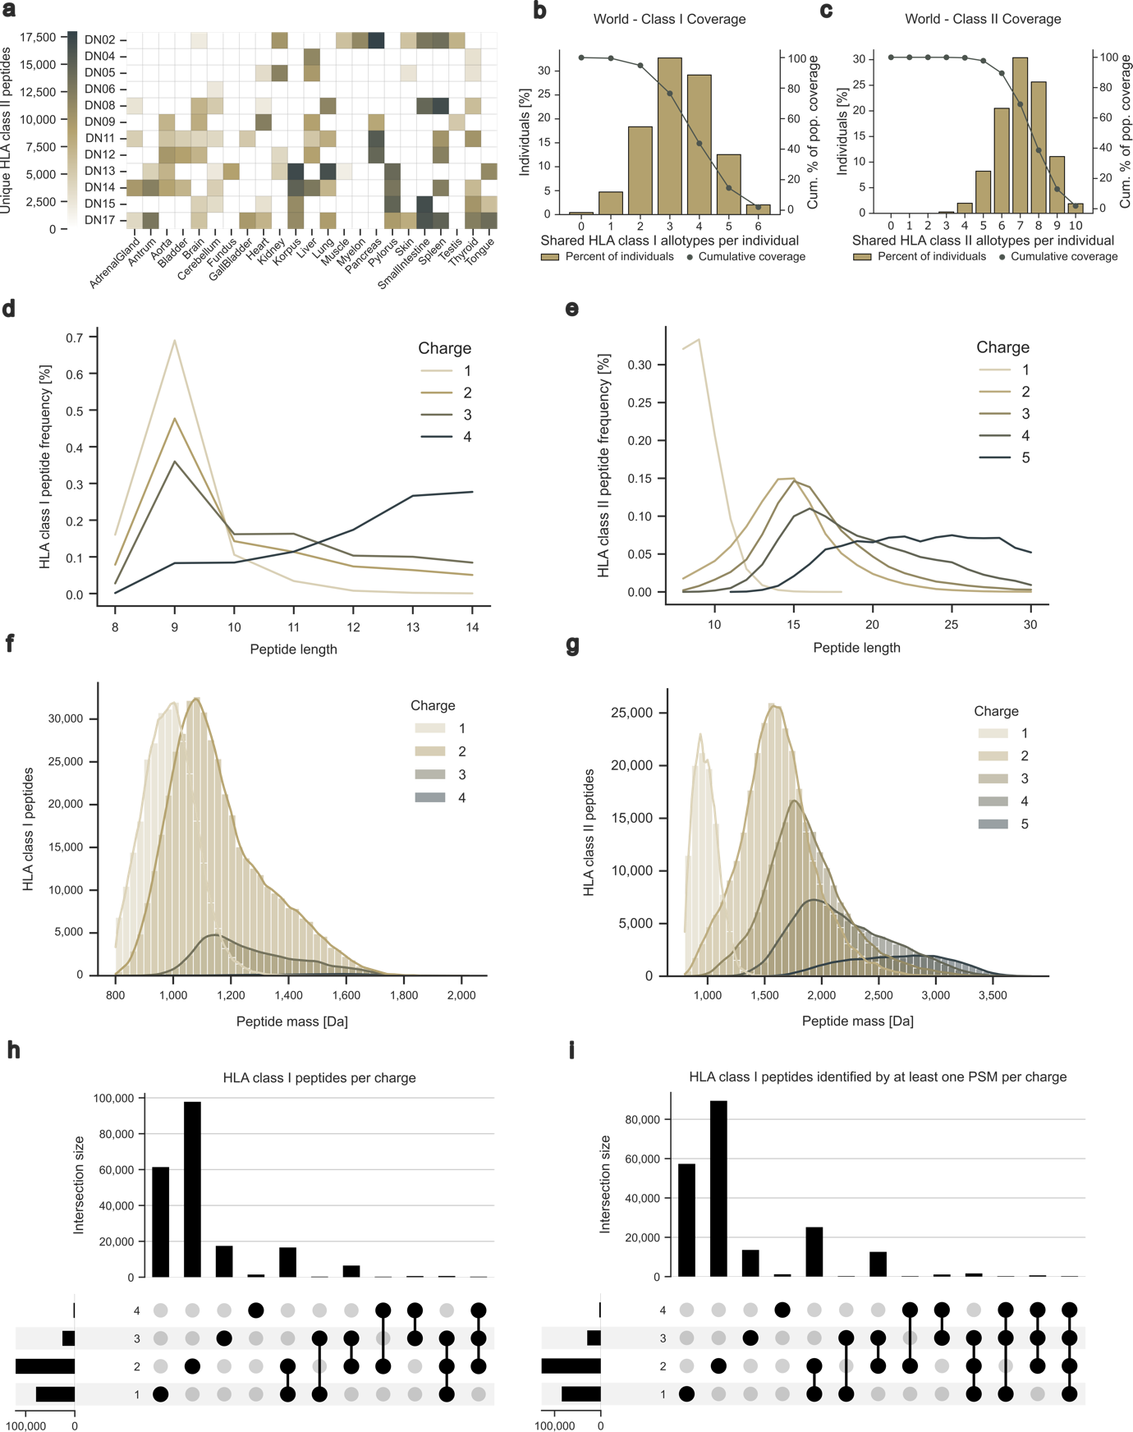
Supplementary Fig. 3 | Characterization of benign_{MHCquant2} dataset. a Sample overview and HLA class II-presented peptide yield. b Population coverage of the HLA class I and c HLA class II allotypes of the benign_{MHCquant2} dataset cohort compared to the world population determined by the IEDB population coverage tool. Frequencies of individuals within the world population carrying up to 6 HLA class I and 10 HLA class II allotypes (x-axis) are indicated as bars on the left y-axis. The cumulative percentage of population coverage is depicted as dots on the right y-axis.
d Length distribution of HLA class I- and e HLA class II-presented peptides according to charge states. f Histogram of mass distribution in Dalton paired with a kernel density estimation of HLA class I- and g HLA class II-presented peptides. h UpSet plot of HLA class I peptide charge states using peptide-level FDR and i using PSM-level FDR, where at least one PSM per charge was identified. Abbreviations: IEDB: Immune Epitope Database; FDR: false-discovery rate; PSM: peptide-spectrum match; HLA: Human leukocyte antigen.
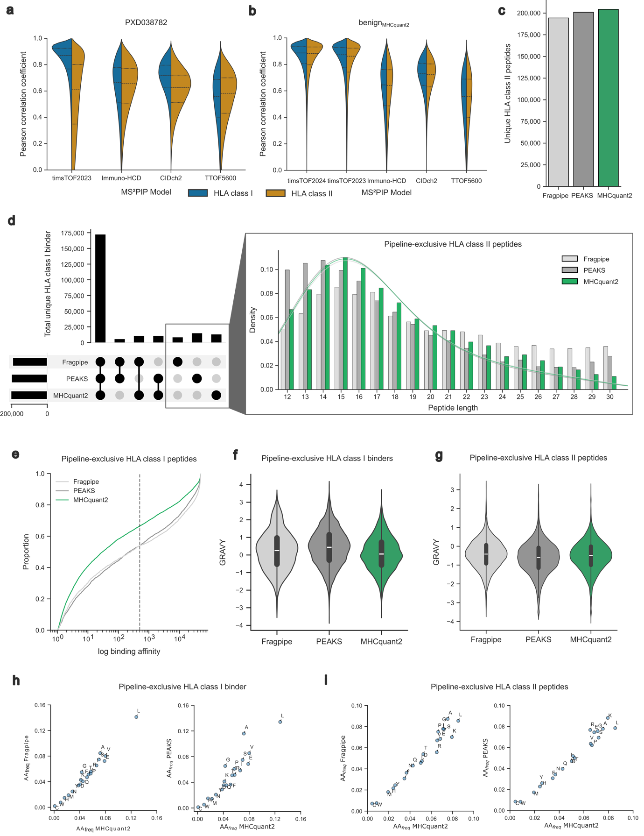
Supplementary Fig. 4 | MS²PIP model evaluation and HLA class II immunopeptidome benchmark of MHCquant2, FragPipe, and PEAKS. a Pearson correlation of experimental and predicted peak intensities of the Hoenisch Gravel et al. dataset (PXD038782) and b of the benign_{MHCquant2} including the timsTOF20204 model. c Total number of unique HLA class II peptides of the benign_{MHCquant2} dataset identified by FragPipe, PEAKS, and MHCquant2. d UpSet plot of intersection size between identified HLA class II-presented peptides identified by FragPipe, PEAKS, and MHCquant2. Length distribution of pipeline-exclusive (bar) and total (line) HLA class II-presented peptides. e Cumulative density plot of NetMHCpan binding affinity for pipeline-exclusive HLA class I peptides. The IC50 threshold smaller or equal to 500 defining a binder is indicated by the vertical line. f Violinplot depicting the GRAVY score distribution of pipeline-exclusive HLA class I binders and g HLA class II-presented peptides. h Amino acid frequency of pipeline-exclusive HLA class I binders comparing MHCquant2 with FragPipe and PEAKS, respectively. i Amino acid frequency of pipeline-exclusive HLA class II-presented peptides comparing MHCquant2 with FragPipe and PEAKS, respectively. Abbreviations: GRAVY: grand average of hydropathy; IC50: Half-maximal inhibitory concentration; HLA: Human leukocyte antigen.
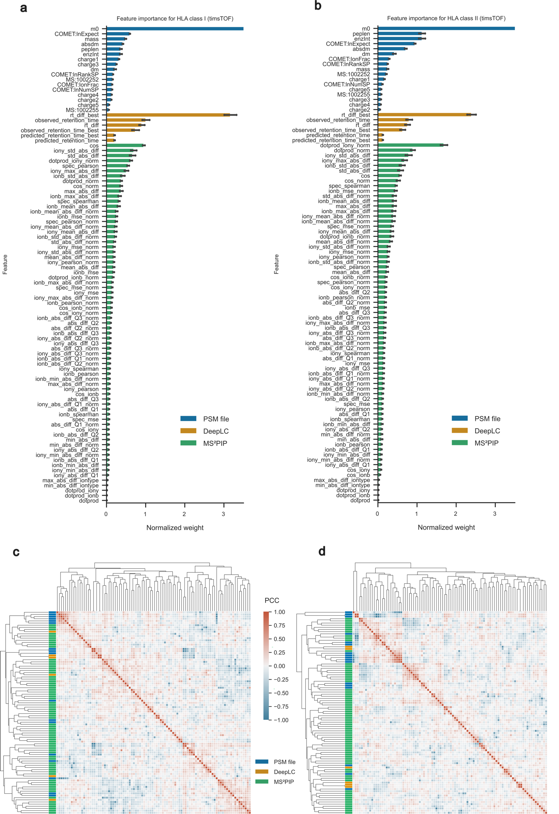
Supplementary Fig. 5 | Percolator feature weight analysis with the benign_{MHCquant2} dataset . a Barplot of normalized feature weights per MS run according to the Comet (PSM file), DeepLC, and MS²PIP for HLA class I and b HLA class II. Each bar is presented with a 95% confidence interval error bar for the mean of each feature. c Hierarchical clustering of Pearson correlation coefficient (PCC) of normalized feature weights per MS run according to Comet (PSM file) DeepLC, and MS²PIP for HLA class I and d HLA class II. Abbreviations: PSM: Peptide-Spectrum match; HLA: Human leukocyte antigen.

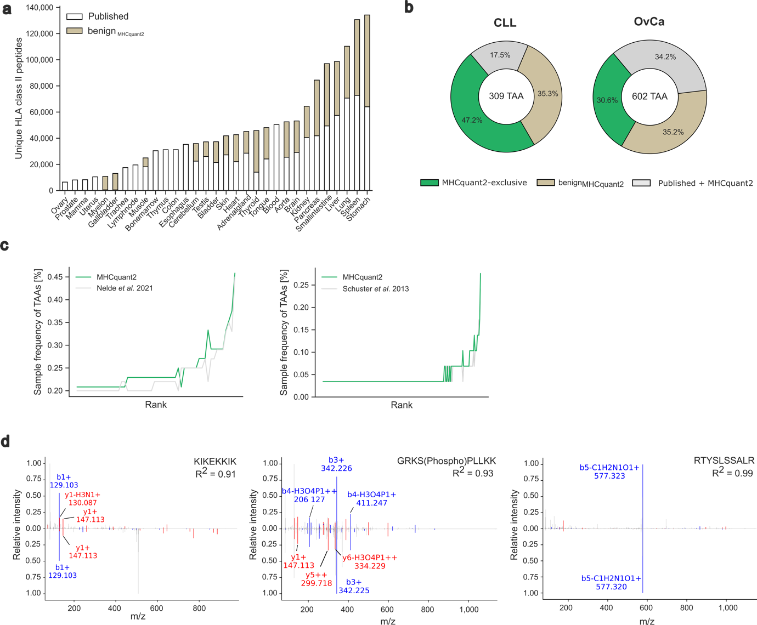
Supplementary Fig. 6 | Refined tumor-associated antigen discovery using MHCquant2.
a Stacked bar plots showing the contribution of benign_{MHCquant2} HLA class II peptides to previous datasets according to primary tissue origin. b Comparison of published TAAs of CLL and OvCa with re-analyzed TAAs by MHCquant2 and TAAs now identified in new benign datasets. TAAs were defined according to the published filter criteria. c Sample frequency of shared HLA class II TAAs proposed by public studies and identified by MHCquant2 for CLL and OvCa. TAAs are ranked according to sample frequency. d Mass-spectrometric neoantigen validation shown as mirror plots of experimentally eluted and synthetically validated spectra of GRKS(Phospho)PLLKK (ENST00000369367 P383S, ENST00000465950 P68S, ENST00000549162 P191S), KIKEKKIK (ENST00000518476 E304K, ENST00000620844 E160K), RTYSLSSALR (ENST00000224237 G41S) of three of the six newly detected neoepitopes in the melanoma dataset by MHCquant2. Abbreviations: TAA: tumor-associated antigen CLL: chronic lymphatic leukemia, OvCa: ovarian carcinoma; HLA: Human leukocyte antigen.

