Figure S1: Risk of bias graph (Red=high risk; yellow=unclear; green=low risk)
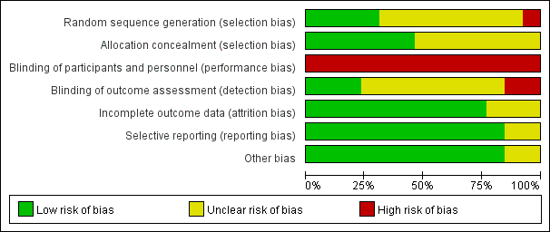

Figure S2: Risk of bias summary (Red=high risk; yellow=unclear; green=low risk)
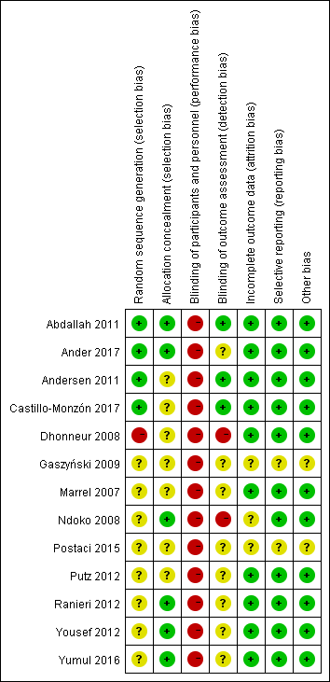

Figure S3: Funnel plot for the successful intubation rate on the first attempt in the pairwise meta-analysis
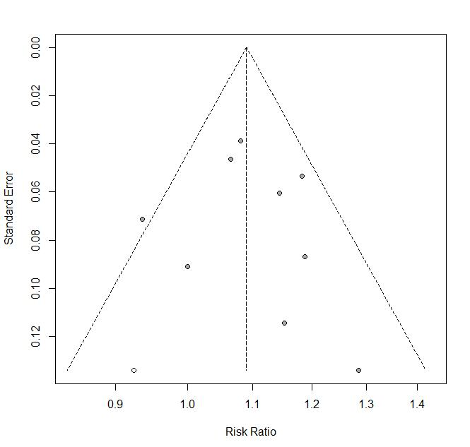

Figure S4: Funnel plot for intubation time in the pairwise meta-analysis
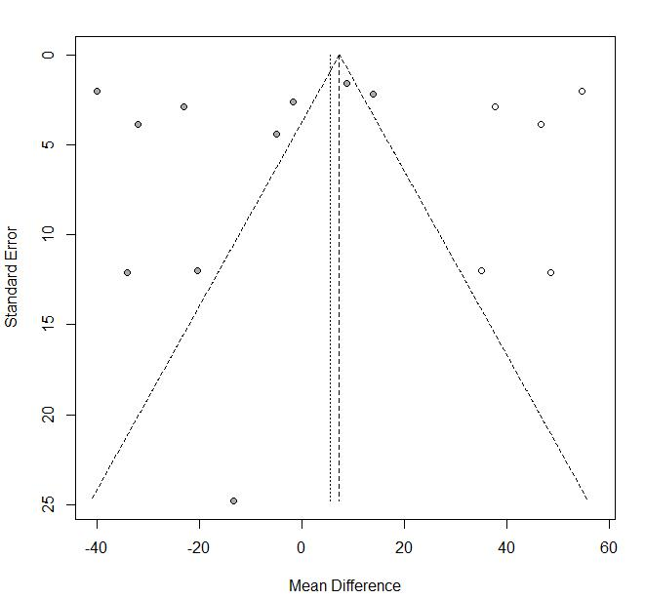

Figure S5: Funnel plot for glottos view in the pairwise meta-analysis
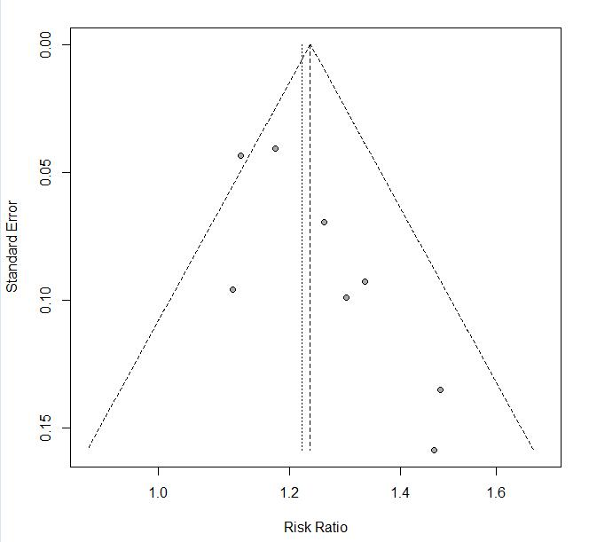

Figure S6: Funnel plot for the incidence of any complications in the pairwise meta-analysis.
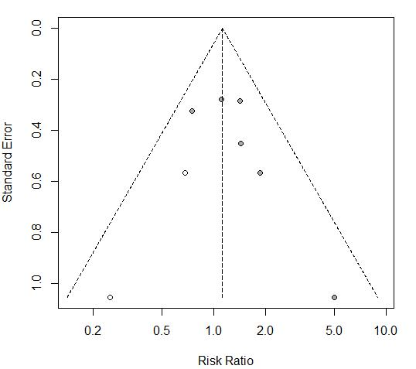

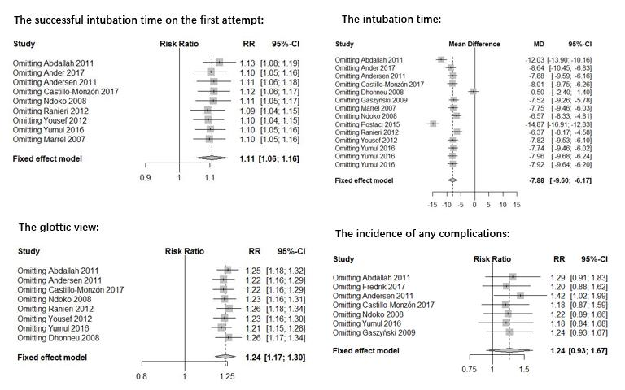
Figure S7: Sensitivity analysis for each outcome in the pairwise meta-analysis.

Figure S8: The network of eligible comparisons for efficacy and probability ranking based on simulations in terms of the successful intubation on the first attempt (a, b), intubation time (c, d), glottic view (e, f) and the incidence of any complications (g, h). The width of the lines is proportional to the number of direct comparisons, and the size of every circle is proportional to the number of individuals randomized to each intervention. (A=Macintosh blade video laryngoscopes, B=angulated blade video laryngoscopes, C=side-channel blade video laryngoscopes, D=conventional Macintosh direct laryngoscopes).

Figure S9: The test of inconsistency accessed by the node splitting method in the successful intubation rate on the first attempt in network meta-analysis. (A= Macintosh blade video laryngoscopes, B= angulated blade video laryngoscopes, C=side-channel blade video laryngoscopes, D=conventional Macintosh direct laryngoscopes).
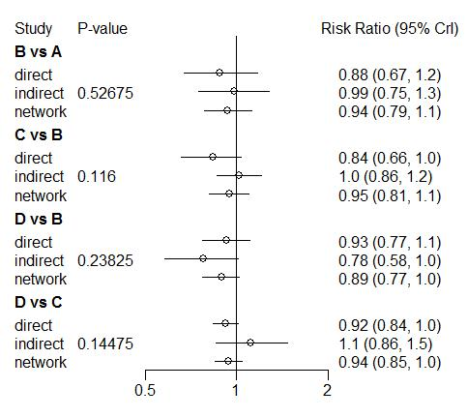

Figure S10: The test of inconsistency accessed by the node splitting method in intubation time in network meta-analysis. (A= Macintosh blade video laryngoscopes, B= angulated blade video laryngoscopes, C=side-channel blade video laryngoscopes, D=conventional Macintosh direct laryngoscopes).
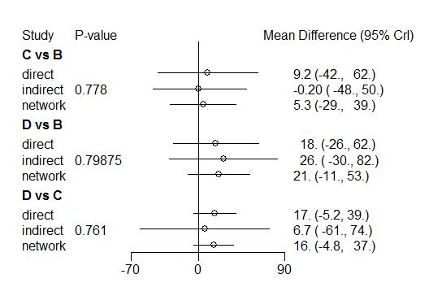

Figure S11: The test of inconsistency accessed by the node splitting method in glottis view in network meta-analysis. (A=Macintosh blade video laryngoscopes, B=angulated blade video laryngoscopes, C=side-channel blade video laryngoscopes, D=conventional Macintosh direct laryngoscopes).
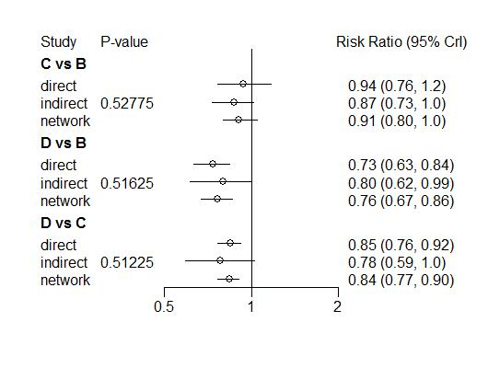

Figure S12: The test of inconsistency accessed by the node splitting method in the incidence of any complications in network meta-analysis. (A= Macintosh blade video laryngoscopes, B= angulated blade video laryngoscopes, C=side-channel blade video laryngoscopes, D=conventional Macintosh direct laryngoscopes).
