Supplementary information
Peaks and pitfalls of electrocatalytic descriptor models at the example of CO₂ reduction

Beomil Kim^{1a}, Seungchang Han^{2a}, Suneon Wang¹, Stefan Ringe^{2*}, Jihun Oh^{1,3*}

¹Department of Materials Science and Engineering, Korea Advanced Institute of Science and Technology, 291 Daehak-ro, Yuseong-gu, Daejeon 34141, Republic of Korea.
²Department of Chemistry, Korea University, Seoul 02841, Republic of Korea
³Institute for Climate Technology and Carbon Neutrality, Korea Advanced Institute of Science and Technology, 291 Daehak-ro, Yuseong-gu, Daejeon 34141, Republic of Korea.

ªBeomil Kim and Seungchang Han contributed equally to this work.
*e-mail: sringe@korea.ac.kr, jihun.oh@kaist.ac.kr

Supplementary Figures

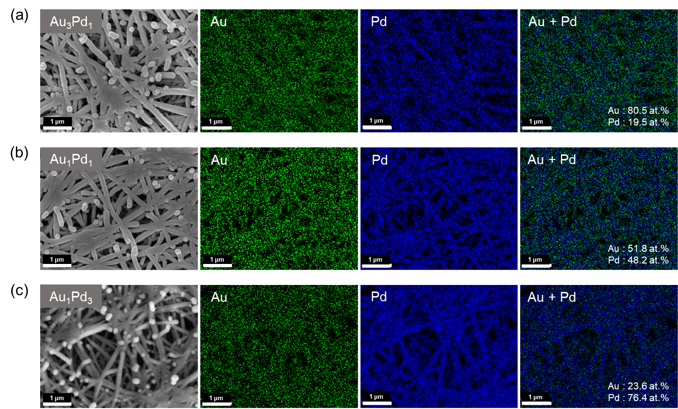

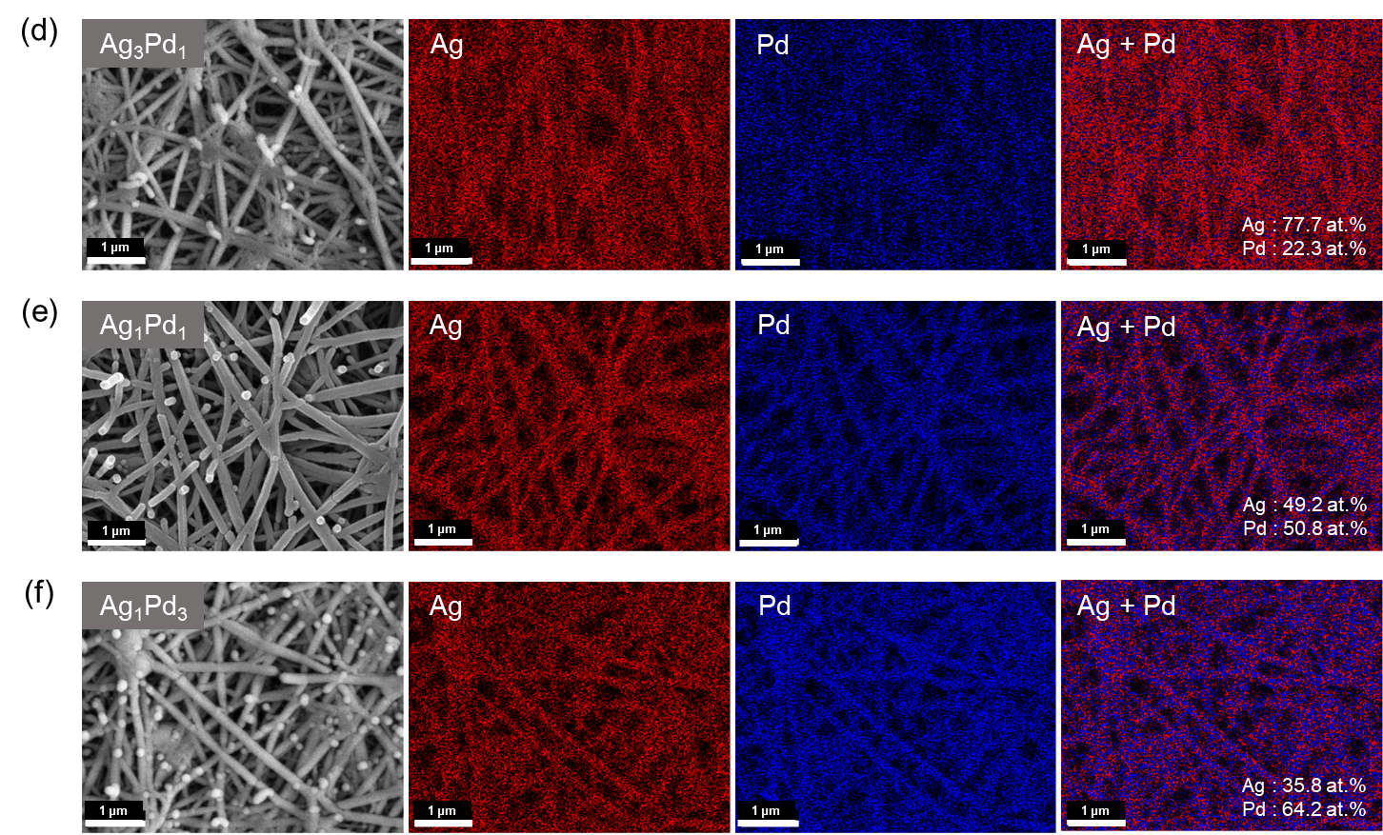

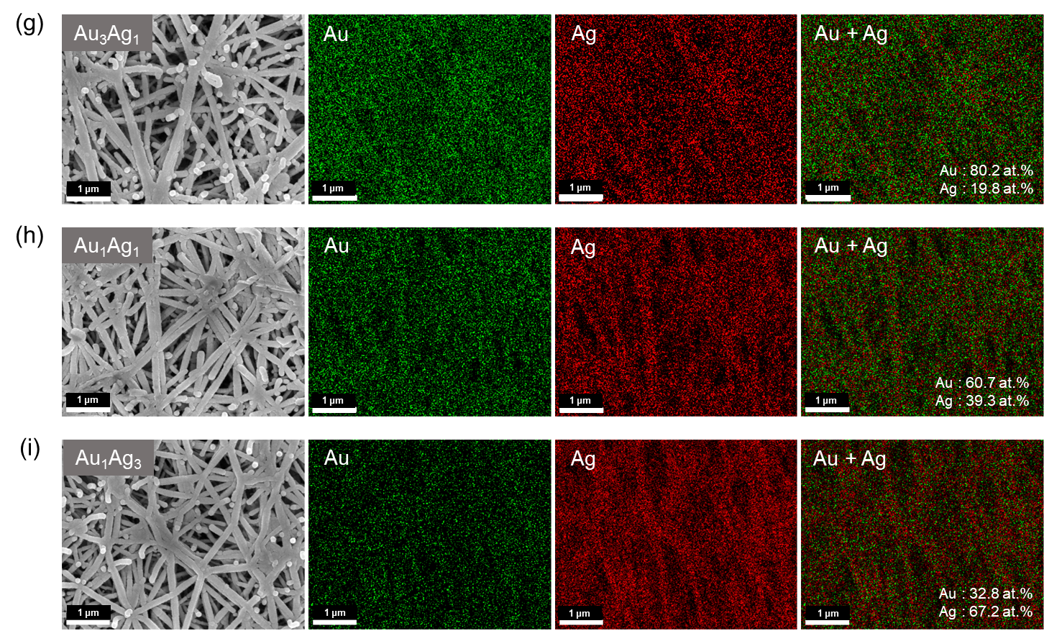

Supplementary Fig. 1 | SEM and SEM-EDS images of (a) AuPd alloys, (b) AgPd alloys, and (c) AuAg alloys.

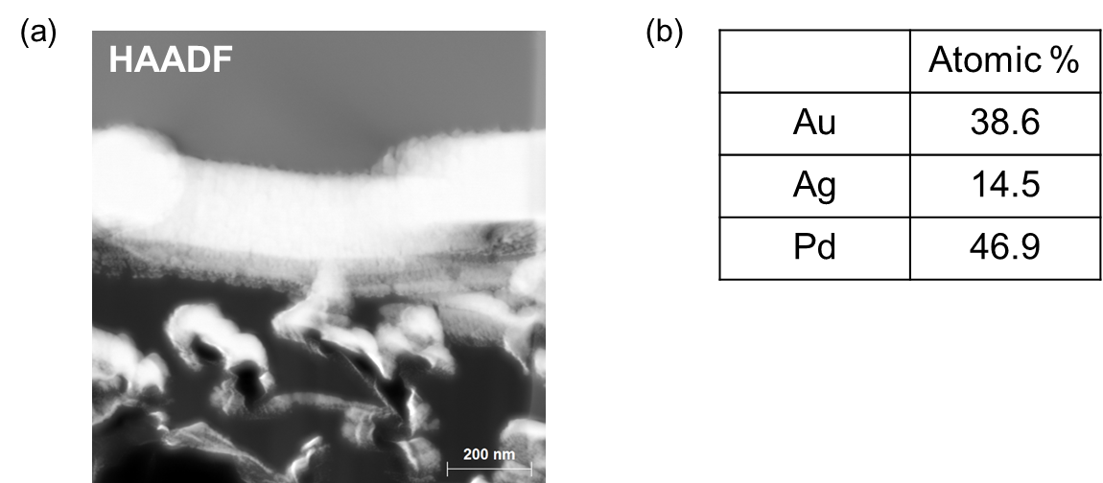

Supplementary Fig. 2 | (a) HAADF image of Au₃Ag₁Pd₃ alloy and (b) the composition of Au, Ag, and Pd in Au₃Ag₁Pd₃ alloy before CO₂RR measured by TEM-EDS.

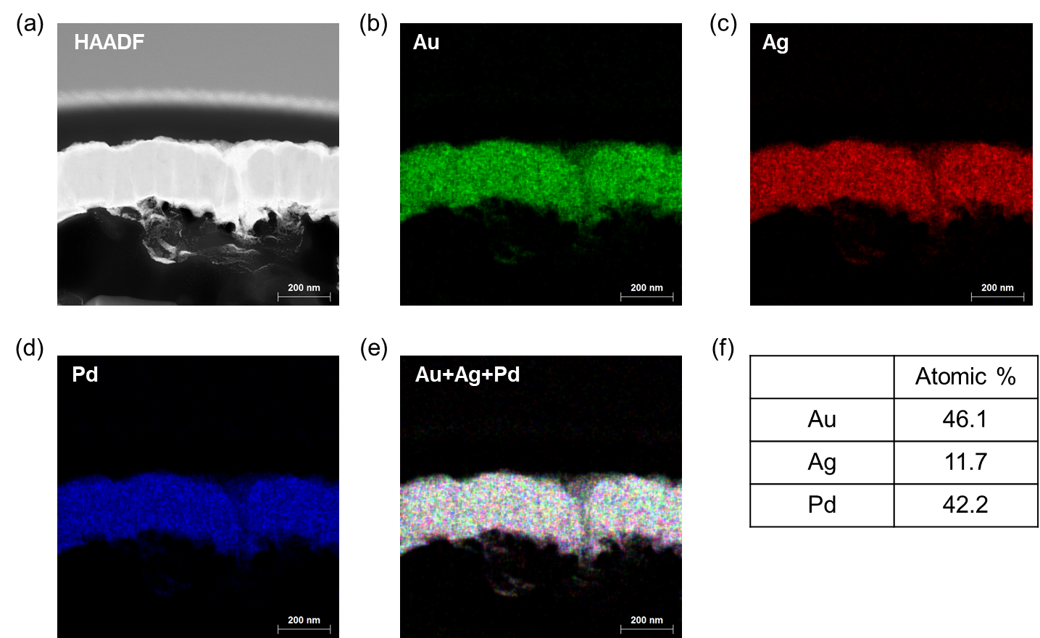

Supplementary Fig. 3 | (a) HAADF image and TEM-EDS images for (b) Au, (c) Ag, (d) Pd, and (e) Au, Ag and Pd after CO₂RR. (d) Composition of Au, Ag, and Pd in Au₃Ag₁Pd₃ alloy after CO₂RR measured by TEM-EDS.

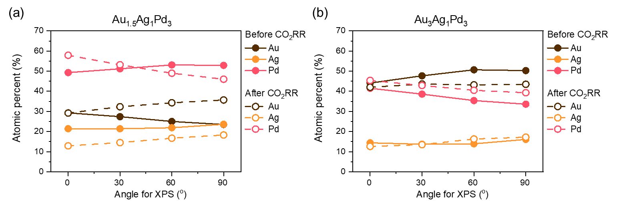
Supplementary Fig. 4 | ARXPS for (a) Au_{1.5}Ag₁Pd₃ and (b) Au₃Ag₁Pd₃. The solid line indicates the metal composition before CO₂RR and the dotted line indicates the metal composition after CO₂RR. 0º of angle for XPS represents normal take-off angle and 90º of angle for XPS represents the shallowest take-off angle.

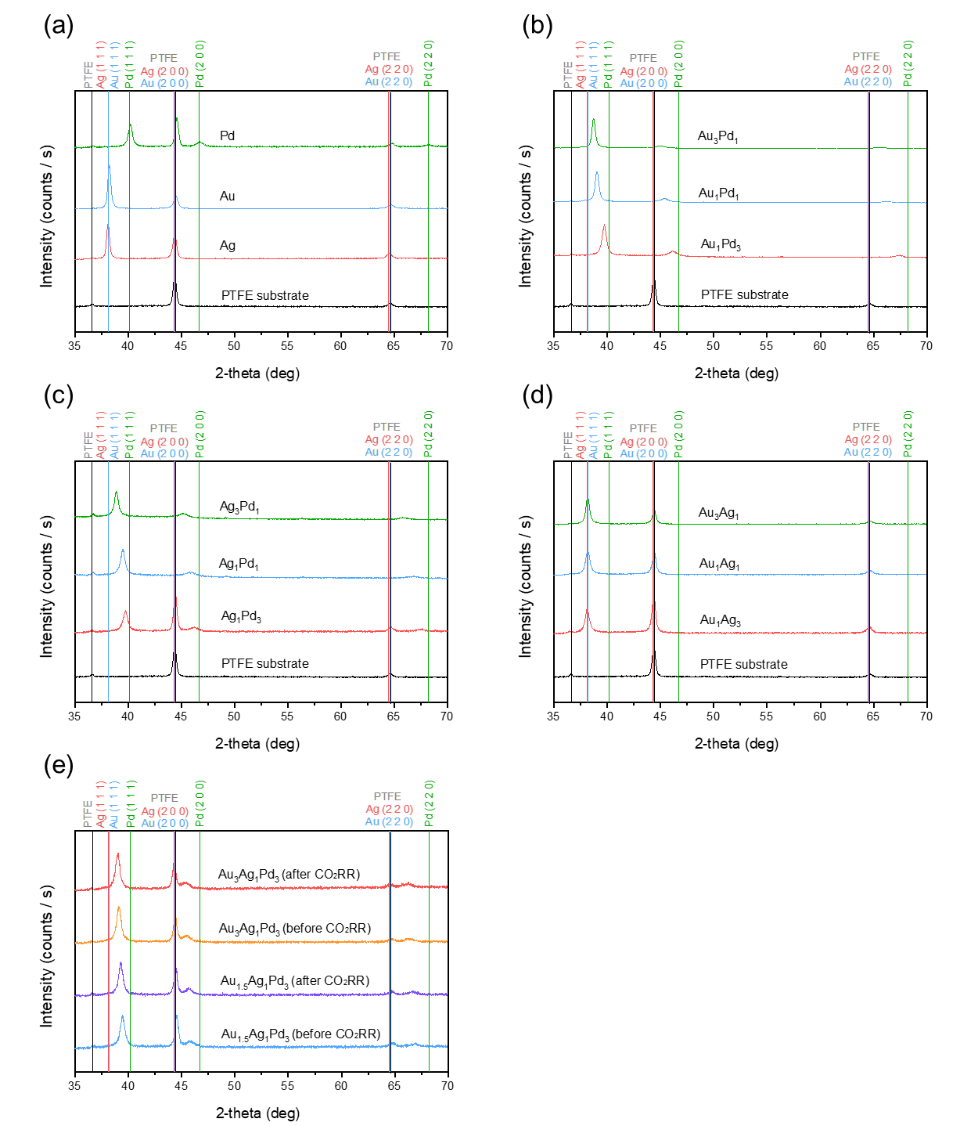
Supplementary Fig. 5 | XRD measurements for (a) pure metals (Au, Ag, and Pd) and PTFE substrate, (b) AuPd alloys, (c) AgPd alloys, (d) AuAg alloys before CO₂RR, and (e) AuAgPd alloys before and after CO₂RR.

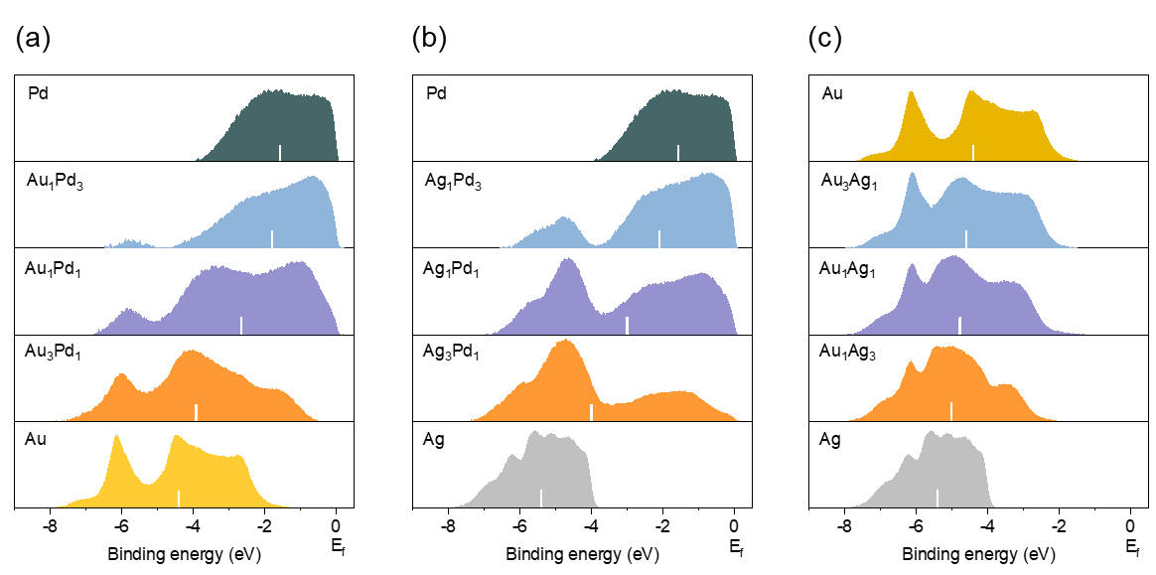

Supplementary Fig. 6 | d-band and d-band center of (a) Au, Pd, and AuPd alloys, (b) Ag, Pd, and AgPd alloys, (c) Au, Ag, and AuAg alloys measured by UPS before CO₂RR.

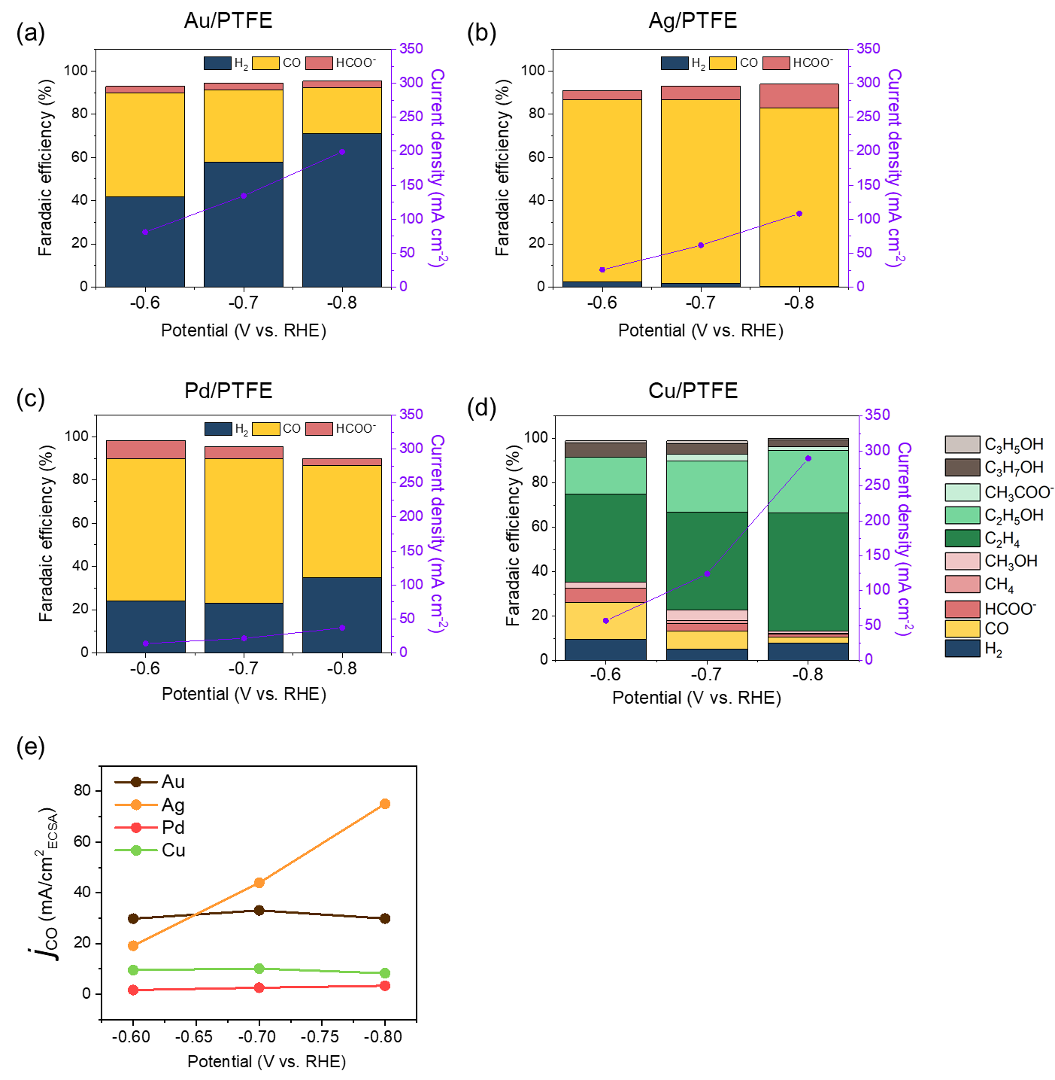
Supplementary Fig. 7 | CO₂RR properties (Faradaic efficiency and total current density) of (a) Au/PTFE, (b) Ag/PTFE, (c) Pd/PTFE, and (d) Cu/PTFE measured at three different potential. (e) Compare the j_{CO,ECSA} of Au, Ag, Pd, and Cu as a function of potential (V vs. RHE). Note that Au exhibits the largest j_{CO,ECSA} at −0.60 V_{RHE} and Ag exhibits the largest j_{CO,ECSA} at both −0.60 V_{RHE} and −0.70 V_{RHE}.

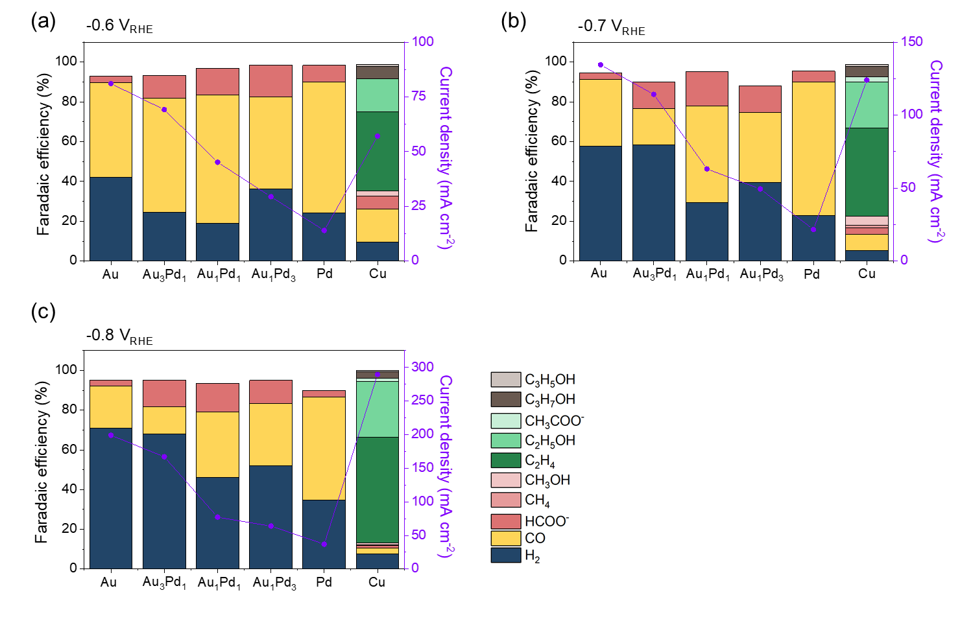
Supplementary Fig. 8 | CO₂RR properties (Faradaic efficiency and total current density) of AuPd alloys at (a) −0.6 V_{RHE}, (b) −0.7 V_{RHE}, and (c) −0.8 V_{RHE}. Note that the total current density decreases with an increase in the Pd composition.

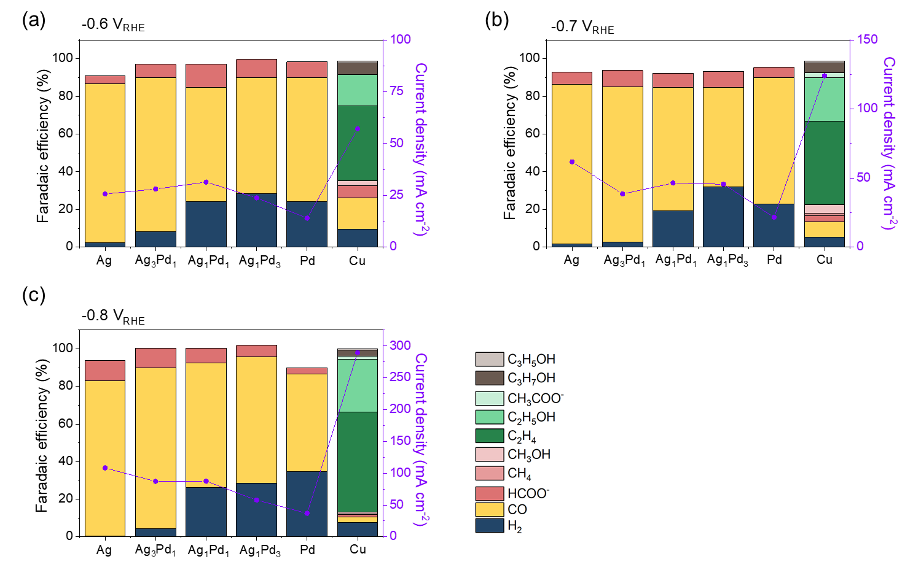
Supplementary Fig. 9 | CO₂RR properties (Faradaic efficiency and total current density) of AgPd alloys at (a) −0.6 V_{RHE}, (b) −0.7 V_{RHE}, and (c) −0.8 V_{RHE}. Note that the total current density decreases with an increase in the Pd composition.

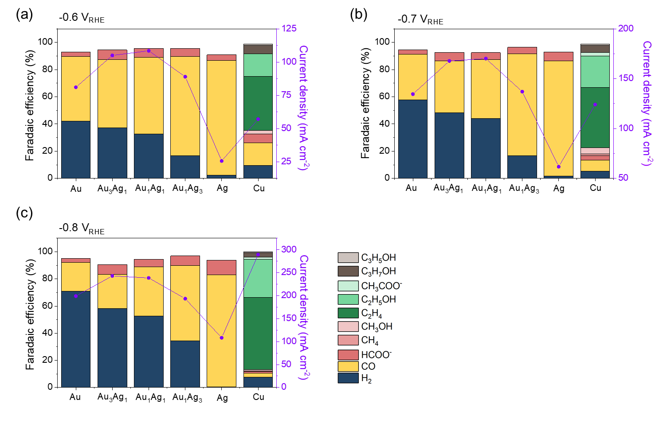
Supplementary Fig. 10 | CO₂RR properties (Faradaic efficiency and total current density) of AuAg alloys at (a) −0.6 V_{RHE}, (b) −0.7 V_{RHE}, and (c) −0.8 V_{RHE}. Note that Au₁Ag₁ exhibits the largest total current density at both −0.6 V_{RHE} and −0.7 V_{RHE}, while Au₃Ag₁ exhibits the largest total current density at −0.8 V_{RHE}.

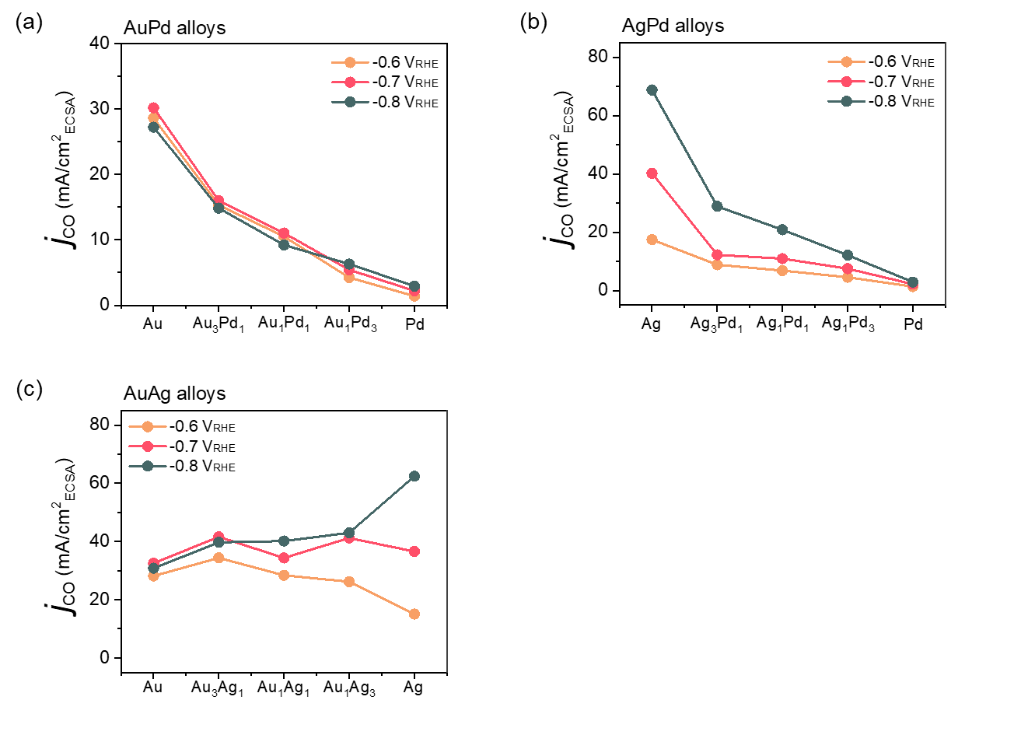
Supplementary Fig. 11 | The j_{CO,ECSA} of (a) AuPd alloys, (b) AgPd alloys, and (c) AuAg alloys as a function of the composition of alloys at −0.6 V_{RHE}, −0.7 V_{RHE}, and −0.8 V_{RHE}. For AuPd alloys and AgPd alloys, the j_{CO,ECSA} decreases more rapidly than the increase in Pd composition at both −0.6 V_{RHE}, −0.7 V_{RHE}, and −0.8 V_{RHE}. It is difficult to discern the trend of j_{CO,ECSA} for AuAg alloys as a function of composition.

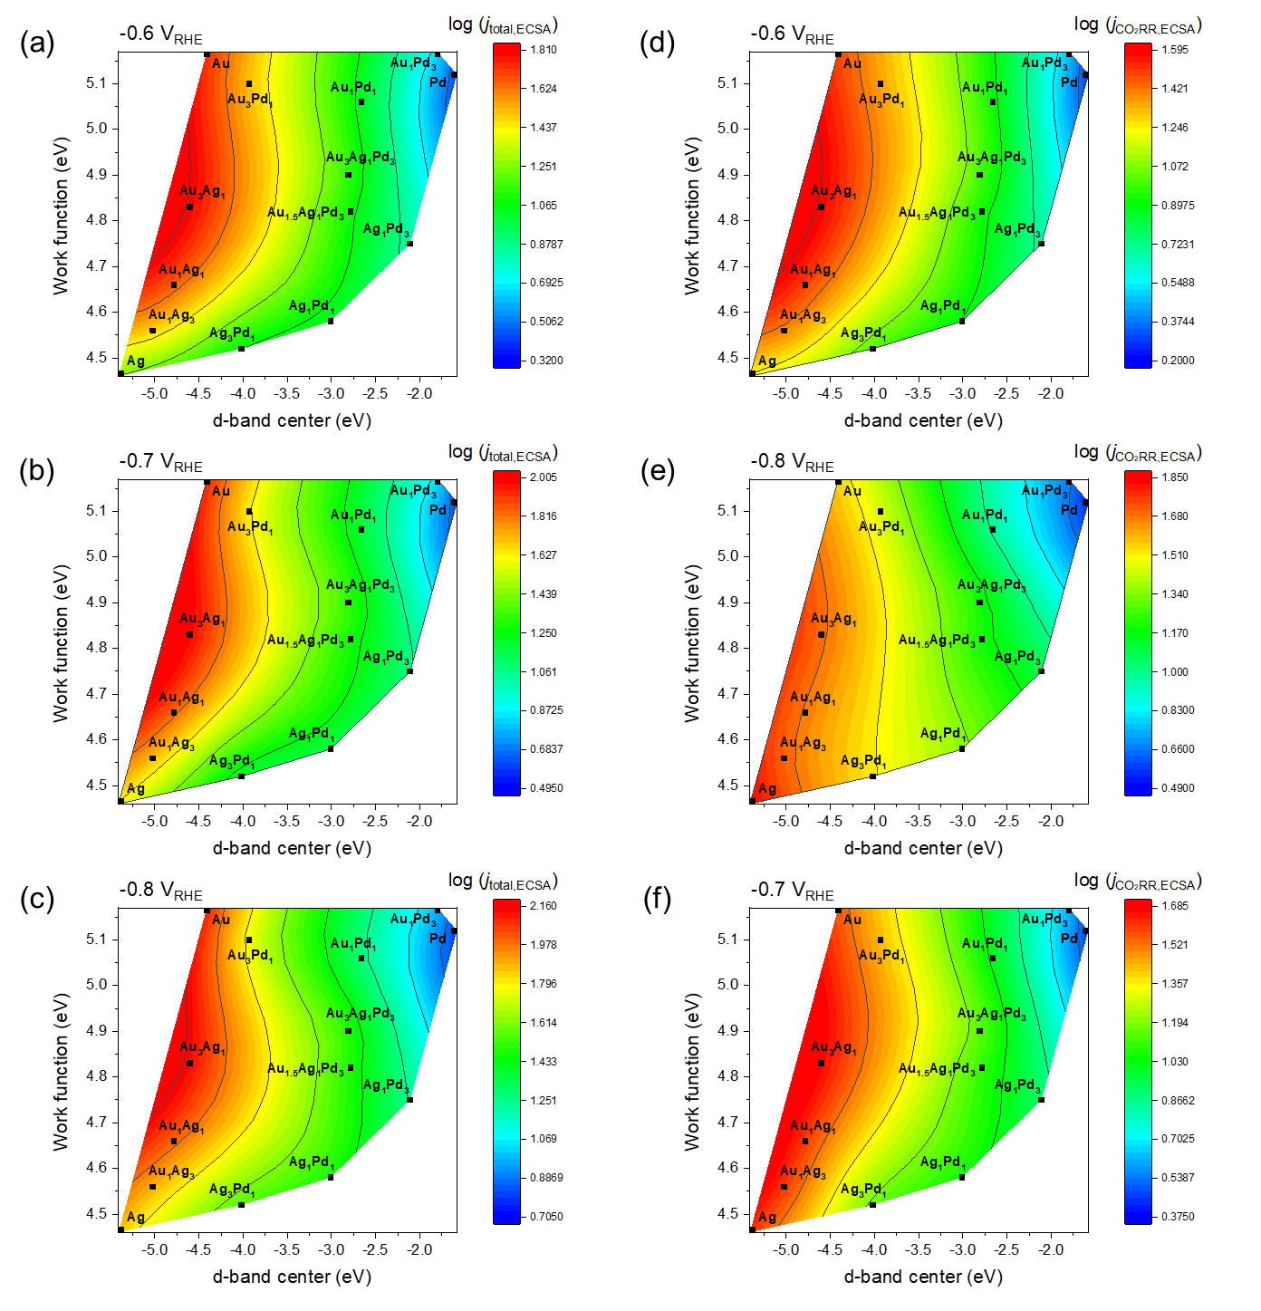
Supplementary Fig. 12 | Contour plots for the logarithm of j_{total,ECSA} as a function of the d-band center and work function for every alloy at (a) −0.6 V_{RHE}, (b) −0.7 V_{RHE}, and (c) −0.8 V_{RHE}. Contour plots for the logarithm of j_{CO2RR,ECSA} as a function of the d-band center and work function for every alloy at (d) −0.6 V_{RHE}, (e) −0.7 V_{RHE}, and (f) −0.8 V_{RHE}.

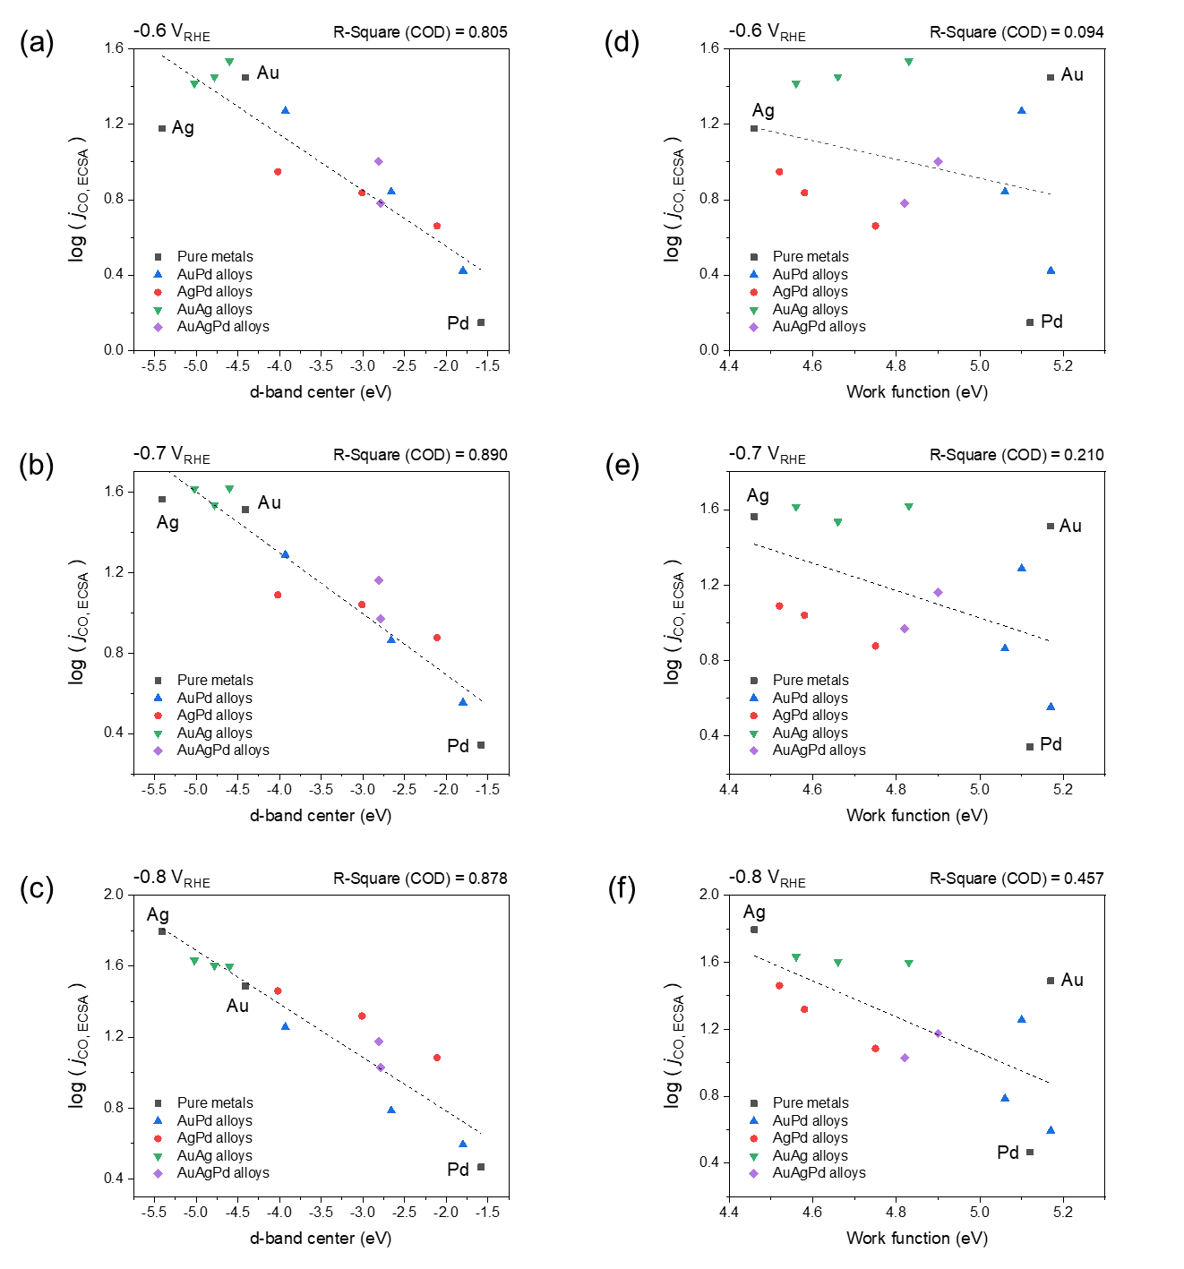
Supplementary Fig. 13 | Scatter plots for the logarithm of j_{CO,ECSA} as a function of the d-band center for every alloy at (a) −0.6 V_{RHE}, (b) −0.7 V_{RHE}, and (c) −0.8 V_{RHE}. Scatter plots for the logarithm of j_{CO,ECSA} as a function of the work function for every alloy at (a) -0.6 V_{RHE}, (b) -0.7 V_{RHE}, and (c) -0.8 V_{RHE}.
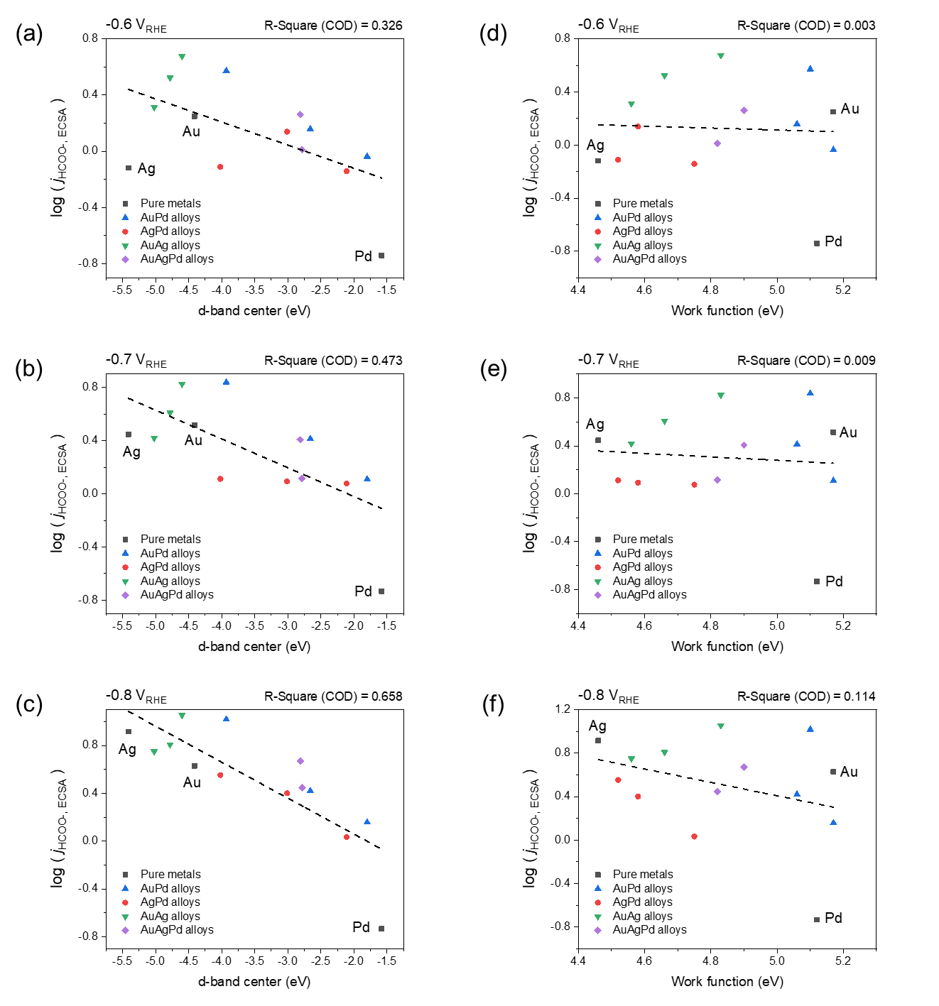
Supplementary Fig. 14 | Scatter plots for the logarithm of j_{HCOO}-_{,ECSA} as a function of the d-band center for every alloy at (a) −0.6 V_{RHE}, (b) −0.7 V_{RHE}, and (c) −0.8 V_{RHE}. Scatter plots for the logarithm of j_{HCOO}-_{,ECSA} as a function of the work function for every alloy at (d) −0.6 V_{RHE}, (e) −0.7 V_{RHE}, and (f) −0.8 V_{RHE}.

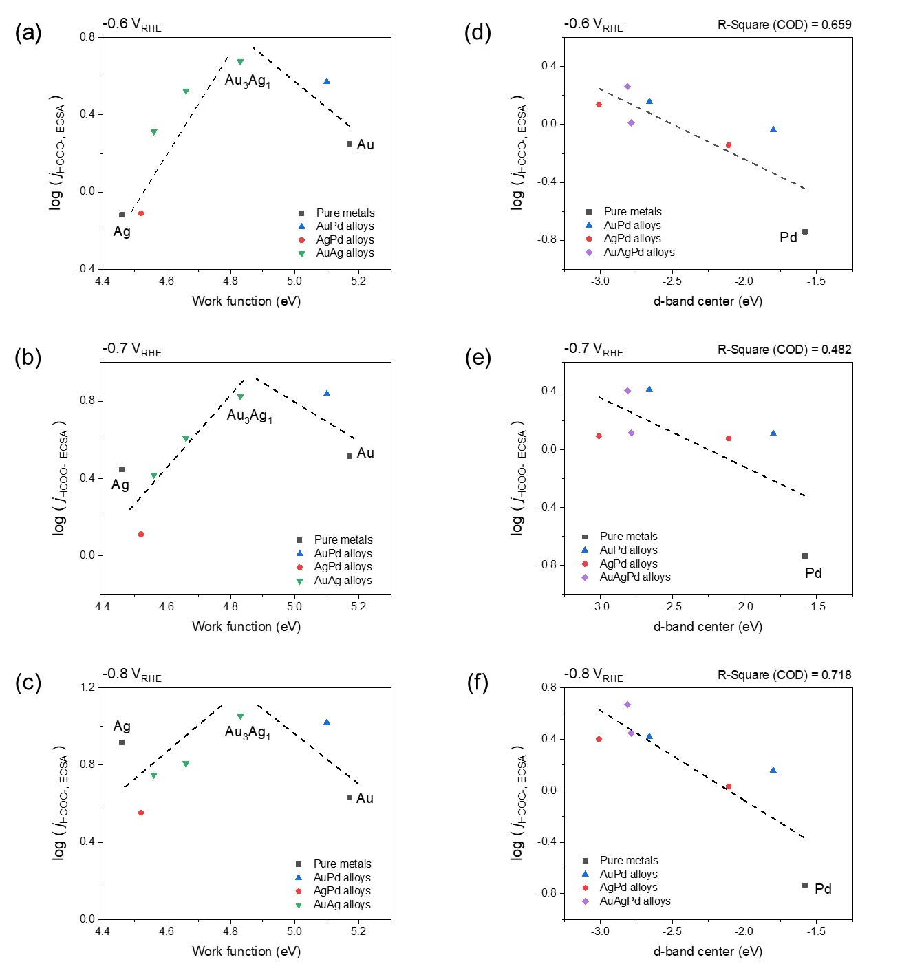
Supplementary Fig. 15 | Scatter plots for the logarithm of j_{HCOO}-_{,ECSA} as a function of the work function for particular alloys with d-band center lower than −3.5 eV at (a) −0.6 V_{RHE}, (b) −0.7 V_{RHE}, and (c) −0.8 V_{RHE}. Scatter plots for the logarithm of j_{HCOO}-_{,ECSA} as a function of the d-band center for particular alloys with d-band center values higher than −3.0 eV at (d) −0.6 V_{RHE}, (e) −0.7 V_{RHE}, and (f) −0.8 V_{RHE}.

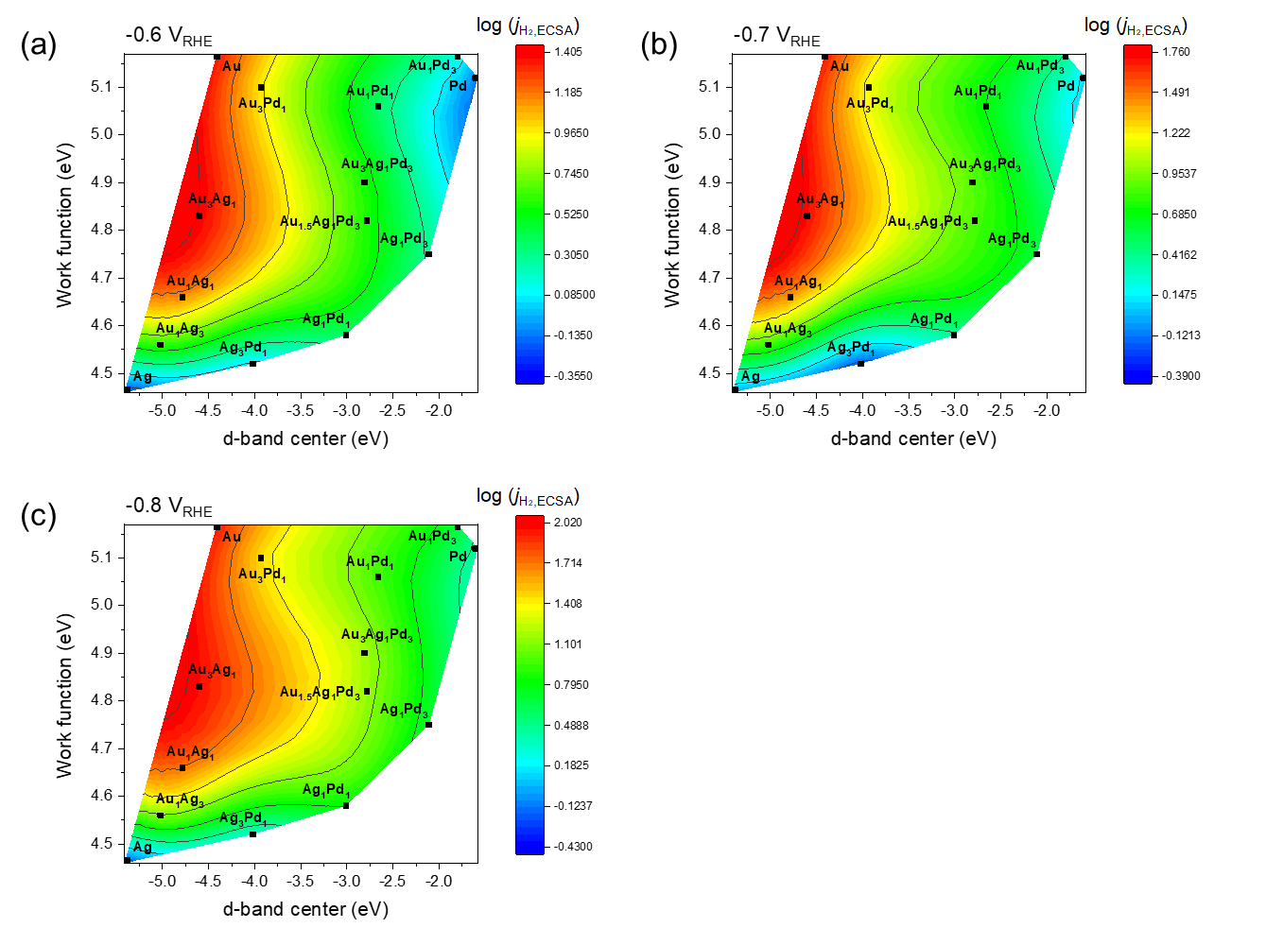Supplementary Fig. 16 | Contour plots for the logarithm of j_{H2,ECSA} as a function of the d-band center and work function for every alloy at (d) −0.6 V_{RHE}, (e) −0.7 V_{RHE}, and (f) −0.8 V_{RHE}.

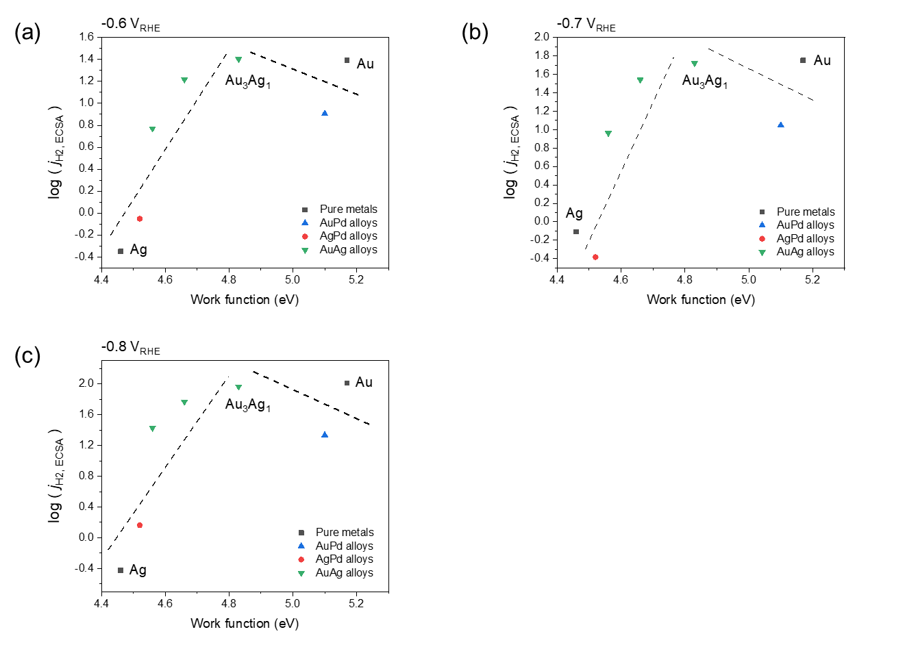
Supplementary Fig. 17 | Scatter plots for the logarithm of j_{H2,ECSA} as a function of the work function for particular alloys with d-band center lower than −3.5 eV at (a) −0.6 V_{RHE}, (b) −0.7 V_{RHE}, and (c) −0.8 V_{RHE}.

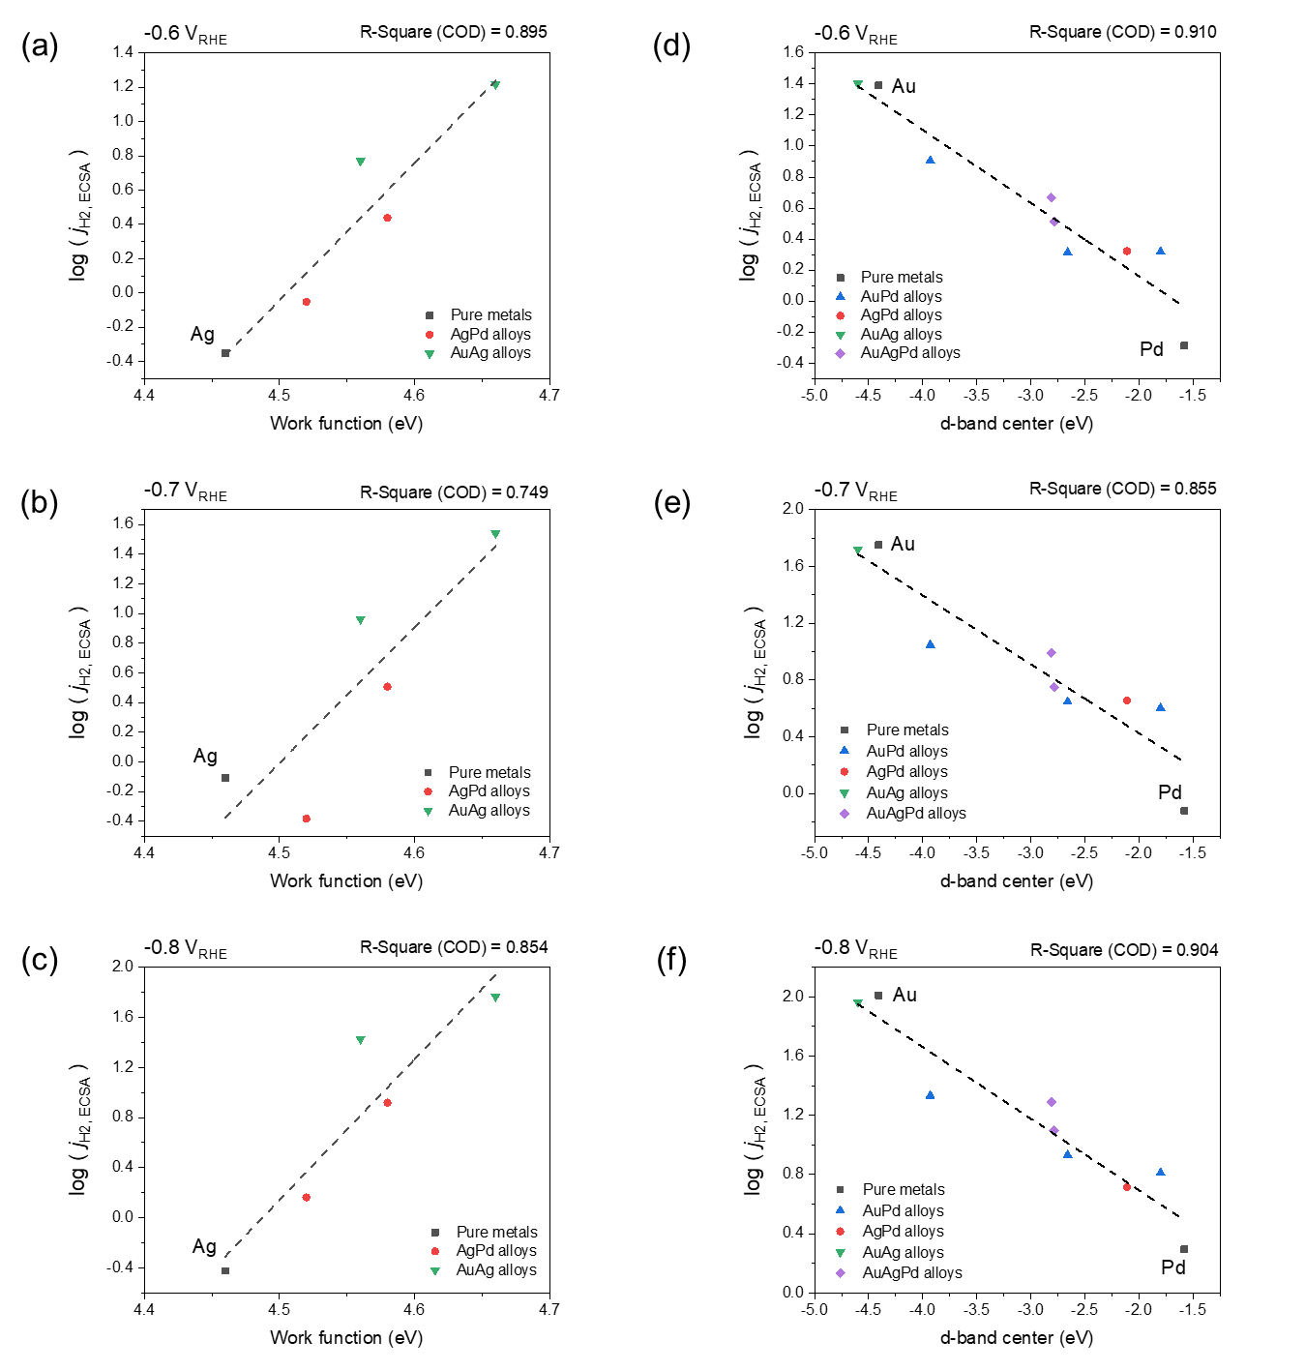
Supplementary Fig. 18 | Scatter plots for the logarithm of j_{H2,ECSA} as a function of the work function for particular alloys with work function lower than 4.7 eV at (a) −0.6 V_{RHE}, (b) −0.7 V_{RHE}, and (c) −0.8 V_{RHE}. Scatter plots for the logarithm of j_{H2,ECSA} as a function of the d-band center for particular alloys with work function higher than 4.7 eV at (d) −0.6 V_{RHE}, (e) −0.7 V_{RHE}, and (f) −0.8 V_{RHE}.

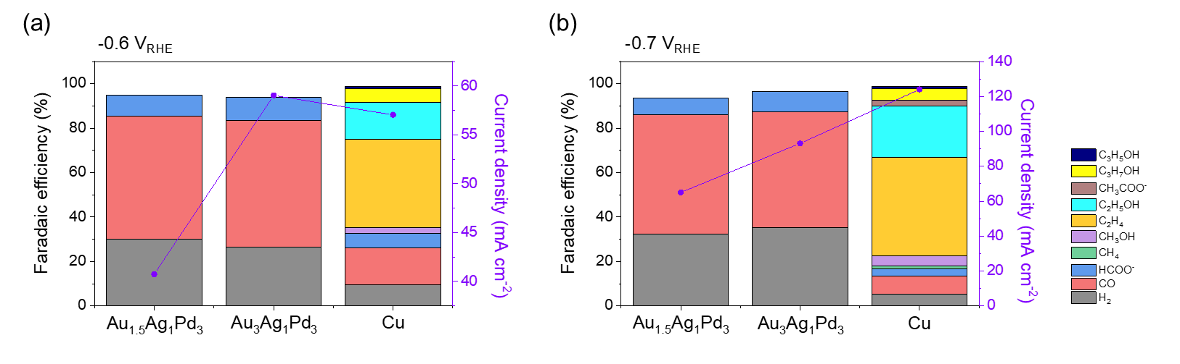
Supplementary Fig. 19 | CO₂RR properties (Faradaic efficiency and total current density) of AuAgPd alloys and Cu at (a) −0.6 V_{RHE} and (b) −0.7 V_{RHE}.

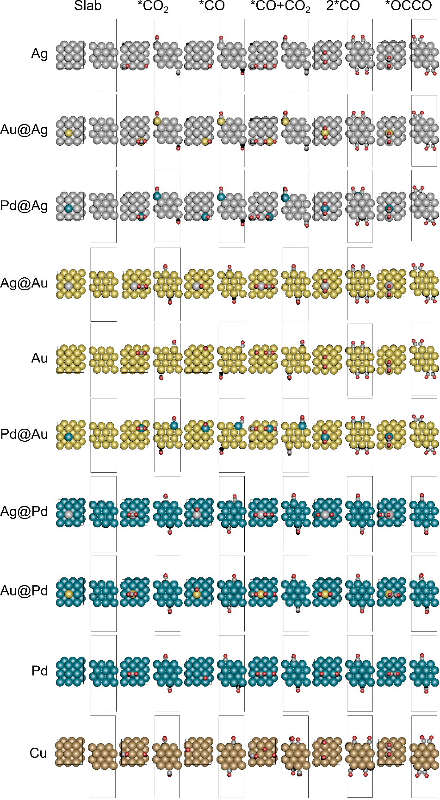
Supplementary Fig. 20 | Surface structures relaxed with implicit solvation. A few structures were relaxed with an additional charge to obtain realistic adsorption.

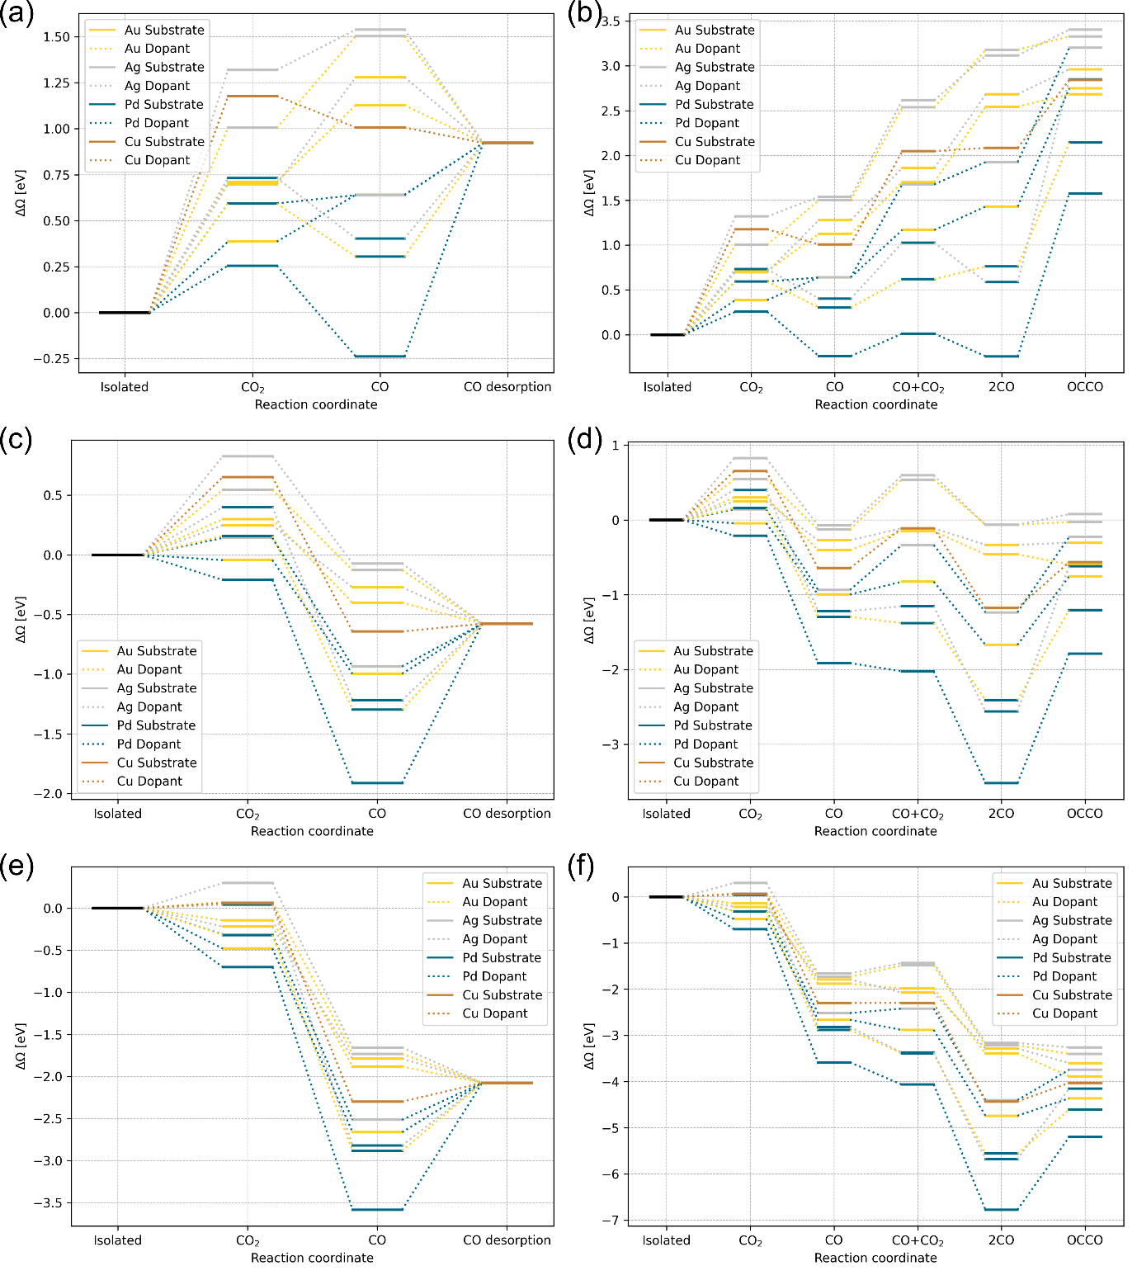
Supplementary Fig. 21 | DFT Calculated free energy diagram of OCCO formation for each system at (b) 0 V_{SHE}, (d) −0.75 V_{SHE}, and (f) −1.5 V_{SHE}. CO desorption at (a) 0 V_{SHE}, (c) −0.75 V_{SHE}, and (e) −1.5 V_{SHE}.
Supplementary Table 1 | The composition of every alloy measured by XPS and SEM-EDS.
Catalysts | XPS (at.%) |  |  |  | SEM-EDS (at.%)
Au₃Pd₁ | Au: 78.6 |  | Pd: 21.4 |  | Au: 80.5 |  | Pd: 19.5
Au₁Pd₁ | Au: 54.5 |  | Pd: 45.5 |  | Au: 51.8 |  | Pd: 48.2
Au₁Pd₃ | Au: 23.7 |  | Pd: 76.3 |  | Au: 23.6 |  | Pd: 76.4
Ag₃Pd₁ | Ag: 77.2 |  | Pd: 22.8 |  | Ag: 77.7 |  | Pd: 22.3
Ag₁Pd₁ | Ag: 52.8 |  | Pd: 47.2 |  | Ag: 49.2 |  | Pd: 50.8
Ag₁Pd₃ | Ag: 25.1 |  | Pd: 74.9 |  | Ag: 35.8 |  | Pd: 64.2
Au₃Ag₁ | Au: 68.8 |  | Ag: 31.2 |  | Au: 80.2 |  | Ag: 19.8
Au₁Ag₁ | Au: 44.9 |  | Ag: 55.1 |  | Au: 60.7 |  | Ag: 39.3
Au₁Ag₃ | Au: 22.7 |  | Ag: 77.3 |  | Au: 32.8 |  | Ag: 67.2
Au_{1.5}Ag₁Pd₃ | Au: 28.7 | Ag: 18.1 |  | Pd: 53.2 | Au: 30.9 | Ag: 14.0 |  | Pd: 53.1
Au₃Ag₁Pd₃ | Au: 43.4 | Ag: 14.7 |  | Pd: 41.9 | Au: 43.7 | Ag: 11.6 |  | Pd: 44.7

Supplementary Table 2 | Crystallite size measured by XRD measurements (Using Scherrer equation).
Catalysts | Crystallite size (nm)
Au | 26.943
Ag | 28.333
Pd | 23.111
Au₃Pd₁ | 25.279
Au₁Pd₁ | 23.567
Au₁Pd₃ | 20.256
Ag₃Pd₁ | 23.163
Ag₁Pd₁ | 21.015
Ag₁Pd₃ | 20.571
Au₃Ag₁ | 23.125
Au₁Ag₁ | 21.852
Au₁Ag₃ | 21.571
Au_{1.5}Ag₁Pd₃ | 21.493
Au₃Ag₁Pd₃ | 20.815

Supplementary Table 3 | The d-band center and work function of every alloy measured by UPS.
Catalysts | d-band center (eV) | Work function (eV)
Cu | −3.09 | 4.9
Au | −4.41 | 5.17
Ag | −5.41 | 4.46
Pd | −1.58 | 5.12
Au₃Pd₁ | −3.93 | 5.10
Au₁Pd₁ | −2.66 | 5.06
Au₁Pd₃ | −1.80 | 5.17
Ag₃Pd₁ | −4.02 | 4.52
Ag₁Pd₁ | −3.01 | 4.58
Ag₁Pd₃ | −2.11 | 4.75
Au₃Ag₁ | −4.60 | 4.83
Au₁Ag₁ | −4.78 | 4.66
Au₁Ag₃ | −5.02 | 4.56
Au_{1.5}Ag₁Pd₃ | −2.78 | 4.82
Au₃Ag₁Pd₃ | −2.81 | 4.90

Supplementary Table 4 | The double layer capacitance and roughness factor of every alloy.
Catalysts | Double Layer Capacitance  (μF/cm²) | Roughness factor
Cu | 415.5 | 1.00
Au | 575.0 | 1.38
Ag | 594.8 | 1.43
Pd | 2718.1 | 6.54
Au₃Pd₁ | 881.3 | 2.12
Au₁Pd₁ | 1735.0 | 4.18
Au₁Pd₃ | 2130.0 | 5.13
Ag₃Pd₁ | 1073.3 | 2.58
Ag₁Pd₁ | 1149.7 | 2.77
Ag₁Pd₃ | 1328.2 | 3.20
Au₃Ag₁ | 638.5 | 1.54
Au₁Ag₁ | 894.0 | 2.15
Au₁Ag₃ | 1035.7 | 2.49
Au_{1.5}Ag₁Pd₃ | 1552.1 | 3.74
Au₃Ag₁Pd₃ | 1393.3 | 3.35

Supplementary Table 5 | Calculated DFT energy at the zero charge, charge-dependent coefficients, predicted potential of zero charge, and thermal, zero-point energy correction.
Substrate | Dopant | Adsorbate | $$E_{0}$$ | $$a$$ | $$b$$ | $$U_{PZC}-ΔU_{SHE}^{exp}$$ | $$E_{T,S,ZPE}^{°}$$
Ag | Ag |  | 27.7410 | 0.4992 | 0.002822 | 3.9951
Ag | Ag | CO₂ | −7.8844 | 0.5665 | 0.002672
Ag | Ag | CO | 3.5047 | 0.5130 | 0.002930
Ag | Ag | CO+CO₂ | −32.1484 | 0.5691 | 0.002788
Ag | Ag | 2CO | −20.6576 | 0.5201 | 0.003201
Ag | Ag | OCCO | −20.1920 | 0.5432 | 0.002780
Ag | Au |  | 25.7404 | 0.5099 | 0.002912 | 4.0998
Ag | Au | CO₂ | −10.3332 | 0.5715 | 0.002847
Ag | Au | CO | 1.4353 | 0.5267 | 0.003018
Ag | Au | CO+CO₂ | −34.1277 | 0.5769 | 0.002792
Ag | Au | 2CO | −22.5668 | 0.5403 | 0.003312
Ag | Au | OCCO | −22.2897 | 0.5580 | 0.002849
Ag | Pd |  | 22.5365 | 0.5093 | 0.003239 | 4.1900
Ag | Pd | CO₂ | −14.2427 | 0.5695 | 0.003219
Ag | Pd | CO | −3.3954 | 0.5192 | 0.003201
Ag | Pd | CO+CO₂ | −38.9337 | 0.5784 | 0.002920
Ag | Pd | 2CO | −28.1094 | 0.5309 | 0.003214
Ag | Pd | OCCO | −25.7210 | 0.5672 | 0.002858
Au | Ag |  | 0.6366 | 0.6319 | 0.003363 | 4.9046
Au | Ag | CO₂ | −35.0847 | 0.6900 | 0.003290
Au | Ag | CO | −23.8738 | 0.6430 | 0.003517
Au | Ag | CO+CO₂ | −59.5416 | 0.6957 | 0.003396
Au | Ag | 2CO | −48.2700 | 0.6417 | 0.003645
Au | Ag | OCCO | −47.4499 | 0.6646 | 0.003248
Au | Au |  | −0.6633 | 0.6460 | 0.003393 | 5.0331
Au | Au | CO₂ | −36.2720 | 0.6958 | 0.003239
Au | Au | CO | −25.4650 | 0.6564 | 0.003598
Au | Au | CO+CO₂ | −61.1184 | 0.6953 | 0.003467
Au | Au | 2CO | −49.8114 | 0.6586 | 0.003754
Au | Au | OCCO | −49.2113 | 0.6800 | 0.003308
Au | Pd |  | −4.1759 | 0.6437 | 0.003675 | 5.1371
Au | Pd | CO₂ | −40.2684 | 0.7001 | 0.003649
Au | Pd | CO | −29.8669 | 0.6571 | 0.003541
Au | Pd | CO+CO₂ | −65.4909 | 0.6994 | 0.003394
Au | Pd | 2CO | −55.4574 | 0.6619 | 0.003807
Au | Pd | OCCO | −52.3072 | 0.6932 | 0.003197
Pd | Ag |  | −53.1506 | 0.5181 | 0.002905 | 4.9673
Pd | Ag | CO₂ | −88.8559 | 0.5587 | 0.002782
Pd | Ag | CO | −79.3444 | 0.5366 | 0.002984
Pd | Ag | CO+CO₂ | −114.7396 | 0.6043 | 0.002749
Pd | Ag | 2CO | −106.1345 | 0.5414 | 0.003028
Pd | Ag | OCCO | −101.2607 | 0.5713 | 0.002603
Pd | Au |  | −54.8826 | 0.5303 | 0.002957 | 5.0911
Pd | Au | CO₂ | −90.6508 | 0.5812 | 0.002758
Pd | Au | CO | −81.2612 | 0.5456 | 0.003014
Pd | Au | CO+CO₂ | −117.2867 | 0.5948 | 0.002902
Pd | Au | 2CO | −107.4385 | 0.5560 | 0.003042
Pd | Au | OCCO | −104.4128 | 0.5684 | 0.002715
Pd | Pd |  | −57.4655 | 0.5225 | 0.002913 | 5.0226
Pd | Pd | CO₂ | −93.9263 | 0.5810 | 0.002800
Pd | Pd | CO | −84.8739 | 0.5462 | 0.002925
Pd | Pd | CO+CO₂ | −121.1224 | 0.5937 | 0.002901
Pd | Pd | 2CO | −111.9426 | 0.5624 | 0.003007
Pd | Pd | OCCO | −108.1538 | 0.5648 | 0.002709
Cu | Cu |  | −12.7537 | 0.4007 | 0.002288 | 4.3144
Cu | Cu | CO₂ | −48.2563 | 0.4697 | 0.001989 |  | 0.2153
Cu | Cu | CO | −37.9834 | 0.4205 | 0.002252 |  | 0.1213
Cu | Cu | CO+CO₂ | −73.4346 | 0.4882 | 0.002168 |  | 0.1754
Cu | Cu | 2CO | −63.1098 | 0.4358 | 0.002317 |  | 0.1363
Cu | Cu | OCCO | −61.5798 | 0.4544 | 0.002040 |  | 0.2184
H₂ |  |  | −7.1678 |  |  |  | -0.0387
CO₂ |  |  | −18.5905 |  |  |  | -0.2611
H₂O |  |  | −13.1414 |  |  |  | 0.1190
CO |  |  | −12.1322 |  |  |  | -0.3898

