Supplementary Materials

Supplementary Text 1

Ethical approvals, funding sources, and acknowledgements

African lion

[Authors involved: D.M.S., N.C.B., N.M., R.M.G.]

Conditions and approvals were granted by the Animals Scientific Procedures Act (ASPA) at Queen’s University of Belfast (QUB-BS-AREC-18-006) and Pretoria University (NAS061-19); permit authorization was given by South African National Parks (permit no. SCAM 1550). Fieldwork was supported, in part, by a Department for Economy Global Challenges Research Fund grant awarded to M.S. For details on the capture techniques, and acknowledgements associated with this fieldwork, refer to https://doi.org/10.1098/rsif.2021.0692.

Aldabra Giant tortoise

[Authors involved: L.B., J.R., N.C., V.T.]

This data collection received ethical approval from the Animal Welfare and Ethical Review Body (AWERB): IP-1516-9. Necessary external approvals for the proposed project/activities were granted by the Mauritian Wildlife Foundation, Granum Road, Vacoas, Mauritius. Additionally, the Durrell Conservation Trust obtained all requisite permits and internal approvals. Funding was obtained from the Beveridge Herpetological Trust and Durrell Conservation Trust.

Alpine ibex, domestic cow, domestic goat, Mediterranean mouflon, and northern chamois

[Authors involved: L.B., R.B., P.M., M.G., J.R., C.T.]

The necessary permissions and approvals for all five species were provided by the Swansea University Ethics Committee (SU-Ethics-Student-090918/981), in collaboration with the Animal Welfare and Ethical Review Body (AWERB) under permit IP-1516-14. Fieldwork was funded by Swansea university - college of science under the ALPINE Ungulates Movement (ALPEN) project. All captures were approved by the French Environment Ministry.

Andean condor

[Authors involved: E.L.C.S., S.A.L.]

All experimental procedures were approved by the Swansea University Ethics Committee in 2010 (prior to the adoption of IP numbers). Funding was obtained via the International Association of Avian Trainers & Educators (IAATE) and the ANCYPT grant no PICT 2021-I-A-00484 awarded to S.A.L, as well as the National Geographic Global Exploration Fund (GEFNE89-13, awarded to E.L.S). For details on the capture techniques, and acknowledgements associated with this fieldwork, refer to https://doi.org/10.1371/journal.pone.0027375.

Arabian oryx

[Authors involved: D.M.S., M.S., A.A., N.C.B.]

Ethical approval was obtained from the University of the Witwatersrand Animal Ethics Committee (2014/53/D). Permission to work in the ﬁeld was granted by the President of the Saudi Wildlife Authority. This study was funded by researchers supporting project #RSPD2023R602, from King Saud University; the Deanship of Scientiﬁc Research at the King Saud University through Vice Deanship of Research Chair; the National Geographic Global Exploration Fund awarded to A.A, and the Royal Society/Wolfson Lab refurbishment scheme awarded to R.P.W. The researchers invested in this fieldwork would like to express gratitude to Prince Bander bin Saud Al-Saud, former President of the Saudi Wildlife Authority (SWA), for his unlimited and enthusiastic support to undertake these studies on the Arabian oryx, managed by the SWA.

Atlantic yellow-nosed albatross, gray-headed albatross & wandering albatross

[Authors involved: P.G.R., S.S.]

Permission to work on seabirds (Atlantic yellow-nosed albatross) at Tristan da Cunha was granted by Tristan Conservation, the Island Council and Administrator, and permission to work on seabirds (gray-headed albatross & wandering albatross) at the Prince Edward Islands was granted by the Prince Edward Islands’ Management Committee. All research was approved by the University of Cape Town’s Science Faculty Animal Ethics Committee (2017/V10REV/PRyan). Financial and logistical support was received from the Royal Society for the Protection of Birds and the South African National Antarctic Programme.

Balearic shearwater

[Authors involved: E.L.C.S., T.G., O.P., N.G.]

Ethical approval for the study was provided by the Government of the Balearic Islands; permit number CEP/2016. Fieldwork was funded, in part, by the Biotechnology and Biological Sciences Research Council (BBSRC), Grant BB/M011224/1, awarded to N.G. For additional information related to the capture protocol, please refer to the following publications: https://doi.org/10.1016/j.biocon.2015.05.012 and https://doi.org/10.1111/j.1474-919X.2008.00805.x.

black-legged kittiwake

[Authors involved: K.E., E.L.S., O.P.]

The project was conducted in accordance with Animal Use Protocol 2015-7599, issued by McGill University, and Swansea University's Animal Welfare and Ethical Review Body permit 110619/1590 (IP-181918). Funding was secured through the NSERC Discovery Grant and the European Research Council under the European Union’s Horizon 2020 research and innovation program, Grant 715874, awarded to E.L.C.S. For additional information related to the capture protocol and acknowledgments, please refer to the following publications: https://doi.org/10.1186/s40462-014-0017-2, and https://doi.org/10.1111/2041-210X.13804.

domestic sheep

[Authors involved: J.M.M, A.dV.]

Ethical approval was obtained from the "Comité Institucional de Cuidado y Uso de Animales de Laboratorio o Experimentación (CICUAL)" from Universidad Nacional del Comahue. Fieldwork was funded by the Argentine fund for scientific and technological research (FONCyT, PICT 2015 0815) awarded to J.M.M.

Eurasian beaver

[Authors involved: F.R., R.M.M.]

Ethical approval for the study was provided by the Norwegian Experimental Animal Board, with the most recent authorization under FOTS ID19557, and the Norwegian Directorate for Nature Management, with the most recent authorization number 2014/14415. The financial support for the project was given by the University of South-Eastern Norway and the Royal Norwegian Society of Sciences and Letters Special. The research team part of this data collection would like to extend their gratitude to Hanna Kavli Lodberg-Holm, Christian Robstad and the other members of the Norwegian Beaver Project for their assistance in the field. For a review of the capture methods used in this study, refer to https://www.jstor.org/stable/3784008.

European badger

[Authors involved: D.M.S., N.M.]

The Department of Agriculture, Environment and Rural Affairs (DAERA) and the Department of Health, Social Services and Public Safety (DHSSPS) in Northern Ireland provided the necessary ethical permissions under a Home Office license. The funding for this research was provided by the Department of Agriculture, Environment and Rural Affairs, Northern Ireland to D.M.S. We would like to express gratitude to the DAERA field staff for their assistance during the fieldwork of this study and the landowners for giving permission to conduct the field survey. For information pertaining to the capture protocol, refer to https://doi.org/10.1186/s40317-022-00282-2.
European pine marten

[Authors involved: J.P.T., N.M., D.M.S.]

Approvals for ethical considerations were granted through the Home Office License and Northern Ireland Environment Agency License 2228. The project was also reviewed and received approval from the Queen's University Animal Welfare and Ethics Review Board. The Challenge Fund and Newry, Mourne and Down District Council funded the project. The researchers involved in this study wish to express gratitude to the National Trust and the Northern Ireland Forest Service for allowing access to field sites. Special thanks to Kieran Corry for his assistance with training and supervision in sampling procedures, and to Johnny Birks and John Martin for their guidance in VHF radio tracking. For further insight into the capture methodologies used, refer to https://doi.org/10.2981/wlb.00760.

golden lion tamarin

[Authors involved: L.B., C.R-M, A.M, A.P.C-N.]

The necessary permissions and approvals were provided by the Swansea University Ethics Committee and the Animal Welfare and Ethical Review Body (AWERB) under permit IP-1516-13. Fieldwork was funded by Swansea University, the College of Science Santander Travel Grant, and Fundação de Amparo à Pesquisa do Estado de São Paulo (FAPESP grant 2014/16320-7). The field team from the Associação Mico Leão Dourado captured and handled the animals and provided logistic support in the field. All captures and field work were approved by the Brazilian Environment Ministry (SISBIO permit 17409).

great frigatebird & red-footed booby

[Authors involved: H.W., A.P.]

All field procedures, methods, and animal handling adhered to the guidelines of the Préfet des Terres Australes et Antarctiques Françaises and Comité National de la Protection de la Nature. The study was part of the EARLYLIFE program, which was financially supported by a European Research Council Advanced Grant under the European Community and 39th Seventh Framework Program FP7/2007–2013 (Grant Agreement ERC-2012-ADG_20120314 to H.W).

Guatemalan beaded lizard

[Authors involved: D.A-S., S.R., F.R., R.M.M.]

Data were collected under permits from Consejo Nacional de Areas Protegidas (CONAP- 013/2015) and ethics approval from the University of South-Eastern Norway. The financial support for the project was received from the University of South-Eastern Norway and Universidad del Valle de Guatemala. The researchers involved in this fieldwork would like to acknowledge Peder Bjureke, Mayari Pérez-Tay, Gilberto Salazar, Erick López. Heloderma Natural Reserve and Zootropic NGO. For information relating to the capture protocol, refer to https://doi.org/10.1002/ecs2.3990.

imperial cormorant

[Authors involved: F.Q., A.G-L., R.M.G.]

Ethical approval was given under SU-Ethics-Student: 260919/1894 and AWERB approval: IP-1819-30. The permission was provided by Disposición Nro 47 /19 Subsecretaría de Conservación y Áreas Protegidas, Ministerio de Turismo, Chubut, Argentina. The study was financed by the National Agency for Science Promotion (PICT2018-01480 and PICT 2017-1996), under the aegis of the Ministerio de Ciencia, Tecnología e Innovación Productiva, Argentina. For an overview of the capture protocol used, refer to https://doi.org/10.1007/s00227-013-2222-8.

Indian elephant

[Authors involved: D.M.S., A.G.]

The ethical clearance for this study was obtained from the Kindred Spirit Elephant Sanctuary in Thailand. Financial support for this work was secured through a First Trust Travel Scholarship from Queens University Belfast, awarded to A.G. Acknowledgements for contributions to the fieldwork go to Sombat Wirakhwamdee, Kerri McCrea, and Talia Gale from the Kindred Spirit Elephant Sanctuary, and to Eleanor Lennon and Adam Duncan for their assistance in the field.

kinkajou, ocelot, red-brocket deer, mantled howler monkey, white-faced capuchin monkey and white-nosed coati

[Authors involved: R.M.G., M.C., J.O., L.T.]

All species involved in this study received field work approval from the Smithsonian Tropical Research Institute under IACUC protocol numbers SI-22031 (field work in BCI, Panama) and 2014-0701-2017 (field work in Gamboa, Panama). The Max Planck Institute for Animal Behavior’s Department for the Ecology of Animal Societies (directed by M.C) provided the necessary funding for the field work. Information regarding the capture protocol used can be found at https://doi.org/10.3389/fevo.2021.743014.

loggerhead turtle

[Authors involved: C.E., R.S.]

The ethical clearance (DNA 27/201) for this study was provided by the Direção Nacional do Ambiente to C.E. as part of the Turtle Project initiated by C.E. Funding for the fieldwork came from a Future Ocean Cluster of Excellence grant (CP1217) given to R.S., along with grants from National Geographic (GEFNE69-13), The Whitley Wildlife Conservation Trust and Future Ocean Capacity Building awarded to C.E. The team wishes to thank Fundação Tartaruga for its logistical support during this project. For additional information, refer to https://doi.org/10.1111/j.1365-2435.2011.01960.x.

Magellanic penguin

[Authors involved: F.Q., R.M.G.]

The ethical consent for this research was granted under SU-Ethics-Student: 260919/1894 and AWERB approval: IP-1819-30. It was further sanctioned by the Disposición Nro 47 /19 from the Subsecretaría de Conservación y Áreas Protegidas, Ministerio de Turismo, Chubut, Argentina. The funding for this work (PICT2018-01480) was secured from the National Agency for Science Promotion, Ministerio de Ciencia, Tecnología e Innovación Productiva, Argentina. This research contributed to the CAASE project funded by King Abdullah University of Science and Technology (KAUST) under the KAUST Sensor Initiative led by C.D. The research team involved in this fieldwork would like to express appreciation to the individuals from Ea. San Lorenzo for logistical support, to the Instituto de Biología de Organismos Marinos (IBIOMAR) – CONICET, and the CCT CENPAT-CONICET for institutional and logistical assistance, and to the Ministerio de Desarrollo Territorial y Sectores Productivos and the Secretaría de Turismo de la Provincia de Chubut, Argentina, for granting permits to work at the Península Valdés natural protected area. To review the capture protocol used, refer to https://www.jstor.org/stable/3783290 and https://doi.org/10.1098/rspb.2022.0535.

northern fulmar

[Authors involved: E.L.C.S., L.B., S.d.G., Ma.J.]

All procedures were approved by the University College Cork Animal ethics Committee, performed under the authorization of the British Trust for Ornithology and conducted under licence issued by the Irish National Parks and Wildlife Service. This study was part of 'The BlueFish project', supported by the European Regional Development fund through the Ireland Wales Co-operation Programme. For additional details about acknowledgements and the capture protocol, refer to https://doi.org/10.3354/meps13887.

northern gannet

[Authors involved: A.B., E. D., D.G., A.P., P.P.]

All work was conducted under permits CRBPO N° 536 and 1275. This study was part of ACTNOW, funded by EU project 101060072.

red deer and wild boar

[Authors involved: V.S., Mi.J., M.P.]

The Ministry of the Environment's ethics committee sanctioned all procedures relating to handling, anaesthesia, and collaring (Red deer: MZP/2018/630/694 and Wild boar: MZP/2019/630/361). This work received support from the University Grant Competition at the Czech University of Life Sciences in Prague (No. 82/2021), the OP RDE project Improvement in Quality of the Internal Grant Scheme at CZ, (No. CZ,.02.2.69/0.0/0.0/19_073/0016944); the “EVA4.0” grant (No. CZ,.02.1.01/0.0/0.0/16_019/0000803), OP RDE, and the "NAZV" grant (No. QK1910462), which was financed by the Ministry of Agriculture of the Czech Republic. For insight into the capture methodology for red deer, refer to https://doi.org/10.1098/rspb.2021.2005, and for wild boar, https://doi.org/10.1016/j.scitotenv.2023.163106.

red-tailed tropicbird

[Authors involved: E.L.S., N.C., V.T.]

Ethical approval for this research was given in line with SU-Ethics-Student: 040118/39 and AWERB approval: IP-1617-9. The European Research Council provided funding under the European Union’s Horizon 2020 research and innovation program (Grant 715874 awarded to E.L.S.). The authors involved in this fieldwork would like to express their gratitude to the National Parks and Conservation Service, Government of Mauritius, for granting permission to access Round Island for tagging red-tailed tropicbirds. They would also like to thank Adam Fell for his contribution in data collection and the Mauritian Wildlife service for their collaboration. Information on the capture protocol can be found at https://doi.org/10.1186/s40317-021-00265-9.

sandbar shark and tiger shark

[Authors involved: M.M., S.A., A.C.G.]

All procedures were carried out in compliance with the guidelines sanctioned by the University of Western Australia Animal Ethics Committee (RA/3/100/1437), and under the jurisdiction of permit numbers 2,881 (WA Department of Fisheries) and 08-000322-3 (WA Department of Parks and Wildlife). Funding for the fieldwork and tagging devices was gathered through a crowdfunding campaign on the Experiment platform (doi:10.18258/7190), a grant from the Holsworth Wildlife Research Endowment, an award from the UWA Graduate Research School for fieldwork, and financial support from the Australian Institute of Marine Science. The authors would like to extend gratitude to Karissa Lear and Frazer McGregor for field support. For information related to the tagging methods, see https://doi.org/10.3389/fmars.2018.00483 and https://doi.org/10.3389/fmars.2019.00229.

streaked shearwater

[Authors involved: K.Y., Y.M.]

The Animal Experimental Committee of Nagoya University and the Ministry of the Environment Government of Japan granted approval for this research. Financial support was provided by the Japan Society of the Promotion of Science through Grants-in-Aid for Scientific Research (16H01769, 16H06541, 22H00569, 21H05294) and by JST CREST (JPMJCR), Japan, awarded to KY. For further details, refer to https://doi.org/10.1073/pnas.2212925119 [and references thein].

thick-billed murre

[Authors involved: K.E., S.W.]

All procedures were approved under the guidelines of the Canadian Council for Animal Care. For details pertaining to this species’ capture protocol, refer to https://doi.org/10.1186/s40462-014-0017-2.

whale shark

[Authors involved: B.M.N., S.D.R.]

Ethical approvals were granted by the University of Queensland (2019-2020): SBS/085/18/WA/INTERNATIONAL, and Murdoch University (2021): RW3327/21. The Western Australia Department of Biodiversity Conservation and Attractions (DBCA) provided Fauna Taking (Scientific or Other Purposes) Licences: FO25000033-4 (2019), FO000033-9 (2020), FO25000033-16 (2021). The study was financially supported by the Estate of the late Winifred Violet Scott, Jock Clough Marine Foundation and Rolex, along with major donors to ECOCEAN Inc. including the MG Kailis Group and RAC Parks and Resorts. The authors would like to extend their gratitude to the Ningaloo Reef whale shark tourism industry for their cooperation, the DBCA Exmouth office—especially Emily Wilson and the Mayabula crew—for their assistance, and all ECOCEAN volunteers (particularly Sonny Lewis), sponsors, and donors for their unwavering support. For details on the tagging protocol used, refer to https://doi.org/10.1016/j.isci.2022.105008.

wild dog

[Authors involved: S.C., J.R.]

All necessary approvals were obtained for animal handling and other aspects of the research were obtained from the Zambian Department of National Parks and Wildlife and the Montana State University IACUC (approval number 2020–123). This research was supported by the National Science Foundation (IOS1145749 and DEB-2032131); National Geographic Society Big Cats Initiative; Gemfields Inc., World Wildlife Fund– Netherlands & Zambia; The Bennink Foundation, Painted Dog Conservation Inc., Rob and Kayte Simpson, Prabha Sarangi and Connor Clairmont, Wilderness Wildlife Trust, Tusk Trust, Panthera, Elephant Charge, Ntengu Safaris, and IUCN Save Our Species/European Union. For information relating to the capture protocol used, see https://doi.org/10.1186/s40462-022-00316-7.

over-arching analysis

[Authors involved: M.L., R.P.W.]

Funding is acknowledged from the European Research Executive Agency (REA) for providing support for the analysis (cross-species) Project 101060072 – ACTNOW

Supplementary text 2

Determining whether an animal’s path can accurately be described by straight-line steps punctuated by sharp turns

For our analysis, we used the algorithm proposed by Potts et al. ¹ to identify turning points. The data put into that algorithm consisted of a sequence of headings, $h_{1},…,h_{N}$, collected at timepoints $t_{1},…,t_{N}$ (evenly spaced at either 10 or 20 Hz: see Table S1). The headings were computed employing the tilt-compensated compass approach, based on tri-axial acceleration and magnetometry data (².
The algorithm of Potts et al. (10) then puts out a series of times $\left\{t_{c1},…,t_{cn}\right\}$ (a subset of $\left\{t_{1},…,t_{N}\right\}$) that corresponds to a set of turning points. Our aim is to evaluate whether our data can be accurately represented by a piecewise-linear path consisting of straight-line segments connecting each pair of successive turning points. For this, we assume that the animal is moving at a constant speed, $v$, arbitrarily selected. More precisely, the animal’s path is reconstructed as a set of points, $x\left(t_{1}\right),…,x\left(t_{N}\right)$, where $x\left(t_{i}\right)=\left(x\left(t_{i}\right), y\left(t_{i}\right)\right)$ is a 2D vector for each $i∈ \left\{1,…,N\right\}$, defined by $x\left(t_{1}\right)=\left(0, 0\right)$, and
(2)

$$x\left(t_{i}\right)=\sum_{j=1}^{i-1}{v\left(t_{j+1-t_{j}}\right)\cos\left(h_{j}\right),}$$
$$y\left(t_{i}\right)=\sum_{j=1}^{i-1}{v\left(t_{j+1-t_{j}}\right)\sin\left(h_{j}\right).}$$

Note that we use bold font here for vectors and normal font for scalars. For a given set of inferred TPs, $\left\{t_{c_{1}},…,t_{c_{n}}\right\}$, the model piecewise-linear path is

$m\left(t_{i}\right)=x\left(t_{c_{k}}\right)+\frac{t_{i}-t_{c_{k}}}{t_{c_{k+1}}-t_{c_{k}}}\left[x\left(t_{c_{k+1}}\right)-x\left(t_{c_{k}}\right)\right]$, for $t_{i}∈\left[t_{c_{k}},t_{c_{k+1}}\right]$. (3)

At time $t_{i}$, the disparity in distance between the model path detailed in Equation (3) and the reconstructed path from in Equation (2) is $d\left(t_{i}\right)=x\left(t_{i}\right)-m\left(t_{i}\right)$ for each $i∈\left\{1,…,N\right\}$. For each linear segment, which is a straight line extending from $x\left(t_{ck}\right)$ to $x\left(t_{c_{k+1}}\right)$ for any $k$, we calculate the standard deviation of $d\left(t_{c_{k}}\right),d(t_{c_{k}+1}),…,d\left(t_{c_{k+1}}\right)$. This is then normalized by dividing by the length of the linear segment, yielding a dimensionless quantity.

$e_{k}=\frac{1}{x\left(t_{c_{k+1}}\right)-x\left(t_{c_{k}}\right)|}\sqrt{\frac{1}{c_{k+1}-c_{k}}\sum_{i=c_{k}}^{c_{k+1}}{\left[d\left(t_{i}\right)∙d\left(t_{i}\right)-{\overline{d}}_{k}∙{\overline{d}}_{k}\right]}}$, (4)
where ${\overline{d}}_{k}$ is the mean of $d\left(t_{c_{k}}\right),d\left(t_{c_{k}+1}\right),…,d\left(t_{c_{k+1}}\right)$. The value of $e_{k}$ is a dimensionless measure of the deviation of a linear segment from a straight line. It gives the ratio between the mean deviation of a path segment from a straight line and the lengths of that line, and it does not depend on the animal’s chosen speed, $v$. We consider a path segment to be straight if $e_{k}$ falls under a certain threshold value $e_{thresh}$.

Lowering the values of $e_{thresh}$ naturally results in a reduction of the proportion of each trajectory classified as straight segments. However, we observed that all species investigated spent more than 90% of their movement time (and 36 out of 43 species spent over 95% of their movement time) with an average deviation of less than 10% from a straight line.
The algorithm of (10) requires the user to pick two predetermined values: a threshold angle, $Θ_{thresh}$, and a window size of $W$ data points (over which we average to find candidate turns: see Ref (10) for details). We now discuss how we made these choices.

Selecting the time window, W

By plotting the turning rate versus the time window, $W$ (measured in seconds), [for a constant threshold angle, $Θ_{thresh}$, - see below] we see that turning rate is a decreasing function of $W$ for all species (Fig. S1).
For consistency across species, we defined W to be the elbow point of this decreasing function (purple lines in Fig. S1), calculated using the R function ‘find_curve_elbow()’ within the ‘pathviewr’ package. This considers the straight line between the first and last points in each plot and finds the point on the curve that is of greatest distance from that line. There was little inter-specific variation in $W$-values ascribed to the elbow points (values ranged between 4 and 8 s, mean = 5.8, SD = 0.94) but we nonetheless used our species-specific $W$-values in our turn identification protocol.
Plotting the turn rates calculated using our species-specific $W$-values against those calculated using a constant value of $W$(1 s – used by Potts et al. ³) showed a linear relationship (Fig. S2) indicating that errors in this might affect absolute turn rates but not trends observed across species.

Selection of the minimum turn angle threshold, $Θ_{thresh}$

The algorithm of Potts et al. (10) also requires that we choose a minimum angle, $Θ_{thresh}$, that an animal has to turn through in order to count as a turning point. We argue that turns greater than 30⁰ are clearly turns, by visual inspection (see e.g. Fig. 1A, B, C). To investigate the effects of varying $Θ_{thresh}$, we evaluated the turning rate versus $Θ_{thresh}$ for a fixed value of $W$. These showed similarly decaying values of turning rate against $Θ_{thresh}$ for all species. Importantly, plotting the turning rate for the value of $Θ_{thresh}$ identified via the ‘elbow’ point method against the equivalent value for $Θ_{thresh}={30}^{∘}$ demonstrated a linear relationship (Fig. S3). This indicates that overall trends would be similar irrespective of the specific value of $Θ_{thresh}$ chosen. With this in mind, we decided to fix $Θ_{thresh}={30}^{∘}$ across all species.

Analysis of turn angles
After segmenting paths into straight lines and turns, we examined the time series of turning angles to see whether it follows the same statistics as a walk where turns are taken uniformly at random. To answer this, we slid a window (of size 25 turns) across the time series, computing the circular standard deviation (CSD) within this window at each point of the time series. To generate a comparative set of uniformly-random turning angles, we constructed a time series of 100,000 turns, each chosen randomly from the range [-180°,-30°)$∪$(30°,180°]. We excluded angles with absolute value less than 30° since $Θ_{thresh}$ = 30°.
The average CSD across this time series of uniformly-random turning angles is $C_{mean}≈1.71$. Thus, if an animal were turning completely at random each time it turned, we would expect approximately 50% of its CSD time series to fall below the $C_{mean}$. However, our analysis shows that ~70% examined spent a significant amount of time confining their turn angles to a narrower set than the full range of [(-180°,-30°)$∪$(30°,180°)] (Fig. 5B, Table S2).

Supplementary text 3

A basic model for deriving the force, work done and power required to make a moving animal turn.

When an animal turns, the distance d it travels along its circular path during the turn is given by:
d = Rθ (1)

where R is the radius of the turn and θ is the angle of the turn (total angle through which the animal turns) (radians).
During such a turn, the animal experiences a centripetal acceleration a_{c} provided by the lateral force F:
$F= Ma_{c}= \frac{Mv^{2}}{R}$ (2)

where M is the mass and v is the speed.
Solving this for R gives;
$R= \frac{Mv^{2}}{F}$ (3)

Combining (1) and (3)
$d=(\frac{Mv^{2}}{F})Θ$ (4)

The distance covered during a turn is related to speed and time t:
$d= vt$ (5)

So, combining (4) and (5):
$vt=(\frac{Mv^{2}}{F})Θ$ (6)

Rearranging eqn (6) to solve for the lateral force F:
$F= \frac{Mv^{2}Θ }{vt}$

$F= \frac{MvΘ}{t}$ (7)

The change in momentum over time Δp due to the change in direction (while maintaining speed) is given by:
$Δp= 2Mvsin(\frac{Θ}{2})$ (8)

[The derivation of this is that the initial and final velocities from an angle of Θ and the magnitude of the change in velocity is:

$|Δv|= 2vsin(\frac{Θ}{2})$

Therefore:
$Δp=M|Δv|= 2Mvsin(\frac{Θ}{2})$ ]

Since the impulse J is the change in momentum over time
$J= Ft= Δp$ (9)

Substituting Δp from eqn (9) into (8)
$Ft= 2Mvsin(\frac{Θ}{2})$ (10)

So that the average lateral force required for the turn is:
$F=\frac{2Mvsin\left(\frac{Θ}{2}\right)}{t}$ (11)

This refines the previous expression for F by incorporating the sine function.
In uniform circular motion at constant speed, the centripetal force does no mechanical work because it acts perpendicular to the displacement. However, the animal expends energy to change its momentum, which can be considered as doing work equivalent to the kinetic energy associated with the change in velocity direction.
The work done W is:

$W=change in kinetic energy=0.5M|Δ{v|}^{2}$ (12)

Substituting $\left|Δv\right|$, the work done:

$W=0.5M{\left(2vsin\left(\frac{Θ}{2}\right)\right)}^{2}= \left(2Mv^{2}\sin^{2}\left(\frac{Θ}{2}\right)\right)$ (13)

Since power is the work done over time:

$P=\frac{\left(2Mv^{2}\sin^{2}\left(\frac{Θ}{2}\right)\right)}{t}$ (14)

These formulations make it clear that the lateral force required for a turn (F) depends on the mass of the animal, the animal’s speed, the turning angle and the time over which the turn occurs. The work done (W) represents the energy associated with changing the direction of motion (with the sine angle dealing with this change). Even though the animal’s speed remains constant (in our example), energy is expended to change the momentum. The power needed (P) depends on the rate of doing work, in other words, how quickly the animal executes the turn. Note that while mechanical work considers forces and motions, physiological (chemical) work includes the metabolic energy used by muscles and actual energies expended by animals will be higher due to inefficiencies and energy losses. Although the centripetal force does no work in ideal circular motion, in practice, changing the direction of mass requires energy because muscles must generate forces to alter momentum, overcoming internal resistances and inefficiencies.

Supplementary text 4
Agent-based null models and quantification of captured prey
To evaluate the foraging efficiency of artificial agents utilizing information extracted from animal trajectories (see Agent-based Modeling section in the main text), we compared the trajectories generated by our agent-based algorithm with two conventional models of animal movement: Correlated Random Walk and Lévy Flight. We simulated 300 trajectories using our agent-based model and generated an equivalent number of trajectories for both the Correlated Random Walk and Lévy Flight models (Fig. 6A).
Correlated Random Walk:
- Step Count: Utilized the same number of steps as the agent-based simulations.
- Step Lengths and Turn Angles: Sampled from the frequency distributions (Empirical Cumulative Distribution Functions, ECDFs) observed in the corresponding agent-based trajectories.
- Direction Determination: The new direction at each step was based on the previous direction and the sampled turn angle, which was randomly assigned to either left or right.

Lévy Flight:
- Step Lengths: Extracted from a truncated power-law distribution. Instead of using a constant mu (μ), where smaller μ leads to heavier tails and longer steps, each agent had a unique μ estimated by fitting a power-law distribution to the step length distributions of the agent-based model trajectories.
- Termination Criterion: Lévy Flight trajectories tracked the cumulative distance traveled at each step and terminated once this distance exceeded that of the corresponding agent-based simulation.
- Maximum Step Lengths: Constrained to match those of the corresponding agent-based trajectories.
We conducted two variants of Lévy flight:
- Lévy Flight (1m Min Step): Implemented a constant minimum step length of 1 meter.
- Lévy Flight (Power-Law Threshold): Determined the minimum step length based on the threshold above which the movement data follows a power-law. This approach ensures that the generated movement steps focus on genuinely scale-free portions of the data, with xmin estimated using the poweRlaw package.

In both model types, the direction of each step was drawn randomly from a uniform distribution over the range [0, 2π].

To quantify the prey capture efficiency of artificial agents adopting any of the three model trajectory types, we used the number of prey pursued per unit time as a proxy for foraging efficiency. We extracted data on the number of prey pursued and the total time spent underwater from empirical foraging trajectories of Magellanic penguins (Spheniscus magellanicus). These trajectories were reconstructed using a GPS-corrected dead-reckoning protocol². Prey pursuits during dives were estimated based on ‘wiggles’ (undulations) in the depth profile, following the methodology of Simeone and Wilson ⁴. Specifically, a single wiggle during which the penguin’s vertical velocity exceeded 0.3 m/s for at least one second was considered to represent a prey capture⁴.

We divided the geographical space of the observed trajectories into 117 grid cells, each 10,000 km² in area. All observations within each cell were pooled to obtain a single score for both the number of prey pursued and the time spent underwater at the cell level. By dividing the total number of prey pursued by the total time spent underwater, we obtained an estimate of the prey pursued per unit time for each cell in the grid. The gridded data was converted to a raster representation using the R package raster. We overlaid the 300 trajectories generated by each of the simulated models—agent-based, correlated random walk, and Lévy flight (both "1m Min Step" and "Power-Law Threshold")—onto the prey pursued per unit time grid to obtain the number of prey pursued at each time step of the simulations. We compared the distributions of total prey pursued across entire trajectories for the 300 replicates per model trajectory type. Pairwise comparisons were conducted using Wilcoxon signed-rank tests (via the wilcox.test function in R) to determine the significance of differences between these values across the model trajectory types (Fig. 6B).

Case Study: High vs. Low Prey Density Scenarios in Simulated Movement (Fig. 6C)
To compare high and low prey density scenarios using our agent-based model (Fig. 6C), we selected grid cells based on their prey pursuit density estimates to define the frequency distributions of turn angles and step lengths. In both scenarios, agents were allowed a total movement distance of 300 km, with inbound phase distributions activated at the halfway point. Agents utilized heading frequency distributions derived from all penguins, specific to each grid cell and journey phase.
Low Prey Density Scenario:
- Grid Selection: Grid cells with a prey pursuit rate of <0.003 (cf. Fig. 6A) were selected, primarily encompassing areas closest to the colony.
- Movement Distributions: Within these cells, agents used frequency distributions specific to low prey pursuit for steps and turns.
- Global Distributions: Outside these cells, agents relied on global outbound/inbound frequency distributions for steps and turns, based on pooled data from the selected low prey pursuit grid cells.
High Prey Density Scenario:
- Grid Selection: Grid cells with a prey pursuit rate of >0.015 (cf. Fig. 6A) were selected, primarily located farther from the colony.
- Movement Distributions: Within these cells, agents used frequency distributions specific to high prey pursuit for steps and turns.
- Global Distributions: Outside these cells, agents relied on global outbound/inbound frequency distributions for steps and turns, based on pooled data from the selected high prey pursuit grid cells.

Fig. S1.
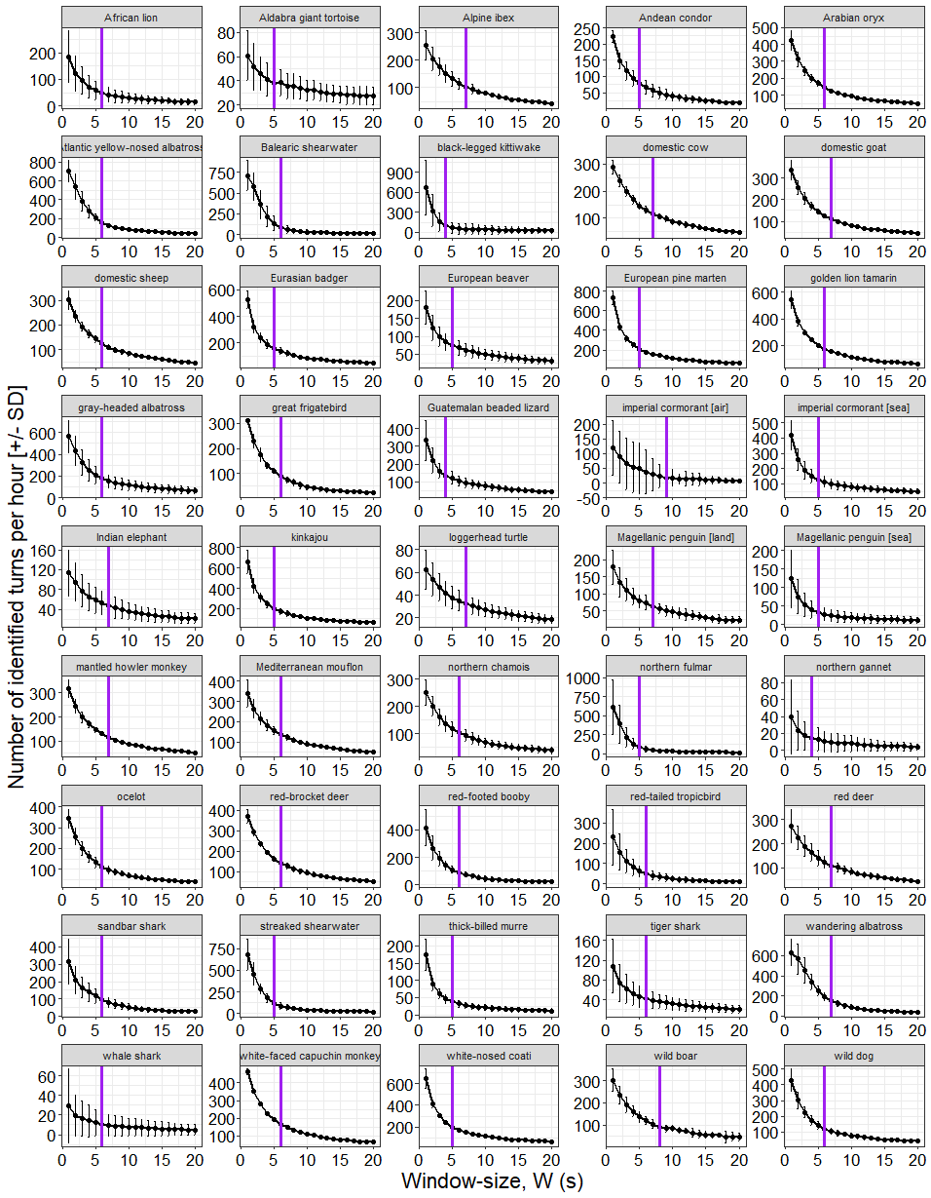
Number of turns identified per hour (+ 1 SE) versus the window-size, W, from Potts et al (10). A constant turn angle threshold of 30° was used (see below). The purple lines show the elbow point of inflection.

Fig. S2.

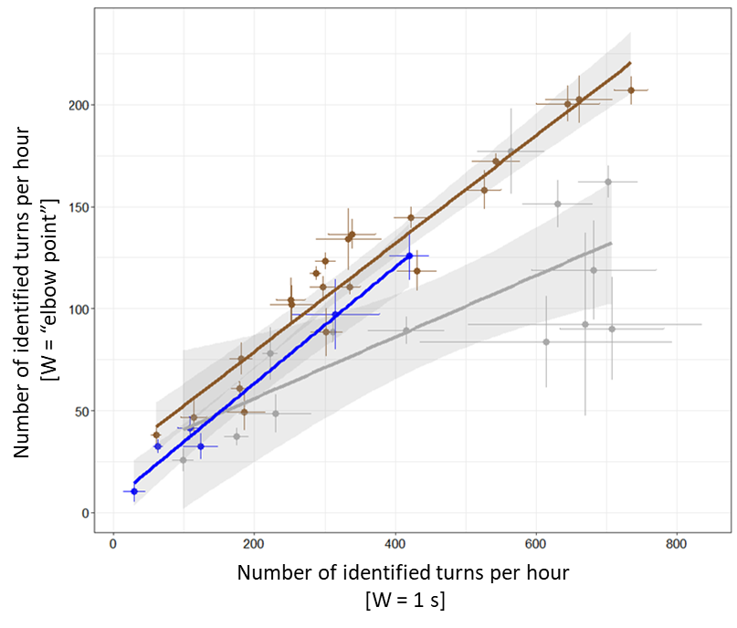
Mean (+ 1 SD) number of identified turns per hour per species using the elbow point of inflection method (see text above) to select species-specific W window, against the mean number of turns per hour identified using a constant W window of 1 s.

Fig. S3.
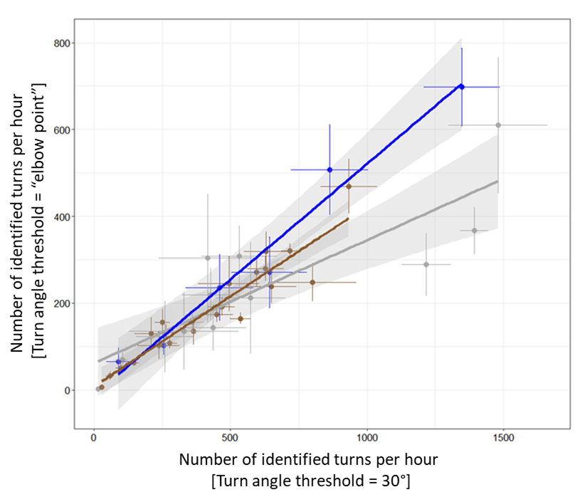
Mean (+ 1 SD) number of identified turns per hour per species using the elbow point of inflection method (see text above) to select species-specific turn angle threshold, against the mean number of turns per hour identified using a constant turn angle threshold of 30⁰.

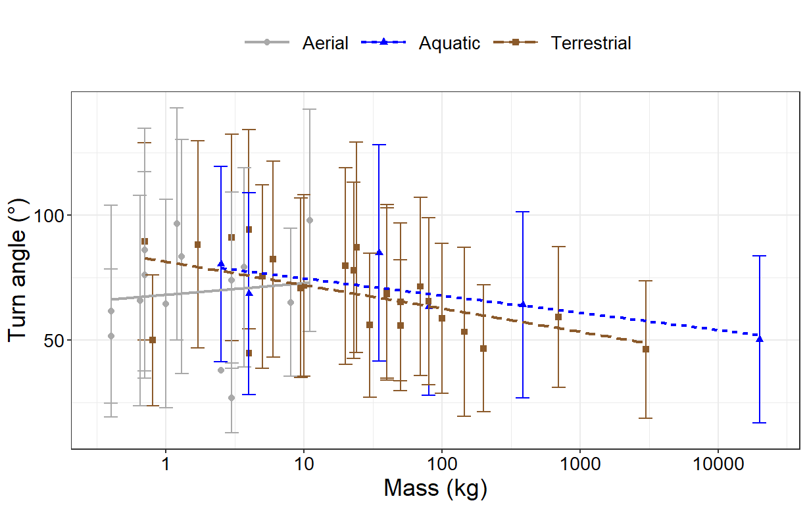
Fig. S4.

Relationship between body mass and average absolute turn angle across different locomotion modes. Each point represents the mean (±1 SD) absolute turn angle (°) for a species. Different colors represent different locomotion modes: (gray = aerial, blue = aquatic, and brown = terrestrial).

Fig. S5.
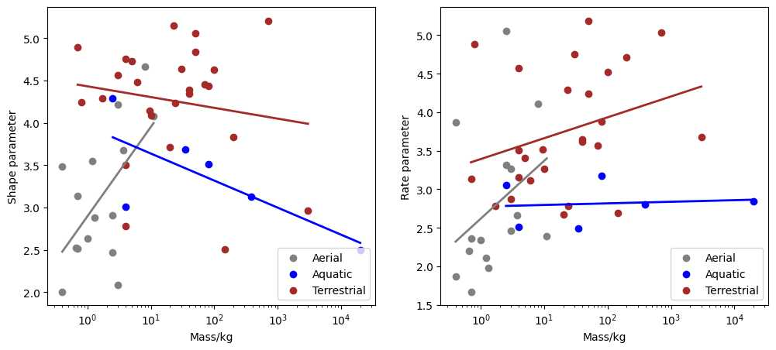

Relationship between the 'shape' and 'rate' parameters of the gamma distribution fit and the mass of various species, classified according to their respective locomotion modes. Each point on the plot corresponds to a specific species. The species are distributed across three distinct locomotion modes: aerial, aquatic, and terrestrial. Among these, only the 'shape' parameter for flighted (aerial) animals shows a significant relationship with species mass.

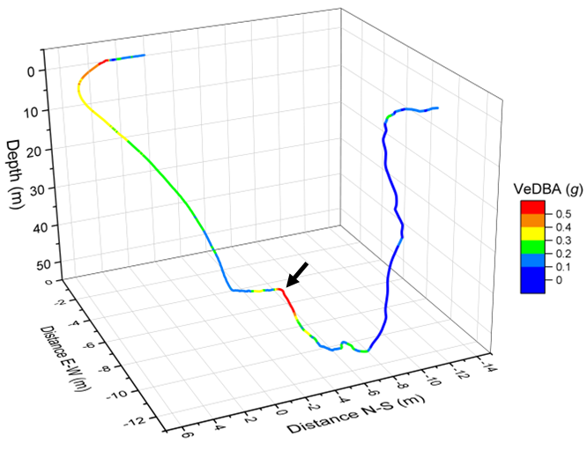
Fig. S6.
The three-dimensional dead-reckoned path of a foraging imperial cormorant during a single dive, showing what we believe is the animal altering its trajectory in response to sighting pelagic prey (black arrow). The color gradient represents the vectorial dynamic body acceleration (VeDBA), a measure that is often used as a proxy for the animal's movement-based energy expenditure. The sharp change in the cormorant's heading, represented by a marked shift in the trajectory, coincides with a spike in VeDBA. This suggests an increased effort or urgency in the animal's movement, likely indicating the initiation of a pursuit phase. This illustrates changes in conditions associated with a turn point.

Table S1.

Details of datasets obtained from various species. Data for all species were initially recorded at a frequency of 10-40 Hz. After the preliminary data processing phase to determine animal headings, all datasets were subsequently subsampled to 20 Hz, apart from those for the wild boar and red deer, which retained their original recording frequency of 10 Hz. Table rows are color-coded based on the predominant mode of locomotion/lifestyle of each species (blue = aquatic, brown = terrestrial, green = arboreal, gray = aerial). Note, however, there are exceptions in certain cases. For example, data for the Eurasian beaver encompassed both terrestrial and aquatic movement, white-nosed coatis occasionally engage in arboreal movement, and the data for Magellanic penguins and imperial cormorants was divided into aquatic and terrestrial phases (for the former), and aerial and aquatic phases (for the latter) stages, each of which was analyzed independently. In all studied species fitted with Daily Diary tags, the weight of the tag did not surpass 5% of the body mass, and all but three species had a tag-to-body mass ratio below 3% to minimize potential tag detriment on the wearers.
Species | Latin name | No. of datasets used | Deployment location | Deployment date | Attachment method
African lion | Panthera Leo | 10 | South Africa | 2019 | Collar
Aldabra giant tortoise | Aldabrachelys gigantea | 8 | Mauritius (Round Island) | 2016 | Epoxy glue
Alpine ibex | Capra ibex | 3 | France (Belledonne) | 2017/18 | Collar
Andean condor | Vultur gryphus | 3 | Argentina (Bariloche) | 2015 | Harness
Arabian oryx | Oryx leucoryx | 6 | Saudi Arabia | 2015 | Collar
Atlantic yellow-nosed albatross | Thalassarche chlororhynchos | 7 | UK (Nightingale Island) | 2018 | Tape
Balearic shearwater | Puffinus mauretanicus | 6 | Spain (Mallorca) | 2016 | Tape
black-legged kittiwake | Rissa tridactyla | 6 | Alaska | 2019 | Tape
domestic cow | Bos taurus | 9 | France (Les Bauges) | 2017 | Collar
domestic goat | Capra aegagrus hircus | 9 | France (Les Bauges) | 2017 | Collar
domestic sheep | Ovis aries | 7 | Argentina (Bariloche) | 2019 | Collar
Eurasian beaver | Castor fiber | 8 | Norway (Telemark county) | 2019 | Epoxy glue
European badger | Meles meles | 8 | Northen Ireland | 2015 | Collar
European pine marten | Martes martes | 9 | Northen Ireland | 2022 | Collar
golden lion tamarin | Leontopithecus rosalia | 3 | Brazil | 2016 | Harness
gray-headed albatross | Thalassarche chrysostoma | 10 | South Africa (Marion Island) | 2017/18 | Tape
great frigatebird | Fregata minor | 2 | France (Europa Island) | 2018 | Tape
Guatemalan beaded lizard | Heloderma charlesbogerti | 6 | Guatemala | 2019 | Epoxy glue
imperial cormorant | Leucocarbo atriceps | 12 | Argentina | 2019 | Tape
Indian elephant | Elephas maximus indicus | 6 | Thailand | 2018 | Collar
kinkajou | Potus flavus | 6 | Panama (BCI) | 2022 | Collar
loggerhead turtle | Caretta caretta | 6 | Cape Verde Islands (Boa Vista) | 2014 | Epoxy glue
Magellanic penguin | Spheniscus magellanicus | 10 | Argentina | 2019 | Tape
mantled howler monkey | Alouatta palliata | 4 | Panama (BCI) | 2024 | Collar
Mediterranean mouflon | Ovis gmelini musimon | 4 | France (Caroux Espinuse) | 2017/18 | Collar
northern chamois | Rupicapra rupicapra | 5 | France (Les Bauges) | 2017/18 | Collar
northern fulmar | Fulmarus glacialis | 4 | Ireland | 2018 | Tape
northern gannet | Morus bassanus | 3 | France | 2024 | Tape
ocelot | Leopardus pardalis | 5 | Panama (BCI) | 2023/24 | Collar
red-brocket deer | Mazama americana | 4 | Panama (BCI) | 2023/24 | Collar
red deer | Cervus elaphus | 5 | Czech Republic (Doupov) | 2019 | Collar
red-footed boobies | Sula sula | 6 | France (Europa Island) | 2015 | Tape
red-tailed tropicbird | Phaethon rubricauda | 7 | Mauritius (Round Island) | 2017 | Tape
sandbar shark | Carcharhinus plumbeus | 4 | Australia (Ningaloo Reef) | 2017 | Clamp
streaked shearwater | Calonectris leucomelas | 4 | Japan (Awashima Island) | 2018 | Tape
thick-billed murre | Uria lomvia | 7 | Canada | 2019 | Tape
tiger shark | Galeocerdo cuvier | 10 | Australia (Ningaloo Reef) | 2017 | Clamp
wandering albatross | Diomedea exulans | 7 | South Africa (Marion Island) | 2007/22 | Tape
whale shark | Rhincodon typus | 6 | Australia (Ningaloo Reef) | 2020/22 | Clamp
white-faced capuchin monkey | Cebus capucinus | 3 | Panama (BCI) | 2024 | Collar
white-nosed coati | Nasua nasua | 4 | Panama (Gamboa) | 2022 | Collar
wild boar | Sus scrofa | 5 | Czech Republic (Kostelec) | 2019 | Collar
wild dog | Lycaon pictus | 6 | Zambia | 2022 | Collar

Table S2.
Species | % turns less than $C_{mean}$  (± margin of error of the 95% confidence interval)
Aldabra giant tortoise | 100 ± 0.0
Alpine ibex | 100 ± 0.0
Indian elephant | 100 ± 0.0
Magellanic penguin | 100 ± 0.0
northern gannet | 100 ± 0.0
whale shark | 99.7 ± 0.7
domestic sheep | 99.6 ± 0.3
Guatemalan beaded lizard | 99.0 ± 1.3
African lion | 98.2 ± 3.2
Balearic shearwater | 97.5 ± 2.1
imperial cormorant | 95.3 ± 9.2
domestic cow | 94.6 ± 4.0
tiger shark | 92.2 ± 7.5
red deer | 90.7 ± 13.0
Mediterranean mouflon | 90.6 ± 4.9
loggerhead turtle | 89.2 ± 7.9
black-legged kittiwake | 88.9 ± 16.6
streaked shearwater | 88.0 ± 14.0
wild boar | 86.9 ± 17.1
thick-billed murre | 85.5 ± 7.9
ocelot | 85.25 ± 9.7
wandering albatross | 81.1 ± 19.6
domestic goat | 81.1 ± 6.8
northern chamois | 80.7 ± 13.7
Magellanic penguin | 80.6 ± 6.0
red-brocket deer | 80.0 ± 7.0
Arabian oryx | 78.2 ± 4.0
northern fulmar | 76.6 ± 26.5
sandbar shark | 74.9 ± 19.5
European badger | 73.7 ± 8.5
gray-headed albatross | 67.2 ± 16.3
red-tailed tropicbird | 66.1 ± 22.0
Atlantic yellow-nosed albatross | 64.0 ± 16.9
Eurasian beaver | 63.4 ± 19.3
red-footed booby | 61.7 ± 12.2
mantled howler monkey | 48.2 ± 18.4
wild dog | 48.1 ± 12.6
Andean condor | 46.8 ± 18.0
imperial cormorant | 43.6 ± 7.7
kinkajou | 41.4 ± 7.1
white-nosed coati | 38.8 ± 12.6
European pine marten | 38.7 ± 7.7
great frigatebird | 31.5 ± 24.9
white-faced capuchin monkey | 28.5 ± 9.3
golden lion tamarin | 23.4 ± 19.1

The mean percentage of each species’ trajectory with a Circular Standard Deviation (CSD) less than the mean of the turning angles for a random trajectory. Table rows are color-coded based on the predominant mode of locomotion/lifestyle of each species (blue = aquatic, brown = terrestrial, green = arboreal, gray = aerial).

Table S3.

Linear regression analysis results for mean absolute values of turn angles per species and locomotion mode, against (log10) mass (kg).
Locomotion Mode | Intercept ± SE | Slope ± SE | R-Value | P-Value
Aerial | 68.070 ± 12.854 | 4.64163 ± 12.85353 | 0.104 | 0.724
Aquatic | 81.536 ± 2.715 | -6.86998 ± 2.71522 | -0.785 | 0.065
Terrestrial | 81.369 ± 3.041 | -9.35958 ± 3.04117 | -0.54 | 0.005

Table S4.

Descriptors for best fit truncated gamma distributions for turn angle data from the different species. The two right-hand columns give the shape and rate values estimated using the best-fit lines shown in Figure S5 together with the species' average mass.

Species | Locomotion mode | Mass/kg | log(Mass/kg) | Shape | Rate | Shape fit | Rate fit
African lion | Terrestrial | 145 | 2.161 | 2.503 | 2.693 | 4.156 | 3.977
Aldabra giant tortoise | Terrestrial | 200 | 2.301 | 3.831 | 4.712 | 4.138 | 4.015
Alpine ibex | Terrestrial | 30 | 1.477 | 4.638 | 4.754 | 4.243 | 3.792
Andean condor | Aerial | 11 | 1.041 | 4.077 | 2.387 | 3.997 | 3.400
Arabian oryx | Terrestrial | 70 | 1.845 | 4.45 | 3.57 | 4.196 | 3.891
Atlantic yellow-nosed albatross | Aerial | 3 | 0.477 | 4.214 | 3.267 | 3.402 | 2.977
Balearic shearwater | Aerial | 0.4 | -0.398 | 3.485 | 3.871 | 2.479 | 2.320
black-legged kittiwake | Aerial | 0.4 | -0.398 | 2.008 | 1.869 | 2.479 | 2.320
domestic cow | Terrestrial | 700 | 2.845 | 5.206 | 5.034 | 4.069 | 4.162
domestic goat | Terrestrial | 40 | 1.602 | 4.387 | 3.616 | 4.227 | 3.826
domestic sheep | Terrestrial | 50 | 1.699 | 5.058 | 5.189 | 4.215 | 3.852
Eurasian beaver | Terrestrial | 20 | 1.301 | 3.715 | 2.673 | 4.266 | 3.744
European badger | Terrestrial | 10 | 1.00 | 4.088 | 3.262 | 4.304 | 3.663
European pine marten | Terrestrial | 1.7 | 0.230 | 4.289 | 2.787 | 4.402 | 3.454
golden lion tamarin | Terrestrial | 0.7 | -0.155 | 4.891 | 3.13 | 4.451 | 3.350
gray-headed albatross | Aerial | 3.7 | 0.568 | 3.675 | 2.662 | 3.498 | 3.045
great frigatebird | Aerial | 1.2 | 0.079 | 3.548 | 2.108 | 2.983 | 2.678
Guatemalan beaded lizard | Terrestrial | 0.8 | -0.097 | 4.246 | 4.881 | 4.443 | 3.366
imperial cormorant | Aerial | 2.5 | 0.398 | 2.469 | 3.318 | 3.319 | 2.917
imperial cormorant | Aquatic | 2.5 | 0.398 | 4.288 | 3.056 | 3.829 | 2.783
Indian elephant | Terrestrial | 3000 | 3.477 | 2.964 | 3.678 | 3.989 | 4.333
kinkajou | Terrestrial | 3 | 0.477 | 4.567 | 2.875 | 4.37 | 3.521
loggerhead turtle | Aquatic | 80 | 1.903 | 3.515 | 3.179 | 3.349 | 2.815
Magellanic Penguin | Terrestrial | 4 | 0.602 | 3.507 | 4.572 | 4.354 | 3.555
Magellanic penguin | Aquatic | 4 | 0.602 | 3.006 | 2.513 | 3.764 | 2.788
mantled howler monkey | Terrestrial | 5 | 0.699 | 4.725 | 3.411 | 4.342 | 3.581
Mediterranean mouflon | Terrestrial | 50 | 1.699 | 4.833 | 4.244 | 4.215 | 3.852
northern chamois | Terrestrial | 40 | 1.602 | 4.348 | 3.644 | 4.227 | 3.826
northern fulmar | Aerial | 0.7 | -0.155 | 3.139 | 2.365 | 2.736 | 2.502
northern gannet | Aerial | 3 | 0.477 | 2.084 | 2.461 | 3.402 | 2.977
ocelot | Terrestrial | 9.5 | 0.978 | 4.139 | 3.52 | 4.307 | 3.657
red-brocket deer | Terrestrial | 23 | 1.362 | 5.144 | 4.287 | 4.258 | 3.761
red deer | Terrestrial | 100 | 2 | 4.625 | 4.521 | 4.177 | 3.933
red-footed booby | Aerial | 1.3 | 0.114 | 2.878 | 1.977 | 3.019 | 2.704
red-tailed tropicbird | Aerial | 0.7 | -0.155 | 2.512 | 1.671 | 2.736 | 2.502
sandbar shark | Aquatic | 35 | 1.544 | 3.689 | 2.491 | 3.464 | 2.807
streaked shearwater | Aerial | 0.65 | -0.187 | 2.522 | 2.199 | 2.702 | 2.478
thick-billed murre | Aerial | 1 | 0 | 2.634 | 2.338 | 2.899 | 2.619
tiger shark | Aquatic | 385 | 2.585 | 3.128 | 2.8 | 3.131 | 2.829
wandering albatross | Aerial | 8 | 0.903 | 4.668 | 4.111 | 3.851 | 3.297
whale shark | Aquatic | 20000 | 4.301 | 2.494 | 2.847 | 2.583 | 2.864
White-faced capuchin monkey | Terrestrial | 4 | 0.602 | 4.753 | 3.158 | 4.354 | 3.555
white-nosed coati | Terrestrial | 6 | 0.778 | 4.476 | 3.117 | 4.332 | 3.603
wild boar | Terrestrial | 80 | 1.903 | 4.435 | 3.88 | 4.189 | 3.907
wild dog | Terrestrial | 24 | 1.38 | 4.23 | 2.785 | 4.255 | 3.766

Table S5.
Correlation between fundamental turn angle and fundamental step duration (for both the step duration before and after a turn) for 43 species of animal. Note, only significant regressions for step duration are given in Fig 4D.
Species | Locomotion Mode | Slope-before | Intercept-before | p-value-before | Slope-after | Intercept-after | p-value-after | Before-sig? | After-sig?
Species | Locomotion Mode | Slope-before | Intercept-before | p-value-before | Slope-after | Intercept-after | p-value-after | Before-sig? | After-sig?
African lion | Terrestrial | -0.00735 | 3.7706 | <0.001 | -0.00584 | 3.68447 | <0.001 | Y | Y
Aldabra giant tortoise | Terrestrial | -0.00169 | 3.60216 | 3.44E-01 | -0.0011 | 3.56666 | 5.33E-01 | N | N
Andean condor | Aerial | -0.00201 | 3.13059 | 3.12E-03 | -0.00236 | 3.16549 | <0.001 | Y | Y
Alpine ibex | Terrestrial | -0.00207 | 3.20774 | 2.98E-02 | 0.00282 | 2.93765 | 3.50E-03 | Y | Y
Arabian oryx | Terrestrial | 0.0011 | 2.68648 | 3.07E-03 | 0.00147 | 2.65794 | <0.001 | Y | Y
Atlantic yellow-nosed albatross | Aerial | -0.00601 | 3.03486 | <0.001 | -0.00628 | 3.04751 | <0.001 | Y | Y
Balearic shearwater | Aerial | -0.01099 | 3.18123 | <0.001 | -0.01221 | 3.22944 | <0.001 | Y | Y
black-legged kittiwake | Aerial | -0.01154 | 3.17797 | <0.001 | -0.01261 | 3.24195 | <0.001 | Y | Y
domestic cow | Terrestrial | -0.00108 | 3.03812 | 1.79E-02 | 0.00022 | 2.96257 | 6.32E-01 | Y | N
domestic goat | Terrestrial | -0.00128 | 3.10375 | 2.84E-03 | -6.00E-05 | 3.01174 | 8.87E-01 | Y | N
domestic sheep | Terrestrial | 2.00E-05 | 2.94969 | 9.58E-01 | 0.00062 | 2.91495 | 1.64E-01 | N | N
Eurasian beaver | Terrestrial | 0.00114 | 2.97057 | 8.13E-02 | 0.00059 | 3.02099 | 3.68E-01 | N | N
European badger | Terrestrial | 0.00034 | 2.62936 | 3.69E-01 | 0.0006 | 2.60993 | 1.10E-01 | N | N
European pine marten | Terrestrial | 0.0012 | 2.34401 | <0.001 | 0.00094 | 2.36713 | 1.46E-03 | Y | Y
golden lion tamarin | Terrestrial | 0.00026 | 2.68967 | 5.53E-01 | 0.00076 | 2.64121 | 9.10E-02 | N | N
gray-headed albatross | Aerial | -0.00543 | 2.92057 | <0.001 | -0.00555 | 2.93051 | <0.001 | Y | Y
great frigatebird | Aerial | -0.0028 | 3.31633 | <0.001 | -0.00313 | 3.3444 | <0.001 | Y | Y
Guatemalan beaded lizard | Terrestrial | -0.00163 | 2.865 | 7.54E-02 | -0.00149 | 2.85887 | 1.09E-01 | N | N
imperial cormorant | Aerial | -0.02772 | 4.11517 | <0.001 | -0.02218 | 4.10929 | 1.23E-03 | Y | Y
imperial cormorant | Aquatic | -0.00076 | 2.67311 | 4.90E-02 | -0.00245 | 2.67063 | <0.001 | Y | Y
Indian elephant | Terrestrial | -0.00211 | 3.78919 | 1.29E-01 | -0.00249 | 3.79313 | 6.94E-02 | N | N
kinkajou | Terrestrial | 0.0007 | 2.46875 | 1.14E-02 | 0.00032 | 2.5029 | 2.54E-01 | Y | N
loggerhead turtle | Aquatic | -0.00164 | 3.80651 | <0.001 | -0.00349 | 3.8895 | <0.001 | Y | Y
Magellanic Penguin | Terrestrial | -0.00724 | 3.36638 | <0.001 | -0.00682 | 3.3725 | 1.55E-03 | Y | Y
Magellanic penguin | Aquatic | -0.00426 | 3.12216 | <0.001 | -0.00525 | 2.89904 | <0.001 | Y | Y
mantled howler monkey | Terrestrial | 0.00215 | 2.76557 | 1.80E-01 | 0.00348 | 2.66102 | 2.94E-02 | N | Y
Mediterranean mouflon | Terrestrial | 0.00141 | 2.75841 | 1.07E-02 | 0.00068 | 2.80956 | 2.16E-01 | Y | N
northern chamois | Terrestrial | -0.00132 | 3.05852 | 2.83E-02 | -0.00105 | 3.03092 | 9.04E-02 | Y | N
northern fulmar | Aerial | -0.00548 | 2.90122 | <0.001 | -0.00564 | 2.91805 | <0.001 | Y | Y
northern gannet | Aerial | 0.003 | 4.51755 | 9.36E-01 | -0.02214 | 5.41238 | 5.56E-01 | N | N
ocelot | Terrestrial | 0.00074 | 2.84536 | 6.27E-01 | 0.00415 | 2.61063 | 6.21E-03 | N | Y
red-brocket deer | Terrestrial | -0.00024 | 2.75274 | 9.44E-01 | 0.00257 | 2.53652 | 4.38E-01 | N | N
red deer | Terrestrial | -0.0012 | 3.11926 | 6.18E-02 | 4.00E-05 | 3.04617 | 9.55E-01 | N | N
red-footed booby | Aerial | -0.00188 | 3.04935 | <0.001 | -0.00302 | 3.14229 | <0.001 | Y | Y
red-tailed tropicbird | Aerial | -0.00759 | 3.96864 | <0.001 | -0.0078 | 3.98743 | <0.001 | Y | Y
sandbar shark | Aquatic | 0.00013 | 3.01859 | 7.57E-01 | 0.00022 | 3.00982 | 5.84E-01 | N | N
streaked shearwater | Aerial | -0.00487 | 2.85553 | <0.001 | -0.00549 | 2.9001 | <0.001 | Y | Y
thick-billed murre | Aerial | 0.00019 | 3.42771 | 7.63E-01 | -0.00274 | 3.62146 | <0.001 | N | Y
tiger shark | Aquatic | -0.00204 | 3.73592 | <0.001 | -0.00297 | 3.80126 | <0.001 | Y | Y
wandering albatross | Aerial | -0.00658 | 3.03923 | <0.001 | -0.00663 | 3.04229 | <0.001 | Y | Y
whale shark | Aquatic | -0.00914 | 4.41148 | <0.001 | -0.01299 | 4.60406 | <0.001 | Y | Y
white-faced capuchin monkey | Terrestrial | -0.00293 | 3.03632 | 8.03E-02 | 0.00352 | 2.43967 | 3.55E-02 | N | Y
white-nosed coati | Terrestrial | 0.00066 | 2.47946 | 1.81E-01 | 0.00123 | 2.43428 | 1.39E-02 | N | Y
wild boar | Terrestrial | 0.00241 | 2.93155 | <0.001 | 0.00092 | 3.02293 | 1.39E-01 | Y | N
wild dog | Terrestrial | 8.00E-05 | 2.67143 | 8.87E-01 | 0.00038 | 2.65188 | 5.30E-01 | N | N
Supplementary references

1 Potts, J. R. et al. Finding turning-points in ultra-high-resolution animal movement data. Methods in Ecology and Evolution 9, 2091-2101 (2018). https://doi.org/https://doi.org/10.1111/2041-210X.13056
2 Gunner, R. M. et al. Dead-reckoning animal movements in R: a reappraisal using Gundog.Tracks. Animal Biotelemetry 9, 23 (2021). https://doi.org/10.1186/s40317-021-00245-z
3 Potts, J. R. et al. Finding turning‐points in ultra‐high‐resolution animal movement data. Methods in Ecology and Evolution 9, 2091-2101 (2018).
4 Simeone, A. & Wilson, R. P. In-depth studies of Magellanic penguin (Spheniscus magellanicus) foraging: can we estimate prey consumption by perturbations in the dive profile? Marine Biology 143, 825-831 (2003). https://doi.org/10.1007/s00227-003-1114-8

