Supplementary Materials

A Fully Automated, Expert-Perceptive Image Quality Assessment System for Whole-Body [18F]FDG PET/CT
- Deep Neural Network
  - CT segmentation
The original format of the medical images in the study was DICOM, and the .png format images corresponding to the key slices by leveraging patient ID data. These were then categorized by anatomy and saved across various directories. We use TotalSegmentator, the largest public datasets and nnUnet based powerful tool in the field of 3D medical image segmentation to segment and slice aortic arch, liver and spleen, ilium, tracheal carina, pancreas, iliac artery bifurcation, and brain. nnUnet was use for the segmentation of the thyroid gland, condyle, and subsequent PET cerebral cortex in the sagittal plane.Fig. S1 Examples of CT segmentation
The model structure of nnU-Net is based on the classical U-Net architecture, consisting of an encoder and a decoder. The encoder is responsible for extracting features from the image and reducing the resolution of the input image through downsampling. The decoder performs upsampling operations to restore the feature maps to the original resolution of the image and generate pixel-level segmentation results.
In the encoder part, nnU-Net utilizes multiple slices of convolution and pooling operations to spatially reduce the input image while extracting features with varying levels of abstraction. These features capture the morphology and texture information of different structures and tissues in medical images.
In the decoder part, nnU-Net employs upsampling and convolution operations to restore the resolution of the feature maps and generate segmentation results that match the size of the input image. To improve segmentation accuracy, the model incorporates skip connections, which fuse features from different levels of the encoder and decoder, thereby preserving richer spatial information.
To enhance the expressive power and generalization ability of the model, nnU-Net also incorporates advanced techniques such as residual connections and batch normalization. These techniques effectively mitigate the issues of gradient vanishing and model overfitting, improving the performance and stability of the model.
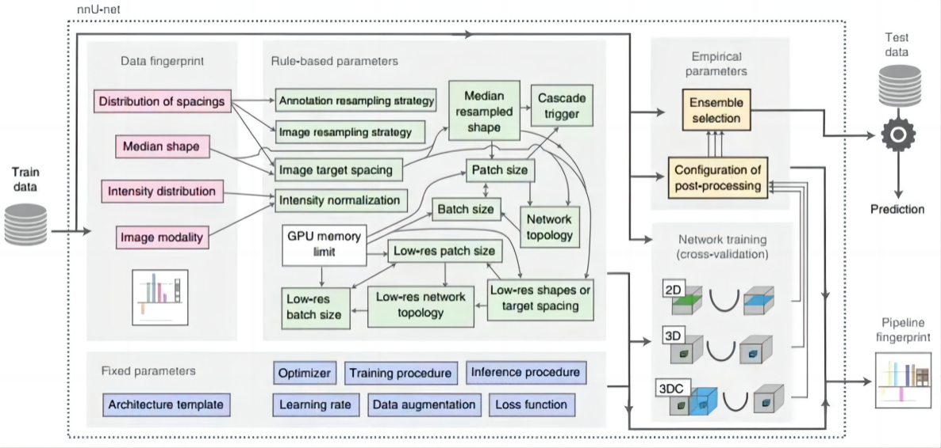
Fig. S2 Pipeline of nnU-Net network
Fig. S2 shows how nnU-Net systematically addresses the configuration of the entire split pipeline and provides a visualization and description of the most relevant design choices. The automatic configuration of the network is based on extracting domain knowledge into fixed parameter groups, rule parameter groups, and empirical parameter groups. First, collect all design choices that do not require adaptation between datasets and optimize their joint configuration to achieve stable generalization on the development dataset. Second, develop clear dependencies between data sets. Dependencies are modeled in the form of interdependent heuristic rules that allow for instant execution on the application. When nnU-Net is applied to a new data set, the automatic configuration of nnU-Net runs without human intervention. Therefore, there is no additional computational cost except for the few remaining empirical choices to be made and the standard network training procedure.
  - Key slices selection logic
Based on the TotalSegmentator dataset, each part is distinguished according to its own similarity and area logic, as shown in Table S1.
Table S1 Key slices selection logic
Position | Evaluation criteria for CT | Evaluation criteria for PET | Note
Basal Ganglia (Brain) | Display basal ganglia region structure and lateral ventricles | Display major sulci of the cerebral cortex | Includes basal nuclei and lateral ventricles.
Basal Ganglia (Brain) |  | Distinguish the neural nuclei in the basal ganglia region (caudate nucleus head, putamen, thalamus) | Includes basal nuclei and lateral ventricles.
Cerebellar Vermis (Brain) | Display cerebellar vermis | Display cerebellar cortex and subcortical nuclei | Features the cerebellar vermis and brainstem.
Cerebellar Vermis (Brain) | Display brainstem | Display cerebellar cortex and subcortical nuclei | Features the cerebellar vermis and brainstem.
Aortic Arch (Thorax) | Differentiate esophagus, trachea, and major vessels structures | Differentiate aortic arch wall and lumen | Select the slice with maximum and clearest aortic arch display
Tracheal Carina (Thorax) | Display lung texture | Lung and mediastinum activity contrast | Select the slice at the bifurcation of the trachea
Tracheal Carina (Thorax) | Display interlobar fissures | Lung and mediastinum activity contrast | Select the slice at the bifurcation of the trachea
Liver (Abdomen) | Display contour of abdominal organs (liver, spleen, stomach) | Distinguish liver and spleen contours, focus on uniform uptake in the liver | Select the slice with the largest combined display area of the liver and spleen
Pancreas (Abdomen) | Display contour of pancreas | Display contour of pancreas | Showcases the maximum pancreatic contour.
Pelvic Bone (Pelvis) | Display bone structure, joints, etc. | Display profile of the iliac bone | Visualizes bones and joint structures.

  - Localization of key slices in head data of PET images
In the head positioning scheme, we have taken a series of precise steps to ensure the accuracy of positioning. The following is the specific operation process:
- Carry out condyle segmentation and calculate the left and right head swing angle (Fig. S3).
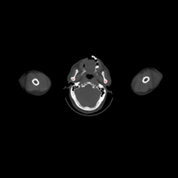
Fig. S3 Slice of condyle segmentation
- Rotate the PET image and obtain sagittal slices, calculate the pitch angle of the head (Fig.S4).
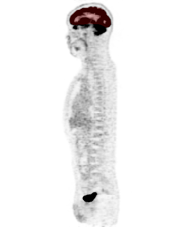
Fig. S4 Rotating Slice View of the Pitch Angle of Head
- Rotate the CT image according to two angles (Figure S5), the key slice of the basal ganglia was found according to the inner diameter of the brain/the maximum area of the brain, and the key slice of the cerebellar vermis was found 35mm down from this key slice.
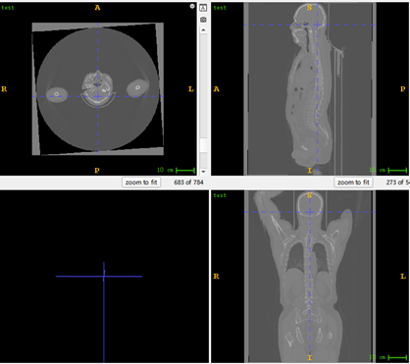
Fig. S5 Image after rotation
- Map the CT results to the PET, overlay the information of the CT image on the PET image. The positioning basis of the head's key slices includes: 1) Head (basal ganglia): Select the level that shows the high uptake of the caudate nucleus, putamen, and thalamus. 2) Head (cerebellar vermis): Display the cerebellar vermis and brainstem.
  - The IQA scoring model
The IQA scoring model applied the multi-dimensional attention network for reference-free image quality assessment (https://github.com/IIGROUP/MANIQA), which combines a vision transformer (ViT) for feature extraction with a transposed attention block (TAB) and a scaled shifted-window transformer block (SSTB) to deploy the attention mechanism across both channels and spatial dimensions. TAB is designed to enhance global interactions across the image's channels (feature dimensions). Traditional attention mechanisms in vision transformers primarily focus on spatial dependencies, which may overlook the rich contextual information present across different channels. TAB addresses this by applying attention across the channel dimension, which allows the model to capture the global context and channel-level dependencies effectively. SSTB is designed to enhance local interactions within the image, focusing on how different patches of the image relate to one another in terms of their spatial arrangement. It uses a modified version of the Swin Transformer architecture to capture fine-grained, patch-level information while ensuring computational efficiency.
The TAB ensured targeted channel weighting in preparation. The SSTB module extracted optimal local information and output the final weighted score of the image through two branches.
After input into the network, the image sequences were first divided into patches of a fixed size, and features are extracted using ViT. Then, these features are passed through the Score Branch, which consists of a series of fully connected slices and activation functions that transform the feature representations into a quality score for each patch. Lastly, the final output of this branch is a score that represents the perceptual quality of each patch, indicating whether the patch has high or low visual quality. The Weight Branch predicts the weight or importance of each patch in determining the overall image quality score. This branch helps the model focus on the most perceptually significant areas of the image, as some patches may be more relevant to human perception than others. First, similar to the Score Branch, the Weight Branch takes the features extracted from ViT as input. It passes these features through its own set of fully connected slices and activation functions (the final activation function in this module uses sigmoid instead of ReLU in the Score Branch) to output a weight for each patch. These weights indicate the relative importance of each patch in contributing to the final image quality score. The output of this branch is a weight map, where each patch is assigned a value that determines how much influence it should have in the final score calculation
  - Training Protocol
Detailed training parameters included: Batch_size, 4; Learn_rate, 10⁻⁵; epochs, 100; Input_size, 224 × 224 × 3; Patch_size, 8; Loss_function, L1Loss; Split Dataset, 80 % training /10 % validation/10% testing. DL model development was implemented using Python version 3.6 and PyTorch version 1.3 running in Ubuntu 16.04 on a workstation with two Xeon E5-2650 (12C24T) 2.2 GHz CPUs (Intel) with 192 Gb RAM and eight NVIDIA GTX 1080 Ti GPUs with 12 Gb memory (NVidia).

- Dataset
The detailed PET reconstruction conditions and PET/CT image counts are provided in follows:
Table S2 Number of images in different datasets
 | CT |  |  |  | PET
 | Total | Train | Val | Test | Total | Train | Val | Test
Basal ganglia | 602 | 481 | 60 | 61 | 521 | 415 | 53 | 53
Cerebellar vermis | 602 | 481 | 60 | 61 | 521 | 415 | 53 | 53
Aortic arch | 638 | 511 | 63 | 64 | 631 | 527 | 52 | 52
Tracheal carina | 638 | 511 | 63 | 64 | 615 | 505 | 55 | 55
Liver | 638 | 511 | 63 | 64 | 633 | 527 | 53 | 53
Pancreas | 638 | 511 | 63 | 64 | 623 | 517 | 53 | 53
Iliac bone | 638 | 511 | 63 | 64 | 636 | 524 | 56 | 56
Train, Training set; Val, Validation Set; Test, Test Set ; After the described process, the images were identified and extracted and then randomly divided into training (80%), validation (10%), and testing (10%) datasets.

- Other information
We offer a Checklist for Artificial Intelligence in Medical Imaging (Table S3) to ensure high-quality scientific communication(1).

Table S3 Checklist for Artificial Intelligence in Medical Imaging
Section / Topic | No. | Item
TITLE / ABSTRACT
 | 1 | Identification as a study of AI methodology, specifying the category of technology used (e.g., deep learning) | √
 | 2 | Structured summary of study design, methods, results, and conclusions | √
INTRODUCTION
 | 3 | Scientific and clinical background, including the intended use and clinical role of the AI approach | √
 | 4 | Study objectives and hypotheses | √
METHODS
Study Design | 5 | Prospective or retrospective study | √
 | 6 | Study goal, such as model creation, exploratory study, feasibility study, non-inferiority trial | √
Data | 7 | Data sources | √
 | 8 | Eligibility criteria: how, where, and when potentially eligible participants or studies were identified (e.g., symptoms, results from previous tests, inclusion in registry, patient-care setting, location, dates) | √
 | 9 | Data pre-processing steps | √
 | 10 | Selection of data subsets, if applicable | √
 | 11 | Definitions of data elements, with references to Common Data Elements | √
 | 12 | De-identification methods | √
 | 13 | How missing data were handled
Ground Truth | 14 | Definition of ground truth reference standard, in sufficient detail to allow replication | √
 | 15 | Rationale for choosing the reference standard (if alternatives exist) | √
 | 16 | Source of ground-truth annotations; qualifications and preparation of annotators | √
 | 17 | Annotation tools | √
 | 18 | Measurement of inter- and intrarater variability; methods to mitigate variability and/or resolve discrepancies | √
Data Partitions | 19 | Intended sample size and how it was determined | √
 | 20 | How data were assigned to partitions; specify proportions
 | 21 | Level at which partitions are disjoint (e.g., image, study, patient, institution) | √
Model | 22 | Detailed description of model, including inputs, outputs, all intermediate slices and connections | √
 | 23 | Software libraries, frameworks, and packages | √
 | 24 | Initialization of model parameters (e.g., randomization, transfer learning)
Training | 25 | Details of training approach, including data augmentation, hyperparameters, number of models trained | √
 | 26 | Method of selecting the final model | √
 | 27 | Ensembling techniques, if applicable
Evaluation | 28 | Metrics of model performance | √
 | 29 | Statistical measures of significance and uncertainty (e.g., confidence intervals) | √
 | 30 | Robustness or sensitivity analysis | √
 | 31 | Methods for explainability or interpretability (e.g., saliency maps), and how they were validated
 | 32 | Validation or testing on external data | √
RESULTS
Data | 33 | Flow of participants or cases, using a diagram to indicate inclusion and exclusion | √
 | 34 | Demographic and clinical characteristics of cases in each partition | √
Model performance | 35 | Performance metrics for optimal model(s) on all data partitions
 | 36 | Estimates of diagnostic accuracy and their precision (such as 95% confidence intervals) | √
 | 37 | Failure analysis of incorrectly classified cases
DISCUSSION
 | 38 | Study limitations, including potential bias, statistical uncertainty, and generalizability | √
 | 39 | Implications for practice, including the intended use and/or clinical role | √
OTHER INFORMATION
 | 40 | Registration number and name of registry | √
 | 41 | Where the full study protocol can be accessed
 | 42 | Sources of funding and other support; role of funders | √

1. Mongan J, Moy L, Kahn CE. Checklist for Artificial Intelligence in Medical Imaging (CLAIM): A Guide for Authors and Reviewers. Radiology: Artificial Intelligence. 2020;2:e200029.

