Effects of Freezing and Thawing on Soil Shear Strength in the Western Farming Pastoral Ecotone of Northern China
Yue Hong ¹, Qiang Zhou ^{1, 2 *}, Weidong Ma ^{1, 2}, Baicheng Niu ^{1, 2},
Fenggui Liu ^{1, 2}, Qiong Chen ^{1, 2}
¹College of Geographical Sciences, Qinghai Normal University, Xining 810008, China.
²Academy of Plateau Science and Sustainability, Xining 810008, China.
*Correspondence: Qiang Zhou, e-mail: zhouqiang729@163.com
Table S1. Basic properties of the three soils
Sampling time | Soil type | WRB classification | Bulk density(g/cm⁻³) | Moisture content(%) | Particle composition(%)
 |  |  |  |  | >2mm | 1-2mm | 0.5-1mm | 0.25-0.5mm | <0.25mm
2024.5.4 | Chernozem | Chernozems | 1.16 | 29.24 | 18.2 | 10.3 | 22 | 14.3 | 35.2
2024.8.25 | Sierozem | Calcisols | 1.06 | 10.89 | 23.2 | 7 | 12.5 | 8.2 | 49.2
2024.8.26 | Loessial soil | Luvisols | 1.12 | 2.66 | 21.8 | 21.8 | 7.5 | 8.8 | 40.1
Table S2. Data on geographic and climatic characteristics of the three soils
Soil type | Longitude  (E) | Latitude (N) | Altitude (m) | Average annual temperature  (℃) | Average annual precipitation (mm) | Number of freezing days (days) | Area proportion (%)
Chernozem | 102°21′ | 35°28′ | 3472.5 | 5.2 | 125.1 | 60-90 | 5
Sierozem | 102°0′ | 36°22′ | 2589.29 | 7.6 | 310.1 | 60-90 | 27
Loessial soil | 104°42′ | 35°28′ | 1907.8 | 7.2 | 377 | 30-60 | 30
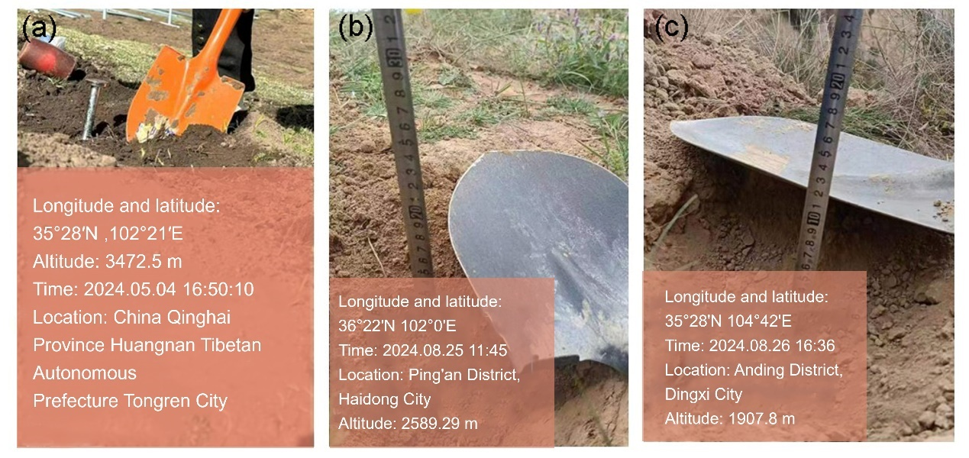
Figure S1. Photographs of chernozem, sierozem, and loessial soil sampling. (a) represents chernozem. (b) represents sierozem. (c) represents loessial soil.

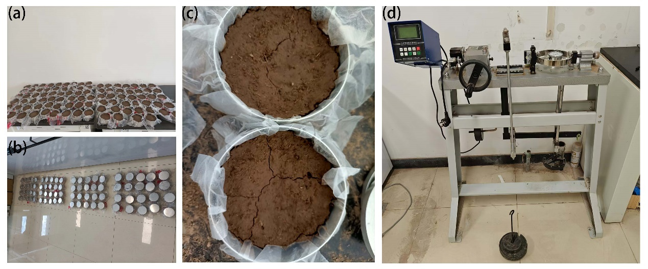
Figure S2. Sample preparation and testing process. (a) Sample filling and remolded soil preparation. (b) Indoor freeze-thaw cycle simulation. (c) Micro-cracks on the surface of samples after freeze-thaw cycles. (d) ZJ type strain-controlled shear tester for unconsolidated undrained quick shear test.
Table S3. Effect of freeze-thaw action on shear strength of loessial soil, sierozem and chernozem
Soil type | Water content  (%) | Freeze-thaw cycle  (times) | Shear strength  (Kpa)
loessial soil | 10 | 0 | 94.29
loessial soil | 10 | 1 | 89.48
loessial soil | 10 | 3 | 89.41
loessial soil | 10 | 5 | 88
loessial soil | 10 | 7 | 85.26
loessial soil | 10 | 10 | 86.82
loessial soil | 15 | 0 | 87.26
loessial soil | 15 | 1 | 84.89
loessial soil | 15 | 3 | 85.41
loessial soil | 15 | 5 | 85.71
loessial soil | 15 | 7 | 83.56
loessial soil | 15 | 10 | 83.93
loessial soil | 20 | 0 | 83.71
loessial soil | 20 | 1 | 79.57
loessial soil | 20 | 3 | 82.31
loessial soil | 20 | 5 | 81.35
loessial soil | 20 | 7 | 82.08
loessial soil | 20 | 10 | 82.53
loessial soil | 30 | 0 | 81.64
loessial soil | 30 | 1 | 77.5
loessial soil | 30 | 3 | 80.24
loessial soil | 30 | 5 | 79.94
loessial soil | 30 | 7 | 78.68
loessial soil | 30 | 10 | 78.53
sierozem | 10 | 0 | 93.47
sierozem | 10 | 1 | 88.81
sierozem | 10 | 3 | 86.89
sierozem | 10 | 5 | 85.86
sierozem | 10 | 7 | 83.86
sierozem | 10 | 10 | 85.78
sierozem | 15 | 0 | 87.19
sierozem | 15 | 1 | 85.56
sierozem | 15 | 3 | 85.93
sierozem | 15 | 5 | 84.89
sierozem | 15 | 7 | 81.71
sierozem | 15 | 10 | 84.3
sierozem | 20 | 0 | 84.89
sierozem | 20 | 1 | 84.38
sierozem | 20 | 3 | 82.31
sierozem | 20 | 5 | 81.79
sierozem | 20 | 7 | 81.57
sierozem | 20 | 10 | 79.05
sierozem | 30 | 0 | 80.83
sierozem | 30 | 1 | 80.09
sierozem | 30 | 3 | 79.27
sierozem | 30 | 5 | 78.53
sierozem | 30 | 7 | 78.09
sierozem | 30 | 10 | 76.98
chernozem | 10 | 0 | 100.87
chernozem | 10 | 1 | 93.47
chernozem | 10 | 3 | 89.55
chernozem | 10 | 5 | 87.48
chernozem | 10 | 7 | 87.56
chernozem | 10 | 10 | 88.52
chernozem | 15 | 0 | 88.15
chernozem | 15 | 1 | 86.82
chernozem | 15 | 3 | 83.79
chernozem | 15 | 5 | 84.45
chernozem | 15 | 7 | 82.82
chernozem | 15 | 10 | 78.68
chernozem | 20 | 0 | 86.37
chernozem | 20 | 1 | 80.9
chernozem | 20 | 3 | 78.68
chernozem | 20 | 5 | 80.44
chernozem | 20 | 7 | 81.42
chernozem | 20 | 10 | 79.79
chernozem | 30 | 0 | 78.98
chernozem | 30 | 1 | 77.43
chernozem | 30 | 3 | 76.54
chernozem | 30 | 5 | 75.5
chernozem | 30 | 7 | 77.29
chernozem | 30 | 10 | 76.76
Table S4. Effect of freeze-thaw action on cohesion of loessial soil, sierozem and chernozem
Soil type | Water content  (%) | Freeze-thaw cycle  (times) | Cohesion  (Kpa)
loessial soil | 10 | 0 | 17.75
loessial soil | 10 | 1 | 16.27
loessial soil | 10 | 3 | 15.53
loessial soil | 10 | 5 | 12.57
loessial soil | 10 | 7 | 11.83
loessial soil | 10 | 10 | 11.83
loessial soil | 15 | 0 | 14.05
loessial soil | 15 | 1 | 13.68
loessial soil | 15 | 3 | 13.31
loessial soil | 15 | 5 | 11.83
loessial soil | 15 | 7 | 10.35
loessial soil | 15 | 10 | 11.83
loessial soil | 20 | 0 | 12.94
loessial soil | 20 | 1 | 13.68
loessial soil | 20 | 3 | 11.09
loessial soil | 20 | 5 | 11.46
loessial soil | 20 | 7 | 11.09
loessial soil | 20 | 10 | 11.09
loessial soil | 30 | 0 | 12.20
loessial soil | 30 | 1 | 11.83
loessial soil | 30 | 3 | 10.35
loessial soil | 30 | 5 | 11.83
loessial soil | 30 | 7 | 10.35
loessial soil | 30 | 10 | 8.87
sierozem | 10 | 0 | 11.83
sierozem | 10 | 1 | 7.40
sierozem | 10 | 3 | 8.13
sierozem | 10 | 5 | 8.87
sierozem | 10 | 7 | 6.66
sierozem | 10 | 10 | 8.13
sierozem | 15 | 0 | 6.66
sierozem | 15 | 1 | 5.92
sierozem | 15 | 3 | 5.18
sierozem | 15 | 5 | 8.13
sierozem | 15 | 7 | 5.18
sierozem | 15 | 10 | 6.66
sierozem | 20 | 0 | 4.81
sierozem | 20 | 1 | 8.50
sierozem | 20 | 3 | 6.66
sierozem | 20 | 5 | 8.13
sierozem | 20 | 7 | 8.13
sierozem | 20 | 10 | 5.18
sierozem | 30 | 0 | 8.50
sierozem | 30 | 1 | 8.87
sierozem | 30 | 3 | 7.39
sierozem | 30 | 5 | 8.87
sierozem | 30 | 7 | 8.87
sierozem | 30 | 10 | 5.55
chernozem | 10 | 0 | 22.55
chernozem | 10 | 1 | 19.60
chernozem | 10 | 3 | 18.12
chernozem | 10 | 5 | 17.38
chernozem | 10 | 7 | 17.01
chernozem | 10 | 10 | 18.86
chernozem | 15 | 0 | 16.27
chernozem | 15 | 1 | 16.27
chernozem | 15 | 3 | 14.79
chernozem | 15 | 5 | 17.01
chernozem | 15 | 7 | 14.05
chernozem | 15 | 10 | 17.01
chernozem | 20 | 0 | 15.16
chernozem | 20 | 1 | 17.01
chernozem | 20 | 3 | 14.79
chernozem | 20 | 5 | 16.42
chernozem | 20 | 7 | 14.42
chernozem | 20 | 10 | 15.90
chernozem | 30 | 0 | 13.31
chernozem | 30 | 1 | 13.31
chernozem | 30 | 3 | 12.20
chernozem | 30 | 5 | 14.05
chernozem | 30 | 7 | 13.75
chernozem | 30 | 10 | 15.53
Table S5. Effect of freeze-thaw action on internal friction Angle of loessial soil, sierozem and chernozem
Soil type | Water content  (%) | Freeze-thaw cycle  (times) | Angle of internal friction(°)
loessial soil | 10 | 0 | 27.03
loessial soil | 10 | 1 | 26.02
loessial soil | 10 | 3 | 26.22
loessial soil | 10 | 5 | 26.7
loessial soil | 10 | 7 | 26.08
loessial soil | 10 | 10 | 26.56
loessial soil | 15 | 0 | 26.02
loessial soil | 15 | 1 | 25.4
loessial soil | 15 | 3 | 25.67
loessial soil | 15 | 5 | 26.22
loessial soil | 15 | 7 | 26.02
loessial soil | 15 | 10 | 25.67
loessial soil | 20 | 0 | 25.26
loessial soil | 20 | 1 | 23.71
loessial soil | 20 | 3 | 25.4
loessial soil | 20 | 5 | 24.98
loessial soil | 20 | 7 | 25.33
loessial soil | 20 | 10 | 25.47
loessial soil | 30 | 0 | 24.84
loessial soil | 30 | 1 | 23.64
loessial soil | 30 | 3 | 24.98
loessial soil | 30 | 5 | 24.42
loessial soil | 30 | 7 | 24.49
loessial soil | 30 | 10 | 24.91
sierozem | 10 | 0 | 28.56
sierozem | 10 | 1 | 28.49
sierozem | 10 | 3 | 27.7
sierozem | 10 | 5 | 27.17
sierozem | 10 | 7 | 27.23
sierozem | 10 | 10 | 27.37
sierozem | 15 | 0 | 28.23
sierozem | 15 | 1 | 27.97
sierozem | 15 | 3 | 28.3
sierozem | 15 | 5 | 27.1
sierozem | 15 | 7 | 27.03
sierozem | 15 | 10 | 27.37
sierozem | 20 | 0 | 28.1
sierozem | 20 | 1 | 26.83
sierozem | 20 | 3 | 26.76
sierozem | 20 | 5 | 26.15
sierozem | 20 | 7 | 26.08
sierozem | 20 | 10 | 26.22
sierozem | 30 | 0 | 25.74
sierozem | 30 | 1 | 25.4
sierozem | 30 | 3 | 25.6
sierozem | 30 | 5 | 24.91
sierozem | 30 | 7 | 24.77
sierozem | 30 | 10 | 25.47
chernozem | 10 | 0 | 27.57
chernozem | 10 | 1 | 26.22
chernozem | 10 | 3 | 25.47
chernozem | 10 | 5 | 25.05
chernozem | 10 | 7 | 25.19
chernozem | 10 | 10 | 24.91
chernozem | 15 | 0 | 25.6
chernozem | 15 | 1 | 25.19
chernozem | 15 | 3 | 24.7
chernozem | 15 | 5 | 24.21
chernozem | 15 | 7 | 24.63
chernozem | 15 | 10 | 22.35
chernozem | 20 | 0 | 25.4
chernozem | 20 | 1 | 23.07
chernozem | 20 | 3 | 23.07
chernozem | 20 | 5 | 23.11
chernozem | 20 | 7 | 24.07
chernozem | 20 | 10 | 23.07
chernozem | 30 | 0 | 23.64
chernozem | 30 | 1 | 23.14
chernozem | 30 | 3 | 23.21
chernozem | 30 | 5 | 22.28
chernozem | 30 | 7 | 22.96
chernozem | 30 | 10 | 22.21

