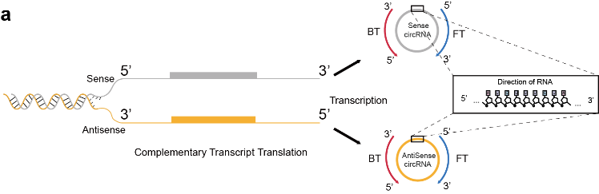
Extended Data Fig.1 | Schematic illustration of the relationship between backward/forward translation and complementary translation.

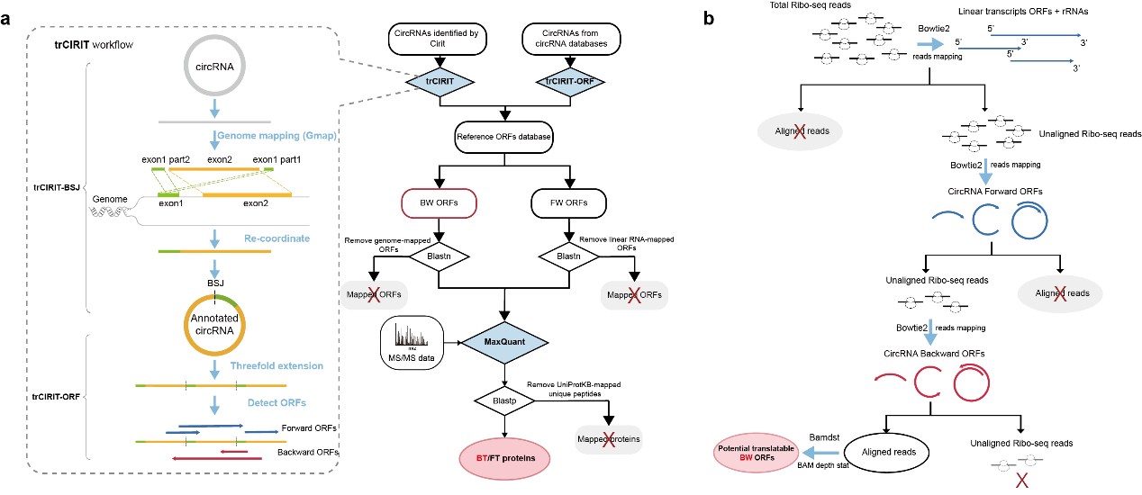
Extended Data Fig.2 | Computational workflow for detecting backward translation protein via searching the Mass spectrometry evidences (a) and the specific Ribo-seq evidences (b).
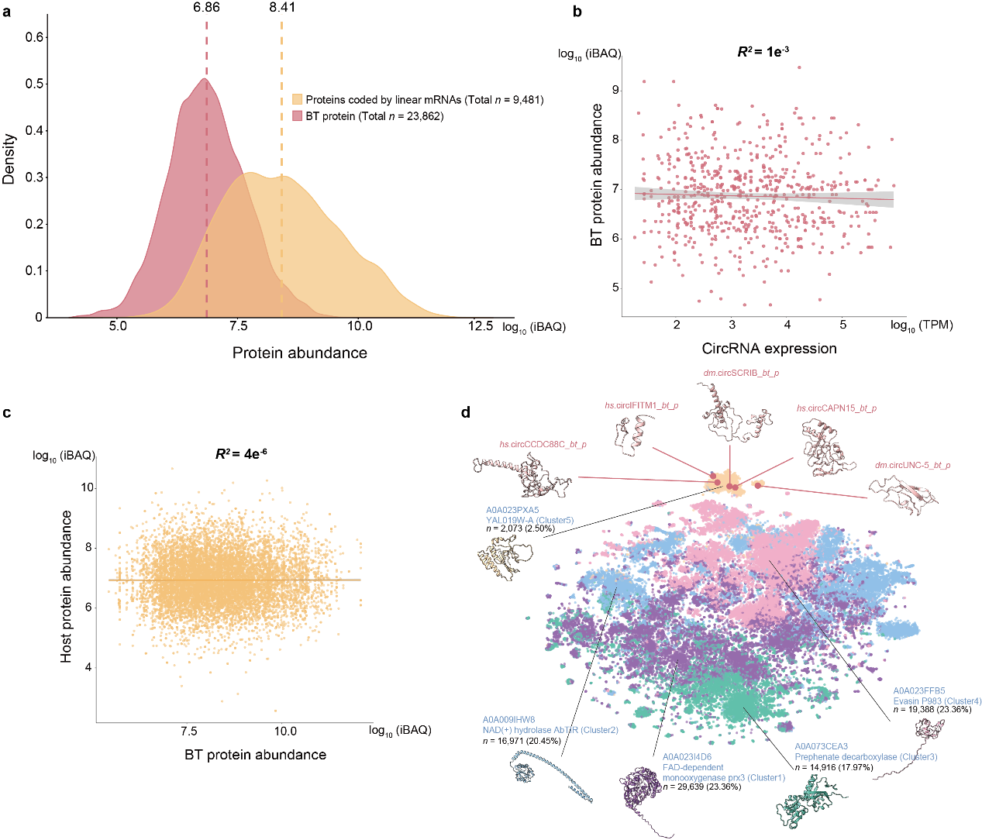
Extended Data Fig.3 | Expression features of BT proteins. a, Abundance comparison between BT proteins and the proteins coded by linear mRNAs (sourced from the UniProtKB). b, Abundance correlation between circRNAs and the BT proteins they produced. The correlation analysis was demonstrated on a parallel transcriptome/proteome dataset determined on 70 liver samples (dataset ID: PXD006512). Sample size: n = 630. c, Abundance correlation between BT proteins and their counterpart parent proteins. The Pearson correlation was utilized and the Coefficient (R²) was calculated. Sample size: n = 12,960. d, Structural features of BT proteins. The structure of five selected BT proteins, including three human BT proteins (hs.circCCDC88C_bt_p, hs.circIFITM1_bt_p, and hs.circCAPN15_bt_p) and two Drosophila BT proteins (dm.circSCRIB_bt_p and dm.circUNC-5_bt_p), were modeled with AlphaFold and subsequently optimized with 50ns molecular dynamics with Gromacs. Structural comparison between five selected BT proteins and present known proteins, including 542,337 AlphaFold-modeled structures. For large-scale comparison, the structures were first represented as the average embedding tokens with the ProtT5-XL-U50 model of ProtTrans. The K-means method was then utilized to cluster the structures. The t-SNE method of the cuML package, Matplotlib and Seaborn were utilized to visualize the clustering result.

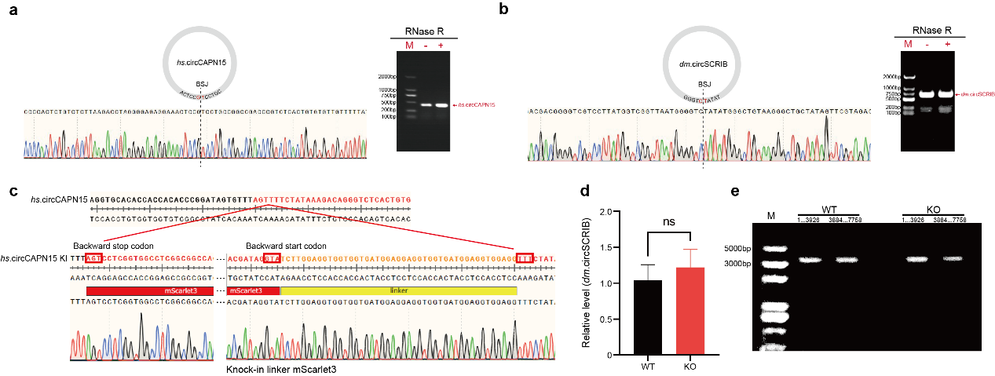
Extended Data Fig.4 | RT-PCR and Sanger sequencing validation of circRNA expression. a, RT-PCR result of hs.circCAPN15. The retained 329 bp band after RNase R treatment confirmed the expression of hs.circCAPN15. b, RT-PCR result of dm.circSCRIB. The retained 596 bp band after RNase R treatment confirmed the expression of dm.circSCRIB. c, The Sanger sequencing of the hs.circCAPN15 knock-in in HeLa cells. d, RT-PCR assays of dm.circSCRIB transcript levels between KO flies and controls. Statistical significance: ns: not significant, “*”: p < 0.05, “**” p < 0.01, and n = 15. e, RT-PCR assays of linear SCRIB transcript levels between KO flies and controls. The CDS of SCRIB is 7,758 bp in length and was thus divided into two segments of approximately 4,000 nt in length for PCR amplification (1..3929 and 3884..7758).

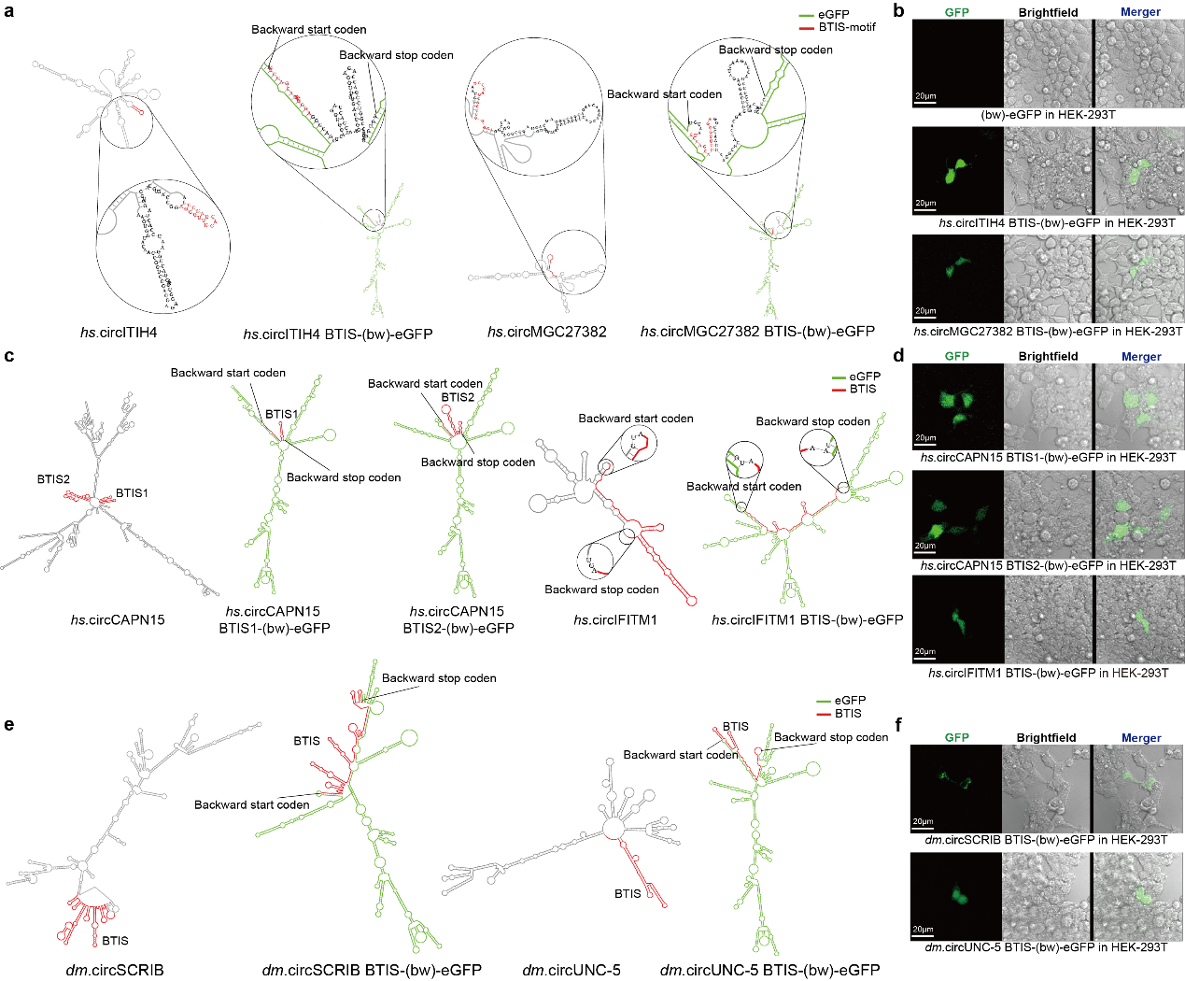
Extended Data Fig.5 | Extraction of the BTISs to initiate eGFP backward translation. a, Extraction the BTISs from hs.circITIH4 and hs.circMGC27382. The BTISs were inserted into the circRNAs separately, linking the start codon and the stop codon of the reverse eGFP ORF. Both BTISs comprised the “TCCCA…TGGGA” motif but did not form the stem-loop structure directly after insertion into the circ-(bw)-eGFPs. b, Backward translation of circ-(bw)-eGFPs in HEK-293T cells, including hs.circITIH4 BTIS-(bw)-eGFP and hs.circMGC27382 BTIS-(bw)-eGFP in HEK-293T. Both circRNAs elicited green fluorescence of eGFP. Representative confocal microscopy images are shown. eGFP in green. Scale bar, 20μm. c, Extraction the BTISs from hs.circCAPN15 (two potential BTISs) and hs.circIFITM1. The BTISs were inserted into the circRNAs separately for constructing circ-(bw)-eGFPs. The BTISs did not contained the “TCCCA…TGGGA” motif but still can form the stem-loop structures before eGFP ORF. d, Backward translation of circ-(bw)-eGFPs in HEK-293T cells, including hs.circCAPN15 BTIS1-(bw)-eGFP, hs.circCAPN15 BTIS2-(bw)-eGFP, and hs.circIFITM1 BTIS-(bw)-eGFP. All circRNAs elicited green fluorescence of eGFP. e, Extraction the BTISs from dm.circSCRIB and dm.circUNC-5. f, Backward translation of circ-(bw)-eGFPs in HEK-293T cells, including dm.circSCRIB BTIS-(bw)-eGFP and dm.circUNC-5 BTIS-(bw)-eGFP. All engineered circRNAs elicited green fluorescence of eGFP. Representative confocal microscopy images are shown. eGFP in green. Scale bar, 20μm.

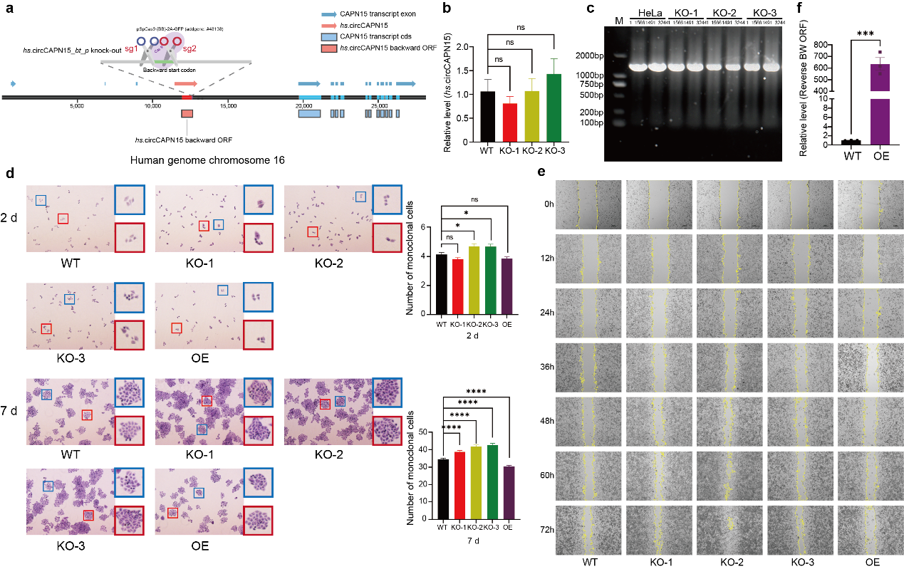
Extended Data Fig.6 | Biological functions of the BT protein hs.circCAPN15_bt_p in human cells. a, Schematic illustration of the genomic loci of hs.circCAPN15 and CAPN15. In genome, hs.circCAPN15 is localized at the non-coding intronic region of gene CAPN15, away from the coding sequence (CDS). b, RT-qPCR results of hs.circCAPN15 before and after knock-out. c, RT-PCR results of host CAPN15 before and after knock-out. The CDS of CAPN15-201, the major CAPN15 transcript, is 3,261 bp in length and was thus divided into two segments of approximately 1,600nt in length for PCR amplification (1..1566 and 1491..3244). d, Plate colony formation assay to assess the impact of hs.circCAPN15_bt_p knock-out and overexpression on the growth rate of HeLa cells in 2 days and 7 days after knock-out. Representative visual fields were marked with red and blue for cell counting. Statistical significance: “*”: p < 0.05, “**”: p < 0.01, “***”: p < 0.001, “****”: p < 0.0001. e, Cell scratch assay to assess the impact of hs.circCAPN15_bt_p knock-out and overexpression on the migration ability of HeLa cells, recording by every 12 hours up to 72 hours. f, RT-qPCR results of the forward-oriented linear hs.circCAPN15_bt_p ORF before and after overexpression. In the bar chart, ns: not significant, “*”: p < 0.05, “**” p < 0.01, “***”: p < 0.001, “****”: p < 0.0001, and repeats n = 15.

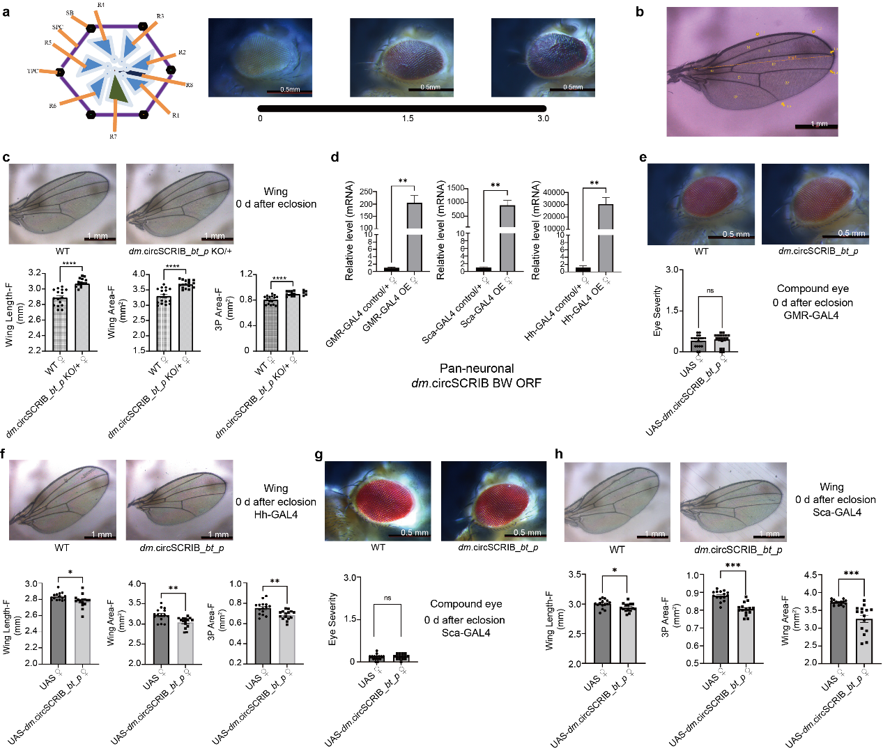
Extended Data Fig.7 | Quantifications of the phenotypes caused by circRNA translation protein knock-out in Drosophila. a, Scoring the disorganization and roughness of the Drosophila compound eye phenotype, ranging from 0.5 to 3. b, Schematic representation of adult Drosophila wing structure. M: Marginal cell, S: Submarginal cell, B1: Basal cell 1, 1P: 1st posterior cell, D: Discal cell, 2P: 2nd posterior cell, A: Anal cell, 3P: 3rd posterior cell, L1: vein L1, L2: radial vein, L3: medial vein, L4: cubital vein, L5: distal vein. c, Adult wing changes in the heterozygotic dm.circSCRIB_bt_p KO Drosophila. The wings were quantified in length, area, and 3P. d, The mRNA levels of linear dm.circSCRIB_bt_p ORF in female Drosophila, measuring with qPCR. Statistical significance: “****” stands for p < 0.0001 and n = 15. e, Compound eye morphology changes in response to overexpression of dm.circSCRIB_bt_p under the GMR-GAL4 regulation system. The compound eye roughness and disorganization were scored on a scale from 0 to 3. f, Wing size change in response to overexpression of dm.circSCRIB_bt_p under the control of Hh-GAL4 system. The wing size was measured in three dimensions of length, area, and 3P. g, Compound eye morphology changes in response to overexpression of dm.circSCRIB_bt_p driven by Sca-GAL4. Statistical significance: “*”: p < 0.05, “**”: p < 0.01, “***”: p < 0.001, “****”: p < 0.0001, n = 15. h, Adult wing size change in response to overexpression of dm.circSCRIB_bt_p driven by Sca-GAL4. Statistical significance: “*”: p < 0.05, “**”: p < 0.01, “***”: p < 0.001, “****”: p < 0.0001, n = 15.

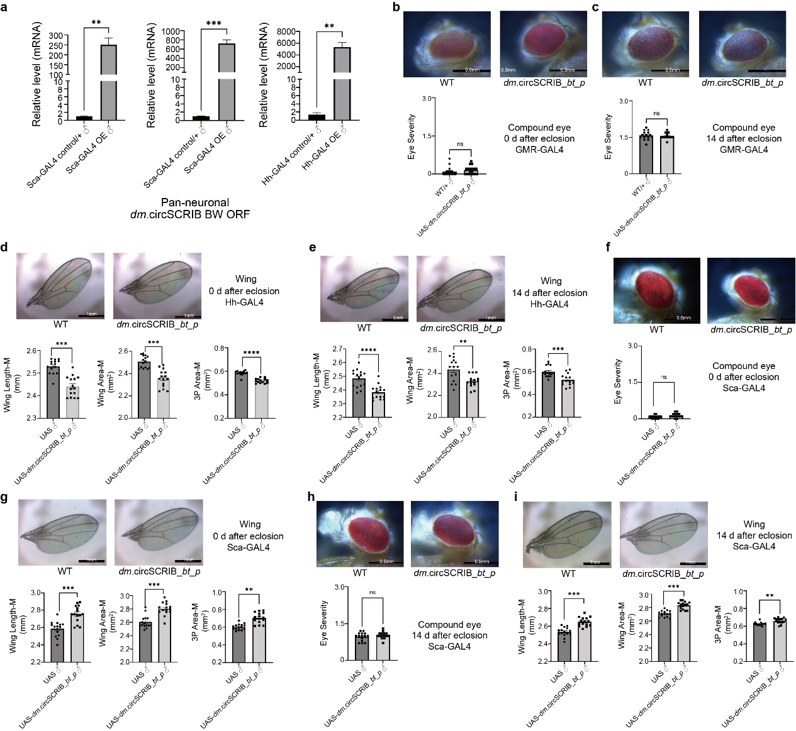
Extended Data Fig.8 | Functional investigation of dm.circSCRIB backward translation in male Drosophila development. a, The mRNA levels of linear dm.circSCRIB_bt_p ORF in male Drosophila, quantified with qPCR. Statistical significance: “****” stands for p < 0.0001 and n = 15. b,c, Compound eye morphology changes in response to overexpression of dm.circSCRIB_bt_p driven by GMR-GAL4. The compound eye roughness and disorganization were scored on a scale from 0 to 3, with data analyzed using GraphPad Prism 9.2.0. d,e, Adult wing size changes in response to overexpression of dm.circSCRIB_bt_p driven by Hh-GAL4. The adult wings were measured in length, area, and 3P. f,h, Compound eye morphology changes in response to overexpression of dm.circSCRIB_bt_p driven by Sca-GAL4. Statistical significance: “*”: p < 0.05, “**”: p < 0.01, “***”: p < 0.001, “****”: p < 0.0001, n = 15. g,i, Adult wing change in response to overexpression of dm.circSCRIB_bt_p driven by Sca-Gal4. Statistical significance: “*”: p < 0.05, “**”: p < 0.01, “***”: p < 0.001, “****”: p < 0.0001, n = 15.

