Table S1 FUNGuild predictions of functional fungal guild relative abundance in Baxijiao
Trophic Mode | CK |  | TA |  | FT |  | RT
Trophic Mode | Mean  (%) | Significance | Mean  (%) | Significance | Mean  (%) | Significance | Mean  (%) | Significance
PG-SA-SY | 0.99 | b | 1.21 | b | 1.18 | b | 2.88 | a
PO | 4.84 | a | 4.43 | a | 6.85 | a | 6.32 | a
PO-SA | 2.76 | a | 3.58 | a | 2.38 | a | 2.51 | a
PO-SA-SY | 8.37 | b | 12.07 | ab | 12.11 | ab | 15.07 | a
PO-SY | 0.53 | a | 0.5 | a | 0.51 | a | 1.17 | a
SA | 15.75 | a | 21.57 | a | 19.65 | a | 24.27 | a
SA-SY | 8.34 | a | 7.24 | a | 10.42 | a | 7.09 | a
SY | 0.48 | a | 0.55 | a | 1.08 | a | 0.41 | a
Unkown | 57.93 | a | 48.84 | a | 45.82 | a | 40.28 | a
Note: PG-SA-SY: Pathogen-Saprotroph-Symbiotroph; PO: Pathotroph; PO-SA: Pathotroph-Saprotroph; PO-SA-SY: Pathotroph-Saprotroph-Symbiotroph; PO-SY: Pathotroph-Symbiotroph; SA: Saprotroph; SA-SY: Saprotroph-Symbiotroph; SY: Symbiotroph. CK: the control treatment; TA: inoculate TR4 alone; FT: foliar application Isotianil and inoculate TR4; RT: root drenching Isotianil and inoculate TR4. Different letters indicate significant (adjusted P < 0.05) differences between treatments by Kruskal-Wallis test and BH method.
Table S2 FUNGuild predictions of functional fungal guild relative abundance in Yunjiao No.1
Trophic Mode | CK |  | TA |  | FT |  | RT
Trophic Mode | Mean  (%) | Significance | Mean  (%) | Significance | Mean  (%) | Significance | Mean  (%) | Significance
PG-SA-SY | 0.6 | b | 0.6 | b | 2.54 | a | 4.21 | a
PO | 2.47 | a | 3.88 | a | 3.81 | a | 3.8 | a
PO-SA | 1.73 | a | 2.23 | a | 2.28 | a | 2.78 | a
PO-SA-SY | 5.77 | b | 7.83 | ab | 12.14 | a | 12.87 | a
PO-SY | 0.58 | a | 0.73 | a | 0.97 | a | 0.82 | a
SA | 12.17 | a | 15.04 | a | 14.92 | a | 16.29 | a
SA-SY | 5.83 | a | 6.83 | a | 6.45 | a | 4.82 | a
SY | 0.47 | a | 1.08 | a | 0.97 | a | 0.48 | b
Unkown | 70.38 | a | 61.78 | ab | 55.94 | ab | 53.93 | b
Note: PG-SA-SY: Pathogen-Saprotroph-Symbiotroph; PO: Pathotroph; PO-SA: Pathotroph-Saprotroph; PO-SA-SY: Pathotroph-Saprotroph-Symbiotroph; PO-SY: Pathotroph-Symbiotroph; SA: Saprotroph; SA-SY: Saprotroph-Symbiotroph; SY: Symbiotroph. CK: the control treatment; TA: inoculate TR4 alone; FT: foliar application Isotianil and inoculate TR4; RT: root drenching Isotianil and inoculate TR4. Different letters indicate significant (adjusted P < 0.05) differences between treatments by Kruskal-Wallis test and BH method.
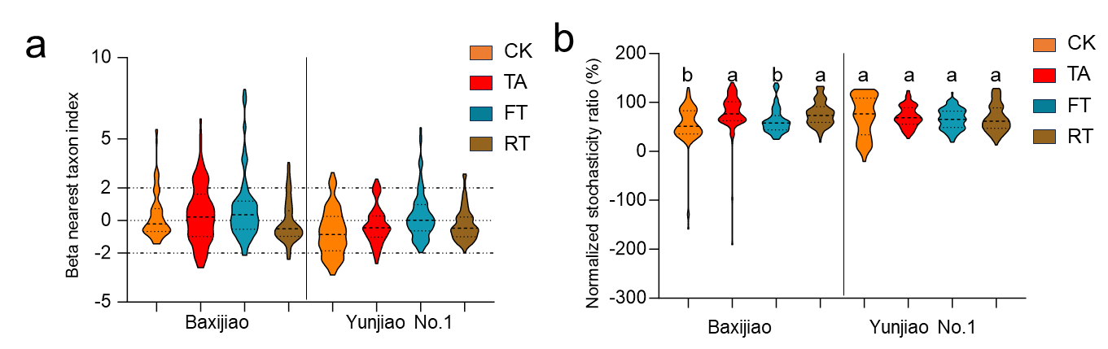
Fig. S1 Assembly mechanisms of fungal communities. (a) Beta nearest taxon index of different treatments. (b) Normalized stochasticity ratio of different treatments. CK: the control treatment; TA: inoculate TR4 alone; FT: foliar application Isotianil and inoculate TR4; RT: root drenching Isotianil and inoculate TR4. Different letters represent significant differences (adjusted P < 0.05) among different treatments within the same variety by Kruskal-Wallis test and BH method.

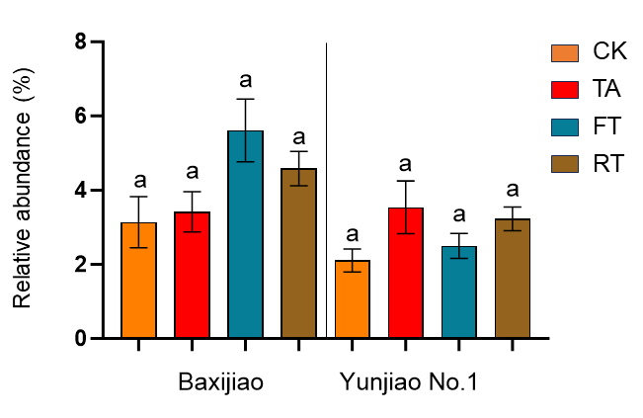
Fig. S2 FUNGuild prediction of relative abundance of plant pathogens. CK: the control treatment; TA: inoculate TR4 alone; FT: foliar application Isotianil and inoculate TR4; RT: root drenching Isotianil and inoculate TR4. Different letters represent significant differences (adjusted P < 0.05) by Kruskal-Wallis test and BH method.

