Supplementary figures

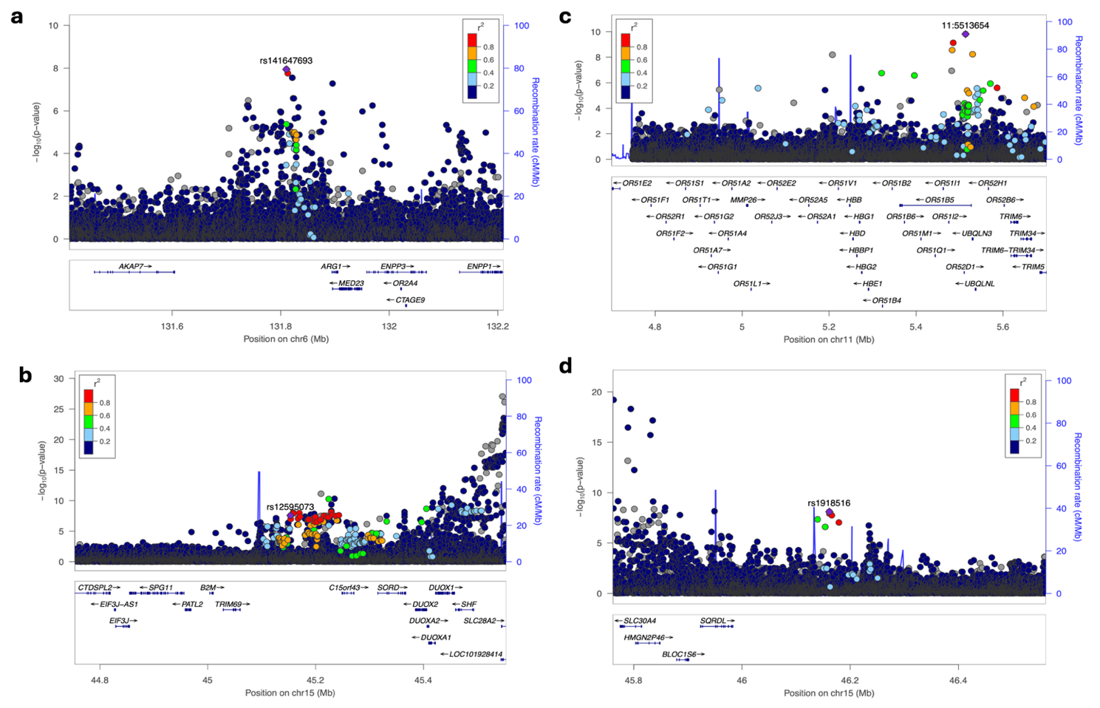

Fig.S2 Locus zoom plots for novel loci associated with eGFR in a pan-African meta-analysis in individuals of African ancestry.

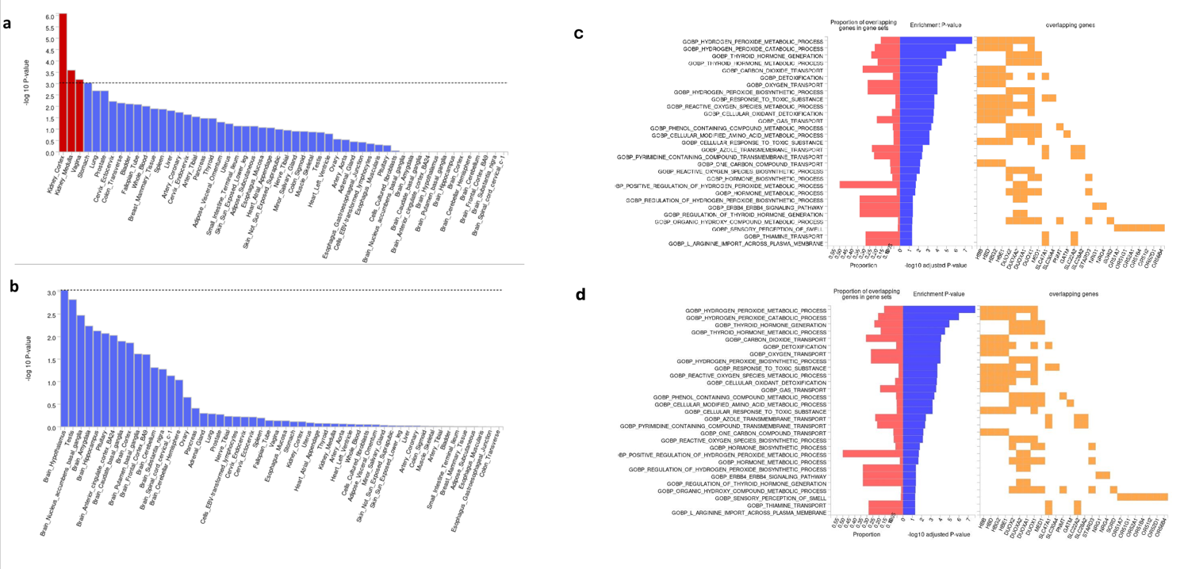
Fig.S3 Pathway analysis using gene-based analysis implemented in FUMA. Our results showed that the mapped genes from the combined African datasets were highly expressed in the kidney (cortex and medulla) and the vagina.

