Supplementary Information for
Transforming zeolite structure direction: metals with a dual role as amine coordinators and siloxy connectors
Juna Bae¹, Dieter Plessers¹, Lynne B. McCusker², and Michiel Dusselier^{1,}*
¹ Center for Sustainable Catalysis and Engineering (CSCE), KU Leuven, Celestijnenlaan 200F, 3001 Leuven, Belgium.
² Department of Materials, ETH Zurich, 8093 Zurich, Switzerland (retired).
*Corresponding author: michiel.dusselier@kuleuven.be

Supplementary Methods

Materials. Colloidal silica (Ludox HS-40, 40%, Aldrich), fumed silica (Aldrich), tetraethylorthosilicate (TEOS, 98%, Aldrich), aluminum tri-sec-butoxide (Al[O(s-Bu)]₃, 97%, Aldrich), cadmium acetate dihydrate (Cd(CH₃COO)₂∙2H₂O, 98%, Aldrich), zinc acetate dihydrate (Zn(CH₃COO)₂∙2H₂O, 98%, Acros), LiOH (98%, Acros), NaOH (50%, Aldrich), ethylenediamine (99.5%, Aldrich), 1,3-diaminopropane (99%, Aldrich), 1,4-diaminobutane (99%, Acros), 1,5-diaminopentane (97%, Aldrich), 1,6-diaminohexane (98%, Aldrich), ammonium hydroxide solution (NH₄OH, 25%, Aldrich), tetramethylammonium hydroxide (TMAOH, 25%, Thermo Scientific), tetraethylammonium hydroxide (TEAOH, 35%, SACHEM), tetrapropylammonium hydroxide (TPAOH, 25%, Thermo Scientific), hydrochloric acid (HCl, 37%, Acros), nitric acid (NHO₃, 65%, Acros), and (non-)crystalline starting materials prepared in this work.

Synthesis of (non-)crystalline starting materials. CIT-6, a zincosilicate analog of zeolite beta with Si/Zn ~ 15, was synthesized with a batch composition of 0.65TEAOH∙0.05LiOH∙0.03Zn(CH₃COO)₂∙2H₂O∙1.0SiO₂∙30H₂O according to the procedures described in the literature¹. As-synthesized CIT-6 was calcined in air at 550 °C for 6 hours to remove the occluded organic molecule. Co-calcined fumed silica with Zn source with Si/Zn = 7.8 was prepared by co-grinding a mixture of Zn(CH₃COO)₂∙2H₂O and fumed silica with a Si/Zn ratio of 8.0, followed by calcination in air at 580 °C for 8 hours. Amorphous metallosilicate with Si/M ~ 8.0 was prepared by heating a synthesis mixture with the composition 0.125NaOH∙0.125M∙1.0SiO₂∙35H₂O, where M is Zn or Cd, at 170 °C for 6 hours².

Synthesis of inorganic-organic hybrid materials. The final composition of the synthesis mixture was xR∙0.1NaOH∙(1/y)Zn∙1.0SiO₂∙30H₂O, where R is diamine and x and y are varied between 0.1 ≤ x ≤ 1.2 and 5 ≤ y ≤ 15, respectively. When necessary, Zn was replaced with the equimolar amount of Cd. After being stirred at room temperature for 1 day, the synthesis mixture was charged into Teflon-lined 23-mL autoclaves and heated at 160 °C for 7-28 days. The solid product was recovered by centrifugation, washed repeatedly with deionized water, and dried in air overnight at 60 °C.

Isolation and swelling of siliceous LEU-1 layer. As-synthesized LEU-1 (0.1 g) was treated with 0.1-12 M HCl solution (20 g) at 95 °C for 0.5-24 hours. The isolated LEU-1 layer (i.e., LEU-1L) was recovered by centrifugation, washed repeatedly with deionized water, and dried in air overnight at 60 °C. LEU-1L (0.1 g) was swollen in a series of quaternary ammonium hydroxide solutions (1.0 mL) by stirring for 1 hour at room temperature. The swollen LEU-1L (i.e., LEU-1L_SW, SW = quaternary ammonium cation) was recovered by centrifugation, washed repeatedly with deionized water, and dried in air overnight at 60 °C.

Topotactic condensation of LEU-1L to LEU-2. LEU-2 was obtained by calcination of LEU-1L and LEU-1L_SW at 560 °C for 6 hours with a temperature ramp of 1 °C min⁻¹.

Hydrothermal conversion of LEU-1L_SW to LEU-3. The LEU-1L_SW (0.1 g) was mixed with a solution of Zn (or Al) source (0.05 g) in 1.0 M HNO₃ solution (3.0 mL) and then heated at 170 °C for 22 hours. The solid product was recovered by centrifugation, washed repeatedly with deionized water, and dried in air overnight at 60 °C. As-prepared solid products were calcined at 620 °C for 12 hours with a temperature ramp of 1 °C min⁻¹ to remove the occluded organic molecule.

General characterization. X-ray powder diffraction (XPD) data were collected on a high-throughput STOE STADI P Combi diffractometer in transmission mode with focusing Ge(111) monochromatic X-ray inlet beams (λ = 1.5406 Å, Cu Kα source). Crystal morphology and average size were determined using a JEOL JSM-6010LV scanning electron microscope (SEM). Elemental analysis was performed using an inductively coupled plasma atomic emission spectrometer (ICP-AES, PerkinElmer Optima 3300 DV) with signals for Si, Al, Zn, Li, and Na at 251.6, 396.2, 213.9, 670.8, and 589.6 nm, respectively. C and N contents were determined by an elemental analyzer (EA 1110, CE Instruments) with combustion at 1020 °C and reduction at 640 °C. A ConFlo IV interface (Thermo Scientific) is used for connection to an IRMS system (Delta V, Thermo Scientific). Elemental fractions are scaled to the overall sample weight. Thermogravimetric analyses (TGA) were performed in air on a TGA/DSC 3+ Mettler Toledo, where the weight losses related to the combustion of organic molecule were further confirmed by differential analyses (DTA) using the same analyzer. The nitrogen sorption experiments were performed on a Tristar II 3020 (Micromeritics) apparatus at 77 K. The relative nitrogen pressure was varied between 0.01 and 0.99 (P/P₀). The t-plot method (Harkins and Jura) was used to determine micropore volumes on the adsorption branch. The Raman spectra were measured on a Bruker Vertex 70 spectrometer with RAM II Raman module laser operating at 1064 nm. The organic sample was exposed to a laser power of 500 mW, accumulating 64 scans at a resolution of 4 cm⁻¹. The solid sample was exposed to a laser power of 200 mW, accumulating 1024 scans at a resolution of 4 cm⁻¹. Diffuse reflectance spectroscopy in the UV-vis-NIR energy range (UV-vis-NIR) was performed with a Varian Cary 5000 UV-vis-NIR spectrophotometer equipped with the internal DRA 2500 accessory at room temperature against a BaSO₄ reflectance standard in the 4000-50000 cm⁻¹ energy range.

¹³C solution nuclear magnetic resonance (NMR) measurement on the organic molecule was recorded in D₂O on a Bruker Avance 400 MHz spectrometer with a BBI 5 mm probe. Solid-state multinuclear NMR measurements were completed on a 11.7 T Oxford wide bore magnet using a 4 mm Chemagnetics HXY probe. All spectra were processed using the Topspin software package and referenced to the unified scale using IUPAC recommended frequency ratios relative to the ¹³C adamantane_{(s)} methylene resonance (δ = 37.77 ppm)^{3,4}. The ¹H NMR (v₀(¹H) = 499.80 MHz) one-pulse experiments were acquired with a MAS frequency of 12 kHz, utilising a π/2 pulse of 4.8 μs (determined on adamantane_{(s)}) and recycle delays of 2-70 s, for 16 scans. The ²⁹Si NMR (v₀(²⁹Si) = 99.29 MHz) one-pulse experiments were acquired with a MAS frequency of 15 kHz, utilising a π/2 pulse of 3.13 μs (determined on kaolinite_{(s)}) and recycle delays of 60 s, for 400 scans. The ²⁹Si{¹H} cross-polarisation experiments were acquired with a MAS frequency of 12 kHz, utilising a ¹H π/2 pulse of 4.8 μs (determined on adamantane_{(s)}), contact pulses of 4000 μs, high power proton decoupling, and recycle delays of 2-70 s, for 525 scans. The ¹³C{¹H} (v₀(¹³C) = 125.68 MHz) cross-polarisation experiments were acquired with a MAS frequency of 12 kHz, utilising a ¹H π/2 pulse of 5.6 μs (determined on adamantane_{(s)}), contact pulses of 5500 μs, high power proton decoupling, and recycle delays of 2-3 s, for 1,000-30,000 scans. Sample dependent recycle delays were determined via saturation recovery experiments which utilised 200 saturation pulses.

Hypothetical zeolite structure generation. The hypothetical periodic models (P1 symmetry) with the LEU-1 layer were built as silica polymorphs using Materials Studio 7.0⁵. These models were optimized using the Dreiding potential⁶ without charges and further optimized using the Sanders-Leslie-Catlow (SLC) potential⁷ in the GULP program⁸. Their highest symmetries were identified by the “Find Symmetry” tool implemented in Materials Studio 7.0. The symmetrized structures were standardized in the VESTA program⁹. To evaluate the feasibility of hypothetical models with P1 symmetry, their framework energies relative to α-quartz¹⁰ were calculated using the SLC potential in the GULP program. In addition, the local interatomic distances (LID) criteria were applied¹¹.

Supplementary Figures
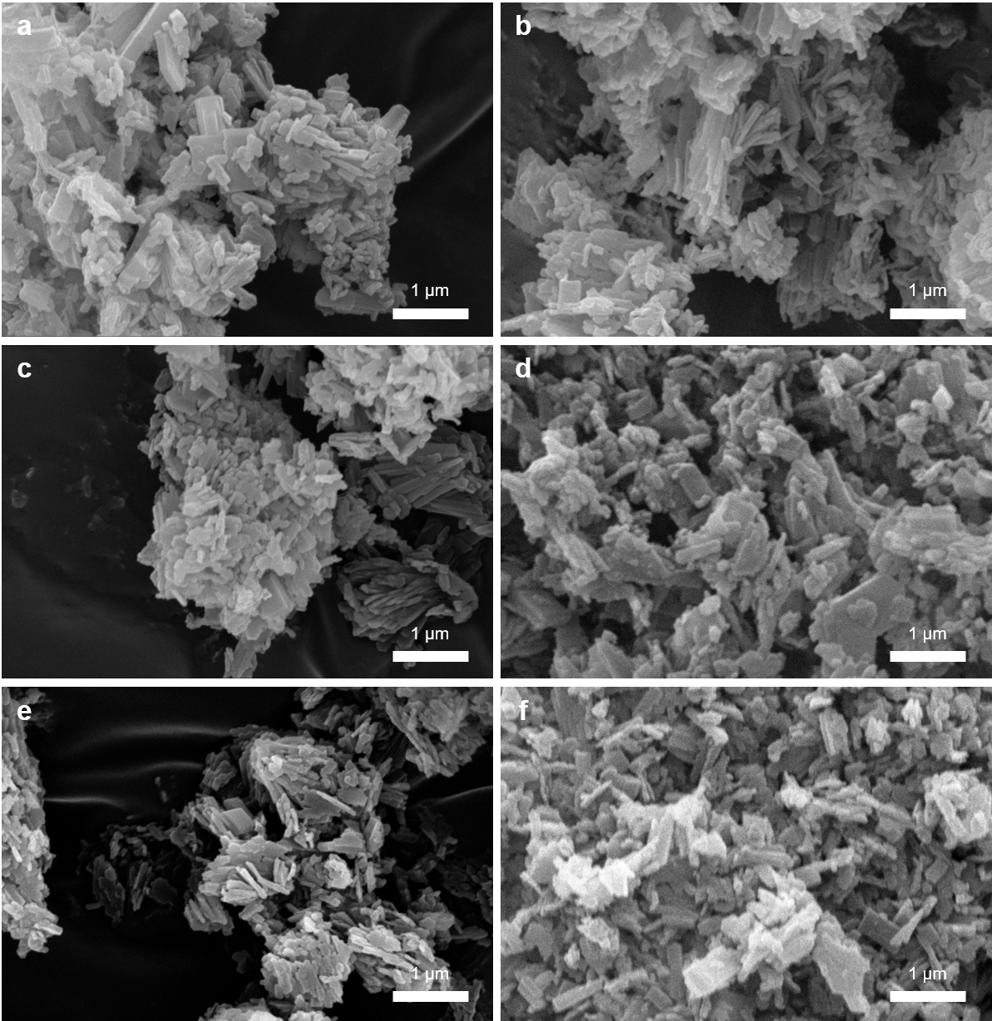

Figure S1. SEM images of as-synthesized LEU-1 (a), calcined LEU-1 (b), LEU-1L (c), LEU-1L_TEA (d), LEU-2 (e), and LEU-3 (f).

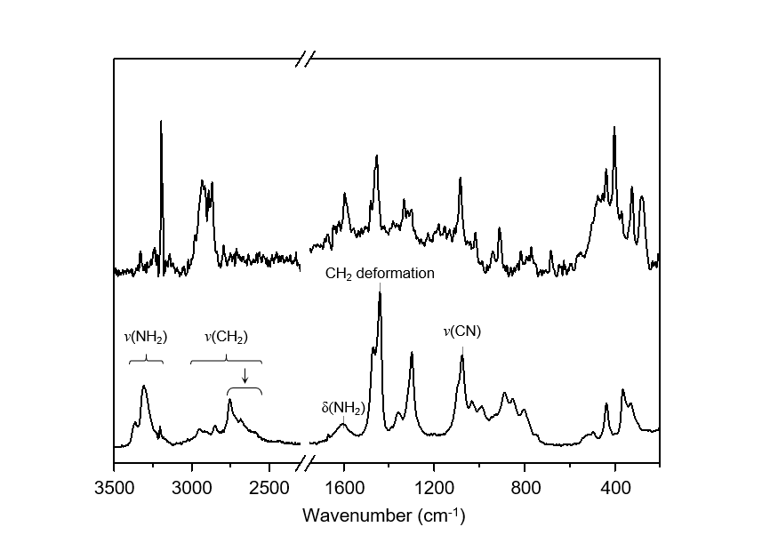

Figure S2. Raman spectra in the 200-3500 cm⁻¹ region of DAB (bottom) and as-synthesized LEU-1 (top). Assignments of the characteristic Raman bands (in cm⁻¹) of neutral DAB: ν_{as}(NH), 3363; ν_{s}(NH), 3309; ν(CH), 2950-2500; Bohlmann bands (arrow), 2800-2500; δ(NH₂), 1605; CH₂ deformation, 1440; ν(CH), 1076^{12,13}. The C/N ratio (2.1; C, 7.2 wt%; N, 4.0 wt%) of organic species in as-synthesized LEU-1 determined by CN analysis is close to the ratio (2.0) of DAB.

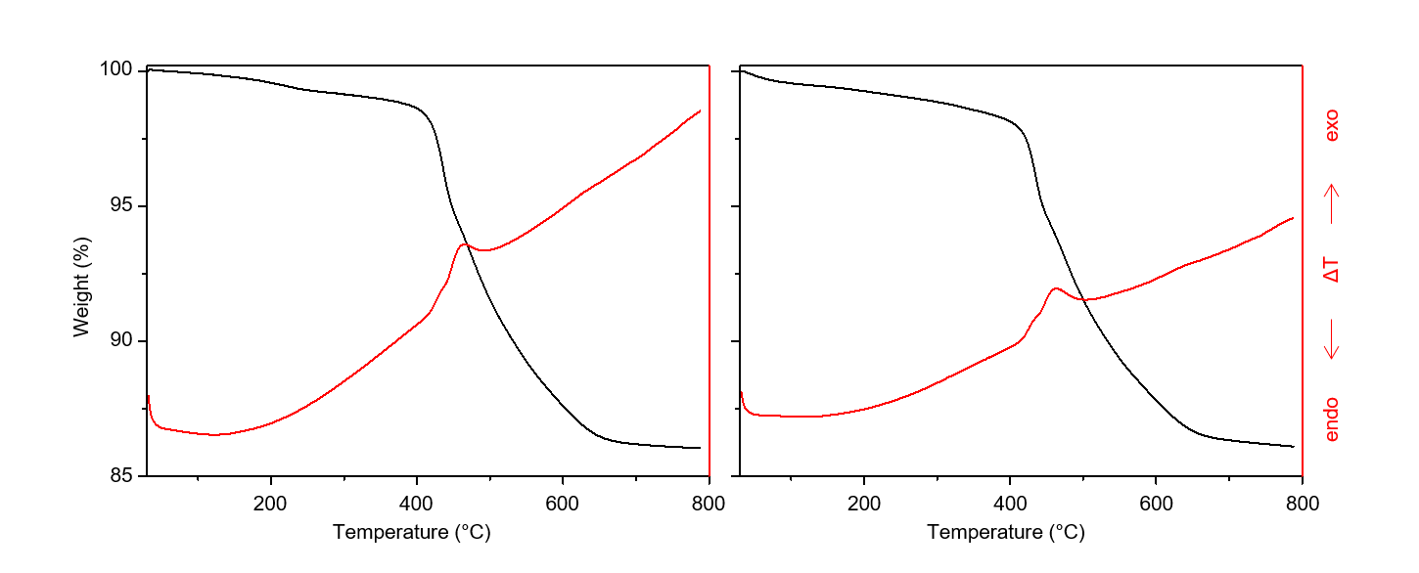

Figure S3. TGA/DTA (black/red) curves of as-synthesized LEU-1 (left) and LEU-1 after three Na⁺ ion exchange treatments (right). Ion exchange of as-synthesized LEU-1 was done in 1.0 M NaCl solution at 80 °C for 8 hours.

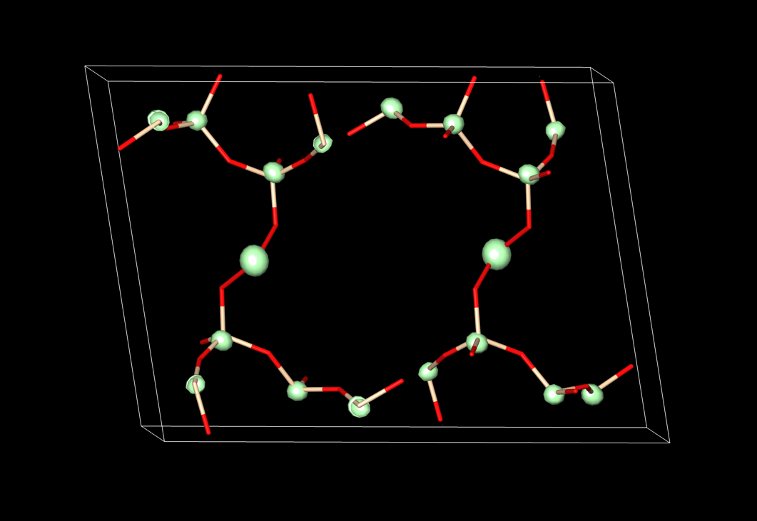
Figure S4. Electron denisty map generated by Superflip, showing just the strongest peaks for clarity (green). The zincosilicate framework derived from the map and used to start the structure refinement is overlaid.

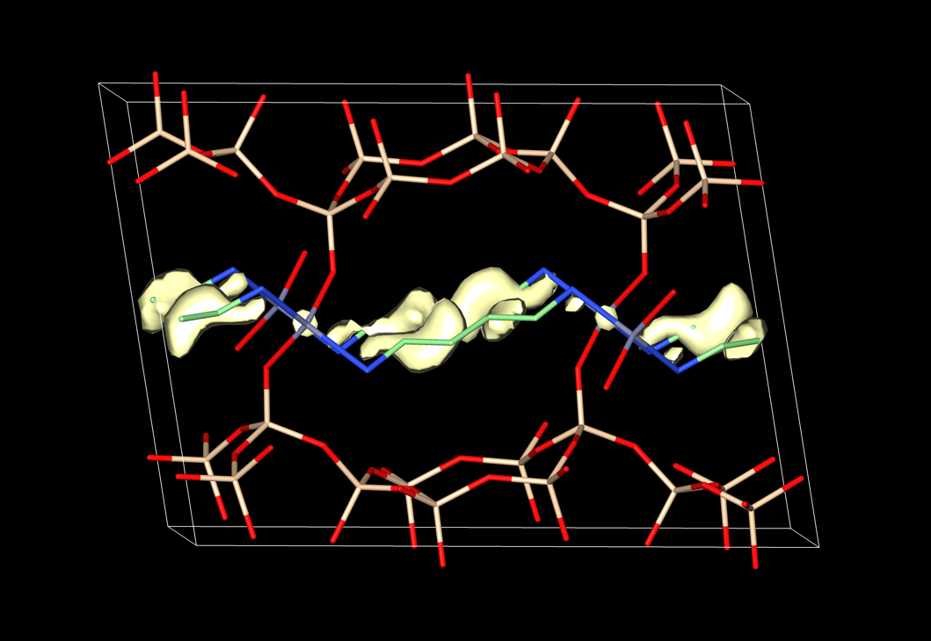
Figure S5. Difference electron density map generated with just the zincosilicate framework in the structural model, showing the residual density (yellow) in the channel between the Zn atoms. The final structure with the refined position of the DAB molecule is overlaid for comparison.

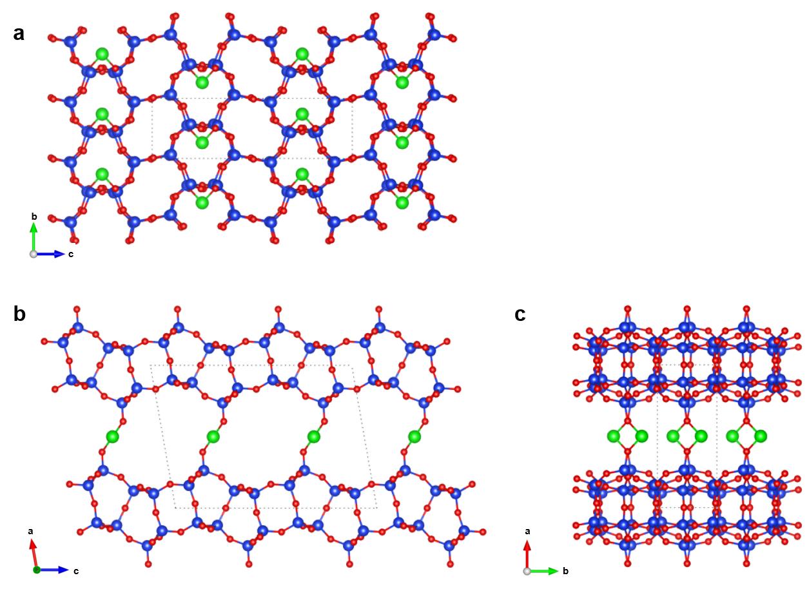

Figure S6. 3D inorganic connectivity of LEU-1 (DAB omitted), viewed along the main crystallographic axes [100] (a), [010] (b), and [001] (c). (Si atoms, blue; O atoms, red; Zn atoms, green).

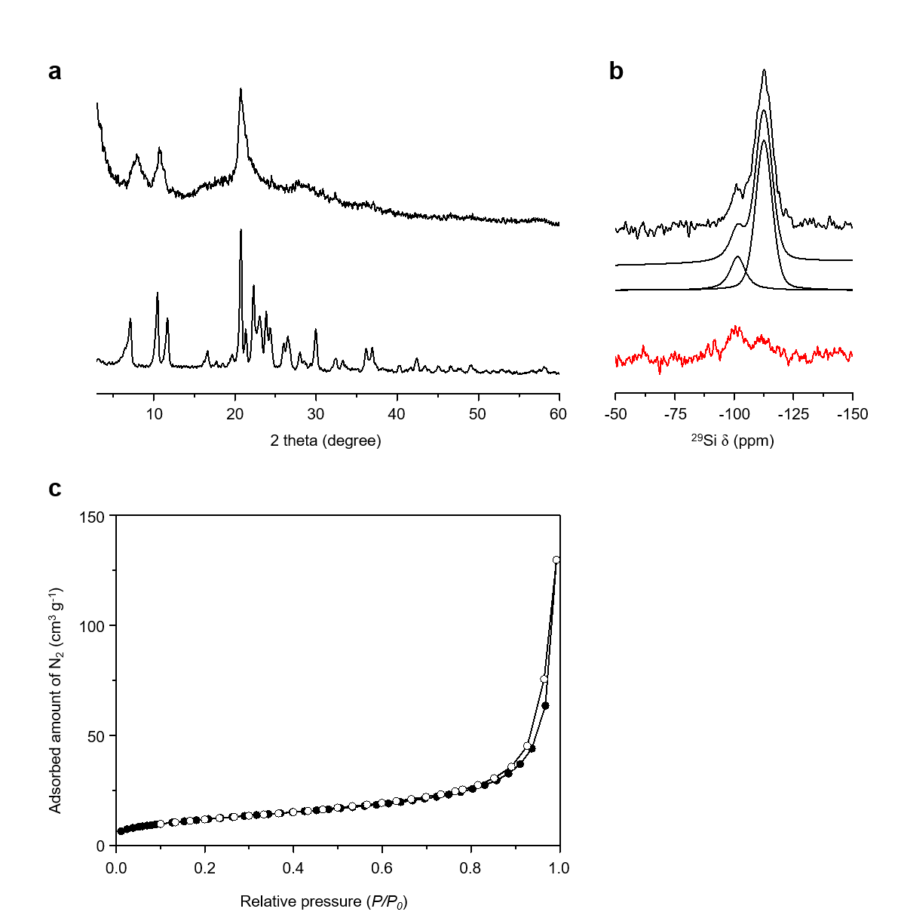

Figure S7. (a) XPD patterns of as-synthesized (bottom) and calcined (top) LEU-1. (b) ²⁹Si{¹H} CP MAS (red) and ²⁹Si MAS (black) NMR spectra of calcined LEU-1. The traces given below the ²⁹Si MAS NMR spectrum are the simulated spectrum and its deconvoluted components. (c) N₂ adsorption (closed) and desorption (open) isotherm of calcined LEU-1. The BET surface area and micropore volume were calculated to be 43 m² g⁻¹ and 0.01 cm³ g⁻¹, respectively.

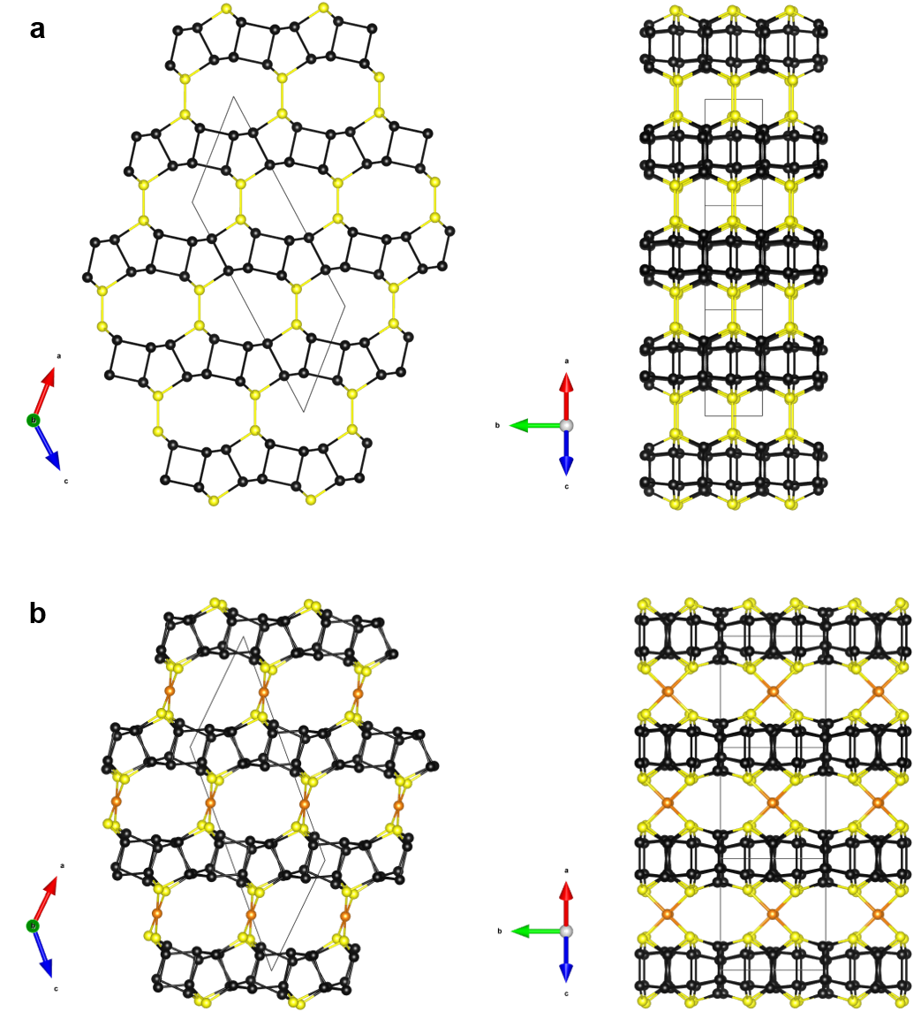

Figure S8. Two hypothetical structures LEU-1_H1 (a) and LEU-1_H2 (b) built from the LEU-1 layer. Bridging O atoms have been omitted for clarity. The LEU-1 layers and T-atoms, terminating the external surface of the LEU-1 layer, are marked in black and yellow, respectively. Additional T-atoms connecting adjacent LEU-1 layers in LEU-1_H2 are marked in orange.

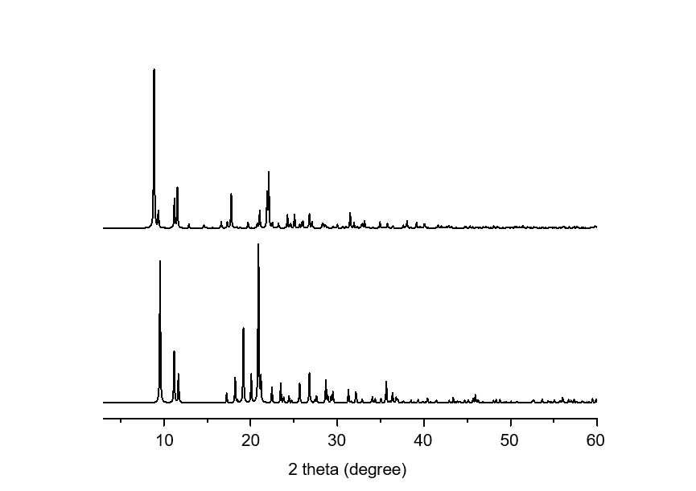

Figure S9. Simulated XPD patterns (λ = 1.5406 Å) of LEU-1_H1 (bottom) and LEU-1_H2 (top) structures.

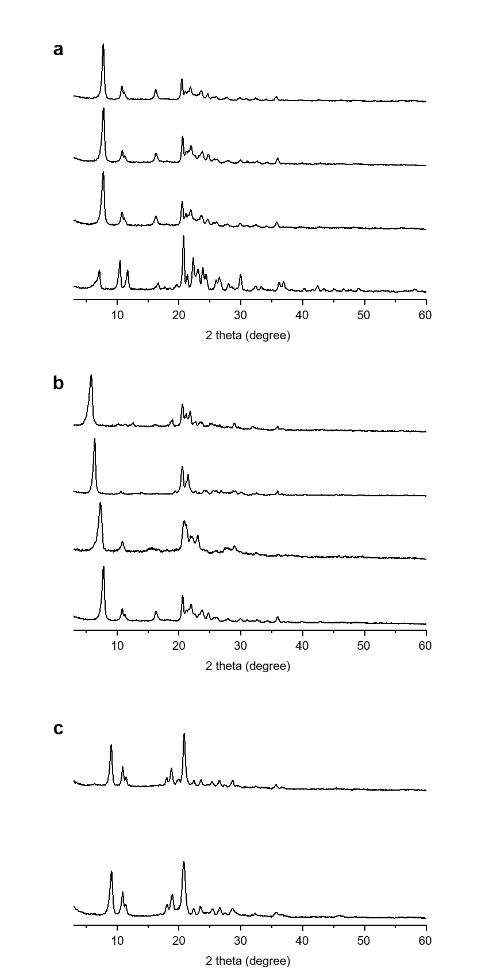
Figure S10. (a) XPD patterns of (from bottom to top) as-synthesized LEU-1, LEU-1 treated with 12 M HCl solution for 24 hours (i.e., LEU-1L_12M_24h), LEU-1L_0.1M_24h, and LEU-1L_0.1M_0.5h. All acid-treatments were performed at 95 °C. (b) XPD patterns of (from bottom to top) LEU-1L_0.1M_24h (i.e., LEU-1L), TMA⁺ ion-exchanged LEU-1L (i.e., LEU-1L_TMA), LEU-1L_TEA, and LEU-1L_TPA. As LEU-1L was treated with larger organic agents, the first reflection shifted to lower 2θ values. (c) XPD patterns of calcined LEU-1L (bottom) and calcined LEU-1L_TEA (top).
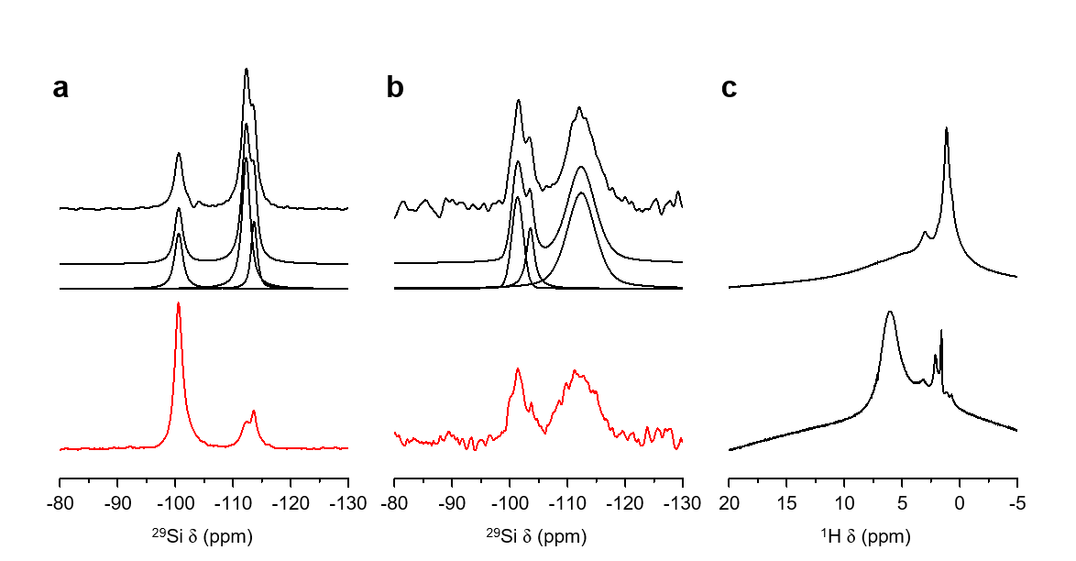

Figure S11. ²⁹Si{¹H} CP MAS (red) and ²⁹Si MAS (black) NMR spectra of LEU-1L (a) and LEU-1L_TEA (b). The traces given below the ²⁹Si MAS NMR spectrum are the simulated spectrum and its deconvoluted components. (c) ¹H MAS NMR spectra of LEU-1L (bottom) and LEU-1L_TEA (top).

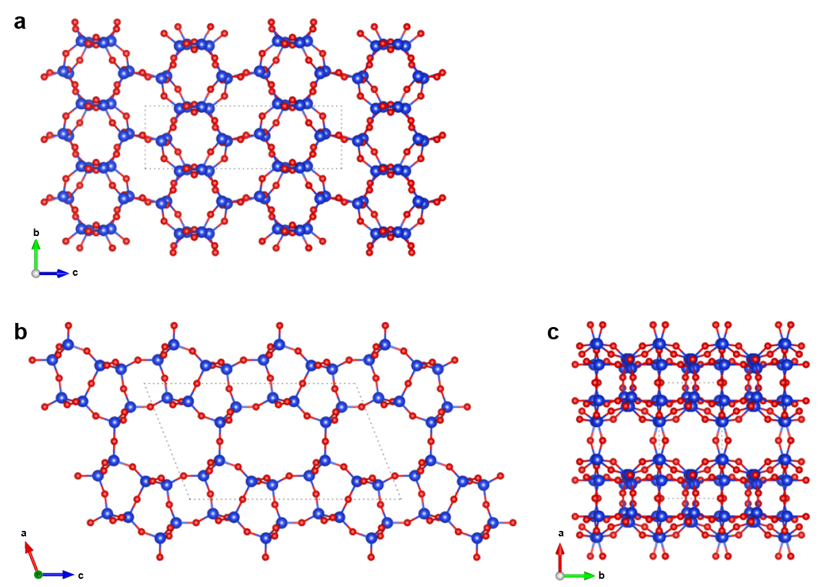

Figure S12. 3D inorganic connectivity of LEU-2 viewed along the main crystallographic axes [100] (a), [010] (b), and [001] (c). (Si atoms, blue; O atoms, red).

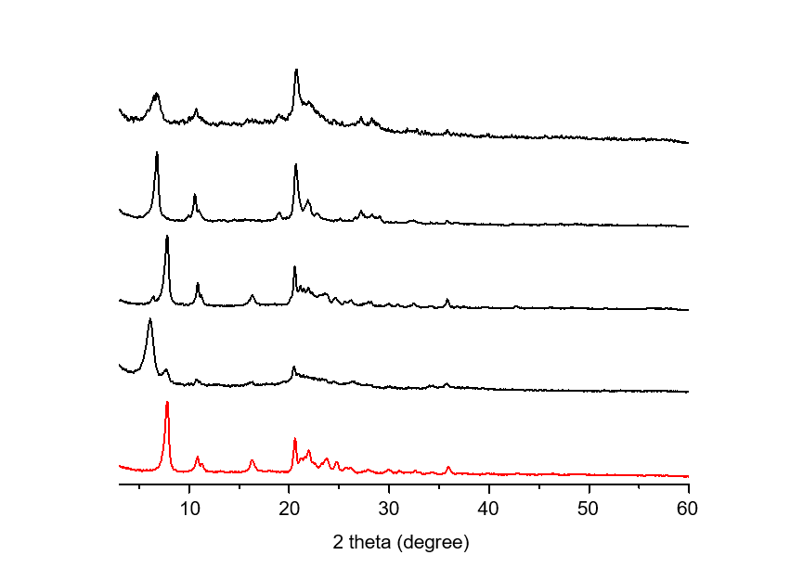

Figure S13. XPD patterns of LEU-1L (red) and solid products (black) obtained after hydrothermal conversion of (from bottom to top) LEU-1L, LEU-1L_TMA, LEU-1L_TEA, and LEU-1L_TPA treated at 170 °C under acidic conditions with an additional Zn source. Pure LEU-3 was synthesized only from the hydrothermal conversion of LEU-1L_TEA.

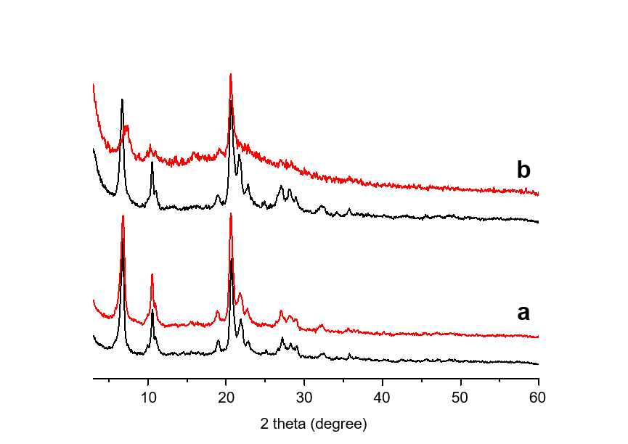

Figure S14. XPD patterns of as-prepared (black) and calcined (red) LEU-3 obtained in Zn- (a) and Al- (b) containing systems.

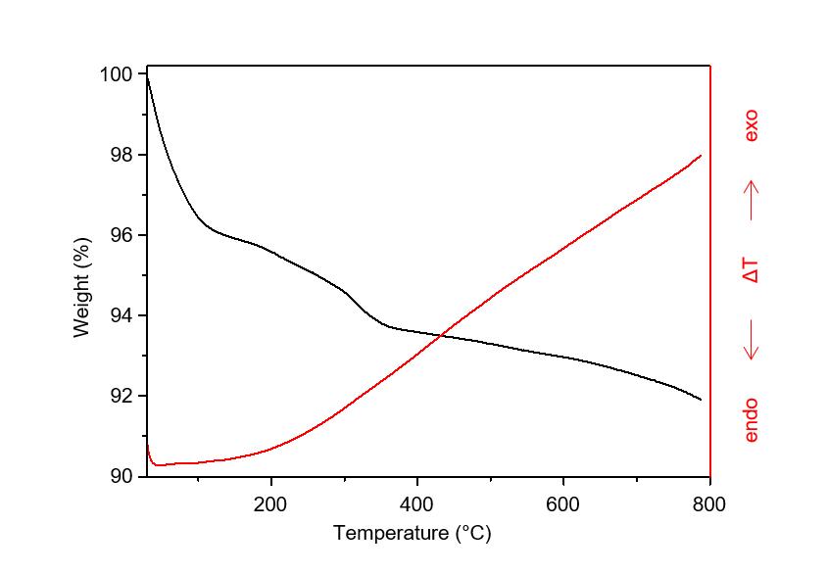

Figure S15. TGA/DTA (black/red) curves of LEU-3 prepared in Zn-containing system. The C/N ratio (8.3; C, 1.7 wt%; N, 0.2 wt%) of its organic species determined by CN analysis is close to the ratio (8.0) of TEA⁺.

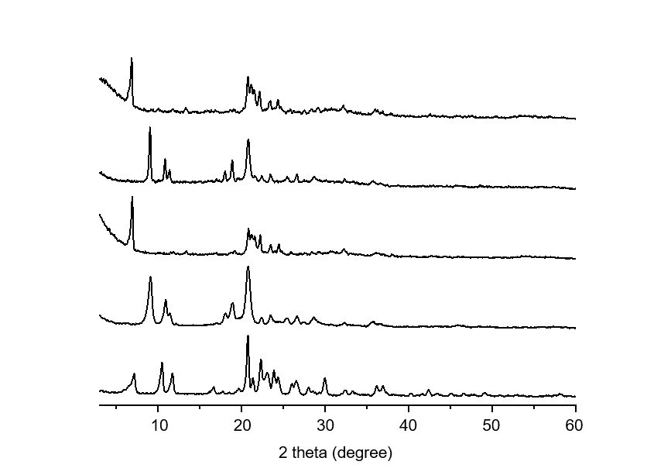

Figure S16. XPD patterns of (from bottom to top) LEU-1, LEU-2, LEU-4, calcined LEU-4, and TEA⁺-treated LEU-4. Calcination of LEU-4 (i.e., calcined LEU-4) at 600 °C led to a direct phase transformation to LEU-2. There was no shift in the X-ray diffraction compared to LEU-4 after three TEA⁺ ion exchange treatments with 35% TEAOH solution for 6 h at 60 °C (i.e., TEA⁺-treated LEU-4).

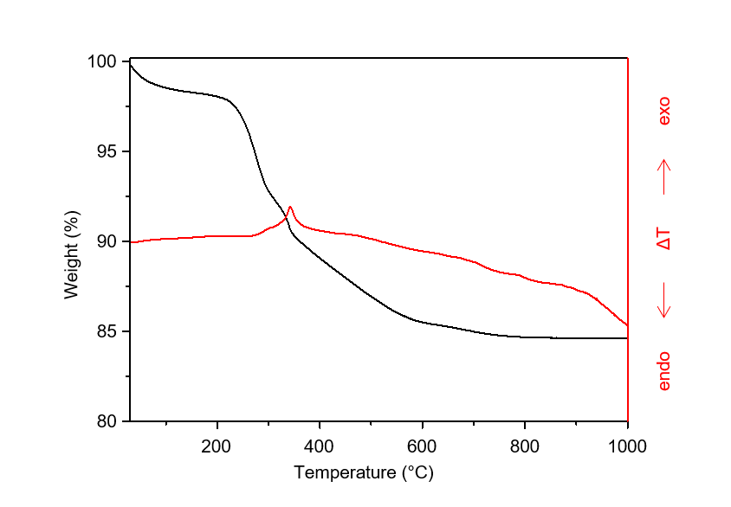

Figure S17. TGA/DTA (black/red) curves of as-synthesized LEU-4. Thermal analysis shows a weight loss of around 13.5 wt% occurred at around 345 °C associated with combustion of organic molecules.

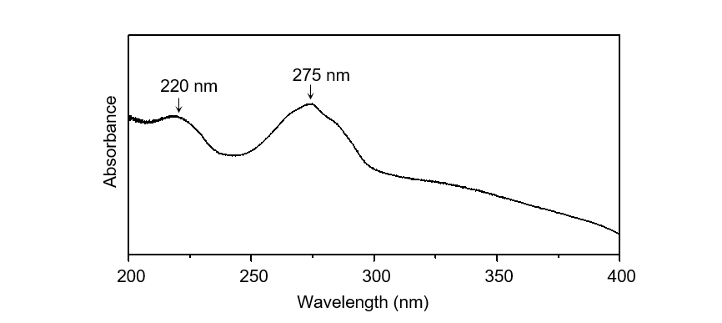

Figure S18. UV-vis spectrum of as-synthesized LEU-4. The UV-vis adsorption bands around 220 and 275 nm can be assignable to the charge transfer transition of framework Cd species with lattice oxygen and amine-to-metal charge transfer, respectively.

Supplementary Tables

Table S1. Representative synthesis results.ª
Run | R | Product^{b}
1 | Ethylenediamine | Zeolite beta + dense
2 | 1,3-Diaminopropane | VET + dense
3 | 1,4-Diaminobutane (DAB) | LEU-1 + VET + dense
4 | 1,5-Diaminopentane | MFI + dense
5 | 1,6-Diaminohexane | MFI + dense
ª The composition of the synthesis mixture is 0.6R∙0.1NaOH∙(1/15)Zn∙1.0SiO₂∙30H₂O, where R is the diamine. The calcined form of the zincosilicate analog of zeolite beta (CIT-6) with Si/Zn ~ 15 was used as the source of Zn and Si. All syntheses were performed under static conditions at 160 °C for 7 days. ^{b} The product appearing first is the major phase.

Table S2. Syntheses from a batch composition of xDAB∙0.1NaOH∙(1/y)Zn∙1.0SiO₂∙30H₂O.ª
 |  | Batch composition |  | Temp/time  (°C/days)
Run | pH_{initial}^{b} | Si/Zn | DAB/Si^{c} | Temp/time  (°C/days) | Product^{d}
6 | 12.7 | 15 | 0.6 (9.0) | 140 / 7 | LEU-1 + dense + (VET)
7 | 11.4 | 5 | 0.6 (3.0) | 160/7 and 28 | Unknown + LEU-1
8 | 12.5 | 8 | 0.6 (4.8) | 160/7 and 28 | LEU-1
9 | 12.7 | 10 | 0.6 (6.0) | 160/7 and 28 | LEU-1
10 | 12.2 | 10 | 0.1 (1.0) | 160 / 7 | Unknown + dense
11 | 12.5 | 10 | 0.3 (3.0) | 160/7 and 14 | LEU-1 + (unknown)
12 | 12.7 | 10 | 0.9 (9.0) | 160 / 7 | LEU-1
13 | 12.8 | 10 | 1.2 (12.0) | 160 / 7 | LEU-1
14e | 12.5 | 8 | 0.6 (4.8) | 160/28 | LEU-1
15^{f} | 12.4 | 8 | 0.6 (4.8) | 160/28 | LEU-1
16^{g} | 11.5 | 8 | 0.6 (4.8) | 160/28 | Amorphous
17^{h} | 11.5 | 8 | 0.6 (4.8) | 160/28 | Amorphous
18^{i} | 11.4 | 8 | 0.6 (4.8) | 160/28 | Amorphous
19^{g} | 12.5^{j} | 8 | 0.6 (4.8) | 160/28 | Amorphous
20^{h} | 12.5^{j} | 8 | 0.6 (4.8) | 160/28 | Amorphous
21^{i} | 12.4^{j} | 8 | 0.6 (4.8) | 160/28 | Amorphous
ª Unless otherwise stated, the calcined CIT-6 with Si/Zn ~ 15 was used as the major source of Zn and Si. The insufficient Zn content was supplemented by adding zinc acetate dihydrate (Zn(CH₃COO)₂∙2H₂O, 98%, Acros). ^{b} The initial pH of each synthesis mixture. ^{c} The values in parentheses are the DAB/Zn ratios. ^{d} The product appearing first is the major phase, and that obtained in a trace amount is given in parentheses. Unknown is an unknown, but probably layered material. ^{e,f} Run performed using co-calcined fumed silica with Zn(CH₃COO)₂∙2H₂O (Si/Zn = 7.8) and amorphous zincosilicate (Si/Zn = 8.0), respectively, which are pre-organized non-crystalline precursors. ^{g,h,i} Run carried out using fumed silica, colloidal silica (Ludox HS-40, Aldrich), and tetraethylorthosilicate (TEOS, 98%, Aldrich) as Si sources, respectively. ^{j} The pH_{initial} of the synthesis mixture was adjusted by adding NH₄OH.

Table S3. Data collection and crystallographic data for LEU-1 and LEU-2.
Material | As-synthesized LEU-1 | Hydrated LEU-2
Chemical unit cell formula | |(H₂O)_{0.5}DAB_{2.0}|[Zn₂Si₁₆O₃₄] | |(H₂O)_{0.6}|[Si₁₆O₃₂]
Refined unit cell formula | |(H₂O)_{0.5}DAB_{1.7}|[Zn₂Si₁₆O₃₄] | |(H₂O)_{0.7}|[Si₁₆O₃₂]
Crystal system | Monoclinic | Monoclinic
Space group | P2/c | P2/c
a (Å) | 12.1098(3) | 10.0220(5)
b (Å) | 4.9760(1) | 5.0371(4)
c (Å) | 16.8349(3) | 16.9849(9)
β (°) | 100.020(2) | 111.509(5)
Unit cell volume (Å³) | 998.97(3) | 797.72(9)
Synchrotron facility | SLS | ESRF
Wavelength (Å) | 0.70810 | 0.35438
Capillary diameter (mm) | 0.3 | 1.0
Step size (°) | 0.0036 | 0.005
2θ scan range (°) | 3.25 - 45.00 | 1.60-20.00
Reflections | 1372 | 942
Geometric restraints | 58 | 49
Profile parameters | 18 | 16
Structural parameters | 55 | 37
Rwp (%) | 2.75 | 3.78
R_{exp} (%) | 0.16 | 0.50
R_{Bragg} (%) | 2.47 | 1.23

Table S4. Atomic coordinates and thermal parameters for as-synthesized LEU-1.
Atom | x | y | z | Occupancy | B_{iso} | Multiplicity
Zn1 | 0.5 | 0.2625(5) | 0.25 | 1 | 1.76(5) | 2
Si1 | 0.1590(3) | 0.0543(6) | 0.0866(2) | 1 | 0.47(2) | 4
Si2 | 0.2634(3) | 0.5519(6) | 0.1736(2) | 1 | 0.47(2) | 4
Si3 | 0.1203(3) | 0.5709(7) | 0.3070(2) | 1 | 0.47(2) | 4
Si4 | 0.1015(3) | 0.0674(7) | 0.4040(2) | 1 | 0.47(2) | 4
O1 | 0.2020(6) | 0.3549(11) | 0.1053(4) | 1 | 1.33(5) | 4
O2 | 0.0311(6) | 0.0228(12) | 0.1014(4) | 1 | 1.33(5) | 4
O3 | 0.2384(6) | 0.8562(11) | 0.1446(4) | 1 | 1.33(5) | 4
O4 | 0.3926(6) | 0.5015(13) | 0.1842(4) | 1 | 1.33(5) | 4
O5 | 0.2169(6) | 0.4948(14) | 0.2561(4) | 1 | 1.33(5) | 4
O6 | 0 | 0.5538(18) | 0.25 | 1 | 1.33(5) | 2
O7 | 0.1464(6) | 0.8729(12) | 0.3428(4) | 1 | 1.33(5) | 4
O8 | 0.1246(6) | 0.3705(11) | 0.3822(4) | 1 | 1.33(5) | 4
O9 | 0.1674(6) | 1.0118(13) | 0.4944(4) | 1 | 1.33(5) | 4
O10 | 0.5 | 0.727(8) | 0.25 | 0.33(1)ª | 4.0(2) | 2
N1 | 0.5918(8) | 0.0137(16) | 0.6753(6) | 1.094(4)ª | 4.0(2) | 4
C2 | 0.5311(9) | -0.108(2) | 0.6037(6) | 1.134(5)ª | 4.0(2) | 4
C3 | 0.5258(11) | 0.080(2) | 0.5367(6) | 1.134(5)ª | 4.0(2) | 4

ª These occupancies include contributions from H atoms, so that for O10 should be interpreted as 0.33*8/10=0.26 H₂O, for N1 as 1.094*7/9=0.85 NH₂, for C2 and C3 as 1.134*6/8=0.85 CH₂.

Table S5. Selected bond lengths and angles for as-synthesized LEU-1.
Bond length (Å) |  | Bond angle (°)
Si1-O1 | 1.60(1) | O1-Si1-O2 | 110.4(4)
Si1-O2 | 1.62(1) | O1-Si1-O3 | 108.6(4)
Si1-O3 | 1.59(1) | O1-Si1-O9 | 108.0(4)
Si1-O9 | 1.61(1) | O2-Si1-O3 | 109.8(4)
Si2-O1 | 1.59(1) | O2-Si1-O9 | 110.6(4)
Si2-O3 | 1.60(1) | O3-Si1-O9 | 109.5(4)
Si2-O4 | 1.56(1) | O1-Si2-O3 | 108.8(4)
Si2-O5 | 1.61(1) | O1-Si2-O4 | 108.4(4)
Si3-O5 | 1.61(1) | O1-Si2-O5 | 108.9(4)
Si3-O6 | 1.60(1) | O3-Si2-O4 | 108.6(4)
Si3-O7 | 1.63(1) | O3-Si2-O5 | 110.6(4)
Si3-O8 | 1.60(1) | O4-Si2-O5 | 111.4(4)
Si4-O2 | 1.61(1) | O5-Si3-O6 | 109.7(4)
Si4-O7 | 1.58(1) | O5-Si3-O7 | 107.6(4)
Si4-O8 | 1.59(1) | O5-Si3-O8 | 110.3(4)
Si4-O9 | 1.62(1) | O6-Si3-O7 | 111.6(4)
Si-O (Avg.) | 1.60 | O6-Si3-O8 | 109.9(4)
 |  | O7-Si3-O8 | 107.7(4)
Zn1-O4 | 1.96(1) | O2-Si4-O7 | 109.5(4)
Zn1-N1 | 2.28(1) | O2-Si4-O8 | 109.4(4)
 |  | O2-Si4-O9 | 110.7(4)
N1-C2 | 1.43(1) | O7-Si4-O8 | 109.7(4)
C2-C3 | 1.45(1) | O7-Si4-O9 | 109.9(4)
C3-C3 | 1.51(2) | O8-Si4-O9 | 107.6(4)
 |  | O-Si-O (Avg.) | 109.3
 |  | O4-Zn1-O4 | 105.2(4)
 |  | O4-Zn1-N1 | 109.8(3)
 |  | O4-Zn1-N1 | 113.2(3)
 |  | N1-Zn1-N1 | 109.8(3)
 |  | Si1-O1-Si2 | 144.4(4)
 |  | Si1-O2-Si4 | 162.0(4)
 |  | Si1-O3-Si2 | 146.6(5)
 |  | Si2-O4-Zn1 | 135.7(4)
 |  | Si2-O5-Si3 | 144.3(5)
 |  | Si3-O6-Si3 | 173.9(3)
 |  | Si3-O7-Si4 | 137.8(5)
 |  | Si3-O8-Si4 | 142.1(5)
 |  | Si4-O9-Si1 | 147.3(6)
 |  | Si-O-Si (Avg.) | 148.2

Table S6. Fractional coordinates of the hypothetical structures built from LEU-1 layer.
 | LEU-1_H1ª |  |  |  | LEU-1_H2^{b}
Atom | x | y | z | Atom | x | y | z
Si1 | 0.51863 | -0.02532 | 0.60999 | Si1 | 0.01902 | -0.02846 | 0.61554
Si2 | 0.5966 | -0.52461 | 0.71435 | Si2 | 0.17604 | -0.29009 | 0.73723
Si3 | 0.99796 | -0.55458 | 0.82554 | Si3 | 0.53246 | -0.27534 | 0.83509
Si4 | 1.21351 | -0.04581 | 0.92094 | Si4 | 0.73953 | -0.00995 | 0.91419
O1 | 0.52874 | -0.32435 | 0.63873 | Si5 | 1.06696 | -0.49585 | 1.10083
O2 | 0.66667 | 0.02386 | 0.60274 | Si6 | 1.11012 | -0.25915 | 1.19477
O3 | 0.55314 | -0.82245 | 0.67852 | Si7 | 1.49431 | -0.23267 | 1.31909
O4 | 0.80446 | -0.48584 | 0.79099 | Si8 | 1.72363 | -0.47021 | 1.44373
O5 | 1.05228 | -0.83924 | 0.871 | Si9 | 0 | -0.50686 | 0.75
O6 | 1.13756 | -0.34098 | 0.8945 | O1 | 0.04322 | -0.16515 | 0.66935
O7 | 1.32486 | -1.0208 | 1.02067 | O2 | 0.16952 | 0.00276 | 0.62041
O8 | -0.5 | -0.45987 | 0.75 | O3 | 0.18393 | -0.40572 | 0.68544
O9 | -1 | -0.55921 | 0.75 | O4 | 0.3607 | -0.21774 | 0.80614
 |  |  |  | O5 | 0.5743 | -0.41593 | 0.89002
 |  |  |  | O6 | 0.68879 | -0.17206 | 0.90481
 |  |  |  | O7 | 0.86883 | -0.53458 | 1.04938
 |  |  |  | O8 | 1.10596 | -0.328 | 1.12432
 |  |  |  | O9 | 1.14124 | -0.52603 | 1.05953
 |  |  |  | O10 | 1.01393 | -0.10854 | 1.16006
 |  |  |  | O11 | 1.30873 | -0.24141 | 1.28503
 |  |  |  | O12 | 1.5621 | -0.07297 | 1.34583
 |  |  |  | O13 | 1.6332 | -0.32015 | 1.40775
 |  |  |  | O14 | -0.15072 | -0.04333 | 0.51294
 |  |  |  | O15 | 0.14491 | -0.38597 | 0.78893
 |  |  |  | O16 | 1.00237 | -0.38 | 1.19395
 |  |  |  | O17 | -0.5 | -0.30194 | 0.75
 |  |  |  | O18 | 0.5 | -0.29074 | 1.25
ª Space group P2/c with a = 9.9825 Å, b = 5.0328 Å, c = 20.8600 Å, β = 130.6439°.
^{b} Space group P2/c with a = 11.0075 Å, b = 9.4538 Å, c = 21.3662 Å, β = 134.2001°.

Table S7. Local interatomic distances (LID) calculation results for the hypothetical structures.
 | LID criteria (Å)ª
Structure | ε_{<OO>}  [<0.0009] | ε_{<TT>}  [<0.0046] | σ_{TO}  [<0.0196] | σ_{OO}  [<0.0588] | σ_{TT}  [<0.0889] | R_{TO}  [<0.0634] | R_{OO}  [<0.2746] | R_{TT}  [<0.3332]
LEU-1_H1 | 0.0004 | 0.0027 | 0.0050 | 0.0231 | 0.0407 | 0.0171 | 0.0857 | 0.1576
LEU-1_H2 | 0.0056 | 0.0098 | 0.0158 | 0.1074 | 0.0960 | 0.0703 | 0.5898 | 0.3630
ª The numbers in square brackets indicate the standard values of feasible structures¹¹. LEU-1_H1 and LEU-1_H2 structures were calculated to have framework energies of 8.7 and 39.4 kJ (mol Si)⁻¹, respectively, with respect to α-quartz.

Table S8. Atomic coordinates and thermal parameters for hydrated LEU-2.
Atom | x | y | z | Occupancy | B_{iso} | Multiplicity
Si1 | 0.2036(9) | 0.479(3) | 0.1092(3) | 1 | 1 | 4
Si2 | 0.3351(8) | 0.986(2) | 0.2125(3) | 1 | 1 | 4
Si3 | 0.1548(7) | 0.961(2) | 0.3251(3) | 1 | 1 | 4
Si4 | 0.1240(7) | 0.443(2) | 0.4174(3) | 1 | 1 | 4
O1 | 0.2019(12) | 0.466(4) | 0.0141(8) | 1 | 2 | 4
O2 | 0.0458(16) | 0.418(3) | 0.1073(7) | 1 | 2 | 4
O3 | 0.2461(17) | 0.768(3) | 0.1460(7) | 1 | 2 | 4
O4 | 0.3168(14) | 0.268(4) | 0.1669(8) | 1 | 2 | 4
O5 | 0 | 1.025(7) | 0.25 | 1 | 2 | 2
O6 | 0.5 | 0.902(6) | 0.25 | 1 | 2 | 2
O7 | 0.2801(10) | 1.000(5) | 0.2894(6) | 1 | 2 | 4
O8 | 0.1833(19) | 0.160(3) | 0.4039(7) | 1 | 2 | 4
O9 | 0.157(2) | 0.659(3) | 0.3575(7) | 1 | 2 | 4
Ow1 | 0.5 | 0.5 | 0.5 | 0.44(1)ª | 2 | 2

ª This occupancy includes contributions from H atoms, so it should be interpreted as 0.44*8/10=0.35 H₂O.
Table S9. Selected bond lengths and angles for hydrated LEU-2.
Bond length (Å) |  | Bond angle (°)
Si1-O1 | 1.61(2) | O1-Si1-O2 | 109.0(7)
Si1-O2 | 1.60(2) | O1-Si1-O3 | 110(1)
Si1-O3 | 1.58(2) | O1-Si1-O4 | 109(1)
Si1-O4 | 1.60(2) | O2-Si1-O3 | 108(1)
Si2-O3 | 1.59(2) | O2-Si1-O4 | 111(1)
Si2-O4 | 1.59(2) | O3-Si1-O4 | 110.0(8)
Si2-O6 | 1.59(1) | O3-Si2-O4 | 109.5(8)
Si2-O7 | 1.59(1) | O3-Si2-O4 | 109(1)
Si3-O5 | 1.64(1) | O3-Si2-O6 | 110(1)
Si3-O7 | 1.59(1) | O4-Si2-O6 | 110(1)
Si3-O8 | 1.61(2) | O4-Si2-O7 | 110(1)
Si3-O9 | 1.61(2) | O6-Si2-O7 | 107.7(5)
Si4-O1 | 1.61(1) | O5-Si3-O7 | 109.4(5)
Si4-O2 | 1.60(2) | O5-Si3-O8 | 111(1)
Si4-O8 | 1.60(2) | O5-Si3-O9 | 110(1)
Si4-O9 | 1.60(2) | O7-Si3-O8 | 108(1)
Si-O (Avg.) | 1.60 | O7-Si3-O9 | 110(1)
 |  | O8-Si3-O9 | 108.9(7)
 |  | O1-Si4-O2 | 111.3(8)
 |  | O1-Si4-O8 | 109.6(9)
 |  | O1-Si4-O9 | 108.6(9)
 |  | O2-Si4-O8 | 108(1)
 |  | O2-Si4-O9 | 109.4(9)
 |  | O8-Si4-O9 | 110(1)
 |  | O-Si-O (Avg.) | 109.5
 |  | Si1-O1-Si4 | 147(1)
 |  | Si1-O2-Si4 | 160(1)
 |  | Si1-O3-Si2 | 156(1)
 |  | Si1-O4-Si2 | 145(1)
 |  | Si2-O5-Si1 | 157(3)
 |  | Si2-O6-Si1 | 149(2)
 |  | Si2-O7-Si2 | 149.6(9)
 |  | Si2-O8-Si3 | 135.5(9)
 |  | Si3-O9-Si3 | 151(1)
 |  | Si-O-Si (Avg.) | 150.1

References
1. Takewaki, T., Beck, L. W. & Davis, M. E. Synthesis of CIT-6, a zincosilicate with the *BEA topology. Top. Catal. 9, 35-42 (1999).
2. Suzuki, Y., Wakihara, T., Kohara, S., Itabashi, K., Ogura., M. & Okubo. T. Mechanistic study on the synthesis of a porous zincosilicate VPI-7 containing three-membered rings. J. Phys. Chem. C. 115, 443-446 (2011).
3. Harris, R. K., Becker, E. D., Cabral De Menezes, S. M., Goodfellow, R. & Granger, P. NMR nomenclature: nuclear spin properties and conventions for chemical shifts: IUPAC recommendations 2001. Solid State Nucl. Magn. Reson. 22, 458-483 (2002).
4. Harris, R. K., Becker, E. D., Cabral de Menezes, S. M., Granger, P., Hoffman, R. E. & Zilm, K. W. Further conventions for NMR shielding and chemical shifts. Pure Appl. Chem. 80, 59-84 (2008).
5. Materials Studio 7.0, Accelrys Inc., San Diego, California (2013).
6. Mayo, S. L., Olafson, B. D. & Goddard, W. A. DREIDING: a generic force field for molecular simulations. J. Phys. Chem. 94, 8897-8909 (1990).
7. Schröder, K. -P., Sauer, J., Leslie, M., Catlow, C. R. A. & Thomas, J. M. Bridging hydroxyl groups in zeolitic catalysts: a computer simulation of their Structure, vibrational properties and acidity in protonated faujasites (H-Y zeolites). Chem. Phys. Lett. 188, 320-325 (1992).
8. Gale, J. D. & Rohl, A. L. The general utility lattice program (GULP). Mol. Simul. 29, 291-341, (2003).
9. Momma, K. & Izumi, F. VESTA 3 for three-dimensional visualization of crystal, volumetric and morphology data. J. Appl. Crystallogr. 44, 1272-1276 (2011).
10. Foster, M. D., Simperler, A., Bell, R. G., Friedrichs, O. D., Paz, F. A. A. & Klinowski, J. Chemically feasible hypothetical crystalline networks. Nat. Mater. 3, 234-238 (2004).
11. Li, Y., Yu, J. & Xu, R. Criteria for zeolite frameworks realizable for target synthesis. Angew. Chem., Int. Ed. 52, 1673-1677 (2013).
12 Amorim da Costa, A. M., Marques, M. P. M. & Batista de Carvalho, L. A. E. Raman spectra of putrescine, spermidine and spermine polyamines and their N-deuterated and N-ionized derivatives. J. Raman Spectrosc. 34, 357-366 (2003).
13 Szyfman, N. W., Tenório, T., Ribeiro, T. S., Felcman, J. & Mercê, A. L. R. Synthesis of novel binary and ternary Zn²⁺ complexes with putrescine and phosphocreatine and the metal complexes study in aqueous solution. J. Mol. Struct. 107, 467-474 (2014).

