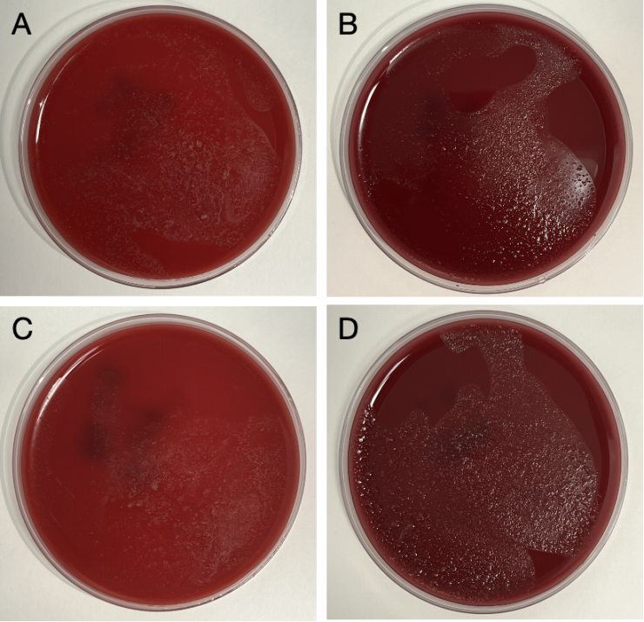
Figure 1: The culturing of fecal sample from germ-free mice after FRT-CS and T-CS. (A) Fecal of GF weanling pups obtained from FRT-CS was cultured in a Columbia blood agar plate under aerobic conditions for 48h. (B) Fecal of GF weanling pups obtained from FRT-CS was cultured in a Columbia blood agar plate under anaerobic conditions for 48h. (C) Fecal of GF weanling pups obtained from T-CS was cultured in a Columbia blood agar plate under aerobic conditions for 48h. (D) Fecal of GF weanling pups obtained from T-CS was cultured in a Columbia blood agar plate under anaerobic conditions for 48h.

Mode of fertilization | Number of female mice | Form of copulatory plug  (G0.5) |  |  |  | EDD | ADD
 |  | 0-24h | 24-48h | 48-72h | NA |  | G18 | G19 | G19.5 | NA
NM | 30 | 5 | 7 | 11 | 7 | G19.5 | 5 | 6 | 12 | 7
IVF | 30 | / |  |  |  | E19.5 | 0 | 2 | 28 | 0
Table 1: Predication of actual delivery date (ADD) for different fertilization models. NA for not available.

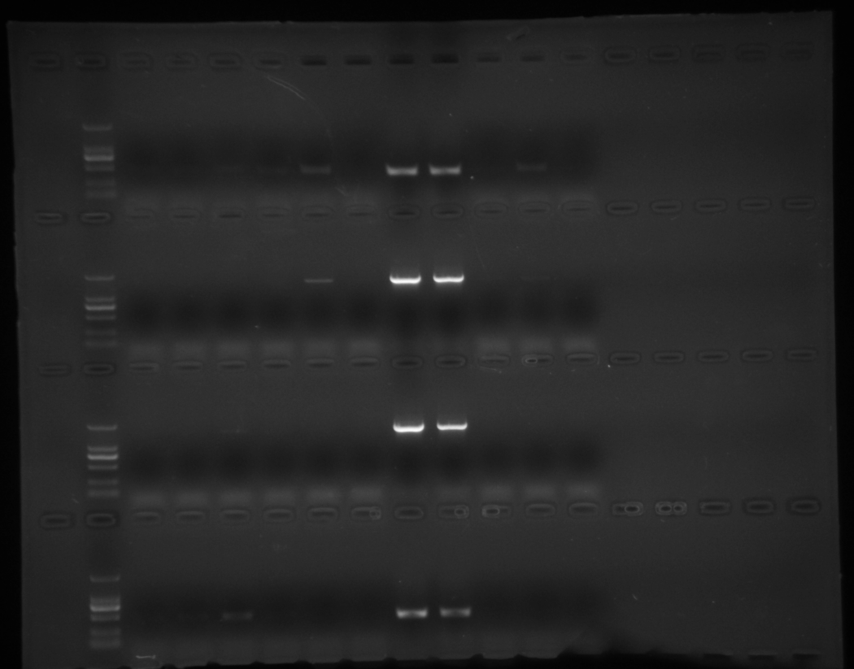
Figure 2：The complete membrane image depicting the detection of bacterial contamination following T-CS is presented in Figure 4 of the manuscript.

Figure 3：The complete membrane image depicting the detection of bacterial contamination following FRT-CS is presented in Figure 5 of the manuscript.

