Quality Characteristics and Antioxidant Activity of Fermented Symbiotic Beverages Supplemented with Eucheuma Cottonii
Muhammad Qasim Ali1, Mohd Akmal Azhar1, Mimi Sakinah Abdul Munaim1, Nur Fathin Ruslan1, Abdurahman Hamid Nour 1, Noormazlinah Ahmad*1, Abeer Essam Noman*2, Luay M Alsubhi3
¹Faculty of Chemical and Process Engineering Technology, University Malaysia Pahang, Al Sultan Abdullah, 26300 Gambang, Pahang, Malaysia.
²Department of Food Science and Nutrition, Faculty of Agriculture, Food and Environment, Sana’a University, Sana’a, Yemen
³Environment Health Laboratory for Food and Water, Jeddah Municipality, Jeddah, Saudi Arabia

Standard curve for Total phenolic content, DPPH, Protein, and FRAP.
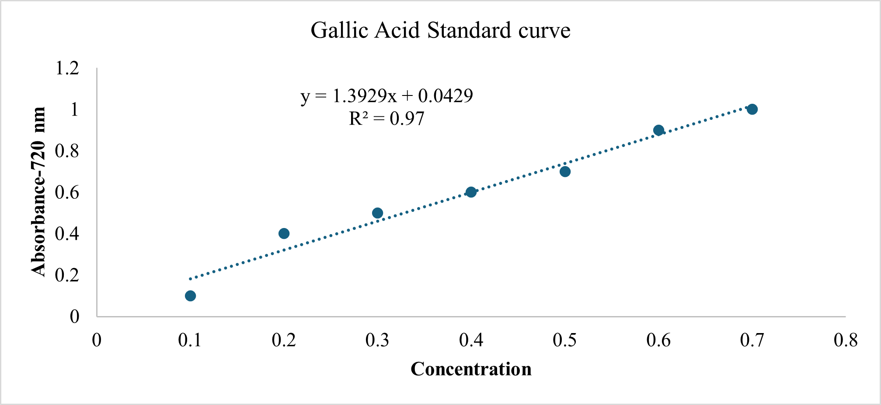
Figure S1. Standard curve for Total phenolic content
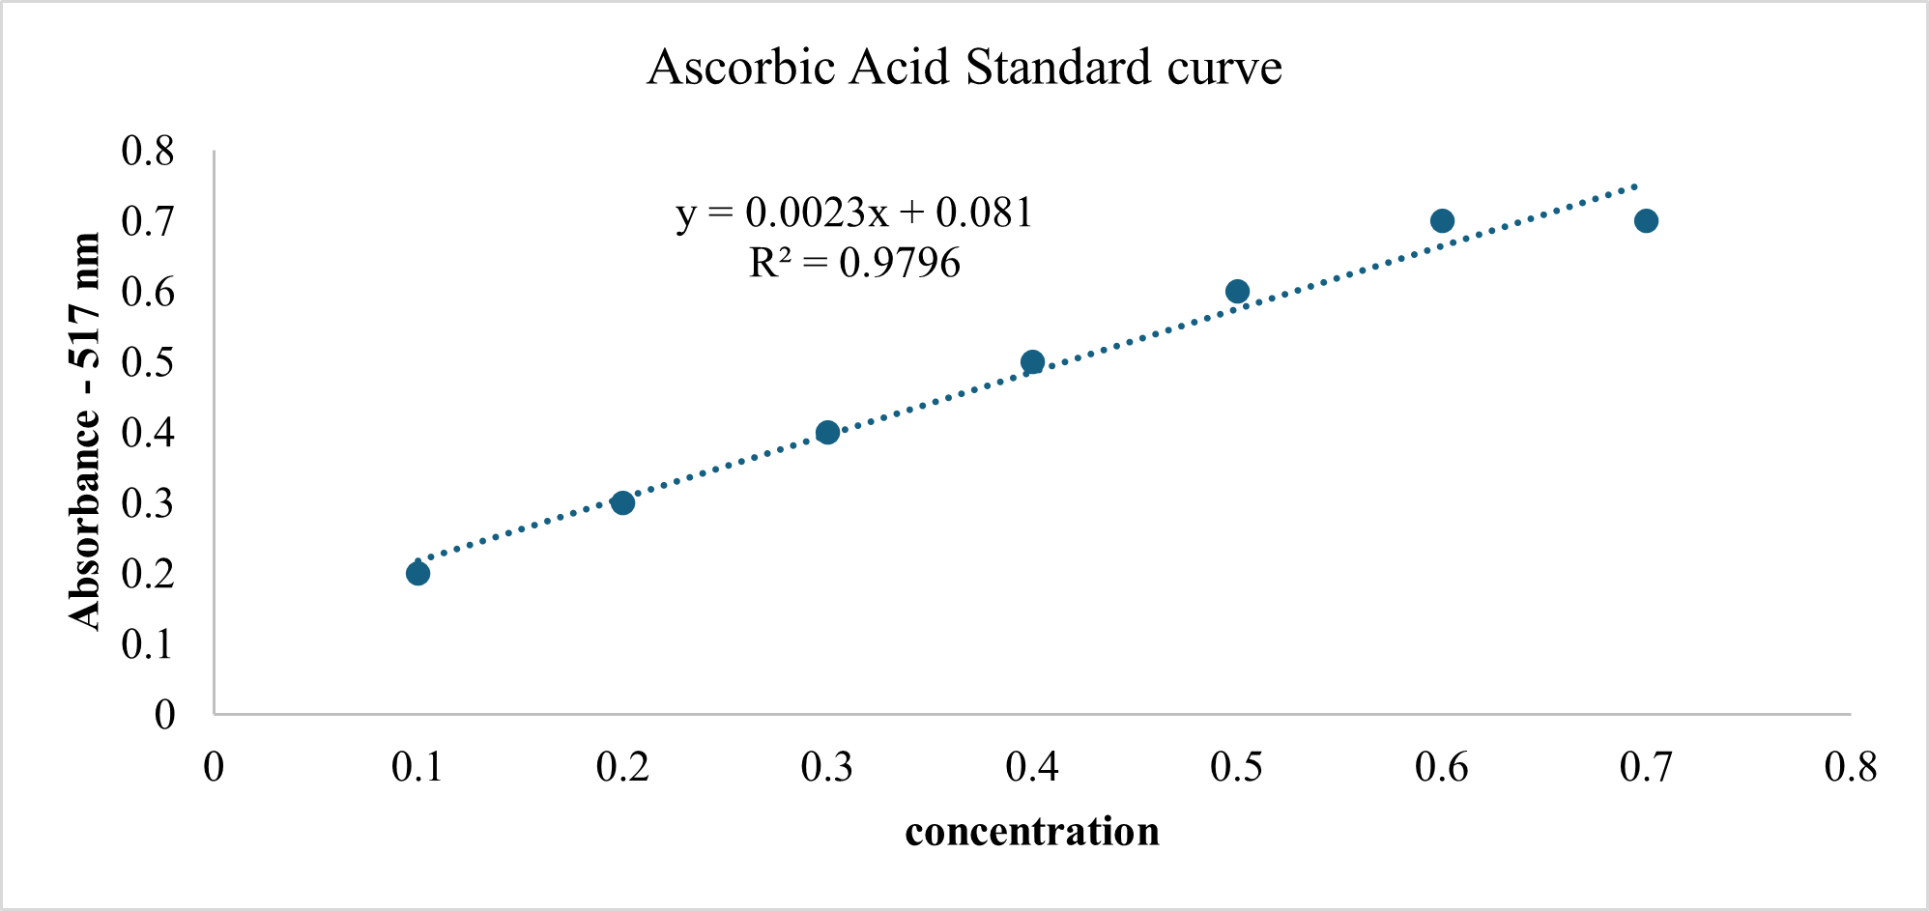
Figure S2. Standard curve for (DPPH) Radical Scavenging Activity
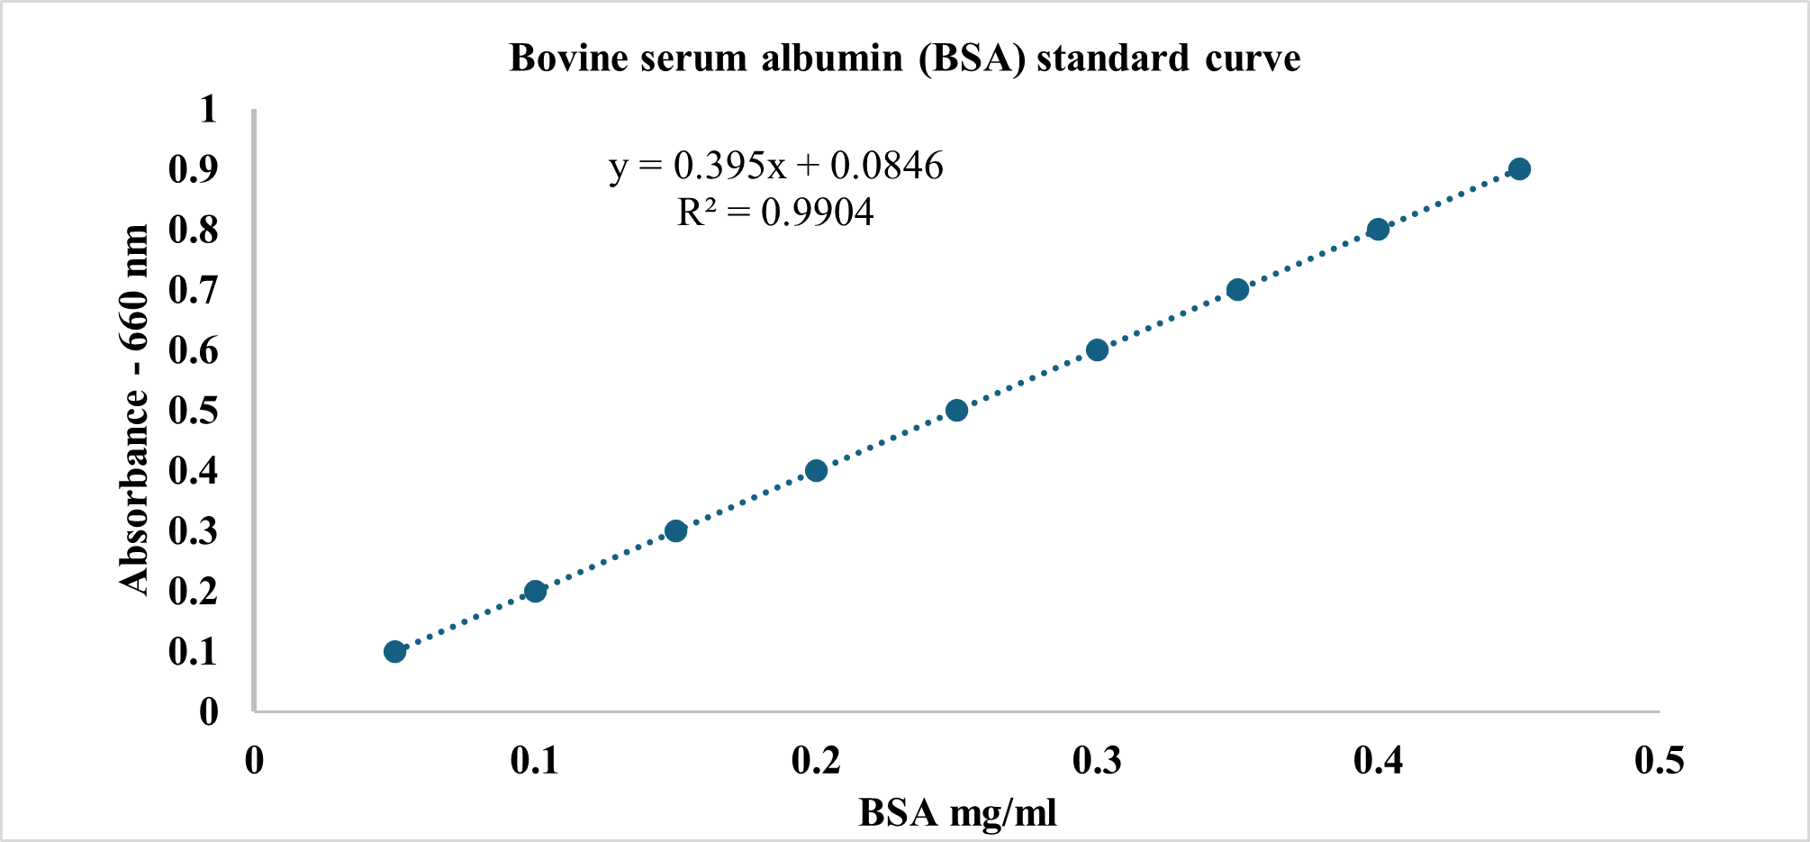
Figure S3. Standard curve for Bovine serum albumin
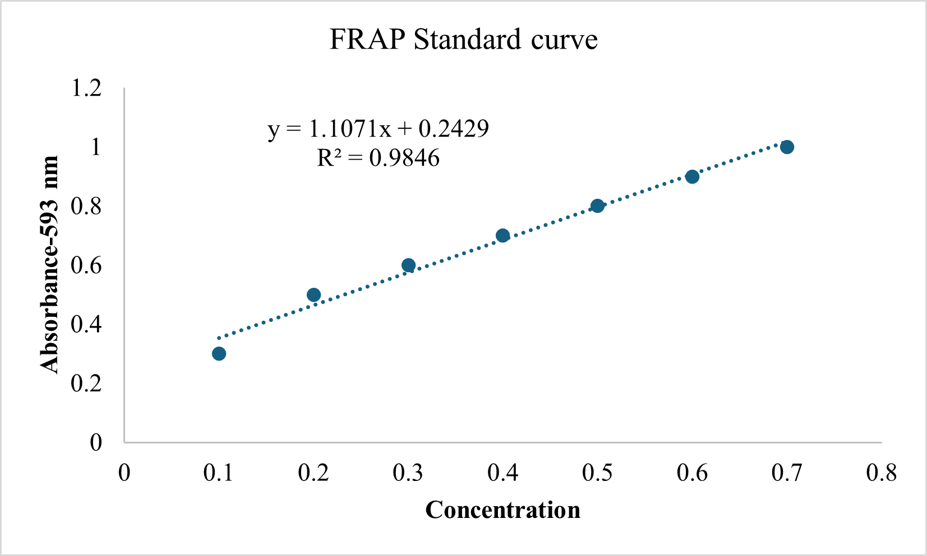
Figure S4. Standard curve for Ferric Reducing Antioxidant Power Assay

Table S1. Sensory evaluation Performa for sensory evaluation

SENSORY EVALUATION
Research Title:

Research Student:

Research Supervisor:
Name of Judge: ____________________________________________________________ |  |  |  |  |  |  |  |  |  |  |  | Dated: ______
9 - POINT HEDONIC SCALE
Score | Remarks |  |  | Score | Remarks |  |  |  |  | Score | Remarks
1 | Dislike Extremely |  |  | 4 | Dislike Slightly |  |  |  |  | 7 | Like Moderately
2 | Dislike Very Much |  |  | 5 | Neither Dislikes nor Like |  |  |  |  | 8 | Like Very Much
3 | Dislike Moderately |  |  | 6 | Likes Slightly |  |  |  |  | 9 | Like Extremely
Evaluation (SCORES) BY THE JUDGE
Sample No |  | Color | Flavor |  |  | Taste |  | Appearances | Overall Acceptability
Sample 1

Sample 2

Sample 3
Sample 4
Sample 5
Remarks for Improvement (Highly valuable and appreciated by us):
Instructions for Judges
- Chew the sample of the sweet and score it.
- Before preceding the next sample, rinse your mouth with water.
- Make an intercomparison of the sample and record the score.

Ref:
Meilgaard M C, G V. Civille and BT. Carr. 2007. Sensory Evaluation Techniques. 4th Edition. C.R.C. Press L.L.C., New York, USA.

