Supplementary information

Flood hazard amplification by intra-event sediment transport
Joshua M Wolstenholme¹*, Christopher J Skinner², Christopher R Hackney³, Matthew T Perks³, Daniel R Parsons¹
*j.m.wolstenholme@lboro.ac.uk
1 Geography and Environment, Loughborough University, Loughborough, UK
2 FloodSkinner, UK
3 School of Geography Politics and Sociology, Newcastle University, Newcastle upon Tyne, UK

Supplementary Table 1: Percentage changes for in-channel (V_{C}) and flood (V_{F}) volumes. * = no static flood. ** = extremely small dynamic flood compared to static.
 | ΔV_{C} (%) |  |  |  | ΔV_{F} (%)
RP | 3 h | 6 h | 12 h | 24 h | 3 h | 6 h | 12 h | 24 h
2 | –7 | +1 | –1 | –19 | * | –100 | +294 | +270
5 | 0 | –3 | –30 | –41 | –100** | +500 | +400 | +423
10 | +1 | –10 | –42 | –45 | –100** | +397 | +495 | +396
50 | –1 | –45 | –53 | –56 | +422 | +515 | +331 | +294
100 | –29 | –52 | –58 | –59 | +455 | +412 | +280 | +249
150 | –36 | –54 | –61 | –61 | +560 | +370 | +248 | +225
500 | –53 | –62 | –65 | –62 | +440 | +234 | +172 | +174
1000 | –55 | –67 | –65 | –62 | +301 | +191 | +145 | +152

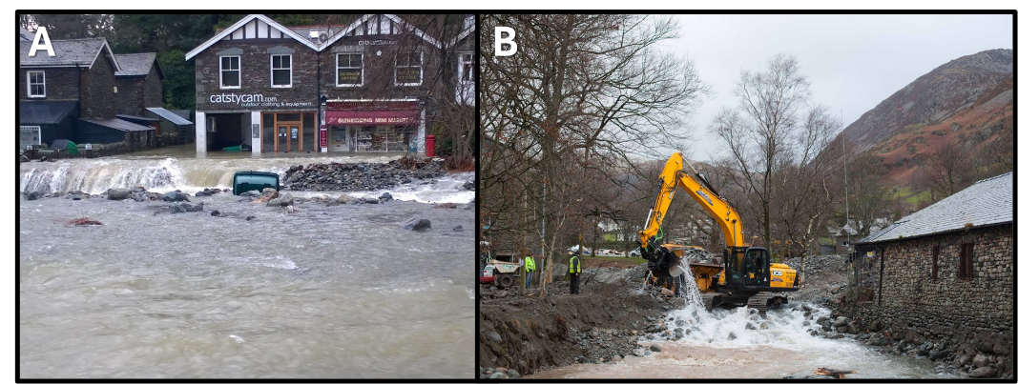
Supplementary Figure 1: Images from Glenridding Beck, Cumbria during Storm Desmond (2015). A) Glenridding Beck burst its banks due to 20,000 tonnes of gravel transported during the flood event and B) removal of sediment from channel. Photos by Ullswater Heritage, used under CC BY-NC-ND 4.0.
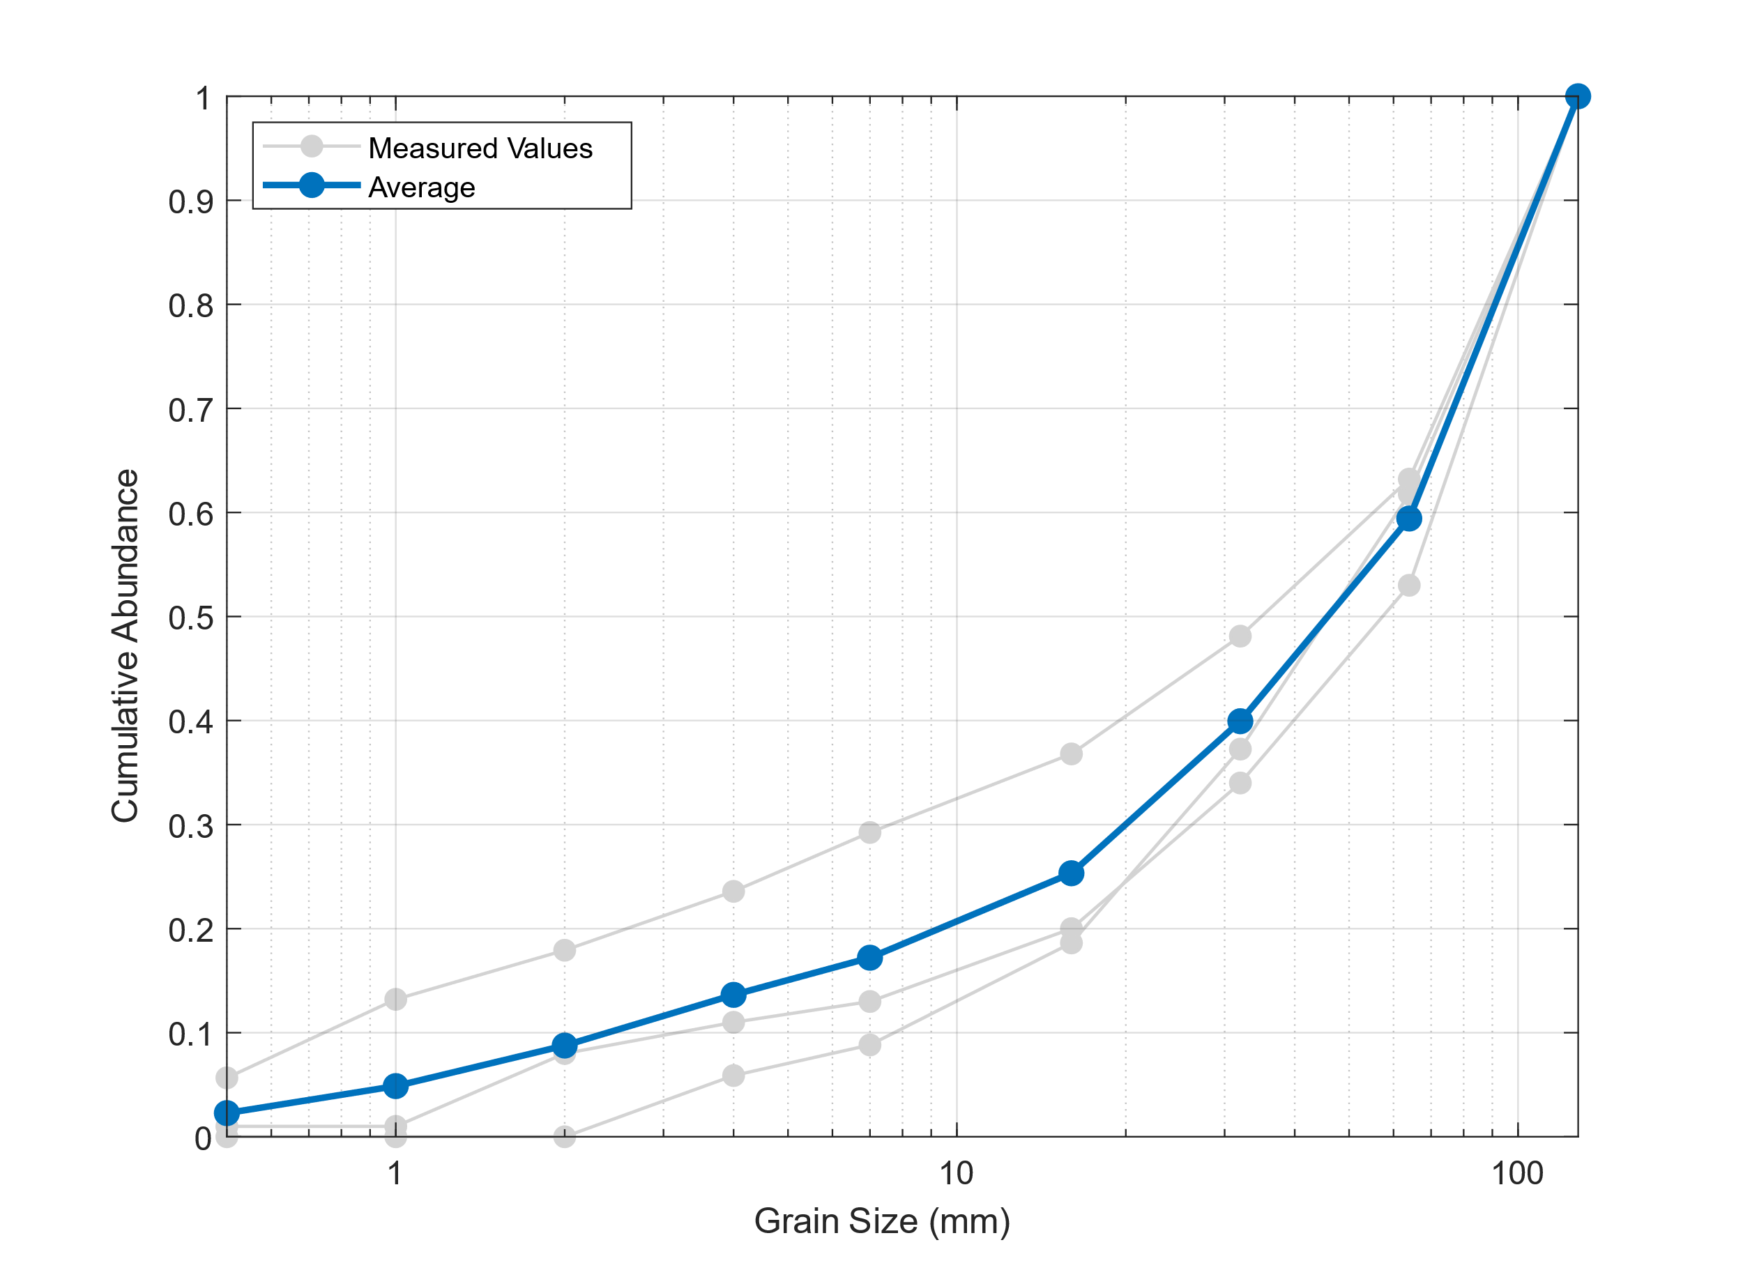
Supplementary Figure 2: Measured grain size distribution (grey) and modelled grain size distribution (blue) that is the average of measured values.
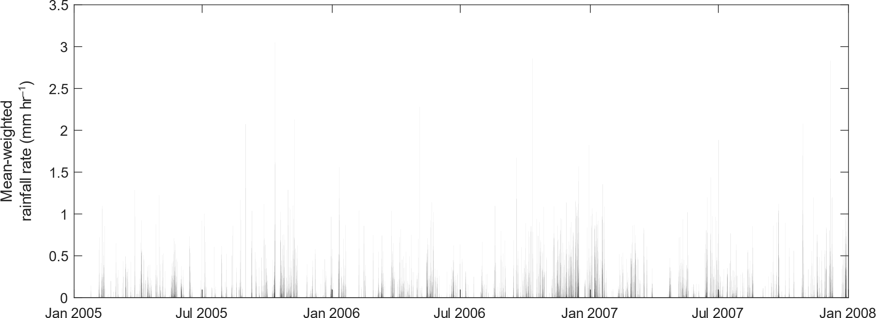
Supplementary Figure 3: Mean-weighted rainfall rate derived from NIMROD¹ 5 km grid cells for the Glenridding catchment. Spatially distributed rainfall from this period was used to "spin" the catchment and distribute sediment throughout.
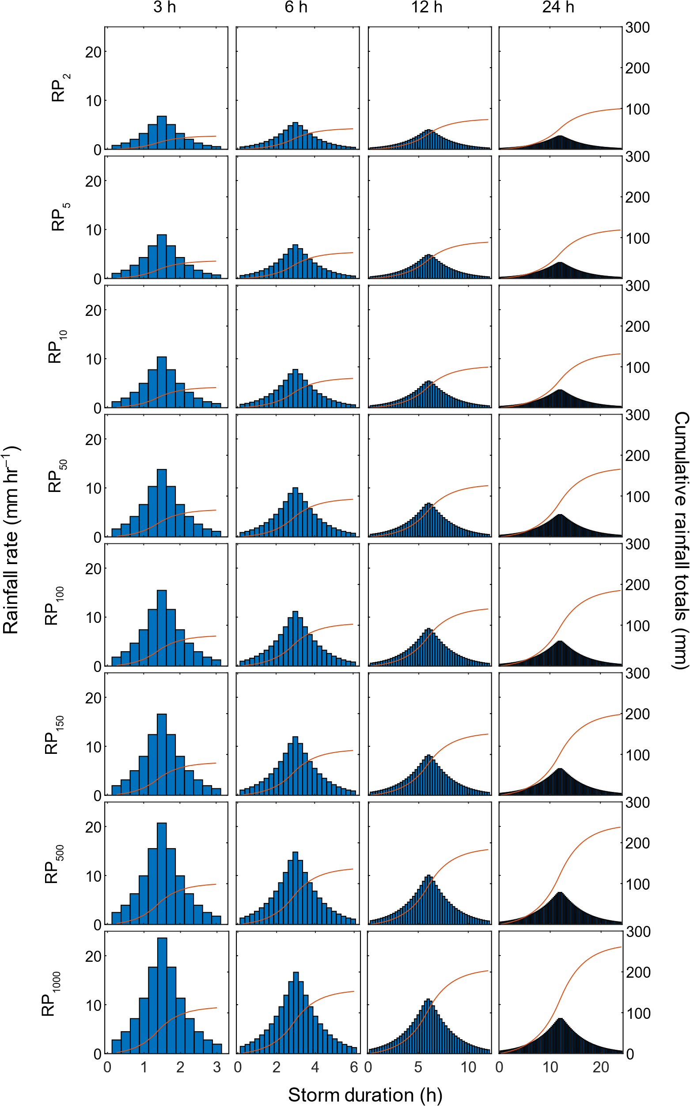
Supplementary Figure 4: Flood estimation handbook² design rainfall events at 15-minute temporal resolution applied globally to the model domain. Red line shows cumulative rain volume. Note different X-axis.
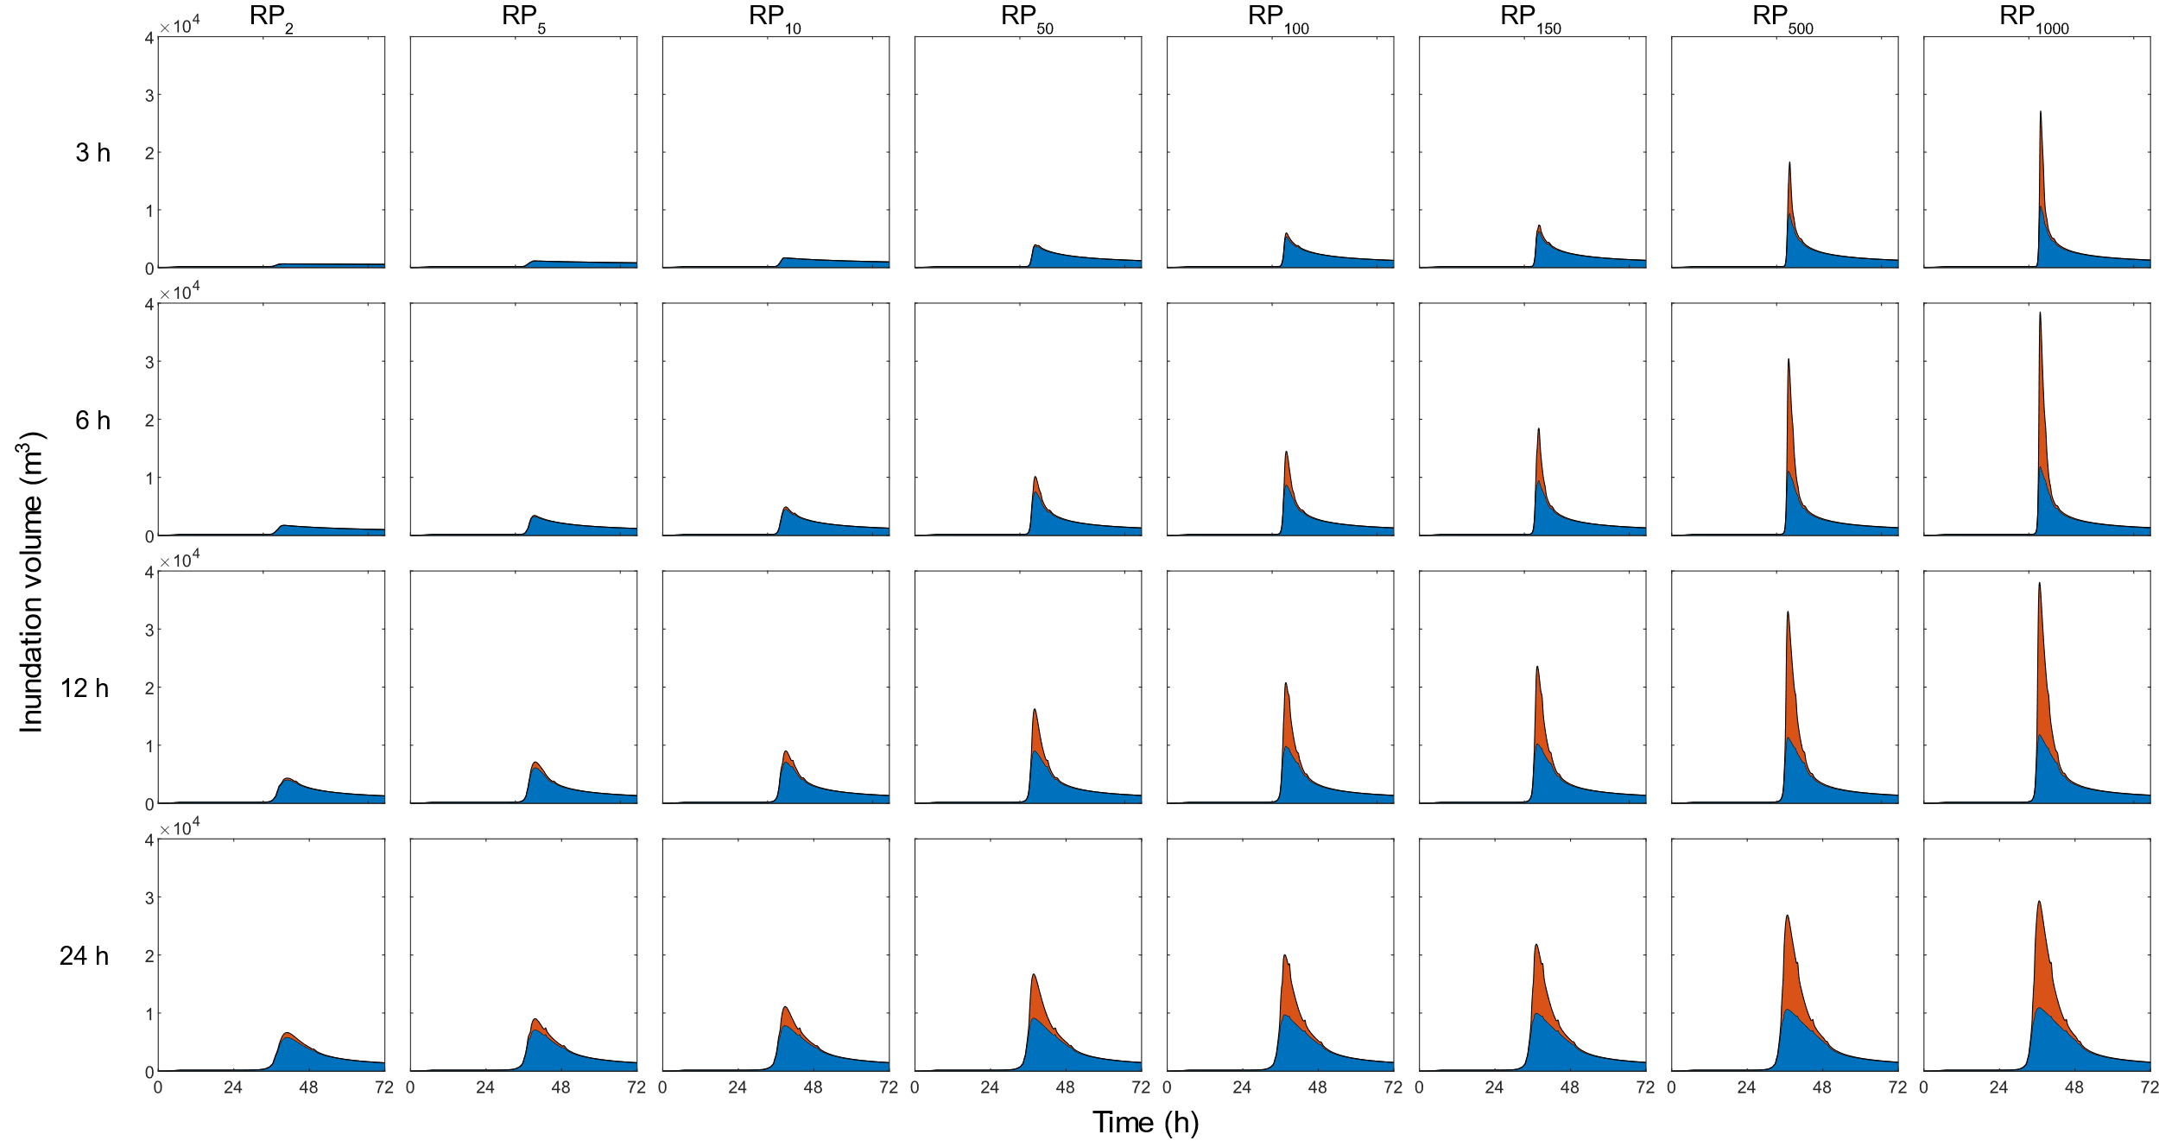
Supplementary Figure 5: Static simulation response to design hydrographs where blue is in-channel inundation volume (V_{C}) over time and orange is flood volume (V_{F}). Return period (RP) is shown across the top of the figure, and storm duration on the left.
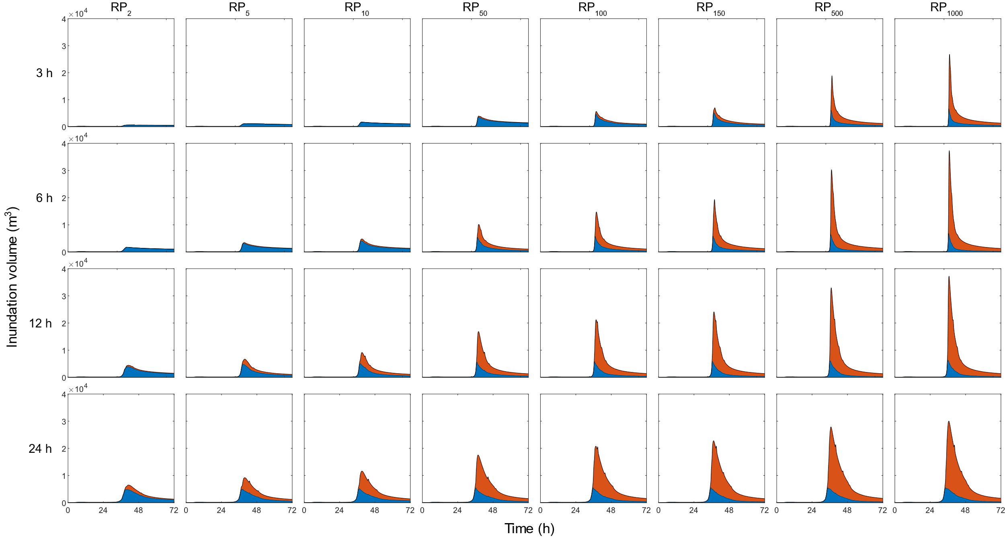
Supplementary Figure 6: Dynamic simulation response to design hydrographs where blue is in-channel inundation volume (V_{C}) over time and orange is flood volume (V_{F}). Return period (RP) is shown across the top of the figure, and storm duration on the left.
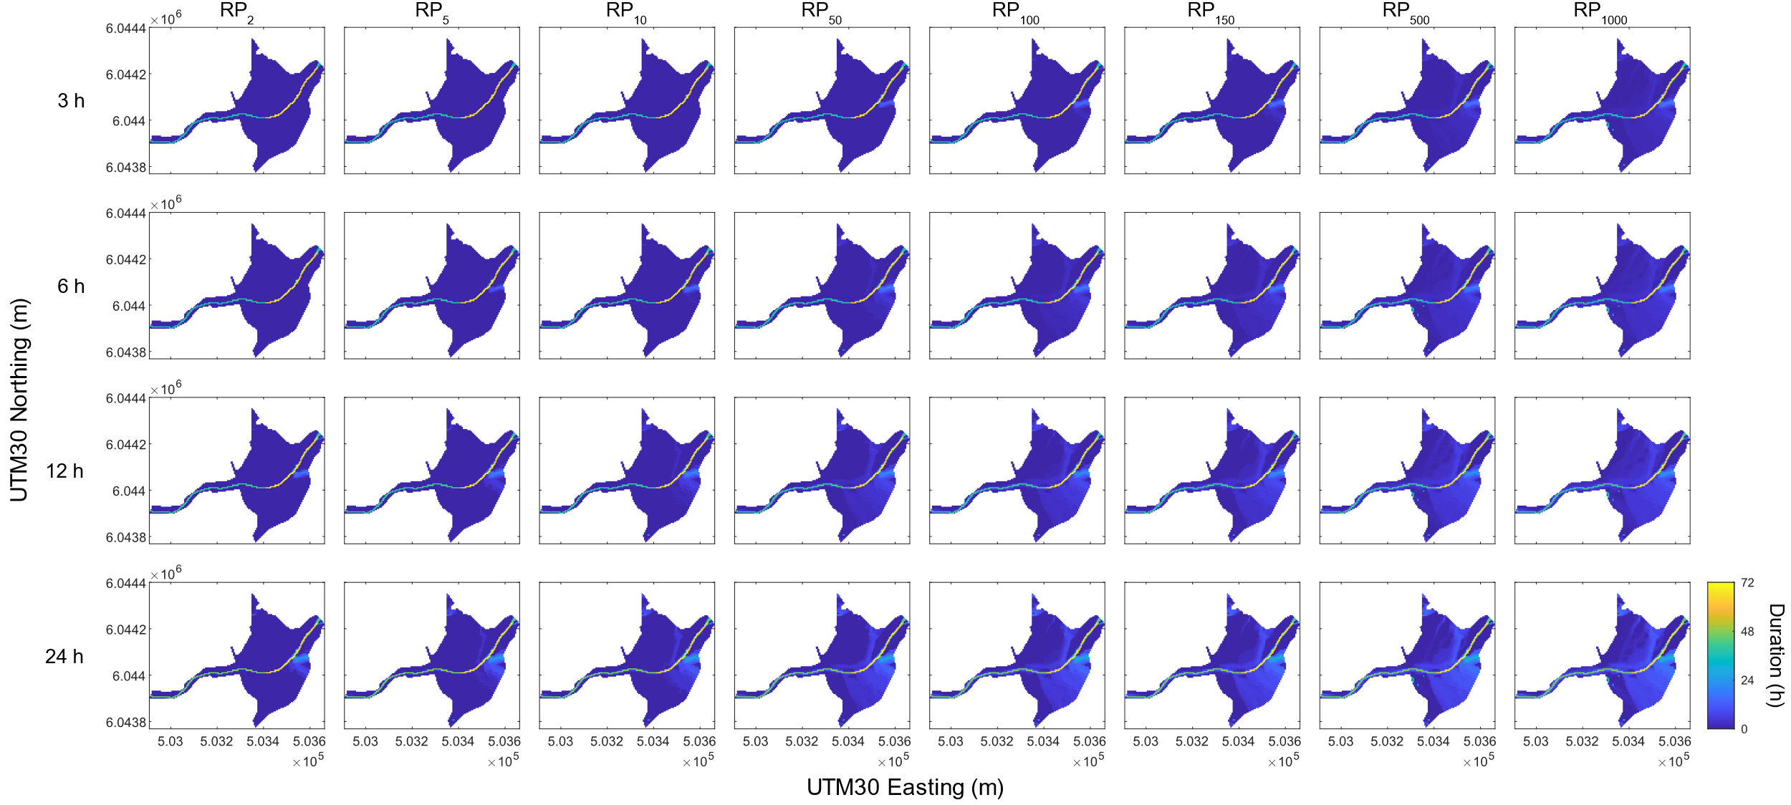
Supplementary Figure 7: Spatially distributed inundation durations for static simulations. Return period (RP) is shown across the top of the figure, and storm duration on the left.
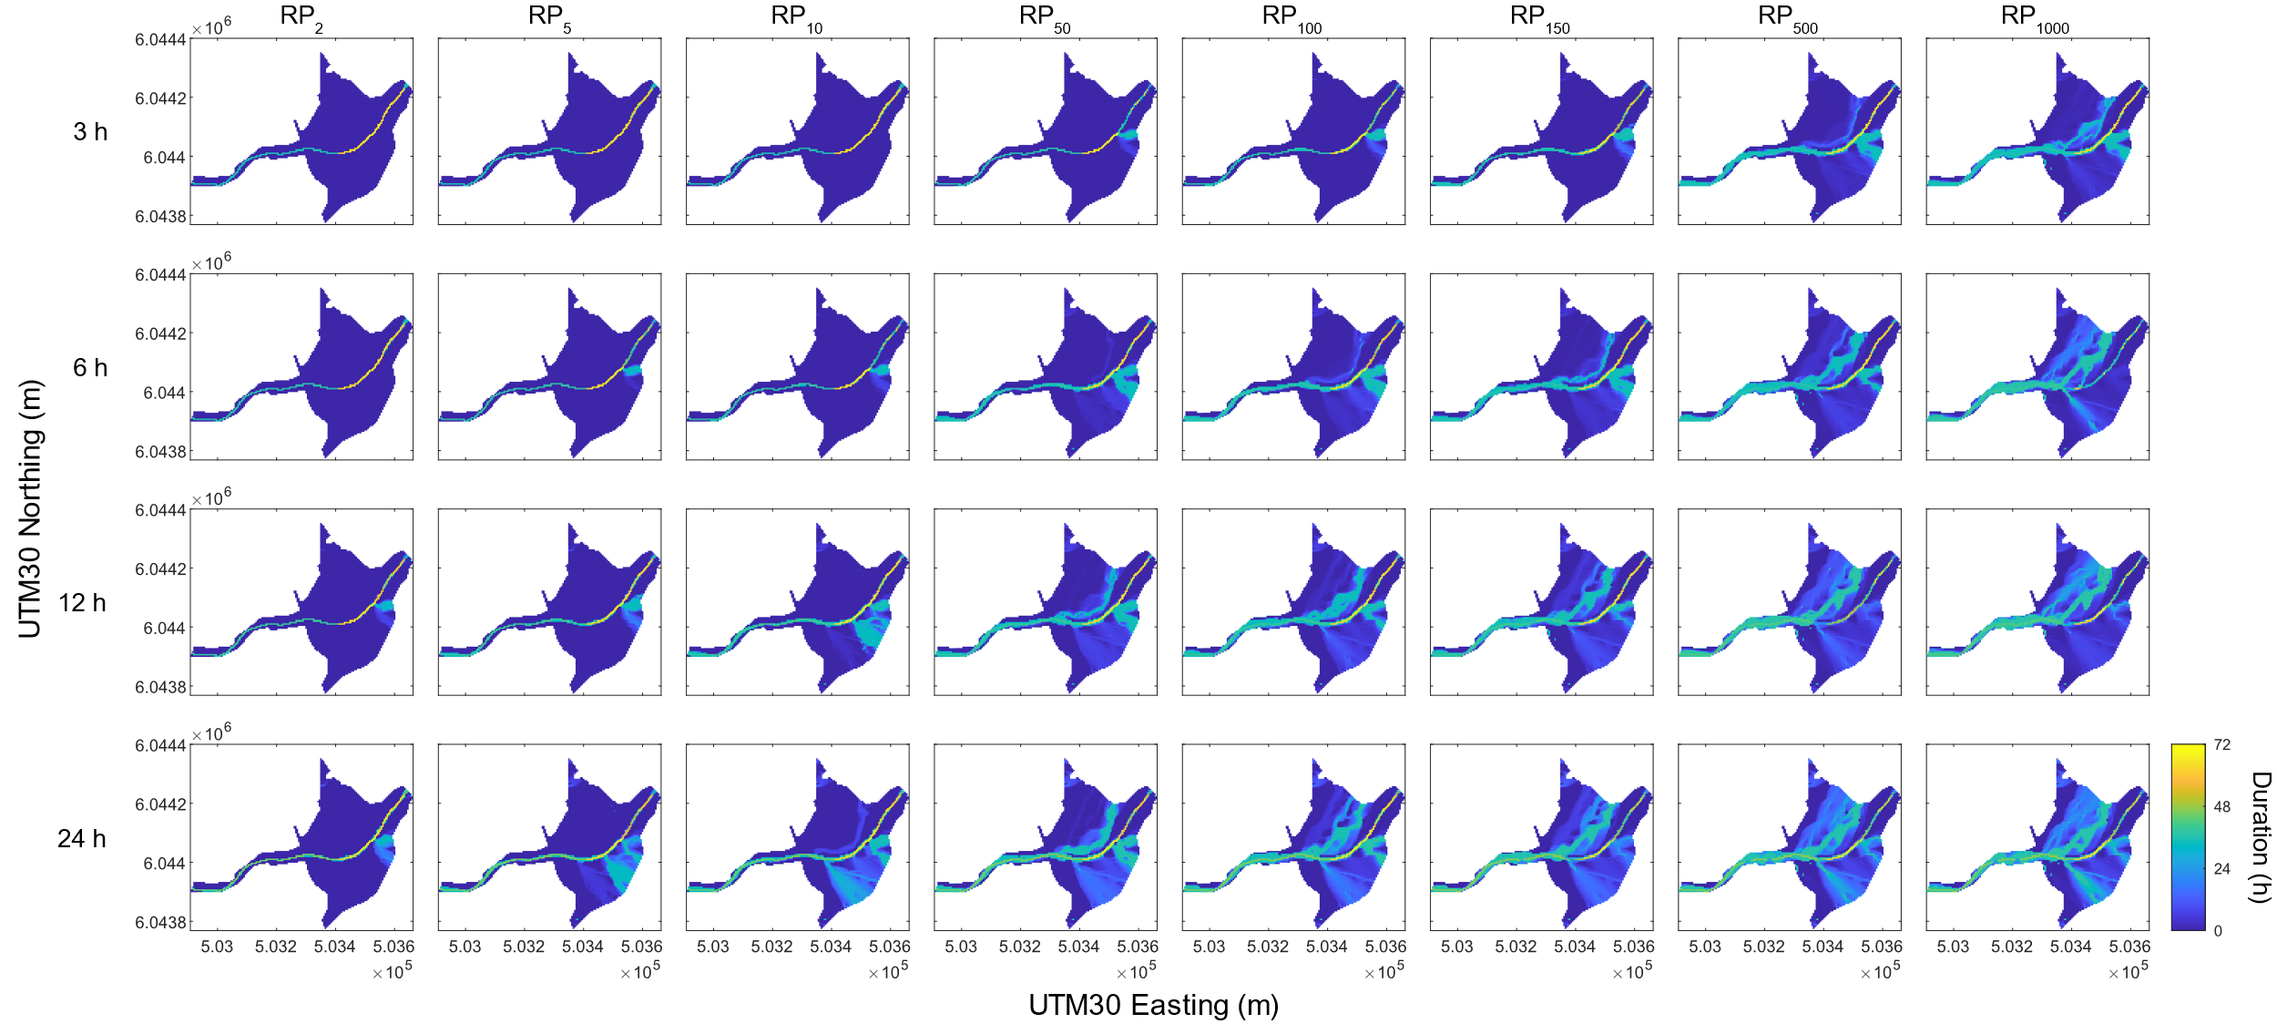
Supplementary Figure 8: Spatially distributed inundation durations for dynamic simulations. Return period (RP) is shown across the top of the figure, and storm duration on the left.
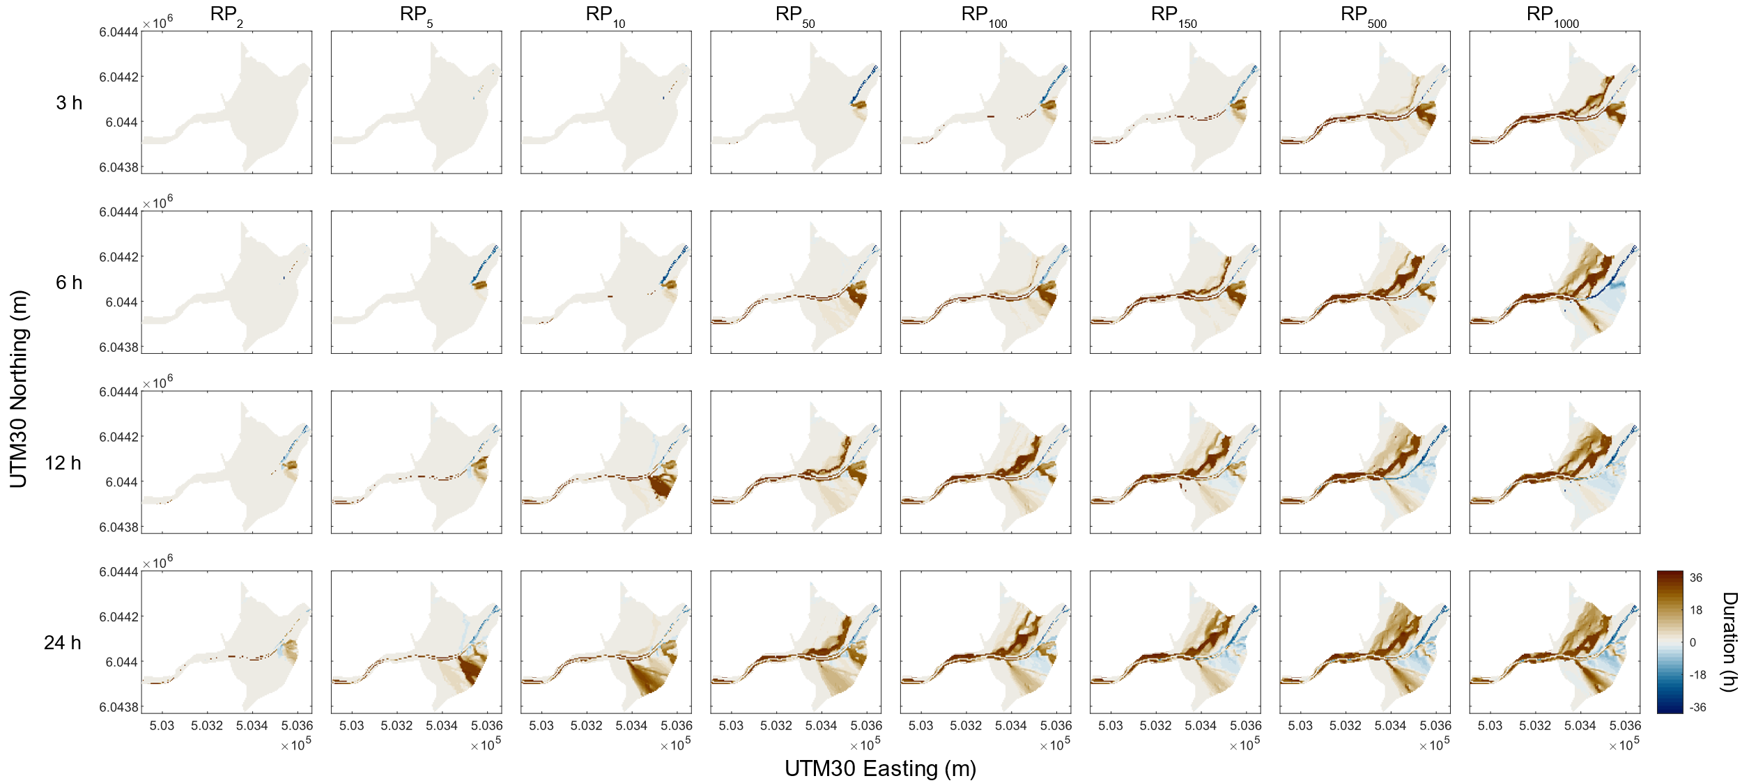
Supplementary Figure 9: Difference in inundation duration between static and dynamic simulations. Return period (RP) is shown across the top of the figure, and storm duration on the left.
References
1. Met Office. 5 km Resolution Europe Composite Resolution Rainfall Data from the Met Office Nimrod System. (2003).
2. Faulkner, D. Rainfall Frequency Estimation, Volume 2 of the Flood Estimation Handbook. (Centre for Ecology and Hydrology, 1999).

