Supplementary information

Novel fusion peptide-mediated siRNA delivery using self-assembled nanocomplex

Yeong Chae Ryu¹, Kyungah Kim¹, Byoung Choul Kim^{1,2}, Hui-Min David Wang³, Byeong Hee Hwang^{1,2,*}

¹ Department of Bioengineering and Nano-bioengineering, Incheon National University, Incheon, 22012, Korea
² Division of Bioengineering, Incheon National University, Incheon, 22012, Korea
³ Graduate Institute of Biomedical Engineering, National Chung Hsing University, Taichung 402, Taiwan

_____
* Corresponding author.
Address: Academy-ro 119, Yeonsu-gu, Incheon, South Korea, 22012
Phone: +82-32-835-8834
Fax: +82-32-835-2699
E-mail address: bhwang@inu.ac.kr

Table S1. List of peptides used in this study
Name | Sequence | Origin | Reference
Skin permeating and cell entering (SPACE) | ACTGSTQHQCG | Artificial | [1]
Oligo-arginine (R11) | RRRRRRRRRRR | Artificial | [2]
TAT | RKKRRQRRR | HIV-1 | [3]
SPACE-R7 (S-R7) | ACTGSTQHQCGGCGRRRRRRR | Artificial | In this study
SPACE-R11 (S-R11) | ACTGSTQHQCGGCGRRRRRRRRRRR | Artificial | In this study
SPACE-R15 (S-R15) | ACTGSTQHQCGGCGRRRRRRRRRRRRRRR | Artificial | In this study
* The underlined sequence indicated a linker between two sequences.

Table S2. Average size, polydispersity index (PdI), and zeta potential of complexes with siRNA and each peptide. The data represented mean ± standard deviation (n=3).
Complex with siRNA | Size | PdI | Zeta potential
SPACE | 647.7 ± 295.18 | 0.889 ± 0.192 | -28.33 ± 1.079
R11 | 413.73 ± 50.28 | 0.228 ± 0.009 | -11.77 ± 0.451
S-R7 | 327.1 ± 42.63 | 0.217 ± 0.013 | 5.23 ± 2.796
S-R11 | 456.97 ± 56.79 | 0.235 ± 0.013 | 6 ± 0.684
S-R15 | 286.97 ± 11.42 | 0.04 ± 0.006 | 6.08 ± 1.618

Table S3. Primer sequences used in real-time PCR
Gene | Sequence
GAPDH | Forward : 5’-GTCTCCTCTGACTTCAACAGCG-3’  Reverse : 5’-ACCACCCTGTTGCTGTAGCCAA-3’
β-actin | Forward : 5’-CACCATTGGCAATGAGCGGTTC-3’  Reverse : 5’-AGGTCTTTGCGGATGTCCACGT-3’

Table S4. Absorbance measurement of released LDH. The data represented mean ± standard deviation (n=3).
Concentration (mg/mL) | S-R7 | S-R11 | S-R15
0 | 1.000 ± 0.195 | 1.000 ± 0.195 | 1.000 ± 0.195
0.0125 | 1.020 ± 0.186 | 1.179 ± 0.145 | 0.836 ± 0.159
0.025 | 0.921 ± 0.122 | 1.157 ± 0.300 | 1.086 ± 0.243
0.05 | 1.185 ± 0.238 | 1.037 ± 0.089 | 0.879 ± 0.352
0.1 | 1.270 ± 0.243 | 1.007 ± 0.102 | 1.044 ± 0.273
0.2 | 1.071 ± 0.235 | 0.983 ± 0.216 | 1.167 ± 0.059

Table S5. Relative in vivo fluorescence values by normalized mean of intensity. The data represented mean ± standard deviation (n=4). The outliers were removed by Grubbs’ test.
Group | 0 h | 1 h | 2 h | 3 h | 4 h
Free siRNA | 1 | 0.568 ± 0.047 | 0.459 ± 0.124 | 0.457 ± 0.166 | 0.421 ± 0.189
S-R11 complex | 1 | 1.011 ± 0.196 | 0.938 ± 0.221 | 0.977 ± 0.228 | 0.972 ± 0.198

Table S6. Relative in vivo fluorescence values by normalized integrated density. The data represented mean ± standard deviation (n=4). The outliers were removed by Grubbs’ test.
Group | 0 h | 1 h | 2 h | 3 h | 4 h
Free siRNA | 1 | 0.451 ± 0.147 | 0.148 ± 0.073 | 0.137 ± 0.123 | 0.089 ± 0.118
S-R11 complex | 1 | 0.756 ± 0.05 | 0.482 ± 0.328 | 0.562 ± 0.175 | 0.544 ± 0.311

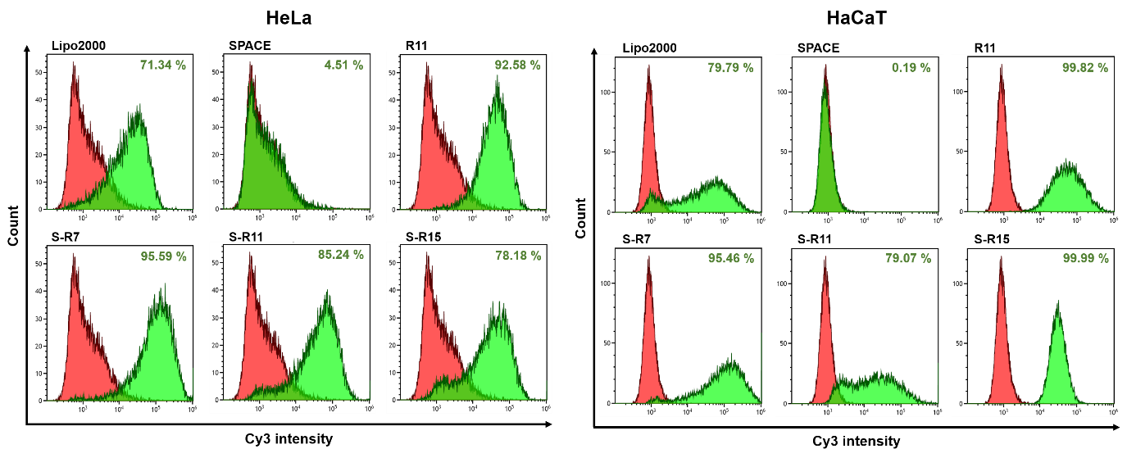
Figure S1. Cellular uptake evaluation of siRNA/peptide nanocomplexes into HeLa and HaCaT cells using a flow cytometry. Cy3-labeled IL10-siRNAs of final 200 nM concentration were delivered into each 3.0×10⁵ cells in a 6-well plate via PC: LipofectamineTM 2000 as a commercialized positive control, SPACE, R11, S-R7, S-R11, and S-R15 (20:1 N/P ratio) for 4 hours. Fluorescent cells of free siRNA and each condition exhibited in red and green populations, respectively. The population of fluorescent-positive cells was expressed as a percentage.

References
[1] T. Hsu, S. Mitragotri, Delivery of siRNA and other macromolecules into skin and cells using a peptide enhancer, P Natl Acad Sci USA, 108 (2011) 15816-15821.
[2] D.J. Mitchell, D.T. Kim, L. Steinman, C.G. Fathman, J.B. Rothbard, Polyarginine enters cells more efficiently than other polycationic homopolymers, J Pept Res, 56 (2000) 318-325.
[3] E. Vives, P. Brodin, B. Lebleu, A truncated HIV-1 Tat protein basic domain rapidly translocates through the plasma membrane and accumulates in the cell nucleus, J Biol Chem, 272 (1997) 16010-16017.

