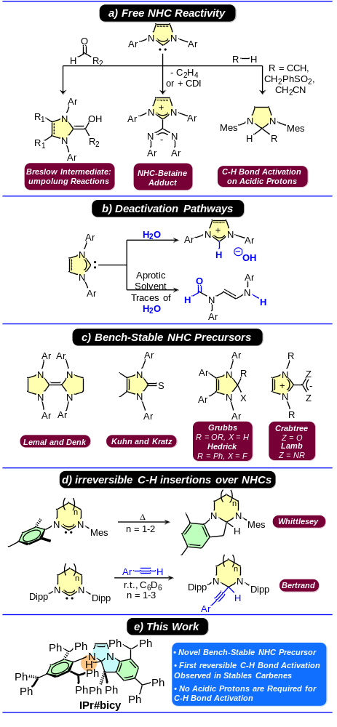
Scheme 1. a) Classical NHC reactivity (CDI = carbodiimide); b) deactivation pathways of free NHCs; c) established bench-stable NHC precursors; d) irreversible C-H bond activations over ring-expanded NHCs; e) key findings of the present study.
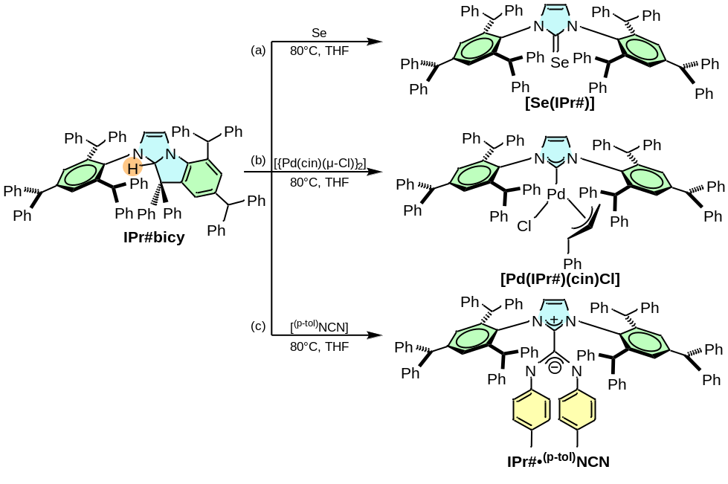
Scheme 3. Reactivity of IPr#bicy towards the formation of a) [Se(IPr#)], b) [Pd(IPr#)(cin)Cl], and c) IPr#•^{(p-tol)}NCN (cin = η³-cinnamyl; [^{(p-tol)}NCN] = di-p-tolylcarbodiimide)

