Additional file 1: Fig. S1 A sandwich ELISA for detecting HuNoVs at diverse processing temperature and time. (∗∗ 0.01 < p < 0.05; ∗∗∗ p < 0.01)

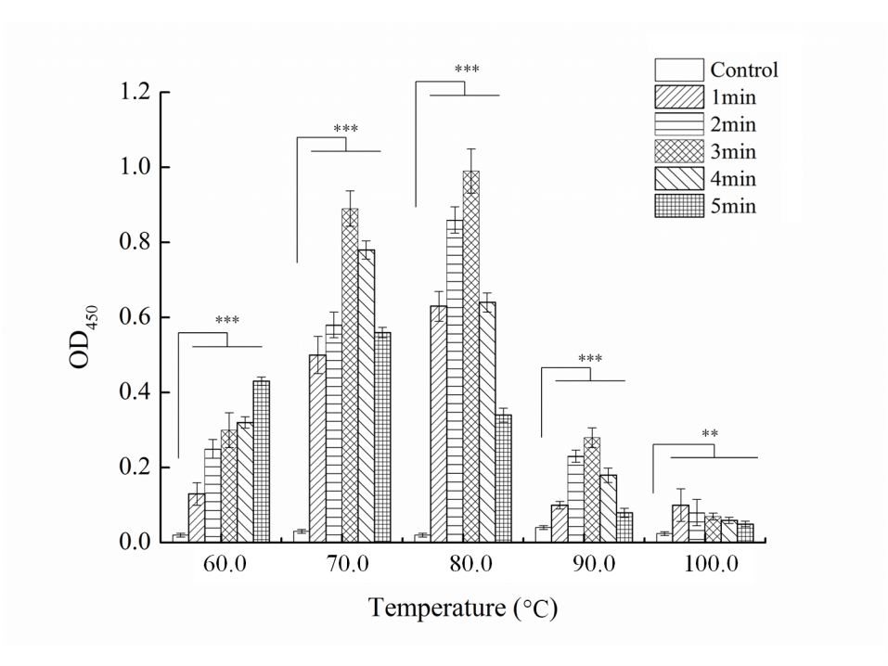

Additional file 1: Fig. S2 A sandwich ELISA analysis of HuNoVs after treatment of pH at different time. (∗∗ 0.01 < p < 0.05; ∗∗∗ p < 0.01)
