Supplementary Information

Piezo1 selectively enhances TGF-β1-induced IgA class switching by B cells

Yoonji Jung^{1,#}, Younghwan Han^{2,#}, Jaeku Kang^{2,3}, Seong-Lan Yu², Seok-Rae Park^{1,2,*}
¹Department of Microbiology, Konyang University College of Medicine, Daejeon 35365, Korea
²Priority Research Center, Myunggok Medical Research Institute, Konyang University College of Medicine, Daejeon 35365, Korea
³Department of Pharmacology, Konyang University College of Medicine, Daejeon 35365, Korea

*Correspondence to Seok-Rae Park
E-mail: srpark@konyang.ac.kr
Supplementary Table 1. RT-PCR primer sequences
Primer  (product size) | Sequence
GLTα  (206 bp) | Sense: 5’- CTACCATAGGGAAGATAGCCT -3’  Anti-sense: 5’- TAATCGTGAATCAGGCAG -3’
GLTγ2b  (318 bp) | Sense: 5’- GGGAGAGCACTGGGCCTT -3’  Anti-sense: 5’-AGTCACTGACTCAGGGAA -3’
GLTγ1  (532 bp) | Sense: 5’- CAGCCTGGTGTCAACTAG -3’  Anti-sense: 5’- CTGTACATATGCAAGGCT -3’
GLTε  (423 bp) | Sense: 5’-ACTAGAGATTCACAACG -3’  Anti-sense: 5’-AGCGATGAATGGAGTAGC -3’
GLTγ2c  (394 bp) | Sense: 5’- GCTGATGTACCTACCTGAGAGA -3’  Anti-sense: 5’- GCTGGGCCAGGTGCTCGAGGTT -3’
GLTγ3  (349 bp) | Sense: 5’- CAAGTGGATCTGAACACA -3’  Anti-sense: 5’- GGCTCCATAGTTCCATT -3’
PSTα  (267 bp) | Sense: 5’- GAGCTGGTGGGAGTGTCAGTG -3’  Anti-sense: 5’- GTCTGGTTAGCCGGACAGAA -3’
PSTγ2b  (246 bp) | Sense: 5’- ACCTGGGAATGTATGGTTGTGGCTT -3’  Anti-sense: 5’- AGTCACTGACTCAGGGAA -3’
PSTγ1  (532 bp) | Sense: 5’- ACCTGGGAATGTATGGTTGTGGCTT -3’  Anti-sense: 5’- ATGGAGTTAGTTTGGGCAGCA -3’
PSTε  (423 bp) | Sense: 5’- CTCGGTGGCTTTGAAGGAAC -3’  Anti-sense: 5’- AGCGATGAATGGAGTAGC -3’
PSTγ2c  (394 bp) | Sense: 5’- ACCTGGGAATGTATGGTTGTGGCTT -3’  Anti-sense: 5’- GCTGGGCCAGGTGCTCGAGGTT -3’
PSTγ3  (349 bp) | Sense: 5’- ACCTGGGAATGTATGGTTGTGGCTT -3’  Anti-sense: 5’- GGCTCCATAGTTCCATT -3’
Piezo1  (257 bp) | Sense: 5’- GCAGTGGCAGTGAGGAGATT -3’  Anti-sense: 5’- GATATGCAGGCGCCTATCCA -3’
β-actin  (318 bp) | Sense: 5’-CATGTTTGAGACCTTCAACACCCC-3’  Anti-sense: 5’-GCCATCTCCTGCTCGAAGTCTAG-3’

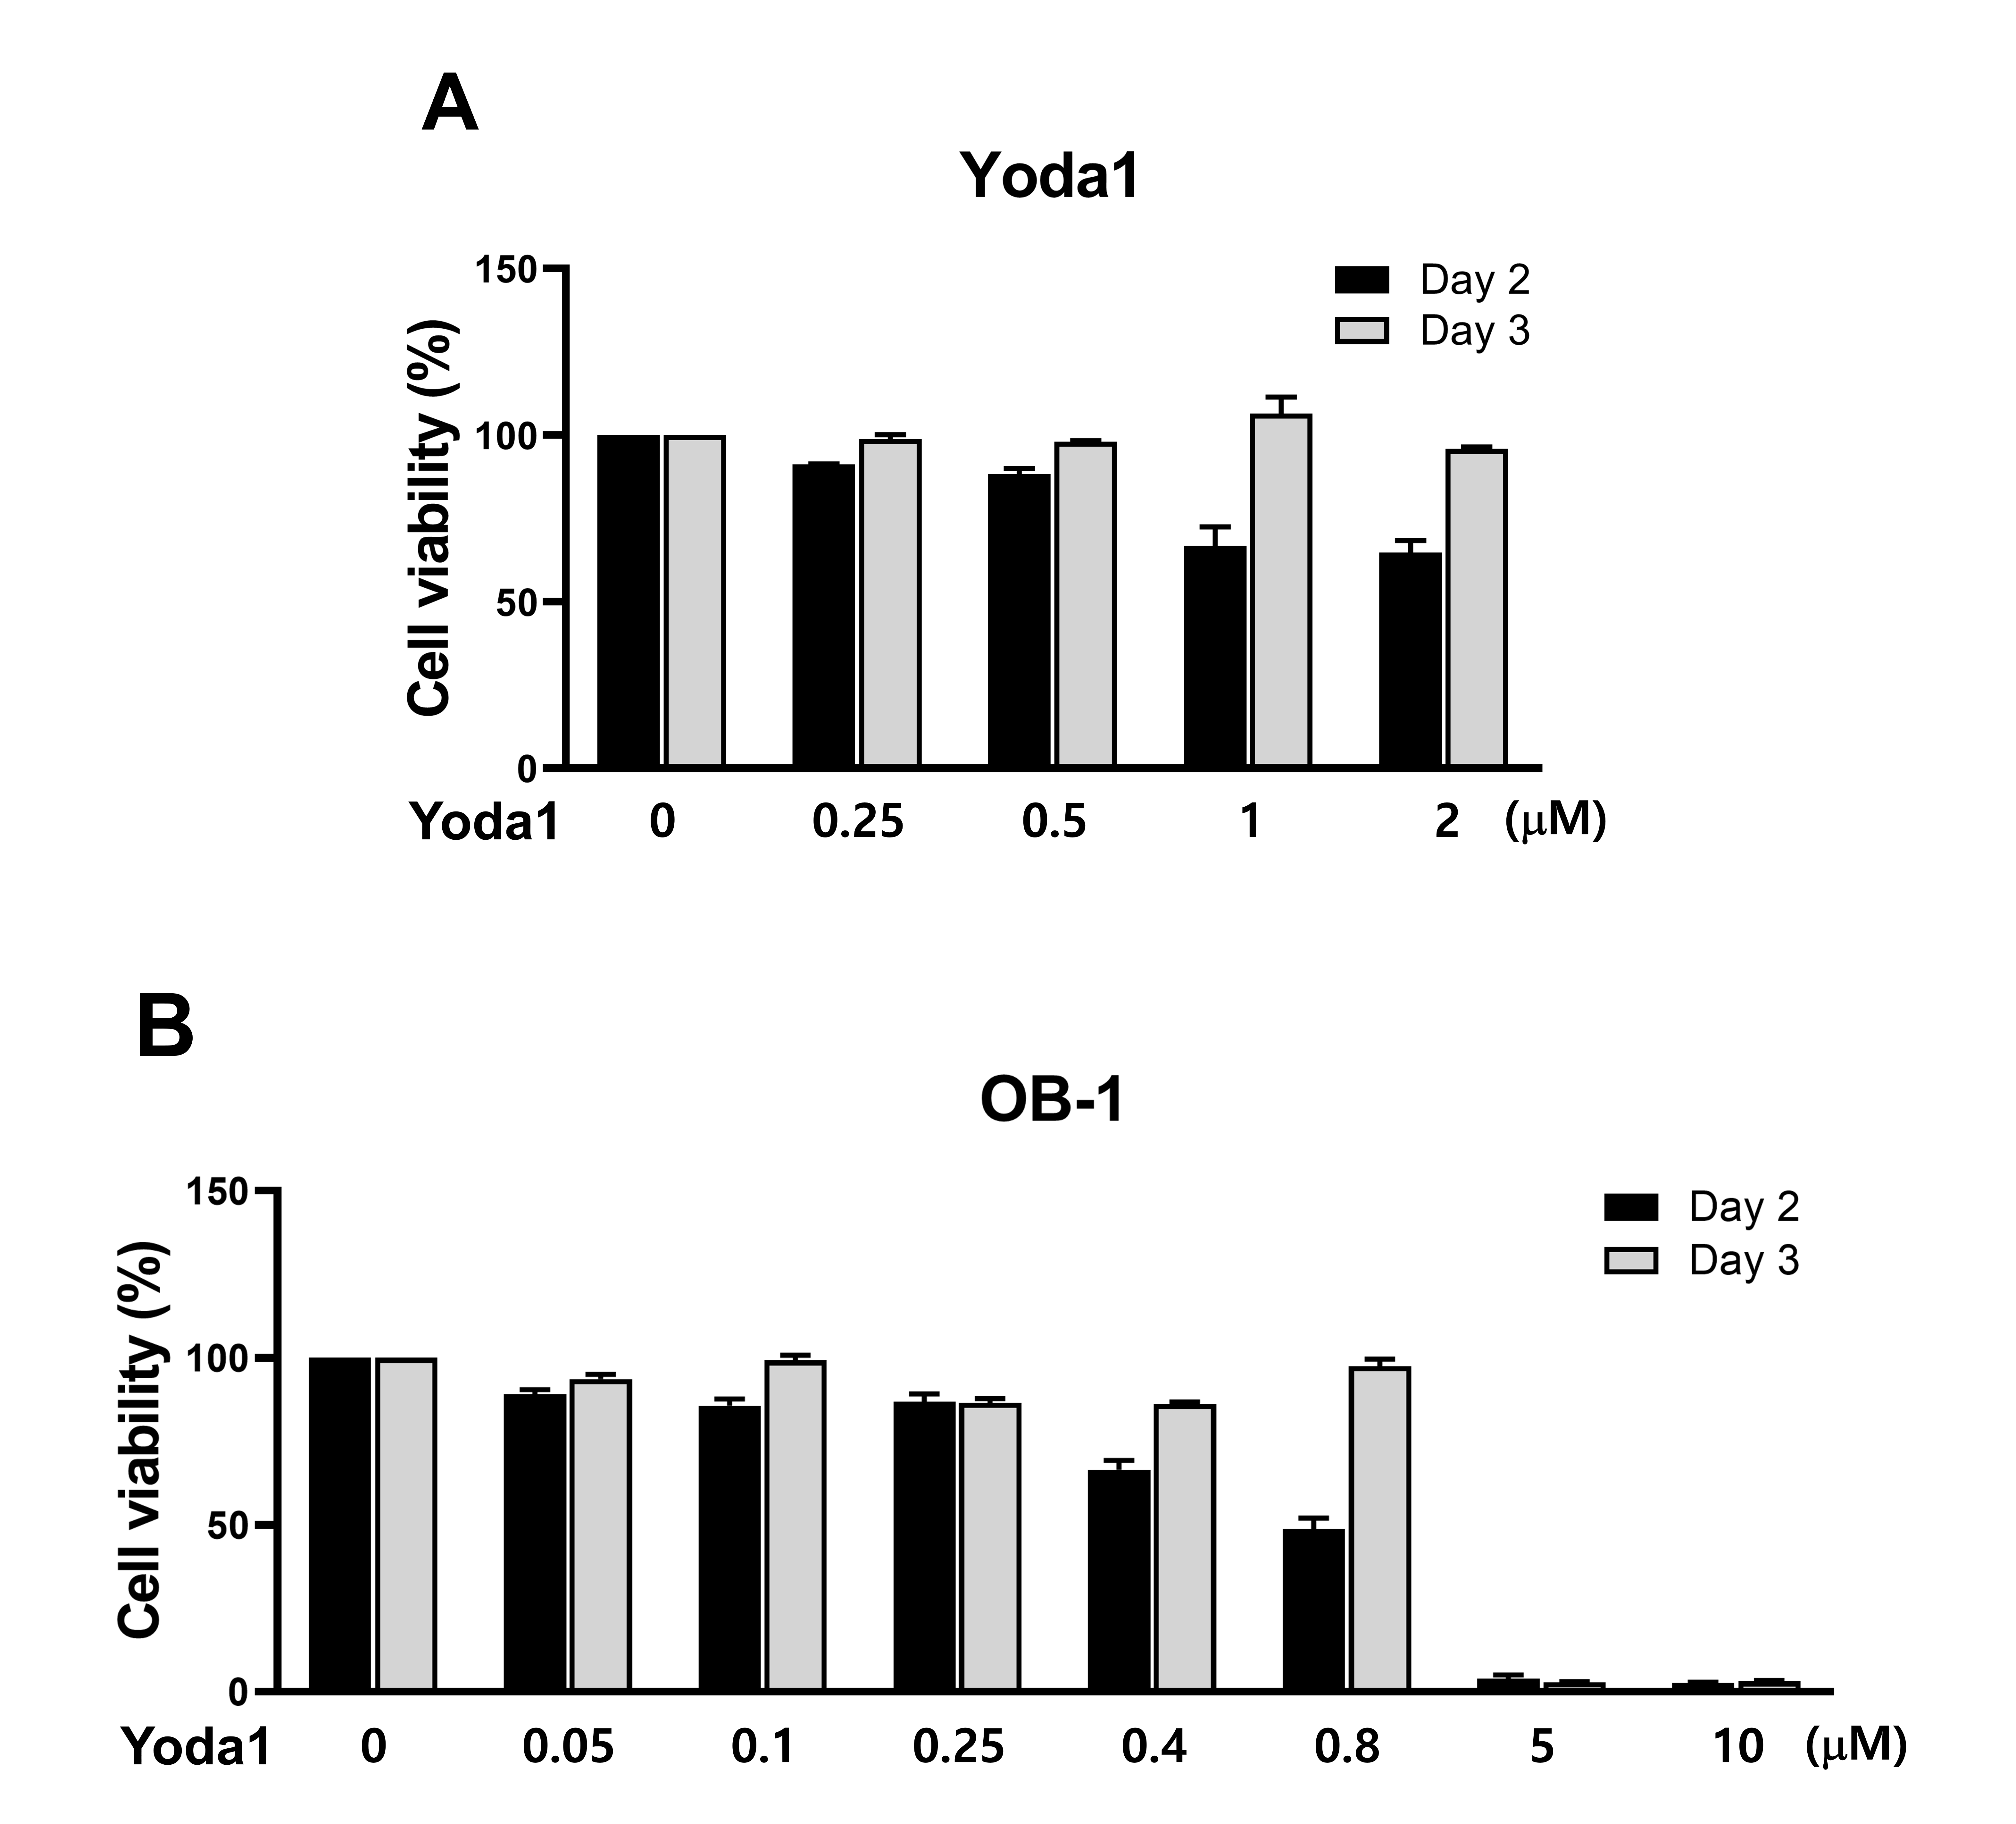Supplementary Fig. 1. Effect of Yoda1 and OB-1 on mouse splenic B cell viability
Purified mouse B cells were stimulated with each concentration of Yoda1 and OB-1 in the presence of LPS (12.5 µg/ml). Cell viability was measured by the Ez-Cytox assay at 2 and 3 days of culture.
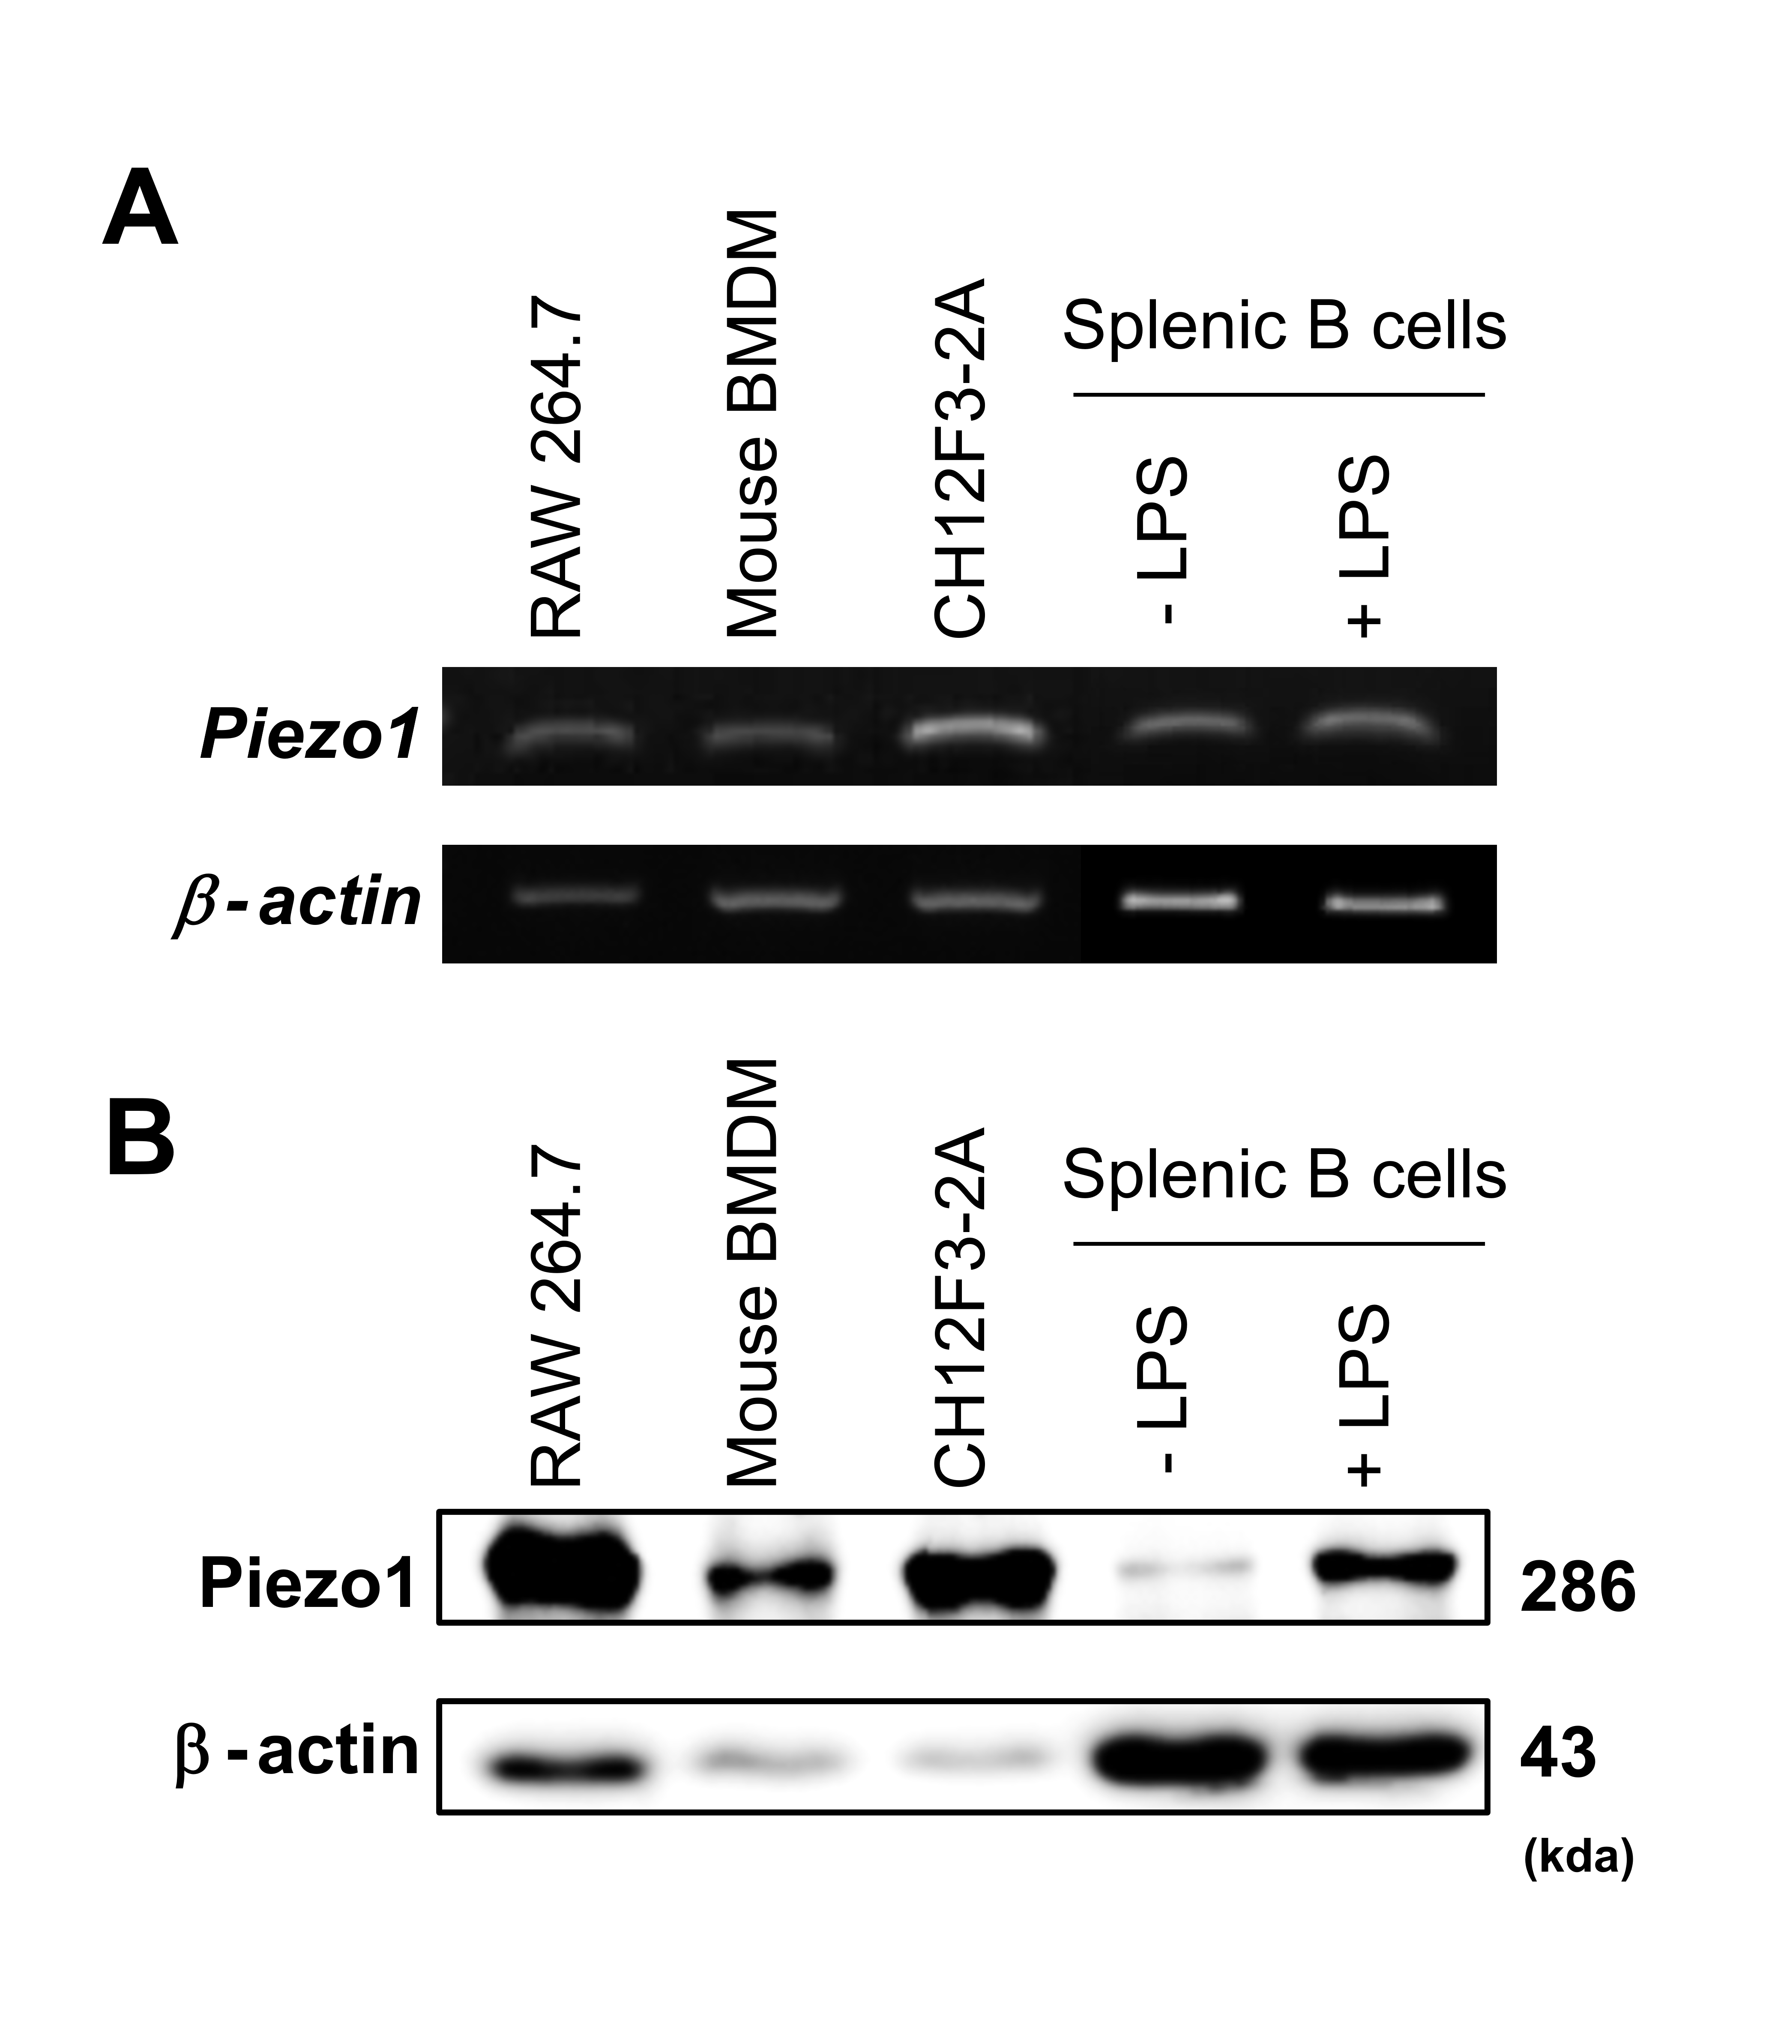
Supplementary Fig. 2. B cells express Piezo1
Total RNA and proteins were isolated from mouse spleen primary cells and cell lines (RAW 264.7, mouse BMDM, CH12F3-2A [mouse mature B cell line, IgM⁺IgD⁺], mouse splenic B cells). RT-PCR (A) and western blots (B) were performed to determine Piezo1 and β-actin levels.

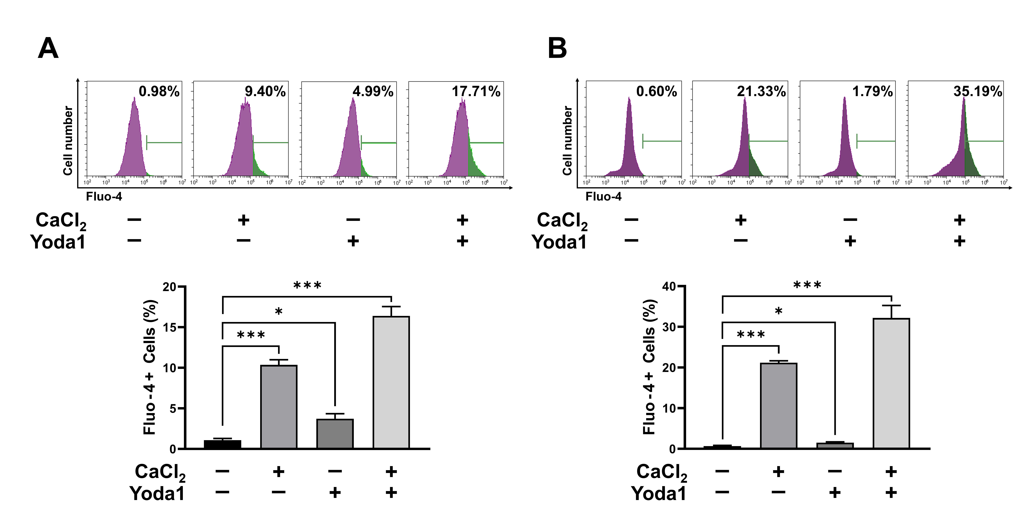
Supplementary Fig. 3. Yoda1 reinforces Ca²⁺ influx in B cells
CH12F3-2A (A) and purified mouse splenic B cells (B) were stained with Fluo-4 (3 μM) before the test. Fluo-4 levels (intracellular Ca²⁺) in CH12F3-2A and purified mouse splenic B cells after treatment with CaCl₂ (250 μM) or Yoda1 (5 μM). Fluo-4 level was measured by flow cytometry (n = 3). Data presented are the mean ± SEM from three independent experiments. *p < 0.05; ***p < 0.001.

Supplementary Fig. 4. CFSE-based B cell proliferation analysis
Splenic B cells were purified from mouse spleens, labeled with CFSE, and treated with the indicated stimuli (TGF-β1, 0.2 ng/mL; Yoda1, 0.5 μM) in the presence of LPS (12.5 μg/mL). The cultured cells were collected at 0, 0.5, 1.5, 2.5, 3.5, and 4.5 days for flow cytometry analysis. Progressive loss of CFSE intensity indicates cell division (cell proliferation). (A) CFSE dilution profile at day 4.5 (left). Percentage of proliferated cells (≥1 division) at day 4.5 (right). (B) Cells were collected at various time after stimulation and stained with anti-IgA-PE. CFSE/IgA double staining under each stimulation condition (left). Levels of surface IgA⁺ B cells within each division (right). Numbers within the plots (to the left of A and B) indicate cell divisions. Data presented are the mean ± SEM from three independent experiments. *p < 0.05; NS, not significant
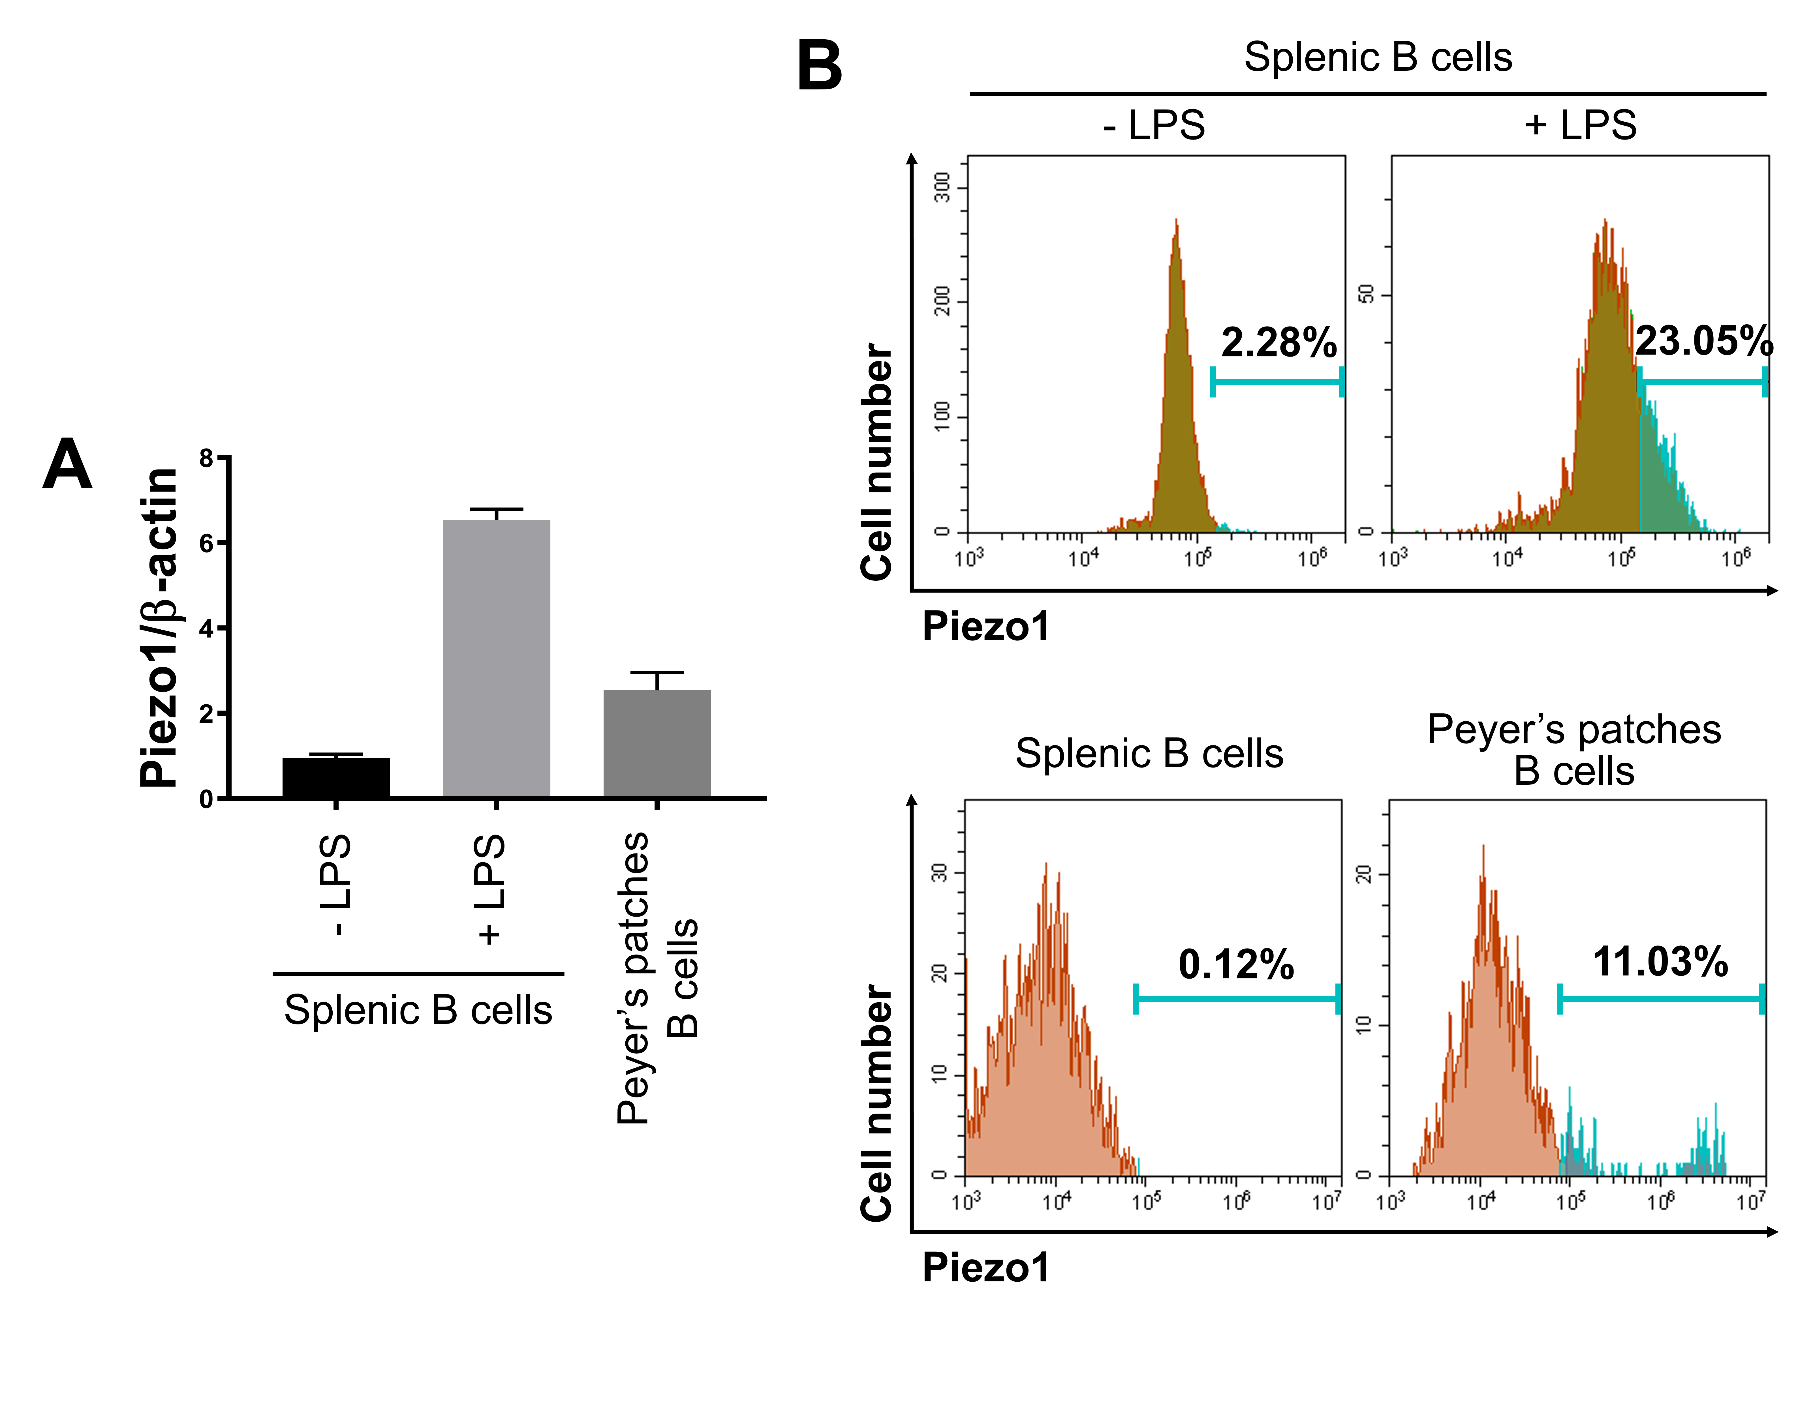Supplementary Fig. 5. Piezo1 expression in splenic B cells and Peyer’s patches
(A) Splenic B cells were purified from mouse spleen and cultured for 1 day in the absence or presence of LPS (12.5 µg/mL). Peyer’s patches cells were analyzed without in vitro culture. Piezo1 mRNA levels were measured by qRT-PCR. Graphs show the relative Piezo1 cDNA levels normalized to the expression of β-actin. (B) Purified splenic B cells were cultured for 1 day with LPS. Piezo1 expression was assessed by flow cytometry following intracellular staining with anti-Piezo1-FITC (upper panel). Splenic and Peyer’s patches cells were isolated from the mouse spleen and Peyer’s patches, respectively. The cells were stained with anti-CD45-BV785, anti-CD20-PE, and anti-Piezo1-FITC (intracellular), and Piezo1 expression in splenic B cells (CD45⁺CD20⁺) and Peyer’s patches B cells (CD45⁺CD20⁺) was analyzed by flow cytometry (lower panel).
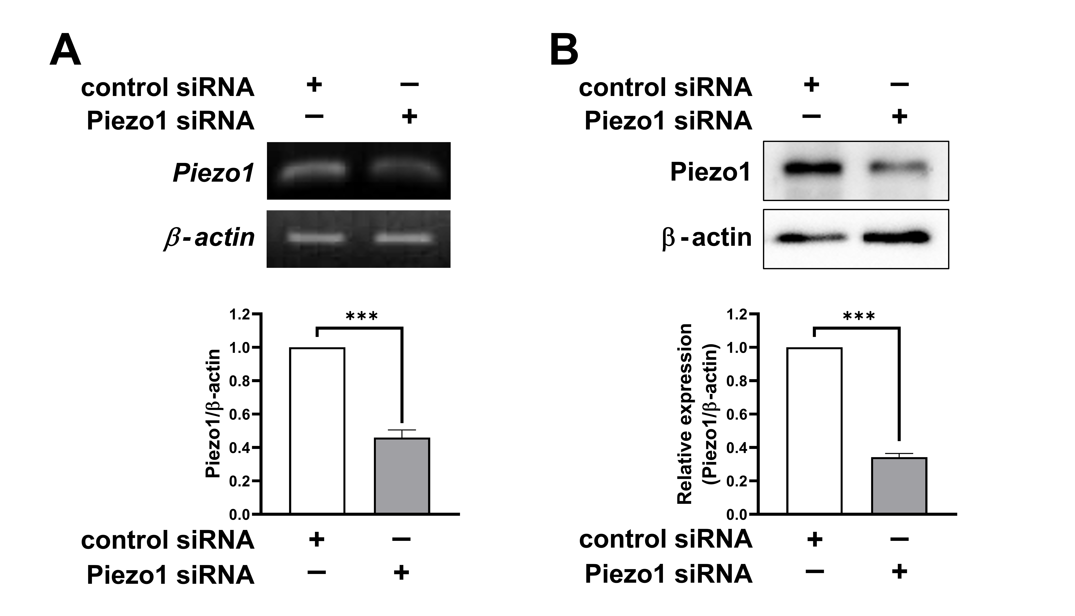
Supplementary Fig. 6. Knockdown of Piezo1 expression by siRNA
The mouse B cell line CH12F3-2A was transfected with mouse Piezo1 siRNA (400 nM). Total RNA and proteins were isolated from transfected CH12F3-2A. RT-PCR (A) and western blots (B) were performed to measure Piezo1 and β-actin levels. Data presented are the mean ± SEM from three independent experiments. ***p < 0.001.

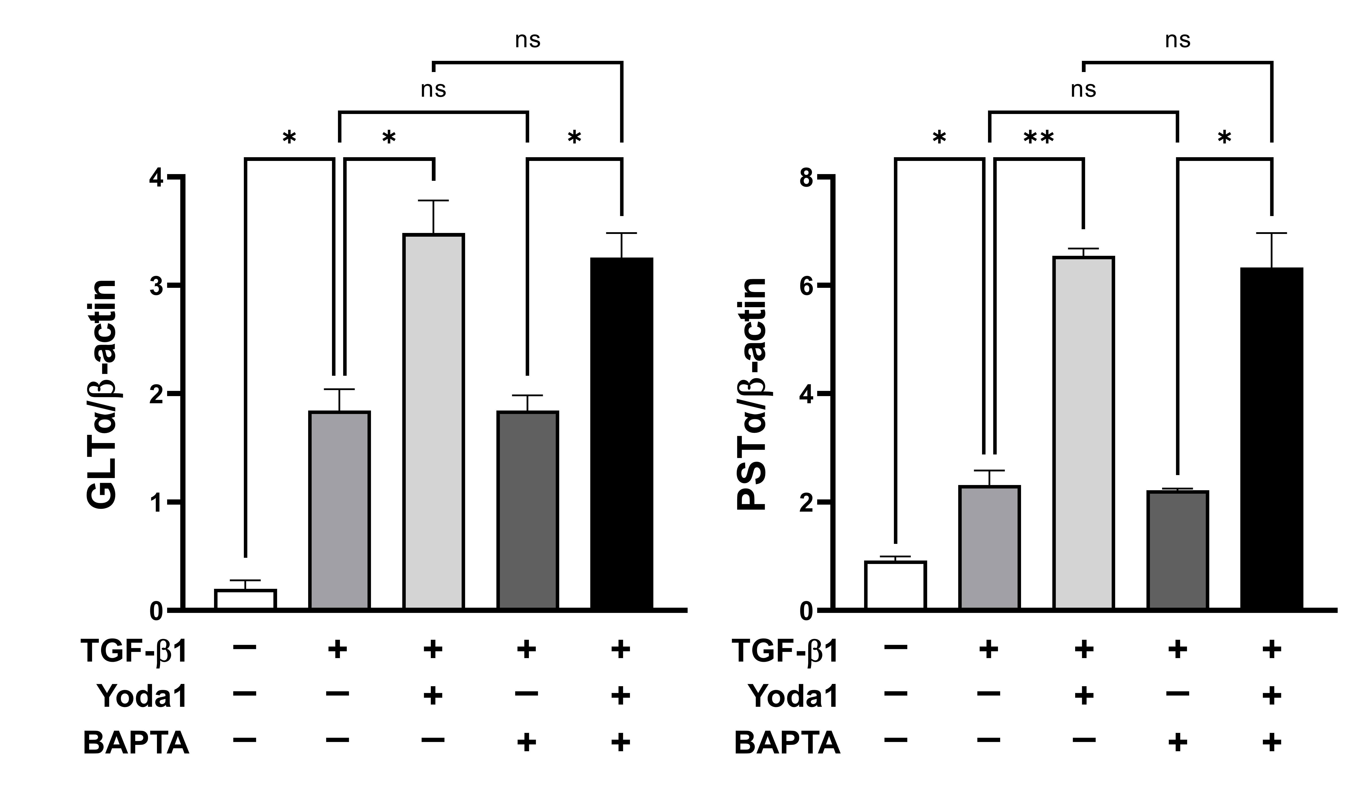
Supplementary Fig. 7. Effect of BAPTA on TGF-β1-induced GLTα and PSTα expression
Resting B cells were purified from mouse spleen and cultured with the indicated stimuli (Yoda1, 0.5 µM; TGF-β1, 0.2 ng/mL; BAPTA, 200 µM) in the presence of LPS (12.5 µg/mL) (n = 3). After 2.5 days of culture, total RNA was isolated. GLTα and PSTα expression levels were measured by qRT-PCR. Graphs show relative GLTα and PSTα cDNA normalized to β-actin expression. *p < 0.05; **p < 0.01; NS, not significant

