Supplementary Information

Machine Vision with CMOS based Hyperspectral Image Sensor Enables Meat Freshness Sensing
Suyeon Lee¹, Hyochul Kim¹, Seokin Kim², Hyungbin Son², Jeong Su Han³, Un Jeong Kim⁴*
¹Samsung Advanced Institute of Technology; Suwon, Gyeonggi-do 16678, Republic of Korea
²School of Integrative Engineering, Chung-Ang University; Seoul 06974, Republic of Korea
³Home Appliance Division, Samsung Electronics; Suwon, Gyeonggi-do 16678, Republic of Korea
⁴Department of Physics, Dongguk university, Seoul 04620, Republic of Korea
*Corresponding author. Email: ujjanekim@dongguk.edu

Contents

Supplementary Figure 1. Schematic of grating based line-scan type HIS.
Supplementary Figure 2. Schematic of snapshot type HIS with Fabry-Perot filters.
Supplementary Figure 3. Fluorescence spectrum of the meat specimen, NAD and myoglobin.
Supplementary Figure 4. Freshness of vacuum-packaged meat specimen on the 12th day.
Supplementary Figure 5. Storage time dependence of RGB^{hyper}.
Supplementary Figure 6. Influence of the packaging material on the acquisition of fluorescence spectrum.
Supplementary Figure 7. Dimensionality reduction from 11 to 2 dimensions in the hyperspectral data by LDA.
Supplementary Figure 8. Decision boundaries and FI depending on machine learning algorithms. Supplementary Figure 9. Storage time dependent FI of the PE- and vacuum-packaged meat specimens from snapshot type HIS.
Supplementary Figure 10. Line-scan type HIS with Fabry-Perot filters and storage time dependent FI of vacuum-packaged meat specimens.
Supplementary Table 1. List of packaging materials and their chemical components.
Supplementary Movie. Demonstration of meat freshness sensor installed in Samsung Family Hub T9000

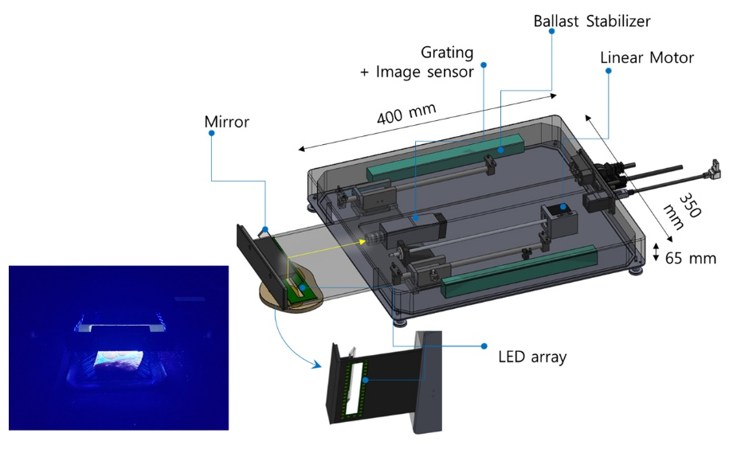
Supplementary Figure 1. Schematic of grating based line-scan type HIS. The schematic shows the details of line-scan type HIS. A moving optical element composed of linear 365 nm LED arrays with a rectangular window and a mirror scan linearly to illuminate and collect fluorescence from the meat surface. The fluorescence signals are transported to a conventional spectrometer composed of grating and an image sensor from Ximea Corporation. An actual photograph of elements in motion to illuminate the LED and collect the fluorescence spectrum from the meat specimen is displayed in the left corner.

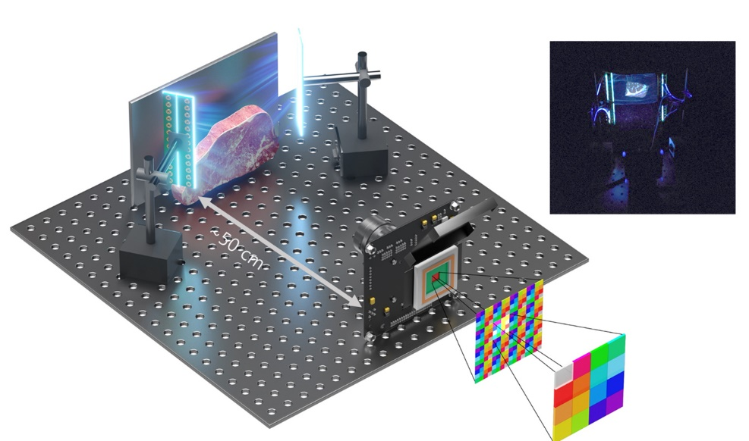
Supplementary Figure 2. Schematic of snapshot type HIS with Fabry-Perot filters. The schematic shows the details of snapshot type HIS. The meat specimen is illuminated by 365 nm LED vertical arrays, and the hyperspectral images of the fluorescence signal generated from the meat specimen are taken by the snapshot type HIS, positioned ~50 cm away. A photograph of the snapshot type HIS used in the experiment is displayed on the upper right.

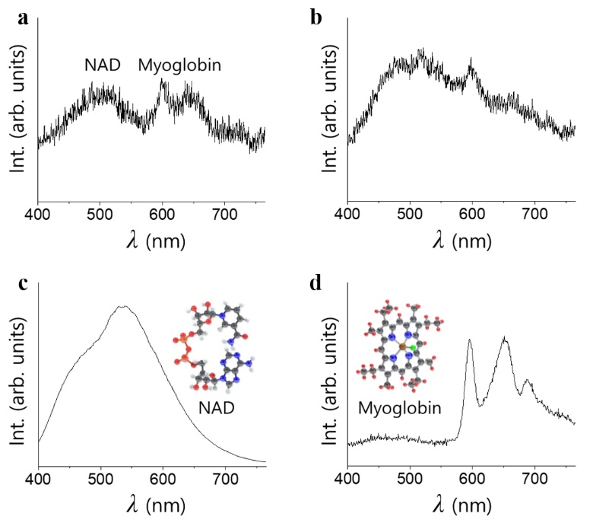
Supplementary Figure 3. Fluorescence spectrum of the meat specimen, NAD and myoglobin. The fluorescence spectrum of a fresh and b rotten meat specimen excited by 365 nm LED arrays. Fluorescence spectrum of c NAD and d myoglobin purchased from Aldrich. Inc. and excited by 365 nm LED. Molecular structures are shown as insets. The characteristic features in the spectrum of meat are close to that of the NAD and myoglobin.

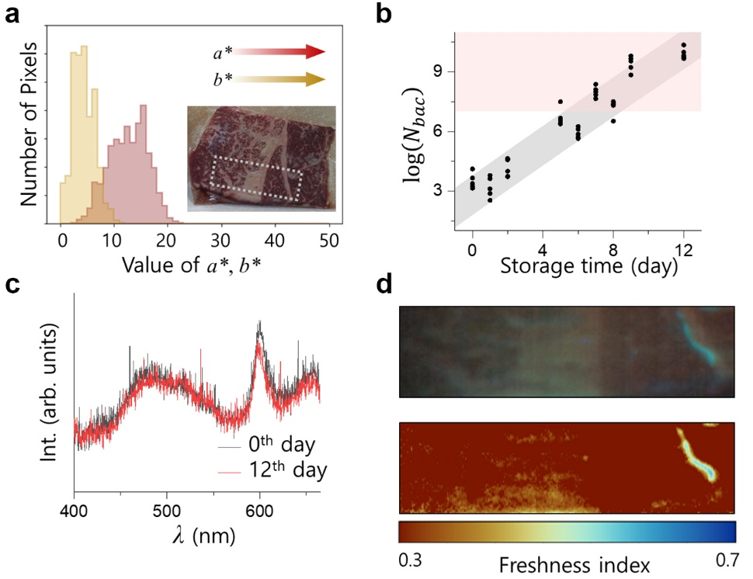
Supplementary Figure 4. Freshness of vacuum packaged meat specimen on the 12th day. a Distribution of a* and b* values of the RGB image as an inset. b Bacterial density ($N_{bac}$) of the PE wrap-packaged sample prepared on the same day with vacuum-packaged sample as a function of storage time. The reddish shaded area in the figure indicates the inedible state. c Two representative fluorescence spectra on the 0th and 12th day of the vacuum-packaged meat specimen. d Hyperspectral image of meat fluorescence and its FI indicated by the white dotted rectangular area in the inset of a.

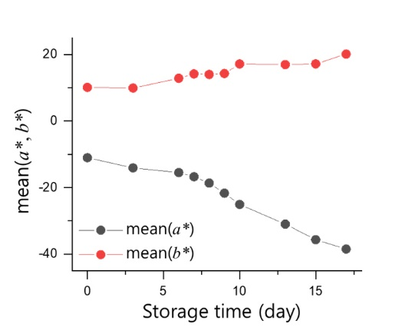
Supplementary Figure 5. Storage time dependence of RGB^{hyper}. Time dependence of mean a* and b* values of the RGB images constructed from the fluorescence hyperspectral images (RGB^{hyper}) of the PE-packaged meat specimen. Values of a* and b* provide limited information to estimate meat freshness in the early stages.

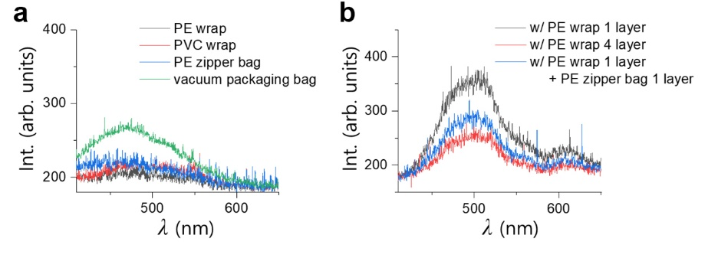
Supplementary Figure 6. Influence of the packaging material on the acquisition of fluorescence spectrum. a Fluorescence spectrum of each packaging material. To amplify the fluorescence effect of the packing material, a spectrum of two layers with 5 s integration time is taken, which is longer than 10 times the actual experimental condition. Roughly, the effect gets amplified more than 20 times. b Fluorescence spectrum of the meat specimen packaged in a PE wrap, where black represents one time and red represents four times wrapping, and PE wrap one time and PE zipper bag (blue), respectively.

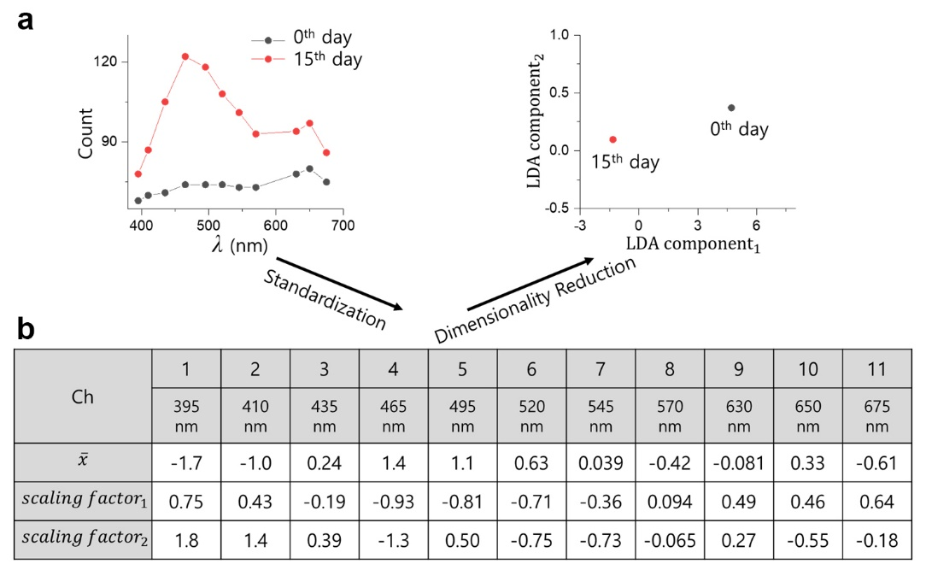
Supplementary Figure 7. Dimensionality reduction from 11 to 2 dimensions in the hyperspectral data by LDA. The process of dimensionality reduction of hyperspectral images has been illustrated. a Two representative data of 11 dimensions on the 0th and the 15th day of the PE-packaged meat specimen and the result of dimensionality reduction. b Wavelength dependent $\overline{x}$ and two scaling factors determined by LDA.

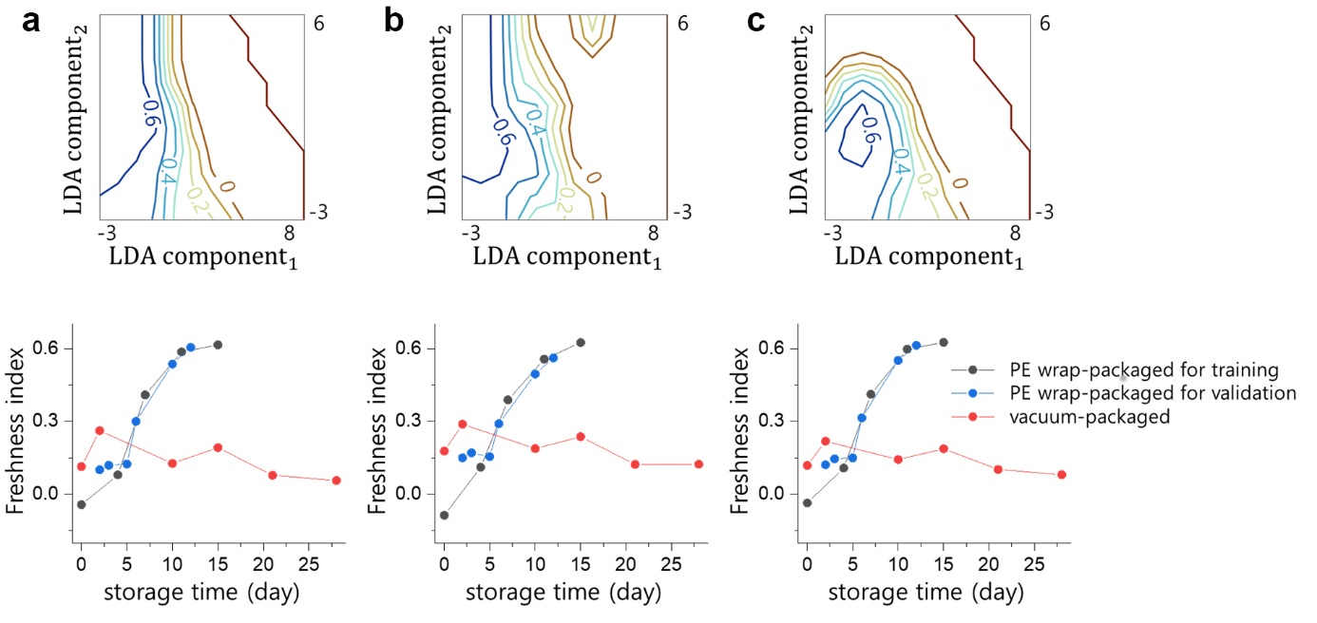
Supplementary Figure 8. Decision boundaries and FI depending on machine learning algorithms. Upper panel shows decision boundaries and lower graphs shows the result of FI depending on machine learning, a LDA, b decision tress, and c Gaussian Naive Bayes.
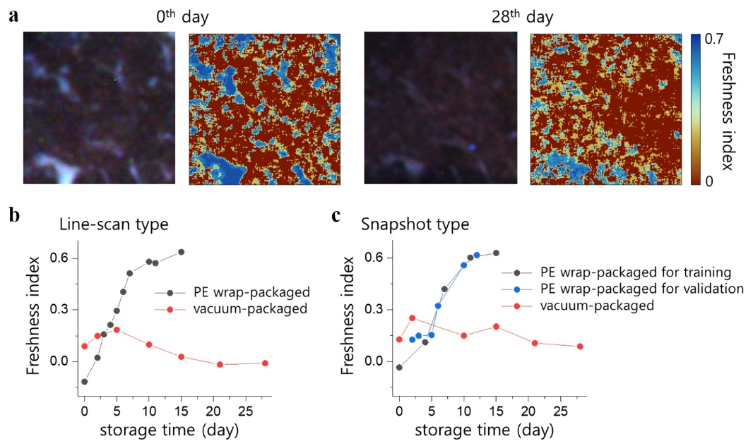
Supplementary Figure 9. Storage time dependent FI of the PE- and vacuum-packaged meat specimens from snapshot type HIS. a Hyperspectral images and FI values on the 0th and the 28th day, obtained by snapshot type HIS. Comparison of FI values as a function of storage time of the PE wrap-packaged for training (black), validation (blue) and vacuum-packaged (red) meat specimens, obtained by b line-scan type and c snapshot type HIS.

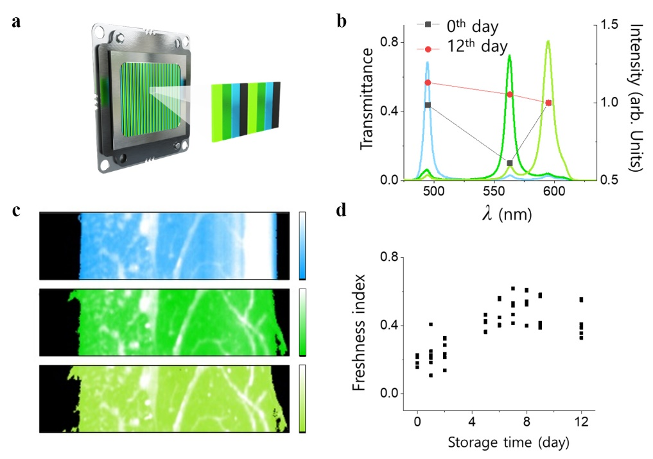
Supplementary Figure 10 Line-scan type HIS with Fabry-Perot filters and storage time dependent FI of vacuum-packaged meat specimens. a Schematics of CMOS with Fabry-Perot filters of line-scan type HIS. Wavelengths of three band pass filters were selected at 495, 563 and 595 nm. The wavelength of two filters were selected at the maximum fluorescence intensity for NADH and myoglobin. That of the last filter was chosen between NADH and myoglobin as reference point to calculate freshness index as indicated as equation 1. b The transmission of three band pass filters at 495, 563 and 595 nm with 5, 7 and 9 nm of full width of half maximum (FWHM), respectively. Values extracted from the hyperspectral data obtained on the 0th (black dots) and the 12th day (red dots) for the PE wrap-packaged specimen, which were in the fresh and rotten state, respectively c Fluorescence intensity images at each wavelength at 0th day. d Storage time dependent FI of PE wrap-packaged meat specimen obtained by line-scan type HIS with Fabry-Perot filters. Same meat specimen was measured by grating based HIS of which results agree well with those taken as shown in Figure 4.

Type | PE wrap | PVC wrap | PE zipper bag | Vacuum packing bag
Chemical component | High density polyethylene  (HDPE) | Polyvinyl chloride  (PVC) | Low density polyethylene  (LDPE) | Polyamide
Table S1. List of packaging materials and their chemical components.

