Supporting Information

Second Generation DNA Methylation Age Predicts Cognitive Change in Midlife: The Moderating Role of Childhood Socioeconomic Status

Sophie A. Bell^{1*}, Christopher R. Beam^{2,3}, Ebrahim Zandi⁴, Alyssa Kam², Emily Andrews¹, Jonathan Becker⁵, Deborah Finkel^{6,7}, Deborah W. Davis^{8,9}, Eric Turkheimer^{1*}
¹Department of Psychology, University of Virginia
²Department of Psychology, University of Southern California
³ Davis School of Gerontology, University of Southern California
⁴Keck School of Medicine, University of Southern California
⁵Department of Family and Geriatric Medicine, University of Louisville School of Medicine
⁶ Institute for Gerontology, Jönköping University
⁷Center for Economic and Social Research, University of Southern California
⁸ Department of Pediatrics, University of Louisville School of Medicine
⁹Norton Children’s Research Institute affiliated with the University of Louisville School of Medicine

*Corresponding authors: Sophie Bell and Eric Turkheimer

Email: bvf7pa@virginia.edu and ent3c@virginia.edu

This file includes:

Figures S1 to S3
Tables S1 to S4
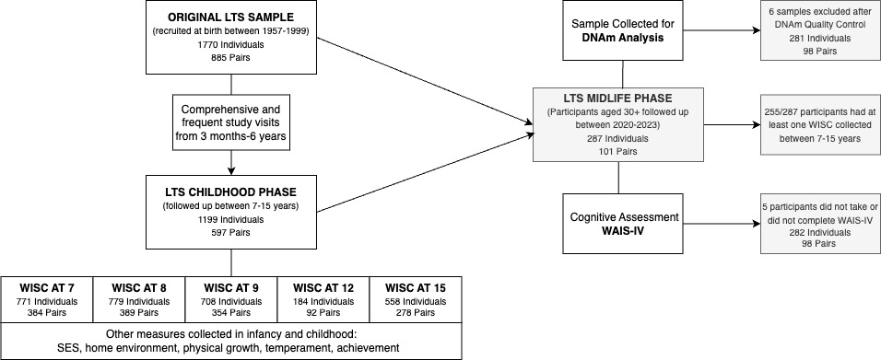

Fig. S1. Participant Flow Diagram from the Louisville Twin Study.

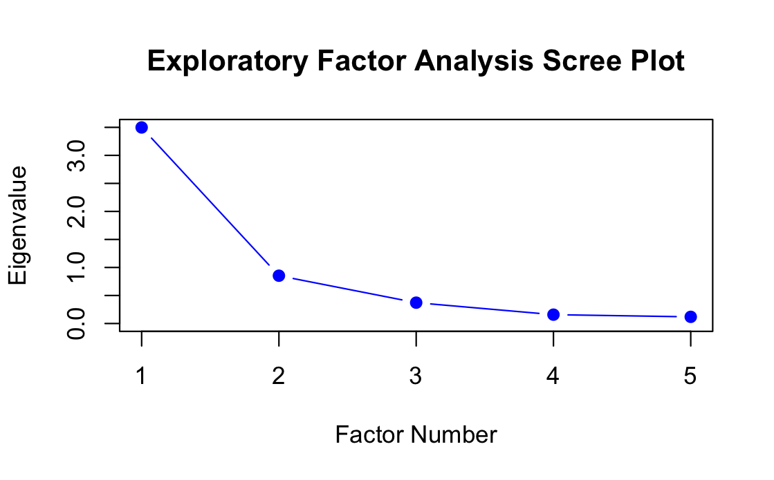Fig. S2. Scree Plot of Eigenvalues.

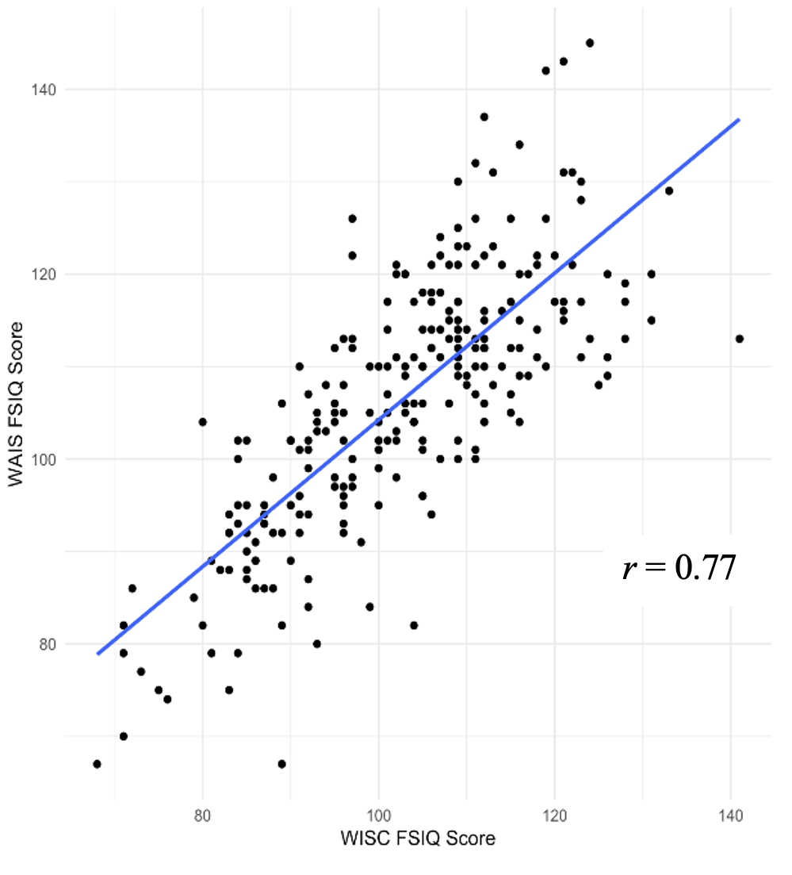

Fig. S3. Relationship between Childhood and Midlife IQ Scores.

Table S1. Pairwise correlations between DNAmAge measures.
DNAmAge Measures | Horvath | Horvath Skin and Blood | Hannum | PhenoAge | GrimAge
Horvath | _
Horvath Skin and Blood | 0.86 | _
Hannum | 0.87 | 0.84 | _
PhenoAge | 0.57 | 0.60 | 0.61 | _
GrimAge | 0.37 | 0.44 | 0.39 | 0.58 | _

Correlations were estimated after DNAmAge values were adjusted for age and cell composition and were winsorized for values more than two standard deviations above or below the mean. All correlations were statistically significant at p<.001.

Table S2. Standardized DNAmAge Measure ACE decompositions.
ACE Model | Horvath  Estimate (SE) | Horvath  Skin & Blood | Hannum | PhenoAge | GrimAge | Factor 1 | Factor 2
A | 0.60 (0.07) | 0.61 (0.07) | 0.57 (0.08) | 0.23 (0.29) | 0.73 (0.06) | 0.50 (0.33) | 0.60 (0.28)
C | 0.00 (0.00)* | 0.00 (0.00)* | 0.00 (0.00)* | 0.33 (0.25) | 0.00 (0.00)* | 0.08 (0.30) | 0.09 (0.26)
E | 0.40 (0.07) | 0.39 (0.07) | 0.43 (0.08) | 0.45 (0.09) | 0.27 (0.06) | 0.42 (0.08) | 0.31 (0.06)

A, additive genetic variance; C, shared genetic variance; E, nonshared environmental variance; SE, standard error estimate.
*C is set to zero because variance estimated as negative

Table S3. Results of the Exploratory Factor Analysis
DNAmAge Measure | Gen 1  Loading (SE) | Gen 2  Loading (SE)
Horvath | 1.00 (0.05) | -0.10 (0.07)
Horvath Skin and Blood | 0.88 (0.03) | 0.06 (0.06)
Hannum | 0.92 (0.01) | 0.00 (0.00)
PhenoAge | 0.30 (0.16) | 0.59 (0.18)
GrimAge | 0.00 (0.00) | 0.77 (0.12)

Bolded values indicate statistical significance at p < .05. The correlation between Gen 1 and Gen 2 is 0.57 (0.12), p < .05.

Table S4. Phenotypic and Quasi-Causal Regression Model Results for Gen 1 DNAmAge

Gen 1 DNAmAge
 |  | Childhood IQ  Estimate (SE) |  | DNAmAge  Estimate (SE) |  | Adult IQ  Estimate (SE)
Phenotypic Association Model | SES
Phenotypic Association Model | b | 0.56 (0.09)** | b | -0.14 (0.22) | b | 0.16 (0.07)*
Phenotypic Association Model | Childhood IQ
Phenotypic Association Model |  | _ | b_{A2} | _ | b_{A1} | _
Phenotypic Association Model |  | _ | b_{C2} | _ | b_{C1} | _
Phenotypic Association Model |  | _ | b_{P2} | 0.03 (0.15) | b_{P1} | 0.71 (0.05)**
Phenotypic Association Model | DNAmAge
Phenotypic Association Model |  | _ |  | _ | b_{A3} | _
Phenotypic Association Model |  | _ |  | _ | b_{C3} | _
Phenotypic Association Model |  | _ |  | _ | b_{P3} | -0.01 (0.02)
Phenotypic Association Model | DNAmAge X SES
Phenotypic Association Model |  |  |  |  | b_{int} | 0.01 (0.02)
Phenotypic Association Model | Variances
Phenotypic Association Model | A | 1.15 (0.34) |  | 5.75 (0.93) |  | 0.50 (0.09)
Phenotypic Association Model | C | 0.12 (0.32) |  | 0.00 (0.00)† |  | 0.00 (0.00)†
Phenotypic Association Model | E | 0.22 (0.04) |  | 2.15 (0.45) |  | 0.27 (0.05)
Quasi-Causal Regression Model | SES
Quasi-Causal Regression Model | b | 0.56 (0.09)** | b | -0.13 (0.11) | b | 0.32 (0.11)*
Quasi-Causal Regression Model | Childhood IQ
Quasi-Causal Regression Model |  | _ | b_{A2} | -0.05 (0.66) | b_{A1} | 0.33 (0.23)
Quasi-Causal Regression Model |  | _ | b_{C2} | 0.36 (1.21) | b_{C1} | 0.61 (0.48)
Quasi-Causal Regression Model |  | _ | b_{P2} | 0.02 (0.45) | b_{P1} | 0.41 (0.14)*
Quasi-Causal Regression Model | DNAmAge
Quasi-Causal Regression Model |  | _ |  | _ | b_{A3} | -0.01 (0.08)
Quasi-Causal Regression Model |  | _ |  | _ | b_{C3} | 0.00 (0.00)
Quasi-Causal Regression Model |  | _ |  | _ | b_{P3} | 0.00 (0.05)
Quasi-Causal Regression Model | DNAmAge X SES
Quasi-Causal Regression Model |  |  |  |  | b_{int} | 0.01 (0.02)
Quasi-Causal Regression Model | Variances
Quasi-Causal Regression Model | A | 1.03 (0.29) |  | 5.71 (0.95) |  | 0.46 (0.10)
Quasi-Causal Regression Model | C | 0.22 (0.28) |  | 0.00 (0.00)† |  | 0.00 (0.00)†
Quasi-Causal Regression Model | E | 0.23 (0.04) |  | 2.15 (0.45) |  | 0.26 (0.05)
b_{P}, phenotypic association between predictor and outcome; b_{A}, amount of variance attributable to additive genetic influences; b_{C}, amount of variance attributable to shared environmental experiences; b_{int}, estimate of the interaction effect. Data are presented as unstandardized regression coefficients with standard errors in parentheses.
†C variances have been set to zero
*p <.05 **p≤ .001

