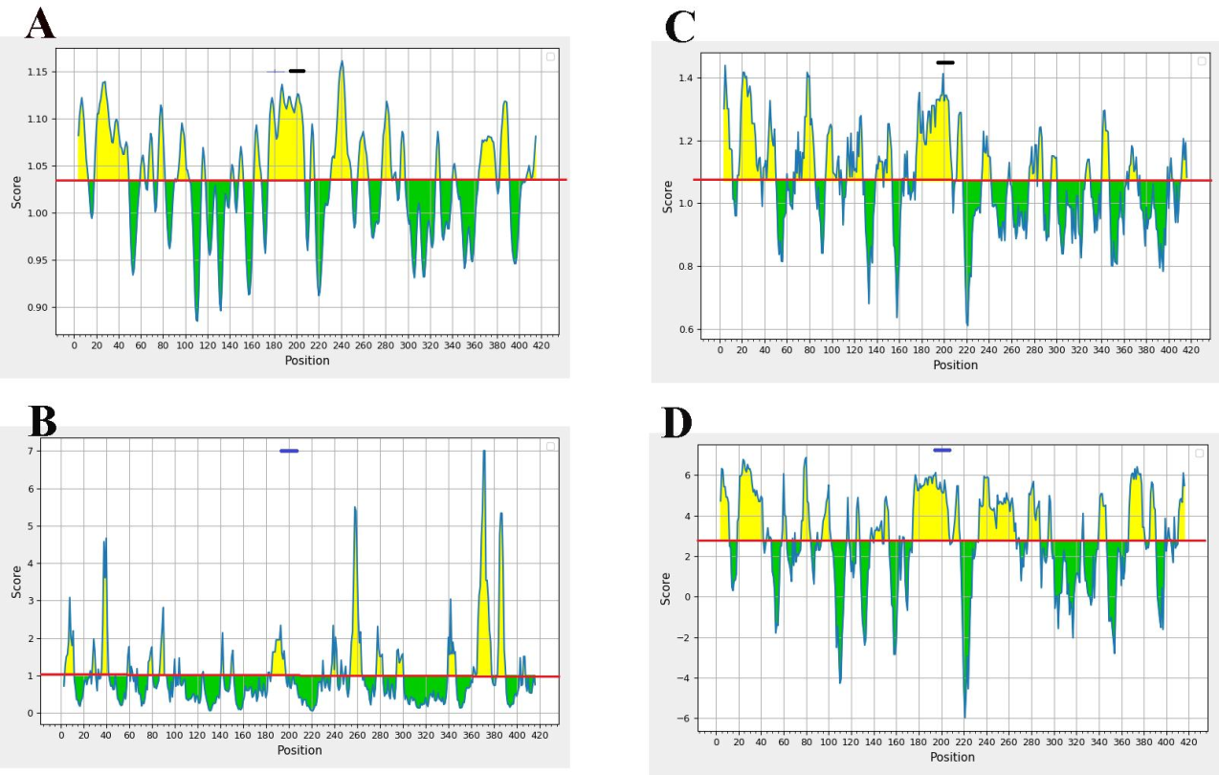
Analysis of B-cell lymphocyte epitopes derived from the N protein of SARS-CoV-2. The graph illustrates (A) Karplus and Schulz flexibility, (B) Emini surface accessibility, (C) Chou and Fasman beta-turn prediction, and (D) Parker hydrophilicity. The X and Y axes represent amino acid positions and their corresponding scores, respectively. The red line indicates the average value of the assessed parameter, while the yellow region above the average denotes favorable values. The BCR epitope sequence (NSTPGSSRGTSPARMA) is represented as a blue line at the top of the graph.

