Ultrasound activated nano TiO₂ loaded with Temozolomide paves the way for resection of chemo-resistant glioblastoma multiforme
Fawad Ur Rehman^{†a *}, Mohd Ahmar Rauf ^{†b}, Sana Shaikh^{c}, Aqsa Qambrani^{c}, Pir Muhammadª, Sumaira Hanifª
a. International Joint Centre for Biomedical Innovations, School of Life Sciences, Henan University, Jin Ming Avenue, Kaifeng, Henan, 475004, China.
b. Barbara Ann Karmanos Cancer Institute, Wayne State University Detroit, Michigan, USA
c. State Key Laboratory of Bioelectronics (Chien-Shiung Wu Lab), School of Biological Science and Medical Engineering, Southeast University, Nanjing 210096, China
*Corresponding Authors: FUR, dawarvet@hotmail.com
† These authors contributed equally

Supporting Information:
Contents
S fig. 1 1
S Fig. 2 1
S Fig. 3 2
S Fig. 4 2
S Fig. 5 3
S Fig. 6 4
S Fig. 7 5

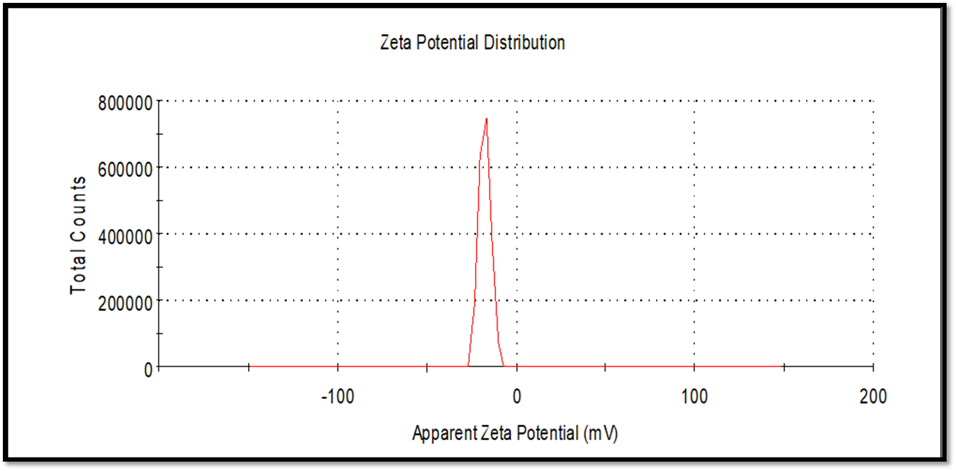
S fig. 1 Zeta potential of TiO₂ nanosticks.

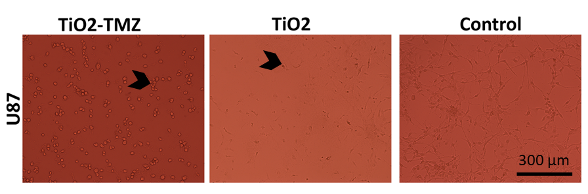
S Fig. 2 U87 cell micrograph showing the TMZ sensitive cells (U87) morphology after ultrasonication. The arrowhead is indicating apoptotic cells post-therapy.

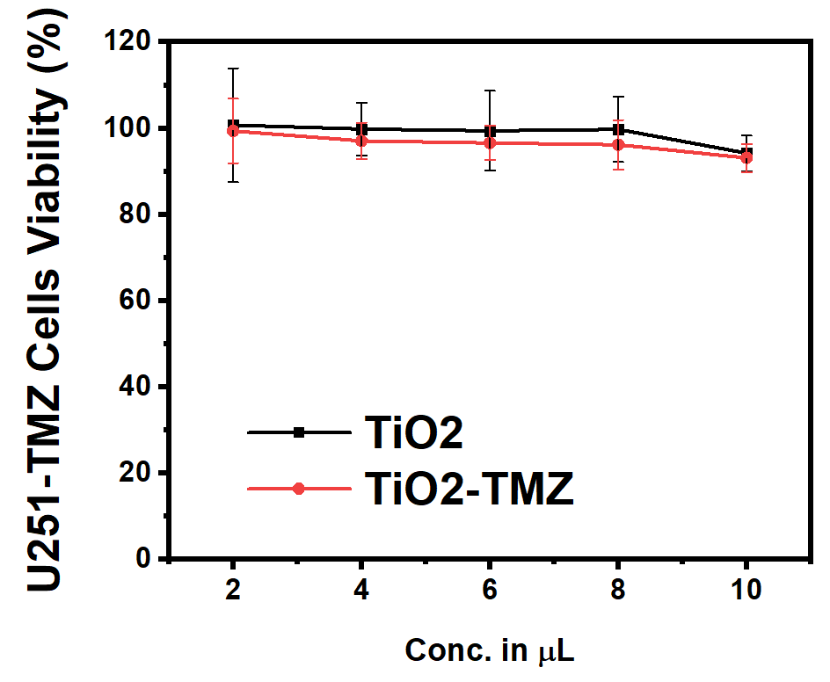
S Fig. 3 cell viability of TMZ resistant (U251) cells without ultrasonication.

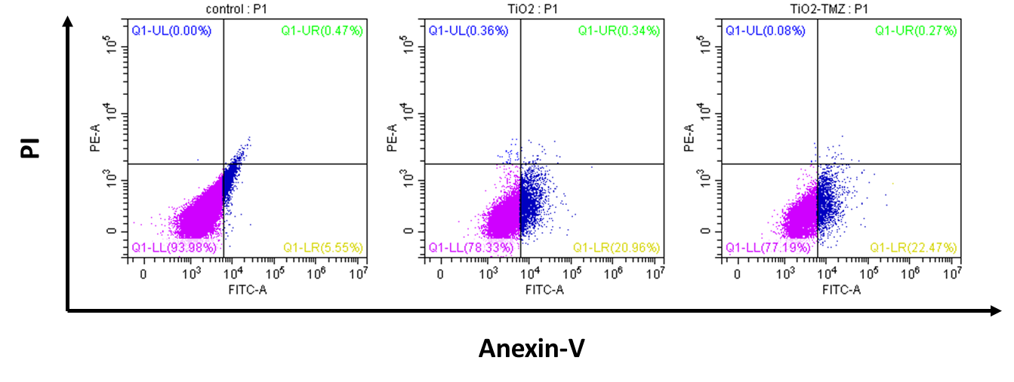
S Fig. 4 Annexin-V PI flow cytometry data of non-sonicated treatment groups in TMZ resistant GBM cells.

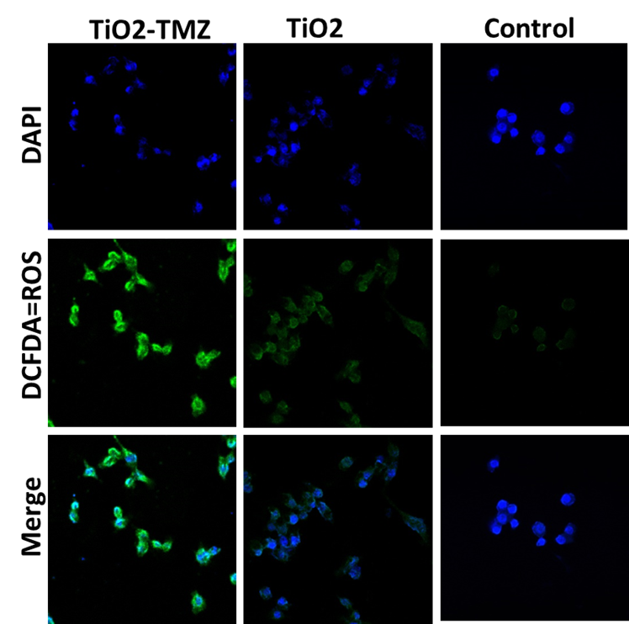
S Fig. 5 Oxidative stress (ROS) generated in TMZ resistant cells (U251) confocal micrograph after treatment with TiO₂ nanosticks loaded with TMZ without sonication. The ROS is represented by green fluorescence generated by DCFDA, whereas the cell’s nucleus is stained with DPAI. The scale bar is 50 µm.

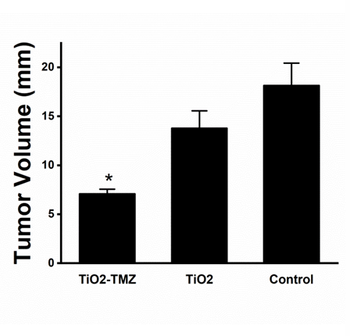
S Fig. 6 In vivo xenograft models tumor volume after treatment with ultrasound activated TiO₂ nanosticks loaded with TMZ. * is representing the significance level p < 0.05 between TiO₂-TMZ and control group.

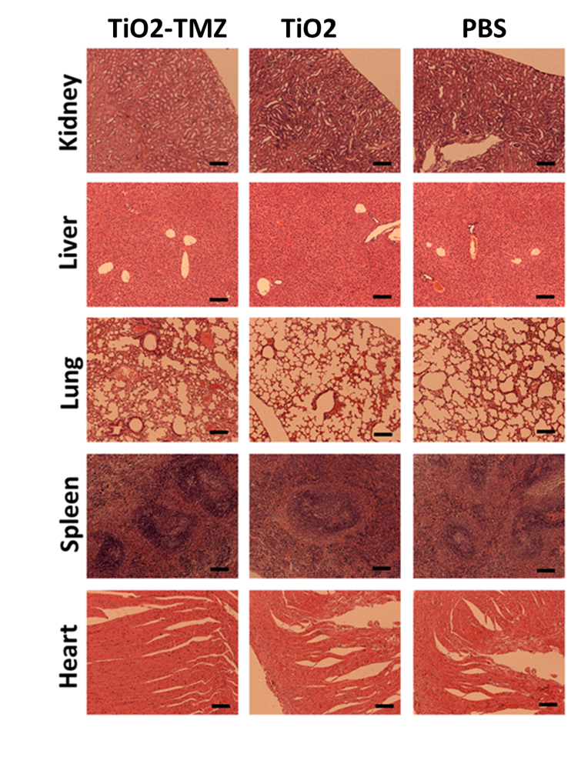
S Fig. 7 Vital organs histopathology after treatment with sonicated TiO₂ and TiO₂-TMZ. The organs were stained with Hematoxylin and Eosin stain. The scale bar is 200 µm.

