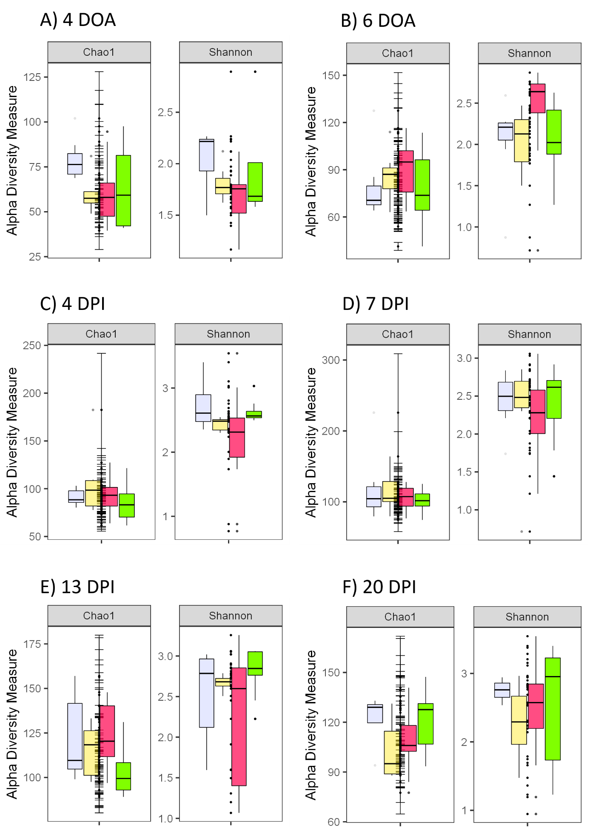
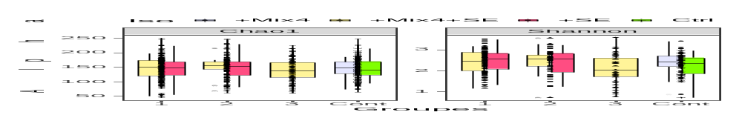
Supplementary Figure 1: α-diversities (Chao1 and Shannon indexes) measured at the different timepoints for the four conditions ‘+Mix4’ (light blue), ‘Mix4 + SE’ (yellow), ‘+SE’ (pink) and ‘Ctrl’ (green).

Supplementary Table 1: Main OTUs showing significant differential abundances between the SLT-SS and SLT-LS chickens after infection.
 |  | log2FoldChange | padj | Family | Genus
4 days p.i. | Cluster_4 | 7.08 | 1.47x10⁻¹¹ | Lactobacillaceae | Pediococcus
 | Cluster_114 | 9.06 | 1.93x10⁻¹⁰ | Campylobacteraceae | Campylobacter
 | Cluster_9 | 7.19 | 2.70x10⁻⁹ | Clostridiaceae 1 | Clostridium sensu stricto 1
 | Cluster_6 | 4.94 | 5.44x10⁻⁵ | Enterococcaceae | Enterococcus
 | Cluster_120 | 6.54 | 8.00x10⁻⁴ | Micrococcaceae | Micrococcus
 | Cluster_19 | 5.50 | 1.37x10⁻³ | Lachnospiraceae | [Ruminococcus] torques group
 | Cluster_41 | 7.03 | 5.42x10⁻³ | Lachnospiraceae | Blautia
 | Cluster_27 | -6.33 | 5.42x10⁻³ | Ruminococcaceae | Oscillibacter
 | Cluster_493 | 5.54 | 6.03x10⁻³ | Enterobacteriaceae | Escherichia-Shigella
 | Cluster_63 | -3.49 | 6.03x10⁻³ | Enterobacteriaceae | Enterobacter
 | Cluster_20 | 3.87 | 6.03x10⁻³ | Clostridiaceae 1 | Clostridium sensu stricto 1
 | Cluster_33 | 5.80 | 6.03x10⁻³ | Clostridiaceae 1 | Clostridium sensu stricto 1
 | Cluster_934 | 6.94 | 6.03x10⁻³ | Lactobacillaceae | Multi-affiliation
 | Cluster_37 | 5.15 | 6.55x10⁻³ | Lachnospiraceae | Epulopiscium
 | Cluster_46 | -5.87 | 7.51x10⁻³ | Erysipelotrichaceae | Erysipelatoclostridium
 | Cluster_79 | 6.18 | 8.93x10⁻³ | Lactobacillaceae | Lactobacillus
 | Cluster_150 | 5.19 | 8.99x10⁻³ | Pseudomonadaceae | Pseudomonas
7 days p.i. | Cluster_27 | -7.76 | 0.0034 | Ruminococcaceae | Oscillibacter
 | Cluster_17 | -8.66 | 0.0034 | Ruminococcaceae | Butyricicoccus
 | Cluster_38 | 4.91 | 0.0039 | Lachnospiraceae | Unknown genus
 | Cluster_40 | 5.08 | 0.0039 | Ruminococcaceae | DTU 089
 | Cluster_4 | 4.22 | 0.0039 | Lactobacillaceae | Pediococcus
 | Cluster_2 | -5.33 | 0.0095 | Enterobacteriaceae | Klebsiella
 | Cluster_58 | 5.59 | 0.0095 | Ruminococcaceae | Ruminococcaceae UCG-005
13 days p.i. | Cluster_17 | -9.29 | 1.58x10⁻⁵ | Ruminococcaceae | Butyricicoccus
 | Cluster_11 | -4.00 | 3.40x10⁻⁵ | Lachnospiraceae | Unknown genus
 | Cluster_7 | -3.74 | 3.40x10⁻⁵ | Ruminococcaceae | Flavonifractor
 | Cluster_2 | -6.98 | 1.38x10⁻⁴ | Enterobacteriaceae | Klebsiella
 | Cluster_1 | 3.32 | 8.87x10⁻⁴ | Enterobacteriaceae | Escherichia-Shigella
 | Cluster_14 | -5.76 | 9.43x10⁻⁴ | Enterobacteriaceae | Klebsiella
 | Cluster_34 | -5.16 | 1.46x10⁻³ | Ruminococcaceae | Multi-affiliation
 | Cluster_27 | -6.06 | 1.46x10⁻³ | Ruminococcaceae | Oscillibacter
 | Cluster_175 | 5.33 | 2.17x10⁻³ | Enterobacteriaceae | Escherichia-Shigella
 | Cluster_8 | -2.74 | 2.70x10⁻³ | Lachnospiraceae | [Ruminococcus] torques group
 | Cluster_51 | -5.22 | 2.70x10⁻³ | Lachnospiraceae | CHKCI001
 | Cluster_56 | -2.56 | 9.82x10⁻³ | Lachnospiraceae | [Ruminococcus] gauvreauii group
20 days p.i. | No differences
Positive log2 fold changes correspond to the OTUs enriched in the SLT-LS chickens.

Supplementary Table II: Relative gene expression in blood of chicks infected with Salmonella Enteritidis and treated or not with the Mix4
Gene | FC 4 DOA | FC 6 DOA | FC at 11 DoA | FC at 14 DoA | FC at 20 DoA | FC at 27 DoA
Casp1 | 3.2 |  |  | 5.0 | 5.3 | 6.0
SOCS3 |  |  |  |  | -2.2
GAL2 |  |  |  |  |  | -2.0
HSP60 |  |  |  |  |  | -2.0
GAL6 |  |  |  |  |  | -2.1

FC represents the ratio between chicks treated with Mix4 and infected with S. Enteritidis and chicks infected with S. Enteritidis without presence of MIX4. Positive FC means that the gene is over-expressed in infected chicks without MIX 4. Ratio >2.0, with a p value <0.05 were considered

Supplementary Table III: Primers used with the Biomark to analyze the chicken response.
Gene | Forward primer | Reverse primer
AH221 | TCTGCTCCTCCTGGCCCTCT | TCACCAGGATCACCGCTGG
ALOX5AP | CAGGCTCCTCTGCCTTTGAA | AAGCACGGCGAGAAACGTA
ARG2 | GGCATGTACATTGCAGAGGAAA | GCTCCAAGCAGTGGATTGAC
ARPC4 | GTGGAGCGCCACAACAAAC | TGATGATCACTGGCTGCAACA
BF2 | AGGAGAGAGCGACCCGAGGT | ATGGGCACCAGGTTGGGCTG
BIRC2 | GGGAGGAAGAGAAAGAGAGACA | ACGCTGGAATAAAGCCATCC
BLB21 | AGAGGAGCGTGGAGCCCAAG | CAGCACCTGGTACGTCCAGT
Casp1 | TATTCTTCCACGCCTGATACT | GAACTTCTTCAGCATTGTAGTC
Casp8 | GGGTGTCTCCGTTCAGGTATC | GGCTCTTGTCCACTTTCCCA
CCR2 | GGACAGTTACCTACGGCATCC | CCCCGGAACAGAGGCAAAA
CCR6 | AAAGTGTTCCTGCCAGTTGC | CCGTCATGGACTTGGTTCGT
CD14 | CCCTGCACCTGGACAACAAC | ACATCCTGCAGGTGCTCCA
CD180 | CACCCGCATAGTGGATGCAA | ATCTGACACCTCGTCAGGTCCA
CD25 | CCGAAGCAAGCAAACAATTCA | AAGATGACTGCCTCCATAAGAT
CD28 | GTCAGAGAGACACCCATCCAA | AGTCTCGTGTTGGTGCATAGG
CD40LG | TGGTGGTACAGACCATTGGG | TGGCTGTCCTATCCTTGCATT
CD47 | AAAACCTCCAACACCAGTGGATA | AACAGCAACACTGCGATGAC
CD69 | TCATCATGCAGTACCACGGC | GCCTTGCGGCTTAAACCAGT
CD80 | CACTTGCTTCGTTGAATATGAT | AAAACAGTGGGAACAGGCGT
CEBPB | AACGAGAGGCTGCAGAAGAA | CGGGCAGCTGTTTGAACAA
CISH | AGAAGATCCAAAGGCTGTCGCTG | AGCCCCAGTACCAGCCGGA
CSF2RA | TGGCAGTTGCAACACTCTTA | TGGCTTTGGGATTTGTGGAA
CTLA4 | AAGGGAAATGGGACGCAACT | CTCTGAATCGCTTTGCCCAC
CTSG | TACGAACCAGAGCAGAGCCA | TTGACCTTCGCTGTCAGCTTG
DDX3X | TGGCTTACGAACAGCATCAC | TCTGGCACCAAATCCTCCA
DEC205 | ATTCAGGCAAGTTGGGGCAG | TCCAAACGAAACCTCCGTGT
GAL2 | CTGGTTTGGCTTTTGGGCTC | GCGAAGACAACCCTGGAGAA
GAL6 / AvBD9 | GTTGCAGGTCAGCCCTACTT | TAGAGTGCCAGAGAGGCCAT
GATA3 | TCGAGCACAGAAGGCAGGGA | GACAGTTAGCACAGGACGTG
HMOX1 | ACGCTGAAAGCATGTCCCAG | AGATGAAGTACAGGGACGCC
HSP60 | CAGAAGAAATTGCACAGGTTG | TGGAATTCACATTTCTGCCCT
HSP90AA1 | ACACATGCCAACCGCATTTA | CCTCCTCAGCAGCAGTATCA
IFNAR1 | AGCAGAGAGGAATGCATCGG | GCTCCGAAGCCCTCTATGTT
IFNAR2 | GTAGCCACAGTAACTGGAAGA | CAGTGGACACAGGAACTGAGA
IFNB | TGACTGCAAACCATCAGTCTC | GGAGGTGGAGCCGTATTCTG
IFNGR1 | TCGGCCTTGGATGAGAGAGA | TTGTGTACTCCAAGCCTGCG
IGSF6 | GGAACGAAGGGCAGAGAACA | AGTTCTTGGGCTATTGCTCGAA
IL10 | GTTTAAGGGGACCTTTGGCTG | TGCTCTGCTGATGACTGGTG
IL12B | AAGCTATAAAGAGCCAAGCAAGAC | GGTGCTCTTCGGCAAATGGA
IL15 | GACTGGACTAACCATCTTCTTCC | CAGAACGTCTGACCACTTACA
IL18 | CGTGGCAGCTTTTGAAGATGTA | CTGAATGCAACAGGCATCCC
IRF2 | ACCGGATGCTGCCATTATCT | GCGGCTGTCCTACAACTACAA
IRF7 | CACAACGCCAGGAAGGATGT | TGTCATTGGGGACGCCTGAG
LEF1 | AACGACCCGTACATGCCTAA | AACTGCGTGAGAAGGCTGTA
LGALS3 | TCGGCTGCTCATAACCATCA | TCGCAGAGCACCTGGAGCTTG
LITAF | ACAAGTACATCTGTTACAGTTC | AACCAGCTATGCACCCCAGC
MDA5 | GGAAATACAGGAGGAACAGAGGA | GCTCTGTCCCAGGTTTTCGT
MX1 | GGGGAACCAGCCACAAGATA | TTAGTGAGGACCCCAAGCGT
MyD88 | CGTGCCAAAGACTTCAGAGC | ACCATCCTCCGACACCTTCTT
NFKB1 | CGAACAGCAGATGGACCGTA | TTACCCACCAAGCTGTGAGC
NLRC3 | AGCCCTGAAGGTCAATCACAG | GCTGCTAAGTCCAGCTTCCTCA
NOD1 | AGCTTGCAGTGATCAGGCTC | TGCTCTTCTGAATGGCCTGG
NOS2 | AATGAGTACCGTGTGCGAGG | TACAGCCTTGGCCAAAATGC
NUMB | TGGATGAATCCAGAGGAATGCA | GCTTTAACCGCCTTCTTCCC
PGK1 | GCTAGAGAACCTCCGATTCCA | CCTCCACTTTTGCAGCATCA
SDCBP | TGGCAACAGCTGGGAATGTA | AGAGTGATCCATGAGGCTTTTCA
SERPINB1 | ACGTCTACCATAAAGCAGAGAG | TATGGCTGCTTCTAGCTTCTC
SIVA1 | CAGCTGCTGTAATGCTGTTACC | GCAGAGAACTTGCTCACCAAC
SLC11A1 | CATGCATGACTTCGCCAAC | GTACACATTGATGGCACACAC
SOCS1 | CACGCACTTCCGAACCTTTC | ACTTCAGCTTCTCATGGGCG
SOCS3 | TAAGACTGTCAACGGGCACC | CCCCTGCTCTTGTGCTTGTA
SPI1 | GACAGCCCCATGACTATTACCA | TGCACGTGGTGTGGATGATA
STAT3 | AAGGGTGACCCAATTGTCCA | TGTTAAACTTCCGGGACCCCC
STAT4 | CAATGAAGCGATGGCAACCA | ACTTTTCCAGTGGTCCCTGC
STAT6 | GCGCAGTTCAATAAGGAGATC | GAAGCCAATGATCAGCCGGT
TGFBR1 | CCCCCAACCACAGAGTAGGA | ACTCGTAATGCCTCACAGCTC
TGFB3 | GGGCCCTGGATACCAACTAC | GGTCCTGTCGGAAGTCAATGTA
TLR1 | TGAGCTTCATGACCAGCCGT | TGGTTGTTTTGTAGGTCCACT
TLR15 | CGTACGTCCAGAAAACCCCA | CTGGAAGGCTTTCGATGGGT
TLR2 | GCTCACAGGCAAAATCACGG | AGCGAAAAAAGGGGCCCAAAC
TLR4 | CAGTCCGTGCCTGGAGGTCA | GTATGGATGTGGCACCTTGA
TLR5 | TGTGTTGTGACCAGGCAGTT | AATCTTCAGGCCAACGCAGA
TNFRSF1A | ATGCAGTAGCCCAGTGACTA | GCCACAATGATGCCAAGAAC
TREM2 | AGACCCAAATCCCAGAGGAAC | GCCACCACAAACTTAGTAGCC
LDHA | AGACTGGGCATCCATCCTCT | ATAGGCACTGTCCACCACCT
SDHA | CGTGATCTGGCTCATCTAAAGAC | TTGCAGTTCAAGGGTCTCCA

Supplementary Table IV: Correlations between immune gene expression levels and taxon abundance
Days of age | SLT-LS | SLT-SS | ST-SS
4 | 13# | 28 | 40
6 | 0 | 2 | 1
11 | 5 | 0 | 3
14 | 22 | 0 | 0
20 | 37 | 0 | 0
27 | 45 | 0 | 94
# These correlations were obtained using HAllA by analysis of significantly differentially immune gene expression levels (dCt) and taxon abundances

