Supplementary Information

Solidified Liquid Metal with Regulated Plasticity for Channel-Free Construction of 3D Structured Flexible Electronics

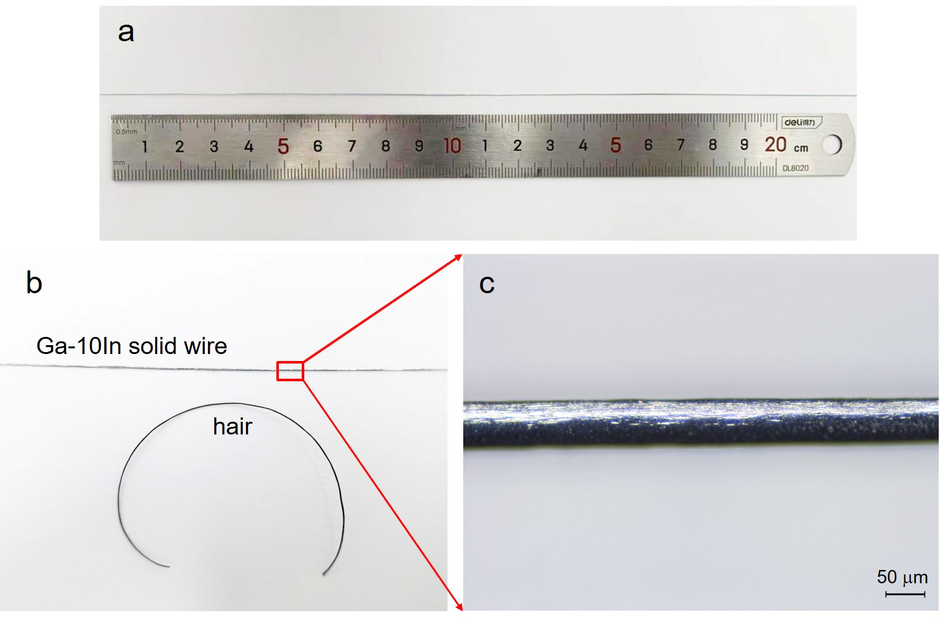
Fig. S1. Photograph and microscopic image of the Ga-10In solid wire. Photo of the long Ga-10In solid wire a) and the comparison of Ga-10In solid wire with a strand of human hair (b). c) Microscopic observation of the Ga-10In solid wire.

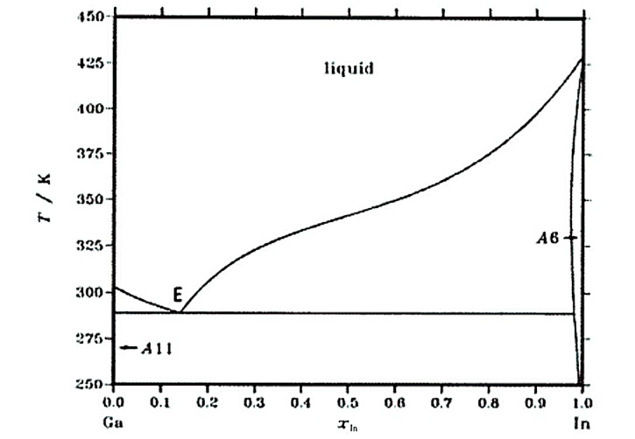
Fig. S2. Phase diagram of Ga-In alloy.

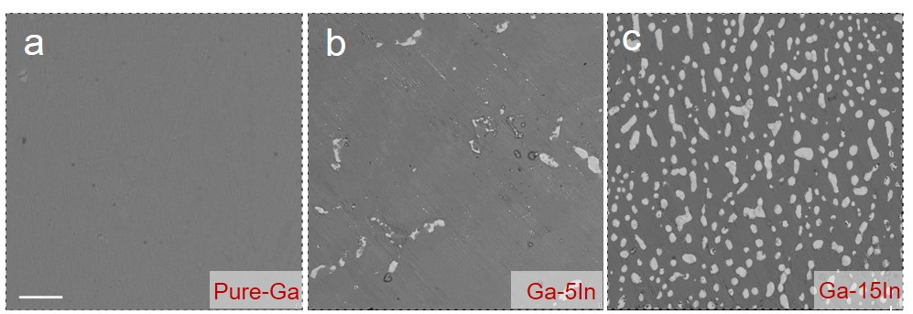
Fig. S3. Microstructure characterization (BSE images) of pure Ga, Ga-5In and Ga-15In alloys, scar bar is 20 μm.

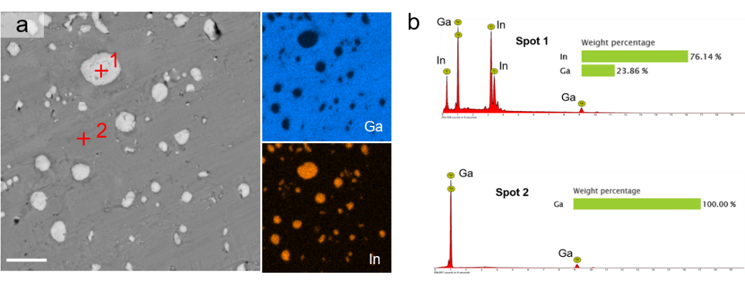
Fig. S4. a) BSE images and energy dispersive X-ray spectroscopy (EDS) element mapping for a framed area of the Ga-10In alloy in Fig. 2a and b) EDS spot analysis for spot 1 and spot 2, scar bar is 10 μm.

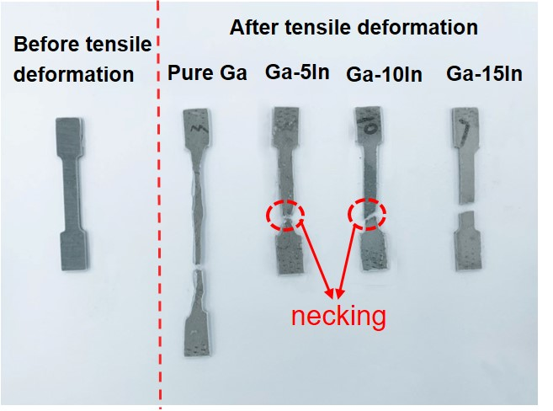
Fig. S5. Image of tensile samples before and after tensile testing.

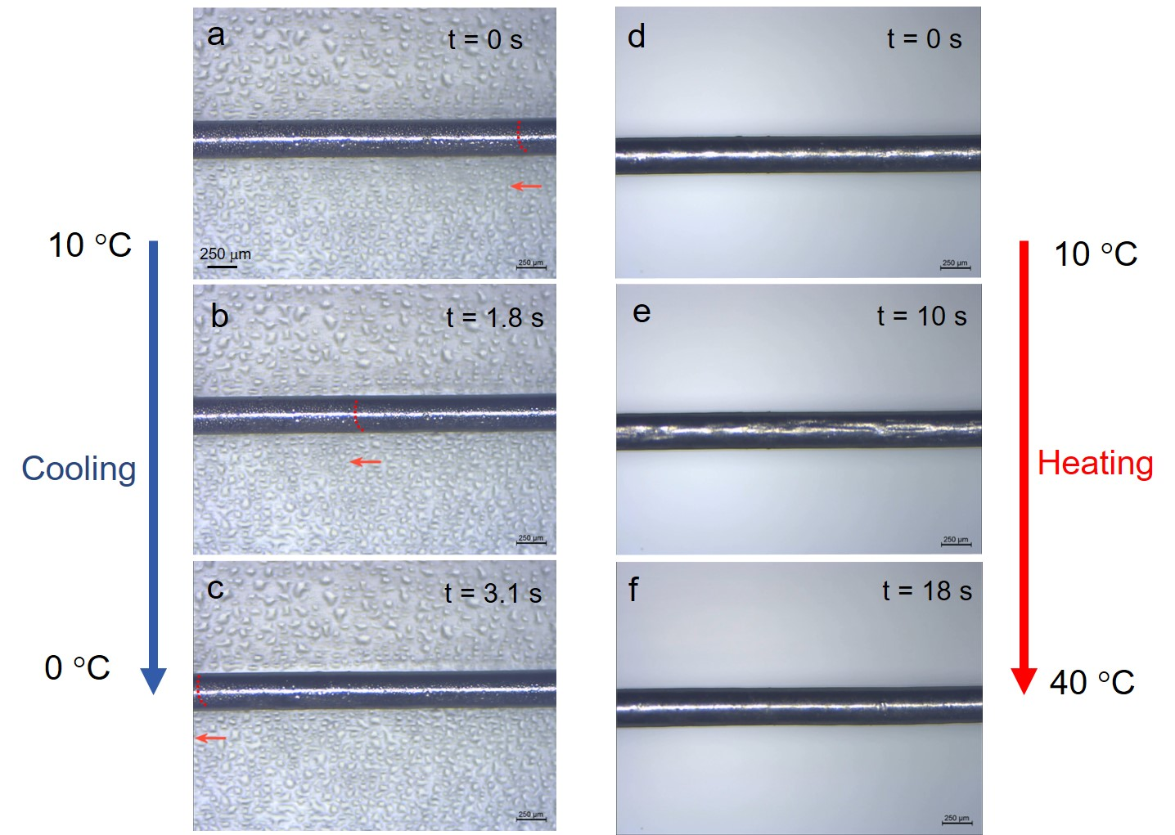
Fig. S6. The crystallization process during cooling (a, b, c) and the heating process (d, e, f) of Ga-10In solid wire.

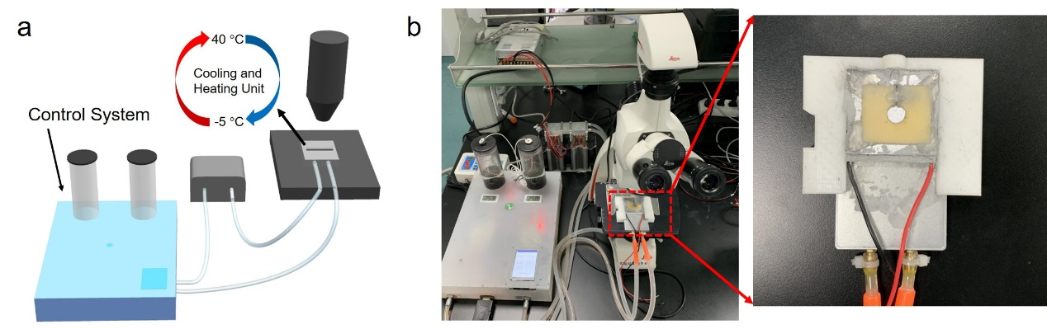
Fig. S7. The schematic diagram a) and photograph b) of the temperature control system, the right insert photograph is the cooling and heating unit.

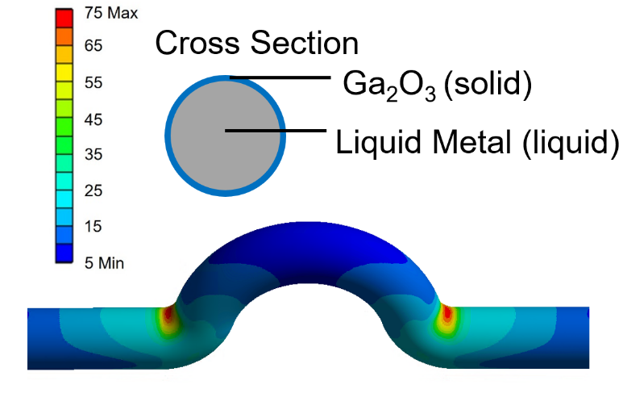
Fig. S8. Results of FEM simulation used to investigate the strain distribution on the surface of the rigid Ga₂O₃ oxide layer of the interconnect arch after melting. The surface of the model is rigid Ga₂O₃ film, and the inside is LM of liquid state.

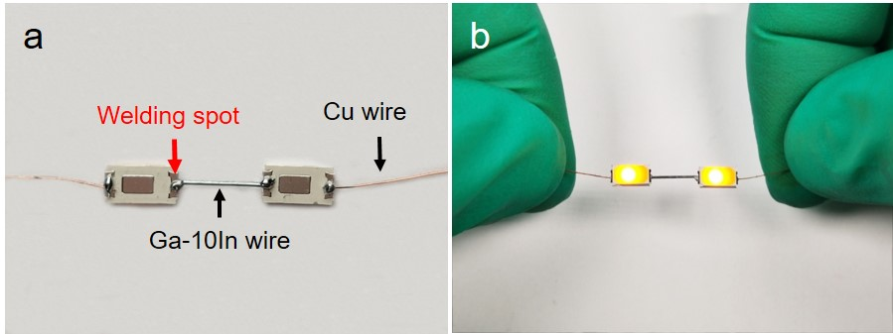
Fig. S9. Display of Ga-10In solid wire and LED electrodes after welding. a) Photograph of the LED connected by Ga-10In wire welding. b) The Ga-10In solid wire is tightly connected with the LED electrode at the welding spot, and the Ga-10In wire can remain stable when suspended in the air.
Welding process: Melt one terminal of the Ga-10In solid wire in ~2 mm length, and bring the liquid part into contact with LED electrode. The un-melted part of the Ga-10In solid wire can provide the nucleation core for the melted part to solidify. After holding for ~2 minutes, the liquid terminal of Ga-10In wire solidified and it can be firmly attached to the LED electrode.

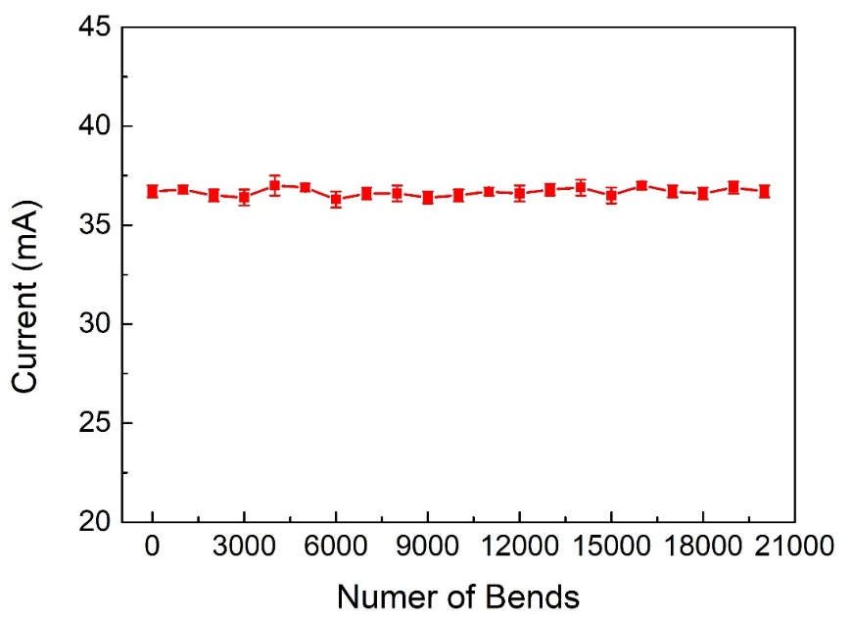
Fig. S10. Long-term stability test of LED array connected by Ga-10In interconnect arches for 20,000 times bending with 22 mm radius of curvature.

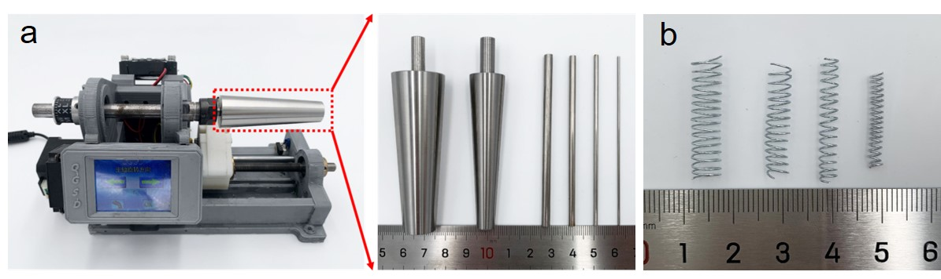
Fig. S11. Photograph of the automatic winding machine a) and Ga-10In alloy based helical 3D structure manufactured by the automatic winding machine b).

The automatic winding machine was used to prepare a 3D helical structure out of plastically deformable Ga-10In solid wires. This winding machine was mainly composed of a mainframe control system and a mold rotation system (working movie provided in Movie S4, SI). To prepare a wearable sensor capable of detecting finger motion that is both comfortable and highly stable, we designed a circular truncated cone structure mold based on the size of our volunteer’s finger joints. Furthermore, the diameter and pitch of the 3D helical conductive structure can be adjusted via the control system and the mold replacement, respectively.

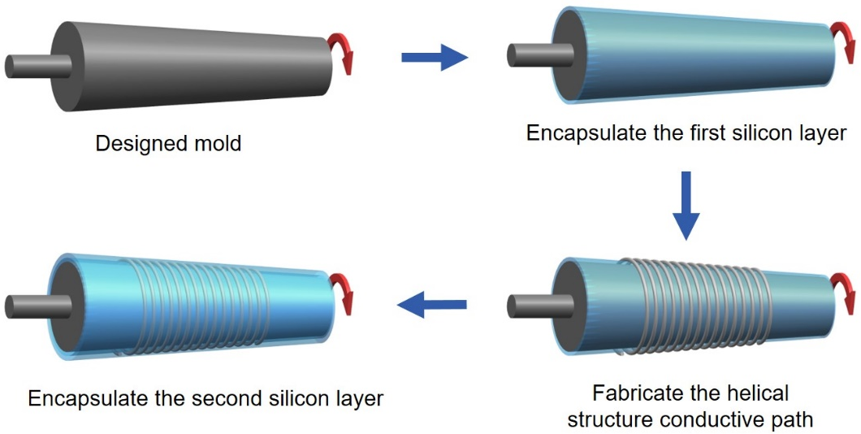
Fig. S12. The fabrication process of the elastomer encapsulation for the 3D wearable finger motion detection sensor. It should be noted that the LM sensor preparation method can be scaled up to larger sizes simply by using larger sized molds, e.g., for fabricating sensors that cover the wrist or knee to sense the movement of these body parts.

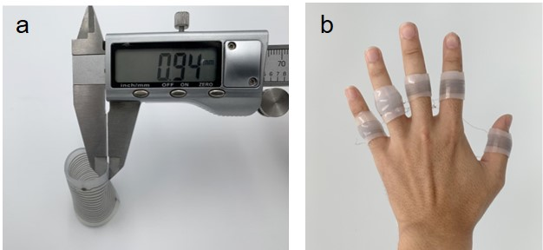
Fig. S13. Demonstration of the 3D structured wearable finger movement detection sensor. a) The wall thickness of the 3D wearable angle sensor is 0.94 mm and b) The 3D wearable sensor can fit tightly and comfortably to the five fingers.

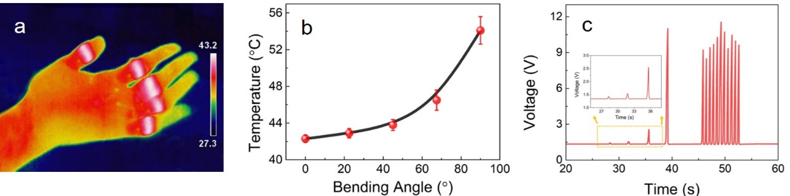
Fig. S14. Thermal therapy function of the 3D structured wearable sensor. a) Thermal image of the hand with five wearable sensors when applying a 0.5A heating current to perform heat therapy of the finger joints using Joule heating. b) Dynamic response of the heating temperature after bending a finger 20 times by a certain angle demonstrating the wearer-controllability of the heating temperature. c) The 3D structured finger wearable sensor realizes the finger motion detection sensitively by detecting the voltage change of the sensor with constant current.

The 3D structured wearable sensor is turned into a thermal therapy device that employs Joule heating. Due to the uniform distribution of LM wire in the thin sensor wall, the wearable sensor can be heated fairly evenly up to a comfortable temperature of about 43 °C. Furthermore, the wearer can actively adjust the temperature used in thermal therapy by bending the finger 20 times by a certain angle (Fig. S14b). For example, the heating temperature of the sensor can be increased by ~12 °C after bending the finger 20 times by 90°. It should be noted that this sensor can perform both tasks at the same time, i.e., sense finger movement and perform thermal therapy. Since any finger movement will induce a change in resistance, this will cause a corresponding change in the sensor voltage when a constant heating current is applied (Fig. S14c and Movie S5, SI). At the end of the Movie S5, the temperature of the sensor detected by the infrared thermal imager is about 41.2 °C. Bending the finger leads to an increase in electrical resistance which in turn results in increased Joule heating and thus temperature. This control mechanism is much more convenient and user friendly for physiotherapy applications compared to having to adjust the input current to adjust the temperature.
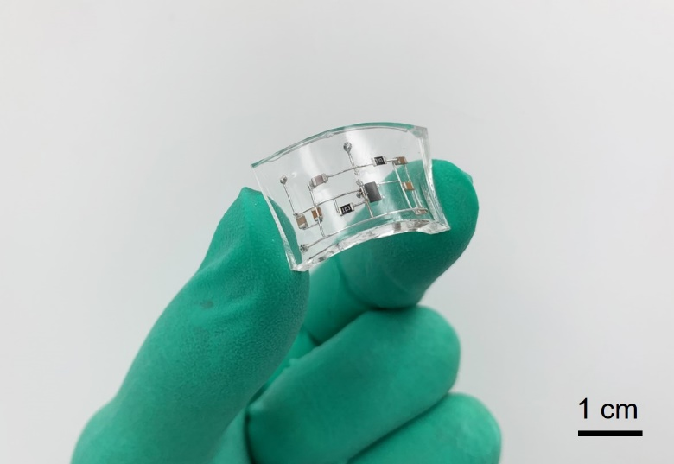
Fig. S15. Photograph of the flexible circuit board with multilayer 3D wiring.
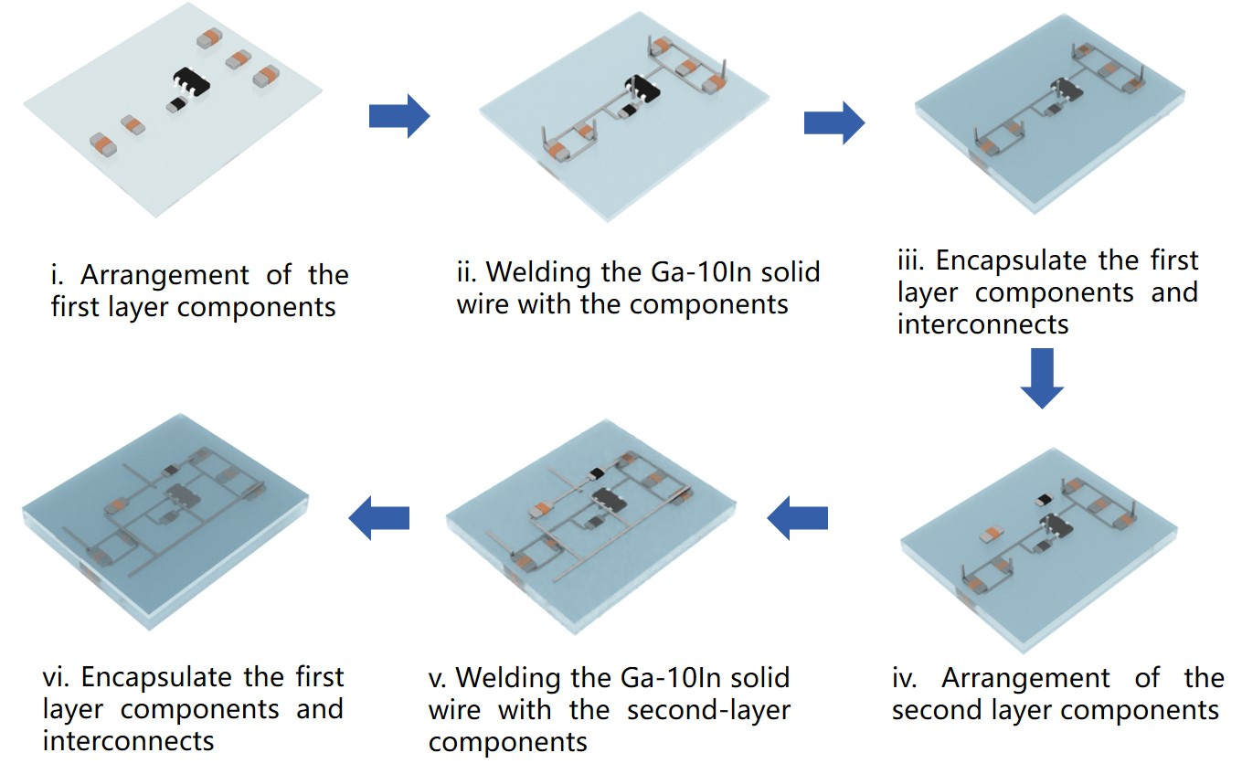
Fig. S16. The scheme for the fabrication of the multilayer voltage regulating circuit board.

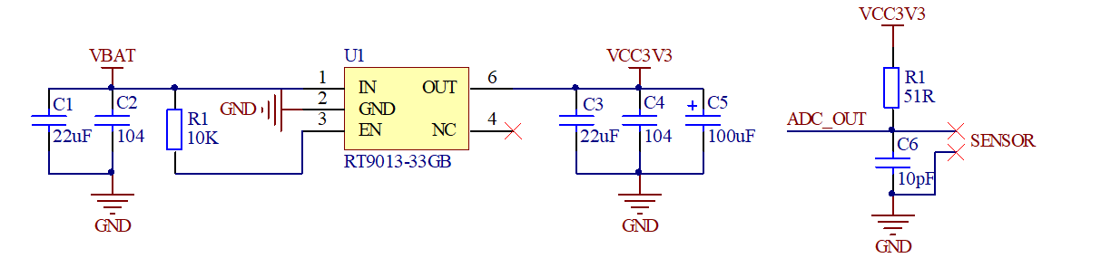
Fig. S17. Circuit diagram of the voltage regulating circuit board.

Table S1. Tensile properties of the studied Ga-In alloys.
