Supplemental Data:
Supplemental Material and Methods:
Manganese quenching:
Calcium influx was assessed using manganese quenching assay. 70 000 PANC-1 or 40 000 MIA PaCa-2 cells were seeded and incubated for 48 hours. Cells were then incubated with 3 µM Fura-2 AM for 45 minutes at 37°C. After loading, fluorescence was measured at the isosbestic point (360 nm excitation) with recordings taken every second for a total duration of 3 minutes. During this protocol, cells were washed with 2 mM Ca²⁺ solution for 1 minute and then perfused with 2 mM Mn²⁺ solution. The quenching was evaluated by calculating the slope, relative to the initial baseline fluorescence.

MTT viability assay:
Cell viability was assessed using MTT assay. 4x10⁴ PANC-1 and MIA PaCa-2 cells were seeded and allowed to adhere for 24 hours. 800 µL of MTT solution (5 mg/mL) was added and incubated for 1 hour at 37°C. The medium was then removed and formazan crystals formed were dissolved in 800 µL of dimethyl sulfoxide (DMSO). The optical density was measured at 570 nm using TECAN spectrophotometer.

Wound healing:
To assess collective cell migration, wound healing assay was performed. 6x10⁶ PANC-1 or MIA PaCa-2 cells were seeded in 6-well plates and allowed to adhere and reach confluence. A sterile 200 µL pipette tip was used to create a wound in the cell monolayer. Cells were washed with PBS to remove all the detached cell and then incubated with medium. The wound was photographed immediately after the experiment (T – 0H) and after 24 hours (T – 24H) using an inverted microscope. Wound areas were quantified using ImageJ software, and the percentage of wound closure was calculated using the following formula:
% of Wound Closure = (Area0H – Area24H) / Area0H x 100

Cell cytometry:
Flow cytometry was performed to evaluate cell cycle distribution. 300 000 MIA PaCa-2 or PANC-1 cells were seeded and incubated for at least 24 hours. C ells were harvested with trypsin-EDTA, washed twice with PBS, once with PBS-EDTA (5 mM) and then fixed with 70% ethanol. After fixation, cells were washed with PBS and resuspended with RNase A and propidium iodide for 30 minutes in the dark. Flow cytometry was performed with Cytometer Accuri C6 and the percentage of cells in the G1, S and G2/M cycle was estimated using Cyflogic software.

Table S1: List of chemicals, products, software and machines used for the study.
Product name | Supplier | Reference
Cell culture
DMEM High Glucose | Gibco | 31966021
Puromycin | Gibco | A11138
Fœtal Bovine Serum | Gibco | 10270  Lot 42Q9079K
Lipofectamine™ 3000 | FisherScientific | 15232475
Invitrogen™ TOPO™ TA Cloning™ Kit | FisherScientific | 10587163
Trypsine EDTA | Gibco | 25300-054
TG100-115 | Selleck Chem | S1352
Products used in patch-clamp and Mn²⁺ quenching assay
Magnesium chlorure | Sigma | M2670
Potassium chlorure | Sigma | P3911
Sodium chlorure | Sigma | S3014
Fura-2 | Sigma | F0888
Calcium gluconate | Sigma | C8231
Magnesium gluconate | Sigma | 344435
Potassium gluconate | Sigma | G500
Sodium gluconate | Sigma | S2054
Glucose | Sigma | G5767
HEPES | Sigma | H3375
TEA | Sigma | T2265
Hematocrit glass | Hirschmann® | 9100160
Migration and invasion
Hematoxylin | Sigma | 1.09253
Boydens chambers - Invasion | FisherScientific | 11553570
Boydens chambers - Migration | FisherScientific | 10136410
Methanol | Sigma | 32213
Cytometry and viability
DMSO | Sigma | 276855
EDTA | Sigma | E5135
Propidium Iodure | FisherScientific | P1304MP
MTT | FisherScientific | F11939
Biochemistry
Acrylamide/bis acrylamide, 40% solution | Sigma | A7168-100
Ammonium Persulfate (APS) | Fisher | BP179-25
DC Protein Assay Reagent A | BioRad | 5000113
DC Protein Assay Reagent B | BioRad | 5000114
DC Protein Assay Reagent S | BioRad | 5005115
Sodium Deoxycholate | Sigma | D6750
ECL RevelBlOt Intense | Ozyme | OZYB002
Glycerol | Sigma | G5516
Glycin | Sigma | G8898
N,N,N′,N′-Tetramethylethylenediamine (TEMED) | Sigma | T22500
Sodium Orthovanadate - Na₃VO₄ | Sigma | S6508-10G
Ponceau Red | Sigma | P3504
Bromophenol Blue | Sigma | B8026
Sodium Dodecyl Sulfate (SDS) - powder | Sigma | L4390
Sodium Dodecyl Sulfate (SDS) - solution | Sigma | 71736
TRIZMA Base | Sigma | T1503
Bovine Serum Albumin (BSA) | FisherScientific | BP9701
Molecular weight loading marker | BioRad | 1610374
Molecular biology
TriReagent (Trizol) | Ambion | 15596018
2-BromoChloroform | Sigma | B9673
Isopropanol | Sigma | I9516
High-capacity cDNA RT kit | Applied Biosystems | 4368814
PowerUp SYBR Green Master Mélange | Applied Biosystems | A25742
RNase away® | Sigma | 83931
NucleoSpin RNA Midi kit | MACHEREY-NAGEL | 740962.20
Softwares
Origin 2018 | OriginLab Corporation, Northampton, USA
GraphPad 9.5 | GraphPad Software, Boston, USA
Quantity One | BioRad, Marnes-la-Coquette, France
ClampFit | Molecular Devices Inc, San José, USA
ImageJ | https://imagej.nih.gov/ij/index.html
ZEN 3.5 Blue edition | Carl Zeiss S.A.S., Rueil Malmaison, France
Cyflogic | CyFlo Ltd, Turku, Finland
MetaFluor | Molecular Devices Inc, San José, USA
iControl | Tecan France S.A.S.U., Lyon, France
NanoDROP | Thermofisher, Life Technologies SAS, Villebon-Sur-Yvette, France
Design & Analysis Software (DA2) | Thermofisher, Life Technologies SAS, Villebon-Sur-Yvette, France
Machines and equipment
AxoPatch 200B | Molecular Devices Inc, San José, USA
Micropipette Puller P-30 | Sutter Instruments, Novato, USA
Micromanipulator MP230 | Sutter Instruments, Novato, USA
Cytometer Accuri C6 | BD Biosciences, Rungis, France
Spectrophotometer NanoDrop 2000 | Thermofisher, Life Technologies SAS, Villebon-Sur-Yvette, France
Inverted microscope -Fluorescence | Thermofisher, Life Technologies SAS, Villebon-Sur-Yvette, France
Monochromator Polychrome V | FEI, Life Technologies SAS, Villebon-Sur-Yvette, France
Inverted microscope – Nikon Eclipse TS100 | Carl Zeiss S.A.S., Rueil Malmaison, France
Camera - AxioCam 208 Color, ZEISS | Carl Zeiss S.A.S., Rueil Malmaison, France
TECAN Spectrophotometer | Tecan France S.A.S.U., Lyon, France
Western Generators | BioRad, Marnes-la-Coquette, France
XRS Imager Chemidoc | BioRad, Marnes-la-Coquette, France

Table S2: References and dilutions of antibodies used in the study
Protein | kDa | Supplier | Reference | Dilution
TRPM7 (coIP) | 212 | Alomone Labs | ACC-047 | 1µg
TRPM7 (Western-Blot) | 212 | Abcam | ab245408 | 1/1000
TRPM7 (PLA) | 212 | Sigma-Merck | SAB5200032-100UG | 1/500
Vimentin | 58 | ThermoFisher | MA5-16409 | 1/10000
E-cadherin | ~ 125 | Abcam | ab76055 | 1/1000
Rac1/2/3 | 21 | Cell Signalling | 2465 | 1/1000
Cdc42 | 21 | Cell Signalling | 2466 | 1/1000
p-PXN (Y118) | 68 | Cell Signalling | 2541S | 1/1000
PXN | 68 | SantaCruz | sc-365379 | 1/1000
PAK1 | 68 | Cell Signalling | 26062 | 1/1000
FAK | 125 | Cell Signalling | 3585 | 1/1000
p-FAK (Y397) | 125 | Cell Signalling | 8556 | 1/1000
RhoA | 21 | Cell Signalling | 2117 | 1/1000
p-AKT (Ser473) | 60 | Cell Signalling | 9271 | 1/1000
AKT | 60 | Cell Signalling | 9272 | 1/1000
p-ERK | 42 | Cell Signalling | 9101 | 1/1000
ERK | 42 | Cell Signalling | 9102 | 1/1000
p-EGFR (Tyr1068) | 175 | Cell Signalling | 3777 | 1/1000
EGFR | 175 | Cell Signalling | 4267 | 1/1000
GAPDH | 37 | Cell Signalling | 97166 | 1/2000
β-Actin | 44 | Cell Signalling | sc-1615 | 1/20000

Table 3: Primers used in the study
Gene | Sequence F / R (5’ 3’)
POP4 | ACCGCCTGAAAGTTATCCCC
POP4 | TTCTTCGCAGACCGTTCACT
MRPL19 | TCAGCCAGTTTCTGGGGATT
MRPL19 | GCAAATCTCGACACCTTGTCCT
TRPM7 (Kinase) | TCCATTTACACCTGTGCCTC
TRPM7 (Kinase) | GGGTGAACTCTCTTCCAAACG
TPRM7 (Channel) | CTGTGCCTCCAAGAGGGGAG
TPRM7 (Channel) | CAGAGGCCTAGTTGTGACCA
Vimentin | AGGAGGAAATGGCTCGTCAC
Vimentin | AGGCAGAGAAATCCTGCTCTC
(E-cadherin) CDH1 | GTTTCTTCGGAGGAGAGCGG
(E-cadherin) CDH1 | CTGGCTCAAGTCAAAGTCCTGG
RhoA | CCCCAGAAGTCAAGCATTTC
RhoA | TGCCTTCTTCAGGTTTCACC
RAC1 | CATTGTTGTGCCGAGAACAC
RAC1 | GAGTTCAATGGCAACGCTTC
RAC2 | CATTGTTGTGCCGAGAACAC
RAC2 | GAGTTCAATGGCAACGCTTC
RAC3 | GAGAATGTTCGTGCCAAGTG
RAC3 | TCAATGGTGTCCTTGTCGTC
CDC42 | CTCAACCCAAAAGGAAGTGC
CDC42 | GAGGCTTTCAAACAGGATGG
PAK1 | ACCCAATAGTGTTCCCATGC
PAK1 | TTTCCCCGACTTCTCAACAC
ZEB1 | GCCAATAAGCAAACGATTCTG
ZEB1 | TTTGGCTGGATCACTTTCAAG
ZEB2 | TTTCAGGGAGAATTGCTTGA
ZEB2 | CACATGCATACATGCCACTC
SNAI1 | GAATACCTCAGCCTGGGTGC
SNAI1 | CGGACATGGCCTTGTAGCAG
TWIST1 | AAACTACAGCGAACTGGACACA
TWIST1 | GCCCCAAAGATGAGGAGTATC
GAPDH (human) | CCACATCGCTCAGACACCAT
GAPDH (human) | CCAGGCGCCCAATACG
GAPDH (mouse) | AGGTCGGTGTGAACGGATTTG
GAPDH (mouse) | TGTAGACCATGTAGTTGAGGTCA

Figure S1:
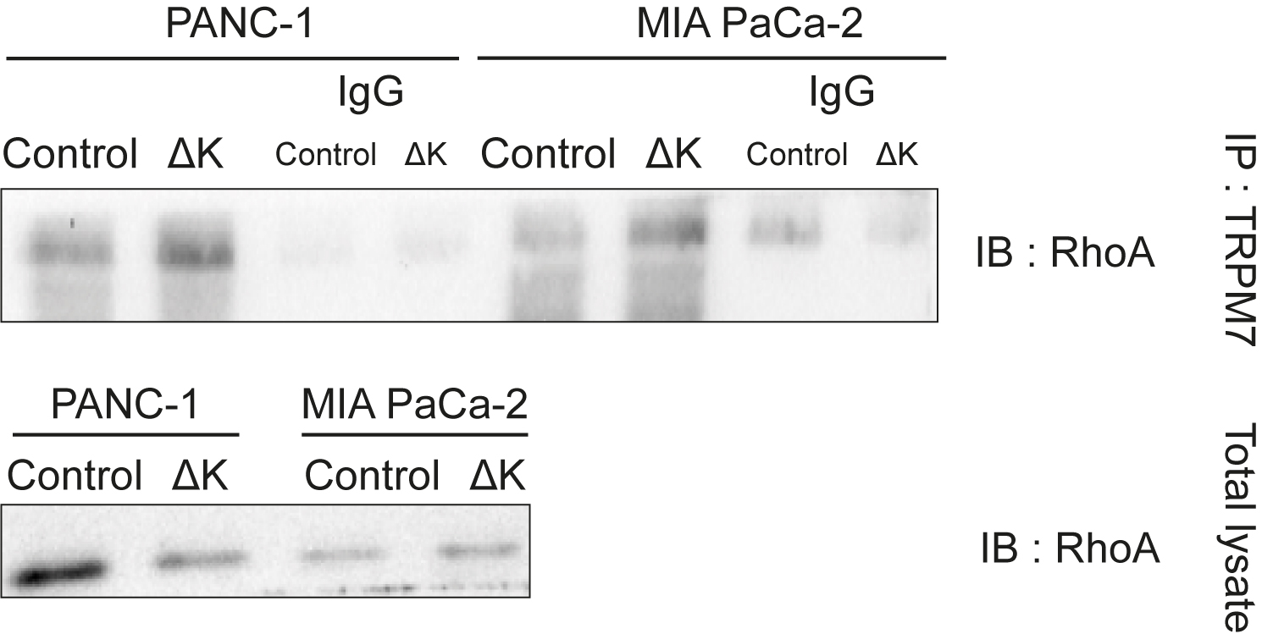
Figure S1: Co-immunoprecipitation of TRPM7 with RhoA in PANC-1 (n=3) and MIA PaCa-2 (n=3) Control and ΔK cells and their respective negative controls.

Figure S2:
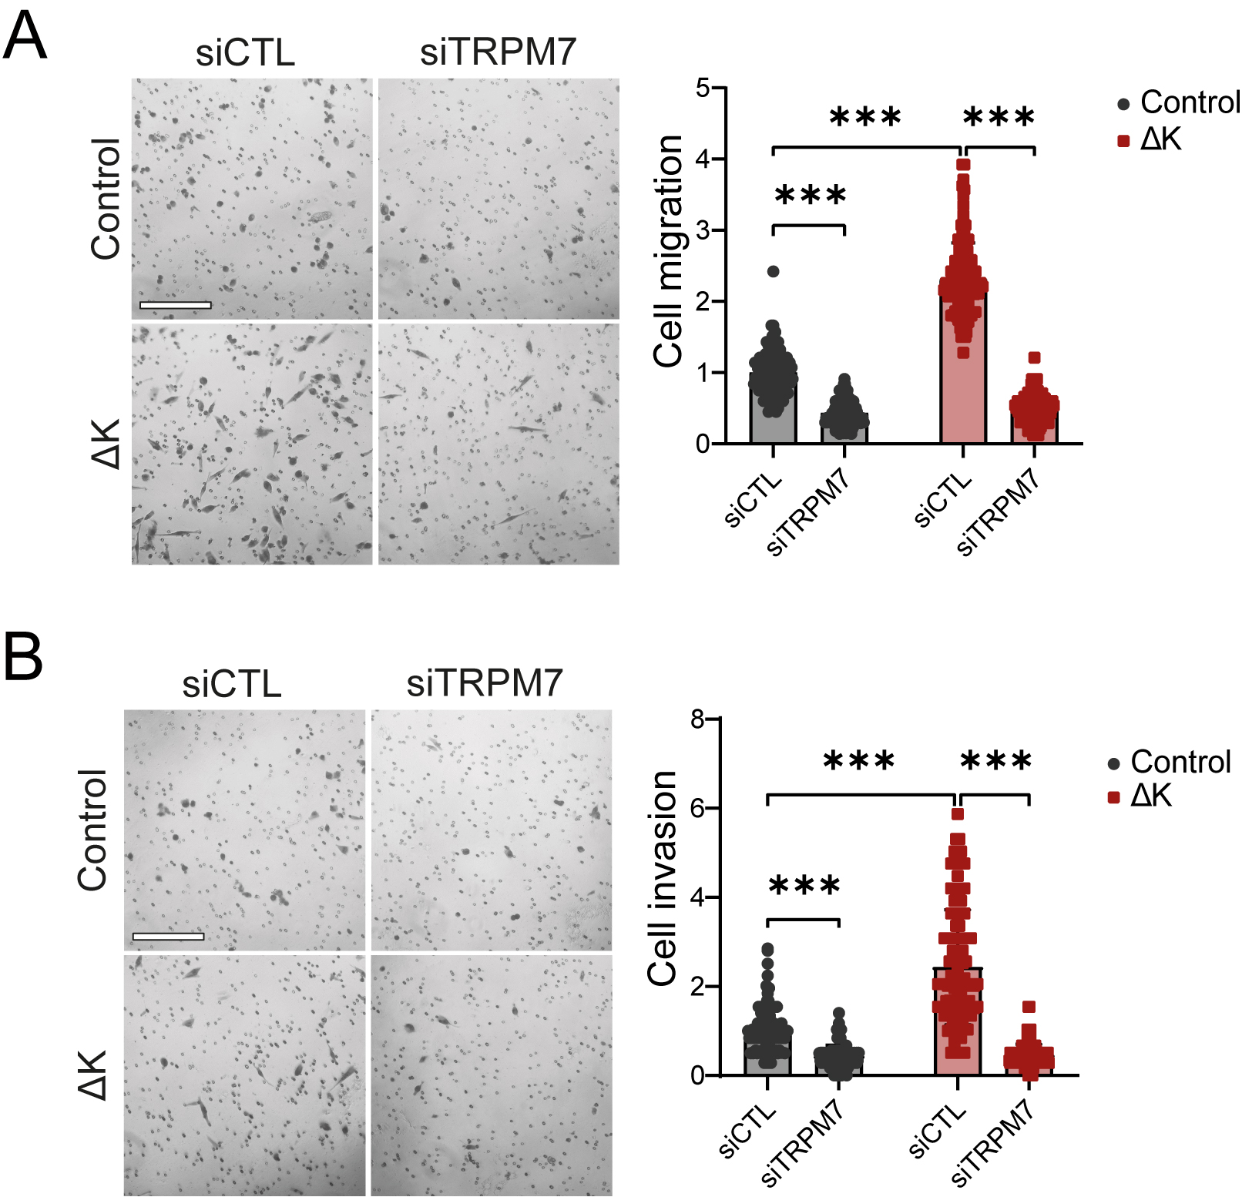
Figure S2: Effect of TRPM7 silencing on MIA PaCa-2 cell migration and invasion. A Cell migration of MIA PaCa-2 Control and ΔK siCTL and siTRPM7 evaluated in Boyden chambers (n=3, p<0.001, Two-way ANOVA followed by Šidák’s post-hoc test). B Cell invasion of MIA PaCa-2 Control and ΔK siCTL and siTRPM7 evaluated in Boyden chambers coated with Matrigel (n=3, p<0.001, Two-way ANOVA followed by Šidák’s post-hoc test). Scale bars are corresponding to 200 µm. Results are shown as mean±SD. ***p<0.001.

Figure S3:
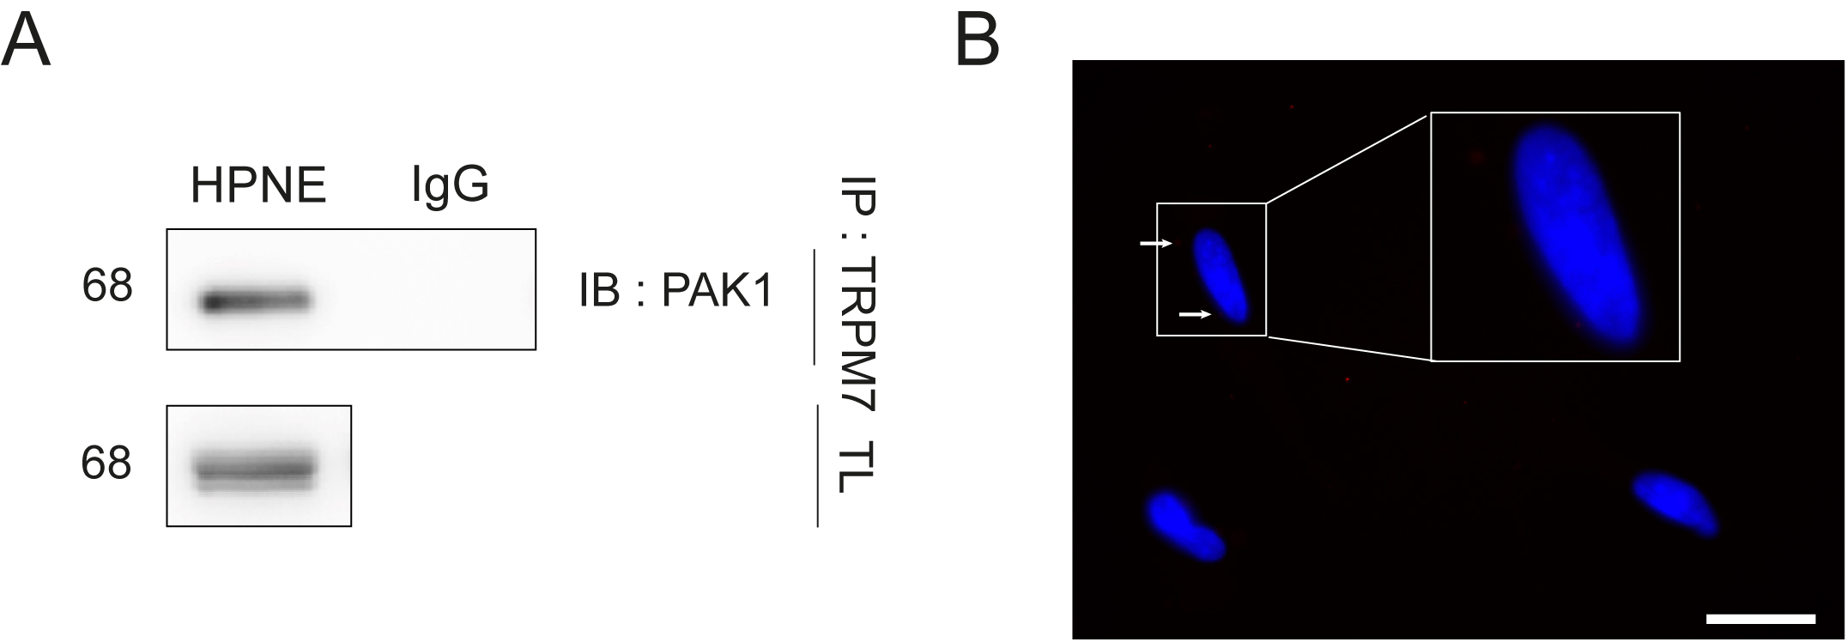
Figure S3: Interaction between TRPM7 and PAK1 in non-cancer cell line. A Co-immunoprecipitation of TRPM7 with PAK1 in normal pancreatic hTERT-HPNE cell line (n=3) and its negative IgG control. B Proximity Ligation assay of TRPM7 with PAK1 in hTERT-HPNE cells. Scale bar = 20 µm.

Figure S4:
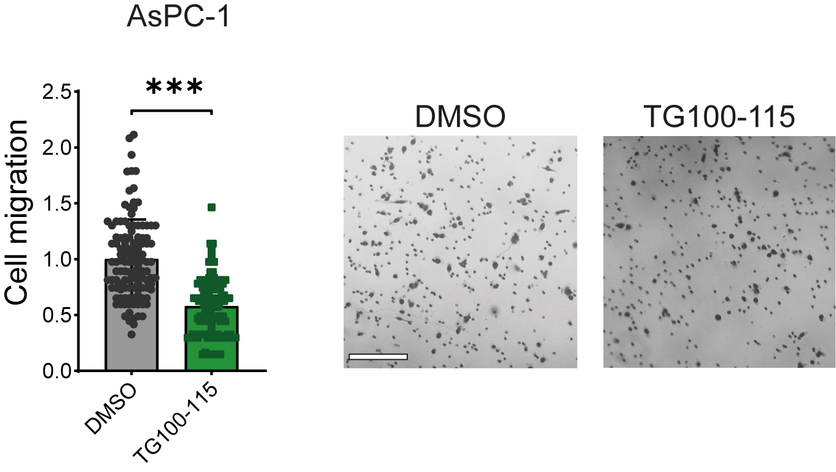
Figure S4: Effect of TG100-115 on KRASG12D mutated AsPC-1 cell migration. A Cell migration of AsPC-1 treated with 50 µM TG100-115 evaluated in Boyden chambers (n=3, p<0.001, Mann-Whitney test). Scale bar is corresponding to 200 µm. Results are shown as mean±SD. ***p<0.001.

Figure S5:
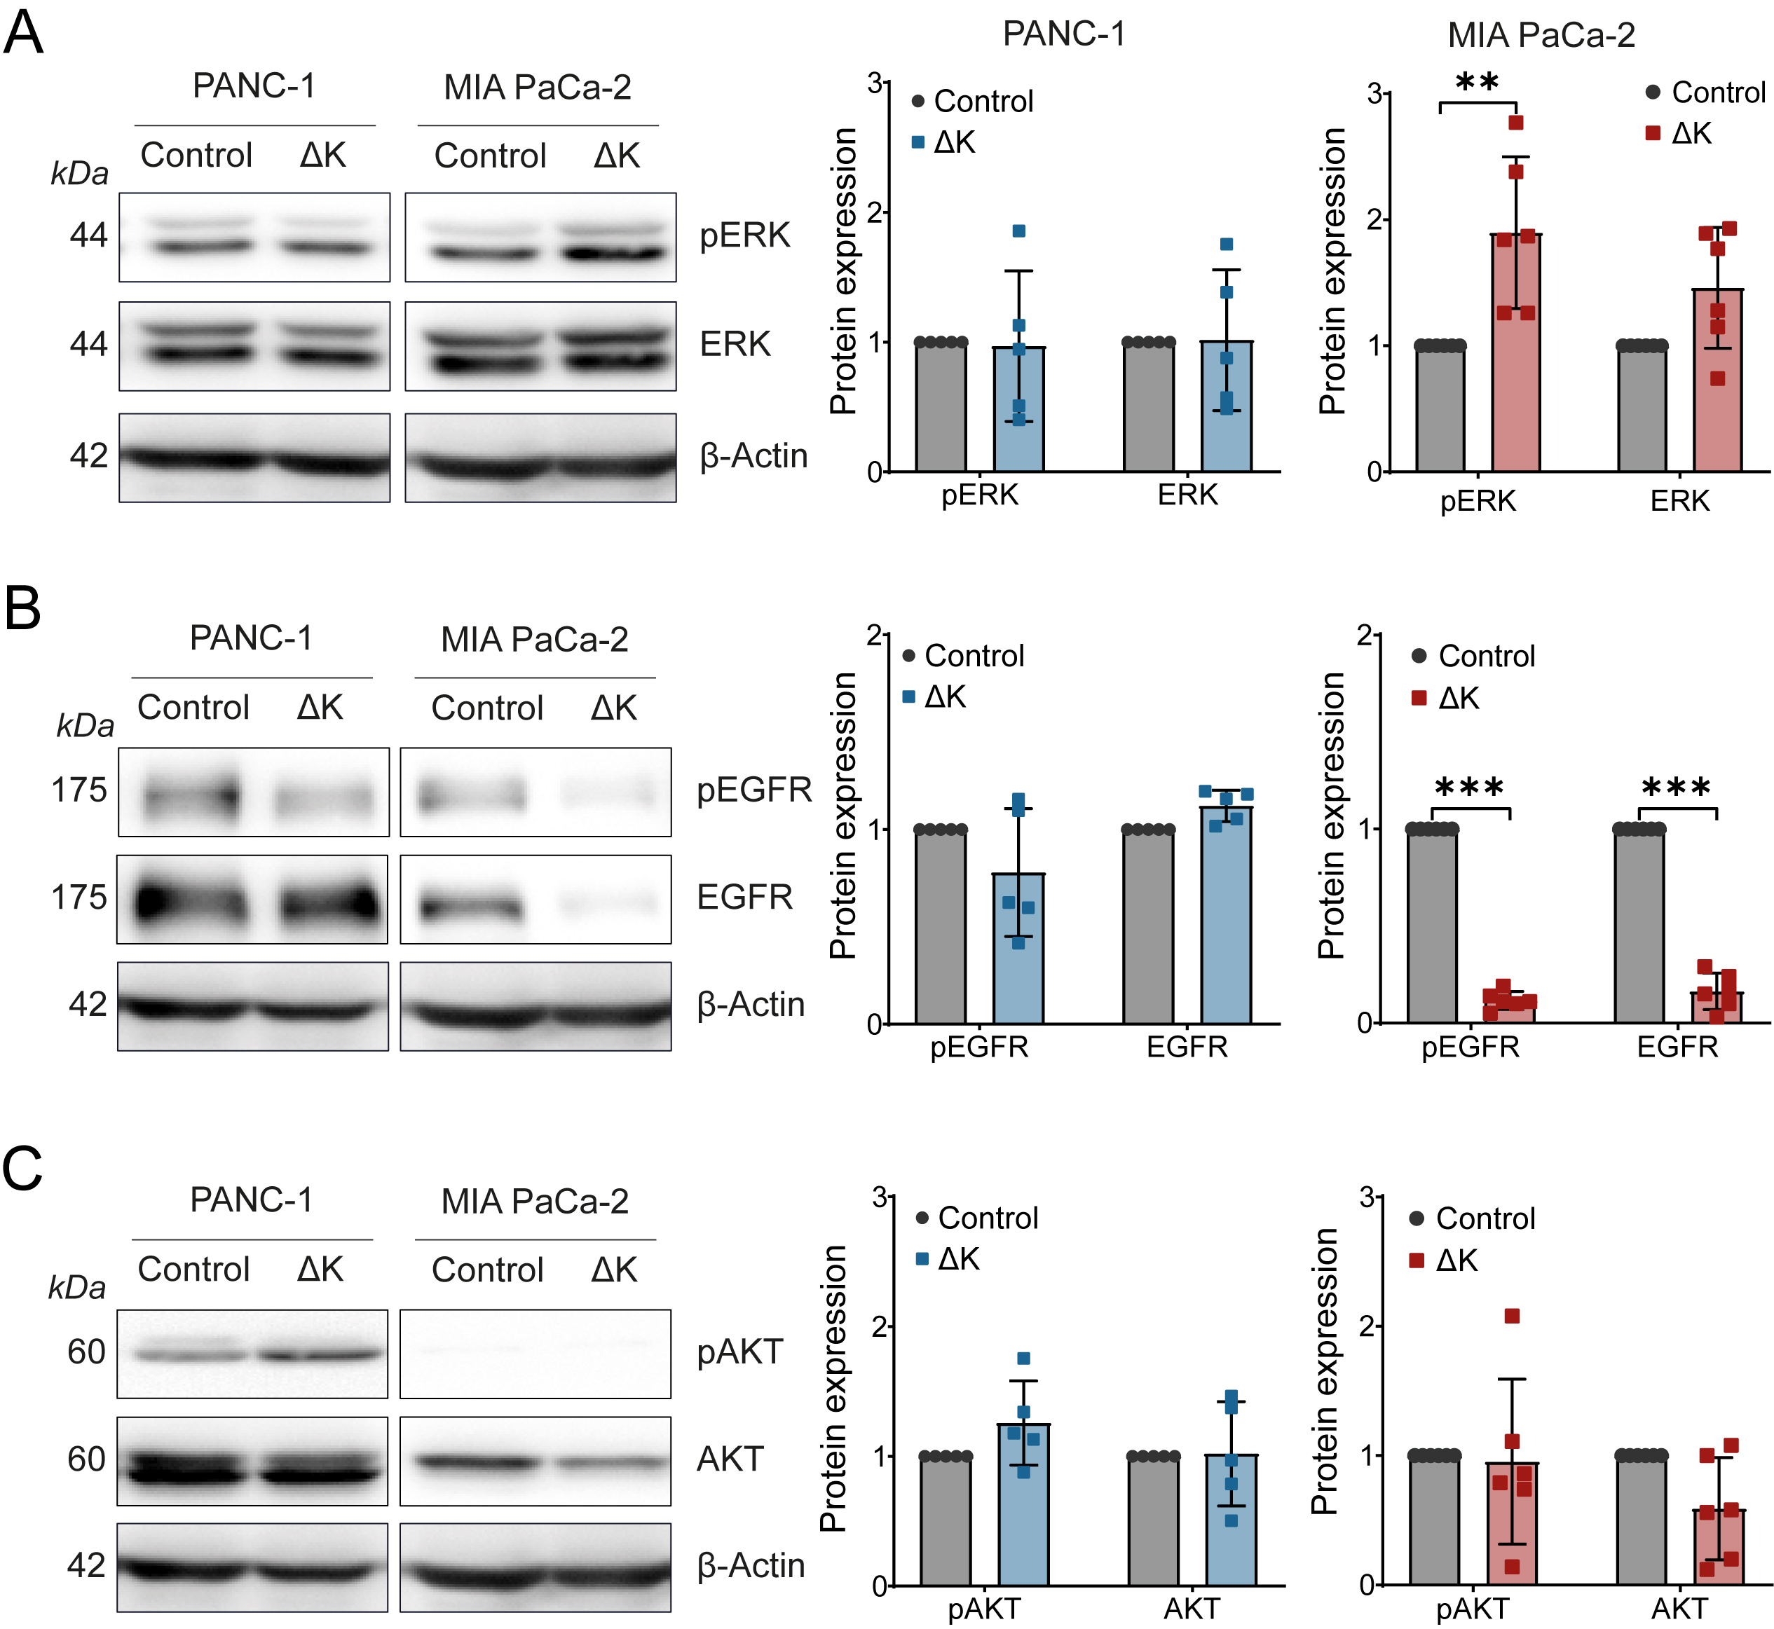
Figure S5: Effects of TRPM7 kinase domain deletion on ERK, AKT, and EGFR phosphorylation in PANC-1 and MIA PaCa-2 cell lines. A Expression and phosphorylation levels of ERK protein in PANC-1 (n=5, Two-way ANOVA followed by Šidák’s post-hoc test) and MIA PaCa-2 cells (n=6, p<0.01, Two-way ANOVA followed by Šidák’s post-hoc test). B Expression and phosphorylation levels of EGFR protein in PANC-1 (n=5, Two-way ANOVA followed by Šidák’s post-hoc test) and MIA PaCa-2 cells (n=6, Two-way ANOVA followed by Šidák’s post-hoc test) C. Expression and phosphorylation levels of AKT protein in PANC-1 (n=5, Two-way ANOVA followed by Šidák’s post-hoc test) and MIA PaCa-2 cells (n=6, p<0.001, Two-way ANOVA followed by Šidák’s post-hoc test). Results are shown as mean±SD. *p<0.05; **p<0.01; ***p<0.001.

