Supplementary Material
Appendix A - Survey

GEMS Educator Survey

This survey relates to your experience as an educator in supporting professional identity formation in students/trainees. All responses are treated anonymously, and your opinions are extremely valuable to us.
Many thanks for your time.
Educator background/demographics:

Question Title

* 1. How long have you been a tutor at your present institution?
1 year or less
2 years
3 years
4 years
5 years or more

Question Title

* 2. Who do you tutor? Choose all that apply
Year 1 student
Year 2 student
Year 3 student
Year 4 student
Intern
Other postgraduate trainee

Question Title

* 3. What is your clinical background (i.e. speciality)?
GP
Medicine
Surgery
Paediatrics
Psychiatry
Obstetrics
ED
Anaesthesiology
Radiology
Prefer not to say
Other (please specify)

Question Title

* 4. Where have you undertaken undergraduate and postgraduate medical training? Choose all that apply
USA
Canada
UK
Ireland
Rest of Europe
Australia
Other (please specify)

Question Title

* 5. How long is it since you completed your undergraduate medical training?
4 years or less
5-9 years
10-19 years
20 years or more

Question Title

* 6. Gender
Male
Female
Prefer not to say

Question Title

* 7. Age bracket
Under 35
35-44
45-54
55-64
65 plus

Question Title

* 8. Nationality
Irish
EU
Non EU
Prefer not to say
Other (please specify)
Recognising student/trainee behaviours:

Question Title

* 9. Give 2 examples of what you consider good professional behaviours in students/trainees

Question Title

* 10. Give 2 examples of minor breaches in professionalism
Minor breach: Defined as small lapse in professionalism with no significant cause for concern

Question Title

* 11. Give 2 examples of moderate breaches in professionalism
Moderate breach: Defined as lapse in professionalism with some cause for concern requiring informal or formal intervention and monitoring

Question Title

* 12. Give 2 examples of serious misconduct in professionalism
Serious breach: Defined as inappropriate behaviour requiring immediate intervention

Question Title

* 13. Do you find it easy to discriminate between minor, moderate and serious breaches in professional behaviour?
Not at all easy
Somewhat easy
Moderately ease
Quite easy
Extremely easy

Question Title

* 14. Do you think it is likely that problem behaviours are overlooked?
Not likely
Moderately likely
Quite likely
Extremely likely

Question Title

* 15. Do you think it is likely that problem behaviours are rewarded?
Not likely
Moderately likely
Quite likely
Extremely likely
Monitoring student/trainee behaviours:

Question Title

* 16. Do you routinely acknowledge good professional behaviours in students/trainees by explicitly telling the student?
Almost never
Once in a while
Sometimes
Often
Almost always

Question Title

* 17. Do you routinely record professional behaviours that you observe in students/trainees for feedback to student/supervisor or as a log of behaviours?
Almost never
Once in a while
Sometimes
Often
Almost always

Question Title

* 18. If yes, how frequently
After each session
Weekly
Monthly
Annually
Other (please specify)

Question Title

* 19. How many times over the past 12 months have you witnessed inappropriate professional behaviour in student/trainee?
Never
Once
Twice
Three times
Four times
More than 5

Question Title

* 20. Please indicate the number of times you have witnessed the following types of inappropriate professional behaviours which you consider:
Number of times
Minor inappropriate behaviours

Minor inappropriate behaviours Number of times menu
Moderate inappropriate behaviours

Moderate inappropriate behaviours Number of times menu
Serious inappropriate behaviours

Serious inappropriate behaviours Number of times menu

Question Title

* 21. Does your action upon witnessing unprofessional behaviour differ if the individual is a student vs an intern vs a postgraduate trainee?
Yes
No

Question Title

* 22. If you answered yes to the previous question, why do you think that is?
Experience of interventions:

Question Title

* 23. Have you ever intervened with a student/trainee on a professional issue?
Yes
No

Question Title

* 24. If yes, how frequently do you intervene with a student/trainee on a professional issue?
Almost never
Once in a while
Sometimes
Often
Almost always

Question Title

* 25. If yes, what triggers an intervention? Please select all that apply
Single unprofessional incident
Apparent pattern of behaviour
A persistent pattern of behaviour
A disciplinary incident
Other (please specify)

Question Title

* 26. If yes, what type of intervention(s) have you carried out? Please select all that apply
Informal conversation addressing the issue with student/trainee
Told a peer (teaching colleague/supervisor)
Completed a professionalism behaviour record form
Referral to professionalism committee
Other (please specify)

Question Title

* 27. If you intervened, how effective was the intervention(s)?
Not at all effective
Slightly effective
Moderately effective
Quite effective
Extremely effective
Other (please specify)

Question Title

* 28. If you intervened by discussing the issue with the student/trainee, how receptive was the student?
Not at all receptive
Slightly receptive
Moderately receptive
Quite receptive
Extremely receptive
Other (please specify)

Question Title

* 29. If you intervened by discussing the issue with a peer (teaching colleague/supervisor), how receptive were they?
Not at all receptive,
Slightly receptive
Moderately receptive
Quite receptive
Extremely receptive
Other (please specify)

Question Title

* 30. If you have never addressed lapses in professional behaviour, what deterred you? Please select all that apply
Implications for the student/trainee
Lack of time
Lack of support
Lack of training
Concerns about medico-legal ramifications
Previous negative experiences with individual concerned
Didn’t see it as my role
Other (please specify)

Question Title

* 31. Do you feel it is your responsibility to address lapses in professionalism?
Yes
No

Question Title

* 32. If no, who is responsible for addressing lapses in professionalism? Please choose all that apply
Senior faculty
Intern network director
Representative of governing body (e.g. RCPI, RCSI etc.)
Colleagues
Not applicable
Other (please specify)
Experience of organisational factors and ideas for improvement:

Question Title

* 33. How confident are you in dealing with professionalism issues in an informal manner?
Not at all confident
Slightly confident
Moderately confident
Quite confident
Extremely confident

Question Title

* 34. How confident are you in dealing with professionalism issues in a formal manner?
Not at all confident
Slightly confident
Moderately confident
Quite confident
Extremely confident

Question Title

* 35. How confident are you in providing feedback to students/trainees?
Not at all confident
Slightly confident
Moderately confident
Quite confident
Extremely confident

Question Title

* 36. How supported are you to oversee substantive behaviour change in students/trainees?
Not at all supported
Slightly supported
Moderately supported
Quite supported
Extremely supported

Question Title

* 37. How supported are you to deliver consequences on lapses in professional behaviour to students/trainees?
Not at all supported
Slightly supported
Moderately supported
Quite supported
Extremely supported

Question Title

* 38. Have you had any training in recognising and assessing professional behaviours in students/trainees?
Yes
No

Question Title

* 39. If you answered yes, please briefly describe the training? Please select all that apply
Workshops
Role play
Record keeping tools
Case-based reference examples
Not applicable
Other (please specify)

Question Title

* 40. If you answered yes, did you feel the training was beneficial?
Yes
No
Not applicable

Question Title

* 41. Have you had any training in providing feedback to students/trainees?
Yes
No

Question Title

* 42. How interested would you be in receiving training on dealing with unprofessional behaviours in students/trainees?
Not at all interested
Slightly interested
Moderately interested
Quite interested
Extremely interested

Question Title

* 43. What type of assistance do you feel would help you in intervening with unprofessional behaviour? Please select all that apply
Workshops
Role play
Record keeping tools
Case-based reference examples
Other (please specify)

Question Title

* 44. Do you have any other comments?
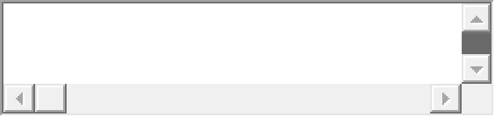

Appendix B - Survey full results table
 | Frequency | Percent
Do you find it easy to discriminate between minor, moderate and serious breaches in professional behaviour? | Not at all | 1 | 5.9
 | Somewhat easy | 7 | 41.2
 | Moderately easy | 7 | 41.2
 | Quite easy | 2 | 11.8
 | Total | 17 | 100.0
Do you think it is likely that problem behaviours are overlooked? | Not likely | 1 | 5.9
 | Moderately likely | 9 | 52.9
 | Quite likely | 4 | 23.5
 | Extremely likely | 2 | 11.8
 | Likely | 1 | 5.9
 | Total | 17 | 100.0
Do you think it is likely that problem behaviours are rewarded? | Not likely | 10 | 58.8
 | Somewhat likely | 4 | 23.5
 | Moderately likely | 2 | 11.8
 | Quite likely | 1 | 5.9
 | Total | 17 | 100.0
Do you routinely acknowledge good professional behaviours in students/trainees by explicitly telling the student? | Once in a while | 5 | 29.4
 | Sometimes | 4 | 23.5
 | Often | 5 | 29.4
 | Almost always | 3 | 17.6
 | Total | 17 | 100.0
Do you routinely record professional behaviours that you observe in students/trainees for feedback to student/supervisor or as a log of behaviours? | Almost neve | 7 | 41.2
 | Once in a while | 3 | 17.6
 | Sometimes | 3 | 17.6
 | Often | 2 | 11.8
 | Almost always | 2 | 11.8
 | Total | 17 | 100.0
If yes, what triggers an intervention? (Combined) | Single unprofessional incident | 5 | 29.4
If yes, what triggers an intervention? (Combined) | Apparent pattern of behaviour | 2 | 11.8
If yes, what triggers an intervention? (Combined) | A persistent pattern of behaviour | 3 | 17.6
If yes, what triggers an intervention? (Combined) | A disciplinary incident | 1 | 5.9
If yes, what triggers an intervention? (Combined) | All of the above | 2 | 11.8
If yes, what triggers an intervention? (Combined) | Single unprofessional incident & Apparent pattern of behaviour | 1 | 5.9
If yes, what triggers an intervention? (Combined) | Single unprofessional incident & A persistent pattern of behaviour | 1 | 5.9
If yes, what triggers an intervention? (Combined) | Apparent pattern of behaviour & a persistent pattern of behaviour | 1 | 5.9
If yes, what triggers an intervention? (Combined) | A persistent pattern of behaviour & A disciplinary incident | 1 | 5.9
If yes, what triggers an intervention? (Combined) | Total | 17 | 100.0
If yes, what type of intervention(s) have you carried out? (Combined) | Informal conversation addressing the issue with student / trainee | 9 | 52.9
 | Completed a professionalism behaviour record form | 1 | 5.9
 | Informal conversation addressing the issue with student / trainee & told a peer | 6 | 35.3
 | Informal conversation with student / trainee & told a peer & completed a professionalism behaviour record form | 1 | 5.9
 | Total | 17 | 100.0
If you intervened, how effective was the intervention (s)? | Not at all effective | 0 | 0
If you intervened, how effective was the intervention (s)? | Slightly effective | 2 | 11.8
If you intervened, how effective was the intervention (s)? | Moderately effective | 7 | 41.2
If you intervened, how effective was the intervention (s)? | Quite effective | 6 | 35.3
If you intervened, how effective was the intervention (s)? | Extremely effective | 2 | 11.8
If you intervened, how effective was the intervention (s)? | Total | 17 | 100.0
If you intervened by discussing the issue with the student/trainee, how receptive was the student? | Not at all receptive | 1 | 5.9
 | Slightly receptive | 2 | 11.8
 | Moderately receptive | 8 | 47.1
 | Quite receptive | 5 | 29.4
 | Other | 1 | 5.9
 | Total | 17 | 100.0
If you intervened by discussing the issue with a peer (teaching colleague/supervisor), how receptive were they? | Quite receptive | 7 | 41.2
 | Extremely receptive | 6 | 35.3
 | Other | 4 | 23.5
 | Total | 17 | 100.0
How confident are you in dealing with professionalism issues in an informal manner? | Not at all confident | 1 | 5.9
 | Slightly confident | 4 | 23.5
 | Moderately confident | 4 | 23.5
 | Quite confident | 8 | 47.1
 | Total | 17 | 100.0
How confident are you in dealing with professionalism issues in a formal manner? | Not at all confident | 8 | 47.1
 | Slightly confident | 2 | 11.8
 | Moderately confident | 4 | 23.5
 | Quite confident | 3 | 17.6
 | Total | 17 | 100.0
How confident are you in providing feedback to students/trainees? | Not at all confident | 1 | 5.9
 | Slightly confident | 2 | 11.8
 | Moderately confident | 1 | 5.9
 | Quite confident | 12 | 70.6
 | Extremely confident | 1 | 5.9
 | Total | 17 | 100.0
How supported are you to oversee substantive behaviour change in students/trainees? | Not at all supported | 1 | 5.9
 | Slightly supported | 1 | 5.9
 | Moderately supported | 5 | 29.4
 | Quite supported | 8 | 47.1
 | Extremely supported | 2 | 11.8
 | Total | 17 | 100.0
How supported are you to deliver consequences on lapses in professional behaviour to students/trainees? | Not at all supported | 1 | 5.9
 | Slightly supported | 2 | 11.8
 | Moderately supported | 4 | 23.5
 | Quite supported | 8 | 47.1
 | Extremely supported | 2 | 11.8
 | Total | 17 | 100.0

Appendix C – Survey & Focus Group Information Sheet
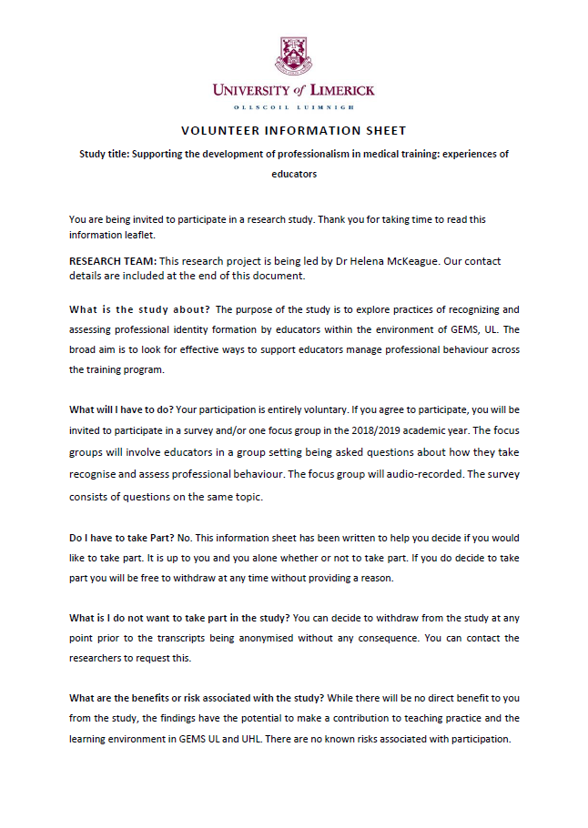
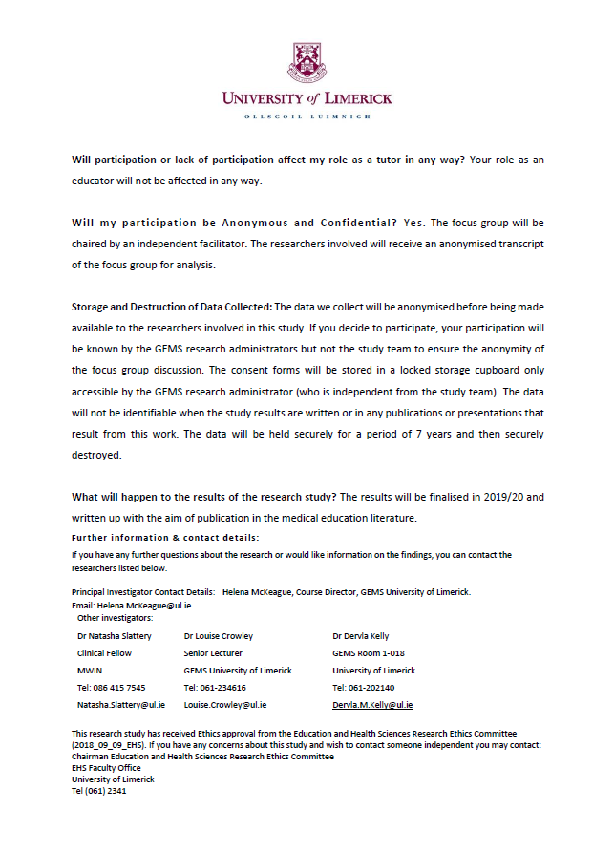

Appendix D – Focus Group Consent Form


PARTICIPANT CONSENT FORM

‘Supporting the development of professionalism in medical training: experiences of tutors and clinical educators’
UL Ethics reference no EHSREC_2018_09_09
Consent
By signing and returning this consent form you are indicating that you are willing to take part in this study and that you are in agreement with the following statements:

I have read and understood the participant information sheet. | Yes | No
I have been given the opportunity to ask questions about the study. | Yes | No
I have had my questions answered satisfactorily. | Yes | No
I understand that I can withdraw from the study without having to give an explanation. | Yes | No
I understand that my data once processed will be anonymous and that only the researcher(s) (and supervisors) will have access to the raw data which will be kept confidentially. | Yes | No
I understand that my data will be stored for a period of 7 years before being destroyed | Yes | No
I agree to take part in the study | Yes | No
This study involves audio recording. Please tick the appropriate box
I am aware that my participation in this study will be recorded (audio) and I
agree to this. However, if I feel uncomfortable at any time I can ask that the
recording equipment be switched off. I understand that I can ask for a copy of my
recording. I understand what will happen to the recordings once the study is
finished.

I do not agree to being audio recorded in this study.

Your signature confirms that you are happy to participate in the study.
Name in Block Capitals
Signature
Date

Dr Helena McKeague  Course Director  GEMS UL  Tel: 061-234820  Helena.McKeague@ul.ie | Dr Natasha Slattery  Clinical Fellow  MWIN  Tel: 086 415 7545  Natasha.Slattery@ul.ie | Dr Louise Crowley  Senior Lecturer  GEMS uL  Tel: 061-234616  Louise.Crowley@ul.ie | Dr Dervla Kelly  Lecturer  GEMS UL  Tel: 061-202140  Dervla.M.Kelly@ul.ie

This research study has received Ethics approval from the Education and Health Sciences Research Ethics Committee (insert approval number). If you have any concerns about this study and wish to contact someone independent you may contact:
Chairman Education and Health Sciences Research Ethics Committee
EHS Faculty Office
University of Limerick
Tel (061) 23410

Appendix E – Focus Group Interview Guide
- Introduce yourself to the group and include whether they mainly deal with junior or senior cycle students/trainees, and the approximate length of time they have been an educator.

- In your experience educators, have you ever reported or considered reporting unprofessional behaviour in medical students or trainees either verbally or in writing

- If you have reported unprofessional behaviour in a student/trainee, how was this situation managed (formal/informal process) and what was the outcome?

- What are some of the factors that prevented you from reporting unprofessional behaviour in the past?

- What do you think are the challenges of reporting unprofessional behaviour in medical students and trainees? (student vs intern? Q21)

- What do you think are the consequences of reporting unprofessional behaviour in medical students and trainees?

- What factors they feel would facilitate or support reporting?

Appendix F – Thematic Roadmap
Themes Draft 1
Themes Draft 2
Themes Draft 3

