Supplementary Information for “Climate feedback of forest fires amplified by atmospheric chemistry”
Wei Chen^{1,2,3}, Yuzhong Zhang^{2,3*}, Yufei Zou⁴, Zhen Zhang⁵
¹College of Environmental and Resource Sciences, Zhejiang University, Hangzhou, Zhejiang, China
²Key Laboratory of Coastal Environment and Resources of Zhejiang Province, School of Engineering, Westlake University, Hangzhou, Zhejiang, China
³Institute of Advanced Technology, Westlake Institute for Advanced Study, Hangzhou, Zhejiang, China
⁴School of Earth and Space Sciences, University of Science and Technology of China, Hefei, Anhui, China
⁵National Tibetan Plateau Data Center (TPDC), State Key Laboratory of Tibetan Plateau Earth System, Environment and Resource (TPESER), Institute of Tibetan Plateau Research, Chinese Academy of Sciences, Beijing, China

Correspondence to: Yuzhong Zhang (zhangyuzhong@westlake.edu.cn)

Contents of this file:
Supplementary Text 1
Supplementary Figures 1 to 6
Supplementary Tables 1 to 4

Text 1 Fire emissions over the past two decades and their impact on the global OH concentration
Despite a decrease in the global burned area driven by human activity over the past two decades^{1,2}, both top-down satellite-based inversions and bottom-up emission inventories consistently indicate that wildfire emissions have remained quasi-stable^{2,3}, with no significant trend in the past two decades^{2,3} (Supplementary Fig.4a,b). This stability results from a balance between the reduction in grassland and shrubland fire emissions, driven primarily by human activity^{1,2}, and the increase in forest fire emissions due to climate change^{2,4}. Therefore, our calculation of the cumulative changes in the global CO₂ burden begins from the 2010s.
Using the GEOS-Chem model driven by GFED4.1s fire emissions³, we investigated the impact of changes in fire emissions over the past two decades on global OH concentrations. The simulation shows insignificant changes of -0.06% in global mean OH concentration between the 2000s and the 2010s (Supplementary Fig.4c,d). This result suggests that the “fire-chemistry-methane” feedback has played a negligible role in the recent rise of atmospheric methane levels. However, it will emerge as a significant factor by the mid-21st century with substantially intensified wildfire activity.
Despite the minor role in the decadal trend, our simulation finds considerable suppression of global mean OH concentrations in extreme fire years (Supplementary Fig. 4c). For instance, global OH concentrations are more than 1% lower than the 2000–2019 average in 2006, 2015, and 2019 due to large anomalies of global fire emissions. Consistent with our simulations, previous studies also reported substantially reduced global OH concentrations in response to large fire events⁵⁻⁷.
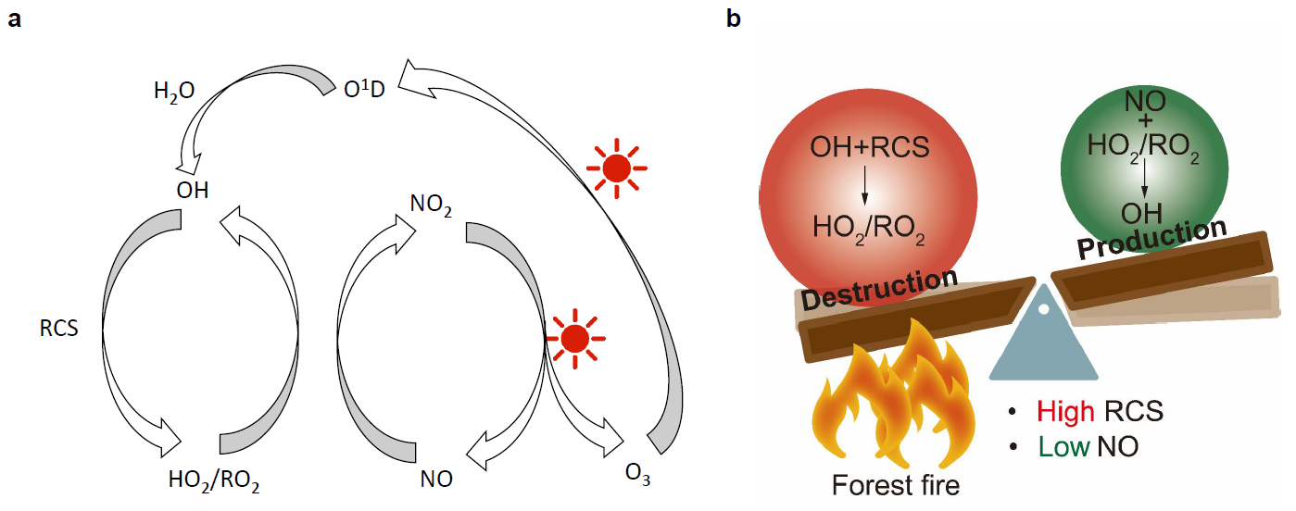
Supplementary Fig.1 | a. Simplified chemical mechanism controlling OH concentrations in the remote atmosphere. b. Schematic diagram of OH production and destruction influenced by forest fire emissions featuring higher RCS emissions relative to NO_{x} emissions.
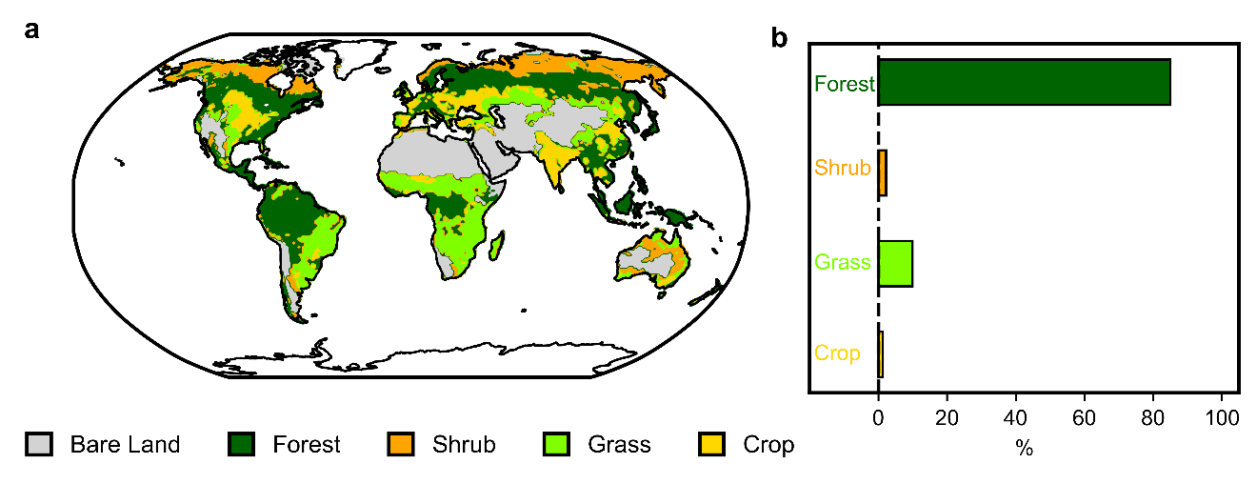
Supplementary Fig.2 | a. Distribution of the dominant plant functional type (PFT) group in the RESFire model. The dominant PFT is defined as the PFT with the largest fraction in each grid cell. b. Proportion increases of fire emissions in the 2050s relative to the 2000s for each PFT. Results are from the simulation by RESFire under RCP4.5^{8,9}.
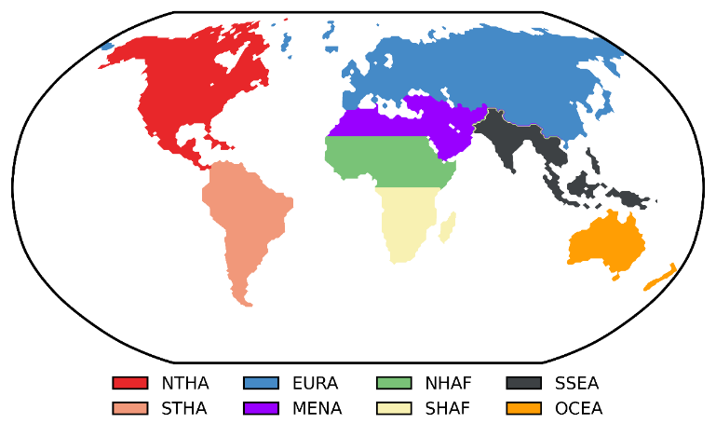
Supplementary Fig.3 | Region definition for Figure 1c.
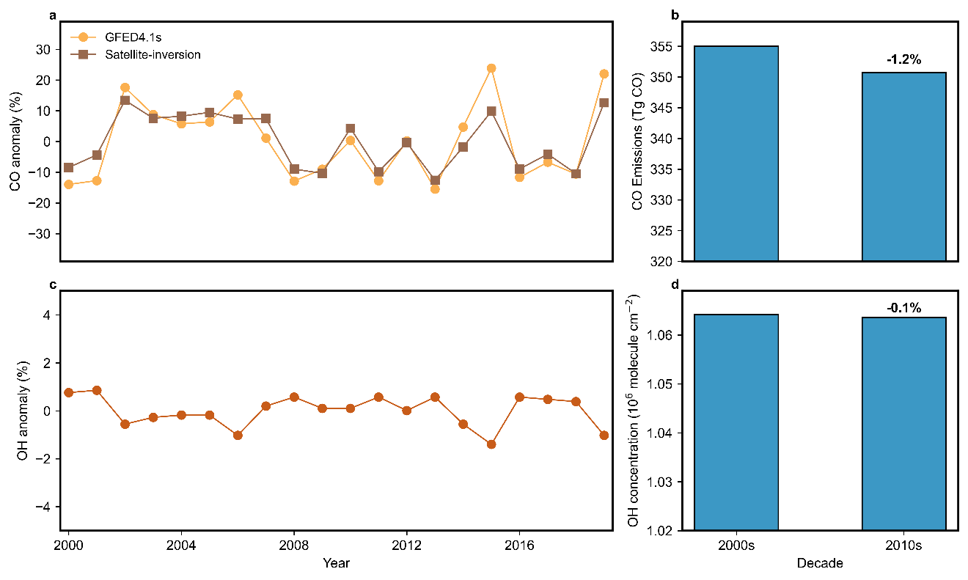
Supplementary Fig.4 | Global fire RCS emissions (represented by CO) and global mean OH concentration driven by fire over the past two decades. a. Annual anomalies of global fire CO emissions from 2000 to 2019, derived from top-down satellite inversions based on MOPITT² and bottom-up GFED4.1s fire emission inventory³. b. Decadal changes in global mean fire CO emissions between the 2000s and the 2010s, as calculated from the GFED4.1s fire emission inventory shown in Panel a. c. Annual anomalies of global mean OH concentration from 2000 to 2019, as simulated by GEOS-Chem driven by the GEFD4.1s fire emission inventory. d. Decadal changes in global mean OH concentrations between the 2000s and the 2010s from Panel a.
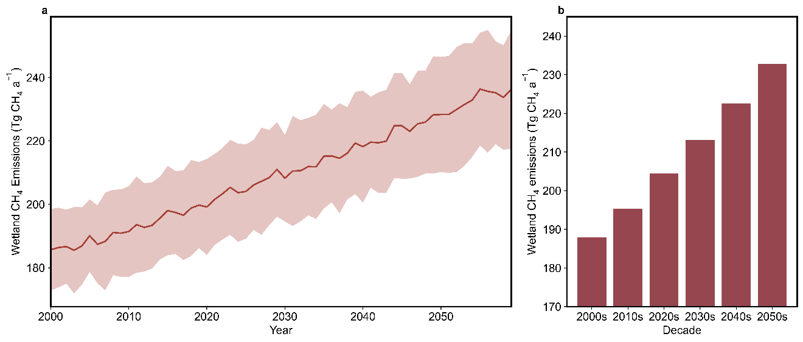
Supplementary Fig.5 | Global wetland methane emissions from the 2000s to the 2050s^{10,11}. a. Time series of annual methane emissions with uncertainty (shaded). b. Decadal mean methane emissions derived based on annual data in Panel a.
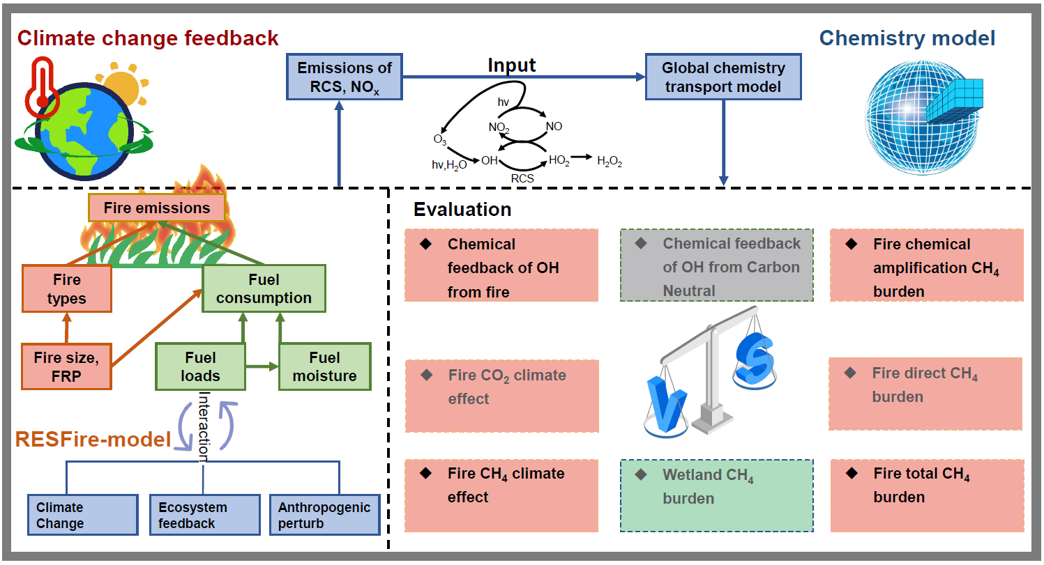
Supplementary Fig.6 | Schematic flowchart of this study. First, fire RCS and NO_{X} emissions for the 2000s and the 2050s are obtained from the RESFire model driven by the CESM climate simulation under RCP4.5. Then, fire emissions are applied to the GEOS-Chem atmospheric chemical transport model. Finally, the impacts of fire emissions on global OH concentrations, the atmospheric methane burden, and radiative forcing are evaluated and compared to the effects of other mechanisms reported in the literature⁸⁻¹².
Supplementary Table 1. Sensitivity of global mean OH to the emissions of CO, VOC and NO_{x}.
Model/Project | ΔOH /ΔE_{CO}ª | ΔOH/ΔE_{VOC}^{b} | ΔOH/ΔE_{NOx}^{c}
GEOS-Chem | -0.033 | -0.046 | 0.528
HTAP^{d} | -0.032 | -0.018 | 0.438
OxComp^{e} | -0.065 | -0.048 | 0.326

ª Simulated percentage changes of global mean OH concentrations in response to changes in CO emissions (%/Tg C).
^{b} Simulated percentage changes of global mean OH concentrations in response to changes in reactive non-methane VOC emissions (%/Tg C).
^{c} Simulated percentage changes of global mean OH concentrations in response to changes in NO_{x} emissions (%/Tg N).
^{d} Ensemble averages of the Hemispheric Transport of Air Pollution (HTAP) multi-model intercomparison project, which includes 4 atmospheric chemical transport models, FRSGCUCI-v01, GISS-PUCCINI-modelE, MOZARTGFDL-v2, and TM5-JRC-cy2-ipcc-v1^{13,14}.
^{e} Ensemble averages of the tropospheric oxidant model comparison (OxComp) project, which includes 9 atmospheric chemical transport models, IASB, KNMI, MOZ1, MOZ2, MPIC, UCI, UIO, UKMQ, and ULAQ^{15,16}.
Supplementary Table 2. Decadal average fire emissions and the standard deviations of interannual variability simulated by the CESM-RESFire model^{8,9}.
Species | 2000s (Tg a⁻¹) | 2050s (Tg a⁻¹)
CO | $$\text{327.85 ±} \text{16.41}$$ | $$\text{675.82} \text{±} \text{63.72}$$
NO_{x} | $$\text{12.27} \text{±} \text{0.57}$$ | $$\text{20.63} \text{±} \text{1.20}$$
CH₃CHO | $$\text{3.92} \text{±} \text{0.23}$$ | $$\text{8.99} \text{±} \text{1.00}$$
C₂H₅OH | $$\text{0.148} \text{±} \text{0.006}$$ | $$\text{0.26} \text{±} \text{0.02}$$
C₂H₆ | $$\text{2.98} \text{±} \text{0.13}$$ | $$\text{5.20} \text{±} \text{0.34}$$
(CH₃)₂S | $$\text{0.041} \text{±} \text{0.002}$$ | $$\text{0.053} \text{±} \text{0.002}$$
C₃H₆ | $$\text{3.00} \text{±} \text{0.15}$$ | $$\text{6.26} \text{±} \text{0.71}$$
CH₃C(O)CH₃ | $$\text{1.61} \text{±} \text{0.09}$$ | $$\text{3.69} \text{±} \text{0.40}$$
C₃H₈ | $$\text{0.60} \text{±} \text{0.02}$$ | $$\text{1.03} \text{±} \text{0.07}$$
C₅H₈ | $$\text{0.46} \text{±} \text{0.03}$$ | $$\text{1.39} \text{±} \text{0.30}$$
C₆H₆ | $$\text{1.26} \text{±} \text{0.07}$$ | $$\text{3.02} \text{±} \text{0.39}$$
C₇H₈ | $$\text{0.78} \text{±} \text{0.06}$$ | $$\text{2.80} \text{±} \text{0.70}$$
C₈H₁₀ | $$\text{0.28} \text{±} \text{0.01}$$ | $$\text{0.56} \text{±} \text{0.05}$$
CH₂O | $$\text{5.34} \text{±} \text{0.26}$$ | $$\text{10.64} \text{±} \text{0.91}$$
CH₃OH | $$\text{7.65} \text{±} \text{0.40}$$ | $$\text{16.66} \text{±} \text{1.78}$$
HCOOH | $$\text{1.94} \text{±} \text{0.11}$$ | $$\text{4.08} \text{±} \text{0.39}$$
RC(O)Rª | $$\text{8.02} \text{±} \text{0.37}$$ | $$\text{14.72} \text{±} \text{1.21}$$
ALK4^{b} | $$\text{5.20} \text{±} \text{0.24 }$$ | $$\text{9.38} \text{±} \text{0.72}$$
CH₄ | $$\text{14.60} \text{±} \text{0.81}$$ | $$\text{33.33} \text{±} \text{3.82}$$
CO₂ | $$\text{6597.68} \text{±} \text{312.67 }$$ | $$\text{12056.08} \text{±} \text{850.28}$$
ª Ketones (excluding acetone)
^{b} Alkanes with at least 4 carbons
Supplementary Table 3. Summary of future regional and global fire predictions.
Geographic domain | Fire activity indicator | Projected change of fire activity | Reference
Global | Fire weather | Global fire-prone conditions are projected to increase significantly, with longer fire seasons and higher frequency of extreme fire-weather events under various climate scenarios. | Refs.¹⁷⁻²²
Global | Fire emissions | Fire emissions are projected to increase significantly across scenarios and timescales. | Refs.²³⁻²⁵
Boreal forest | Fire weather | By the 2050s, rising temperatures and increased moisture deficits are expected to enhance fire activity and carbon emissions, with seasonal severity ratings increasing significantly. | Refs.^{26,27}
Boreal forest | Fire emissions | Fire emissions in boreal forests are projected to increase two- to six-fold under future climate scenario. | Refs.²⁸⁻³¹
Boreal forest | Fire conditions | Fire conditions are projected to worsen significantly under future scenarios, with increased fire severity and greater contributions to fire-related emissions. | Refs.³²⁻²⁴
Arctic-Subarcstic | Burned area | The burned area in 2085 is approximately 2.6 times greater than that observed in 2020. | Ref.³⁵
Amazon forest | Fire conditions | By 2071–2100, fire activity is projected to increase under the optimistic RCP 4.5 scenario the pessimistic RCP 8.5 scenario | Ref.³⁶
Amazon forest | Burned area | HESFIRE simulations project an 850% rise in annual burned area by 2080–2100 under RCP 8.5, while RCP 4.5 limits it to 165%. | Ref.³⁷
Indonesian forest | Fire risk | Fire risk is projected to increase significantly under future scenarios, driven by hydrological droughts and extreme events. | Ref.^{38,39}
Indonesian forest | Burned area | Hydrological droughts expand wildfire burn areas, and with increasing extreme El Niño events predicted, longer dry seasons may further intensify and extend burn areas in the future. | Ref.⁴⁰
Supplementary Table 4. Emission factors used in the RESFire modelª.
Species^{b} | SAVA | BORF | TEMF | DEFO | PEAT | AGRI
DM  CO | $$\text{1000}$$  $$\text{63}$$ | $$\text{1000}$$  $$\text{127}$$ | $$\text{1000}$$  $$\text{88}$$ | $$\text{1000}$$  $$\text{93}$$ | $$\text{1000}$$  $$\text{210}$$ | $$\text{1000}$$  $$\text{102}$$
NO_{x} | $$\text{3.9}$$ | $$\text{0.9}$$ | $$\text{1.92}$$ | $$\text{2.55}$$ | $$\text{1}$$ | $$\text{3.11}$$
CH₃CHO | $$\text{0.57}$$ | $$\text{0.77}$$ | $$\text{0.77}$$ | $$\text{1.55}$$ | $$\text{3.27}$$ | $$\text{1.24}$$
C₂H₅OH | $$\text{0.024}$$ | $$\text{0.055}$$ | $$\text{0.1}$$ | $$\text{0.037}$$ | $$\text{0.037}$$ | $$\text{0.035}$$
C₂H₆ | $$\text{0.66}$$ | $$\text{1.79}$$ | $$\text{0.63}$$ | $$\text{0.71}$$ | $$\text{0.71}$$ | $$\text{0.91}$$
(CH₃)₂S | $$\text{0.0013}$$ | $$\text{0.00465}$$ | $$\text{0.008}$$ | $$\text{0.00135}$$ | $$\text{0.00135}$$ | $$\text{0.0013}$$
C₃H₆ | $$\text{0.79}$$ | $$\text{1.13}$$ | $$\text{0.61}$$ | $$\text{0.64}$$ | $$\text{3.05}$$ | $$\text{0.68}$$
CH₃C(O)CH₃ | $$\text{0.16}$$ | $$\text{0.75}$$ | $$\text{0.54}$$ | $$\text{0.63}$$ | $$\text{1.25}$$ | $$\text{0.45}$$
C₃H₈ | $$\text{0.1}$$ | $$\text{0.44}$$ | $$\text{0.22}$$ | $$\text{0.126}$$ | $$\text{0.126}$$ | $$\text{0.28}$$
C₅H₈ | $$\text{0.039}$$ | $$\text{0.15}$$ | $$\text{0.099}$$ | $$\text{0.13}$$ | $$\text{1.38}$$ | $$\text{0.38}$$
C₆H₆ | $$\text{0.2}$$ | $$\text{1.11}$$ | $$\text{0.27}$$ | $$\text{0.39}$$ | $$\text{3.19}$$ | $$\text{0.15}$$
C₇H₈ | $$\text{0.08}$$ | $$\text{0.48}$$ | $$\text{0.19}$$ | $$\text{0.26}$$ | $$\text{1.55}$$ | $$\text{0.19}$$
C₈H₁₀ | $$\text{0.014}$$ | $$\text{0.18}$$ | $$\text{0.13}$$ | $$\text{0.11}$$ | $$\text{0.11}$$ | $$\text{0.114}$$
CH₂O | $$\text{0.73}$$ | $$\text{1.86}$$ | $$\text{2.09}$$ | $$\text{1.73}$$ | $$\text{1.4}$$ | $$\text{2.08}$$
CH₃OH | $$\text{1.18}$$ | $$\text{2.82}$$ | $$\text{1.74}$$ | $$\text{2.43}$$ | $$\text{8.46}$$ | $$\text{3.29}$$
HCOOH | $$\text{0.21}$$ | $$\text{0.57}$$ | $$\text{0.28}$$ | $$\text{0.79}$$ | $$\text{0.38}$$ | $$\text{1}$$
CH₄ | $$\text{1.94}$$ | $$\text{5.96}$$ | $$\text{3.36}$$ | $$\text{5.07}$$ | $$\text{20.8}$$ | $$\text{5.82}$$
CO₂ | $$\text{1686}$$ | $$\text{1489}$$ | $$\text{1647}$$ | $$\text{1643}$$ | $$\text{1703}$$ | $$\text{1585}$$
ª SAVA represents savanna, grassland, and shrubland fires. BORF represents boreal forest fires. TEMF represents temperate forest fires. DEFO represents deforestation fires. PEAT represents peat fires. AGRI represents agricultural waste burning.
^{b} Units are expressed as grams of species per kilogram dry matter (DM) burned. NO_{x} emissions are represented as NO emissions. Data sources include refs.^{3,41}.

Reference
1 Andela, N. et al. A human-driven decline in global burned area. Science 356, 1356-1362 (2017).
2 Zheng, B. et al. Increasing forest fire emissions despite the decline in global burned area. Sci. Adv. 7, eabh2646 (2021).
3 van der Werf, G. R. et al. Global fire emissions estimates during 1997–2016. Earth Syst. Sci. Data 9, 697-720 (2017).
4 Jones, M. W. et al. Global rise in forest fire emissions linked to climate change in the extratropics. Science 386, eadl5889 (2024).
5 Duncan, B. et al. Indonesian wildfires of 1997: Impact on tropospheric chemistry. J. Geophys. Res.: Atmos. 108 (2003).
6 Prinn, R. et al. Evidence for variability of atmospheric hydroxyl radicals over the past quarter century. Geophys. Res. Lett. 32 (2005).
7 Worden, J. et al. El Niño, the 2006 Indonesian peat fires, and the distribution of atmospheric methane. Geophys. Res. Lett. 40, 4938-4943 (2013).
8 Zou, Y. et al. Development of a REgion‐specific ecosystem feedback fire (RESFire) model in the Community Earth System Model. J. Adv. Model. Earth Syst. 11, 417-445 (2019).
9 Zou, Y. et al. Using CESM-RESFire to understand climate–fire–ecosystem interactions and the implications for decadal climate variability. Atmos. Chem. Phys. 20, 995-1020 (2020).
10 Zhang, Z. et al. Emerging role of wetland methane emissions in driving 21st century climate change. Proceedings of the National Academy of Sciences 114, 9647-9652 (2017).
11 Zhang, Z. et al. Recent intensification of wetland methane feedback. Nat. Clim. Change 13, 430-433 (2023).
12 Liu, M. et al. Enhanced atmospheric oxidation toward carbon neutrality reduces methane’s climate forcing. Nat. Commun. 15, 3148 (2024).
13 Fry, M. M. et al. The influence of ozone precursor emissions from four world regions on tropospheric composition and radiative climate forcing. J. Geophys. Res.: Atmos. 117 (2012).
14 Stevenson, D. S., Derwent, R. G., Wild, O. & Collins, W. J. COVID-19 lockdown emission reductions have the potential to explain over half of the coincident increase in global atmospheric methane. Atmos. Chem. Phys. 22, 14243-14252 (2022).
15 IPCC. Climate Change 2001: The Scientific Basis (eds Houghton, J. T. et al.) (Cambridge Univ. Press 2001).
16 Gong, C. et al. Global net climate effects of anthropogenic reactive nitrogen. Nature, 1-7 (2024).
17 Senande-Rivera, M., Insua-Costa, D. & Miguez-Macho, G. Spatial and temporal expansion of global wildland fire activity in response to climate change. Nat. Commun. 13, 1208 (2022).
18 Abatzoglou, J. T., Williams, A. P. & Barbero, R. Global emergence of anthropogenic climate change in fire weather indices. Geophys. Res. Lett. 46, 326-336 (2019).
19 Flannigan, M. et al. Global wildland fire season severity in the 21st century. For. Ecol. Manage. 294, 54-61 (2013).
20 Bowman, D. M. et al. Human exposure and sensitivity to globally extreme wildfire events. Nat. Ecol. Evol. 1, 0058 (2017).
21 Bowman, D. M. et al. Vegetation fires in the Anthropocene. Nature Reviews Earth & Environment 1, 500-515 (2020).
22 Jones, M. W. et al. Global and regional trends and drivers of fire under climate change. Rev. Geophys. 60, e2020RG000726 (2022).
23 Hamilton, D. et al. Global Warming Increases Fire Emissions but Resulting Aerosol Forcing is Uncertain. (2024).
24 Kloster, S., Mahowald, N., Randerson, J. & Lawrence, P. The impacts of climate, land use, and demography on fires during the 21st century simulated by CLM-CN. Biogeosciences 9, 509-525 (2012).
25 Kim, H.-J. et al. Pervasive fire danger continued under a negative emission scenario. Nat. Commun. 15, 10010 (2024).
26 Byrne, B. et al. Carbon emissions from the 2023 Canadian wildfires. Nature, 1-5 (2024).
27 Flannigan, M. D., Stocks, B. J. & Wotton, B. M. Climate change and forest fires. Sci. Total Environ. 262, 221-229 (2000).
28 Allen, R. J., Samset, B. H., Wilcox, L. J. & Fisher, R. A. Are Northern Hemisphere boreal forest fires more sensitive to future aerosol mitigation than to greenhouse gas–driven warming? Sci. Adv. 10, eadl4007 (2024).
29 Zhong, Q., Schutgens, N., Veraverbeke, S. & van der Werf, G. R. Increasing aerosol emissions from boreal biomass burning exacerbate Arctic warming. Nat. Clim. Change, 1-7 (2024).
30 Dong, X. et al. Historical simulation and future projection of Arctic‐boreal fire carbon emissions and related surface climate by 17 CMIP6 ESMs. J. Geophys. Res.: Atmos. 129, e2024JD041806 (2024).
31 Blanchard-Wrigglesworth, E., DeRepentigny, P. & Frierson, D. Increasing boreal fires reduce future global warming and sea ice loss. (2024).
32 Amiro, B., Cantin, A., Flannigan, M. & De Groot, W. Future emissions from Canadian boreal forest fires. Can. J. For. Res. 39, 383-395 (2009).
33 de Groot, W. J., Flannigan, M. D. & Cantin, A. S. Climate change impacts on future boreal fire regimes. For. Ecol. Manage. 294, 35-44 (2013).
34 Huang, X. et al. Escalating wildfires in Siberia driven by climate feedbacks under a warming Arctic in the 21st century. AGU Adv. 5, e2023AV001151 (2024).
35 Kim, I.-W. et al. Abrupt increase in Arctic-Subarctic wildfires caused by future permafrost thaw. Nat. Commun. 15, 7868 (2024).
36 Fonseca, M. G. et al. Effects of climate and land‐use change scenarios on fire probability during the 21st century in the Brazilian Amazon. Global Change Biol. 25, 2931-2946 (2019).
37 Le Page, Y. et al. Synergy between land use and climate change increases future fire risk in Amazon forests. Earth Syst. Dyn. 8, 1237-1246 (2017).
38 Rendana, M. et al. Current and future land fire risk mapping in the southern region of Sumatra, Indonesia, using CMIP6 data and GIS analysis. SN Appl. Sci. 5, 210 (2023).
39 Davies-Barnard, T., Catto, J. L., Harper, A. B., Imron, M. A. & van Veen, F. F. Future fire risk under climate change and deforestation scenarios in tropical Borneo. Environ. Res. Lett. 18, 024015 (2023).
40 Taufik, M. et al. Amplification of wildfire area burnt by hydrological drought in the humid tropics. Nat. Clim. Change 7, 428-431 (2017).
41 Akagi, S. et al. Emission factors for open and domestic biomass burning for use in atmospheric models. Atmos. Chem. Phys. 11, 4039-4072 (2011).

