Supplementary information

Near-Infrared Long Lifetime Upconversion Nanoparticles for Ultrasensitive microRNA Detection via Time-Gated Luminescence Resonance Energy Transfer
Suyeon Kim^{1,2,9}, Yeonkyung Park^{3,9}, Jiwoo Han^{1,2}, Hansol Kim³, Hyowon Jang³, Min-Young Lee⁴, Byeong-Ho Jeong⁵, Yuree Byun⁶, Eun-Kyung Lim^{3,7,8}, Juyeon Jung^{3,7,8}, Taejoon Kang^{3,7,}*, Joonseok Lee^{1,2,}*

¹Department of Chemistry, Hanyang University, Seoul 04763, Republic of Korea
²Research Institute for Convergence of Basic Sciences, Hanyang University, Seoul 04763, Republic of Korea
³Bionanotechnology Research Center, Korea Research Institute of Bioscience and Biotechnology (KRIBB), Daejeon 34141, Republic of Korea
⁴Department of Nano-Bio Convergence, Surface Materials Division, Korea Institute of Materials Science (KIMS), Changwon, Gyeongsangnam-do 51508, Republic of Korea
⁵Division of Pulmonary and Critical Care Medicine, Department of Medicine, Samsung Medical Center, Sungkyunkwan University (SKKU) School of Medicine, Seoul 06351, Republic of Korea
⁶Smart Healthcare Research Institute, Research Institute for Future Medicine, Samsung Medical Center, Seoul 06351, Republic of Korea
⁷School of Pharmacy, SKKU, Suwon, Gyeonggi-do 16419, Republic of Korea
⁸Department of Nanobiotechnology, KRIBB School of Biotechnology, University of Science and Technology (UST), Daejeon 34113, Republic of Korea
⁹These authors contributed equally: Suyeon Kim, Yeonkyung Park

*e-mail: joonseoklee@hanyang.ac.kr; kangtaejoon@kribb.re.kr
Supplementary Note 1
Immobilization of pDNAs on LRET donors
We conjugated the LRET donors with the pDNAs complementary to their respective target miRNAs through a series of surface modifications: amine-modification, maleimide-modification, and DNA-conjugation (Supplementary Fig. 8a). Water-soluble amine-modified donors (amine-donors) were prepared via a surface ligand exchange of the as-synthesized UCNPs, capped with hydrophobic oleic acid ligands. The amine ligands were then replaced with maleimide ligands, which enabled subsequent conjugation to thiolated pDNAs via thiol-maleimide reaction. The DNA-modified donors (DNA-donors) were characterized by FT-IR analysis, zeta potential measurements, and ultraviolet-visible (UV-vis) absorbance analysis. The FT-IR peaks corresponding to each ligand exchange step, from the oleic acid-capped donors to DNA-donors, confirmed the successful conjugation of pDNAs onto the donors (Supplementary Fig. 8b). Two new peaks at 1078 cm⁻¹ (for PO₂⁻ groups) and 1682 cm⁻¹ (for C=O groups) appeared, which are indicative of pDNA immobilization ¹. The zeta potential of donors shifted from +33.9 mV to -38.3 mV after maleimide modification, then to -31.3 mV after DNA conjugation (Supplementary Fig. 8c). Additionally, the DNA-donors exhibited an absorption peak at 260 nm (Supplementary Fig. 8d), consistent with DNA absorption.
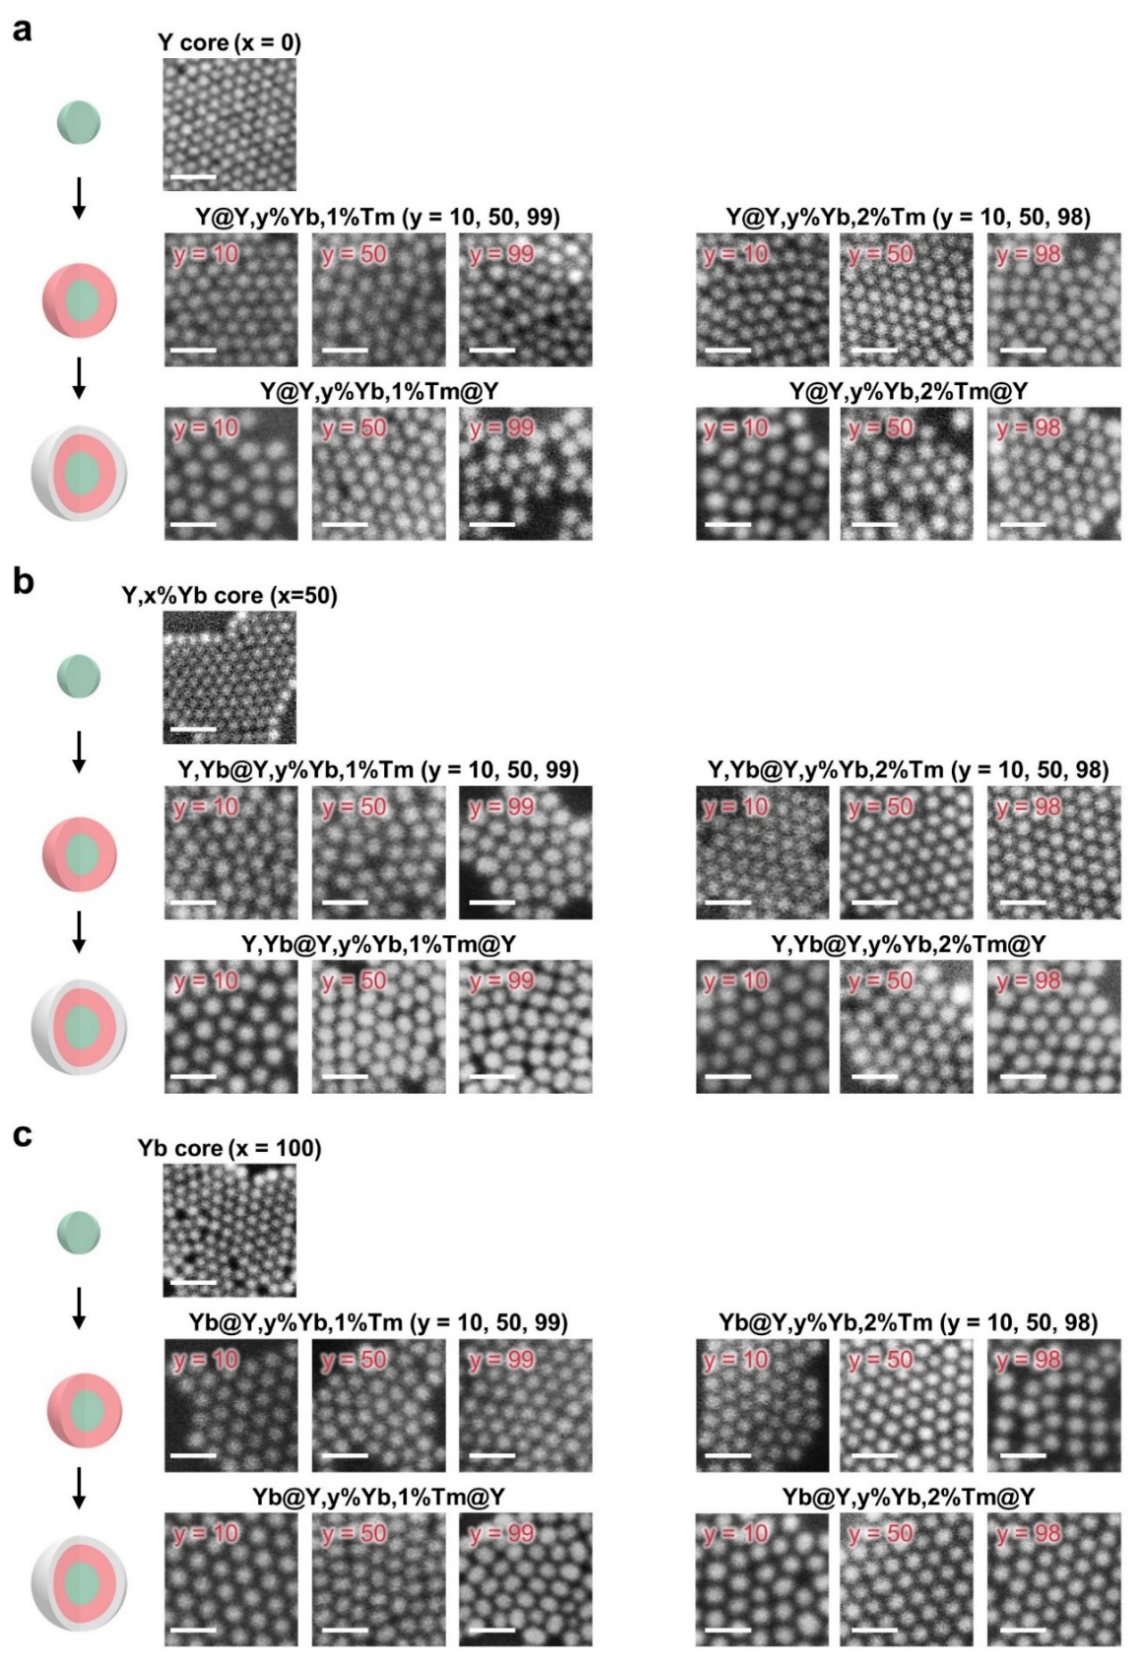
Supplementary Fig. 1. SEM images of synthesized UCNPs. a-c Series of core/shell/shell UCNPs with different Yb³⁺ doping ratio (x in EM core and y in ETU shell) and Tm³⁺ doping ratio (z in shell). UCNPs have identical core size and similar thickness of each shell. Scale bar: 50 nm.
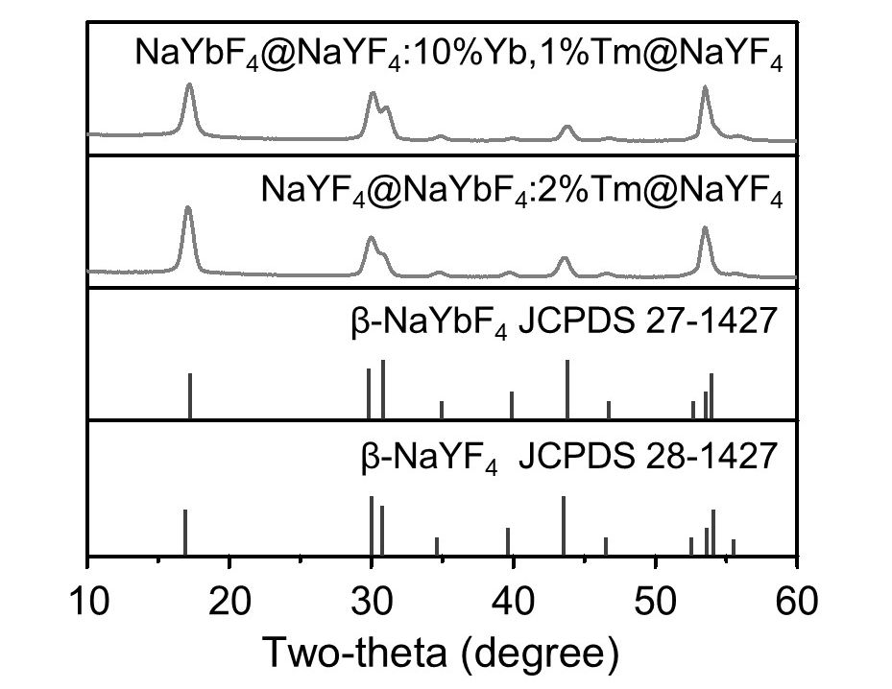
Supplementary Fig. 2. XRD analysis of NaYbF₄@NaYF₄:10%Yb,1%Tm@NaYF₄ and NaYF₄@NaYbF₄:2%Tm@NaYF₄ NPs. The typical XRD patterns of hexagonal phases of NaYbF₄ (#27-1427) and NaYF₄ (#28-1427) are included at the bottom for reference.
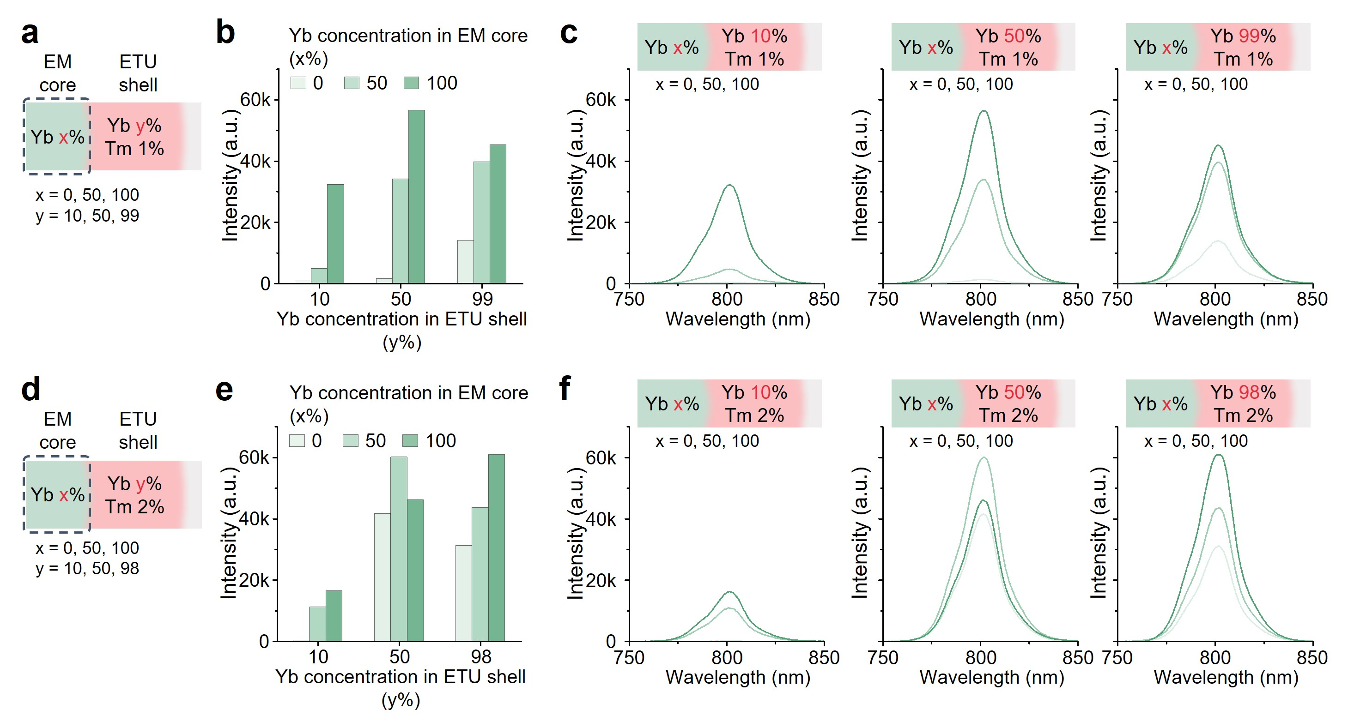
Supplementary Fig. 3. NIR luminescence intensity at 800 nm using series of UCNP samples with different x and y. a Structure illustration of NaYF₄:x%Yb@NaYF₄:y%Yb,1%Tm@NaYF₄ (x = 0, 50, 100; y = 10, 50, 99). b,c (b) Luminescence intensity values at 800 nm, and (c) luminescence spectra of UCNP samples with different sensitizer distribution in the EM core. d Structure illustration of NaYF₄:x%Yb@NaYF₄:y%Yb,2%Tm@NaYF₄ (x = 0, 50, 100; y = 10, 50, 98). e,f (e) Luminescence intensity values at 800 nm, and (f) luminescence spectra of UCNP samples with different sensitizer distribution in the EM core.
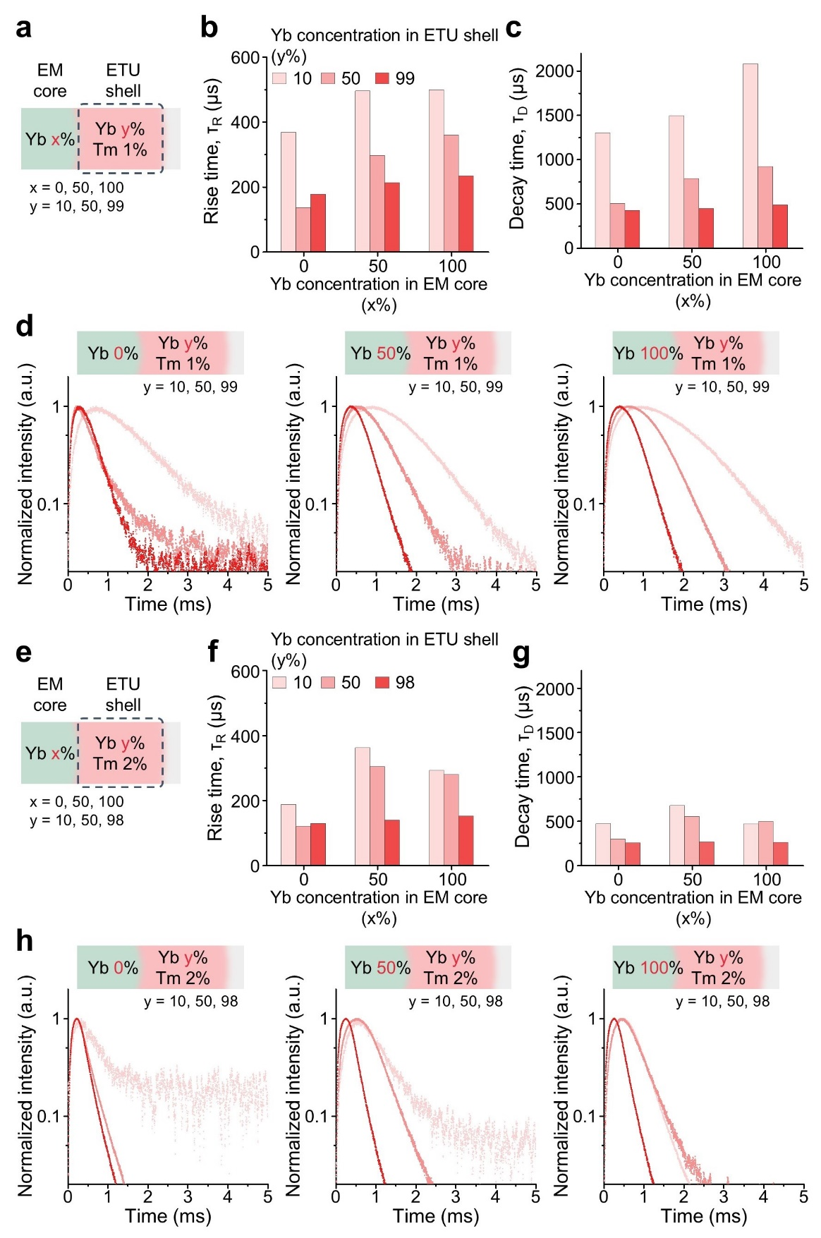
Supplementary Fig. 4. NIR luminescence lifetime at 800 nm of UCNP samples with different x and y. a Structure illustration of NaYF₄:x%Yb@NaYF₄:y%Yb,1%Tm@NaYF₄ (x = 0, 50, 100; y = 10, 50, 99). b-d (b) Luminescence rise and (c) decay time value at 800 nm, and (d) luminescence decay profiles of UCNP samples with different sensitizer distribution in hell. e Structure illustration of NaYF₄:x%Yb@NaYF₄:y%Yb,2%Tm@NaYF₄ (x = 0, 50, 100; y = 10, 50, 98). f-h (f) Luminescence rise and (g) decay time value at 800 nm, and (h) luminescence decay profiles of UCNP samples with different sensitizer distribution in shell.
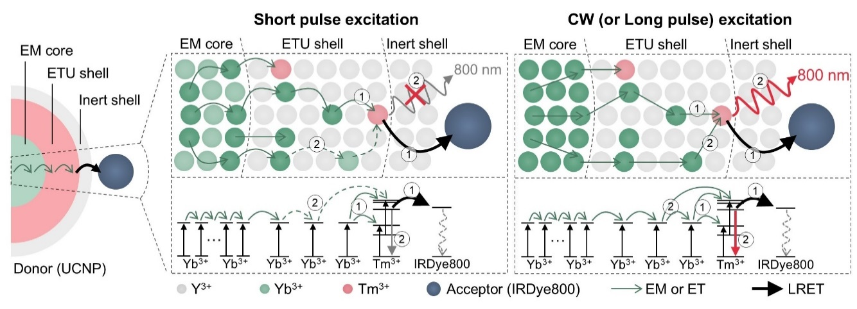
Supplementary Fig. 5. Schematic diagram of energy transfer of L-donor with IRDye800 on the surface, under short pulse and CW excitation.
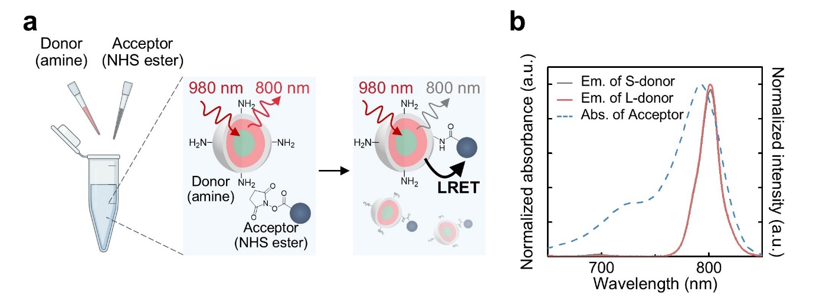
Supplementary Fig. 6. Emission and absorbance properties of LRET donor and acceptor. a Schematic representation of LRET between donor (UCNP) and acceptor (IRDye800). b Absorbance spectra of acceptor and emission spectra of S-donor and L-donor (under 980 nm excitation).
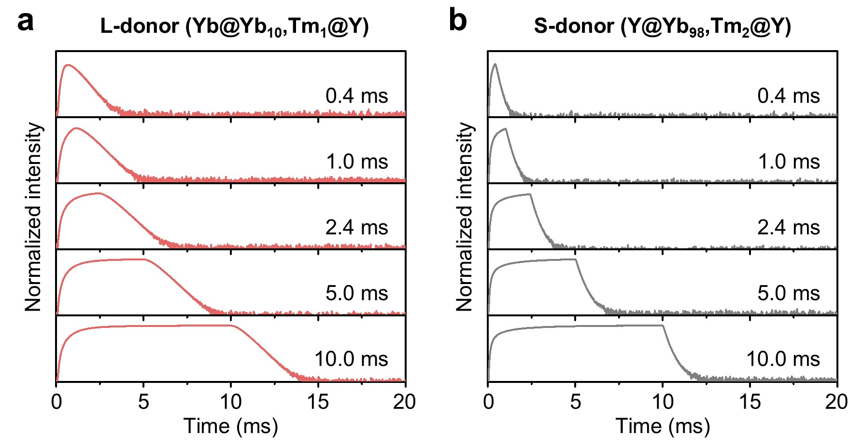
Supplementary Fig. 7. NIR luminescence decay profiles of LRET donor. Luminescence decay of Tm³⁺ at 800 nm as a function of excitation pulse width at a fixed frequency (50 Hz) for (a) L-donor and (b) S-donor.
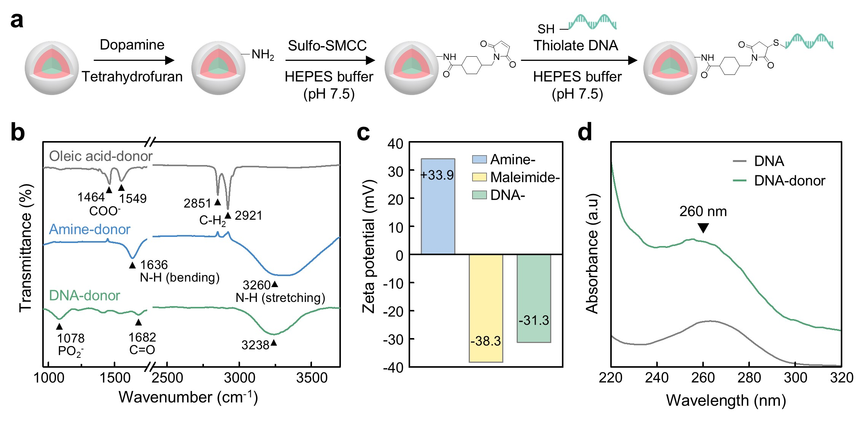
Supplementary Fig. 8. Surface modification of the LRET donor. a Schematic illustration of conjugation path of LRET donor to pDNA. b FT-IR spectra of oleic acid capped, amine-modified, and pDNA-modified donor. c Zeta potentials of amine-modified, maleimide-modified, and pDNA-modified donor. d UV-vis spectra of pDNA and pDNA-donor. The observed peak of 260 nm indicates the immobilization of pDNA.
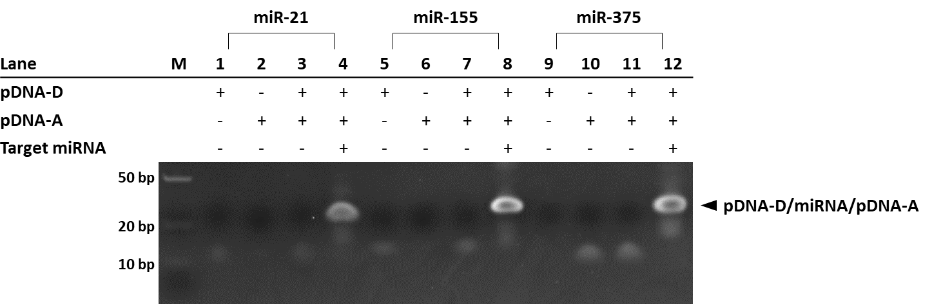
Supplementary Fig. 9. PAGE image of the products after hybridization between pDNA-D, pDNA-A, and target miRNA. The final concentrations of pDNA-D, pDNA-A, and target miRNA are 10 µM and the reaction time is 10 min.
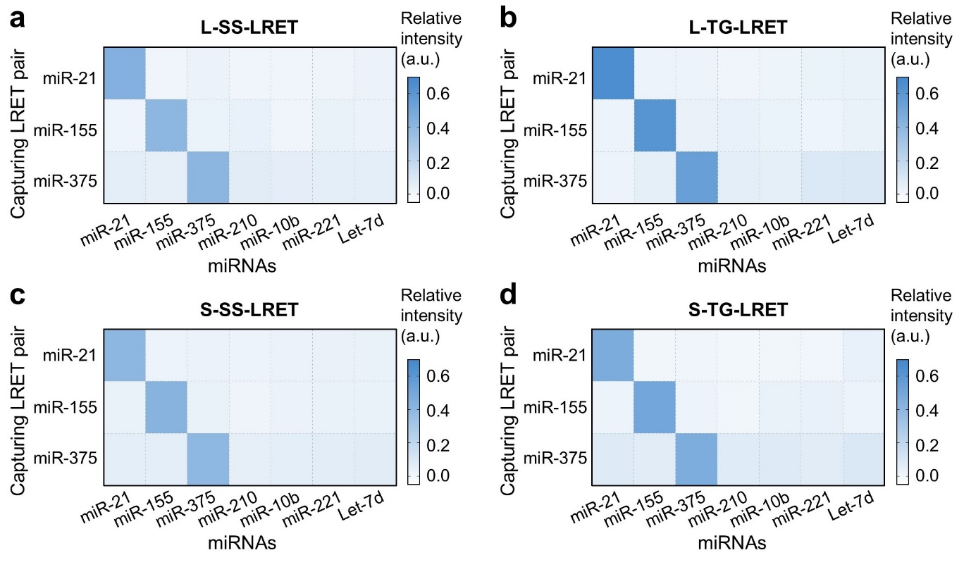
Supplementary Fig. 10. Specificity of the LRET systems. a, b Specificity of LRET assay using L-donor under (a) steady-state, and (d) time-gated detection conditions. c, d Specificity of LRET assay using S-donor under (c) steady state, and (d) time-gated detection conditions. L(S)-SS-LRET indicates conventional steady-state detection using L(S)-donor under 980 nm CW excitation and L(S)-TG-LRET indicates time-gated detection using L(S)-donor under 980 nm pulse excitation.
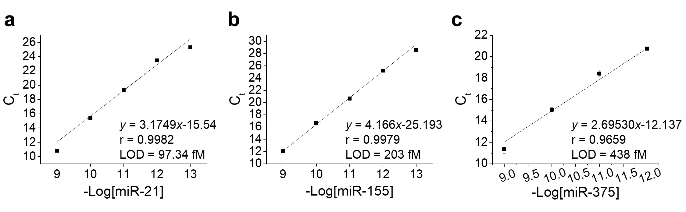
Supplementary Fig. 11. Calibration curves for PCR. a-c C_{t} (threshold cycle) as a function of -Log concentration of (a) miR-21, (b) miR-155, and (c) miR-375. All reported values represent the mean ± SD, n =3 independent experiments.
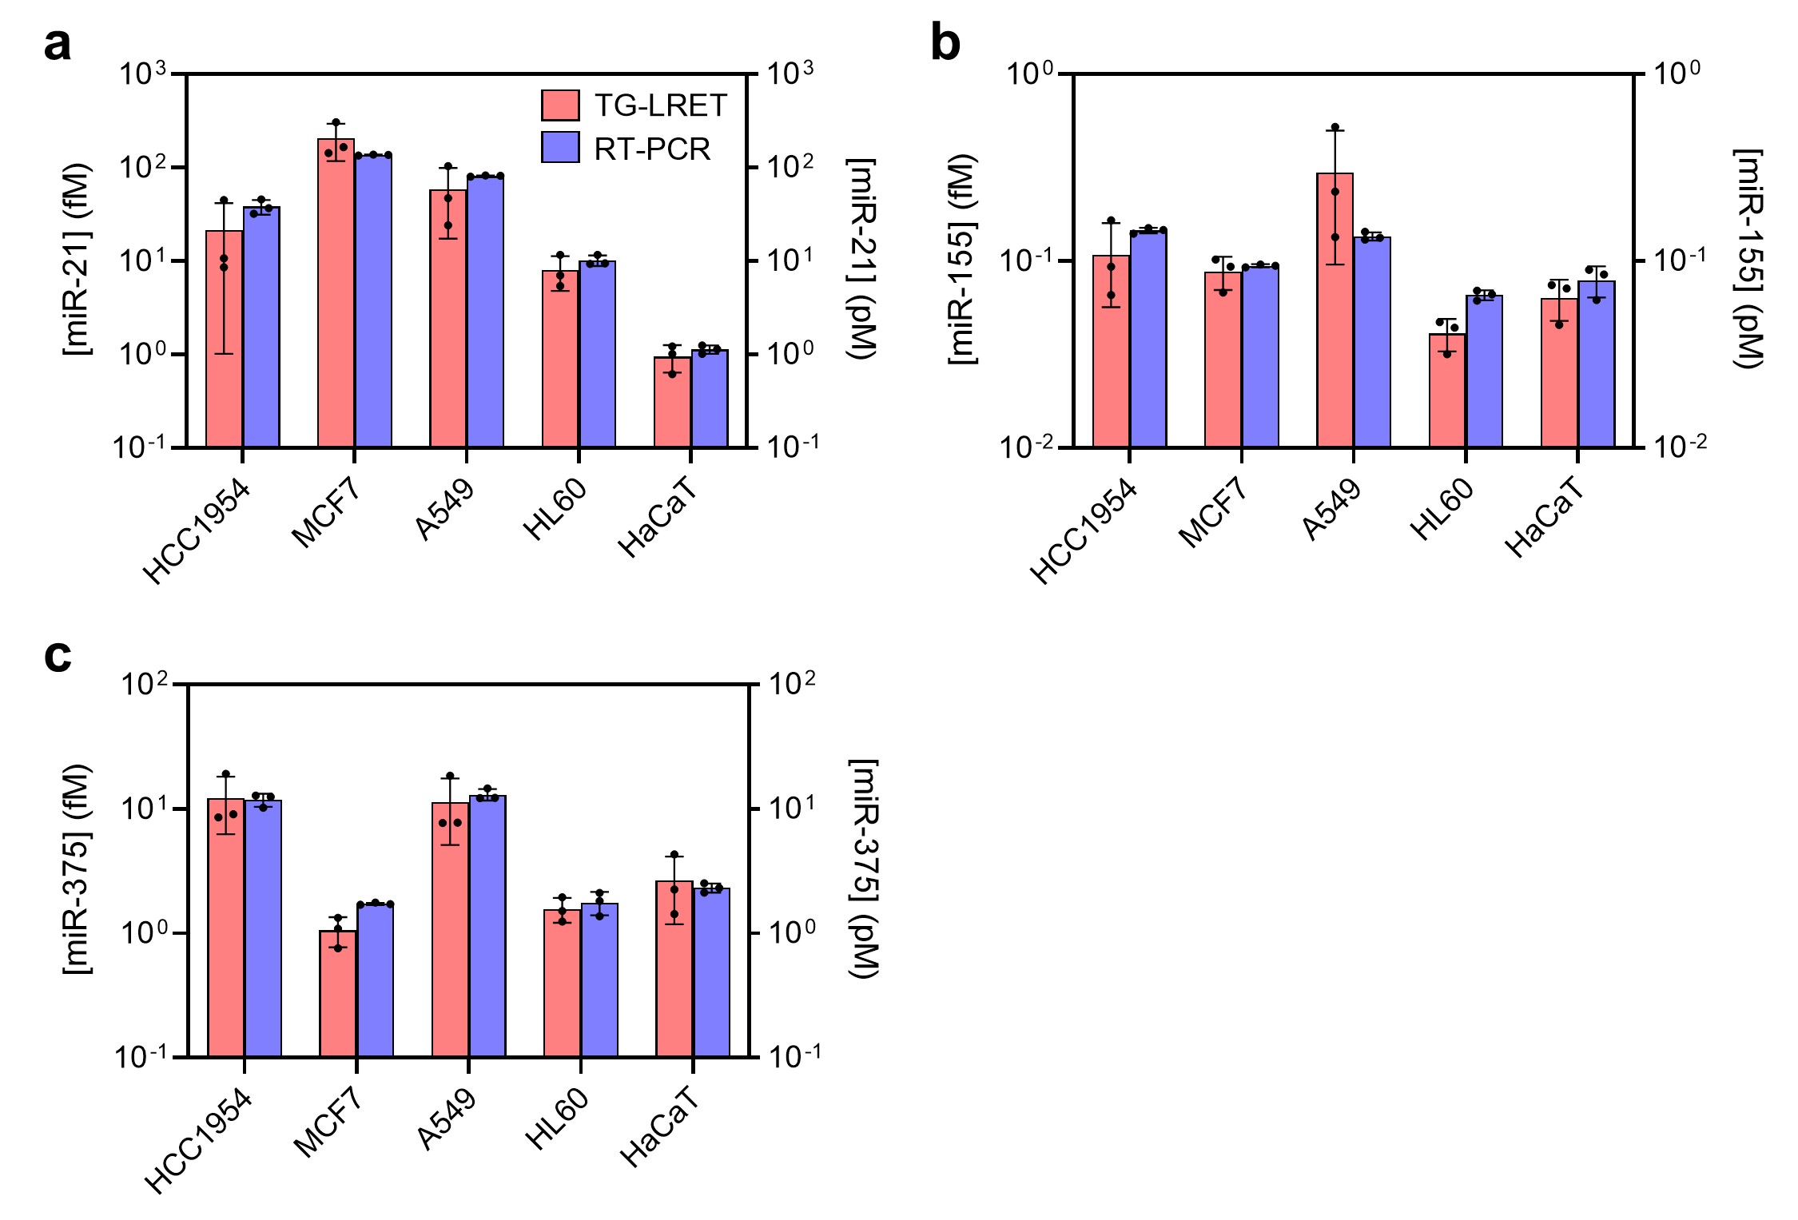
Supplementary Fig. 12. Detection of miRNA in cancer cell lines. a-c Detection of (a) miR-21, (b) miR-155, and (c) miR-375 in cell lines (HCC1954, MCF7, A549, HL60, and HaCaT) obtained by L-TG-LRET and PCR. The left-side y-axis denotes the scale for the concentration of miRNA obtained by L-TG-LRET and the right-side y-axis denotes the scale for the concentration of miRNA obtained by PCR. Concentrations of miRNAs were calculated from the calibration curves in Fig. 4 and Supplementary Fig. 11.
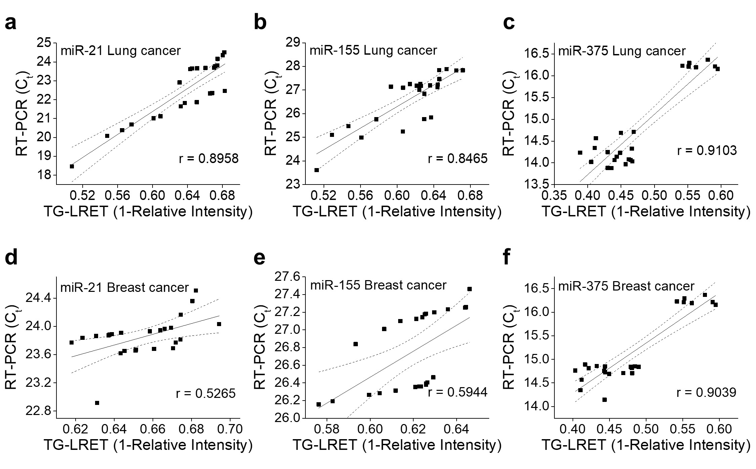
Supplementary Fig. 13. Correlation between L-TG-LRET and PCR results for the detection of miRNA. a-f Correlation between L-TG-LRET and PCR for (a) miR-21, (b) miR-155, and (c) miR-375 in the plasma of lung cancer patients and of (d) miR-21, (e) miR-155, and (f) miR-375 in the plasma of breast cancer patients. Data points represent the mean of three replicates of each measurement for each method. Linear fitting of data points was performed to generate linear correlation curves. Dashed lines represent 95% confidence bands of the best fit line.
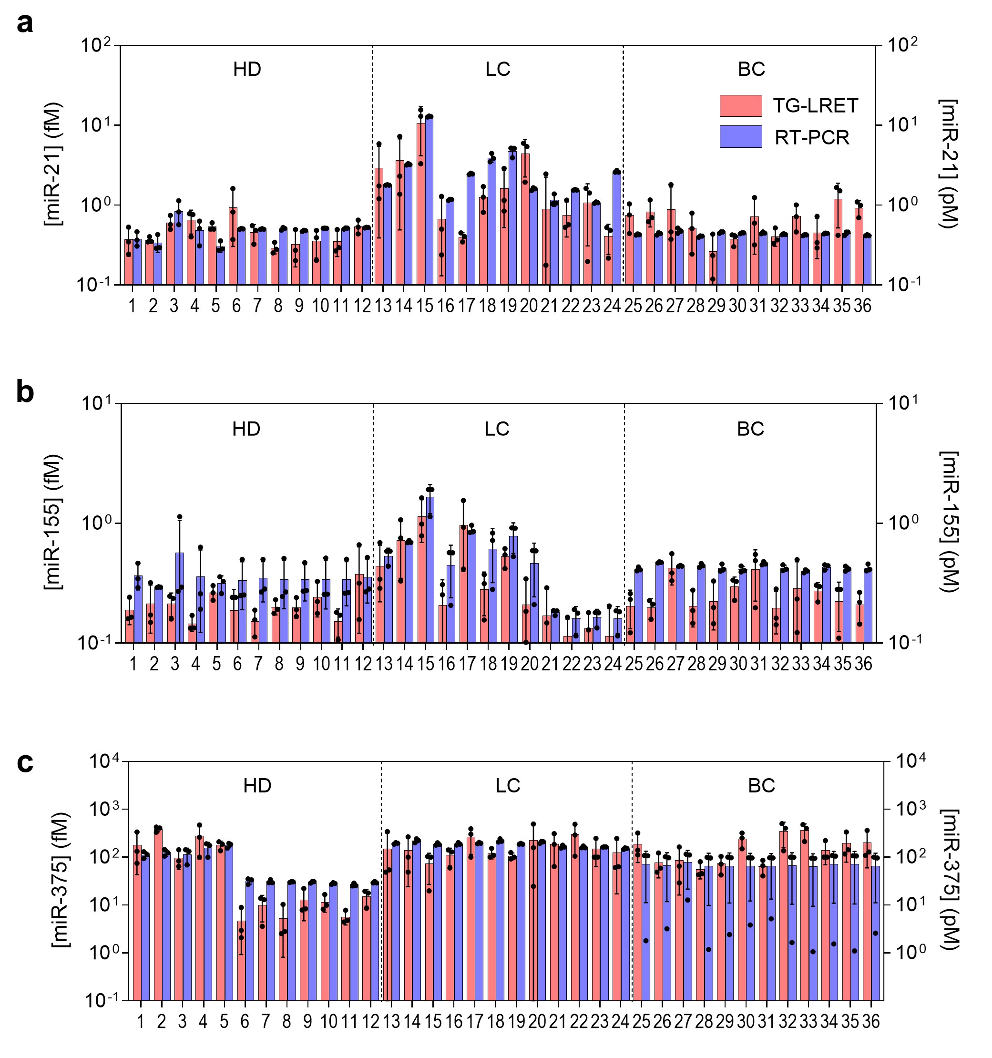
Supplementary Fig. 14. Detection of miRNA in plasma samples. a-c Detection of (a) miR-21, (b) miR-155, and (c) miR-375 in plasma samples from healthy donors (n = 12), lung cancer patients (n = 12), and breast cancer patients (n = 12) obtained by PCR and L-TG-LRET. The left-side y-axis denotes the scale for the concentration of miRNA obtained by L-TG-LRET and the right-side y-axis denotes the scale for the concentration of miRNA obtained by PCR. Concentrations of miRNAs were calculated from the calibration curves in Fig. 4 and Supplementary Fig. 11.
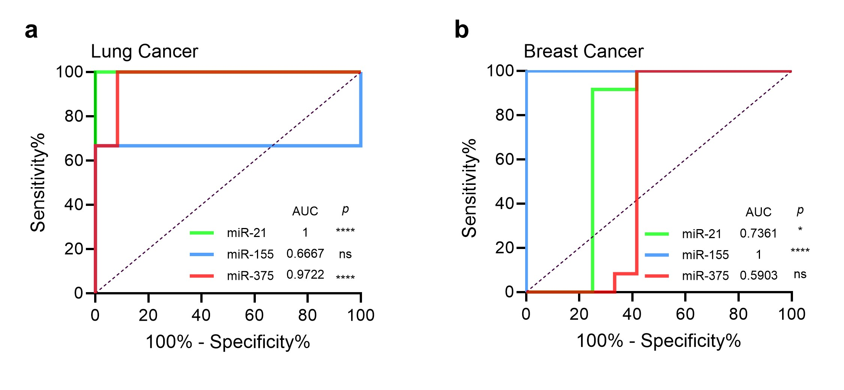
Supplementary Fig. 15. ROC curves obtained by PCR. a, b ROC curves for differentiation of (a) lung cancer patients from healthy donors and (b) breast cancer patients from healthy donors by PCR detection of miR-21 (p ≤ 0.0001 and p ≤ 0.05), miR-155 (p > 0.05 and p ≤ 0.0001), and miR-375 (p ≤ 0.0001 and p > 0.05). The AUC is annotated in the graph.
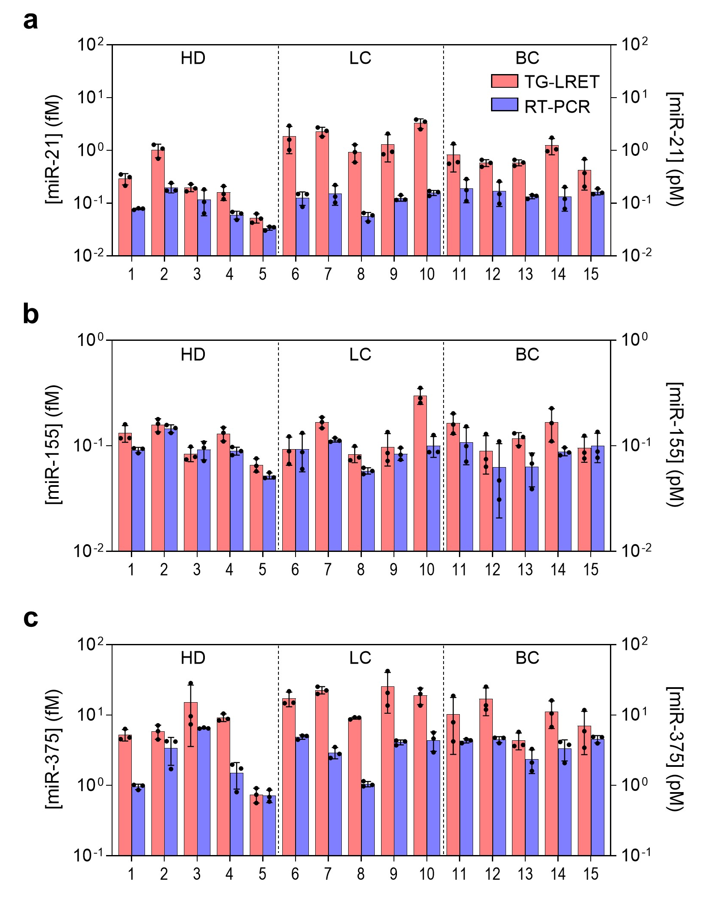
Supplementary Fig. 16. Detection of miRNA in exosome samples. a-c Detection of (a) miR-21, (b) miR-155, and (c) miR-375 in exosome samples from healthy donors (n = 5), lung cancer patients (n = 5), and breast cancer patients (n = 5) obtained by the L-TG-LRET and the PCR. The left-side y-axis denotes the scale for the concentration of miRNA obtained by L-TG-LRET and the right-side y-axis denotes the scale for the concentration of miRNA obtained by PCR. Concentrations of miRNAs were calculated from the calibration curves in Fig. 4 and Supplementary Fig. 11.
Supplementary Table 1. Upconversion luminescence lifetimes of core@shell@shell NPs. Rise lifetimes (τ_{R}) and decay lifetimes (τ_{D}) for ³H₄ → ³H₄ energy level transition (800 nm).
 | τ_{R} (μs) | τ_{D} (μs) |  | τ_{R} (μs) | τ_{D} (μs)
Y@10%Yb,1%Tm@Y | 367 | 1301 | Y@10%Yb,2%Tm@Y | 186 | 467
Y@50%Yb,1%Tm@Y | 135 | 499 | Y@50%Yb,2%Tm@Y | 119 | 293
Y@99%Yb,1%Tm@Y | 176 | 424 | Y@98%Yb,2%Tm@Y | 128 | 250
50%Yb@10%Yb,1%Tm@Y | 495 | 1494 | 50%Yb@10%Yb,2%Tm@Y | 361 | 671
50%Yb@50%Yb,1%Tm@Y | 296 | 784 | 50%Yb@50%Yb,2%Tm@Y | 303 | 547
50%Yb@99%Yb,1%Tm@Y | 212 | 443 | 50%Yb@98%Yb,2%Tm@Y | 138 | 259
Yb@10%Yb,1%Tm@Y | 498 | 2080 | Yb@10%Yb,2%Tm@Y | 291 | 464
Yb@50%Yb,1%Tm@Y | 358 | 917 | Yb@50%Yb,2%Tm@Y | 279 | 490
Yb@99%Yb,1%Tm@Y | 233 | 482 | Yb@98%Yb,2%Tm@Y | 151 | 256

Supplementary Table 2. Qualitative comparison of luminescence decays of LRET donors. Decay lifetimes (τ_{D}) for two photoexcitation types for ³H₄ → ³H₄ energy level transition (800 nm).
 |  | Short pulse (5 ns) | Long pulse (5 ms)
 | IRDye (μM) | τ_{D} (μs) | τ_{D} (μs)
L-donor | 0 | 1066.55 | 723.44
L-donor | 10^{-0.5} | 1021.03 | 713.68
L-donor | 10⁰ | 956.894 | 689.45
L-donor | 10^{0.5} | 870.335 | 651.69
L-donor | 10¹ | 725.36 | 608.83
S-donor | 0 | 131.69 | 168.16
S-donor | 10^{-0.5} | 127.18 | 166.08
S-donor | 10⁰ | 120.88 | 156.53
S-donor | 10^{0.5} | 111.72 | 149.6
S-donor | 10¹ | 100.6 | 142.13

Supplementary Table 3. Oligonucleotides used in this work.
Name | Sequence (5'3') | Modification
miR-21 | UAG CUU AUC AGA CUG AUG UUG A
miR-155 | UUA AUG CUA AUC GUG AUA GGG GUU
miR-375 | UUU GUU CGU UCG GCU CGC GUG A
pDNA-D21 | TCT GAT AAG CTA | Thiol (3’)
pDNA-A21 | T CAA CAT CAG | IR800 (5’)
pDNA-D155 | C GAT TAG CAT TAA | Thiol (3’)
pDNA-A155 | AAC CCC TAT CA | IR800 (5’)
pDNA-D375 | A ACG AAC AAA | Thiol (3’)
pDNA-A375 | T CAC GCG AGC CG | IR800 (5’)
SL primer miR-21 | CTC AAC TGG TGT CGT GGA GTC GGC AAT TCA GTT GAG TCA ACA TC
SL primer miR-155 | CTC AAC TGG TGT CGT GGA GTC GGC AAT TCA GTT GAG AAC CCC TA
SL primer miR-375 | CTC AAC TGG TGT CGT GGA GTC GGC AAT TCA GTT GAG TCA CGC GA
F primer miR-21 | ACA CTC CAG CTG GGT AGC TTA TCA GAC TGA
F primer miR-155 | ACA CTC CAG CTG GGT TAA TGC TAA TCG TGA TA
F primer miR-375 | ACA CTC CAG CTG GGT TTG TTC GTT CGG CTC
R primer | CTC AAC TGG TGT CGT GGA GTC GGC AA

Supplementary Table 4. Comparison of L-TG-LRET assay with alternative assays for miRNA detection
Donor/ Acceptor | Measurement strategy | Target | LOD | Dynamic range | Assay time | Ref
UCNP/ Dye (Cy3.5) | Time-resolved | DNA | 7.8 pM | 0 to 50 nM | 30 min | ²
UCNP/ Dye (Cy3) | Steady-state | miRNA | 30 pM | 10 pM to 1 nM | 30 min | ³
UCNP/ Dye (Cy3.5 or Cy5.5) | Steady-state | miRNA | 1 nM | 0 to 10 nM | 30 min | ⁴
UCNP/ Graphene oxide | Steady-state | mRNA | 5 fM | 5 fM to 6 µM | 40 min | ⁵
UCNP/ Dye (Cy3) | Steady-state | miRNA | 95 pM | 200 pM to 1.4 nM | 90 min | ⁶
Tb complex/ Quantum dot | Time-gated | miRNA | 80 fM | 3 pM to 500 pM | 280 min | ⁷
Dye (Cy3)/ Dye(Cy5) | Steady-state | miRNA | 9 pM | 9 pM to 500 pM | 180 min | ⁸
AIEgen/ MoS2 | Steady-state | miRNA | 20 pM | 100 pM to 1 nM | 60 min | ⁹
Dye (AMCA)/ Dye (Cy5.5) | Steady-state | miRNA | 3.5 pM | 10 pM to 1 µM | 120 min | ¹⁰
Dye (Cy3)/ Dye(Cy5) | Steady-state | miRNA | 1 nM | 0 to 80 nM | 2 min | ¹¹
UCNP/ Dye (IRDye800) | Time-gated | miRNA | 1.6 aM | 10 aM to 100 fM | 10 min | This work

Supplementary References
1. A. Hassan, L. J. A. Macedo, J. C. P. de Souza, F. C. D. A. Lima & F. N. Crespilho. A combined Far-FTIR, FTIR Spectromicroscopy, and DFT Study of the Effect of DNA Binding on the [4Fe4S] Cluster Site in EndoIII. Sci. Rep. 10 (2020).
2. Federico Pini, Laura Francés-Soriano, Vittoria Andrigo, Marta Maria Natile & Niko Hildebrandt. Optimizing Upconversion Nanoparticles for FRET Biosensing. ACS Nano 17, 4971-4984 (2023).
3. Laura Francés-Soriano, Nestor Estebanez, Julia Pérez-Prieto & Niko Hildebrandt. DNA-Coated Upconversion Nanoparticles for Sensitive Nucleic Acid FRET Biosensing. Adv. Funct. Mater. 32, 2201541 (2022).
4. Shashi Bhuckory, Satu Lahtinen, Niina Höysniemi, Jiajia Guo, Xue Qiu, Tero Soukka & Niko Hildebrandt. Understanding FRET in Upconversion Nanoparticle Nucleic Acid Biosensors. Nano Lett. 23, 2253-2261 (2023).
5. Davide Giust, María Isabel Lucío, Afaf H. El-Sagheer, Tom Brown, Lorraine E. Williams, Otto L. Muskens & Antonios G. Kanaras. Graphene Oxide–Upconversion Nanoparticle Based Portable Sensors for Assessing Nutritional Deficiencies in Crops. ACS Nano 12, 6273-6279 (2018).
6. Dong Zhu, Zhao Yi Miao, Yue Hu & Xiao Jing Zhang. Single-step, homogeneous and sensitive detection for microRNAs with dual-recognition steps based on luminescence resonance energy transfer (LRET) using upconversion nanoparticles. Biosens. Bioelectron. 100, 475-481 (2018).
7. Jingyue Xu, Xue Qiu & Niko Hildebrandt. When Nanoworlds Collide: Implementing DNA Amplification, Nanoparticles, Molecules, and FRET into a Single MicroRNA Biosensor. Nano Lett. 21, 4802-4808 (2021).
8. Jing Li, Jiaoli Wang, Shiyuan Liu, Nuli Xie, Ke Quan, Yanjing Yang, Xiaohai Yang, Jin Huang & Kemin Wang. Amplified FRET Nanoflares: An Endogenous mRNA‐Powered Nanomachine for Intracellular MicroRNA Imaging. Angew. Chem. 132, 20279-20286 (2020).
9. Qin Zhang, Bohan Yin, Yingying Huang, Yutian Gu, Jiaxiang Yan, Jiareng Chen, Chuanqi Li, Yu Zhang, Siu Hong Dexter Wong & Mo Yang. A dual “turn-on” biosensor based on AIE effect and FRET for in situ detection of miR-125b biomarker in early Alzheimer's disease. Biosens. Bioelectron. 230, 115270 (2023).
10. Shasha Lu, Jianyu Yang, Huanhuan Xing, Yuanyuan Chang, Jian Sun, Chunxian Guo & Xiurong Yang. FRET cascade miRNA addition probe from non-crosstalk DNA photonic wire assisted with clustering algorithm for early diagnosis of acute myocardial infarction. Biosens. Bioelectron. 224, 115080 (2023).
11. Zhixin Zhou, Daoqing Fan, Jianbang Wang, Yang Sung Sohn, Rachel Nechushtai & Itamar Willner. Triggered Dimerization and Trimerization of DNA Tetrahedra for Multiplexed miRNA Detection and Imaging of Cancer Cells. Small 17, 2007355 (2021).

