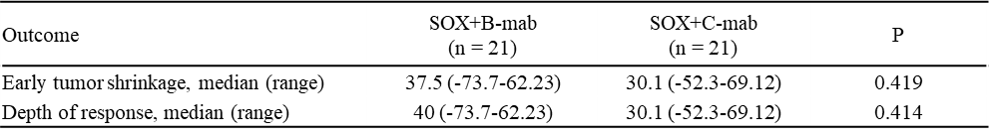
-75
-50
-25
0
25
50
75
Depth of response (%)
P=0.414
SOX+B-mab
SOX+C-mab
DpR
-75
-50
-25
0
25
50
75
P=0.419
SOX+B-mab
SOX+C-mab
ETS
Percentage of ETS (%)
Supplemental Table.2 ETS and DpR

